Inspection Services Department of Urban Development
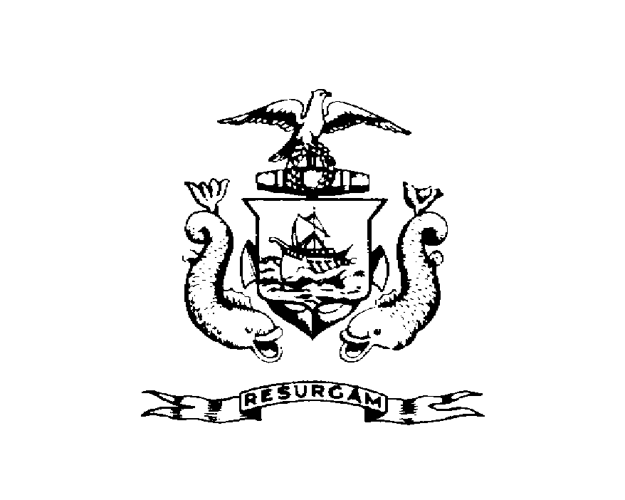
Michael J. Nugent Joseph E. Gray, Jr.
Manager Director

CITY OF PORTLAND

July 30, 2026

Jennifer Plourde
12 School Street
Portland ME 04102

RE: 12 School St
CBL: 057H00400101

Dear Jennifer Plourde:

A re-inspection at the above noted property was made on Mar-29-2000.

This is to certify that you have complied with our request to correct the violation(s) of the Municipal Code relating to housing conditions noted on our letter dated Jan-13-2000.

Thank you for your cooperation. If you have any questions, feel free to contact this office
Marland Wing @ 874-8696.

Sincerely,

Marland Wing @ 874-8696
Code Enforcement Officer

Nbw/

