Inspection Services Department of Urban Development
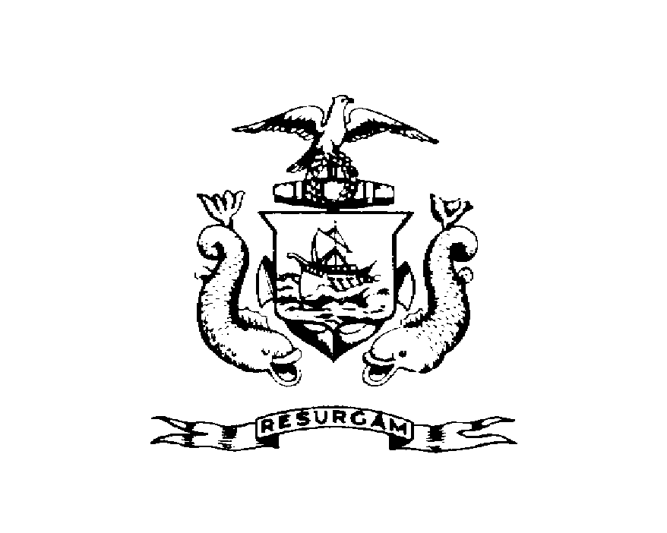
Michael J. Nugent Joseph E. Gray, Jr.
Manager Director

CITY OF PORTLAND
SECOND NOTICE OF VIOLATION
BILLING NOTIFICATION
July 31, 2026

Scott D. Collins
3 Glendon Rd.
Cape Elizabeth, ME 04107

RE: 10 Dow St
CBL: (055-E-02200101)
Certified Mail Receipt # Z 564 696 460
Dear Scott D. Collins;

An evaluation of your property at 10 Dow St on Feb-28-2000 time revealed that the structure remains non-compliant with the Housing Code of the City of Portland.

Attached is a list of the violations.

This is a SECOND notice of violation pursuant to Section 6-118 of the Code. All referenced violations shall be corrected within days of the date of this notice. A re-inspection of the premises will occur on Mar-24-2000 at which time compliance will be required.
Failure to comply will result in this office referring the matter to the City of Portland Corporation Counsel for legal action and possible civil penalties, as provided for in Section 1-15 of the Code and in Title 30-A M.R.S.A. ss 4452.
Please be advised that because this is the second inspection and there are repeat violations, Section 6.2 of the Code requires that you pay a $75.00 re-inspection fee. This must be paid prior to Mar-24-2000. Failure to pay the assessed fee within 30 days shall cause the City to assess a lien against the property pursuant to Section 1-16 of the Code. Please feel free to contact Tom Markley @ 874-8705, if you wish to discuss the matter or have any questions.

Sincerely,

Tom Markley @ 874-8705
Code Enforcement Officer

CC: Central File
John Corbin

