EXISTING

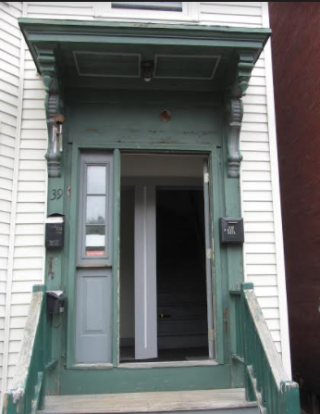

PROPOSED:

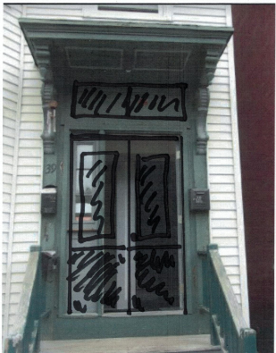

29 ¾” x 83” X 2” – Architectural Salvage: Glass will be replaced with single light glass. Once restored these would work well with the rough opening at 60”.

