Inspection Services Department of Urban Development
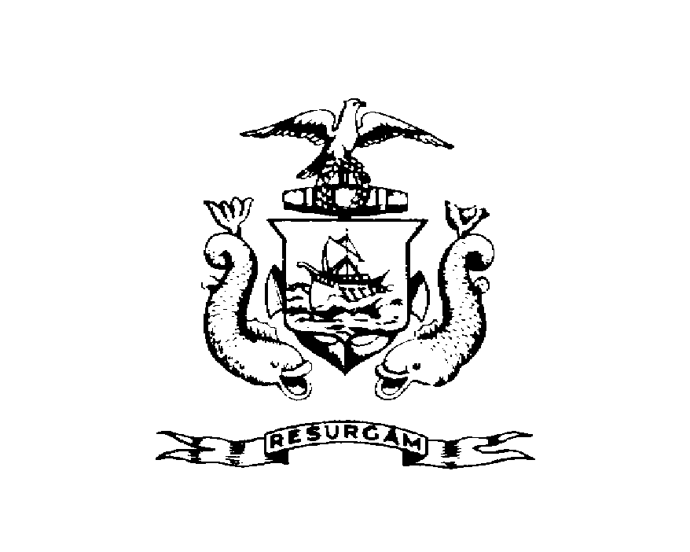
Michael J. Nugent Joseph E. Gray, Jr.
Manager Director

CITY OF PORTLAND
July 28, 2026

Robert Solotaire
228 Brackett St
Portland, ME 04102

RE: 228 Brackett St
CBL: 055-B-02500101

Certified Mail Receipt # Z 397 901 871

Dear Mr. Solotaire:

An evaluation of your property at 228 Brackett St on May 5, 2000 revealed that the structure fails to comply with Chapter 6.Article V. of the Code of Ordinances of the City of Portland, The Housing Code. Attached is a list of the violations.

This is a notice of violation pursuant to Section 6-118 of the Code. All referenced violations shall be corrected within 30 days of the date of this notice. A re-inspection of the premises will occur on June-30-2000 at which time compliance will be required. Failure to comply will result in this office referring the matter to the City of Portland Corporation Counsel for legal action and possible civil penalties, as provided for in Section 1-15 of the Code.

This constitutes an appealable decision pursuant to Section 6-127 of the Code. Please feel free to contact Marland Wing @ 874-8696, if you wish to discuss the matter or have any questions.

Please be advised that the Portland City Council has amended the Building regulations to include a $75.00 re-inspection fee. This violation will automatically cause a re-inspection at no charge. If there are any subsequent inspections, however, the $75.00 fee will be assessed for each inspection.

Sincerely,

Marland Wing @ 874-8696
Code Enforcement Officer

Nbw/

