Inspection Services Department of Urban Development
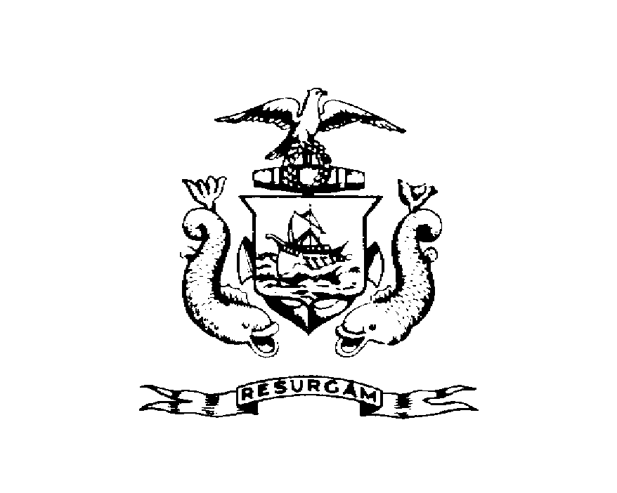
Michael J. Nugent Joseph E. Gray, Jr.
Manager Director

CITY OF PORTLAND

July 28, 2026

Robert S. Solotaire
228 Brackett Street
Portland ME 04102

RE: 228 Brackett St
CBL: 055B02500101

Dear Mr. Robert S. Solotaire:

A re-inspection at the above noted property was made on Feb-03-2000.

This is to certify that you have complied with our request to correct the violation(s) of the Municipal Code relating to housing conditions noted on our letter dated Feb-04-1999.

Thank you for your cooperation. If you have any questions, feel free to contact this office
Marland Wing @ 874-8696.

Sincerely,

Marland Wing @ 874-8696
Code Enforcement Officer

Nbw//

