
Memorandum
Planning and Urban Development Department
Planning Division

To: Sean Dundon, Chair, and Members of the Portland Planning Board
From: Nell Donaldson, Senior Planner, and Caitlin Cameron, Urban Designer
Date: November 9, 2018
Re: MMC Congress Street Hospital Building
Project #: 000331-2018 CBL: 53-D-7
Meeting Date: November 13, 2018

I. INTRODUCTION
Maine Medical Center (MMC) appears before the Planning Board for a second workshop on the third and final phase of the short-term expansion proposed in their 2017 Institutional Development Plan. This phase involves the demolition of the existing 360,000 SF Gilman Street employee parking garage and replacement with a 285,000 hospital building. As proposed, the hospital building would house 64 private patient rooms, 19 procedure rooms, and connections to both the Congress Street corridor and the interior of the Bramhall campus. The proposal is subject to the standards of the Maine Medical Center Institutional Overlay Zone (MMC IOZ) and qualifies for Level III site plan review under the city’s land use code. The application is also subject to the state’s Site Location of Development Act, for which the city has delegated review authority. Advertisement of this workshop appeared in the Portland Press Herald on November 2 and 3, 2018. In addition, 254 notices were sent to property owners within 500 feet and the interested citizens list.

The Planning Board met on October 23, 2018 to review the preliminary plans for MMC’s proposed Congress Street hospital building, focusing primarily on the urban design and construction management aspects of the review. In the intervening time, staff has reviewed revised submittals from MMC, providing comments with respect to all IOZ and site plan standards. Because this second workshop will concentrate on transportation and utility-related elements of the plans, only those IOZ and site plan standards are explored in detail here. The final Planning Board hearing report will include a complete analysis against all aspects of the site plan and Institutional Overlay Zone ordinances, as well as the standards of the Site Location of Development Act.

Applicant: Maine Medical Center
Consultants: Will Conway, Sebago Technics; Jeff Keilman, Perkins & Will; Randy Dunton, Gorrill-Palmer; Turner Construction

II. REQUIRED REVIEWS
Waiver Requests | Applicable Standards
Sidewalk material – to allow concrete sidewalks on Congress and Gilman Streets | Technical Manual Section 1.8 – The City sidewalk materials policy shall be consulted to determine the appropriate type of sidewalk construction.
Provision of sidewalk – to allow a portion of the Gilman Street frontage without a sidewalk | Section 14-526(a)2.c.(i) - All developments shall provide sidewalks along all frontages….installed to city specifications, with waiver provisions under 14-506(b).
Driveway width – to allow a driveway approximately 30’ in width | Technical Manual Section 1.7.2.4 – Maximum widths shall not exceed 24’ for two way access to commercial sites.

Review | Applicable Statute
Institutional Overlay Zone | Section 14-282
Site Plan | Section 14-526
Site Location of Development | Technical Manual Section 14
III. PROJECT DATA
Existing Zoning | Institutional Overlay Zone
Existing Use | Structured parking
Proposed Use | Hospital building – 19 procedure rooms, 64 inpatient rooms
Parcel Size | 12.5 acres (contiguous Bramhall campus)
 | Existing | Proposed | Net Change
Building Footprint | 36,000 SF | 50,000 SF | 14,000 SF
Building Floor Area | 360,000 SF | 285,000 SF | -75,000 SF
Impervious Surface Area | 398,575SF | 412,862SF | 14,287SF
Parking Spaces | 3,279 (for entire campus, including employee garage) | 3,279 | 0
Bicycle Parking Spaces | 193 (campus-wide) | 193 | 0

IV. CONTEXT
Maine Medical Center’s Institutional Development Plan (IDP), approved by the Planning Board in the fall of 2017, laid the groundwork for a major hospital expansion over the next decade. The short- and long-term expansion plans proposed in the IDP were designed to respond to an emergent clinical need for private beds, to retire aging facilities which no longer meet the needs of patients and visitors, to reorganize the campus to address evolving best practice in health care design, and to centralize parking for employees and visitors. As of the fall of 2018, the hospital has received site plan approval for two of the three projects that comprise the hospital’s short-term development plan – the vertical expansions of the East Tower and Visitor Garage and the construction of the Employee Garage at 190 St. John Street. The third project, a new 285,000 SF hospital building with a major entrance on Congress Street, is under consideration here.

The site of the proposed Congress Street hospital building lies on the northwest corner of MMC’s Bramhall campus, at the intersection of Congress and Gilman Streets (Figure 1). The bulk of the Bramhall campus sits up gradient behind the site. The Maine Sleep Institute lies to the west across Gilman Street, commercial properties face the site from the north across Congress Street, and MMC’s Visitor Garage lies to the east. The site is currently occupied by MMC’s Gilman Garage.

The site lies within the MMC Institutional Overlay Zone (IOZ), a zoning designation adopted into the land use code by the City Council in November of 2017 (Figure 2). The IOZ establishes use and dimensional standards which govern proposed development by MMC within the zone, as well as a series of general development standards. Development within the IOZ which meets the criteria for site plan review is also subject to the site plan standards of the land use code.

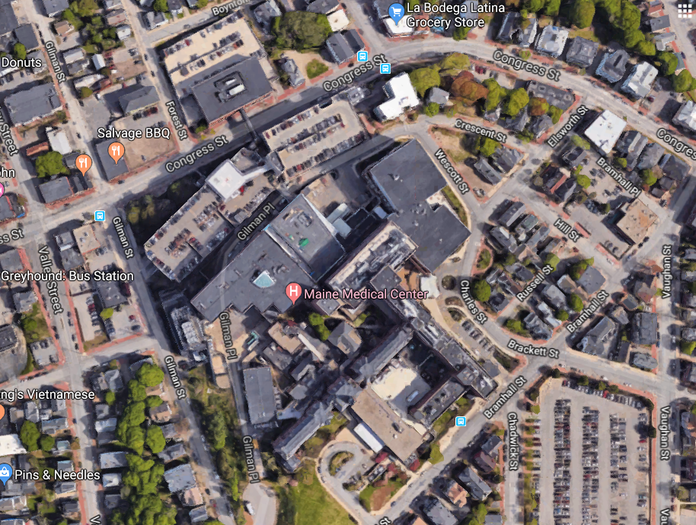
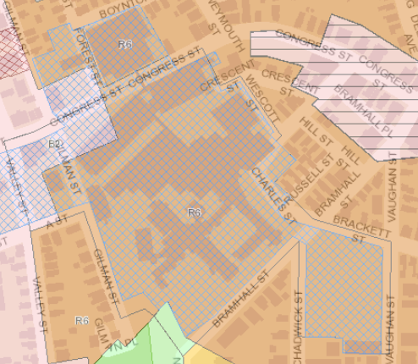
Figures 1 & 2: Project site land use context (above) and zoning context (below)
Visitor Garage
Commercial
Office/
Commercial

887 Congress MOB
Institutional Overlay Zone
B-2
V. PROPOSED DEVELOPMENT
The site plan application includes the demolition of the existing 360,000 SF Gilman Garage, which has stood on the site since the mid-1970s and is nearing the end of its useful life. Following demolition, significant site work is proposed, including substantial regrading, utility work, and the installation of an underground stormwater detention and treatment facility.

The new 285,000 SF building which is proposed to replace the Gilman Garage would contain circulation space and pre-operative/recovery rooms on the first floor, a second floor containing 19 procedure rooms, and inpatient rooms on the third and fourth floors. A landscaped roof garden is proposed with access from the 3rd floor. Connections to the upper campus would be provided through a vertical tower at the southeast corner of the building , with access from the fifth, sixth, and seventh floors of this tower.

The building has been designed to function as a major point of entry to the hospital, giving the campus a new face on Congress Street and a new way of engaging with the neighborhoods that surround it. The building’s most active areas, including circulation and lobby spaces, are oriented towards Congress Street, where significant amounts of glass are proposed. The building would lie between 20 and 30 feet from the right-of-way line on Congress Street and directly adjacent to the right-of-way line on Gilman Street.

The site plan includes an arrival area tucked partly below the second floor at the easterly end of the building. This turnaround would provide access for vehicles, pedestrians, and bicyclists destined for the main building entrance as well as vehicles entering the visitor garage. The turnaround is proposed in hardscape, with shade-tolerant plantings in the center. This area would be held by a significant retaining wall at the Congress Street property line, one-story above a separate plaza space with plantings and low seating walls at the northwesterly corner of the site. A broad stairway is proposed to join these two exterior spaces.
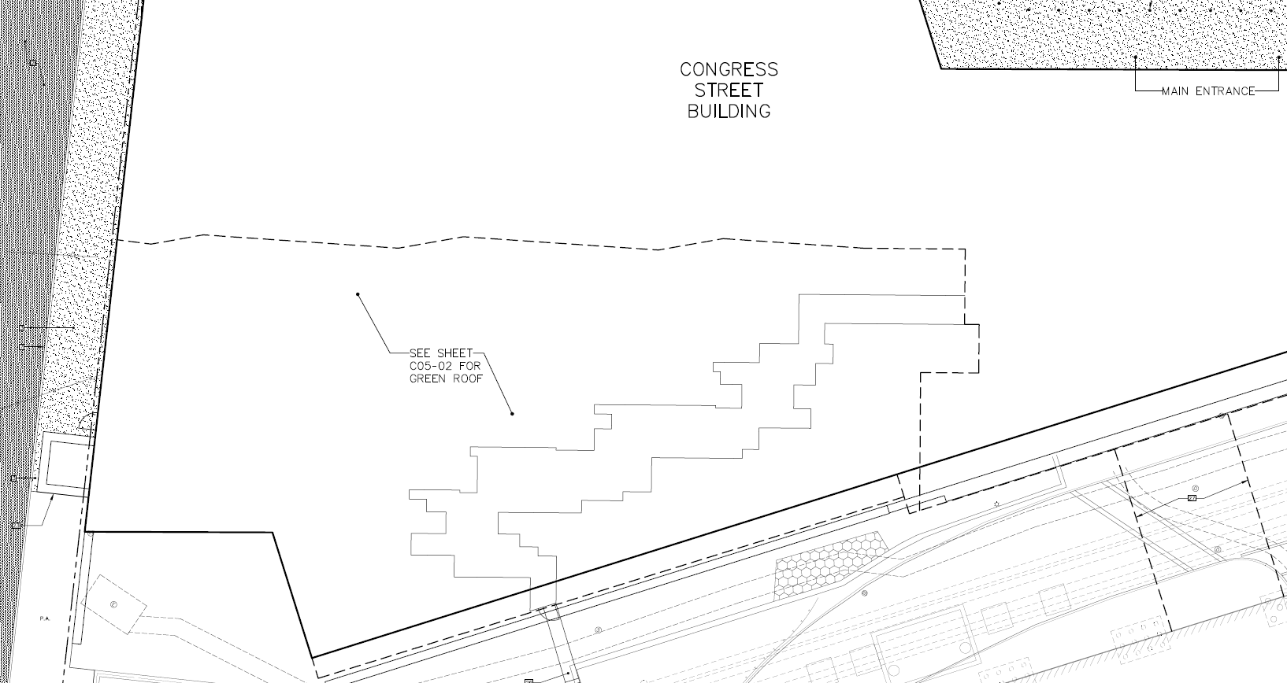
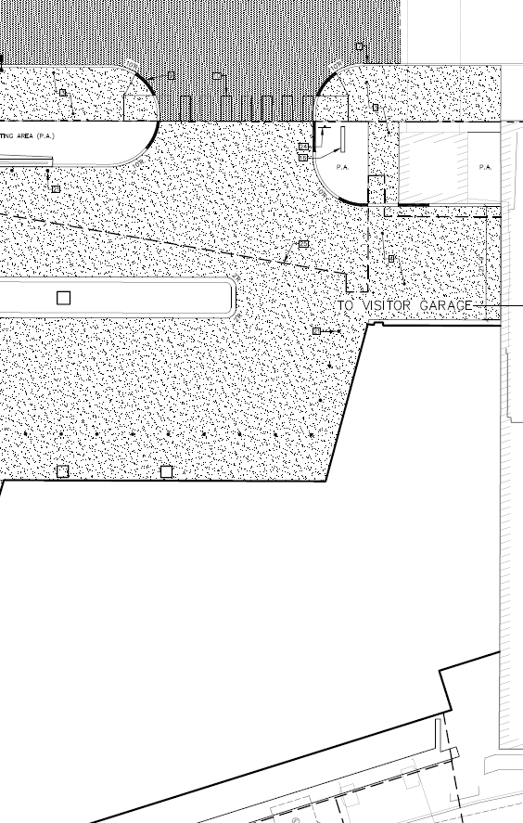
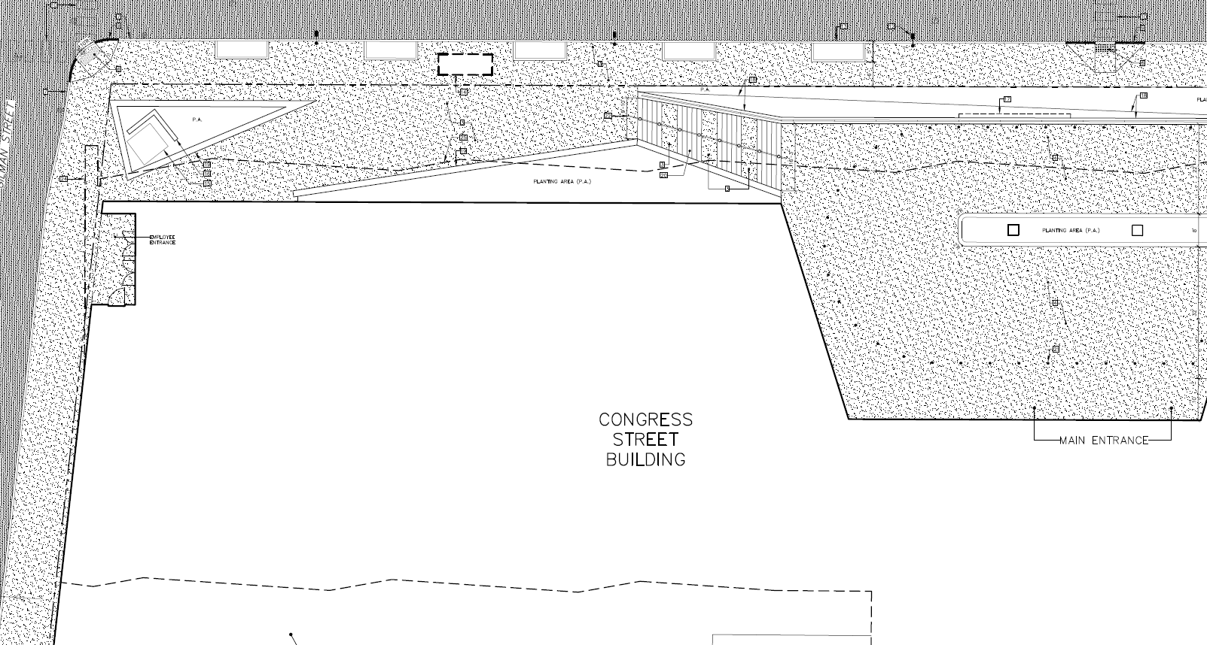
Lower Plaza
Pick-up/Drop-off Area
Employee Entrance
Visitor Garage Access
Figure 3: Preliminary site plan
Main entrance

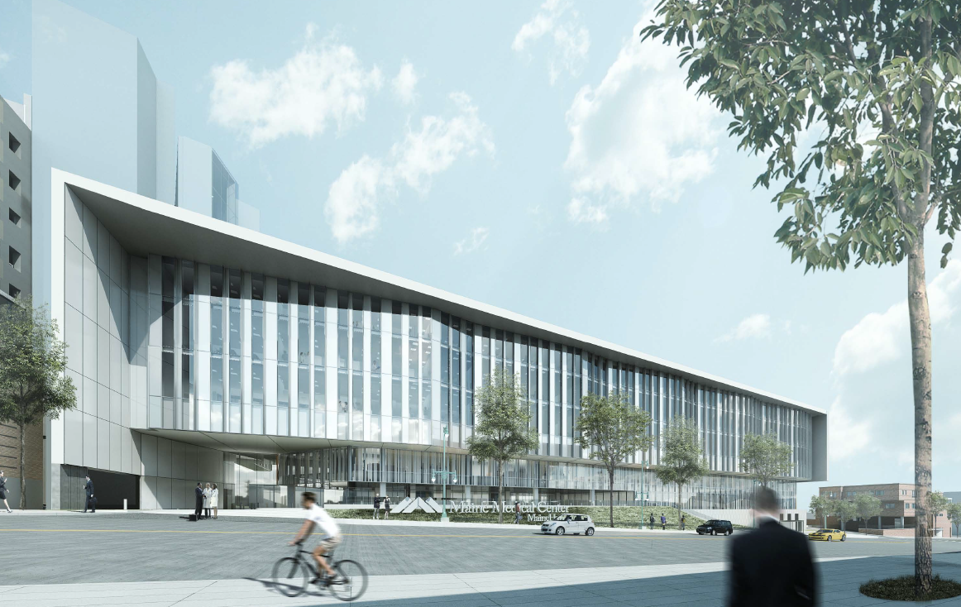
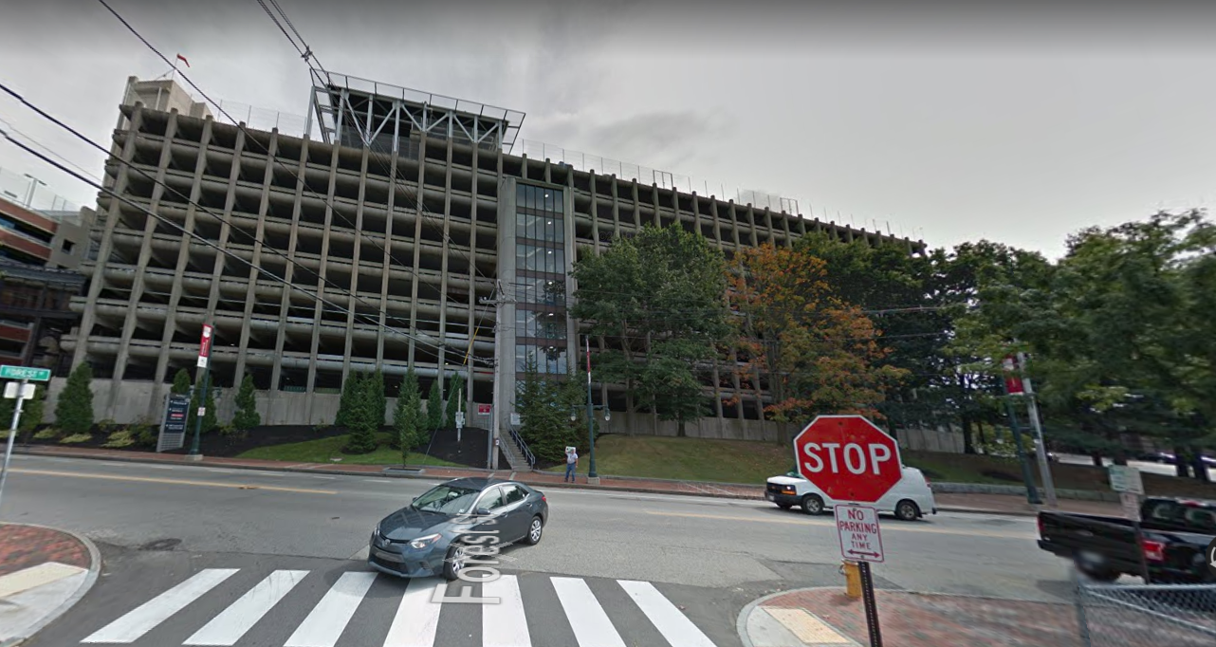
Figures 4 and 5: View from Forest Street looking south across Congress Street, existing (above) and proposed (below)

VI. PRELIMINARY ZONING & SITE PLAN REVIEW – TRANSPORTATION
Staff has conducted a preliminary review of the site plan application with respect to the transportation-related standards of the Institutional Overlay Zone and land use code. Preliminary staff comments are summarized below.

- Impact on Surrounding Street Systems
The proposed Congress Street medical building, although not designed to increase the number of patient beds at MMC, is anticipated to add 200 employees to the MMC campus by 2023 and 324 employees by 2026. Altogether, this increase in employees is estimated to generate over 100 AM, PM, and Saturday peak hour trips. As a result, a Traffic Movement Permit (TMP) is required.

It should be noted that previous MMC site plans reviewed by the city, including the 2013 Bean 2 addition, the East Tower and Visitor Garage expansion approved in early 2018, and the Employee Garage approved in mid-2018, have not individually met the trip generation thresholds for Traffic Movement Permits. As a result, TMPs were not required for those projects. However, as required under TMP regulations, the current TMP application does include some analysis of previously approved expansions by MMC, including the Bean 2 addition, in order to assess total change in trip generation on the campus over the past ten years. Tom Errico, the city’s consulting traffic engineer, has reviewed this analysis and writes,

Traffic Movement Permit regulations require Applicants to document incremental changes to a site over the prior 10 years to determine factors that have influenced traffic generation from the site. In my professional opinion, the Applicant has not provided documentation that adequately addresses historical changes at MMC.

In conversation, Mr. Errico has requested additional documentation on operational shifts on the campus which may have affected employee and patient volumes over the past ten years.

The trip generation estimated in the TMP application is based on a projected employment number for 2026, approximately five years following initial occupancy of the new medical building. These trips have been assigned to the roadway network based on both existing employee travel data and observations of the existing transportation system. The traffic study has taken projected shifts in routing into account; the demolition of the existing employee garage and the construction of the new employee garage on St. John Street will affect employee trips within the immediate study area, for example, shifting traffic away from Gilman Street and towards St. John, and the addition of an entrance on Congress Street will shift some traffic currently destined for the Bramhall entrance. Lastly, MMC has calculated trip generation associated with the proposed shuttle service from the Employee Garage on St. John Street to both the new north entrance and the existing Bramhall entrance. Mr. Errico has reviewed the trip generation analysis and trip distribution and writes,

I generally find the methods used in the development of the base traffic volumes to be reasonable and acceptable. It should be noted that the volume timeframe for the analyses was the peak hour of the roadway system, which does not correspond to employee peaking in the morning (employees arrive before the peak hour). The Applicant should provide documentation noting traffic volumes on roadways during both the peak hour of the system and peak hour of traffic generation from MMC.

As is customary, the traffic analysis includes a discussion of impacts to roadway capacity, including level of service (LOS) and queue analyses at 11 nearby intersections stretching from Park Street/St. John Street east to Bramhall Street/Congress Street and south to Valley Street/Commercial Street. The level of service analysis, which assumes some imminent changes in the roadway network, such as the elimination of the Congress Street/Valley Street signal, generally shows acceptable levels of service, with some marginal negative impacts, for example to overall level of service at the Congress Street/St. John Street intersection at the PM peak hour. Other intersections, such as Park Street/St. John Street, are anticipated to improve in LOS in the post-development condition. Queue lengths are anticipated to increase on many intersection approaches. Mr. Errico has reviewed the level of service analysis and writes,

The Park Avenue/St. John Street intersection has improving levels of service and delay following project build-out. The Applicant should specifically note any traffic signal equipment modifications that are needed to accomplish the noted optimization.

The Commercial Street/Valley Street intersection has improving levels of service and delay following project build-out. The Applicant should specifically note any traffic signal equipment modifications that are needed to accomplish the noted optimization.

The Congress Street/St. John Street intersection was modeled assuming existing roadway conditions. The Applicant shall also conduct an analysis assuming the Dunkin Donuts improvements on St. John Street are implemented (converting St. John Street from four lanes to three lanes).

The Applicant shall recommend pedestrian and vehicle improvements at the Congress Street/Valley Street intersection during post-traffic signal conditions.

I continue to review traffic model output for vehicle queuing and will provide comments in the future.

The traffic analysis also includes a general discussion of sight lines from the proposed pick-up/drop off area, noting that they appear to meet city and MaineDOT standards. Mr. Errico writes,

The Applicant shall provide specific sight distance measurements at the Congress Street/Drop-Off driveway according to Site Plan information.

The traffic analysis provides an examination of existing crash data within the study area for the most recent three-year period. This data shows that there are seven high crash locations within the area studied, including four intersections and three street segments. The traffic study includes an analysis of crash patterns observed at these locations, including pedestrian and bicycle collisions, and in some cases recommends modifications to roadway design, signal timing, or signs to mitigate safety concerns. Mr. Errico has reviewed the analysis and writes,

The Park Avenue/Valley Street intersection is a High Crash Location. The Applicant shall provide specific recommendations with implication of such changes for review and consideration.

The Congress Street/Gilman Street intersection is a High Crash Location. The Applicant suggests that the future removal of the traffic signal at Congress Street/Valley Street may mitigate crashes. I continue to review this, but a monitoring requirement post signal conditions may be suggested.

The St. John Street/A Street is a High Crash Location. The Applicant suggests that traffic volume reductions may mitigate crashes. The new employee parking garage will increase traffic volumes in the area and may negatively impact conditions. I continue to review this, but a monitoring requirement after the employee parking garage is open may be suggested.

Park Avenue/St. John Street is a High Crash Location. The Dunkin Donuts project on St. John Street will likely be implementing improvements to the northbound St. John Street approach. The D[unkin] D[onuts] scope of this work is not expected to mitigate all crash patterns. The Applicant shall specifically recommend strategies for mitigating all crash patterns that are correctable by improvements.

Valley Street between and A Street and C Street is a High Crash Location. The Applicant noted at the TMP Scoping Meeting that traffic volumes will be declining on Valley Street in this area and thus may reduce collisions. The Applicant shall document specific before/after traffic volumes changes on Valley Street as part of assessing mitigation of crash rates.

The Congress Street/St. John Street intersection is not a High Crash Location but experienced 25 crashes over the reported three-year period. The Applicant shall conduct a safety review of the intersection.

In his review, Mr. Errico has paid particular attention to the safety analysis for the segment of Congress Street between Gilman Street and Weymouth Street, where the applicant has suggested implementation of a center turn lane as mitigation to address a pattern of rear end collisions (Figure 6). Mr. Errico writes,

Congress Street is a High Crash Location between Forest Street and Weymouth Street. To assess potential mitigation strategies, I conducted a review of police reports. The Applicant has suggested the provision of a three-lane roadway with a center left-turn lane. There were 10 crashes reported over the most recent three-year period with a Critical Rate Factor of 1.45. [Mr. Errico’s analysis of the collisions in this location is included in Attachment 2].

Based upon my review of the data, at most 50% of the crashes could be mitigated with the introduction of a center turn lane. I would note again that some of the rear end collisions may not have been related to a left-turn movement, but to congested dense slow-moving vehicle conditions. The center turn lane would not mitigate those crashes.

City staff is concerned about changing the roadway context of Congress Street (particularly in comparison with nearby intown Congress Street conditions) and how it has the potential for dangerous increased vehicle speeds. I would note that the Applicant’s traffic simulation model of Congress Street in this area depicts a roadway with little to no vehicle delay suggesting limited turning vehicle conflict opportunities. Lastly, it is my professional opinion that this section of Congress Street will change contextually when the project is completed, functioning more like an urban street (similar to intown Congress Street), due to changes to the building activity, enhanced streetscape, increased pedestrian/bicycle activity, slower vehicle speeds, thus creating a Complete Street serving all users. In my professional opinion this change to a Complete Street would result in safe conditions for all users.
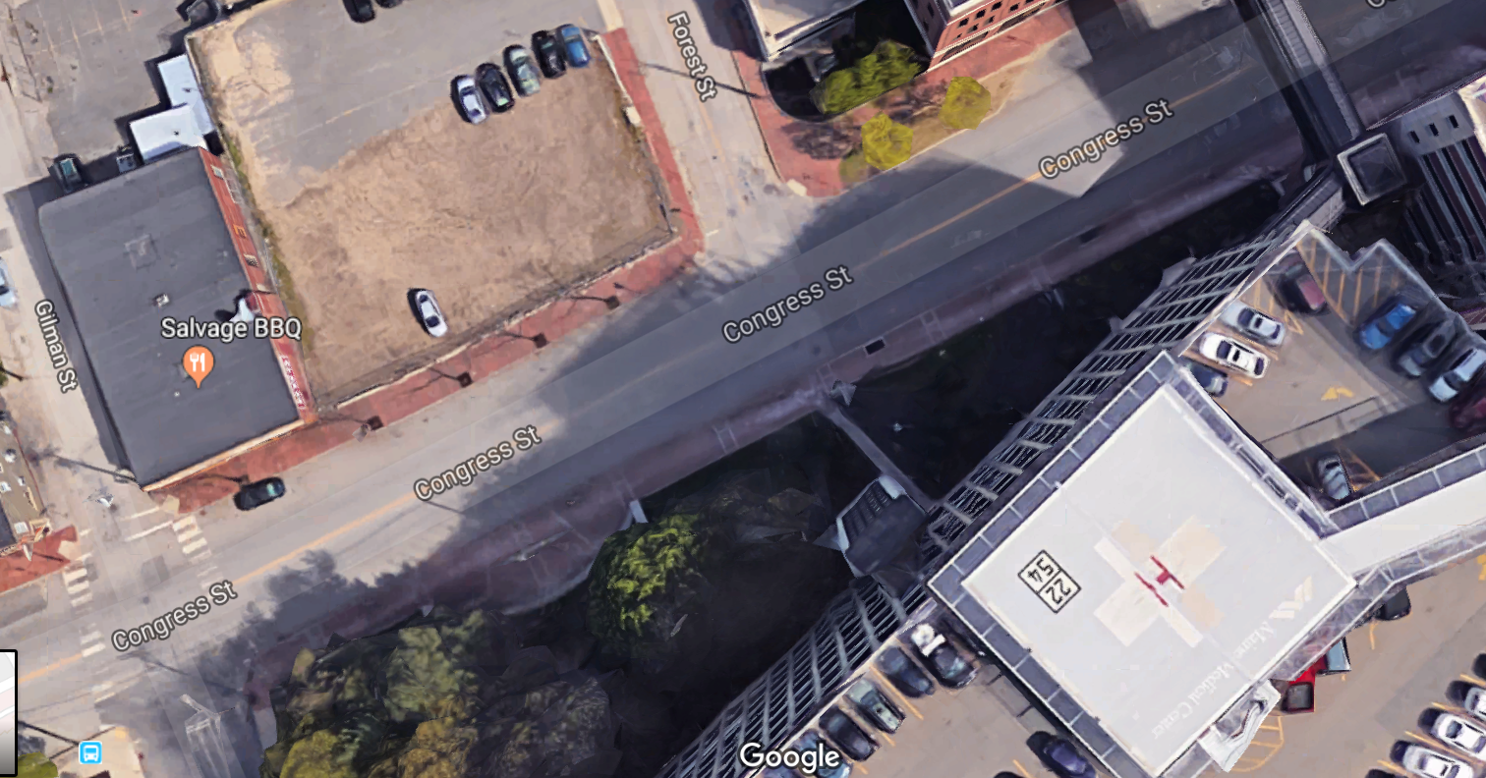
Department of Public Works staff has echoed this position regarding the recommendation of a center turn lane on this segment of Congress Street. Jeremiah Bartlett, the city’s Transportation Systems Engineer, writes,
Figure 6: Congress Street from the intersection of Gilman Street east along the proposed hospital building frontage.

I concur with [Mr. Errico’s] comments. In particular, I share concerns with the non-urban nature of a three-lane cross section fronting MMC and implications for vehicle speed...

Given these findings, a center turn lane is not recommended for this stretch of Congress Street at this time.

- Access and Circulation
In the revised submittal, the applicant has provided a site plan, as well as a diagram for the pick-up/drop off area that shows proposed circulation patterns (Plan 46). The site plan remains largely unchanged from the time of the October 23 Planning Board workshop, where the Congress Street and Gilman Street streetscapes were considered. However, MMC and staff have engaged in numerous discussions in the intervening time about the Congress Street and Gilman Street right-of-way design, with the aim of providing safe and reasonable access to the entire site, as well as safe access within the right-of-way for the traveling public at large.

In previous review comments and in subsequent meetings with the applicant, staff has outlined a preferred section for the 66’ Congress Street right-of-way that includes the retention of an 11’ sidewalk on the north side, an 8’ north side parking lane, two 12’ travel lanes, a 2-3’ buffer, a 6-7’ climbing bicycle lane, and a 13-15’ sidewalk on the south side of the street along the hospital frontage. The concept behind this section is to retain existing parking on the north side of Congress Street, provide ample travel lanes to support emergency service vehicles, allow a buffered climbing bicycle lane on the south side of the street, and provide generous sidewalks, consistent with other portions of Congress Street, in front of the hospital, with room for street trees, street lights, and a METRO shelter and landing area.

In response to these comments, MMC has produced two concepts, one of which shows a cross-section with a center turn lane, two travel lanes, and eastbound and westbound bicycle lanes (Plan 45), and one of which shows an approximation of the cross-section recommended by city staff (Plan 46). Staff has reviewed these sections and continues to provide guidance to the applicant regarding the preferred street section as outlined above, including comments from the Department of Public Works and Fire Prevention. Final details regarding the location of the south side curbline and associated sidewalk width will be finalized prior to public hearing.

Vehicle Access
Vehicles are proposed to access the site via a pick-up/drop-off loop located partially underneath the proposed building (Figure 7). This turnaround is proposed with access from Congress Street through a two-way driveway with a center island, approximately 30’ in width. Given the width proposed, a waiver will be required.

The pick-up/drop-off area has been designed based on observations of MMC’s existing Bramhall entrance. As proposed, the pick-up/drop-off would operate as a one-way loop, with storage capacity for up to 11 vehicles. The loop would provide direct access to the Visitor Garage to the east, as well as back to Congress Street. Exiting visitors could access the loop directly from the Visitor Garage and from there exit to Congress Street. A valet is proposed to operate out of this area.

Bicycle Access
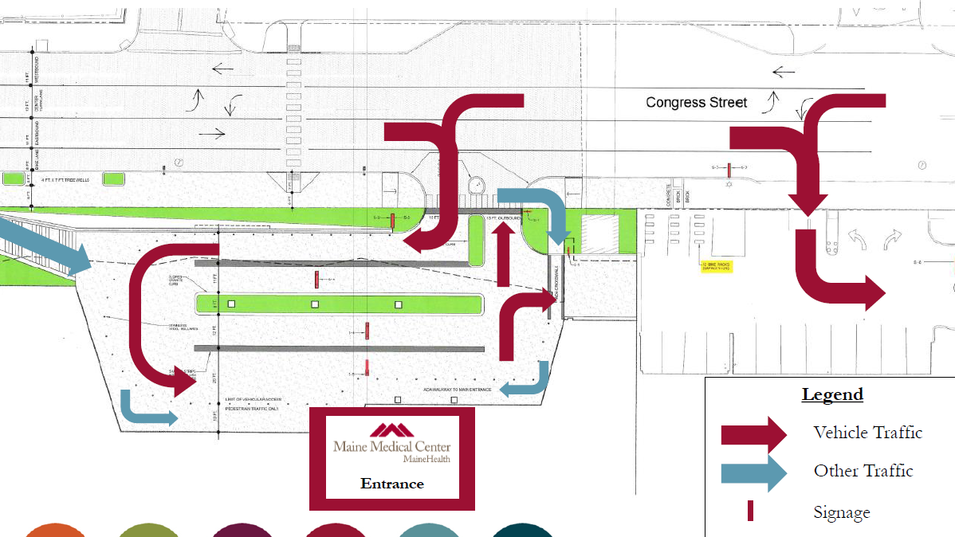
As noted above, staff has requested the provision of a climbing bicycle lane in the eastbound direction on Congress Street, and shared lane markings within the travel lane in the westbound direction. This section of Congress Street has been slated for bicycle infrastructure in prior long-range planning work on the part of the city, and would provide direct access to the hospital from existing bicycle infrastructure, particularly from the west. From the bicycle network, bicycles would enter the pick-up/drop-off loop integrated with vehicular traffic. Covered bicycle parking is proposed in the ground floor of the adjacent Visitor Garage. Staff has requested that the applicant clarify how visitors would identify the location of this proposed parking.
Figure 7: Proposed pick-up/drop-off circulation

Pedestrian Access
As previously discussed, the preliminary plans include new concrete sidewalks on Congress Street and Gilman Street, which converge at an open plaza space at the northwest corner of the site. This plaza, which would lie adjacent to the employee shuttle bus pickup/drop off, is proposed in concrete as well, with granite seating walls rimming the two proposed planting areas. The plaza leads to a wide stair in granite, which provides direct pedestrian access to the main entrance via the turnaround above.

As noted above, staff has previously requested modifications to both the Gilman Street and Congress Street sidewalks to allow safe pedestrian access. In his preliminary comments, Mr. Errico wrote,

General sidewalk width given future pedestrian demand on Congress Street seems inadequate. Congress Street cross-section width should specifically be detailed. How will bikes, parking, bus, vehicles be accommodated?

The flared curb ramp near the main entrance vehicle driveway is not acceptable partly because it creates a narrow pedestrian accessible route. Also, the crosswalk location should be evaluated.

The provision of the City’s preferred two-ramp configuration at the Gilman Street corner should be investigated.

The Gilman Street non-tangent curb alignment is not acceptable. A straight curb is suggested. Gilman Street width dimensions shall be provided.

In addition, staff has raised some questions regarding ADA accessibility in the sidewalk design. In his preliminary comments, Bruce Hyman, the city’s Transportation Program Manager, wrote,

I don't believe, based on the grading plan submitted, (C40-01/02) that the curb ramps serving the mid-block crosswalk meet ADA in terms of cross-slope (2% max. cross-slope)…. Please document the ADA analysis.

I need to further assess curb ramp design- for instance, there is not sufficient landing area for the curb ramp serving the mid-block crossing along the retaining wall - a 5' deep (measured perpendicular to the street) ramp landing area is required where a ramp meets vertical obstructions (not the usual 4')

As noted above, the applicant has proposed concrete sidewalks, although both the Congress Street and Gilman Street sidewalks are designated as brick in the City’s sidewalk material policy. In their most recent submittal, MMC has provided a Pedestrian Network Plan, required under the Institutional Development Plan, to clarify the need for a sidewalk material waiver, as well as a formal waiver request. Staff support the use of concrete sidewalk material in front of the new building on Congress Street and Gilman Street, given that the concrete sidewalks would provide continuity to the private plaza design. The applicant has proposed a mid-block transition from concrete to red brick with granite bands. Staff prefer that this transition occur at the curb line for the Visitor Garage, which would extend the concrete further than the new building but would create a more seamless transition.

The applicant’s site plan shows the Gilman Street sidewalk terminating short of the southerly end of the proposed hospital building and approximately 100’ north of the A Street intersection. In the revised submittal, the applicant has formally requested a sidewalk waiver on this stretch of Gilman, on the grounds that an alternative walking route exists in the sidewalk on the west side of Gilman Street and that the construction of a sidewalk on the east side would result in the loss of significant site features in the form of existing landscape along the face of MMC’s Central Utility Plant. In staff’s analysis, these waiver criteria are not met. Staff has requested that the applicant extend this sidewalk to the south in order to provide continuous access to A Street.

In addition, staff has requested that the applicant address the presence of a proposed mechanical areaway within this sidewalk area, as well as a large electrical structure to the south of the area. This utility infrastructure must be below grade or flush so as not to preclude pedestrian access, and may require license agreements. Similarly, areas of sidewalk which are proposed to lie on private property along this frontage will require a public pedestrian easement.

Within the proposed pick-up/drop-off area, pedestrians would access the front door via bollard-protected routes against the building face. The ADA-accessible route is proposed from the sidewalk at the northeast corner of the site. Staff has raised questions about the access from the Forest Street approach, which involves crossing the driveway mouth as well as the Visitor Garage entryway. Staff suggest legibility and wayfinding to the building entrance might be enhanced with a pavement material change (color, material type, etc.) to further delineate the pedestrian areas from the vehicular paths. Currently, bollards and planting areas are used to demarcate these zones.

For the sidewalk and plaza design, there is conflicting information on the site plan compared with the renderings which show seams and accent banding, but this level of detail does not appear in the plans. Staff has requested clarification on the design detail, including material, scale, color, pattern, seams, placement. Some level of detail, whether with seams, color changes, or patterns, should be incorporated to bring visual interest and scale to this space.

Shuttle Access
The site plan application includes details regarding the proposed shuttle operations between the Employee Garage on St. John Street and the new medical building. Employee access to the medical building is proposed via card reader through doors at the northwest corner of the building. The Congress Street shuttle route would drop off and pick up employees at this door, operating on a counterclockwise loop via Valley Street, A Street, Gilman Street, Congress Street, and St. John Street. Shuttles are proposed to operate on 15 minute headways during peak hours. A shuttle would also provide access from the Employee Garage to the Bramhall entrance with a route via Danforth, Vaughan, and the Western Promenade.

- Public Transit Access
The site is located on several METRO routes, including METRO Route 1 with cross-peninsula service to Munjoy Hill, Route 9 with service to Deering and North Deering, and the METRO Breez from the north, as well as the ShuttleBus Zoom from the south. There are existing transit stops on Congress at Gilman Street and Weymouth Street. Early in the site plan review for the Congress Street hospital building, METRO identified consolidation of these existing stops as a priority for this stretch of Congress Street. Bus stop consolidation presents an opportunity for MMC, as it could allow transit access directly from the hospital’s new front door. This concept clearly aligns with MMC’s transportation demand management goals.

Per the site plan standards, a transit facility is required for a project of this size if the development is proposed along a public transit route and the nearest existing transit shelter and/or pullout is further than ¼ mile from the site. In this case, there are no transit shelters or pullouts within ¼ mile, and as a result, a transit facility is required.

However, the placement of a bus shelter along the site frontage is complicated by the existing grades on Congress Street. Staff continues to work with MMC to engineer an ADA-compliant bus shelter and landing area on the south side of Congress along the hospital frontage, as well as a companion stop on the north side of the street, with a crosswalk in between. Further design work to integrate a bus shelter on the south side of Congress Street in front of the proposed building is anticipated prior to Planning Board hearing.

- Parking
The hospital building is proposed with no on-site parking for employees. Instead, off-site parking would be provided at the Employee Garage on St. John Street, with shuttle and pedestrian access between this new facility and the employee entrance on Gilman Street. With regard to visitors, parking is proposed at the adjacent Visitor Garage. Access to this parking is proposed directly from the pick-up/drop-off loop. It should be noted that valet parking is also proposed from within the turnaround area.

On-street parking currently exists on the north side of Congress Street directly across from the proposed hospital building. The city’s preferred section for Congress Street retains this on-street parking.

Twelve bicycle racks are proposed within the ground floor of the adjacent Visitor Garage, with access from the pick-up/drop-off turnaround. In the final submittal, staff has requested that the applicant document how employees and visitors to the hospital will locate this parking, which may not be readily visible from the front door.

- Snow Storage
The submittal states that the applicant will contract with a property management company to remove snow from the site. A snow melting system is proposed within the pick-up/drop-off area.

- Transportation Demand Management
MMC’s most current Transportation Demand Management plan has been informed by MMC’s newly-hired TDM coordinator, and includes a summary of current employee commuting behavior, an analysis of baseline employee parking demand, and a description of existing TDM measures employed by MMC. In the short term, the plan targets a reduction in MMC’s parking demand/employee ratio of 2% (or approximately 50 spaces, assuming no change in the number of employees) and in the long term, the plan targets a 5% reduction (or 114 spaces, assuming no change in the number of employees). The plan lays out a series of strategies designed to achieve those targets, including full subsidies for transit users, implementation of a guaranteed ride home program, a reassessment of parking pricing in the mid-term, enhanced data collection, and improved education and incentives. Additionally, MMC has pledged in their TDM plan to participate in regional partnerships to improve employee travel choice. This TDM plan has been reviewed by staff over the course of several previous site plan reviews, and no comments are currently outstanding.

- Street-Related Design Considerations
As in the preliminary plans reviewed in late October, the streetscape design includes five street trees in raised tree wells along the Congress Street curb line. Staff has requested street trees be added to Gilman Street. The plans show four street lights on the Congress Street frontage; none are proposed for Gilman Street. The applicant should update and coordinate the drawings to reflect street trees on Gilman Street, the correct location and symbols for the Downtown Street light fixtures, and street tree wells that meet the Technical Manual standards.

The applicant has provided cut sheets and photometric plans to better explain the building, landscape, and site lighting. Staff are satisfied that the lighting levels meet the site plan standards and address concerns over safety and CPTED. If street lights are not to be provided on Gilman, lighting in the public realm is provided by building lights. Similarly, the private plaza will have lights within the planter edges providing visibility and a sense of liveliness at night. There are high levels of light at the building entrance/atrium to indicate the entrance and provide street presence given the building is set back from the street.
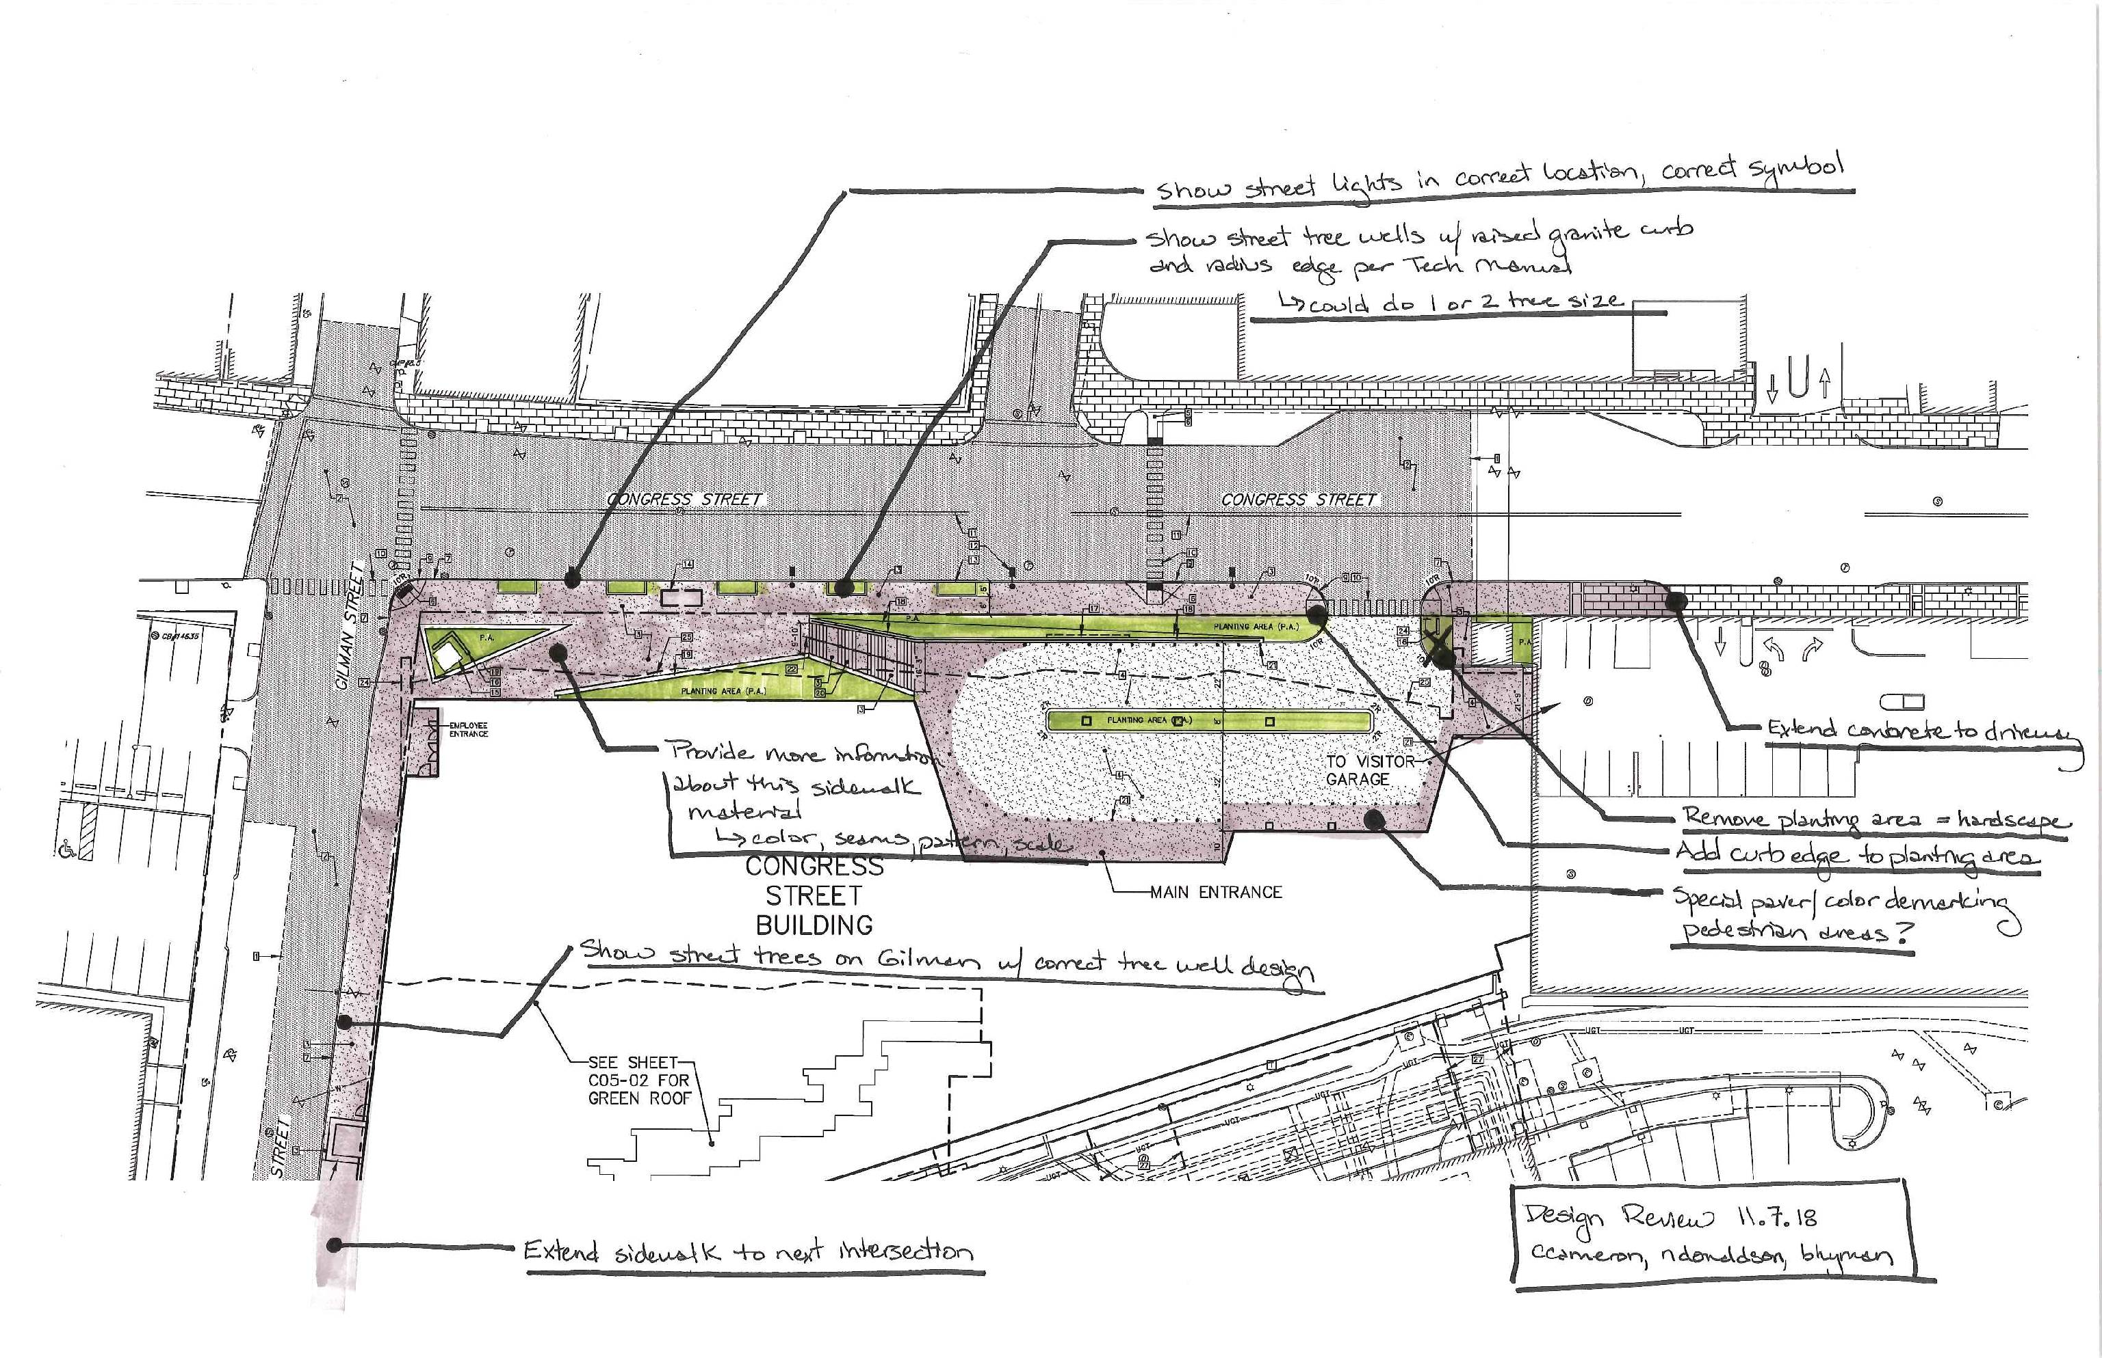
Figure 8: Staff streetscape review comments
In general, staff support the landscape approach with a few revisions (Figure 8). Regarding circulation into the site, staff has requested an edge treatment between the planting area and the sidewalk to prevent pedestrians from walking on the planting area and into the vehicular driveway. Similarly, the planted area at the sidewalk next to the pedestrian entrance is not viable and should be changed to hardscape. The applicant has not incorporate dtrees into the planting areas as suggested at the October 23 workshop; it appears the viability of street trees is limited in these locations given conflicts with the building overhang and the utility box. In response to public comment, however, the City Arborist has suggested the applicant revise the plant and tree selection:

We would like to see when possible a higher degree of 'native' plant types in our city landscapes. The use of 'native' plants and we know that this is a general term, should fit well into the overall MMC goal. Tree and landscape values could be a theme for MMC and future project that consider landscape greenery and how it relates to human health and well being.

Street trees - knowing that the project frontage will have a bus stop and bring in a tall vehicle close to the curb, a more upright cultivar of Honeylocust like the 'Streetkeeper' might be a good selection. 'Princeton' or 'Accolade' Elm could work as well. The web links below offer some comparison values on the attributes that can help select what works best for this site. (Open to other suggestions also).

Staff request the site and landscape plans to be updated to reflect these comments, revisions to the street tree well design, and street trees on Gilman Street. The street tree wells could be sized for either one or two trees.

VII. PRELIMINARY ZONING & SITE PLAN REVIEW – STORMWATER MANAGEMENT & UTILITIES
Staff has also conducted a review of the stormwater management plans. It should be noted that the stormwater system for the medical building is subject to a condition of approval from the site plan review for MMC’s East Tower vertical expansion. Over the course of this previous review, there was substantial discussion regarding the potential for hospital connection to separated storm drains in Gilman Street, as opposed to the existing combined system in Congress Street, which drains to the city’s most active CSO. Given existing grades and a complicated network of existing utilities, connection to the separated system was not deemed feasible. As a result, the East Tower was approved subject to a condition which requires that the stormwater system for this Congress Street building “add detention capacity in lieu of stormwater separation in order to reduce the burden of the existing and proposed development on the City’s infrastructure.”

In keeping with this condition, the Congress Street hospital building stormwater management plan addresses treatment standards, but also focuses on reducing the rate of runoff to the Congress Street combined sewer. The applicant’s design includes a subsurface sand filter below the proposed turnaround area, which has been sized to detain and treat not only roof runoff from the proposed Congress Street building, but also the rooftop runoff from the existing Visitor Garage, which currently drains undetained to the combined sewer in Congress Street. During storm events, the subsurface sand filter would hold stormwater runoff prior to discharge to the combined sewer in Congress Street. In addition, the applicant has proposed a green roof treatment on the 2nd floor roof at the building’s rear.

Mike Geuthle, the city’s consulting civil engineer, has reviewed the plans and writes,

Level III Site Plan applications with the City of Portland must submit a stormwater plan pursuant to the regulations of MaineDEP Chapter 500 Stormwater Management Rules. This includes conformance with the Basic, General, and Flooding Standards…

The applicant has provided information indicating that greater than 50% of the project’s impervious surfaces, and greater than 50% of the total developed area, are conveyed to a Subsurface Sand Filter. The applicant has removed pretreatment credits that were included in the initial submission calculations, including the HIL unit credit. The applicant shall clarify the following and provide responses:
i. The applicant will be required to inspect, maintain, and report on the filter in accordance with the Chapter 32 stormwater requirements. The applicant has provided inspection, maintenance, and housekeeping information in Section 23 of the application. The applicant has indicated that a stormwater maintenance agreement will be provided for the proposed stormwater treatment units upon project approval.
ii. The MaineDEP Stormwater BMP manual indicates that, “The surface area of the filter must be no less than the sum of 5% of the impervious area and 2% of the landscaped area draining to the system.”.
- The applicant has asked for a waiver of this principle to allow additional surface flows to be conveyed to the treatment system, as requested by the City.
- The revised calculations indicate that the proposed sand filter surface area is approximately 80% of the minimum required surface area. The applicant shall provide an understanding of how providing less than the minimum surface area is anticipated to impact TSS, nutrient loading, temperature, and other stormwater loading criteria.

The applicant has provided information for pre-development and post-development flow rates to the combined sewer system for a 1-inch, 24-hour rain event. This storm event has been mentioned in previous discussions with the applicant and City Department of Public Works (DPW). The applicant has requested written confirmation from City DPW to ensure that all involved parties agree with evaluating this storm event for the CSO location. This confirmation will be provided as it becomes available.

The applicant has asked for a written or e-mail confirmation from the Department of Public Works that proposed connections to existing drainage and sewer systems are being completed in accordance with City of Portland Code of Ordinances section 14-526 (b) 3.a, subsection iii and iv. The applicant has indicated that this confirmation will be provided as it becomes available.

Additional information has been provided on Sheet C30-01, C11-01, C40-01, and C30-04 to indicate site grading and pipe information. The following shall be clarified:
i. SD-2 References two different pipes. Please clarify.
ii. SD-3 is a 12-inch pipe that accepts flow from a 15” pipe and conveys flow to a 15” pipe. Please revise or indicate the need for this size change.
iii. Several of the slopes indicated in the “STORM DRAIN PIPE DATA” table do not match the slopes calculated from the invert and length data indicated in the “STORM DRAIN STRUCTURE DATA” table. Please revise.
iv. A 1% cross-slope is shown for the sidewalk locations of Congress Street, whereas the technical manual indicates a 2% cross-slope. Please indicate why a 1% cross-slope is being proposed or revise.

Isolator row detail on C30-04 indicates a 12” maximum inlet pipe. Please confirm with manufacturer if this inlet is large enough facilitate maintenance/cleaning access to the isolator row.

Additional spot grades have been provided to confirm grading at curb and drainage locations. Locations and details of granite headstone curb and gutterline “dishpan” grading at catch basins should be provided on construction documents for clarity.

With respect to other utilities, the applicant has proposed 6” domestic and 8” fire service from an existing main in Congress Street, as well as 6” domestic and 6” fire service from a main in Gilman Street. Sewer service would be provided from existing 12” main in Gilman Street as well as an existing 12” main in Congress Street. Electrical service is proposed to run underground from existing above ground service on Gilman Street both the north and the south of the site. All utility poles along the Gilman and Congress frontages of the site would be removed. It appears that significant electrical manhole is proposed within the right-of-way on Gilman Street. Staff has requested additional clarification on this utility infrastructure.

Mr. Geuthle has reviewed the plans and writes,

Electrical and Communications manholes, pull boxes, and duct banks are proposed. Details were provided for utility manholes. Utility duct bank details were not observed on the proposed details. Please provide information or details on duct bank size and material; and approximate duct bank elevations in locations where utility crossings are proposed.
A transformer is scheduled to be removed on the Demolition Plan under item U-4. Please confirm if the transformer is to be relocated, as well as the location of any new transformer. Above-ground utility infrastructure shall be sited and screened in accordance with City standards.

Sewer manhole, steps, frame and cover details, as well as pipe slopes, have been included on Sheet C11-01 and C30-03. Pipe design and slopes and in accordance with the City of Portland Technical Manual.

The applicant has indicated that capacity to serve letters from utilities will be provided as they become available. This may be considered a condition of approval for the project. The Capacity to Serve process will require a level of coordination between the applicant and utility companies and typically includes compliance with applicable utility standards and details. Central Maine Power and Consolidated Communications should review the plan and verify the depiction of changes to primary electrical and communication lines, respectively. Modifications to utility layout and design from the capacity to serve process shall be confirmed by the City prior to construction.

VIII. PUBLIC COMMENT
One written public comment was received by the Planning Division (Attachment PC1). This comment suggested additional trees and use of native trees, and raised questions regarding the city’s recommendation for honey locust trees and snow ban parking. In response, the City Arborist has asked the applicant to incorporate more native plants and suggested some native plant and street tree options (vertical honeylocust or elms). In addition, members of the public have engaged staff to ask questions regarding MMC’s plan for assessing and managing both construction and traffic impacts.

At the October 23 workshop, there was one public comment from the same member of the public, which focused on the loss of existing trees and whether shade will be provided by this design, requested native species be used where possible, and suggested more trees in the planting areas, as well as irrigation.

The applicant hosted a neighborhood meeting on Wednesday, October 17 (Attachment MM). This meeting included discussion about the St. John employee garage as well as the Congress Street medical building. There were six attendees. Discussion covered design, construction impacts, and anticipated traffic impacts. Questions and comments included concerns about blank facades, explanation of future expansion phases, property surveys, loss of existing trees, and new tree selection.

IX. NEXT STEPS
- MMC to address staff and Board comments on all topics
- Planning Board hearing

X. ATTACHMENTS
Planning Board Report Attachments
- Traffic Engineer review (memo from Thomas Errico, 10/10/18)
- Traffic Engineer review (memo from Thomas Errico, 11/8/18)
- Transportation Program Manager review (memo from Bruce Hyman, 10/10/18)
- Transportation Systems Engineer review (memo from Jeremiah Bartlett, 11/8/18)
- City Arborist review (memo from Jeff Tarling, 11/1/18)
- Fire Prevention Bureau review (memo from Mike Thompson, 10/31/18)
- Surveyor Review (memo from Bill Scott, 10/31/18)
- Civil Engineer Review (memo from Mike Geuthle, 11/8/18)
- Urban Designer review (notes from Caitlin Cameron, 11/7/18)

PUBLIC COMMENT
PC1. Karen Snyder 10/24/18

Applicant’s Submittals
- Project Description
- Completed Application Checklist
- Right, Title, & Interest
- Evidence of State and Federal Approvals
- Zoning Assessment
- Existing and/or Proposed Easements
- Waiver Requests
- Financial Capacity
- Technical Capability
- Transportation Analysis
- Access and Circulation
- Loading and Servicing
- Sidewalks
- Public Transit
- Off-Street Parking
- Bicycle Parking
- Snow Storage
- TDM Plan
- Preservation of Significant Natural Features
- Landscaping and Landscape Preservation
- Site Landscaping
- Parking Lot Landscaping
- Street Trees
- Water Quality
- Consistency with City Master Plans
- Public Safety and Fire Prevention
- Adequacy of Public Utilities
- Massing, Ventilation, and Wind Impact
- Shadows
- Snow and Ice Loading
- View Corridors
- Historic Resources
- Exterior Lighting
- Noise and Vibration
- Signage and Wayfinding
- Zoning-Related Design Standards
- Construction Management Plan
- Neighborhood Meeting Minutes 10/17/18
- MMC Planning Board Workshop Presentation 10/25/18
- Pedestrian Network Plan
- Response to Comments 10/30/18

PLANS
- Boundary Survey
- Boundary Survey
- Demolition Plan
- Site Plan
- Site Plan, Green Roof
- Utility Plan
- Utility Plan, Main Entrance
- Plan and Profile, Utility Corridor
- Grading Plan, Upper Congress
- Grading Plan, Lower Congress
- Grading Plan, Gilman
- Level B Foundation Drainage Plan
- Level B Foundation Drainage Plan
- Level 1 Foundation Drainage Plan
- Details
- Details, Stormwater System
- Details, Stair Section
- Wall Details
- Erosion Control Plan
- Landscape Plan, Upper Congress
- Landscape Plan, Lower Congress
- Pre-Development Campus Watershed Plan
- Post-Development Campus Watershed Plan
- Post-Development Watershed Plan
- Exterior Elevation, North
- Exterior Elevation, West
- Exterior Elevation, South
- Building Section
- Level B Plan
- Level 1 Plan
- Level 2
- Level 3
- Level 4
- Level 5 Plan
- Level 6 Plan
- Level 7 Plan
- Rendering
- Rendering
- Rendering
- Rendering
- Rendering
- Rendering
- Rendering
- Pick-up/Drop-off Diagram
- Congress Street Section
- Congress Street Section

