
PLANNING BOARD REPORT
PORTLAND, MAINE

MMC Employee Garage & Associated Site Improvements
190 & 222 St. John Street
Level III Site Plan
Project #000207-2018
CBLs: 64-A-2, 64-A-8, 64-A-9, 64-A-11, 75-A-6, 74-A-7, 68-D-13, 68-D-14, 68-D-16
With off-site improvements at 64-A-1 and 68-D-3 and in the public right-of-way
Maine Medical Center, Applicant

Submitted to: Portland Planning Board  Public Hearing Date: September 11, 2018 | Prepared by: Nell Donaldson  Date: September 7, 2018

I. INTRODUCTION
Maine Medical Center (MMC) appears before the Planning Board for a final hearing on their proposal to construct a 2,400 space employee parking garage with associated surface parking, landscaping, utilities, and right-of-way improvements at 190 and 222 St. John Street in the city’s St. John/Valley Street neighborhood. The proposal is subject to the standards of the Maine Medical Center Institutional Overlay Zone (MMC IOZ) and qualifies for Level III site plan review under the city’s land use code. A workshop was previously held on July 10, 2018. Advertisement of this hearing appeared in the Portland Press Herald on August 31 and September 3, 2018. In addition, 99 notices were sent to property owners within 500 feet and to the City’s interested citizens list.

Applicant: Maine Medical Center
Consultants: David Senus, Woodard & Curran; Mark Wilcox, Winton Scott Architects; Randy Dunton, Gorrill-Palmer; Gretchen Guimarro, Michael Boucher Landscape Architects; Owen Haskell, Surveyor

II. REQUIRED REVIEWS
Waiver Requests | Applicable Standards
Bicycle parking – to allow 40 bicycle parking spaces on site, less than required. | Section 14-526(a)4.b. Bicycle parking for non-residential uses required at a ratio of 2 bike spaces:10 vehicular spaces required (for first 100 spaces), and 1:20 thereafter. Supported by staff.
Driveway width – to allow a 30’ wide driveway from St. John St. at D St. | Technical Manual, Section 1.7.2.4. Two-way driveways to commercial developments shall be a maximum of 24’ in width. Supported by staff.
Parking lot and parking space design – to allow spaces inside the garage at less than standard width (8.5’) | Technical Manual, Section 1.14. Standard parking space dimensions shall be 9’ x 18’. Supported by the City’s consulting traffic engineer (Attachment 2).
Parking lot and space design – to allow aisles less than a 24’ wide within the garage (23’ 9.5”) and greater than 24’ in the adjacent surface lot (27’ 4”) | Technical Manual, Figures I-28 to I-31. Standard aisle width for two-way right angle parking shall be 24’. Supported by the City’s consulting traffic engineer (Attachment 2).
Illumination levels – to allow an average illumination level in the north parking area of 1.9 footcandles and average and maximum illumination levels on the top deck of the garage of 2.4 and 6.4 footcandles respectively. | Technical Manual, Section 12.2.3. Average illumination levels shall not exceed 1.25 foot candles and maximum illumination levels shall not exceed 5 footcandles. Supported by staff.

Review | Applicable Statute
Institutional Overlay Zone | Section 14-282
Site Plan | Section 14-526
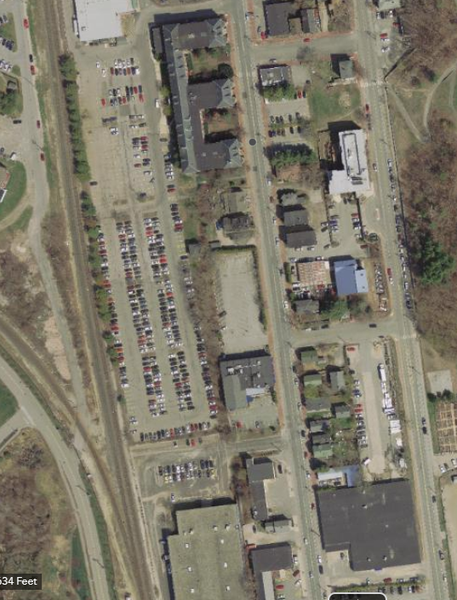
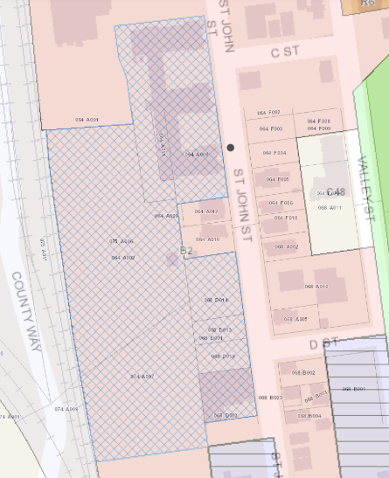
III. PROJECT DATA
222 St. John
(ME Central RR building)
190 St. John
(garage site)
212/214 St. John
210 St. John
Eagles
(184 St. John)
Former Eagles lots

MMC IOZ
B-2
Union Station Plaza
Existing Zoning | Institutional Overlay Zone
Existing Use | Surface parking
Proposed Use | Structured and surface parking
Parcel Size | Approximately 5.5 acres (including 190 St. John and 222 St. John)
 | Existing | Proposed | Net Change
Building Footprint | 480 SF (190 St. John only) | 92,334 SF | 92,334 SF
Building Floor Area | 960 SF (190 St. John only) | 812,797 SF | 812,797 SF
Impervious Surface Area | 190,582 SF | 176,076 SF | -14,506 SF
Parking Spaces | 283 | 2,452 | 2,169
Bicycle Parking Spaces | 0 | 40 | 40
Figures 1 & 2: Project site zoning context (left) and land use context (right).
Office
Residential
Fraternal Organization
Commercial/Industrial
Railroad

IV. CONTEXT
Maine Medical Center’s approximately 6,000 existing employees currently park in a number of parking facilities, including lots and garages both on-campus and in remote locations in the vicinity. For almost 50 years, one of the hospital’s primary employee parking locations has been a 1,274 space garage at the southeast corner of Gilman and Congress Streets. The Gilman garage was originally permitted in the 1970s and is now nearing the end of its useful life. For this reason, MMC has been planning for the construction of a replacement employee garage for several years, with the goals of eliminating a current deficit in parking supply, concentrating employee parking in one location, and accommodating projected employee growth. In their initial Institutional Development Plan (IDP) proposal, submitted in conjunction with their application for an Institutional Overlay Zone (IOZ), MMC proposed a new employee garage at the southwest corner of Gilman and Congress Streets, directly opposite Gilman Street from the existing employee garage. In response to strong concerns from neighbors about this location, MMC looked, through the IDP review process, for an alternate site. Ultimately, MMC was able to find an alternative in the St. John Street lot which is the subject of this site plan application. The final IDP, submitted in October of 2017 and approved by the Planning Board, laid the framework for an employee garage in this location (Attachment A).

The project site lies on the western side of the city’s St. John/Valley neighborhood (Figure 2). The site is bounded by a Portland Terminal Company railroad line and Mercy Hospital on the west, industrial and commercial uses to the south, residential properties and an auto service business to the east along St. John Street, and residential and commercial to the north. There are two residential properties with frontage on St. John Street, 210 St. John Street and 212/214 St. John Street, that are effectively surrounded by the site. The site also sits behind the Fraternal Order of Eagles at 184 St. John Street.

The site plan application includes proposed work across a number of existing parcels, including the Union Station Plaza parcels, the historic Maine Central Railroad office building parcels (which currently house surface parking used by MMC), three parcels used as surface parking by the adjacent Fraternal Order of Eagles and recently purchased by MMC, and the Eagles Lodge lot itself. In the site plan application, the Maine Central Railroad parcels, formerly under single ownership, have been divided into two lots under separate ownership, with a new lot line running perpendicular to St. John Street between the Maine Central Railroad building and the adjacent property at 212/214 St. John Street (Figure 1). The northerly of these two lots, 222 St. John Street, has been designed around the Maine Central Railroad building and its parking. The southerly, with a new address of 190 St. John Street, is the site of the proposed garage. MMC holds rights to both under long-term lease agreements.
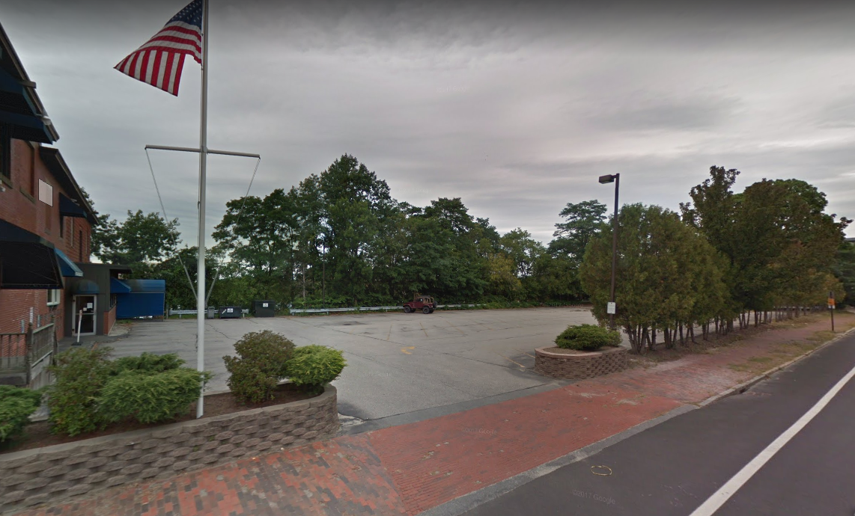
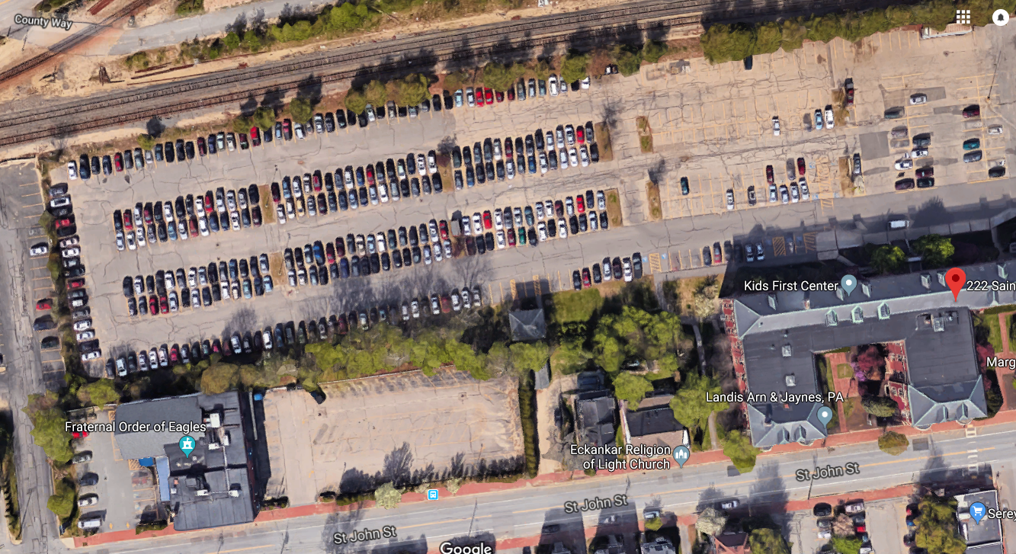
Figures 3 & 4: 190 St. John Street from the D Street intersection (left) and project site from above, showing existing MMC surface parking, Eagles’ parking, and the Maine Central Railroad building at bottom right.

As noted above, the project site includes the Maine Central Railroad office building, which fronts St. John Street, as well as a small associated building which sits at the bottom of a slope behind 210 St. John Street. The Maine Central Railroad building is listed on the National Register; the second building has not been deemed historic.

The site lies within the MMC Institutional Overlay Zone, a zoning designation adopted into the land use code by the City Council in November of 2017. The IOZ establishes use and dimensional standards which govern proposed development by MMC within the zone, as well as a series of general development standards. Development within the IOZ which meets the criteria for site plan review is also subject to the site plan standards of the land use code.

V. PROPOSED DEVELOPMENT
The proposed MMC employee garage would include 2,400 parking spaces on nine floors of parking, one of which would be located below grade from St. John Street (Figure 5). Vehicular access to the lowest two of these floors is proposed via an entrance north of the existing Maine Central Railroad building, the “Margarita’s entrance.” MMC has proposed access to the seven upper parking decks via a new driveway from St. John Street directly opposite D Street. In the revised plans, a direct entrance to 50 reserved spots in the first parking deck is also proposed from the Eagles Lodge driveway. This access would serve Eagles patrons only. All access to the garage would be controlled with an electronic reader system akin to an EZ pass.

The site plan also includes 52 additional surface parking spaces to the north of the garage, most of which would lie on the 222 St. John Street lot. A storage and treatment unit is proposed below this parking area. The plan also shows stormwater treatment on the east side of the building. Utilities are generally proposed from St. John Street.

The parking structure is proposed to sit back from St. John Street by approximately 120’, with primary pedestrian access to Level 1 via concrete pathways to a door fronting St. John Street, and secondary pedestrian access to the ground level at the northeast corner of the building. The preliminary plans show landscaping around the site, including a broad landscaped area in the space between the garage’s main pedestrian entrance and St. John Street.

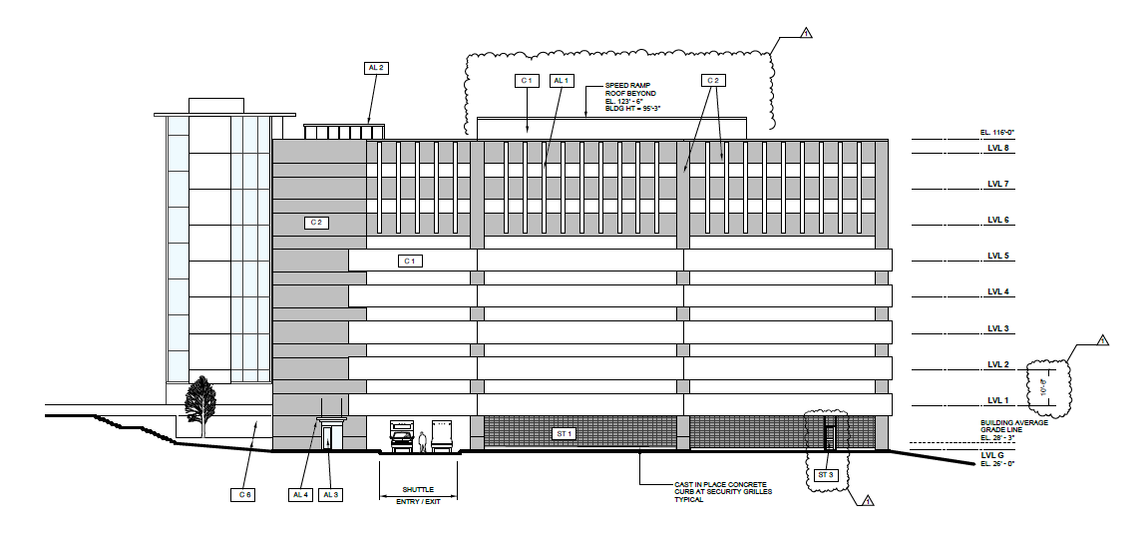
Under the proposed plans, the garage would operate as a remote parking facility for MMC, meaning that staff would park and then access the main hospital campus, at a distance of approximately ¼ mile, by either shuttle or by foot. The proposed shuttle system would involve 13 shuttles operating at 15-minute headways during peak hours, with access to both the hospital’s Bramhall entrance and to the future entrance on Congress Street. The site plan application includes modifications to the Margarita’s entrance and to St. John Street to accommodate employee vehicles and shuttle traffic, as well as to various sidewalks in the area to accommodate pedestrian access between the garage and the hospital.
Figure 5: North elevation
Figure 5: North elevation of the proposed garage, showing the below grade level and Level 1, which would lie at grade with St. John Street.

ME Central RR building
Eagles
210
St. John
Union Station Plaza

212/214
St. John

Figures 6 & 7: Final site plan, showing proposed parking structure and adjacent site improvements (top) and rendering from the D Street entrance (bottom)

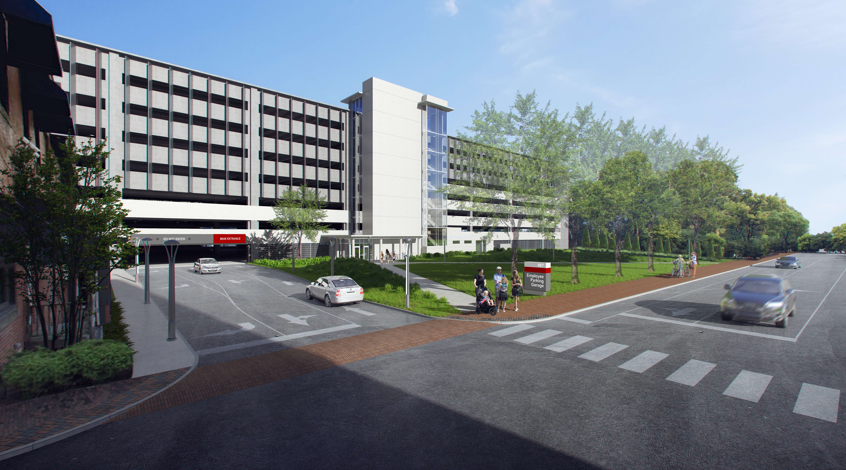
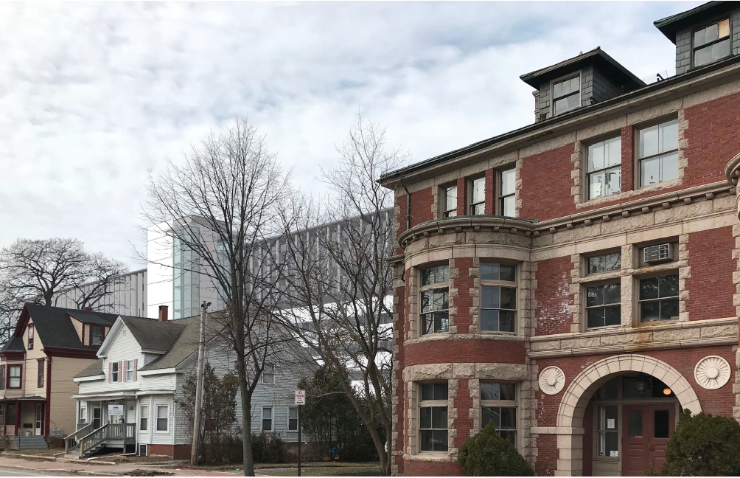
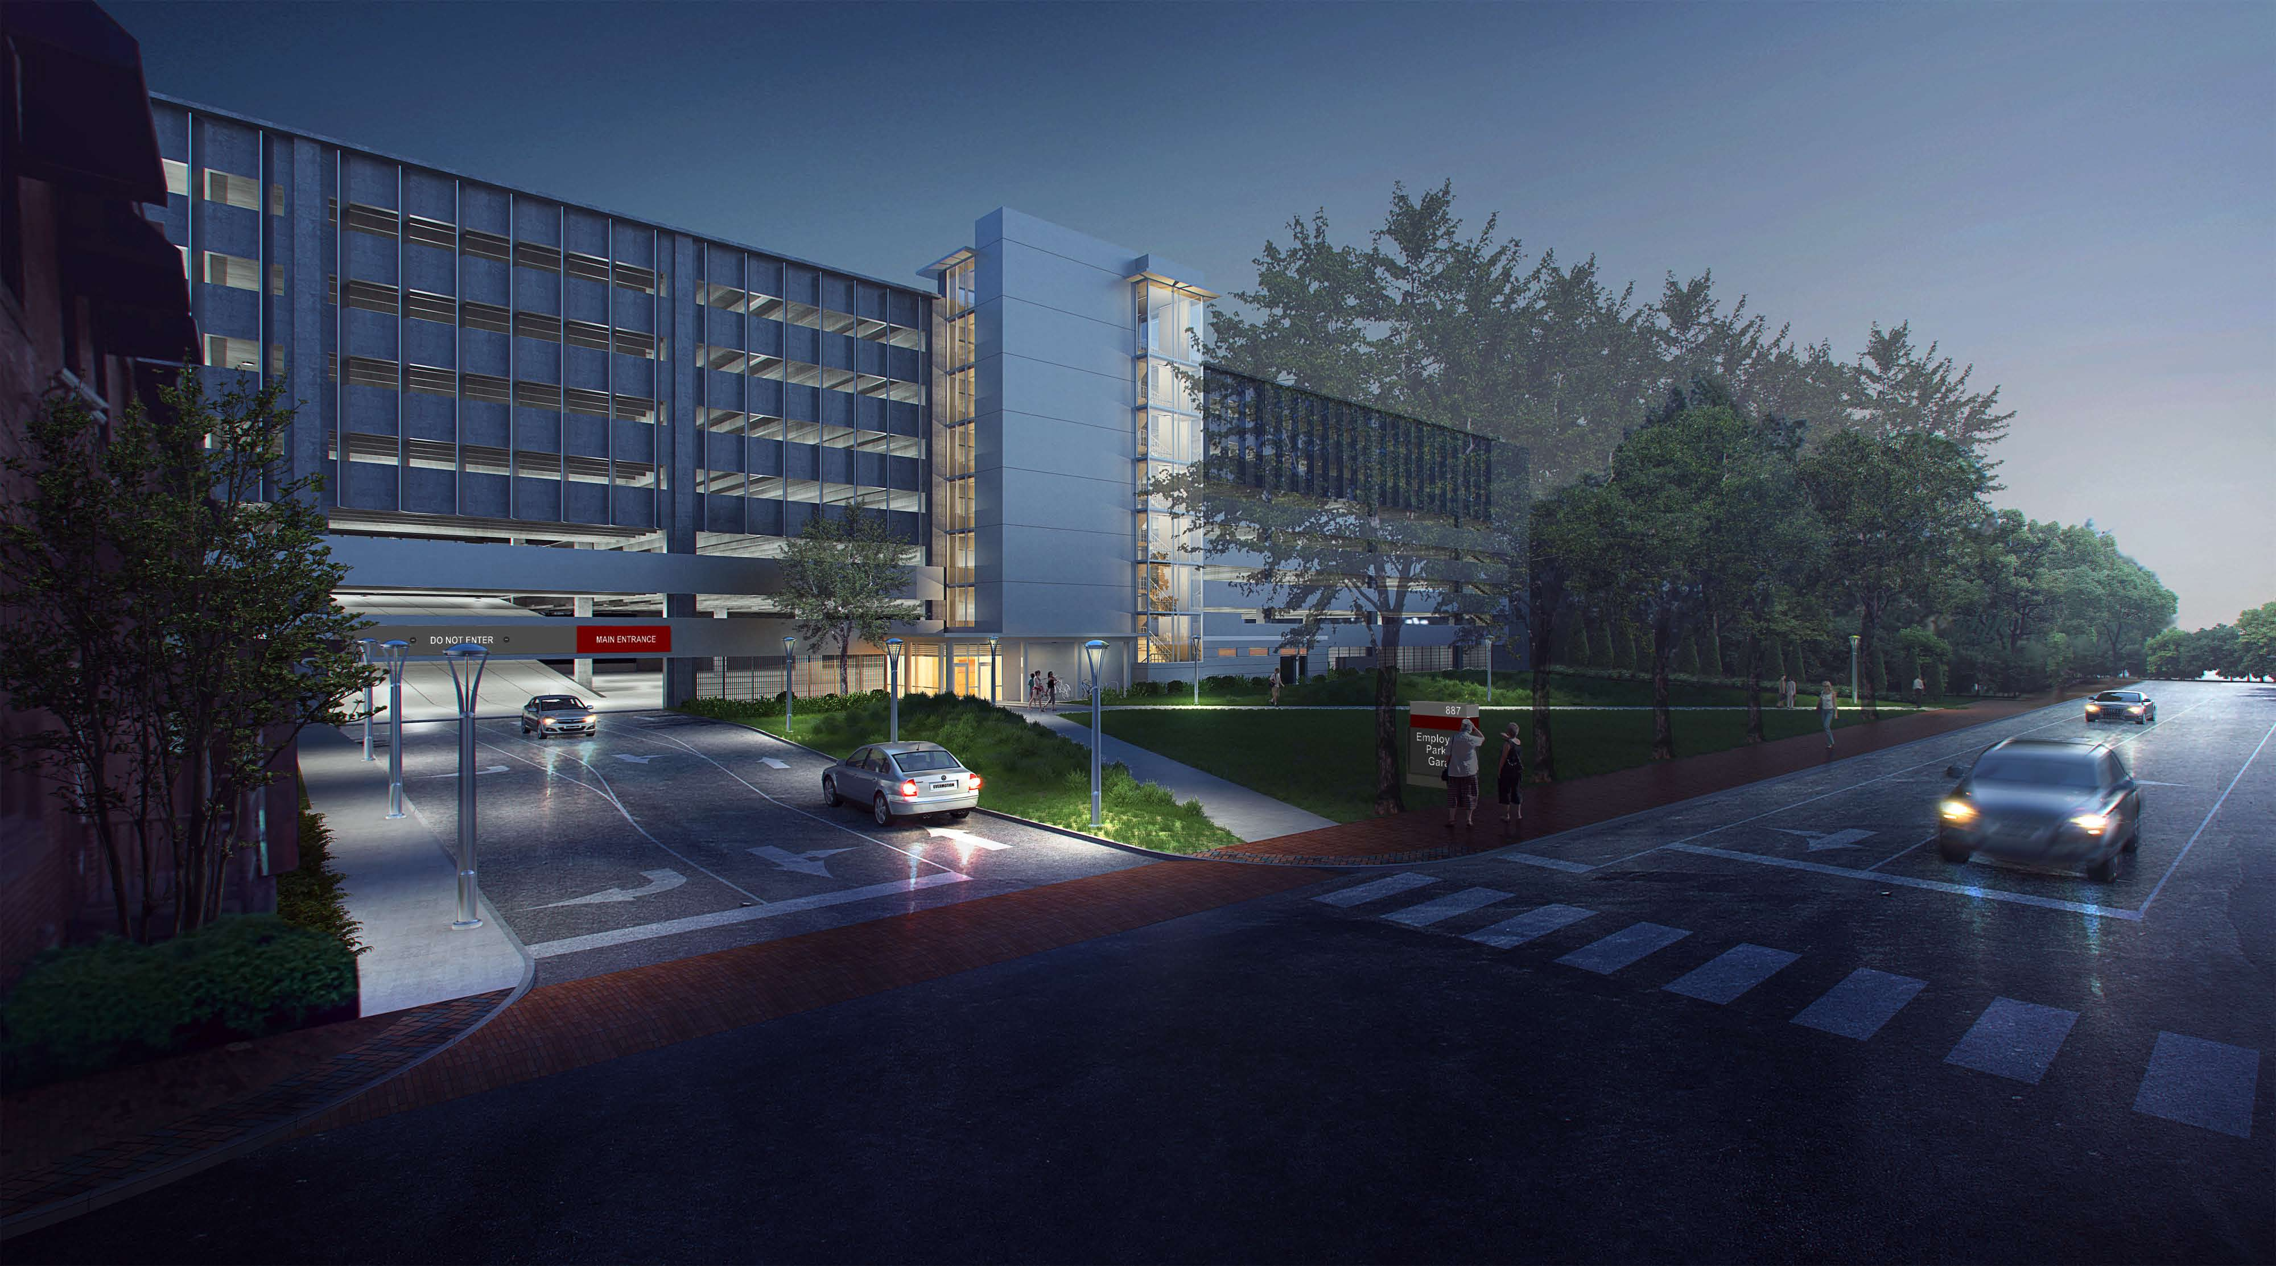

Figures 8 & 9: Rendering looking north from St. John Street at night (top) and south from the Maine Central Railroad building (bottom)

VI. PUBLIC COMMENT
The applicant hosted a neighborhood meeting on June 25, 2018 and has provided written notes as documentation (Attachment V). The notes reflect questions from attendees regarding traffic movement from nearby driveways to and from St. John Street, loss of on-street parking, plant selections, site grading, soils, and the possibility of alternative access points for construction vehicles. Public comments were also received at the Planning Board workshop held on July 11, 2018. At the workshop, three members of the public commented on traffic impacts, loss of trees, snow ban parking, safety and security issues, and the loss of on-street parking. Lastly, the Planning Division also received a number of public comments on the application (Attachments PC 1 – PC 17). These comments raise concerns regarding construction impacts to adjacent buildings, the design of the St. John Street bike lanes and signal timing at the proposed D Street garage entrance, the loss of on-street parking due to the proposed reconfiguration of St. John Street near the project site, the scale of the building and shadow impacts, backing maneuvers from nearby residential driveways, the TDM plan, snow ban parking, and the impacts of the D Street sidewalk construction.

It should be noted that a particular outreach effort has been made around the design of the proposed D Street sidewalk, which is shown in the final plans on the north side of D Street. There are several encroachments into the right-of-way in this area. In the design, all efforts have been made to avoid impacts to neighboring properties to the extent possible.

VII. RIGHT, TITLE, & INTEREST
The MMC IOZ is only applicable to properties to which MMC has right, title, or interest. As noted above, the application includes work proposed on a number of parcels, including three previously held by the Fraternal Order of Eagles but now owned by MMC. The plans also show work on lots originally held under single ownership by Cowcatcher, LLC, which have been split into two parcels, one retained by Cowcatcher (222 St. John Street) and one now owned by Caste Cow, LLC (190 St. John Street). MMC holds long-term land leases for both of these parcels and has provided evidence of rights to make improvements (Attachment F).

In addition to the construction of the parking structure and associated infrastructure on lots to which MMC holds title or land lease, the plans include improvements to the Eagles lot, some grading on the 210 St. John Street lot, and some improvements to the Union Station Plaza parcel as well. Staff has suggested a condition of approval requiring documentation of rights to make improvements on these adjacent lots.

The project site is both subject to and benefits from several easements, including easements between the 190 and 222 St. John Street lots and access and stormdrain easements across the Union Station Plaza lot to the north of the site (Attachment I). Staff has suggested a condition of approval requiring documentation of access and utility easements that are necessitated by the plans. These include access and utility easements between 190 St. John and the MMC-owned parcels, access easements between 190 St. John and the Eagles lot, and a drainage easement for stormwater infrastructure associated with the garage across the 222 St. John Street lot as well.

VIII. FINANCIAL & TECHNICAL CAPACITY
The applicant has provided a description of the project team and a letter regarding their financial capacity (Attachment J).

IX. ZONING ANALYSIS – INSTITUTIONAL OVERLAY ZONE REGULATORY FRAMEWORK
As noted above, the site lies within the Maine Medical Center Institutional Overlay Zone, which establishes use, dimensional, and development standards for MMC projects within its bounds. The project has been reviewed for conformance with these standards. Staff comments are below.

- Use
Parking lots and parking garages are permitted uses within the IOZ.

- Dimensional Requirements
The project meets requirements related to building height, length, and setbacks.

- Design
New buildings within the IOZ are required to adhere to the design guidelines of the IDP, which are intended to promote campus cohesion, activation of the public-realm, neighborhood compatibility, pedestrian-scaled edges, the use of high quality materials, the integration of gateway features, and quality of long-views. In their final submittal, the applicant has provided elevations (Plans 23 and 24), renderings (Attachment AA), and a design narrative reflecting these guidelines (Attachment E).

The proposed building is of significant size, approximately 480’ long and almost 100’ in height. The building itself is proposed with precast reinforced concrete of two tones, clear anodized aluminum windows in the stair tower and at the entrance, extruded aluminum fins, and black metal security grilles. The mass of the building is broken by the stair and elevator tower, which is also used to signify the main entrance from St. John Street.

In the final submittal, the applicant has provided material samples that address previous comments regarding the level of contrast between the proposed colors of the two precast concrete elements of the building composition. They have also extended the canopy at the main entrance, added bicycle parking to this area, and added windows to address previous concerns regarding street activation. Lastly, as requested, the applicant has modified the spacing on the spandrel panels so as to achieve a regular pattern of solid to void.

Caitlin Cameron, the city’s Urban Designer, has documented the results of the city’s review of the revised plans (Attachment 1). This review generally found that the design meets the design standards of the IDP. Outstanding comments can be summarized as follows,

Upon review, the sign design and branding is consistent with the new MMC sign master plan also submitted as part of this application. Staff commented that the hierarchy and design of this sign differs from those proposed elsewhere on campus – please clarify. Staff should verify this sign does not interfere with traffic sight lines.

Staff has suggested a condition of approval to address the design of the proposed freestanding sign in conjunction with the proposed master sign plan.

- Signs
Signs within the IOZ are required to conform to a unified, campus-wide signage plan and relate in proportion and character to building facades and adjacent street typology. In the final submittal, MMC has provided a draft sign plan (Attachment Y). Staff has reviewed this plan and provided the following comments:

No signs will be permitted on properties not owned by MMC (e.g. 1.b).

There are concerns about sight line obstructions on several of the signs, including 1.a, CS.2, and EG.1a. Please provide a sight line analysis.

There are concerns about the size of the signs in general. Could those proposed as 11’ in height be brought to a more pedestrian scale (e.g. 8’?) There are particular concerns about the size of 4.a, which is replacing a much smaller sign, and 6.a. Both of these should be brought to a pedestrian scale.

Eliminate one of the signs marked 5.b and reduce the size of the remaining to the scale of the existing sign
Please indicate dimensions of CS.1 and method of illumination. At first blush, this sign appears out of scale.

The layout of EG.1a is inconsistent with other signs of similar purpose (e.g. ST.3a). Please provide some explanation.

Final review of the sign plan has been suggested as a condition of approval.

- Transportation
The IOZ requires the submission of a TDM plan. Because MMC had not yet hired a TDM coordinator at the time of the preceding site plan review for the visitor garage and East Tower expansion, that site plan was approved with a condition that the applicant submit a TDM plan prior to issuance of a certificate of occupancy for the East Tower. In an effort to satisfy this condition, a TDM plan has been included within this application (Attachment L). This most recent version of the TDM plan has been informed by MMC’s newly-hired TDM coordinator, and includes a summary of current employee commuting behavior, an analysis of baseline employee parking demand, and a description of existing TDM measures employed by MMC. In the short term, the plan targets a reduction in MMC’s parking demand/employee ratio of 2% (or approximately 50 spaces, assuming no change in the number of employees) and in the long term, the plan targets a 5% reduction (or 114 spaces, assuming no change in the number of employees). The plan lays out a series of strategies designed to achieve those targets, including full subsidies for transit users, implementation of a guaranteed ride home program, a reassessment of parking pricing in the mid-term, enhanced data collection, and improved education and incentives. Additionally, MMC has pledged in their TDM plan to participate in regional partnerships to improve employee travel choice. It is anticipated that the TDM plan will receive a targeted workshop before the Board in association with the Congress Street hospital building review.

Per the IOZ, parking requirements are to be established at the time of site plan review based on a parking study that examines campus-wide supply and demand. In their submittal, MMC speaks to existing and projected parking demand and supply in both their traffic and parking analysis and in their TDM plan (Attachment L). Based on data provided in the IDP, in 2016, MMC hosted an average of 4,615 employees, students, and contractors on campus on a typical weekday, and served these employees, students, and contractors with a total of 2,027 on-campus and remote parking spaces (Tables 1 & 2). These spaces include the existing lot at 222 St. John Street (the First Atlantic Lot, which will be replaced by the garage), the existing Gilman Garage (which will be demolished to make room for a new hospital building), and a number of lots and garages located remotely to campus. Given the total parking supply available to MMC in 2016 and the total average weekday employee population cited above, the hospital currently supplies parking at a ratio of .44 spaces/average weekday employee. Per the TDM plan, which speaks to a higher employee parking demand figure (2,250) as well as the total number of Bramhall campus employees (and not those on campus on an average weekday)(6,000), the existing parking demand per employee ratio is lower: .375. This is the figure cited in the plan as the baseline for future parking demand analysis.

According to the applicant’s traffic and parking analysis, the hospital’s existing parking system operates at or above capacity during weekday daytime hours. Per the TDM plan, MMC parking staff has estimated the existing employee parking deficit at 200-300 spaces. It should be noted that MMC acknowledges that a number of employees are currently using on-street spaces for all-day parking, and estimates that this accounts for approximately 200 occupied spaces in the neighborhoods surrounding the campus on an average weekday. For reference, the TDM plan cites an observed total parking demand, including patients and visitors, during weekday peak hours of 3,125. This figure is approximately 250 spaces higher than the 2,877 total (including visitor parking) parking spaces currently provided by the hospital.

Table 1: Existing and Projected MMC Employees, Students, and Contractors: Average Weekday
 | 2016 | 2026 | Change
Shift 1 | 3,640 | 3,900 | 260
Shift 2 | 210 | 220 | 10
Shift 3 | 520 | 550 | 30
Total Employees | 4,370 | 4,670 | 300
Med Students | 100 | 110 | 10
Nursing Students | 100 | 100 | -
Other Students | 20 | 25 | 5
Non-MFP Related Contractors | 25 | 25 | -
Total | 4,615 | 4,930 | 315

Table 2: Existing and Projected Parking Facilities Used by MMC Employees
2016/2018 |  | Post-Garage Construction
First Atlantic Lot (222 St. John St.) | 283 spaces | Employee Garage (190 St. John St.) | 2,252 spaces*
Gilman Garage | 1,274 | Employee Garage (190 St. John St.) | 2,252 spaces*
Sportsman Lot (905 Congress) | 60 | Employee Garage (190 St. John St.) | 2,252 spaces*
Gateway Garage (181 High St.) | 100 | Employee Garage (190 St. John St.) | 2,252 spaces*
Classic Lot (993 Congress St.) | 97 | Employee Garage (190 St. John St.) | 2,252 spaces*
321 Brackett St. | 9 | Employee Garage (190 St. John St.) | 2,252 spaces*
Forest Street Garage | 178 | To remain in use by MMC | 178
7 Bramhall St. | 26 | To remain in use by MMC | 26
On-Street Parking (estimated) | 200 | Not to remain in use by MMC | 0
Total | 2,227 spaces |  | 2,456 spaces
* 200 spaces in the Employee Garage and adjoining surface lot will be allocated to the Eagles Lodge (50 spaces) and to tenants of 222 St. John (150 spaces)

The IDP and traffic submittals for this application also speak to future demand. The IDP estimates a projected increase of approximately 300 employees, students, and contractors on an average weekday over the next ten years. Per the applicant’s traffic and parking analyses, approximately 500 to 600 additional employee parking spaces are required to meet projected demand associated with growth in employees. The TDM plan commits MMC to better data-keeping with respect to parking demand and supply in the future.

According to the applicant’s submittal, the proposed garage has been designed to achieve multiple purposes with respect to the preceding figures: to address existing employee parking shortfalls experienced by the hospital, to consolidate a number of existing employee parking facilities in use by MMC, and to accommodate future projected parking demand. When completed, the structure and associated surface parking will bring the total employee parking supply to 2,456 spaces, or 200 spaces more than existing estimated employee parking demand.

It should be noted that the parking structure and adjacent surface lot have been designed to serve not only MMC, but tenants of the Maine Central Railroad building and the Eagles as well. Together, these secondary users are proposed to occupy approximately 200 spaces in the garage and adjoining surface lot. In the final submittal, the applicant has provided documentation as to the parking supply associated with 222 St. John, which is not anticipated to change as a product of the garage construction. The proposed parking for the Eagles Lodge will meet zoning requirements for places of assembly. The 50 Eagles spaces will be accommodated in a segregated area of the first floor of the garage, with access from a separate driveway on St. John Street. As this arrangement is specific to the use of the adjacent lot by the Eagles, staff has suggested a condition of approval that requires a reassessment of this arrangement at such time as the Eagles use changes.

- Environment
The IOZ requires that development proposed by MMC be designed to integrate with the surrounding context. Review comments related to this standard can be found under site plan review below.

- Mitigation Measures
The IOZ requires that MMC mitigate impacts to off-premise infrastructure in a manner proportionate to those impacts. Review comments related to this standard can be found under site plan review below.

- Neighborhood Integration & Neighborhood Engagement
The IOZ also requires that MMC engage neighbors consistently through ongoing community engagement and through periodic and more intensive engagement during construction periods. MMC continues to hold regular expansion group meetings and use their website, www.mmc.org/modernization, to communicate with surrounding neighborhoods and the public more broadly.

- Construction Management
The applicant has provided a revised construction management plan in the final submittal (Attachment K). This construction management plan identifies points of contact, establishes a construction schedule, outlines measures to be taken to ensure public safety, and describes construction logistics. It should be noted that the final construction management plan includes provisions for quarterly updates, including updates on construction schedule, delivery impacts to traffic, off-hours work, and notice of impactful work, to the city and neighbors. The plan also includes provisions for pre-construction surveys of neighboring properties.

Tom Errico, the City’s consulting traffic engineer, has reviewed the plan and writes,

Construction plans shall be provided for the roadway/signal work in St. John Street, D Street, and
Valley Street…A condition of approval shall include development of a Construction Management Plan prior to any City Permit.

A condition of approval has been suggested to address this comment.

- Other
The IOZ also requires MMC to provide neighborhood parking during snow bans, much as the hospital currently does. In the final submittal, MMC has noted that it is “exploring ways to improve access to [snow ban parking.] For example, in the July newsletter sent to all neighborhood representatives, MMC requested feedback regarding MMC’s proposed parking garage and asked specific questions about utilization, frequency of use, and preferred location in the future” (Attachment EE).

X. SITE PLAN SUBMISSION REQUIREMENTS (Section 14-527)
The application has been reviewed against the submittal requirements of the site plan ordinance. In the site plan submittal, MMC has identified several required state and federal permits, including a Maine Construction General Permit and an FAA Aeronautical Study for Determination of Hazard for height. All required documentation has been submitted.

XI. SITE PLAN REVIEW (Section 14-526)
The proposed development has been reviewed for conformance with the relevant review standards of the City of Portland’s site plan ordinance. Staff comments are below.

- Transportation Standards
- Impact on Surrounding Street Systems
The applicant has projected traffic volumes entering and exiting the proposed garage and evaluated potential impacts to the adjacent roadway network. These projections are based largely on traffic counts at existing MMC employee parking facilities, the First Atlantic Lot at 222 St. John Street and the existing Gilman Garage, which will be replaced by the proposed employee garage. The analysis assumes that the proposed garage will experience much the same traffic pattern as these facilities, with the exception that the Gilman Garage peaks may shift modestly to account for the increased travel time associated with a walk or shuttle ride from the proposed parking structure to the hospital campus. The garage is projected to generate peak traffic from 6:00 to 7:00 AM (with 1,097 trip ends) and 4:15 to 5:15 PM (with 571 trip ends). The AM peak hour of the garage is offset significantly from the peak hour of the adjacent street, St. John Street, which experiences its peak hour from 7:30 to 8:30 AM. The projected PM garage peak is closer to the PM peak hour of St. John Street, which occurs between 4:00 and 5:00 PM.

Because the proposed garage is not technically anticipated to generate new traffic, but instead to shift existing traffic from other locations, no Traffic Movement Permit (TMP) is required. It is assumed that under the site plan review for the future Congress Street hospital building, the TMP requirement will be triggered.

As proposed, all of the vehicles parking on the ground level and first deck of the garage, including visitors to the Maine Central Railroad building and the Eagles, some MMC employees, and all shuttles providing access to and from the campus, would use the “Margarita’s entrance” at the north end of the Maine Central building. All vehicles parking on the second deck and above would use a separate entrance directly off St. John Street at D Street. Given projected traffic volumes entering and exiting at D Street, MMC has suggested a traffic signal in this location. However, the traffic evaluation finds that the intersection of the garage entrance at D Street and St. John Street does not warrant a signal. As such, while a signal would be installed as a product of the plans, it would not be activated at time of completion. Tom Errico, the city’s consulting traffic engineer, has reviewed the plans for this signal and writes,

A traffic signal is proposed at the St. John Street/D Street/Garage Driveway location. I support the installation of a traffic signal given vehicle volume conditions and anticipate pedestrian movements. I would note that the applicant is responsible for development of design plans and equipment specifications for review and approval by the City. All costs associated with the installation of the traffic signal is the responsibility of the applicant…The applicant is responsible for development of design plans and equipment specifications for review and approval by the City. All costs associated with the installation of the traffic signal is the responsibility of the applicant. The applicant will also be responsible for all data collection in association with activation of the traffic signal. I would recommend the initial monitoring effort occur after one week of opening and six months after opening (if needed). Additional monitoring efforts shall be determined following the review of the data collected after 6 months. I would note that the applicant shall be responsible for final activation under the supervision of City staff following a review and approval of the installation by City staff.

A condition of approval has been drafted to address this comment.

The applicant has conducted capacity analyses at nearby intersections, and found that, in the post-development condition, movements at studied intersections are forecasted to operate at levels of service of C or higher during the AM and PM peak hours of the garage. This includes all approaches to the Congress Street/St. John Street and Congress Street/Valley Street intersections. The only level of service below C in the post-development condition is forecasted for eastbound vehicles exiting the Margarita’s entrance during the AM peak hour of the garage, when there will be heavy conflicting southbound volumes on St. John Street. Changes in shuttle routing may resolve this issue. Mr. Errico has reviewed the level of service analysis and writes,

During the TMP process, refinement of the model may be required. As noted in the applicant’s response to comments, the pedestrian phasing at the Congress Street/St. John Street intersection is inefficient and a contributing factor to long vehicular delays and queues. In conjunction with this application, the traffic signal equipment shall be upgraded to allow for concurrent pedestrian phasing. Implementation shall take place prior to the opening of the garage….The applicant shall be responsible for traffic signal changes that would allow for concurrent pedestrian phasing at the Congress Street/St. John Street intersection. As part of this effort, the applicant shall be responsible for development of a plan for the Congress Street/Valley Street intersection under a traffic signal removal scenario. This plan shall include recommendations that provide for safe pedestrian movements. Additionally, the applicant shall coordinate with MaineDOT (providing supporting technical information) on approval of the traffic signal removal. If MaineDOT does not approve the removal, the applicant shall implement traffic signal equipment modifications at the Congress Street/Valley Street intersection to allow for the previously noted pedestrian concurrent phasing.

A condition of approval has been suggested to address this comment.

It should be noted that, at the city’s request, the applicant did pursue the possibility of providing access to the garage from Fore River Parkway as a means of minimizing impacts to Congress, St. John, and Valley Streets (Attachment L). This access would require a railroad crossing. The analysis identified grade and right, title, and interest issues as obstacles to direct access from Fore River Parkway, but suggested that a connection through the Mercy Hospital campus is the most feasible of the three options studied. This connection would require easements from both Mercy Hospital and the Portland Terminal Company. It could also have significant implications for Mercy’s long-term plans. While this connection is therefore not being pursued at this time, it is staff’s understanding that the garage has been designed in such a manner so as not to preclude a connection should it be possible at some point in the future.

- Access and Circulation
As noted above, primary vehicular access is proposed at a modified curb cut at the intersection of St. John and D Street. Secondary access is proposed at an existing access point north of the Maine Central Railroad building, the “Margarita’s entrance.” Tenants of the Maine Central Railroad building, the Eagles, some MMC employees, and shuttles destined for the ground floor and first deck of the garage are proposed to use the Margarita’s entrance. The remainder of the employees would use the primary D Street entrance, which, as noted above, will operate with an EZ pass type of card reader system. The D Street entrance has been designed with three lanes, including a center lane which will function primarily as an egress lane. This lane has been designed to operate in reverse in emergency situations. Due to the three-lane configuration, the driveway is wider than allowed per the City’s technical standards. A waiver is supported by staff.

In the final submittal, MMC has responded to Board concerns regarding the impact of garage traffic on nearby residences, particularly around the D Street intersection, which, in the post-development condition, will essentially function as a four-leg intersection with the garage entrance acting as the fourth leg. In their final submittal, MMC has noted that peak exiting traffic will generally occur during daylight hours, dropping off sharply after 7 pm (Attachment DD).
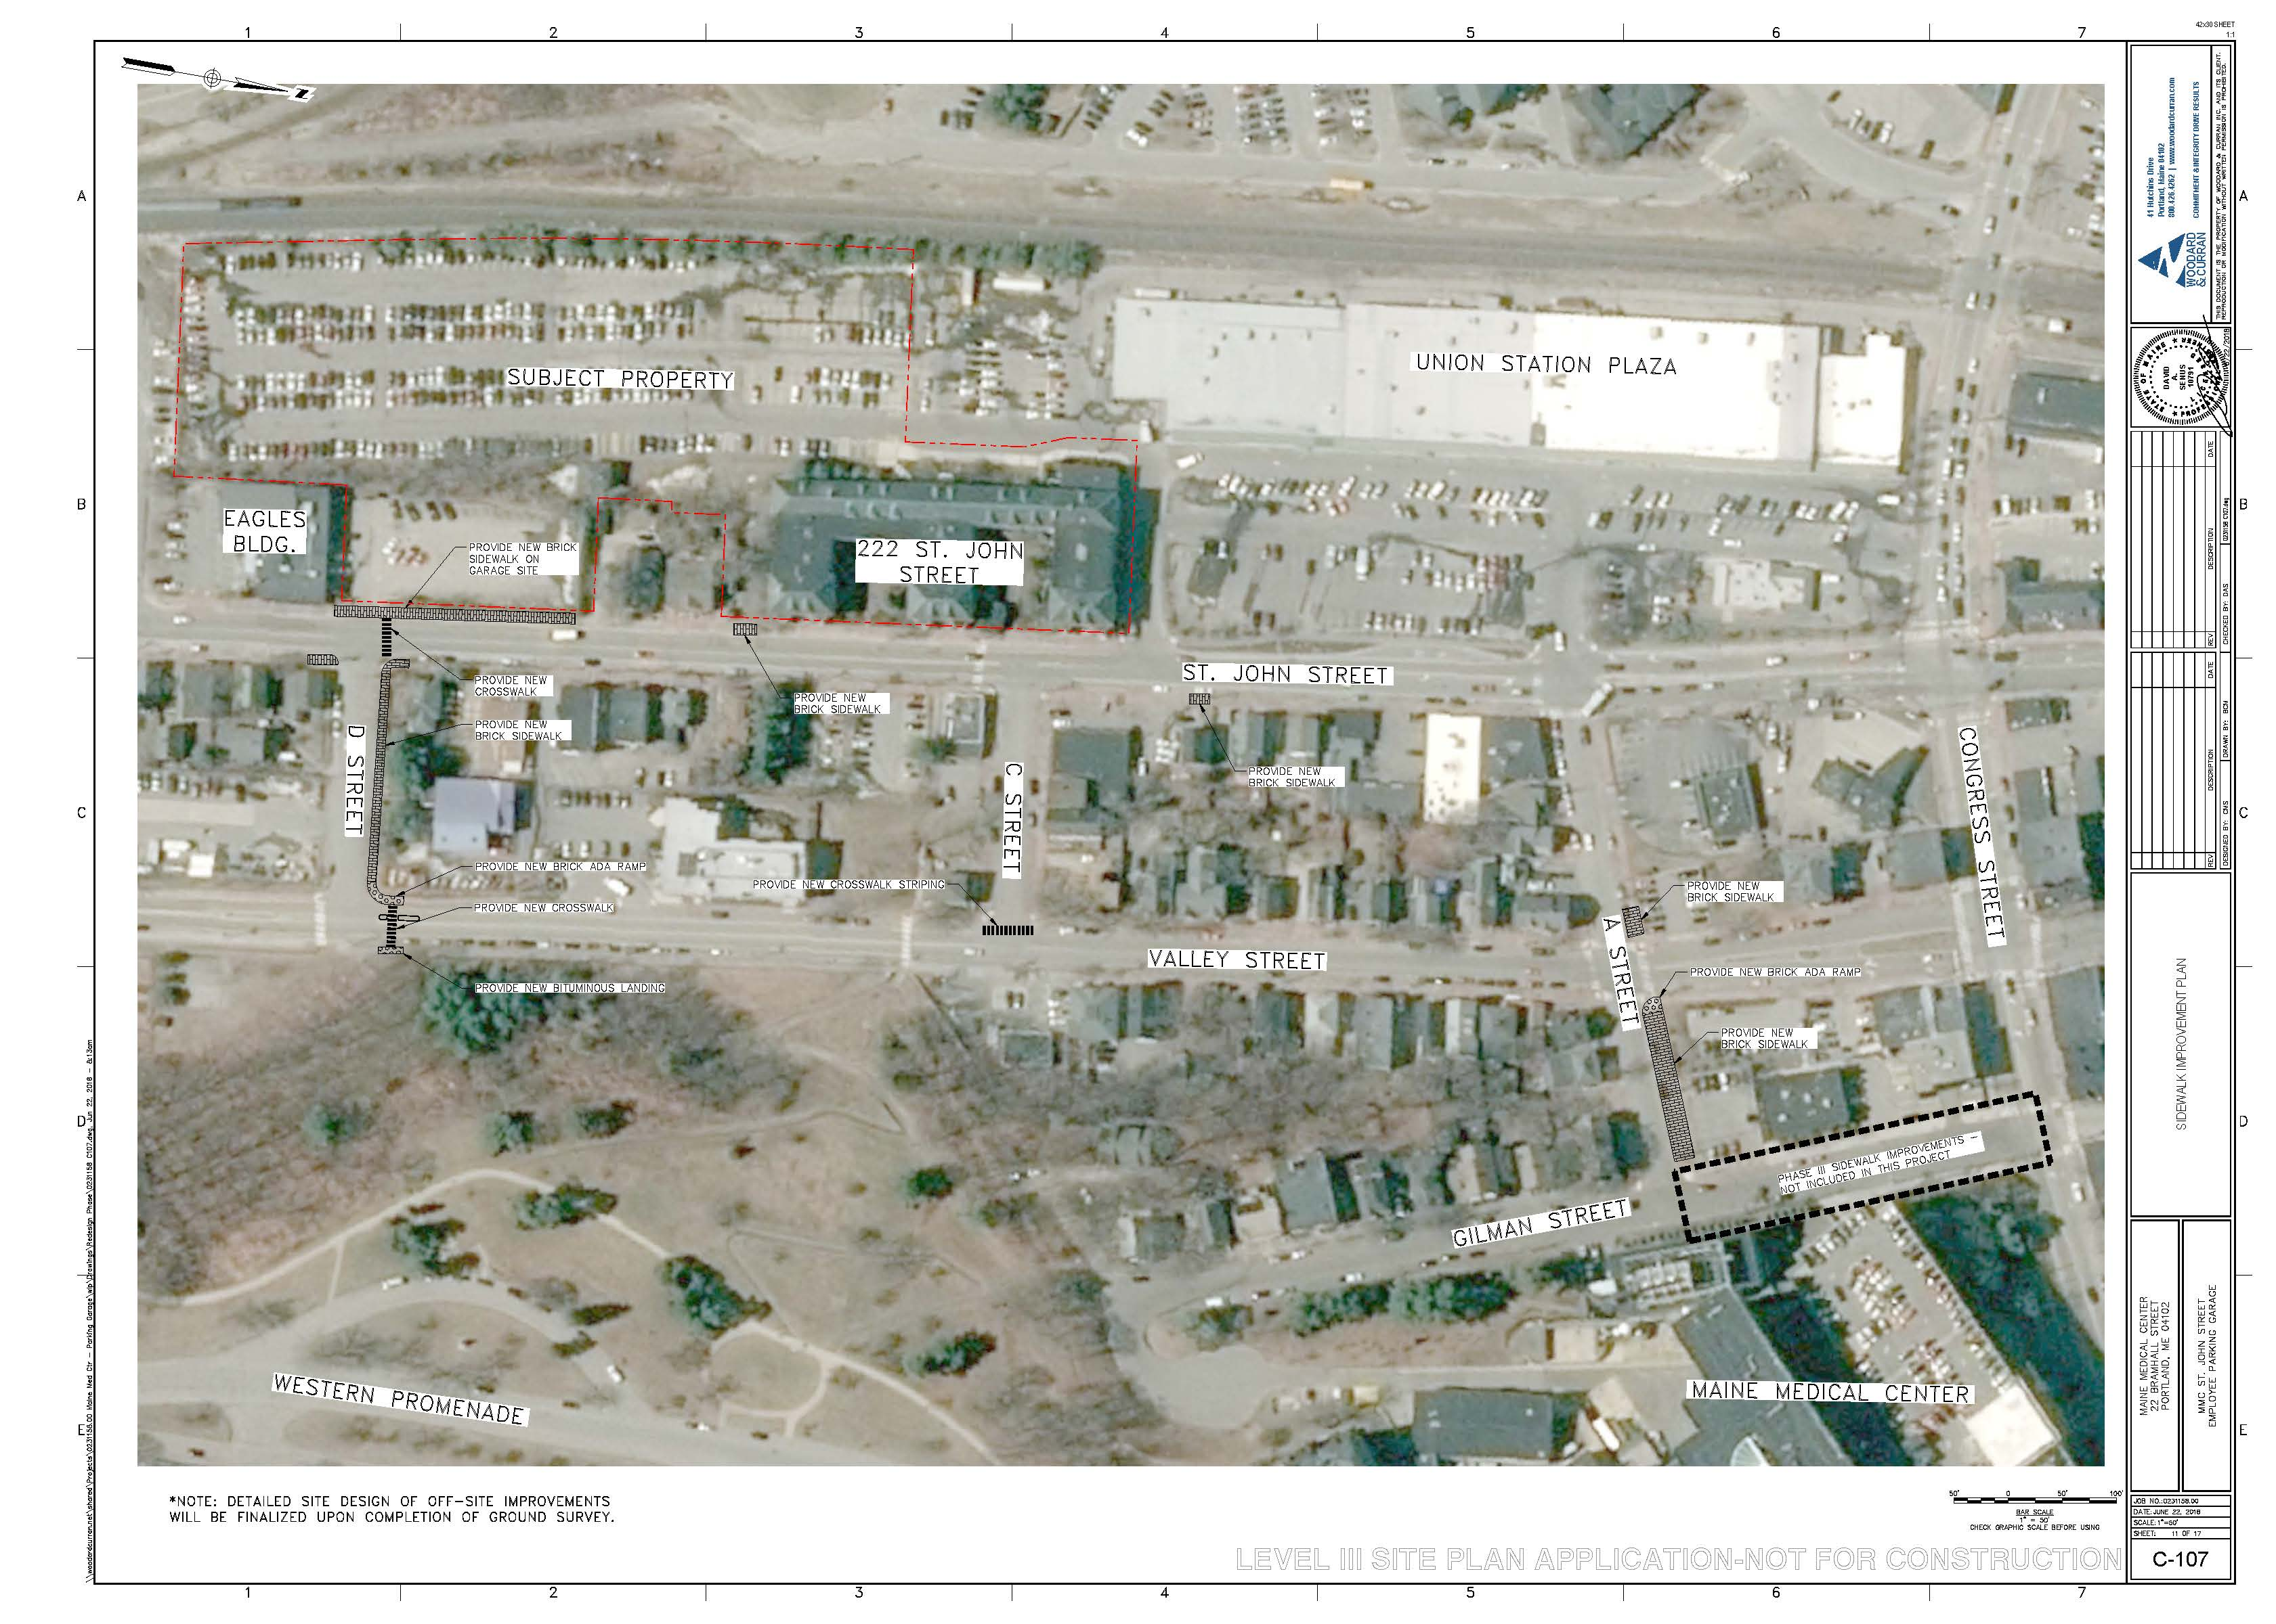
The final site plan site plan shows some significant changes to the configuration of St. John Street along the front of the site near the D Street entrance, including the addition of left-turn lanes in both the northbound and southbound directions and a southbound right-turn lane into the garage entrance. In order to accommodate these turn lanes, through movements, and bicycle lanes, the elimination of approximately 13 on-street parking spaces is proposed. As noted above, neighbors have raised concerns about this proposed loss of on-street parking. Neighbors have also raised concerns about access to and from adjacent residential driveways, particularly at 210 St. John and 212/214 St. John.
Figure 10: Proposed off-site pedestrian improvements

The applicant has proposed to provide shuttle service to the main hospital campus at 15-minute headways during peak hours. Given the garage’s proximity to the main campus, however, there is a high likelihood that employees will walk between the proposed garage and the hospital. Pedestrians electing to walk would exit the garage at either the front door on the first parking deck or at the ground floor on the northeast corner of the building, and from there proceed either up the stairs adjacent to the Maine Central Railroad building or on a sidewalk around the building’s north side. The final plans show concrete sidewalks, with site lighting, from all pedestrian entrances to public sidewalks on St. John Street.

From the internal sidewalk network, pedestrians could either traverse adjacent neighborhood streets or access the hospital via the Valley Street Trail through the Western Promenade. In order to improve pedestrian access, the plans show new sidewalks and curb ramps at both garage entrances, a new crosswalk at C Street and Valley Street, new brick sidewalk on the northerly side of A Street, and small areas of sidewalk repair on St. John Street (Figure 10). In addition, a new 6.5’ brick sidewalk is proposed on the north side of D Street, and a new crosswalk with median treatment is proposed at D Street and Valley Street near the base of the Valley Street Trail.

Bruce Hyman, the City’s Transportation Program Manager, has reviewed the plans and writes,

Further revisions to the Site Layout and Material Plan 1 C-100 are to be made -
The final Pavement Marking and Signage Plan(s) is to be revised and approved by DPW and the Planning Authority for corrections, including but not limited to correcting the striping around the refuge island on Valley Street, the bike lane pavement markings on St. John Street, and the "Yield to Bikes" sign
Move label for CB30 on D Street to not obscure the light fixture
Revise the design of the curb ramp on the SW corner of St. John at the garage driveway to eliminate the skewed area with the vertical curb next to the ramp flares between the curb ramps
The site plan is not consistent with C-104 Utility plan - the utility pole placement on C-100 on the SE corner is incorrect.
A condition of approval has been drafted to address these comments.

Valley Street is currently being repaved by MaineDOT. Given the timing of this review, MMC was not able to complete the proposed Valley Street improvements in advance of that paving. Instead, MMC has arranged for MaineDOT to pave all areas of Valley Street except the intersection with D Street. MMC will complete the Valley Street improvements this fall. This has been suggested as a condition of approval.

In the final plans, street trees and street lights are shown along the proposed D Street sidewalk. Staff has reviewed these plans and generally found that they meet technical standards. While staff has also approached all D Street neighbors on the block between St. John and Valley to discuss sidewalk design, curb cuts, and existing encroachments into the right-of-way, staff anticipates that there may be minor modifications to plan details based on future correspondence with abutting neighbors. The submittal of final details for the D Street sidewalk design, based on the results of continued discussion with adjacent neighbors, has been suggested as a condition of approval.

In previous review comments, staff requested that MMC conduct an assessment of access through the Western Promenade, which is transected by a desire line between the proposed garage site and the MMC campus. In fact, there are several existing ‘goat paths’ that traverse the Western Promenade in a direct line between the Dana Center and the Valley Street entrance to the park (and MMC’s surface parking at 222 St. John Street beyond). These depart from the existing bituminous Valley Street Trail (Figure 11). In the final submittal, MMC’s assessment found existing ADA, erosion, and lighting issues associated with the pathways through the Western Promenade (Attachment Z). Ethan Hipple, the city’s Parks Director, and Deb Andrews, the Historic Preservation Manager, have both reviewed this assessment. Mr. Hipple writes,

In speaking with our sidewalk plow operators, they have made it clear that even during light snow events, the grade and tight radius of the Valley Street Paved Path switchbacks makes it very difficult/impossible to clear snow with our existing Trackless or Holder sidewalk plows. The root of the problem is that the switchbacks themselves are too small and steep, making it very tricky to get the plows around the steep corners. The narrowness of the path also contributes to the difficulty. Enlarging and flattening the switchbacks (requiring alteration or additional retaining walls) would reduce the problem. Because of the difficult passage there, when an
operator is clearing snow on the neighborhood routes, they will typically skip the Valley St Path and come back later with a different piece of equipment that can clear the steep sections. This can lead to delay of up to several days because we will complete our standard routes first (using Trackless or Holders), then return to get problem areas/pinch points with specialized equipment when all other routes are cleared.

If we were to improve the trail so that we could clear it safely with the normal Trackless or Holder equipment, it would be cleared as part of the regular route and would result in much timelier completion. If we leave it as is, we will continue to clear it using alternative equipment, but it will cause delays and will certainly have an impact on the higher expected volume of pedestrians using that route.

For the goat paths leading from Valley St to Gilman Place, then up the grassy slope to MMC, we recommend the following:

- Lower Goat Path (Valley St to Gilman Place): At Valley Street, create a break in the retaining wall with stairs leading to the lower goat path. Install timber box stairs and stone dust fill on steep, eroded sections of trail.

- Upper Goat Path (Gilman Place to MMC): Combine braided system of multiple goat paths into a single improved trail. Install timber box steps and stone dust fill on steep sections. Alternative is to pave this section of trail.
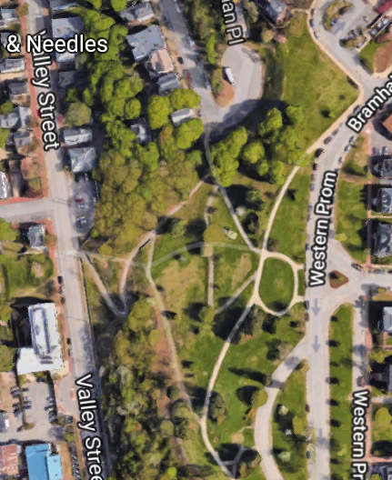
Figure 11: Western Promenade ‘’goat paths’
Any plans for modifications to the Western Promenade would be subject to review by both the Parks Department and Historic Preservation. A condition of approval has been drafted to address future access improvements serving MMC employees who traverse the park.

The final plans show bicycle lanes in both the north and southbound directions on St. John Street. On the recommendation of the consulting traffic engineering firm, the southbound bicycle lane, whose through movements will conflict with heavy right turns for vehicles traveling in the same direction entering the garage, has been relocated to the inside of a separate southbound right-turn lane for vehicles. This design was deemed to provide the safest condition for bicyclists.

- Public Transit Access
The site is located on METRO Route 1, with service to Congress Street and Munjoy Hill. There is an existing transit stop on the site’s St. John Street frontage. Per the site plan standards, a transit facility is required for a project of this size if the development is proposed along a public transit route and the nearest existing transit shelter and/or pullout is further than ¼ mile from the site. In this case, there is a pullout located in front of the Union Station Plaza, approximately 700 feet to the north. Thus, no transit facility is technically required. In the final plans, the bus stop has been moved to the south of the Eagles driveway, so as to avoid conflicts with turning vehicles entering and exiting the garage.

- Parking
Staff has reviewed the final parking layout within the garage, as well as within adjacent surface parking areas proposed under the site plan application. Mr. Errico writes,

Sufficient traffic analyses have been conducted to document acceptable operations at the St. John Street signalized entrance. The applicant should provide documentation/examples of 2,400+ parking garages that have adequate internal traffic circulation capacity with one primary entrance.

To efficiently manage parking circulation, dynamic ITS signage noting parking availability per level shall be provided…A condition of approval shall be included that requires submission of specific ITS devices for optimizing vehicle circulation and counting for review and approval by the City.

MMC has indicated that they have contracted with a third party to provide documentation regarding the internal parking layout. Final review of both this documentation and the plan for ITS devices has been suggested as a condition of approval.

In the final submittal, the applicant has provided several drawings which show an interim and final revised striping layout for parking spaces currently used by tenants of 222 St. John in the Union Station Plaza lot. Mr. Errico has reviewed these layouts and raised concerns regarding backing maneuvers. A condition has been suggested.

Per the site plan standards, the applicant is required to provide two bicycle parking spaces/10 vehicular spaces required for the first 100 vehicular spaces, plus one/20 vehicular spaces over 100. The applicant has proposed to provide 40 bicycle parking spaces and requested a partial waiver from the bicycle parking standard on the grounds that most employees traveling to and from work at MMC would opt for bicycle storage on the main campus rather than bicycle to an off-campus parking location and walk or shuttle to the main campus. This waiver is supported by staff. MMC’s final plans show bicycle parking on the northwest and southeast corners of the ground (below-grade) floor of the building, as well as at the main entrance on St. John Street.

- Snow Storage
The applicant has proposed to remove snow from the top deck of the garage with a snow melt system. This system will not encroach on parking or pedestrian areas.

- Transportation Demand Management
The applicant has submitted a TDM plan with the final submission. This TDM plan is discussed under the zoning analysis above.

2. Environmental Quality Standards
- Preservation of Significant Natural Features
The applicant has provided documentation to confirm that there are no critical habitats, conserved lands, or protected wetlands on the site (Attachment M).
- Landscaping and Landscape Preservation
The applicant has provided a planting plan designed to feature low-maintenance and predominantly native plants. The planting is organized in four zones around the site.

The first zone encompasses the surface parking behind the Maine Central Railroad building, which lies primarily on the 222 St. John Street lot. This zone is proposed with sweet ferns and honey locust trees in the islands, which together meet the parking lot landscaping standards of the land use code. Honey locust trees are listed among the approved plant species in the city’s Technical Manual.

The second zone, in the area between the Maine Central Railroad building and the northeast corner of the proposed garage, is proposed for major regrading such that the site and portions of the adjacent 210 St. John Street lot are brought up to the level of St. John Street along the easterly face of the garage. Under the site plan, existing invasive species in this area would be removed. Shad trees, sumac, four Freeman maples, and clethra are proposed. A metal fence is proposed to prevent access into the area between the garage face and the rear of 210 and 212/214 St. John. A 6’ cedar fence is proposed along the rear of these properties; along the northerly side of 212/214 St. John, this fence is proposed to taper to 4’. As requested in the design review, the proposed fence along the northerly property line of 212/214 is proposed as metal.

In the third zone, which occupies the approximately 120’ between the garage’s main pedestrian entrance and St. John Street, the applicant has proposed bearberry, yellowroot, sweetfern, hay-scented fern, bayberry, and clethra, with turf, one shad tree, and six Princeton elms at the street line. This area will be graded with 3’ berms to provide some added measure of visual interest. Checkerblock pavers with turf are proposed in a utility access corridor that runs parallel to the building at the rear of this space.

The final landscaping zone, on the south side of the building, is proposed with clethra and hedge maples to provide some buffering and limit movement through the area behind the Eagles’ building.

It should be noted that the final landscaping plan also shows two street trees and plantings to be selected in coordination with the adjacent D Street property owner along the new sidewalk on the north side of D Street.

- Water Quality/Storm Water Management/Erosion Control
The project site is currently almost entirely impervious. The garage proposal is projected to result in a decrease of approximately 14,500 SF of impervious surface. Under the applicant’s proposal, a small area of the site around the D Street entrance would drain to an existing 30” separated storm drain in St. John Street to the east of the site. The remainder of the site, including the entire area of the parking garage and the surface parking behind the Maine Central Railroad building, would drain underneath the railroad tracks to an existing 18” stormdrain. Per the applicant’s stormwater management plan, the existing 18” receiving pipe is not sufficiently sized (Attachment M). As a result, the applicant has proposed to both store and treat runoff in this direction with R-tanks and a jellyfish filter system underneath the surface parking area on 222 St. John Street. A StormBasin catch basin filter is proposed to treat the eastbound runoff.

Michael Geuthle, the city’s consulting civil engineer, has reviewed the stormwater management plan and writes,

The MaineDEP approval letter dated January 21, 2015 for the Jellyfish Filter requires manufacturer approval for each design, as noted in item 7 of this letter (page 14 of Section 12, original submission). The applicant has noted this letter has been requested and will be forwarded upon receipt.

Grading review identified that Pipe 14 between CB15-CB16 has a negative slope. On C-103, the Pipe Table reflects this change to a positive slope, but the Structure Table indicates a negative slope between basins. Please revise.

Drainage for an elevator pit connection is provided. It is recommended this connection enter an oil/water separator prior to entering the storm drain system.

A condition of approval has been suggested to address these outstanding comments.

3. Public Infrastructure and Community Safety Standards
- Consistency with Related Master Plans
The site plan application is generally deemed consistent with related master plans.

- Public Safety and Fire Prevention
As noted above, the garage is proposed to sit back over 100’ from St. John Street, behind several residential properties, the Eagles, and the Maine Central Railroad building. This means that large portions of the site are not readily visible from the street or sidewalk, and that some portions of the site are screened entirely from the public way. Railroad tracks lie at the property’s rear.

With respect to building program, the garage has been designed such that shuttle service will be provided within the garage’s ground floor, which, given topography of the site, would lie below the grade of St. John Street. This means that the pedestrian activity associated with the shuttle service will be entirely hidden from public view. The only exterior natural surveillance opportunity generated by the garage itself is from pedestrians walking to and from the building to the hospital.

Without the benefit of significant intrinsic natural surveillance opportunities, the applicant has generally designed the site to allow sight lines into the main entrance area and pursued an access control strategy in areas without clear lines of sight. All garage decks at grade level would include security grilles. The plans show fencing in the space between 210 and 212/214 St. John and the garage (Figure 11), between the Eagles Lodge and the garage, and between the garage and the railroad tracks. The applicant has also provided a lighting plan which demonstrates the intent to light exterior spaces. Pedestrian-scaled light fixtures are proposed around the D Street entrance from St. John Street, as well as along the walkway by 222 St. John. Building lights are proposed on all building facades. In the final submittal, MMC has also tried to activate the space by widening the canopy over the main entrance to the garage, adding bicycle parking at this main entrance, and adding horizontal windows on the first floor adjacent to the open space.

Mike Thompson, of the city’s Fire Prevention Bureau, has reviewed the plans and has not provided any outstanding comments.

- Availability and Capacity of Public Utilities
Underground electric, gas, water, and telecommunication services are proposed from St. John Street under the proposed driveway at D Street. A transformer and generator are proposed north of the entrance on the east side of the building. Sewer associated with two single fixture bathrooms is proposed to leave the site to St. John Street via a pump station along the south side of the Maine Central Railroad building. An oil/water separator is proposed to filter runoff from vehicles within the garage. A dumpster is proposed at the northwest corner of the site in a chain link enclosure. All required capacity to serve letters have been provided.

4. Site Design Standards
- Massing, Ventilation, and Wind Impact
The bulk, location, or height of the proposed parking structure is not deemed likely to result in ventilation or wind impacts.

- Shadows
The project is not anticipated to result in shadows on publicly accessible open space.

- Snow and Ice Loading
The project is not anticipated to result in snow or ice accumulation on public ways or adjacent properties.

- View Corridors
The project does not abut a protected view corridor.

- Historic Resources
The proposed garage lies within 100 feet of the Maine Central Railroad Office Building at 222 St. John Street, which is listed as a historic landmark on the National Register. As such, the design is subject to an advisory review under the historic preservation ordinance. The city’s Historic Preservation Board met on April 18, 2018 to review the preliminary design for the garage building (Attachment 9). Deb Andrews, the City’s Historic Preservation Program Manager, provided an update to the Historic Preservation Board at their July 11, 2018 meeting. Ms. Andrews has indicated that the Historic Preservation Board was generally satisfied with the direction of the garage design at that time.

- Exterior Lighting
The applicant has provided a lighting plan which shows full cutoff building-mounted lights on all facades, as well as lights under the pedestrian entry canopies and along walkways, on poles along the entrance drives, and within the surface parking area. 18’ pole-mounted lights are also proposed on the roof deck of the garage. These have been clustered at the interior of the top floor so as to minimize impact. All lights would be on motion sensors after 11 pm. The applicant has also proposed new street lights in association with proposed sidewalk work on D Street.

It should be noted that the applicant has requested a waiver for average and maximum illumination levels in the surface lot north of the garage and on the top deck of the garage. For safety reasons, this waiver is supported by staff.

- Noise and Vibration
The applicant has requested that HVAC be reviewed as a condition of approval.

- Signage and Wayfinding
As noted above, the applicant has proposed a freestanding sign at the St. John entrance. This sign will require a separate permit.

- Zoning-Related Design Standards
Review comments related to design can be found under the zoning analysis above.

- STAFF RECOMMENDATION
Planning Division staff recommends that the Planning Board approve the proposed MMC Employee Garage and associated site improvements at 190 St. John Street subject to the proposed motion and conditions of approval listed below.

XIII. PROPOSED MOTIONS FOR THE BOARD TO CONSIDER
- Waivers
On the basis of the application, plans, reports and other information submitted by the applicant; findings and recommendations contained in the Planning Board report for the public hearing on September 11, 2018 for application 207-2018 relevant to Portland’s technical and design standards and other regulations; and the testimony presented at the Planning Board hearing:

- The Planning Board finds/does not find, based upon staff review, that extraordinary conditions exist or undue hardship may result from strict compliance with the site plan standard Section 14-526(a)4.b, which establishes a bicycle parking standard for non-residential uses of 2 bicycle spaces per 10 vehicular spaces for the first 100 vehicular spaces and 1 per 20 spaces thereafter, that substantial justice and the public interest are secured with the variation in this standard, and that the variation is consistent with the intent of the ordinance. The Planning Board waives/does not waive the site plan standard Section 14-526(a)4.b to allow 40 bicycle parking spaces on site;

- The Planning Board finds/does not find, based upon the consulting transportation engineer’s review (Attachment 2), that extraordinary conditions exist or undue hardship may result from strict compliance with the Technical Manual standard (Section 1.7.2.4) which establishes a maximum driveway width of 24 feet for commercial sites with two-way access, that substantial justice and the public interest are secured with the variation in this standard, and that the variation is consistent with the intent of the ordinance. The Planning Board waives/does not waive the Technical Manual standard (Section 1.7.2.4) to allow a driveway of 30 feet in width at D Street;

- The Planning Board finds/does not find, based upon the consulting transportation engineer’s review (Attachment 2), that extraordinary conditions exist or undue hardship may result from strict compliance with the Technical Manual standard (Section 1.14) which requires that aisle width for right-angle parking be 24 feet per Figure I-27, that substantial justice and the public interest are secured with the variation in this standard, and that the variation is consistent with the intent of the ordinance. The Planning Board waives/does not waive the Technical Manual standard (Section 1.14) to allow a 23’ 9.5” wide aisle in the garage and a 27’ 4” wide aisle in the north parking area;

- The Planning Board finds/does not find, based upon the consulting transportation engineer’s review (Attachment 2), that extraordinary conditions exist or undue hardship may result from strict compliance with the Technical Manual standard (Section 1.14 and Figures I-27 to I-29) which establishes standard parking space dimensions of 9’ x 18’, that substantial justice and the public interest are secured with the variation in this standard, and that the variation is consistent with the intent of the ordinance. The Planning Board waives/does not waive the Technical Manual standard (Section 1.14 and Figures I-27 to I-29) to allow spaces inside the proposed garage at 8.5’ in width; and

- The Planning Board finds/does not find, based on staff review, that extraordinary conditions exist or undue hardship may result from strict compliance with the Technical Manual standard (Section 12.2.3) which establishes average and maximum illumination levels of 1.25 footcandles and 5 footcandles respectively, that substantial justice and the public interest are secured with the variation in this standard, and that the variation is consistent with the intent of the ordinance. The Planning Board waives/does not waive the Technical Manual standard (Section 12.2.3) to allow an average illumination level in the north parking area of 1.9 footcandles and average and maximum illumination levels on the top deck of the garage of 2.4 and 6.4 footcandles respectively.

- DEVELOPMENT REVIEW
On the basis of the application, plans, reports and other information submitted by the applicant; findings and recommendations contained in the Planning Board Report for the public hearing on September 11, 2018 for application 207-2018 relevant to the site plan regulations; and the testimony presented at the Planning Board hearing, the Planning Board finds that the plan is/is not in conformance with the site plan standards of the land use code and the MMC IOZ Regulatory Framework, subject to the following conditions of approval, which must be met as follows:
Prior to the issuance of a building permit:
- The applicant shall provide evidence of rights to make improvements to adjacent lots where site work is proposed, including 184 St. John, 210 St. John, and the Union Station Plaza lot, for review and approval by the Planning Authority;
- The applicant shall provide a final construction management plan including details related to the proposed roadway/signal work in St. John Street, D Street, and Valley Street for review and approval by the Department of Public Works;
- The applicant shall submit a revised site plan including:
    - Revised striping around the refuge island on Valley Street;
    - Revised bike lane pavement markings on St. John Street;
    - "Yield to Bikes" sign;
    - Modified label for CB30 on D Street to not obscure the light fixture;
    - revised design of the curb ramp on the SW corner of St. John at the garage driveway to eliminate the skewed area with the vertical curb next to the ramp flares between the curb ramps; and
    - Revised utility pole placement consistent with C-104 Utility plan
for review and approval by the Planning Authority and Department of Public Works;
- The applicant shall provide final details for the sidewalk installation on D Street for review and approval by the Planning Authority and Department of Public Works;
- The applicant shall provide:
- Evidence of the adequacy of internal parking circulation capacity;
- Revised plans for the final Union Station Plaza parking layout that address safety and circulation standards
for review and approval by the Department of Public Works; and
- The applicant shall provide:
- Documentation of design approval from the manufacturer of the stormwater treatment system;
- Revised plans addressing slope inconsistencies on Pipe 14;
- Revised plans showing a drainage from the elevator pit into an oil/water separator prior to entering the storm drain system
for review and approval by the Department of Public Works.
Prior to the issuance of a sign permit:
- The applicant shall provide a revised signage master plan for review and approval by the Planning Authority.
Prior to the issuance of a certificate of occupancy:
- The applicant shall provide evidence of all utility and access easements necessitated by the development of the site for review and approval by the Planning Authority:
- The applicant shall provide design plans and equipment specifications for the D Street signal for review and approval by the Department of Public Works. Within one week of certificate of occupancy and six months thereafter if necessary, the applicant shall provide an assessment of the operation of the D Street intersection for review by the Department of Public Works. Should such an assessment show that the signal at this intersection is warranted, the applicant shall submit a plan for activation of the signal for review and approval by the Department of Public Works. Following such approval, the applicant shall activate the D Street signal under the supervision of the Department of Public Works;
- The applicant shall submit plans for Intelligent Transportation Systems (ITS) devices to enhance efficiency within the garage for review and approval by the Department of Public Works;
- The applicant shall submit a plan for trail improvements associated with employee pedestrian access through the Western Promenade for review and approval by the Planning Authority, the Parks Department, and the Historic Preservation staff. Following approval, MMC will be responsible for implementing such improvements; and
- The applicant shall provide evidence that HVAC systems meet the standards of the land use code for review and approval by the Planning Authority.
Other or ongoing conditions:
- The applicant shall complete pedestrian and roadway improvements on Valley Street prior to the end of the 2019 paving season for review and approval by the Department of Public Works;
- Prior to issuance of a demolition permit for the Gilman Garage, the applicant shall:
    - Submit a plan for traffic signal changes at Congress Street/St. John Street that would allow for concurrent pedestrian phasing for review and approval by the Department of Public Works. The applicant shall implement such a plan following approval;
    - Submit a plan for the Congress Street/Valley street intersection under a traffic signal removal scenario, including recommendations that provide for safe pedestrian movements, for review and approval by the Department of Public Works, and coordinate with MaineDOT on traffic signal removal. The applicant shall implement such a plan following approval. If MaineDOT does not approve of the removal, the applicant shall submit a plan for traffic signal equipment modifications at the Congress Street/Valley Street intersection to allow for concurrent pedestrian phasing at Congress Street/St. John Street for review and approval by the Department of Public Works. The applicant shall implement such a plan following approval; and
- The connection between the Eagles lot (184 St. John) and the proposed garage shall be approved for such time as the Eagles Lodge remains in active use. At such time as the use is changed, the connection between the Eagles lot and the garage shall be reevaluated by the Department of Public Works and the Planning Authority. Should such evaluation find the connection unwarranted, it shall be discontinued by the property owner.

XIV. ATTACHMENTS
Planning Board Report Attachments
- Design review (memo from Caitlin Cameron, 8/27/18)
- Traffic Engineer review (memo from Thomas Errico, 9/5/18)
- Transportation Program Manager review (memo from Bruce Hyman, 9/7/18)
- Civil Engineer review (memo from Mike Geuthle, 9/5/18)
- Parks review (memo from Ethan Hipple, 9/5/18)
- HP Board memo (memo from Deb Andrews, 4/12/18)

Public Comment
- MacKenzie 3-27-18
- Holder 6-7-18
- Noddin 6-26-18
- Prosser 6-26-18
- Heald 6-26-18
- Flexon 6-27-18
- Durgin 6-28-18
- Barowitz 7-10-18
- Barowitz 7-11-18
- Chase 7-16-18
- Chase 7-16-18
- Chase 7-19-18
- Snyder 7-20-18
- Barowitz 7-27-18
- Heald 7-27-18
- Chase 8-29-18
- Libbytown Neighborhood Association 8-30-18
- Moldaver 8-30-18

Applicant’s Submittals
- MMC Institutional Development Plan
- Cover & Table of Contents
- Application Form
- Application Fee
- Project Description
- Evidence of Right, Title, & Interest
- Evidence of State & Federal Permits
- Assessment of Zoning
- Easements & Other Burdens
- Evidence of Financial & Technical Capacity
- Construction Management Plan
- Traffic & Parking Analyses
- Significant Natural Features
- Stormwater Management Plan & Calculations
- Consistency with Comprehensive Plan
- Utility Capacity to Serve
- Solid Waste
- Summary of Fire Codes
- Consistency with Portland Land Use Code
- HVAC
- Soils
- Neighborhood Meeting Documentation
- Waiver Requests
- Lighting Design
- Master Sign Plan
- Western Promenade/Valley Street Trail Assessment
- Renderings
- Night Renderings
- Response to Comments 7-24-18
- Response to Comments 8-24-18
- Public Comment Responses

PLANS
- General Notes, Legend
- Boundary & Topographic Survey
- Existing Conditions & Demolition Plan
- Site Layout & Materials Plan – 1
- Site Layout & Materials Plan – 2
- Grading & Drainage Plan – 1
- Grading & Drainage Plan – 2
- Utility Plan – 1
- Utility Plan – 2
- Fire Truck Movement Plan
- Sidewalk Improvement Plan
- Civil Details – 1
- Civil Details – 2
- Civil Details – 3
- Civil Details – 4
- Civil Details – 5
- Civil Details – 6
- Planting Plan
- Planting Details
- Ground Level Code Information
- Level 1 Code Information Plan
- Level 2 Code Information Plan
- Building Elevations
- Building Elevations
- Grade Level Parking Layout
- Level 1 Parking Layout
- Levels 2, 4, & 6 Parking Layout
- Levels 3 & 5 Parking Layout
- Level 7 Parking Layout
- Roof Deck Parking Layout
- Site Lighting Calculation Plan - 1
- Site Lighting Calculation Plan - 2
- Site Lighting Calculation Plan - 3
- Site Lighting Calculation Plan - 4
- Roof Deck Lighting Calculation Plan
- Electrical Site Plan - 1
- Electrical Site Plan - 2
- Electrical Site Plan – 3
- Roof Deck Electrical Plan
- Union Station Plaza Parking Figure 1
- Union Station Plaza Parking Figure 2
- Union Station Plaza Parking Figure 3
- Core Floor Plans

