(d) Dimensional requirements. The MMC Institutional Overlay Zone shall have the dimensional requirements listed in the table and depicted in the maps, below.

Dimensional Requirements
Max. Building Heights | Max. building heights for new buildings within the IOZ shall be governed by the Maximum Building Heights Map, or by the Transition Zones clause of this table (see below) for those buildings located in Transition Zones. Refer to IDP “Chapter 5. Design” for methodology on determining heights.
Minimum Building Heights | Three stories, except in transition zones, where the minimum building height shall be two stories. Minimum building heights shall not apply to building awnings, associated kiosks, pavilions or similar building components.
Maximum Building Length | Length of proposed parking garage at 222 St John St shall not exceed 500 feet as measured roughly parallel to St John St.
Minimum Building Setbacks | Minimum building setbacks shall be governed by the Minimum Setbacks Map. Additional requirements are listed in the Transition Zones and Congress Street Build-to-Zone sections of this table.
Congress Street Build-to-Zone* | A Build-to-Zone is identified for some properties that abut Congress Street. See Minimum Setbacks Map for the location of Build-to-Zone.  - The Congress Street Build-to-Zone extends between 0 to 40 feet from the right-of-way boundary.  - Buildings located in these parcels must have a minimum of 70% of the façade facing Congress Street located within the Build-to-Zone.
Transition Zones | Transition zones are identified inside the IOZ boundary in areas where the IOZ abuts or is located across a public right-of-way from a residential zone or a historic-designated district.  See Maximum Building Heights Map for location of transition zones.  - Transition zones shall extend 50 feet into the parcel from the parcel boundary.  - Transition zones that abut a Residential zone with or without an intervening public right-of-way shall have a maximum height limit that matches the maximum height permitted within that Residential zone.  - In areas where the IOZ abuts a Residential zone without an intervening public right of way, minimum side and rear yard requirements of the abutting Residential zone apply within the IOZ boundary, unless noted otherwise in Minimum Setbacks Map.
*A "build-to zone" is the area on the lot where all or a portion of the street-facing building facade must be located, measured as a minimum and max. yard (setback) range from the public right-of-way boundary.

Maximum Building Heights
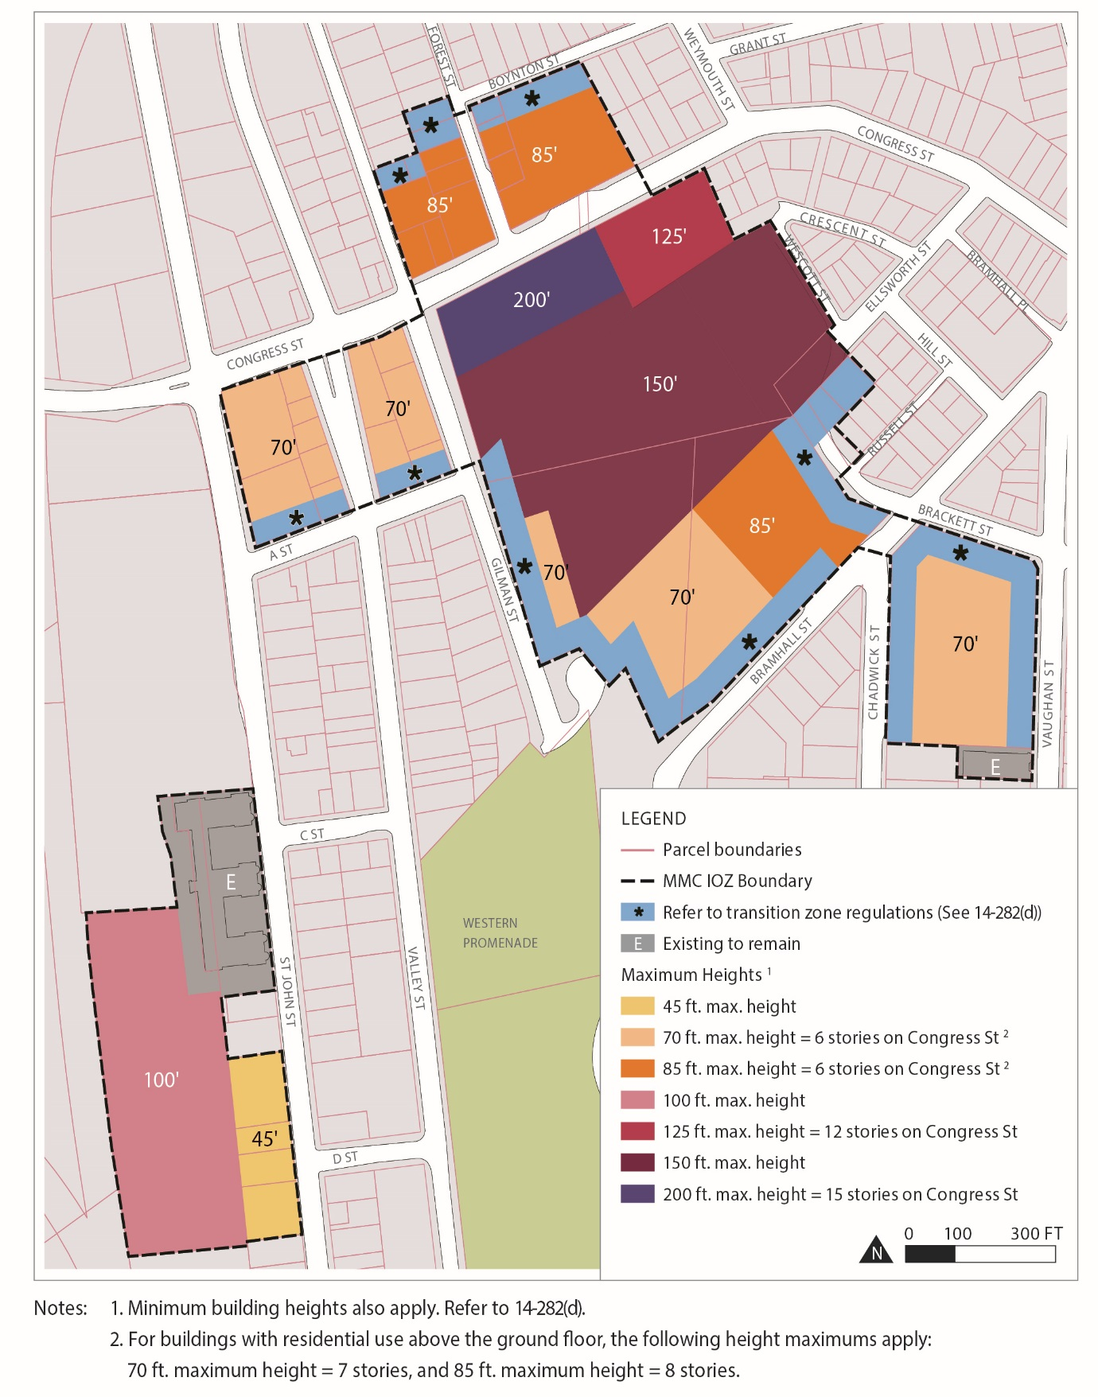

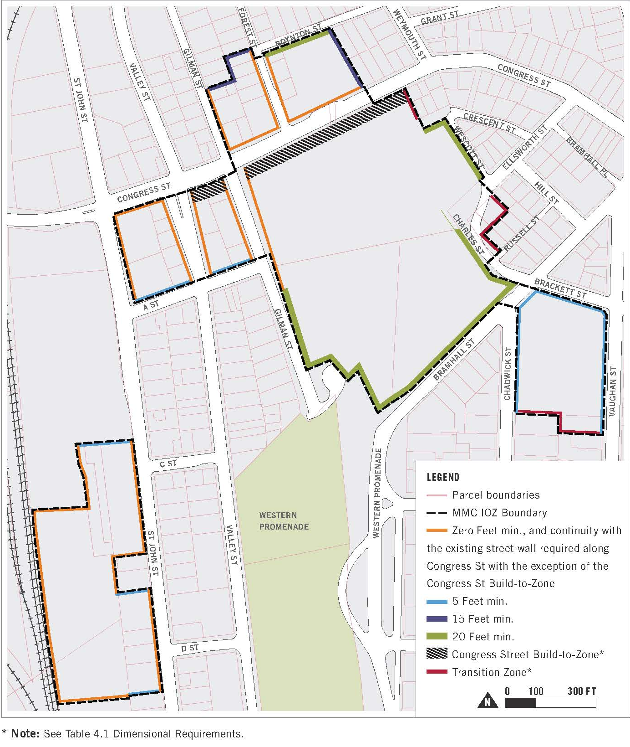
Minimum Setbacks

(e) Design. New buildings within the IOZ shall adhere to the Design Guidelines set forth in Chapter 5: Design of the IDP and the site plans standards of the City of Portland.

(f) Signs.

1. At the time of first site plan review following IDP approval, a unified campus-wide Signage Plan shall be submitted for review and approval by the Planning Authority. Any update to such plan due to a change in name or logo shall not require amendment to the IDP.

2. Signs shall be designed in accordance with the campus-wide Signage Plan. All signs shall be designed in proportion and character with building facades and adjacent street typology. All signs shall be coordinated with the building and landscaping design and be constructed of appropriate permanent, high quality materials and finishes.

(g) Transportation.

1. Transportation Demand Management (TDM):

a. At the time of the first site plan review following IDP approval, MMC shall submit a campus- wide TDM Plan substantially in accordance with those TDM objectives and strategies identified in the approved Institutional Development Plan. The TDM Plan may be phased into short-,mid-, and long-term actions to allow for progressive implementation over time.

b. The TDM Plan shall be designed to provide transportation choice with the goal of reducing parking demand and single-occupancy vehicle trips to and from MMC by employees and visitors.

c. The TDM Plan shall establish parking and trip reduction targets associated with the short-term (0-2 years), mid-term (2-5 years), and the long-term (5+ years), as well as a data collection plan.

2. Parking:

a. Parking requirements in the IOZ shall be established at the time of site plan review based on a parking study that includes a campus-wide analysis of demand and supply. The parking demand study shall determine parking requirements and shall be sufficient to alleviate parking pressure on surrounding neighborhoods.

b. Parking studies developed by MMC shall integrate parking and trip reduction achievements and data contained in the TDM Plan.

(h) Environment. Development proposed by MMC shall be designed to integrate with the surrounding context, including open space and pedestrian networks and infrastructure.

(i) Mitigation measures. MMC shall mitigate site plan impacts to off-premise infrastructure in a manner proportionate to those impacts. Mitigation may include financial or in-kind contributions to existing or planned City projects focused on mitigating the impacts of MMC development. Mitigation contribution shall be determined based on the City’s standard procedure in effect at the time of site plan review.

(j) Neighborhood Integration and neighborhood engagement.

1. For the purpose of keeping surrounding residential areas appraised of its future development plans, and to address any neighborhood issues related to the operations of the MMC Bramhall campus, MMC shall adhere to the ongoing community engagement principles identified in the approved Institutional Development Plan.

2. MMC shall conduct ongoing community engagement, including the formation of a Neighborhood Advisory Committee comprised of representatives of MMC, the Parkside neighborhood, the West End neighborhood, the Western Promenade Neighborhood Association, the St. John Valley neighborhood, the Libbytown neighborhood, and the City.

(k) Construction management.

1. At the time of site plan review, MMC shall submit a Construction Management Plan substantially in accordance with those construction management principles identified in the approved Institutional Development Plan for review and approval by the Planning Authority.

2. The Construction Management Plan shall include a construction schedule, as well as strategies for managing neighborhood communication and noise, air quality, traffic, and parking impacts associated with the construction as set forth on the Construction Management Template developed by the City and attached and incorporated to the IDP as Appendix A.

(l) Other requirements.

1. Helipad. MMC shall be governed by the provisions of the Helistop Overlay Zone with the following exceptions:

a. Setback requirements of Section 14-327(3); and

b. Fencing requirements of Section 14-327(4).

2. Snow Ban Parking. When the City of Portland declares a Snow Parking Ban, MMC shall make parking available to neighbors in a designated parking area on or near its campus upon the following condition:

a. Hours: Due to the patterns of patient flow in the hospital, the hours of snow ban parking for registered vehicles during an announced City of Portland Snow Parking Bans are 6:00 p.m. until 6:00 p.m. Vehicles that are not moved out of these parking areas by the applicable time each morning are subject to towing at the owner’s expense.

3. Healthy Communities- Recognizing that a stable residential and commercial environment is key to the health of any neighborhood, MMC commits to supporting its existing and future neighbors in the St. John Valley, Parkside, West End, Western Prom and Libbytown neighborhoods. Accordingly, MMC shall implement and participate in the healthy communities programs as described below.

a. Caring Community Grants- MMC shall develop an annual grant program with available funds of up to $30,000. Goals, priorities, eligibility requirements, program guidelines and allocation approach will be developed by the MMC Neighborhood Council, as described in Chapter 6 of the IDP approved on September 26, 2017. Neighborhood associations or other entities located or operating in the St. John Valley, Parkside, West End, Western Promenade and Libbytown neighborhoods may apply for grant funding relating to the following initiatives:

i. Neighborhood Investment and Infrastructure-focused on creating strong, safe, accessible and vibrant neighborhoods;

ii. Quality of life- Focused on improving access to recreation, arts or cultural experiences in the neighborhoods;

iii. Diversity and Inclusion- Focused on fostering the building of relationships and understanding among diverse groups, including capacity building and outreach activities;

iv. Public Safety- Focused on supporting public safety programs through training programs, equipment or other means in the neighborhoods; and

v. Environmental sustainability- Focused on preventing waste, increasing recycling or supporting other programs that work to improve the environment.

b. Healthy Neighborhoods Program- MMC shall initiate and adopt a memorandum of understanding (MOU) by and between the MMC, the City of Portland, an identified Community Housing Development Organization and any other community partners that may be identified later establishing a Healthy Neighborhoods program. Such a program shall be designed to fund and execute housing and community improvement and development programs in St. John Valley and the other neighborhoods surrounding MMC’s Bramhall Campus.

