|  |
| --- |
|  |
| Sound Measurement Plan |
| Bramhall Campus Helipad |
|  |
|  |
| **December 21, 2018**  **Revised DATE 9/18/19** |

|  |
| --- |
|  |

Contents

1. About this Plan 2

2. Background of MMC Helipads 3

a. History of Helipads at MMC 3

b. Operating the New Helipad on top of MMC’s East Tower 4

c. Anticipated Growth 5

3. Standards for Aircraft Sound 5

a. National Standards 5

b. Local Standards 8

4. Measuring Sound Generated by MMC’s Helipad 9

a. Sound Measurement Locations 10

b. Comparison of Historic Data is Challenging 10

5. Complaints and Monitoring 10

a. Complaints Process 11

b. Properties Potentially Impacted 11

c. Mitigation Measures 13

d. Long-Term Monitoring 13

6. Conclusion 13

Appendix 14

Appendix 1: Consultant Qualifications 14

Appendix 2: The Basics of Noise and Sound 18

Appendix 3: Flight Paths 20

Appendix 4: Sound Measurement Summary Tables 20

Appendix 5: East Tower Helipad Design 21

Appendix 6: 2017 Sound Study Measurement Locations 22

Appendix 7: 2017 Flight Test Tracks 23

Appendix 8: LMax dBA Comparison 24

# About this Plan

The purpose of this Sound Measurement Plan (SMP) is to fulfill a condition of approval for MMC’s East Tower expansion project approved by the City of Portland Planning Board on March 27, 2018. The condition states:

*That within nine months of the date of this site plan approval the applicant shall submit a “Sound Measurement Plan” for review and approval by the Planning Authority, for assessing the actual changes in sound impacts on nearby properties between the helipad operating at the existing site and at the new location, including criteria for mitigation where such impacts are severe based on appropriate national standards. The “Sound Measurement Plan” is required in the event that the predicted sound levels are incorrect, and it shall be approved and implemented at least two months before the helipad is relocated.*

This plan provides a brief history of air ambulance services at Maine Medical Center (MMC), describes the planned operations of the air ambulances at MMC in the future, and defines a noise compliant process related to air ambulance traffic at MMC.

MMC and regional air ambulance service providers are dedicated to providing high quality emergency and trauma healthcare services. MMC is the only level 1 trauma center in Maine and is the leading provider of complex medical care in Northern New England. Patients from every county in Maine and Carroll County, New Hampshire routinely come to MMC for health care services. When a serious accident occurs in Maine or a patient at another hospital needs care at MMC, an air ambulance is often used to transfer the patient. Time is critical when transferring patients to MMC for lifesaving care.

MMC recognizes that residents of the neighborhoods surrounding MMC are affected by noise from helipad operations. This plan seeks to provide a clear path forward for MMC and neighbors to better understand helipad operations.

The Federal Aviation Administration (FAA) is the authority over aircraft operations in the United States and provides guidance on projects that do not require a noise analysis. FAA 1050.1F Desk Reference Chapter 11 section 1.2 states:

“…no noise analysis is needed for projects involving existing heliports or airports whose forecast helicopter operations in the period covered by the NEPA (FAA National Environmental Policy) document do not exceed 10 annual daily average operations with hover times not exceeding 2 minutes.”

The forecasted helicopter operations is 750 flights annually or an average of 2.1 flights per day. Air ambulances at MMC do not have hover times exceeding 2 minutes. MMC wants to better understand its impact on the residents of the surrounding neighborhoods and is exceeding the expectations of the FAA for noise analysis for a helipad such as MMC’s.

MMC’s Institutional Development Plan, approved by the City of Portland Planning Board in November 2017, states:

“MMC shall conduct a noise study as part of the site plan process if any change to the helipad are being proposed, and work to mitigate any potential noise impacts.”

MMC completed a noise study during the site plan process that is further described in Section 4 of this document and is establishing plans to mitigate any potential noise impacts in this plan.

The following experts in hospital-helicopter operations and sound engineering were consulted in the creation of this SMP:

* Norman R. Dotti, P.E., P.P a Principal at Russel Acoustics, LLC, a nationally recognized sound and vibration-engineering firm.
* Thomas Judge, CCT-P, the Executive Director of LifeFlight of Maine.

More information on the qualifications of the consultants listed above is available in Appendix 1: Consultant Qualifications.

Appendix 2: The Basics of Noise and Sound provides a full definition of noise and sound as well as describes how sound is measured. It is included in this document to provide an education reference to anyone reading this plan.

# Background of MMC Helipads

## History of Helipads at MMC

In 2001, MMC began the planning and approval phase of adding a helipad to its facilities. Beginning operations in December 2007, MMC’s helipad is used by LifeFlight of Maine to provide emergent, lifesaving access to emergency medical care for patients in Maine. Although MMC is Northern New England’s only tertiary care hospital, it was the last of three top-level trauma centers in Maine to gain approval for the use of a helipad. Previously, critically ill patients flew to New Hampshire, Boston, or the Portland Jetport followed by an ambulance ride to MMC. A ground-ambulance ride in addition to an air-ambulance ride wastes valuable lifesaving time and is not considered best practice. The addition of a helipad addressed a longstanding unmet need for best practice air ambulance services of Maine’s most critically ill patients.

The existing helipad was approved in 2005 as part of a contract zoning agreement between MMC and the City of Portland based on sound studies and assessment of potential impacts.

In 2018, the City of Portland approved MMC’s Site Plan to relocate the helipad and vertically expand the East Tower and Visitor Garage subject to the condition requiring this document quoted in the above section. The approved helipad includes two landing pads. A primary pad that is larger and will be the most heavily used pad, and a secondary pad that is smaller and used when the primary pad is occupied. Please see Appendix 5: East Tower Helipad Design.

The benefits of the relocated helipad include:

* Immediate access to the Emergency Department. The former helipad, on top of the Gilman St. parking garage, required emergency staff to move laterally within the hospital before reaching the Emergency Department.
* Expanded capabilities to meet the growing need for emergency advanced care. The relocated helipad includes two landing zones that will provide unfettered access to lifesaving care at MMC.
* The number of flights per patient transported by air ambulance will decrease. The former pad, on top of the Gilman St. garage, required air ambulance pilots to relocate to the Portland Jetport if another air ambulance arrived with a patient. Air ambulance pilots would have to return to MMC to pick up the air ambulance crew and the second air ambulance’s pilot would have to repeat the same process creating 4 flights (2 incoming and 2 outgoing) per patient to the MMC helipad. The new design allows air ambulance pilots to land offload the crew and patient and power down until the air ambulance crew returns even if a second air ambulance arrives with a patient.

## Operating the New Helipad on top of MMC’s East Tower

The East Tower helipad has two landing locations, a primary and secondary pad. The primary pad is nearest to the parking garage. The location of the primary pad was chosen specifically to mitigate potential noise to the neighborhood adjacent to the East Tower. The primary pad will have the highest volume of flights. The secondary pad will be used in the event the primary pad is occupied. This can occur when two air ambulances are present. For example, if there is a car accident where more than one person needs to be air-lifted to emergency services, both air ambulances can have access to MMC’s helipad without multiple flights. This can also happen when two patients need to be transferred to MMC from two hospitals at the same time. All flights to MMC’s helipad are emergencies and there is no way to schedule flights or predict how frequently the secondary pad will be used. It is important to note that only one patient may be in an air ambulance at once. Please see Appendix 5: East Tower Helipad Design for a diagram of the East Tower helipad.

MMC requires any provider of helicopter emergency medical transport to operate in compliance with the Fly Neighborly Guide prepared by the Helicopter Association International Fly Neighborly Committee and published by the Helicopter Association International. Fly Neighborly is a voluntary noise reduction program that seeks to create better relationships between communities and helicopter operators by establishing noise mitigation techniques and increasing effective communication. The Fly Neighborly Guide encourages operational changes to minimize the potential noise impact of helicopter operations. This includes:

* Climbing turns are quieter than level and/or descending turns.
* Accelerating climbs are quieter than steady-state and/or decelerating climbs.
* Collective climb is quieter than cyclic climb.
* A higher altitude should be selected to reduce noise footprint.
* Turn away from the advancing blade.
* Steeper take-offs greatly reduce the noise footprint.
* A steep approach glidepath reduces the size of the noise footprint.
* Make smooth control inputs to reduce the noise footprint.
* Maximize steady state segments.
* Maintain the same airspeed during a turn.[1]

For more information about the Fly Neighborly Guide, visit - <https://www.rotor.org/home>.

Air ambulance providers that operate at MMC’s helipad include LifeFlight of Maine, Boston MedFlight, and the Dartmouth-Hitchcock Advanced Response Team (DHART), and U.S. Coast Guard. The types of helicopters used by these emergency service providers include A109E, A109SP, EC135, H145, S76, and the U.S. Coast Guard’s Jayhawk. The types of helicopters used at MMC’s helipad may vary and are subject to change in the future. MMC and LifeFlight of Maine are committed to working with all air ambulance providers who may visit MMC’s helipad to manage helipad utilization so as to minimize potential impacts to the neighborhoods surrounding MMC. MMC will share this plan with air ambulance providers and request that they adhere to it.

MMC and air ambulance providers, like LifeFlight of Maine, operate all day, every day of the year. Additionally, emergencies requiring air ambulance transport can happen at any time. Air ambulance services and emergency services are community benefits that MMC is committed to providing. Any efforts to limit the number of flights, the frequency of flights, or the time of day of flights are all methods of reducing potential noise impacts that will negatively impact patient care which is unacceptable.

The number of flights to MMC is directly related to the need for services at MMC. Northern New England states are the oldest states in the U.S. with Maine leading as the oldest with a median age of 44.6 years.[2] The use of healthcare services is highest among people 65 years or older. In addition, MMC is a provider of highly complex services offered nowhere else in Northern New England. As a result, MMC predicts the number of flights will increase over time. This prediction is based on the forecasted increase of the demand for healthcare services. The forecast considers the incidence and prevalence of disease, improvements in technology, and other factors impacting the demand for healthcare services.

## Anticipated Growth

Due to an increase in the need for highly complex care in the State of Maine, the number of flights is expected to increase in the coming years. However, due to the addition of a secondary pad, the number of flights per patient will decrease.

Today, with one helipad, approximately 2-3 times per month concurrent flights require access to MMC’s helipad. With only one pad, the first patient must depart from MMC and relocate to the jetport after dropping off a patient, leaving behind its medical crew and equipment, and wait for the second aircraft to land and dispatch patients and crews. Once the second aircraft has departed to the jetport, the first aircraft flies back to MMC, picks up its crew and leaves. When two patient trips overlap, there can be as many as eight individual helicopter trips (four in-bound, four out-bound). As a result of these eight additional helicopter trips, unnecessary noise is created in surrounding neighborhoods, which could be a contributing factor in noise complaints. The addition of the secondary pad on top of the East Tower will reduce the number of flights per patient, therefore, reducing the potential sound impact on the neighborhoods.

MMC’s recently approved project to replace the existing helipad and add another pad will reduce the number of individual flights generated by the helipad-to-jetport shuffling required in today’s environment.

# Standards for Aircraft Sound

## National Standards

Aircraft sound in the U.S. is governed by the Federal Aviation Administration (FAA). The metric used for assessing sound by them is the Day-Night Average Sound Level, abbreviated Ldn or DNL (the two terms are used interchangeably). Ldn/DNL is used by major Federal agencies (U.S. Environmental Protection Agency (EPA), U.S. Department of Housing and Urban Development (HUD), the U.S. Department of Energy (DOE), The U.S. Department of Defense (DOD), and others) and internationally in the assessment of potential noise impacts as a result of aerial vehicle operation (planes and helicopters). Additionally, the FAA regulates sound levels produced by all aircraft manufactured and certified for use in the U.S. to reduce potential noise impact on people to an acceptable limit before they even take flight. These regulations have produced quieter modern aircraft like those that currently use MMC’s helipad and are considered industry standard.

A 2011 report for the Volpe National Transportation Systems Center (DOT/FAA/AEE/2011‐03) stated “The Day-Night Average Sound Level, DNL, is the cornerstone of aviation noise impact analysis in the United States.”

MASSPORT, the Massachusetts Port Authority, which administers multiple airports and other transportation venues in the state, defines the Day-Night Sound Level as follows:

***Ldn:*** *The Day-night Average Sound Level (Ldn) is the level of noise expressed (in decibels) as a 24-hour [logarithmic] average. Nighttime noise, between the hours of 10:00 p.m. and 7:00 a.m. is weighted; that is, given an additional 10 decibels to compensate for sleep interference and other disruptions caused by nighttime noise. An annual average of DNLs is used by the Federal Aviation Administration to describe airport noise exposure.*

The aircraft-only DNL considers not only how loud a particular aircraft or helicopter event (landing or takeoff) is but also how long the sound is present, how many events occur over time, and whether the events occur during daytime or at night. The aircraft DNL is developed using computer modeling coupled with actual sound measurements of the various models of aircraft using a particular site and the facts of the pathways and frequency of aircraft flights.

DNL / Ldn can be calculated as follows

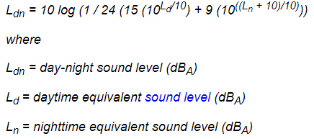

The use of DNL comes from 14 C.F.R. Part 150, issued to implement portions of Title I of the Airport Safety and Noise Act to address land use compatibility. Section 4-1 of FAA Part 150 lists significance thresholds and factors to consider for various environmental impact categories. The environmental impact category “Noise and Noise-Compatible Land Use” is the only category that may be applicable and has an established threshold. Under Noise and Noise-Compatible Land Use, Section 4-1 states:

|  |  |  |
| --- | --- | --- |
| **Environmental Impact Category** | **Significance Threshold** | **Factors To Consider** |
| **Noise and Noise-Compatible Land Use** | *The action would increase noise by DNL[3] 1.5 dB or more for a noise sensitive area that is exposed to noise at or above the DNL 65 dB noise exposure level, or that will be exposed at or above the DNL 65 dB level due to a DNL 1.5 dB or greater increase, when compared to the no action alternative for the same timeframe*. For example, an increase from DNL 65.5 dB to 67 dB is considered a significant impact, as is an increase from DNL 63.5 dB to 65 dB. | Special consideration needs to be given to the evaluation of the significance of noise impacts on noise sensitive areas within Section 4(f) properties (including, but not limited to, noise sensitive areas within national parks; national wildlife and waterfowl refuges; and historic sites, including traditional cultural properties) where the land use compatibility guidelines in 14 CFR part 150 are not relevant to the value, significance, and enjoyment of the area in question. For example, the DNL 65 dB threshold does not adequately address the impacts of noise on visitors to areas within a national park or national wildlife and waterfowl refuge where other noise is very low and a quiet setting is a generally recognized purpose and attribute. |

Source: U.S. Department of Transportation, Federal Aviation Administration, 7/16/2015

If an area already experiences a DNL of 65 dB or higher due to aircraft and there is an increase of 1.5 dB or more, then the significance threshold has been reached.

The FAA defines noise sensitive areas in section 11-5.b.(10) as

“(10) Noise Sensitive Area. An area where noise interferes with normal activities associated with its use. Normally, noise sensitive areas include residential, educational, health, and religious structures and sites, and parks, recreational areas, areas with wilderness characteristics, wildlife and waterfowl refuges, and cultural and historical sites.”

It is important to note that aircraft DNL and a DNL of all sound in an area are different. The FAA does not provide guidance on an acceptable threshold for the DNL of all sound in a neighborhood. In a recent study commissioned by the City of Portland, DNL levels were calculated at locations around the City. The following figure provides the DNLs calculated by the study. The complete study is available at the City of Portland.

**Figure 1 - Mean Measured DNL, Summer 2018**

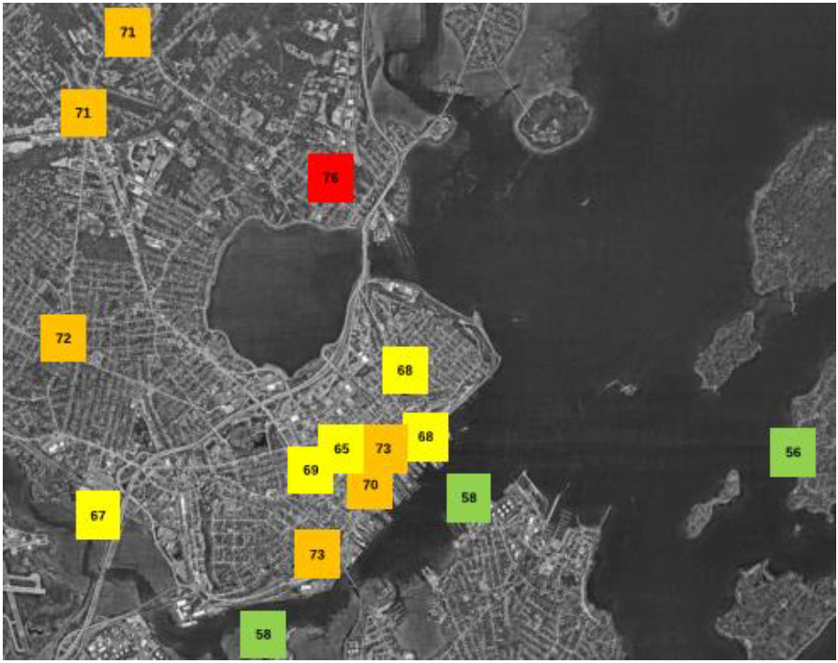

Source: Accentech Memo Dated January 4, 2019, Submitted to the City

As noted in the study, DNLs around the city are already above a DNL of 65 dB.

## Local Standards

MMC is bound by Chapter 14 section 282 Maine Medical Center Institutional Overlay Zone Regulatory Framework which was approved by the Portland City Council in November 2017. Section (a) of 14-282 states

*(a) Applicability. All development proposed by Maine Medical Center (MMC) within the boundary of the Institutional Overlay Zone (IOZ) shall be consistent with the approved Institutional Development Plan (IDP), consistent with the Comprehensive Plan, and meet applicable standards of the land use code, unless such standards are superseded by the following Regulatory Framework. This Regulatory Framework shall govern future development by MMC within the IOZ unless amended by the Portland City Council upon formal application of MMC.*

The Institutional Development Plan for MMC was approved by the Portland City Planning Board in October 2017. This Sound Measurement Plan is consistent with the Noise Impact and Mitigating Impacts of the Helipad Operations sections of chapter four of MMC’s IDP.

There are no other applicable local standards in the City of Portland.

# Measuring Sound Generated by Helicopter Operations at MMC’s Helipad

The aircraft DNL was determined through a combination of actual sound measurements collected as part of a sound study completed in 2017, sound test data from the FAA, and computer generated sound information.

The 2017 sound study was conducted by Russell Acoustics, LLC based in Point Pleasant, New Jersey. The sound measurements were collected over three calendar days at nine test locations (see Appendix 6: 2017 Sound Study Measurement Locations); from 12:00 to 12:00 (noon to noon) on 1 to 2 May 2017, and 14:00 to 15:00 on 2 and 3 May. The locations were chosen to reproduce the locations used in the 2003 report. The first set of measurements included ambient sounds only; there were no helicopter operations of any type during this period. Test flights were flown on the afternoon of 2 May, between 17:00 and 18:00. The flight tests were done within the one hour (i.e., not split across the on-the-hour times). The flight paths followed the FAA approved flight paths available in Appendix 3: Flight Paths. A recording of GPS (global positioning system) readouts from the test flight is available in Appendix 7: 2017 Flight Test Tracks. As indicated by the GPS readout, the flight test visited the existing garage helipad and the location of the proposed East Tower helipads. The aircraft landed on the existing pad and hovered over the location of the future pads during the flight test.

During the site plan review, MMC provided the City with a memo, dated February 2, 2018, describing the change in sound per sound measurement location to quantify the difference in sound between the garage pad and the East Tower pad. The summary tables from that memo are included in Appendix 4: Sound Measurement Summary Tables. These tables discuss the difference in terms of ambient sound and sound during the flight test. There is no national standard to compare these measurements to.

Determining the aircraft DNL is the best possible measure for determining sound generated by MMC’s helipad. It is a measurement used by the FAA and airports across the U.S. as discussed in section 3.a. It isolates sound generated by helicopters using the helipad and it does not account for other sounds in the neighborhood. In order to determine the aircraft DNL, the following factors and assumptions were considered.

* Sound data collected during the 2017 sound study.
* The average sound of the varying types of helicopters that use MMC’s helipad previously mentioned from the FAA. Sound data from the FAA is conservative because of the way the FAA conducts its sound recordings – the approach and departure slope is much shallower than typical practice which results in a noisier flight from the perspective of someone standing on the ground.[4]
* The frequency of visits from each type of helicopter. In order to estimate future DNL, MMC assumed two (2) flights per day or 730 flights per year.
* The time of day helicopters are flown. MMC assumed two flights per twenty-four (24) hour period – one during the day and one at night. The FAA defines nighttime as between 10:00 PM - 7:00 AM. Night time flights are penalized by adding 10 dBA.
* The flight “patterns” used by pilots arriving and departing from MMC’s helipad. Pilots are generally coming straight into the helipad descending from a cruising altitude rather than arriving over the helipad and descending straight down from cruising altitude. This is to minimize the amount of sound exposure to the residents of neighborhoods surrounding MMC.
* The height of the helipad (134’ above grade).

The typical aircraft DNL generated by MMC’s helipad is 65 at the foot of the East Tower, on which the helipad sits. Because sound dissipates as distance increases, the modeled DNL is 61.7 at two hundred (200) feet from the foot of the building.

## Sound Measurement Locations

There is no “standard” or formula for selecting sound measurement locations for these evaluations. The principal concern is what residents hear, day and night, in the vicinity of helicopter operations into and out of the hospital. In previous sound studies several monitors were located close to the hospital and the rest spread further out into the community to bracket a good range of residences. For the sound measurement locations of the 2017 study, please see Appendix 6: 2017 Sound Study Measurement Locations.

## Comparison of Historic Data is Challenging

Comparisons between sound studies done at different times (times of day, time of the week, months during the year) is challenging due to the impact of meteorological factors as well and other environmental factors such as the presence of other sound generators contributing to Portland neighborhoods’ ambient sound levels. Previous sound studies at MMC have demonstrated a universal increase in ambient sound levels. However, with the assistance of Sound Engineering consultants, MMC will provide comparisons of the data from this study to historical studies with the stipulation that a true comparison is impossible to provide given the variable changes that occur.

# Complaints and Monitoring

MMC will reestablish its phone hotline for neighborhood complaints and will, working with the City of Portland Planning Department, address appropriate neighborhood sound issues. The number to call with complaints about MMC’s Helipad is:

**MMC Helipad Complaint Hotline: 207-662-4880.**

1. *General Complaints Process*

Callers will be asked to leave their name, contact information, the day, the time, and the details of the compliant via voicemail. MMC will confirm receipt of complaints by communicating directly with the individual who filed the complaint. Complaints will be recorded and shared upon request and shared with LifeFlight of Maine.

If ten (10) complaints are filed by property owners, within the area under the approved flight paths, about a single flight, MMC will work with emergency air transportation providers to complete a retroactive review of the flight’s path and log whether an exception occurred. The review will be summarized in a report that will be shared with the MMC’s Neighborhood Advisory Committee.

If a pattern of non-compliance[5] is necessary, it it shall be reviewed by the FAA and the City of Portland. If approved, MMC will reevaluate the approved flight paths as well as the effectiveness of helicopter operations guidelines. If a new flight path is approved, MMC will reevaluate the list of properties eligible for mitigation using the same methodology as described below.

## Properties Potentially Eligible for Mitigation

If after 6 months of operations twenty (20) complaints are filed within a contiguous six (6) months by property owners of properties listed below, MMC will recalculate aircraft DNL to determine if the significance threshold as defined by the FAA and provided in section 3.a has been reached. Aircraft DNL will be recalculated based on measured data at 1 second intervals within six (6) months of reaching the complaint threshold.

14 CFR Part 150 Appendix A from the FAA establishes the basis for determining noise exposure maps[6][7]. It says that a sound contour for 65 DNL should be identified on a noise exposure map. As previously stated, 65 DNL is the FAA threshold for noise impact. Appendix A reaffirms this by listing residential, public use, commercial use, manufacturing and production, and recreational use as compatible with a DNL below 65. Therefore, properties within the 65 DNL sound contour would be eligible for mitigation.

As discussed in section 4, projected DNL from the helipads is 65 at the foot of the East Tower. Aircraft DNL at all points farther from the East Tower, as modeled, is less than 65. Therefore, no properties are eligible for mitigation at present. However, MMC understands that sound impacts are subjective and perceived differently by different individuals. In order to identify properties that might be eligible at some future point , MMC mapped properties within four hundred (400) feet of MMC’s helipads.

If the recalculated aircraft DNL demonstrates that the FAA threshold has been met, the following properties will be eligible for mitigation measures if they are within a 65 DNL contour.

Figure 2 - Map of Distance Contours from MMC's Helipad

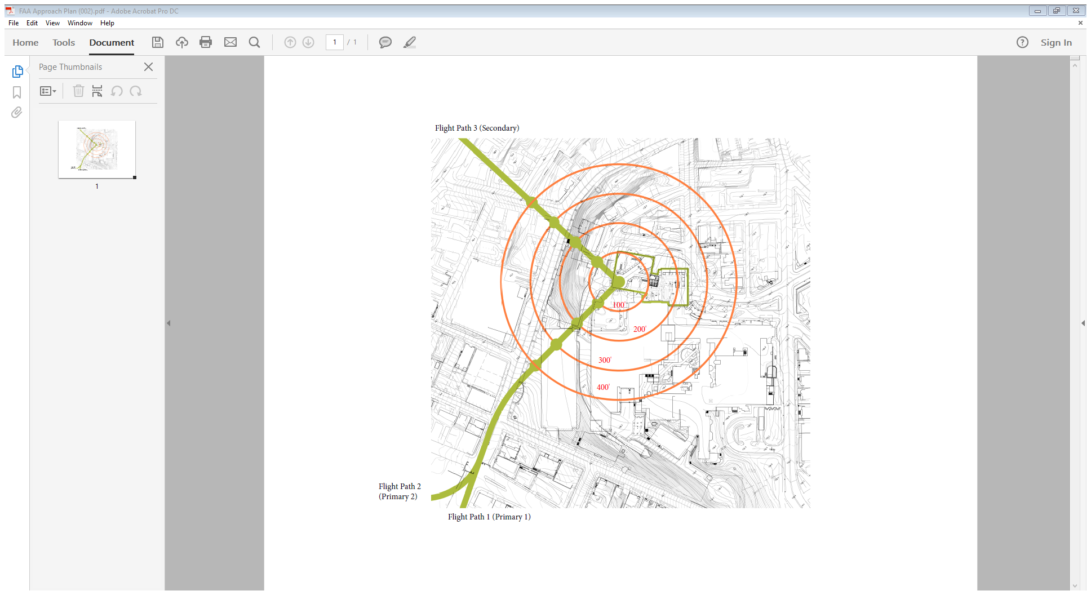

Figure 3 - Properties within 400' of MMC's East Tower Helipad

|  |  |  |  |
| --- | --- | --- | --- |
| 40 Ellsworth | 17 Hill St | 25 Crescent St | 863 Congress St |
| 15 Russell St | 25 Ellsworth St | 832 Congress St | 861 Congress St |
| 11 Russell St | 23 Ellsworth St | 852 Congress St | 5 Weymouth |
| 9 Russell St | 19 Ellsworth St | 867 Congress St |  |
| 7 Russell St | 2 Crescent St | 871 Congress St |  |
| 14 Hill St | 9 Wescott St | 873 Congress St |  |
| 18 Hill St | 3 Crescent St | 879 Congress St |  |
| 20 Hill St | 5 Crescent St | 8 Weymouth St |  |
| 32 Ellsworth St | 9 Crescent St | 12 Weymouth St |  |
| 34 Ellsworth | 15 Crescent St | 8 Boynton St |  |
| 19 Hill St | 19 Crescent St | 12 Boynton St |  |

## Mitigation Measures

The FAA 1050.1F Desk Reference Chapter 11 section 6 lists potential mitigation measures related to noise and noise-compatible land use that include:

* Acquisition of land or land interests, including air rights, easements, and development rights, to ensure the use of property for purposes compatible with noise exposure;
* Sound insulation of residences and other noise sensitive structures; and
* Construction of noise barriers or acoustic shielding to mitigate ground-level noise.

The above mentioned mitigation measures will be explored by MMC and the property owner(s) if the FAA threshold is reached and the property owners request mitigation action. For owners to qualify for mitigation, the aircraft DNL must exceed the FAA threshold triggering mitigation. The manner of mitigation, should it be deemed necessary, shall be made in consultation with property owners and determined by MMC.

## Long-Term Monitoring

MMC will conduct a sound study every three years following the opening of the helipad but no sooner than three years if a sound study is completed based on the complaint criteria above. Future sound studies will account for the number of flights and flight paths used at the time of the study. Future sound studies will use the same sound measurement locations and method for calculating aircraft DNL. Future sound studies will capture sound in 1 second intervals, which is best for calculating DNL.

If there is a change to the approved flight paths, MMC will reevaluate the list of properties eligible for mitigation using the same methodology as described in section **Error! Reference source not found.**. Any properties then added to the list of eligible properties will be eligible for mitigation as described in section **Error! Reference source not found.**.

If the FAA threshold is met, the properties listed in **Error! Reference source not found.** will be eligible for mitigation measures listed in **Error! Reference source not found.**.

# Conclusion

This revised Sound Measurement Plan provides guidance for measuring sound generated by MMC’s helipad and future determination of sound mitigation and changes in helicopter operations.

This plan meets the requirements established in a condition of approval for MMC’s East Tower expansion project approved by the City of Portland Planning Board on March 27, 2018.

Once approved by the City, this plan will be presented by MMC to the Neighborhood Advisory Committee.

# Appendix

## Appendix 1: Consultant Qualifications

**NORMAN R. DOTTI, P. E., P. P.**

**Principal**

Mr. Dotti is a graduate Mechanical Engineer, a Registered Professional Engineer, and a Licensed Professional Planner. As a practicing Acoustical Engineer since 1971, he has over 30 years of direct experience with sound and vibration measurement, analysis, control and engineering project management. He has applied over two decades of electronics, instrumentation and computer programming experience to designing and supplying systems and software for sound and vibration measurement and analysis.

As part of his work he has: conducted hundreds of on-site studies of environmental, architectural and industrial sound and vibration problems; started, developed and managed a group of consulting engineers specializing in noise and vibration control; testified as an expert witness in planning hearings and local, State and Federal courts; worked with experts in other fields on large engineering and architectural projects to integrate sound and vibration controls; designed, programmed and built automated sound and vibration measurement systems for environmental and industrial clients; worked with clients from industry, all levels of government, associations, military, as well as private individuals and community groups.

**Professional Experience**

* 2005 - Present

Principal, Russell Acoustics, LLC. Consulting engineering services pertaining to sound and vibration measurement, analysis and control.

* 1987 - 2004

President, Knorr Associates. Acoustical consulting and management of environment, health and safety information management systems development. Responsible for all company technical and business operations. This includes proposal development, field and laboratory studies, analysis and design, report writing, and testimony.

* 1979 - 1987

Vice President, Ostergaard Associates. Planned, proposed, managed and conducted architectural, environmental and industrial sound and vibration studies for client projects. Developed field instrumentation for long-term environmental monitoring projects. Planned and managed corporate computer system for word processing and data collection and analysis, including spectrum analyzer interfaces and computer graphics. Testified as an expert witness in acoustics for planning boards and in courts to the Federal level.

* 1971 - 1979

Manager, Noise & Vibration Services, National Loss Control Service Corporation (NATLSCO). Proposed, started and managed sound and vibration (S&V) consulting group within large multi-national consulting firm. Developed computerized sound lab and company multi-user computer system for engineering. Work included performing and managing S&V projects for environmental, architectural and industrial clients, including finite element analysis of power plant and submarine systems. Developed and taught training courses for Bruel & Kjaer Instruments (INC I & II) and the OSHA Training Institute.

* 1968 - 1971

Pilot, U. S. Air Force. U.S.A.F. pilot training, AC-119K combat crew pilot. Holds a Commercial Pilot license with Multi-engine and Instrument ratings.

* 1965 - 1968

Research Engineer, Underwater Weapons Division, Davidson Laboratory. Computer analysis and modeling of high performance underwater vehicles; DSRV submarine rescue vehicle, Polaris missile, MK-48 torpedo, DENISON hydrofoil boat. Performed original research in the mathematics of modeling complex stability and control systems on digital computers.

**Education**

* Bachelor's degree: Stevens Institute of Technology, Bachelor of Engineering degree, 1968. Machine design, stability and control, computer programming.
* Master's degree: New Jersey Institute of Technology, School of Management, Master of Business Administration (MBA) in Management of Technology, 2003

**Specialized Postgraduate Courses**

* Fifth Institute of Noise Control Engineering Industrial Noise Control (B&K)
* Designing Quiet Products (B&K) Microphones & Accelerometers (B&K)
* Acoustic Materials & Structures (B&K) Designing Digital Filters
* Applied Time Series Analysis (GenRad) Acoustic Modeling (MIT)
* Industrial Hygiene Engineering Industrial Hygiene Toxicology
* Reading Speech Spectrograms (MIT)

**Professional Licenses**

* Licensed Professional Engineer, New Jersey and Illinois
* Licensed Professional Planner, New Jersey
* Professional Associations, Societies & Memberships
* Acoustical Society of America
* Audio Engineering Society
* Institute of Noise Control Engineers
* American Industrial Hygiene Association - Noise Committee
* Air Pollution Control Association - TP6 Noise Committee
* Illinois Manufacturers Association Noise Advisory Committee - Chairman
* National Council of Acoustical Consultants representative to American National Standards Institute S3 Committee on Bio-acoustics
* New Jersey Noise Control Regulation Task Force
* Research Fellow of the Research and Development Staff of Metrosonics, Inc.

**Teaching**

Mr. Dotti has developed courses for and taught at the U.S. Department of Labor's OSHA Training Institute, Des Plaines, IL, for over ten years. His Advanced Noise Control course has been presented to hundreds of OSHA industrial hygienists and safety compliance officers, military personnel, Coast Guard and Postal Service employees and labor and industry representatives.

He also developed the course notes for and taught week-long sound and vibration measurement and control seminars for Bruel & Kjaer Instruments. The Industrial Noise Control I and II courses were taught over a period of six years.

The above courses and custom classes have been prepared for and taught to Federal, State and local government agencies, including the U. S. Navy and the States of Virginia, Kentucky and South Carolina. Classes in sound and vibration measurement and control for industry have been presented to companies including IBM, Borg-Warner and several workers' compensation insurance carriers.

Mr. Dotti was an Adjunct Professor for several years at Montclair State College, where he taught courses in numerical analysis and computer programming.

**Representative Projects**

Mr. Dotti has managed many of the following projects and has actively participated in the planning, measurement and engineering of all of them:

**Environmental Sound**

Custom design, construction and installation of computer controlled community noise monitoring systems for industrial plants and other community sources|Test and design of muffler and barrier systems for manufacturing plant fan, process and stand-by equipment noise control|Solid waste transfer station testing and analysis for engineering noise control and permitting|Computer programming for acoustical evaluation of S&V engineering alternatives|Helicopter and fixed wing aircraft sound assessment, measurement and regulation development|Truck and other motor vehicle drive-by tests, road-side barrier design|Long-term measurement of community sound levels and variations, including HUD surveys|Site development community and traffic noise surveys for zoning and planning review|Measurement of interior sound levels from outside sources and acoustical design review of construction details|Property line measurements for regulation compliance

**Industrial Sound**

Employee noise exposure and OSHA surveys|Engineering noise control measurement and design|Hearing conservation and audiometric testing programs|Computerized noise exposure and audiometric test data analysis|Machinery noise source identification and control|Employee education programs and manuals|Sound level contour mapping.

**Architectural Sound**

Recording and broadcast studio building and ventilation design|Office sound isolation materials selection and ventilation system (HVAC) modeling and modifications|Conference and classroom voice articulation|Electronic paging and voice re-enforcement systems|Isolation of exterior noise sources; traffic, aircraft, music, manufacturing|Apartment, town house and other residential sound isolation|Identification of exterior noise sources.

**Vibration**

Finite element analysis of nuclear power plant components for earthquake response|Structure-borne noise generation measurements and analysis of Navy shipboard power supplies and Trident submarine trailing SONAR array|Air conditioning chiller pipe and floor vibration isolation design and test|PATH Journal Square Transportation Center building and cooling tower vibration tests|Semiconductor manufacturing and clean room equipment vibration isolation|Impact isolation of power press and general manufacturing equipment|Measurement and prediction of human response to ground-borne and building vibration |Design and programming of maintenance vibration monitoring systems.

**Forensic Acoustics**

Expert witness testimony and litigation support|Measurements to determine compliance with local, State and Federal regulations|Expert report review|Identification of contributing sound and vibration sources|Regulation review and development|Enhancement and recovery of tape-recorded conversations|Tape authentication|Speech analysis and speaker identification|Measurement and analysis of live and recorded voice intelligibility and comprehension|Physiological and psychological response to sound and vibration|Testing of "cordless" telephone in-ear sound levels|Measurement of sound and vibration levels and frequency for determining human detectability and annoyance|Pre- and post-construction building site ambient levels measurement and design of mitigation measures|Re-zoning application surveys|Heliport and helistop sound level assessment|Gunshot measurement and analysis; hearing damage.

**Personal Background**

Mr. Dotti enjoys teaching and is active in community affairs; he has served as a Captain in his community's volunteer fire department and has been a member for over 25 years.

___________________________________________

**Thomas Judge, CCT-P**

*Executive Director, LifeFlight of Maine*

Tom Judge serves as the Executive Director of LifeFlight of Maine, a non-profit hospital-based helicopter critical care system serving the entire state of Maine. He also serves as Executive Director of the LifeFlight Foundation, a non-profit charitable organization that funds aviation infrastructure and outreach education services to hospital and EMS providers. LifeFlight has been nationally recognized for quality, safety and innovative excellence in community service.

Tom brings thirty years of experience in pre-hospital emergency medical services to these organizations, in roles ranging from provider to system planner. He currently serves on the board of the Foundation for Airmedical Research and Education and is a past president of the board of the Association of Air Medical Services. In 2009, he was appointed to the National EMS Advisory Council where he provides advice and recommendations on matters relating to all aspects of the development and implementation of EMS. He also is a consultant for an international accreditation group, serves on the faculty of the annual conference of the National Association of EMS Physicians and on the editorial board of the Emergency Medicine Journal. Locally, he serves as a trustee for Penobscot Bay Healthcare in Rockport and is an active paramedic for the St. George Volunteer Firefighters and Ambulance Association.

In the mid-1990s, Tom spent a year in the United Kingdom as an Atlantic Fellow in Public Policy, during which time he studied at the Medical Care Research Unit, the University of Sheffield and with the Scottish Ambulance Service. He is particularly interested in the effects of healthcare policy and the issues of access and equity in the provision of rural medical care.

Tom has written dozens of articles for emergency and air medical journals and made several presentations at international EMS conferences around the world including South Africa, London, the Czech Republic, Vancouver, Japan, Paris, Spain, Scotland and across the United States.

## Appendix 2: The Basics of Noise and Sound

There are many factors that impact noise and sound.

**Noise**

Noise can be defined as any unwanted sound. What sounds may annoy someone may or may not annoy others. In addition, what sounds annoy an individual can vary, depending on the situation.[8]

Here are some things that affect an individual’s level of annoyance:

* Time of Day - For example, you may be more upset by noise heard at night while you are trying to sleep or relax, than from the same noise heard during a busy day at work. Noise at night may also be more noticeable because the background noise level is lower than during the daytime.
* Length of Time - The longer you are exposed to a noise, the more it may annoy you.
* Predictability - If you cannot predict when the noise will occur, it may annoy you.
* Control - If you have little control over the noise, it may annoy you.
* Emotional Variables - Emotional noise variables are those that cause differences in your perception of a noise. It depends on your experiences, values, beliefs, and mood. If you believe that a noise is unnecessary or unimportant, you may be more annoyed by the noise. For example, if you were awakened by noise from an airplane that you believed was transporting tourists, you could be irritated. On the other hand, if you knew the airplane was transporting goods such as food, medicine, mail, and other perishable necessities, you may be more willing to tolerate the disturbance.
* Physical Surroundings - Surroundings such as snow, grass, trees, and other vegetation can help alleviate noise by reducing the sound through absorption or deflection of sound waves. However, during the summer months, open windows and more time spent outside may result in more noise exposure.

**Sound**

Sound is all around us; sound becomes noise when it interferes with normal activities, such as sleep or conversation.

Sound is a physical phenomenon consisting of minute vibrations that travel through a medium, such as air, and are sensed by the human ear. Whether that sound is interpreted as pleasant (e.g., music) or unpleasant (e.g., jackhammers) depends largely on the listener's current activity, past experience, and attitude toward the source of that sound.

The measurement and human perception of sound involves three basic physical characteristics: intensity, frequency, and duration. First, intensity is a measure of the acoustic energy of the sound vibrations and is expressed in terms of sound pressure. The greater the sound pressure, the more energy carried by the sound and the louder the perception of that sound. The second important physical characteristic of sound is frequency, which is the number of times per second the air vibrates or oscillates. Low-frequency sounds are characterized as rumbles or roars, while high-frequency sounds are typified by sirens or screeches. The third important characteristic of sound is duration or the length of time the sound can be detected.[9]

Distance from whatever is generating sound also has an impact. Distance can be horizontal or vertical. For example, two people speaking at a distance of three feet can be heard and likely understood while two people talking 100 feet away may be barely audible.

**How is Sound Measured?**

Sound intensity or level is measured by decibels.

The loudest sounds that can be detected comfortably by the human ear have intensities that are a trillion times higher than those of sounds that can barely be detected. Because of this vast range, using a linear scale to represent the intensity of sound becomes very unwieldy. As a result, a logarithmic unit known as the decibel (abbreviated dB) is used to represent the intensity of a sound. Such a representation is called a sound level. A sound level of 0 dB is approximately the threshold of human hearing and is barely audible under extremely quiet listening conditions. Normal speech has a sound level of approximately 60 dB; sound levels above 120 dB begin to be felt inside the human ear as discomfort. Sound levels between 130 to 140 dB are felt as pain (Berglund and Lindvall 1995).[10]

**Figure 4 - Comparative Sound Levels**

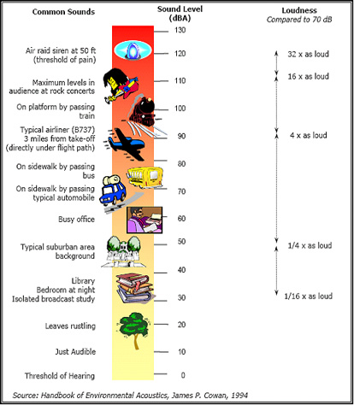

## Appendix 3: Flight Paths

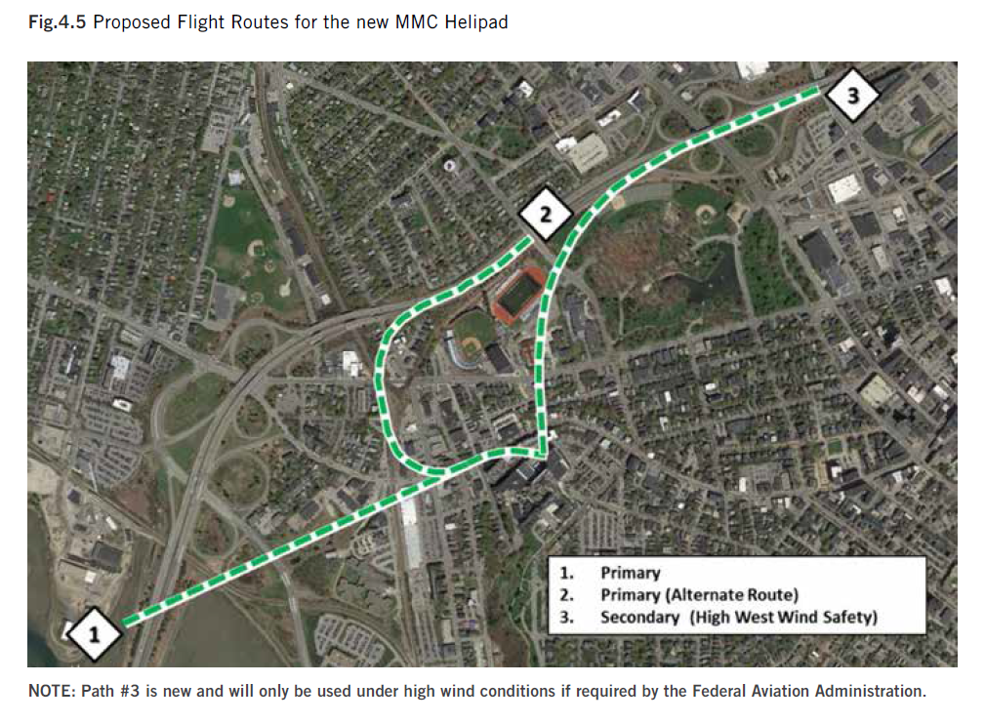

## Appendix 4: Sound Measurement Summary Tables

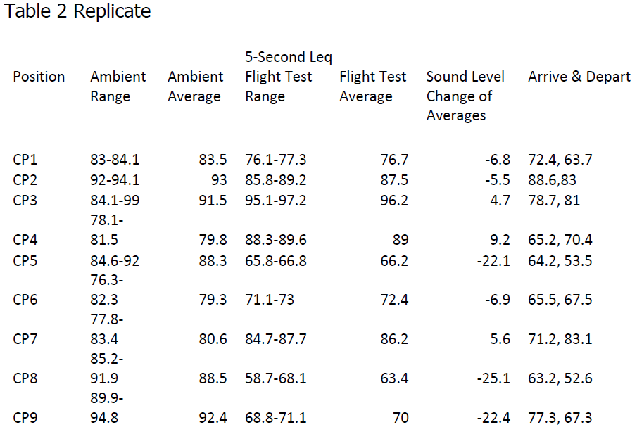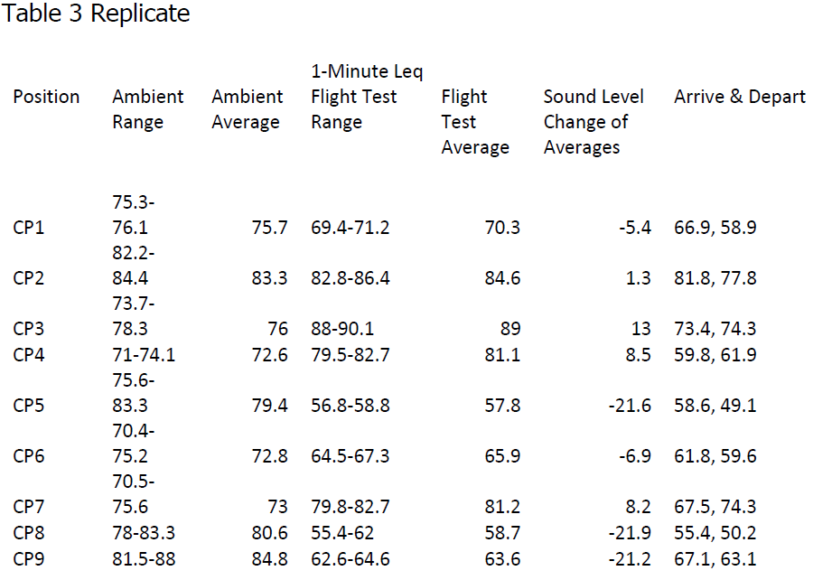

Table 2 and Table 3 were extracted from a February 2, 2018 memo from Russell Acoustics, LLC to MMC’s Manager of Facility Development that was submitted to the City of Portland as part of the East Tower & Visitor Garage site plan review process.

## Appendix 5: East Tower Helipad Design

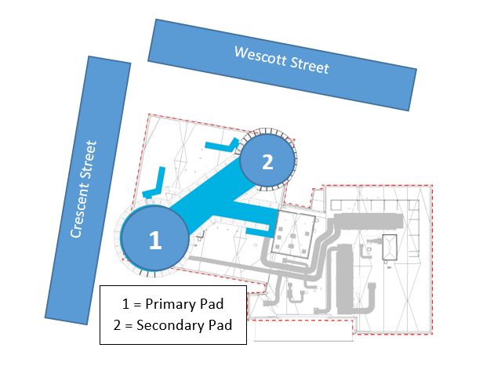

## Appendix 6: 2017 Sound Study Measurement Locations

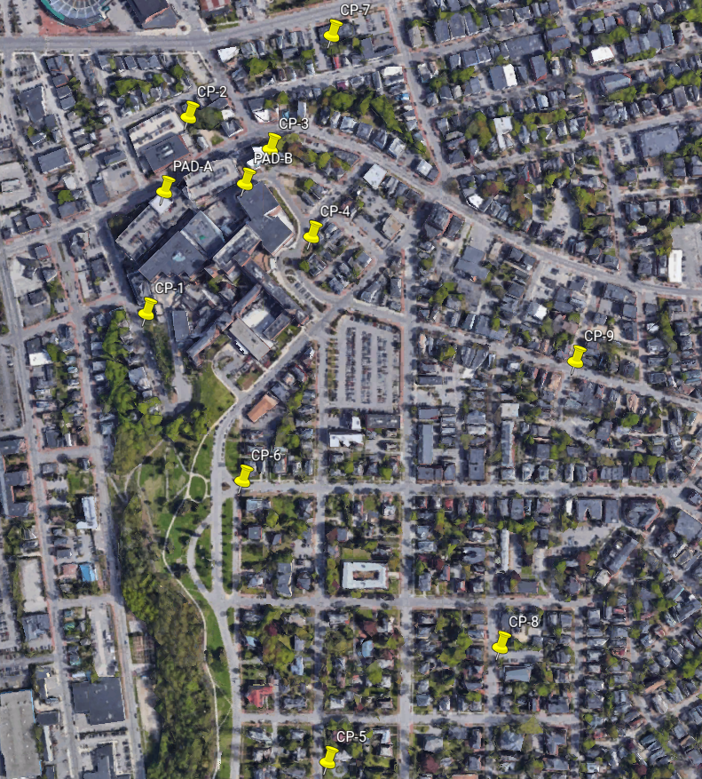

## Appendix 7: 2017 Flight Test Tracks

From on-board GPS. 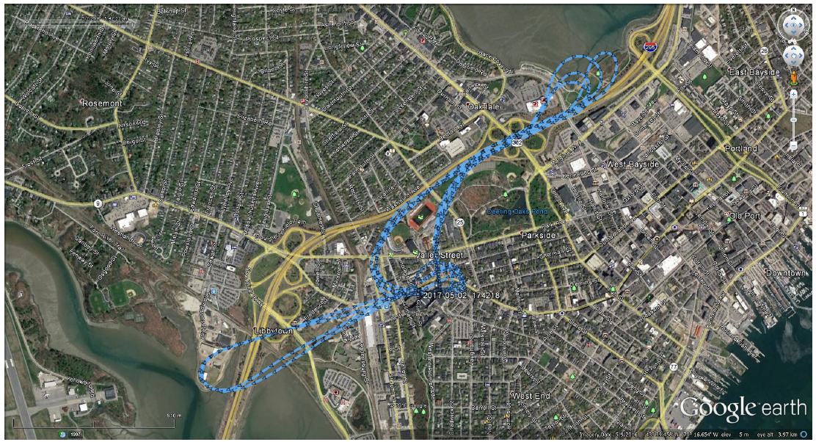

## Appendix 8: LMax dBA Comparison

The following graphs show the maximum sound energy generated by an A109 aircraft – the most commonly used aircraft used by LifeFlight. The FAA data is collected using a typical arrival, landing, and departure. The test flight completed during the 2017 sound study did not include a landing. Instead, the helicopter hovered which is a, generally speaking, louder event than a landing.

FAA Graph 1: Aircraft Approach

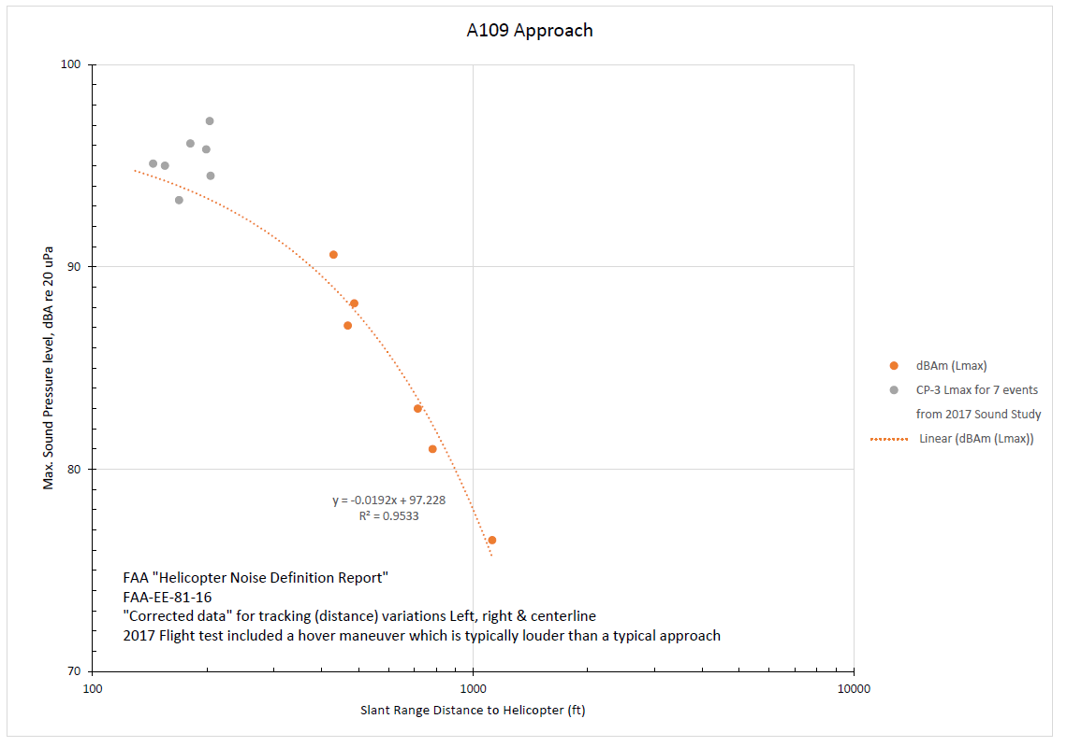

2017 Sound Study Graph 1: Sound Measurement Location CP2

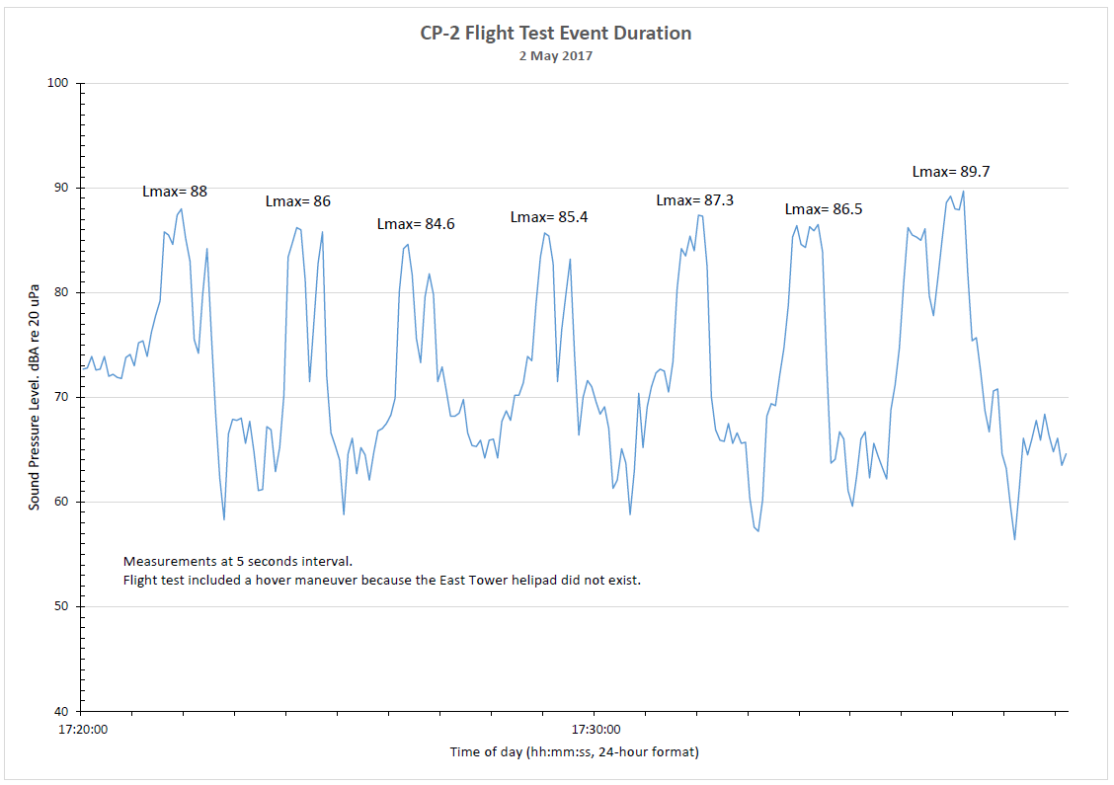

2017 Sound Study Graph 2: Sound Measurement Location CP3

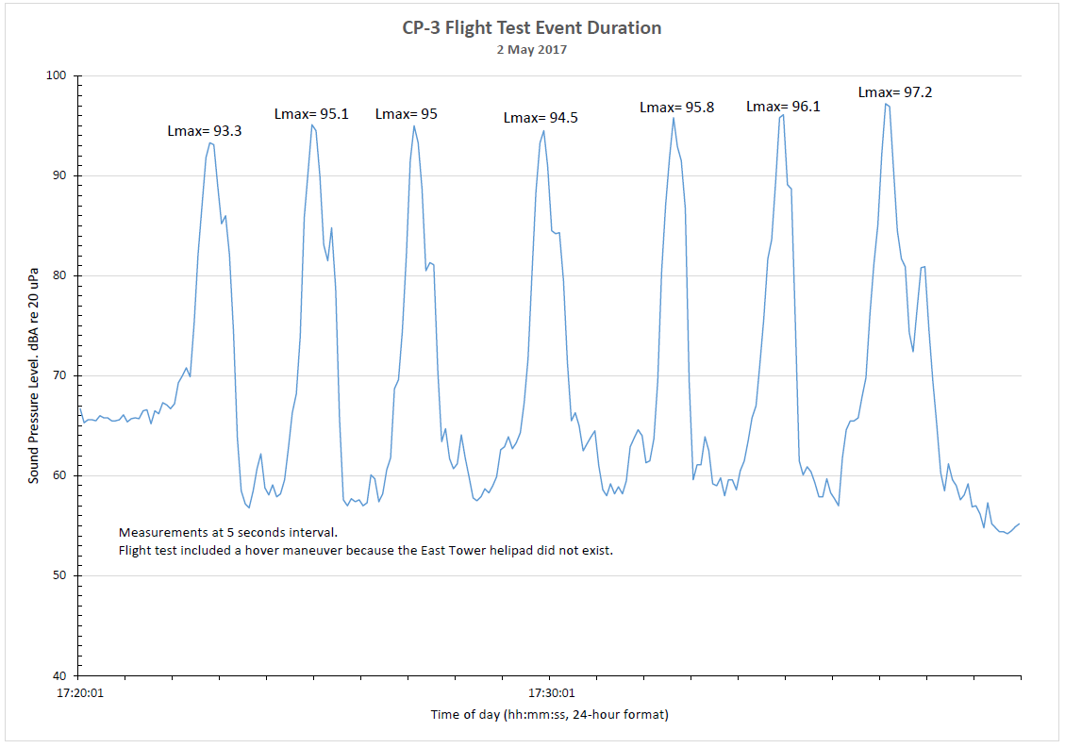

1. Fly Neighborly. Helicopter Association International. August 13, 2019. <https://www.rotor.org/resources/operations/fly-neighborly2>.
2. Northern New England States Still the Oldest. The Associated Press. September 14, 2018. <https://www.usnews.com/news/best-states/maine/articles/2018-09-14/northern-new-england-states-still-the-oldest>.
3. Day-Night Average Sound Level (DNL). The 24-hour average sound level, in decibels, for the period from midnight to midnight, obtained after the addition of ten decibels to sound levels for the periods between midnight and 7 a.m., and between 10 p.m., and midnight, local time. The symbol for DNL is Ldn
4. A comparison between the maximum sound energy (Lmax) recorded by the FAA for the A109 model helicopter (the most common helicopter used by LifeFlight of Maine) and the maximum sound energy recorded by a sound study completed by MMC in 2017 is available in Appendix 8: LMax dBA Comparison. The maximum sound energy recorded by the FAA and the 2017 sound study are similar. As a result, the use of FAA data in DNL calculations was considered to be valid.
5. A pattern of non-compliance is defined as thirty-three percent (33%) of total flights using an alternative route within a contiguous six (6) months.
6. FAA 14 CFR part 150 Appendix A
7. Appendix A also offers the following guidance to local governments: *“(1) Where the community determines that residential or school uses must be allowed, measures to achieve outdoor to indoor Noise Level Reduction (NLR) of at least 25 dB and 30 dB should be incorporated into building codes and be considered in individual approvals. Normal residential construction can be expected to provide a NLR of 20 dB, thus, the reduction requirements are often stated as 5, 10 or 15 dB over standard construction and normally assume mechanical ventilation and closed windows year round. However, the use of NLR criteria will not eliminate outdoor noise problems.”*
8. Noise Basics, Noisequest.psu.edu, 2018
9. Noise Basics - Basics of Sound, Noisequest.psu.edu, 2018. For more on the basics of sound, please see the Science of Sound video produced by NASA at <https://youtu.be/_ovMh2A3P5k>.
10. Noise Basics – Basics of Sound, How is Sound Measured?, Noisequest.psu.edu, 2018.