***DRAFT***

***7.9.19 REVIEW OF MMC SOUND MANAGEMENT PLAN (as revised 6.19.19)***

*The submitted SMP was reviewed against the two previous e-mails sent by the City to clarify what was expected in the SMP. The City’s objective is not to compare data with that from 2003-2004, but to have data that shows what changes in sound impacts will result from the relocation of the helipad, and then if those changes are significant to clarify whether and where mitigation would be offered.*

*The revised SMP does not provide that information and the following review (see bold* ***red*** *comments) outlines the additional information that needs to be submitted in order to meet the condition of approval on the East tower and visitors Garage Expansion:*

***PREVIOUS E-MAILS:***

1. Re: MMC East Tower and Visitor Garage Conditions of Approval

https://ssl.gstatic.com/ui/v1/icons/mail/profile_mask2.png

|  |  |  |  |  |
| --- | --- | --- | --- | --- |
| |  | | --- | | **Jean Fraser <jf@portlandmaine.gov>** | | AttachmentsWed, Nov 14, 2018, 12:06 PM |  | https://mail.google.com/mail/u/0/images/cleardot.gif  https://mail.google.com/mail/u/0/images/cleardot.gif |
| |  | | --- | | to Alexander, Stuart, Helenhttps://mail.google.com/mail/u/0/images/cleardot.gif | | | |

Hello Al

Below I have summarized the expectations related to the "*Sound Measurement Plan*" referenced in the condition of approval (quoted below).

i.           That within 9 months of the date of this site plan approval the applicant shall submit a “*Sound Measurement Plan*” for review and approval by the Planning Authority, for assessing the actual changes in sound impacts on nearby properties between the helipad operating at the existing site and at the new location, including criteria for mitigation where such impacts are severe based on appropriate national standards. The “*Sound Measurement Plan*” is required in the event that the predicted sound levels are incorrect, and it shall be approved and implemented at least 2 months before the helipad is relocated;

The  Study should include the following elements:

1. The identification of several additional study points to reflect the fact that the new helipad location will not benefit from the shadow of any MMC or other building (documents from the 2005 review confirm that is was assumed by both MMC and City sound consultants that sound from the helipad at its existing location would be "blocked" by buildings to the north of it).  The new location could affect residents and businesses that are not impacted by the existing helipad.  The plan below (from your submitted report) shows the original study locations for the submitted sound study and there are no points to the mid north and to the NE of the proposed helipad location.

**REVIEW OF 6.19.19 SMP: The revised SMP identifies an additional point (CP10) as advised by the Peer Review and this addresses this element.**

2.  Provision of a table for all of the points, including the new ones, that sets out sound levels for the ambient, impact of existing helipad, and predicted for the new helipad (similar to that included in the attached submission).  An explanation of how to interpret this data and what it may mean for occupiers would help to "qualify" the information (and clarify the note over the table in the attached submission).

**REVIEW OF 6.19.19 SMP: The revised SMP needs to include a table (based on the 2017 flight tests as augmented by flight tests done now) that complete the following table by adding in CP10 and adding in a column for “ambient, including current helicopter flights to the existing helipad”, and qualifying that “flight test” refers to flight tests for the new location of the helipad. The 2003 information does not need to be included as historical comparisons are not particularly helpful as pointed out in the SMP - what we need to understand is whether the new location compared to the old location would increase substantially the sound impacts to properties to the north and northeast of the East Tower (note that the Peer Review sent to you in March suggested some could experience a 6dbl or greater impact).**

**CP10 must be included as that is the point of this Plan (ie to assess areas that may be impacted by the relocation of the pad) - a LifeFlight test should be done now for that point so the data can be presented and analysed. The table should include DNL absolute and change from existing (including current helicopter flights) for all 10 points. This table would provide the “predicted baseline” sound level against which future montiroing of actual would be compared.**

**Clarify that ambient incde exiing flights**

**DNL-0- vlume; duration; day vs night; # events**

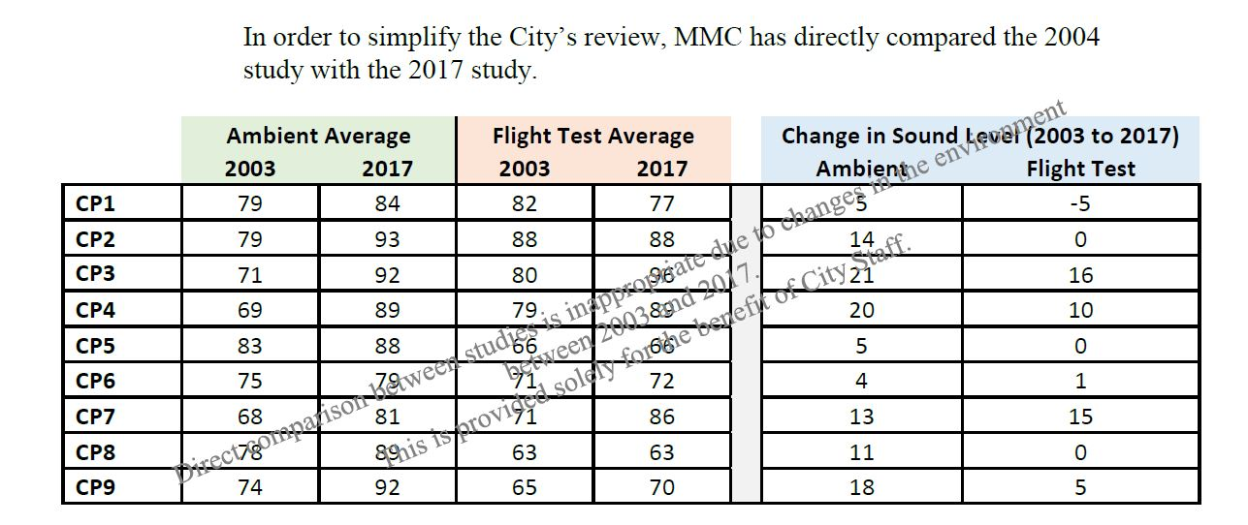

1. Setting out a measurement protocol for measuring  the actual  sound levels once the new helipad is in operation;  this would verify the accuracy of the predicted sound levels (at the locations noted in the table).

**REVIEW OF 6.19.19 SMP: The SMP needs to include a specific monitoring obligation to verify the actual levels are close to those predicted.**

1. An analysis as to whether the increase (either re the predicted or re the actual) is acceptable based on appropriate national and local standards (to be referenced).  Based on this, identify the criteria for mitigation and identify which properties are eligible for mitigation.

**REVIEW OF 6.19.19 SMP: The SMP needs to address the Federal Standards that were pointed out by the Peer Reviewer:**

**“** Federal Aviation Administration (FAA) Order 1050.1F (FAA 2015) the proposed DNL is greater than or equal to 65 dB DNL and the change between the existing and proposed environment would be at least 1.5 dB DNL. ‘

**and how the data from the proposed location compares with the existing ambient INCLUDING the existing flights to the existing pad.**

5.  Clarify the process and timetable for making mitigation available to any parties that meet the criteria (of actual sound level changes pre and post new helipad operation).

(Note-  the text in the CZA clarified proposed mitigation and what would trigger such mitigation, so this frames expectations for mitigation:

(g) Mitigation. **MMC**will pay for the installation costs associated with the full

installation of soundproofing improvements contained within Exhibit D, except in lieu of central air conditioning MMC will also pay for the installation of ventilation improvements to one or more rooms within each such dwelling unit asreasonable and appropriate as determined by the

**CITY.**The **CITY**shall contract for such work and **MMC**shall be responsible for the costs associated therewith, plus a 10% administrative fee to be paid to the **CITY.**Before ente1ing into any contract for such work, the CITY shall notify M11C and give MMC the oppo1tunity to comment on the scope of the proposed work and the estimated cost thereof. The properties to be included under this provision are as follows: 879 Congress Street (Map53, Block I, Lot 16), 921 Congress Street (Map 65, Block D, Lot 17), 925 Congress Street (Map 65, Block D, Lot 16) and 929 Congress Street (Map 65, Block,D, Lot 14). Such funds shall only be expended if the present owners of such buildings request such improvements no earlier than six months and no later than eighteen months after commencement of the operation of the Helicopter Landing Pad. For a period of five years from the date of this Agreement, any new owner of the aforementioned properties mayrequest such improvements no later than eighteen months after purchase of said property(s).

**REVIEW OF 6.19.19 SMP: The SMP lists properties and these may be appropriate, but they need to be mapped in relation to the measuring points that show an increase in sound over 1.5 decibles, and confirm that other properties may be eligible if future monitoring in the vicinity indicates that this delta has been experienced (or similar criteria as per the condition of approval which reads: (ref og 6 last line under “sound mitigataion”**

i.           That within 9 months of the date of this site plan approval the applicant shall submit a “*Sound Measurement Plan*” for review and approval by the Planning Authority, for assessing the actual changes in sound impacts on nearby properties between the helipad operating at the existing site and at the new location, including criteria for mitigation where such impacts are severe based on appropriate national standards. The “*Sound Measurement Plan*” is required in the event that the predicted sound levels are incorrect, and it shall be approved and implemented at least 2 months before the helipad is relocated;

complatin based- need hone no and proecess

6.  Document the stated intentions in the IDP pages 94-96.

**REVIEW OF 6.19.19 SMP: The revised SMP does not include this.**

I have copied this to Tuck and Nell who may wish to add to this.

Thank you

Jean

Re: Sound Management Plan

https://ssl.gstatic.com/ui/v1/icons/mail/profile_mask2.png

|  |  |  |  |  |
| --- | --- | --- | --- | --- |
| |  | | --- | | **Jean Fraser <jf@portlandmaine.gov>** | | Tue, Mar 19, 2:22 PM |  | https://mail.google.com/mail/u/0/images/cleardot.gif  https://mail.google.com/mail/u/0/images/cleardot.gif |
| |  | | --- | | to Alexander, Aaron, Dennis  https://mail.google.com/mail/u/0/images/cleardot.gif | | | |

Al

Following on from my e-mails on Friday and Monday, please see below a summary of the Peer Reviewer (HMMH 3.7.19) recommendations in respect of your *Sound Management Plan.*The ones in **bold type**(under headings) appear to be the most important:

* ***Methodology used in Sound Management Plan***
  + **Measure two 24 days (eg typical weekend day and weekday) to confirm ambient sound levels (3.1)**

**REVIEW OF 6.19.19 SMP: Not sure if this is addressed- may not be an issue.**

* + Specify the flight tracks used in the sorties used for measurements, and document intended flight paths (3.2)
  + Specify formulae and weather data (3.3)
* ***Determining whether any significant sound impacts of the relocated helipad***
  + **Clarify national criteria (thresholds, delta) for determining significant noise impacts as per section (4)**

**REVIEW OF 6.19.19 SMP: The Federal standards are only partially included.**

* + Clarify location of sound devices relative to flight paths (5.1)
  + **Add in measurement location between CP-3 and CP-4 and collect data as for others (5.2)**

**REVIEW OF 6.19.19 SMP: this has been addressed.**

* + Address question of whether flight paths are different and therefore impact properties not taken into account previously (I believe that 1 & 2 are as originally assessed, and #3 was for high wind conditions so this may just need a comment, although I have observed quite a few flights coming in from the south so not using these flight paths) (5.2)
  + **Add tabular compilations of data as recommended (6)**

**REVIEW OF 6.19.19 SMP:** this has not been completed- see above.

* ***Mitigation Process***
  + **Explain the basis for selection of properties identified as being eligible for mitigation (link to measurements and criteria).**

**REVIEW OF 6.19.19 SMP:** this has not been completed- see above. These appears arbitrary and need to be based on some analysis of the data.

Please let me know if any questions on the above.

I will be writing separately (within the next day) with a status update on all of the conditions of approval for the East Tower/Visitors Garage.  As part of that update I will address a question that you recently raised with Nell regarding possible changes to the Visitors Garage facade (facing Congress Street).

thank you

Jean