**7.16.19 Planning Div. Comments on**

**MMC *Sound Management Plan* (rev 6/19/2019)**

1. Background:

The *Sound Management Plan* (referred to in this note as the *Plan*) was submitted in December 2018 to address the following condition of approval (from PB in March 2018):

1. *That within 9 months of the date of this site plan approval the applicant shall submit a “Sound Measurement Plan” for review and approval by the Planning Authority, for assessing the actual changes in sound impacts on nearby properties between the helipad operating at the existing site and at the new location, including criteria for mitigation where such impacts are severe based on appropriate national standards. The “Sound Measurement Plan” is required in the event that the predicted sound levels are incorrect, and it shall be approved and implemented at least 2 months before the helipad is relocated;*

The City engaged a Peer Reviewer (Principal Consultant at HMMH) to review the submitted *Plan*. The Peer Review comments were given to MMC in March, 2019 and the city requested that the *Plan* be revised to address the Peer Review concerns. The current revised *Plan* was received June 19, 2019 and our review has concluded that it does not address all of the Peer Review comments nor all of the city’s specific requests as set out in e-mails dated 11/14/18 and 3/19/19. The comments below summarize the key outstanding issues.

1. Standards of Aircraft Sound: The Peer Reviewer recommended that in the absence of local standards for this unique issue, that the FAA standards regarding environmental impact of helicopter/aircraft sound impacts should be used. The revised *Plan* refers to this but does not quote the standard (relevant to compatibility with residential land use) in full nor include the reference to a 1.5 DNL increase if it brings the level over 65 DNL. Also, it does not provide a summary of the current and predicted (for new location) DNL levels related to the measuring points (see below) in order to see whether the predicted sound levels associated with the relocated and more frequent flights are below or above the FAA standard.
2. Location of Sound Devices - the *Plan* addresses the Peer Review suggestion to add in a tenth location but does not include the data from this location.
3. Comparison with Historical data: We would note that the *Plan* contains a number of statements about comparability with  the 2003 data and measuring locations, and this may be useful in understanding the changes over time. However, as noted in the condition of approval we are focused on getting a baseline regarding current ambient (including current flights) at locations where impacts might be expected, against which to assess predicted and actual change in sound levels which result from the relocation of the pad -  which then would provide a basis for sound mitigation where needed.
4. Helicopter Test Flights; All flights, including for new location 10, should be completed as part of the current study with results included in the *Plan* as a baseline against which evaluation of complaints and monitoring can take place (see below).
5. Continuing Operations: the *Plan* refers to dealing with complaints as per the IDP, so the *Plan* should include the requirements set out in the IDP and then expand on them as per the condition of approval. The *Plan* is intended to augment the IDP to clarify how such complaints would be addressed eg process for making a complaint; criteria for assessing whether a complaint was legitimate; and what forms of mitigation might be appropriate (whether physical mitigation for that property, or modification of the helicopter operations). The Neighborhood Advisory Committee could be identified as one of the ways of clarifying to neighbors how the question of increased helicopter sound would be addressed in the future.
6. Sound mitigation/criteria for mitigation: The *Plan* lists properties that would be eligible for physical mitigation though it is unclear how these have been identified. Any reference to specific properties would be based on the predicted sound levels and flight characteristics being correct in actuality. However, as noted in the condition of approval, the *Plan* needs to include a “protocol” for evaluating - based on actual sound levels in this area and other potential areas- what other properties may be eligible for mitigation if future monitoring in the vicinity indicates the FAA standard has been exceeded elsewhere.
7. Assessing actual changes (as noted in the condition): The *Plan* needs to include some form of monitoring going into the future to confirm that the actual sound levels of the relocated and increased frequency of helicopter flights (see below re monitoring) is as predicted. A baseline of current and predicted sound levels needs to be established as the basis for the mitigation “protocol” (mentioned in 7 above) and for assessing the actual sound levels once the new helipad is in operation on a regular basis. The table below was submitted during the review and we would request an updated version of that table to be part of the *Plan* and to include the new measuring point (CP10); the table should be in DNL levels and confirm that the ambient 2017 includes current helicopter flight sounds.

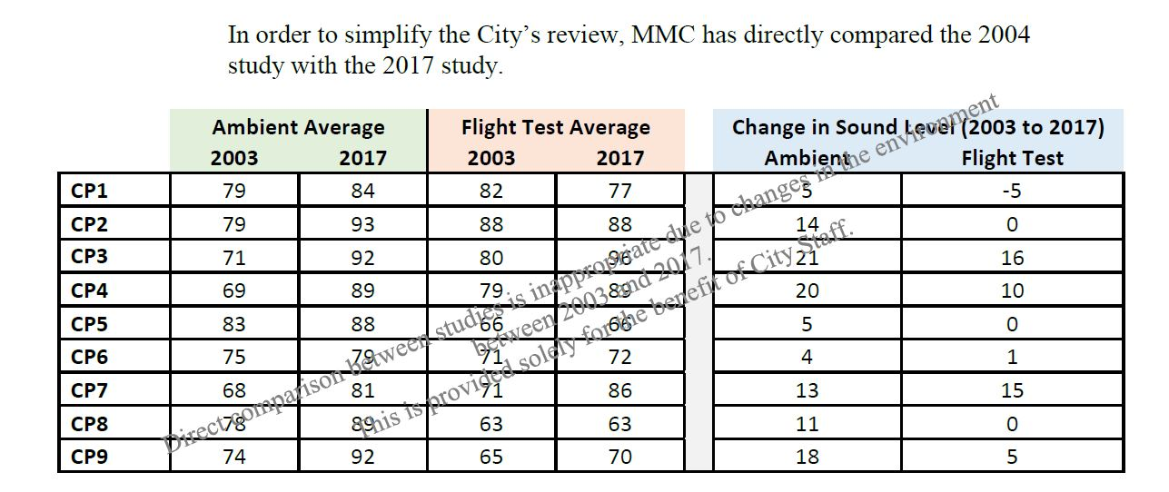

1. Monitoring and triggers for assessing implications of any changes: There are anecdotal observations that helicopters are currently using different flight paths from those confirmed in the IDP, and are operating at a greater frequency than has been advised during the review. The Plan should include some mechanism for monitoring both of these flight characteristics as from the start of operations at the new helipad, as these could generate unacceptable new sound levels for the surrounding residential neighborhood, including some properties not previously affected by the helicopters using the former helipad location (see IDP for discussions regarding flight paths).

If monitoring confirms that new flight paths over residential areas are being utilized and /or that the frequency of flights is greater than predicted, there needs to be a point identified which, if reached, would trigger a review of the helicopter operations to be undertaken in consultation with Life Flight and the city. This possibility should be acknowledged and addressed in the *Plan.*

*JF& ND/7.16.19*