***DRAFT 12.6.18***

***Scope and Timetable***

***Sound analysis - impacts of MMC relocation of the heliport***

**INTRODUCTION**

1. The Planning Division is seeking expert advice from HMMH to help us review and approve the “*Sound Measurement Plan*” as required in the following condition of approval. The condition relates to the approved MMC proposal that includes the relocation of the helipad from the roof of the existing employee garage to the top of the East Tower (after two stories have been added to the East Tower).

*That within 9 months of the date of this site plan approval the applicant shall submit a “Sound Measurement Plan” for review and approval by the Planning Authority, for assessing the actual changes in sound impacts on nearby properties between the helipad operating at the existing site and at the new location, including criteria for mitigation where such impacts are severe based on appropriate national standards. The “Sound Measurement Plan” is required in the event that the predicted sound levels are incorrect, and it shall be approved and implemented at least 2 months before the helipad is relocated;*

1. During the review of the project that included the relocation of the revised helipad reviewers had several concerns:
   1. The helipad would now be a heliport with two landing areas to avoid sending a helicopter to the airport and to accommodate the larger helicopters used by the Coast Guard. The key MMC submissions presented to the PB are attached and we considered that these did not fully address the concerns regarding the changed sound impacts. The studies done by their consultant at the time of the review (Russell Acoustic LLC) are also attached as background.
   2. The concern is that the submitted comparative information (see Graphic B at end of this note) used the same study points as for the original studies carried out at the time the current location was chosen (for which HMMH was the review consultant for the Planning Division). The new location is moved to the north and east and therefore is nearer (albeit higher) to residential and other properties on that side of the main MMC complex (see Graphic A at end of this note).
   3. The original study conducted by consultants for MMC in 2004 (by Resource Systems Engineering) noted that the location of the helipad on the top of the employee garage was beneficial regarding noise impacts, as this location would allow the helipad sound to be blocked by existing MMC buildings. We are not sure if the new location loses some of that benefit or not.
2. MMC was requested (in e-mail to MMC as quoted below) to include the following elements in the Plan:
3. The identification of several additional study points to reflect the fact that the new helipad location will not benefit from the shadow of any MMC or other building (documents from the 2004/5 review confirm that is was assumed by both MMC and City sound consultants that sound from the helipad at its existing location would be "blocked" by buildings to the north of it).  The new location could affect residents and businesses that are not impacted by the existing helipad.  The plan below (from your submitted report) shows the original study locations for the submitted sound study and there are no points to the mid north and to the NE of the proposed helipad location.
4. Provision of a table for all of the points, including the new ones, that sets out sound levels for the ambient, impact of existing helipad, and predicted for the new helipad (similar to that included in the attached submission (*Ed note-* *eg Graphic B*).  An explanation of how to interpret this data and what it may mean for occupiers would help to "qualify" the information (and clarify the note over the table in the attached submission).
5. Setting out a measurement protocol for measuring  the actual  sound levels once the new helipad is in operation;  this would verify the accuracy of the predicted sound levels (at the locations noted in the table).
6. An analysis as to whether the increase (either re the predicted or re the actual) is acceptable based on appropriate national and local standards (to be referenced).  Based on this, identify the criteria for mitigation and identify which properties are eligible for mitigation.
7. Clarify the process and timetable for making mitigation available to any parties that meet the criteria (of actual sound level changes pre and post new helipad operation).
8. Document the stated intentions in the IDP pages 94-96 (copy attached).
9. The 2005 conditional Zoning Agreement (based on the earlier studies on which HMMC had commented) clarified proposed mitigation and what would trigger such mitigation, so this frames expectations for mitigation:

(g) Mitigation. **MMC**will pay for the installation costs associated with the full

installation of soundproofing improvements contained within Exhibit D, except in lieu of central air conditioning MMC will also pay for the installation of ventilation improvements to one or more rooms within each such dwelling unit as reasonable and appropriate as determined by the **CITY.**The **CITY**shall contract for such work and **MMC**shall be responsible for the costs associated therewith, plus a 10% administrative fee to be paid to the **CITY.**Before ente1ing into any contract for such work, the CITY shall notify M11C and give MMC the oppo1tunity to comment on the scope of the proposed work and the estimated cost thereof. The properties to be included under this provision are as follows: 879 Congress Street (Map53, Block I, Lot 16), 921 Congress Street (Map 65, Block D, Lot 17), 925 Congress Street (Map 65, Block D, Lot 16) and 929 Congress Street (Map 65, Block,D, Lot 14). Such funds shall only be expended if the present owners of such buildings request such improvements no earlier than six months and no later than eighteen months after commencement of the operation of the Helicopter Landing Pad. Fora period of five years from the date of this Agreement, any new owner of the aforementioned properties may request such improvements no later than eighteen months after purchase of said property(s).

SCOPE OF WORK FOR CONSULTANT

1. Superficial review of the final 2004/5 study and comments and the previous 2018 MMC submissions to provide background and context.
2. Review of the *“Sound Measurement Plan”*  submitted by MMC (expected in December or January).
3. Assess whether the submitted *“Sound Measurement Plan”*  addresses the review concerns and required elements as listed above.
4. Allow for one conference call with the Planning Division staff to discuss any issues that you feel need to be addressed.
5. Provide written review comments on the submitted *Plan*.
6. Allow for up to two reviews (one on the initial submission, and one on the revised submission to provide updated final comments).
7. Cost Estimate basis: The scope outlined above anticipates a total time of less than 25 hours, unless agreed with the Planning Division in advance.
8. Timetable: The addition of two floors to the top of the East Tower is scheduled to be completed in late 2019, and it is assumed that the construction would need to be substantially complete before the new heliport could be used. Therefore the timetable, as currently understood, is that the “*Sound Measurement Plan”* would need to be approved in early 2019 so it could be implemented in mid-2019. It is envisaged that each review of the submitted *Plan* would be completed in about 2-3 weeks after its receipt in the Planning Office.

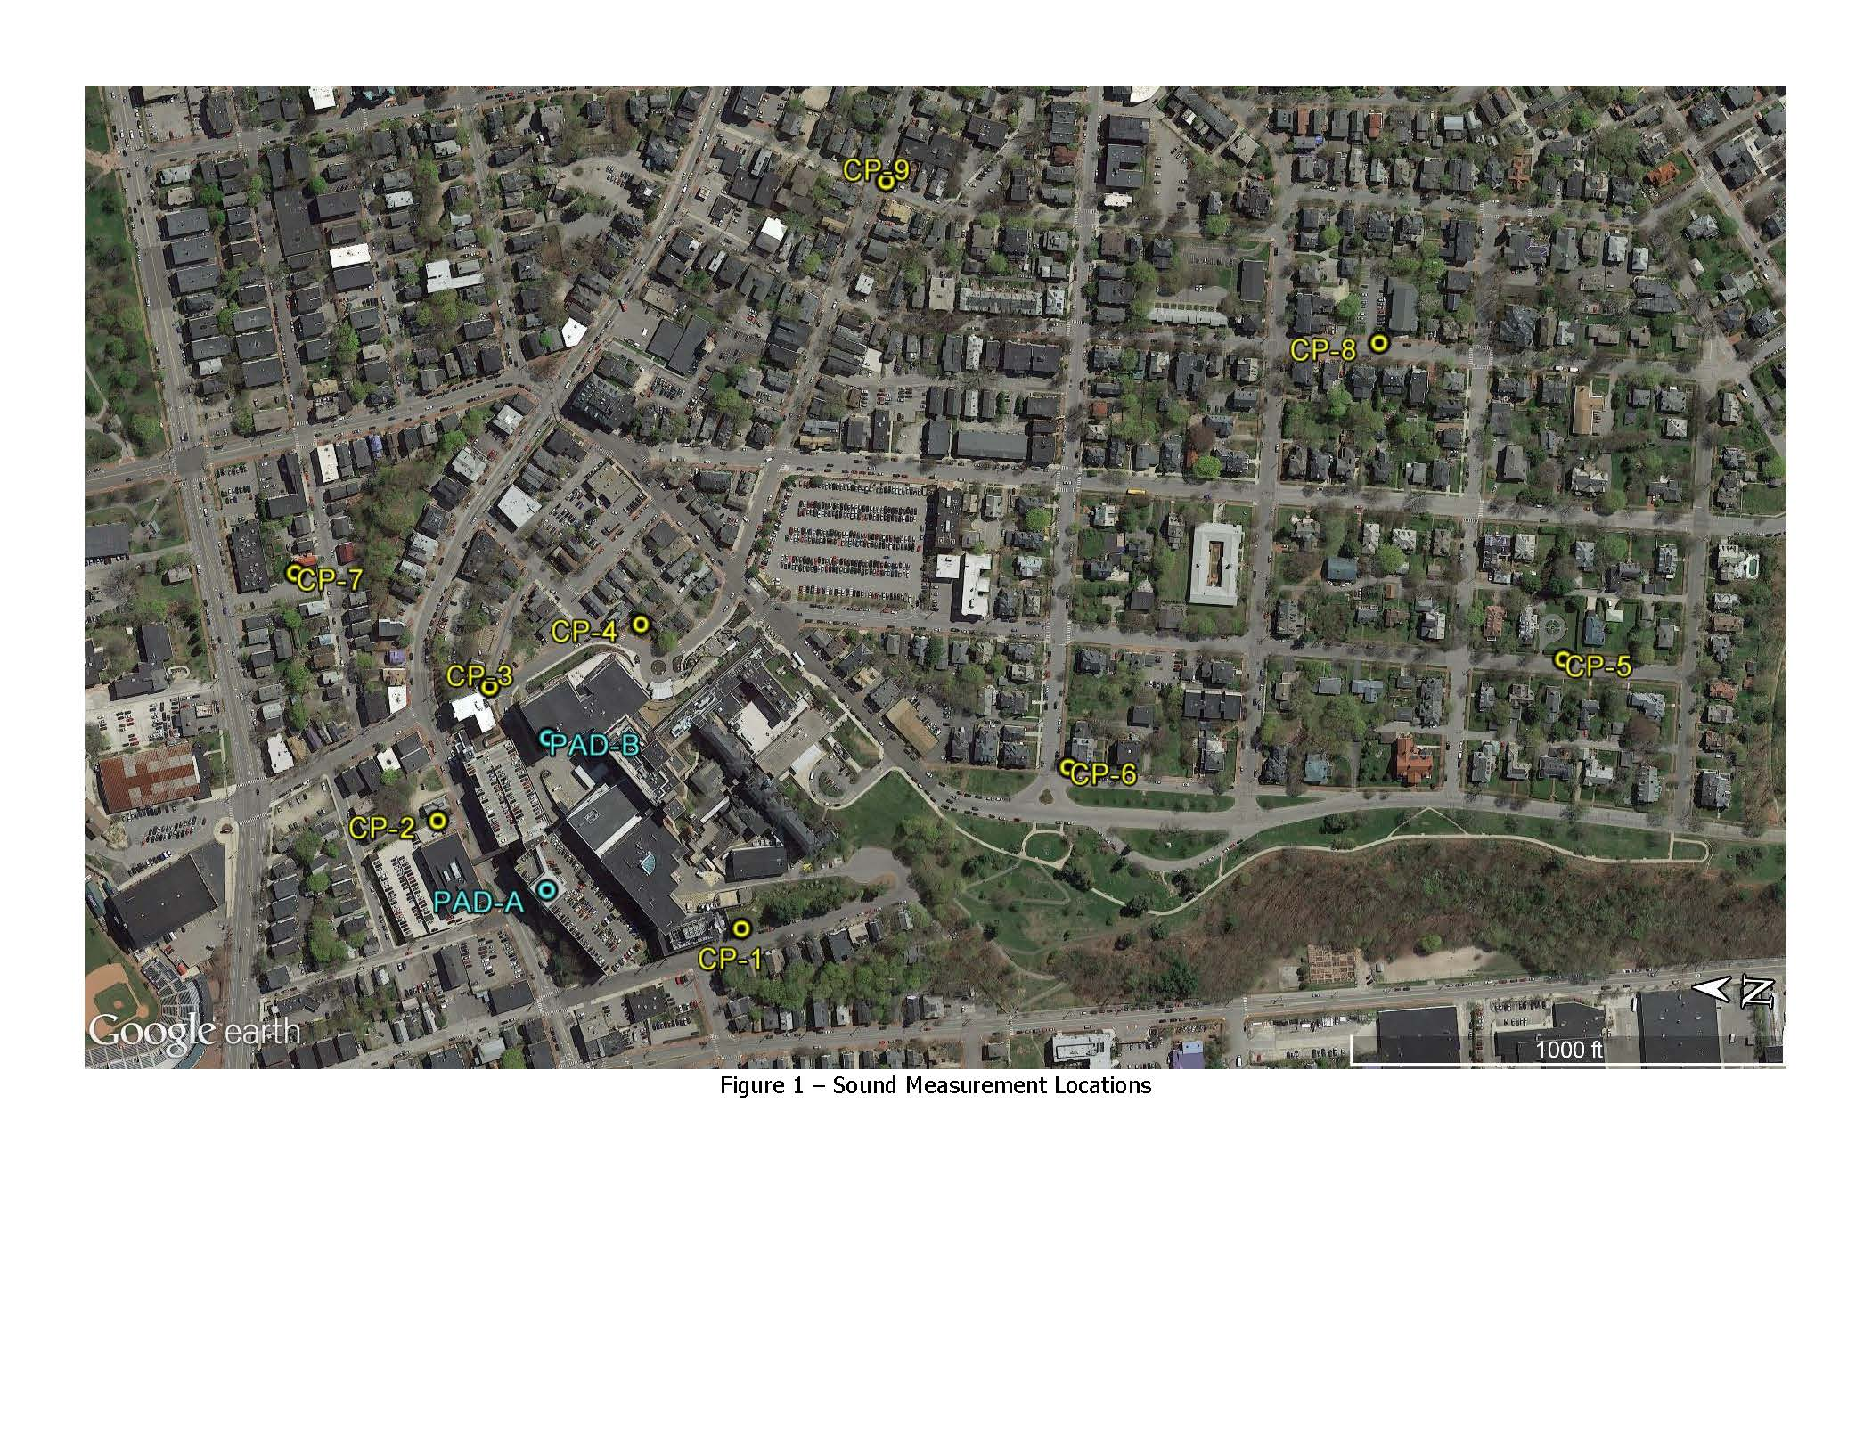Graphic A: Submitted Aerial showing original (2004) Study points and the approx. location of the existing and proposed helipads

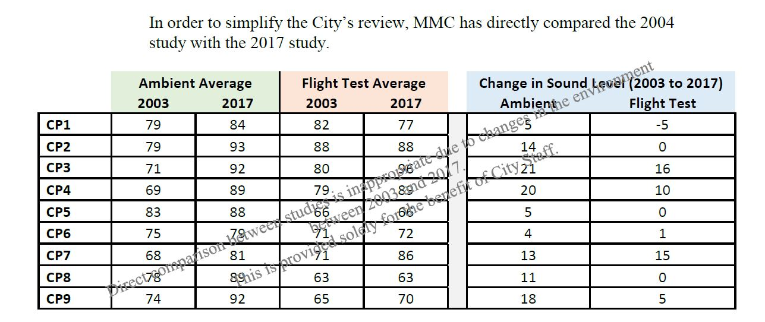Graphic B: Extract from MMC 2.22.18 “Heliport Comment Responses” (Study Points (CP1 etc) relate to the aerial above)