



**PLANNING BOARD REPORT**

**PORTLAND, MAINE**

**MMC East Tower and Visitor Garage Vertical Expansion and Relocation of Helipad**

**22 Bramhall Street**

**Level III Site Plan**

**Project # 2017-289**

**Maine Medical Center, Applicant**

|  |  |
| --- | --- |
| Submitted to Portland Planning Board:  Public Hearing Date: March 27, 2018 | Prepared by: Jean Fraser  Date: March 23, 2018 |

1. **INTRODUCTION**

Maine Medical Center has requested a final review of its Level III Site Plan application for vertical extensions to the existing East Tower (two stories; approx. 60,000 sq ft) and to the existing Visitor’s Garage on Congress Street (3 stories to provide an additional 225 parking spaces). The applicant has confirmed that the application and review does not include the Central Utility Plant.

It is understood that the 64 single-occupancy bedrooms will not add patient capacity as they would allow existing double-occupancy patient rooms elsewhere to be single-occupancy.

The application is the first of three Site Plan applications associated with the short-term MMC expansion plans. The proposals follow on from the City’s recent adoption of an MMC Institutional Overlay Zone and the associated Institutional Development Plan and Regulatory Framework (both attached to this Memo). The review includes aspects of the MMC IOZ Regulatory Framework that required action at the time of the first site plan (TDM and Signage Plans).

The first Workshop was held on 1.23.18 and addressed the following topics: (see – add link)

* Design, including Street Activation
* Helipad
* Construction Management Plan overview, plus East Tower

The second Workshop was held on 2.27.18 and focused on the following topics: (see – add link)

* Construction Management Plan and associated Traffic Control (Detour) Plans
* Design Update
* Utilities including stormwater and wastewater capacity

Applicant: Maine Medical Center; Alexander Green, Director of system Planning and Regulatory Compliance

Agent and Engineer: Sebago Technics Inc

Architect: Perkins + Will; Jeffrey Keilman, Senior Project Manager, Senior Associate

Required Reviews:

|  |  |
| --- | --- |
| *Applicant’s Proposal* | *Applicable Standards* |
| Addition of 60,940 sq ft to the East Tower; addition of 77,021 sq ft to the Visitor Garage | Level III Site Plan Review 14-526 |
| Additions that would increase height; helipad | MMC IOZ Regulatory Framework |

Waiver Requests: None identified at this time.

1. **PUBLIC COMMENTS**

This Hearing was noticed to XXX neighbors and interested parties and advertised in the March 19th and 20th 2018 editions of the *Portland Press Herald.* The Planning Division previously received two public comments raising concerns mainly related to the proposed construction detour. The *Detour Presentation* (Attachment X) explains the detour options considered and the basis for the proposals.

1. **PROJECT DATA**

|  |  |  |
| --- | --- | --- |
| ***SUBJECT*** | ***DATA for EAST TOWER*** | ***DATA for VISITORS GARAGE*** |
| **Existing Zoning** | IOZ | |
| **Existing Use** | Hospital | Hospital parking garage |
| **Proposed Use** | Hospital- adding single rooms for 64 patient beds | Hospital parking garage – 3-story addition for 225 parking spaces |
| **Parcel Size** | 12.52 acres | |
| **Impervious Surface Area**  **--Existing**  **--Proposed**  **--Net Change** | 415,220 sq ft  0 sq ft  0 sq ft | 415,220 sq ft  0 sq ft  0 sq ft |
| **Total Disturbed Area** | 0 | 0 |
| **Building Footprint**  **--Existing**  **--Proposed**  **--Net Change** | 30,470 sq ft  0 sq ft  0 sq ft | 25,674 sq ft  0 sq ft  0 sq ft |
| **Building Floor Area**  **--Existing**  **--Proposed**  **--Net Change** | 152,350 sq ft  213,290 sq ft  60,940 sq ft | 200,000 sq ft  277,021 sq ft  77,021 sq ft |
| **Parking Spaces**  **--Existing**  **--Proposed**  **--Net change**  **--# of handicapped spaces** | 2,328 (entire campus)  2,553  225  6 | |
| **Bicycle parking Spaces**  **--Existing**  **--Proposed**  **--Net change** | 193 (entire campus)  0  0 | |
| **Estimated Cost of the Project** | TBD | |

1. **PLANNING BOARD WORKSHOPS - SUMMARY OF ISSUES AND COMMENTS**

The following table summarizes the PB comments and the responses:

|  |  |
| --- | --- |
| **PB comment** | **Response** |
| Design - comments regarding the East Tower such as:   * Looks like new building on top; Looks glaringly institutional; Seeking more cohesive- more integration * Would like more info on how the white wall of the ET expansion will relate to other new buildings * Would like to see renderings with other colors (?silver)/options for Board to consider | Staff met with MMC on several occasions to better understand the options that were considered and the constraints.  The applicant submitted a “*Design Review Update*” (WS Q -2 2.23.18) and amplified on this at the second Workshop (Presentation x) AND ewcently submitted WS Q -3 *Design Review Update 3.22.18* to clarify the design process and respond to comments. |
| Would like to see details of visitor garage fencing and other fall protection | Included in “*Design Review Update*” (WS Q -2 2.23.18 under Second Workshop Applicants Submittal) |
| How is MMC addressing the loss of parking in visitors garage while under construction | Displaces visitors parking spaces will be relocated into employee garage. Access to visitors garage will be via the employee garage during construction. |
| What upgrading is planned for retail units under garage? | Fitting out for Turners but will anticipate future retail uses. |
| Interested in the 2-way Park Avenue option | Discussed a large “check -in” meeting between staff and MMC and concluded that this was too complicated to do safely and correctly in the time available (would need to be designed and implemented by May 8). |
| Disappointed not relating the buildings better to local streets to be part of neighborhood | No further information submitted. |
| Parking garage needs more visual interest – more creative way that doesn’t reinforce massing | The applicants have advised staff that the overbuild on the Visitors Garage will incorporate an extension to the existing grid design cladding above the top level so it overlaps the fencing at the top level. |
| NEED TO ADD ANY NEW COMMENTS FROM SECOND WORKSHOP |  |

1. **SITE AND CONTEXT**

The approved Institutional Development Plan (IDP) (Attachment 4.) provides information regarding the hospital site and its development over the years, along with context information. Photographs of the existing buildings (to be expanded) are included below.

1. **PROPOSALS**

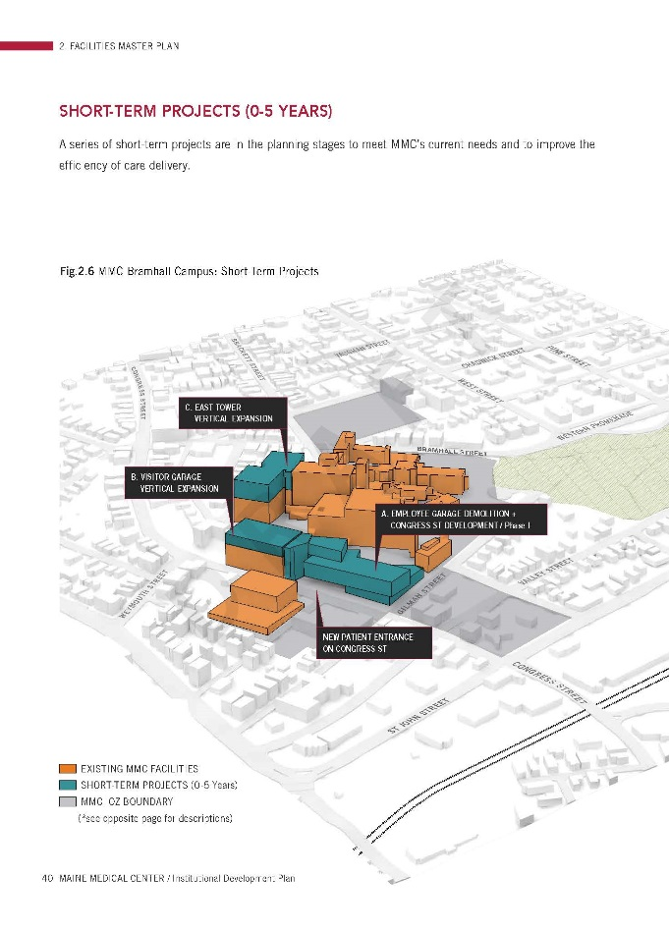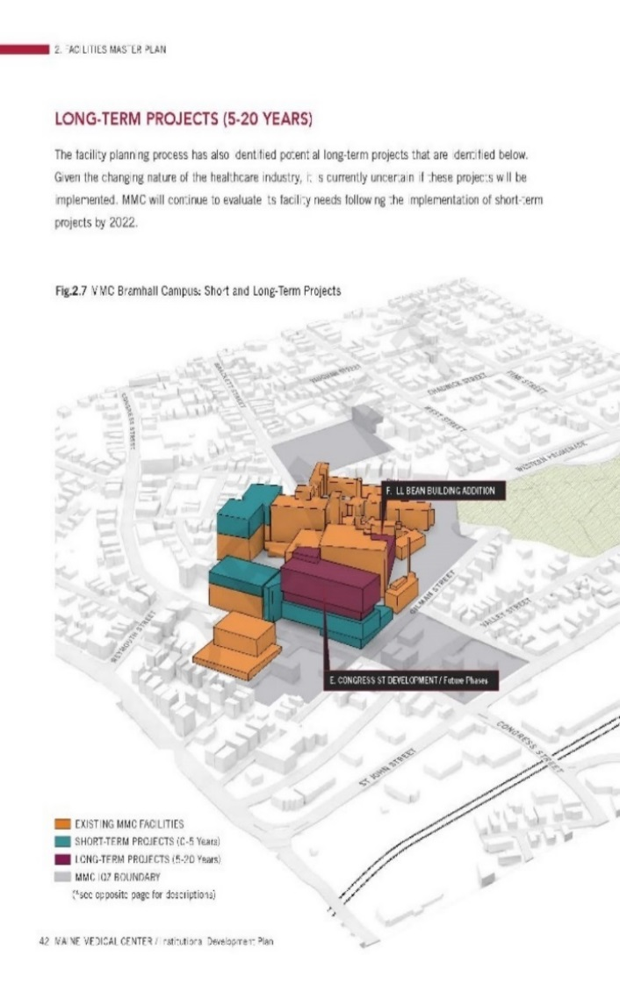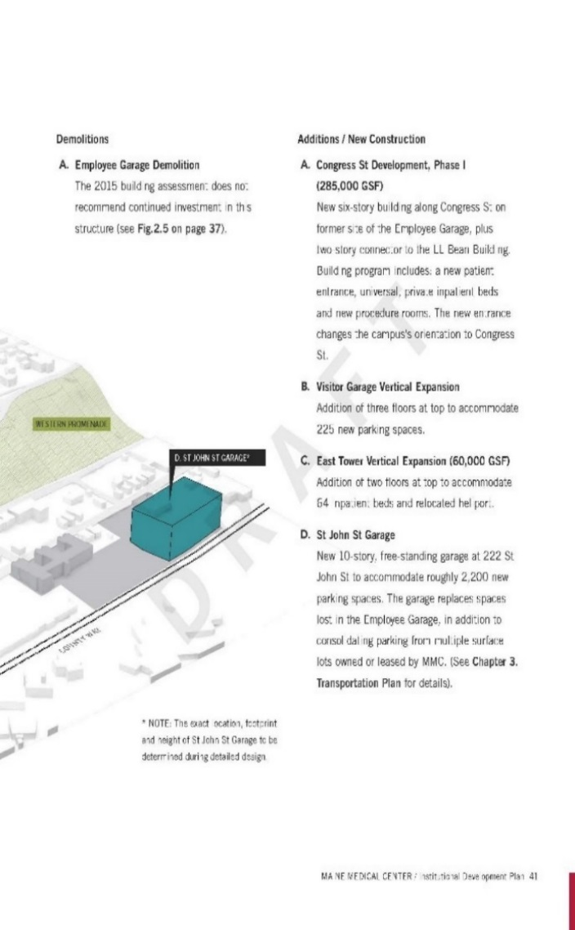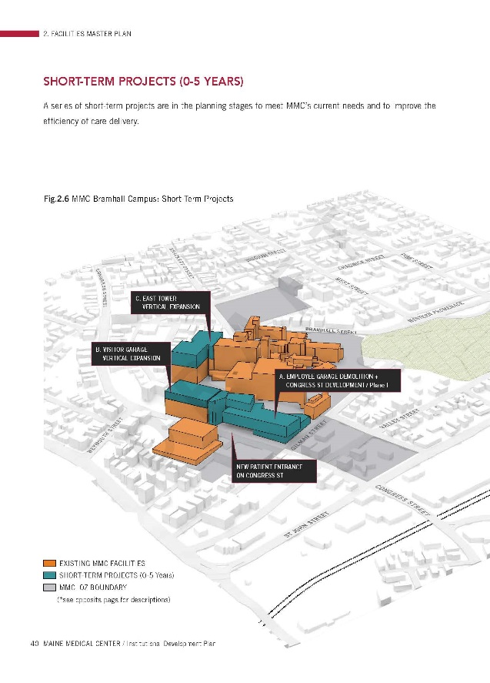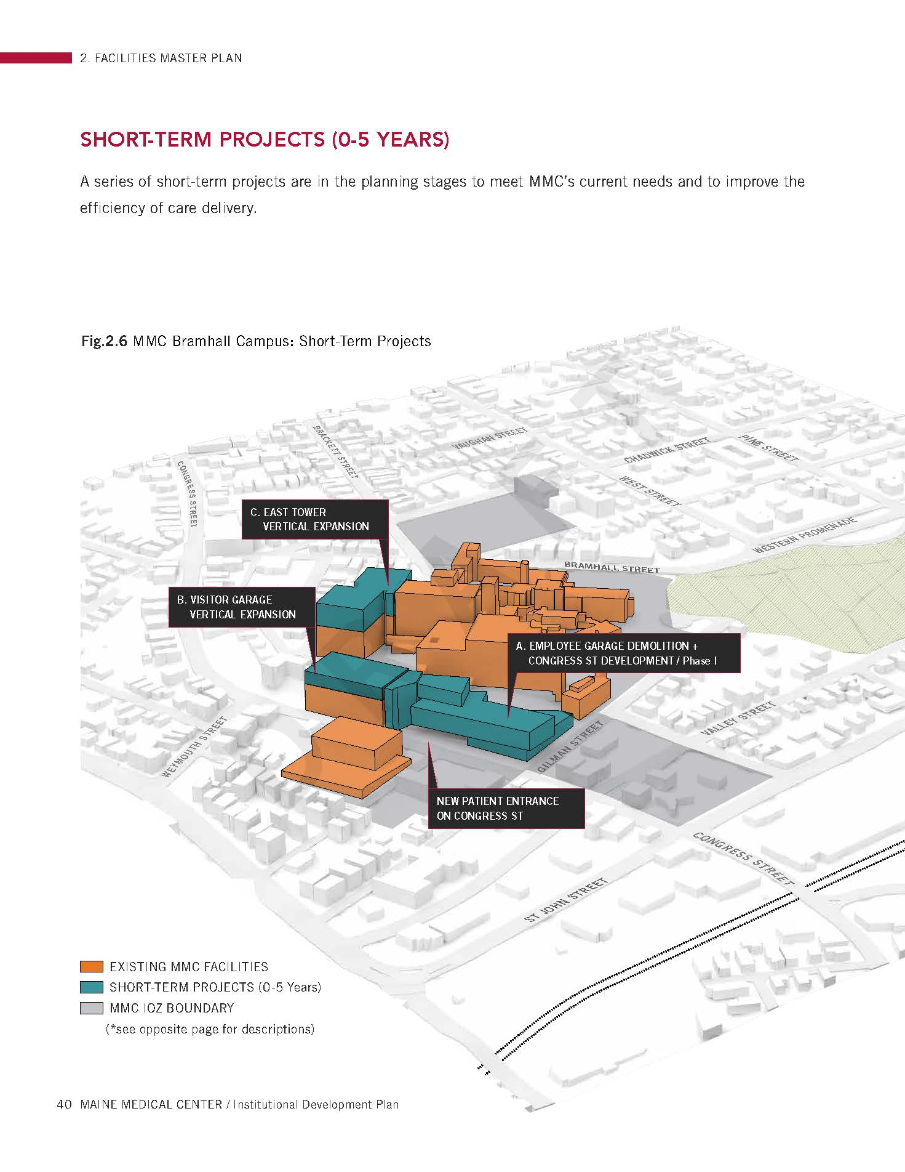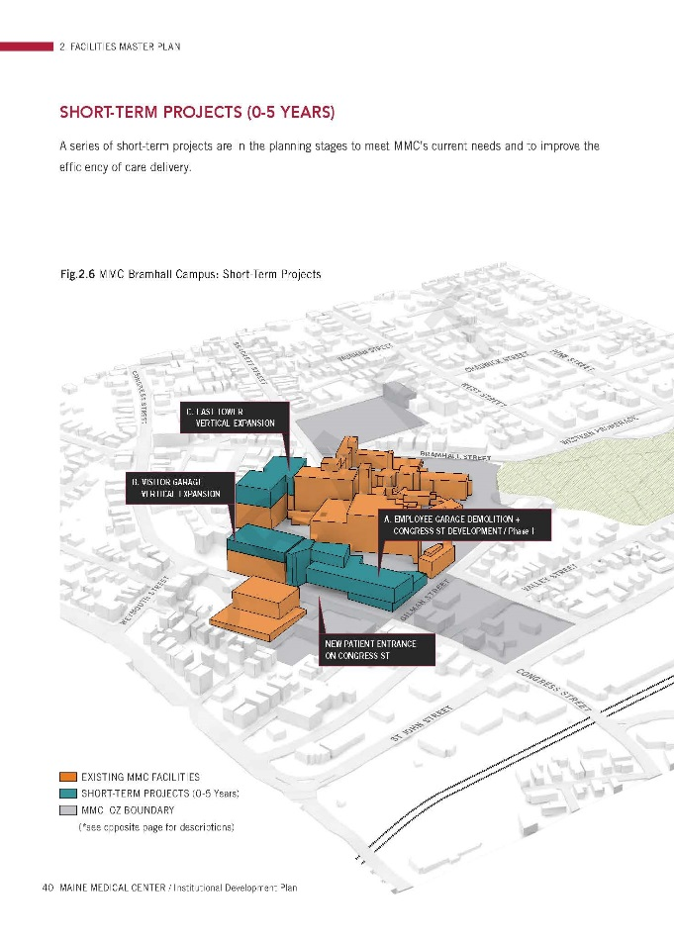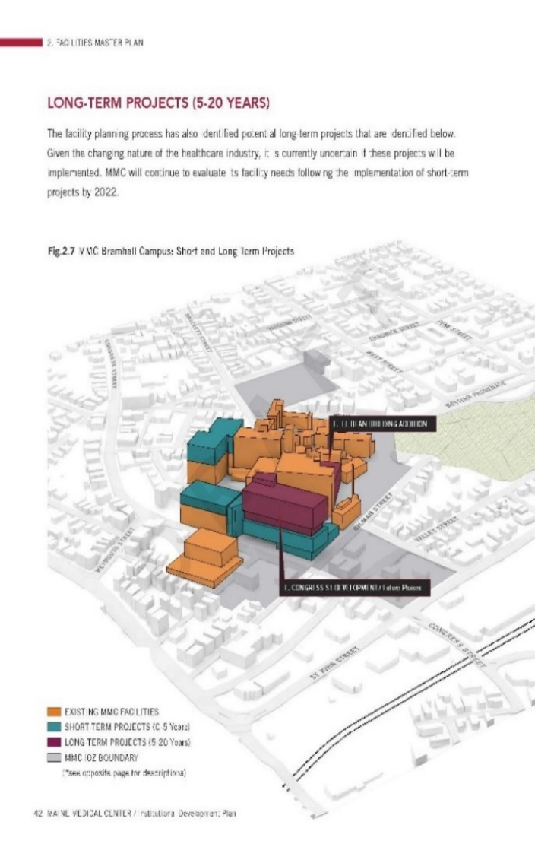

The submissions include a description of the proposals and plans and graphics of the proposed “overbuild”. The graphic to right is extracted from the IDP in Att.4 (pages 44/45)

*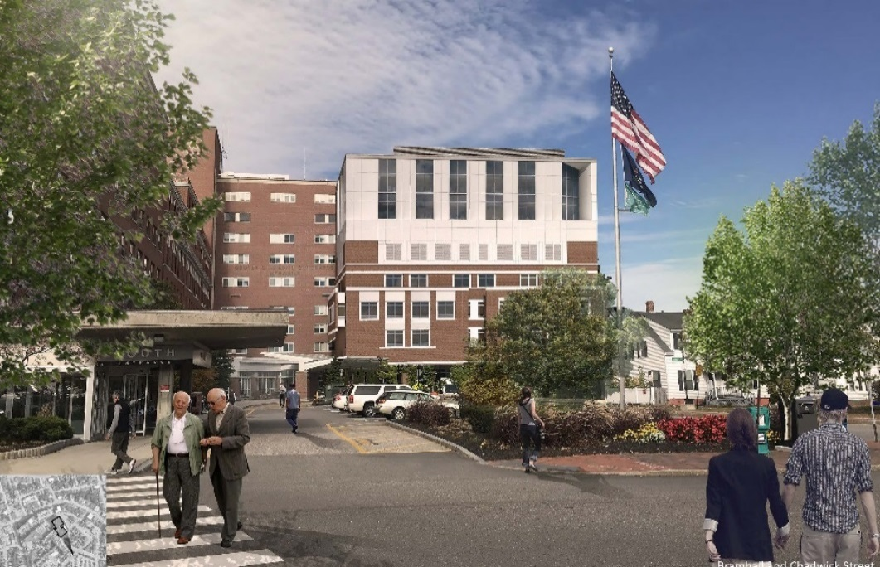***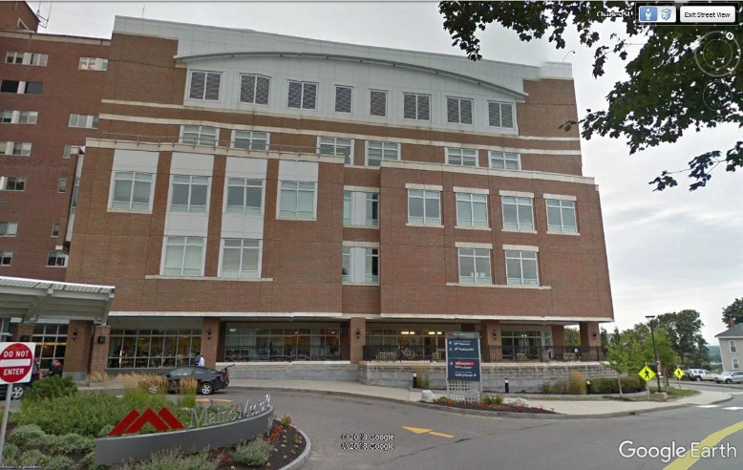East Tower: Addition of two floors (64 patient rooms, single-occupancy):**

*Existing from south Proposed, comparable rendering (see WSQ – 1)*

**Visitor Garage: 3 additional floors of parking spaces:**  (renderings not submitted)

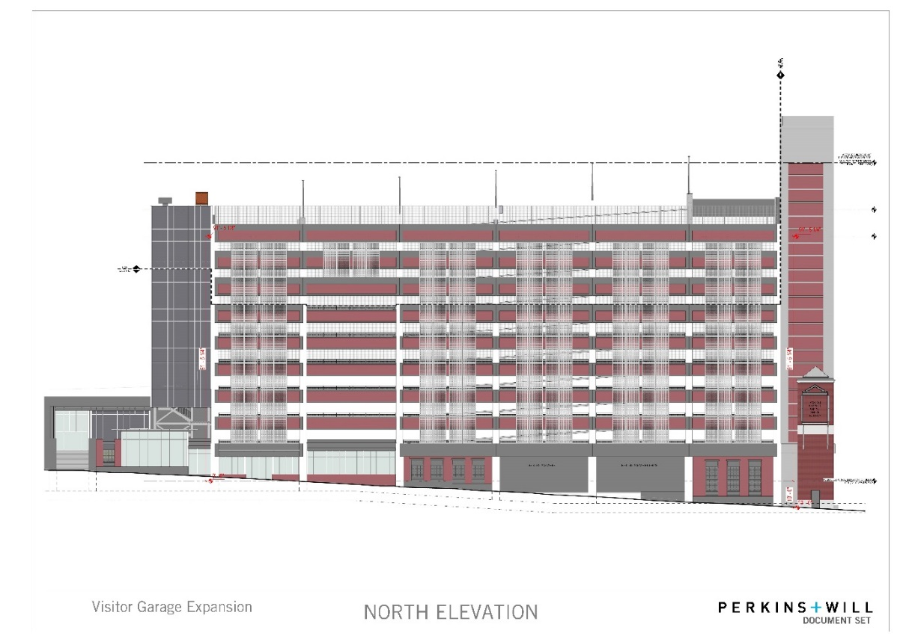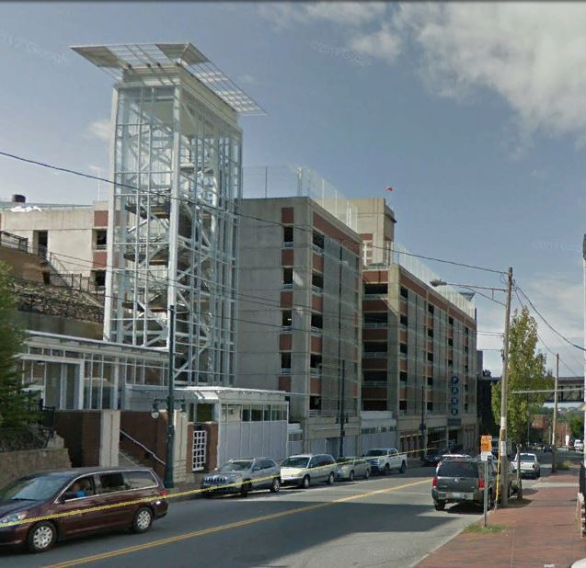

*Existing as viewed looking west Proposed west elevation*

1. **RIGHT, TITLE, & INTEREST**

The applicant has provided a XXX as evidence of Right, Title & Interest in Attachment X

*Land Transfers ref submitted “recording plats”:* The original submission included two “recording plats” that identified street transfers and discontinuances that relate to the two buildings under review. After some research, staff agree that these do not require Planning Board action, but suggest a condition of approval that requires completion of any necessary procedural steps by the time of a CO for East Tower and Visitors Garage overbuild.

1. **FINANCIAL & TECHNICAL CAPACITY**

A financial letter from xxx, dated xxx, was submitted to demonstrate ability to complete the project.

1. 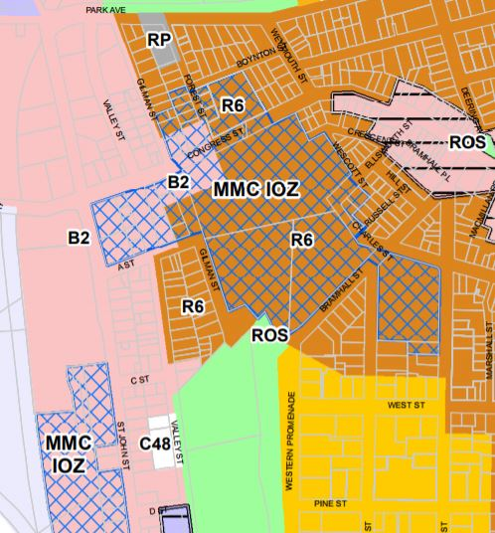**SITE PLAN SUBMISSION REUIREMENTS**

**9NEEDS REFERENCE TO Site plan reuirement for stagte and fed permits to be obtained, refers to recent FAA narrative and helipad FAA application, and then refer to the condiiong.**

1. **ZONING ANALYSIS and REVIEW**

***Overview***

The zoning map at right shows the recently adopted MMC IOZ in blue cross hatch:

The MMC IOZ *Regulatory Framework* (Attachment 5) is the zoning ordinance that applies to the proposed site plan projects; this was reviewed by the Planning Board in early 2017 and adopted by the City Council in December 2017.

The proposed additions to the East Tower and the Visitors Garage were included in the IDP background material for the zoning amendment, and the proposals now subject to this site plan review are consistent with what was discussed during that review.

Table 1 below summarizes the *Regulatory Framework* provisions that apply to the current review and includes staff comments:

**THE YELLOW NEEDS TO BE REDRAFTED TO TIE INTO THE CONDITIONS OF APPROVAL**

***TABLE 1 RELEVANT EXTRACTS FROM MMC IOZ REGULATORY FRAMEWORK (entire document is in Att. 5)***

|  |  |  |
| --- | --- | --- |
| ***MMC IOZ Regulatory Framework provisions*** | ***MMC Site Plan submissions to address the RF provisions*** | ***Staff Review Comments for Hearing*** |
| **(c) Uses:**  Note under list:  1. Mixed Uses: In recognition that Maine Medical Center is part of a mixed-use area of the City, with important existing services and businesses that serve the local and wider community, healthcare facility development fronting onto Congress Street and St. John Street shall activate the public realm, to the extent able, with uses such as service and retail/restaurant, landscaping, active building entrances, pocket parks, etc., on the ground or other publicly accessible level, consistent with the design intent contained in the approved Institutional Development Plan (IDP). In areas identified in the IDP as “Priority zone for commercially oriented/retail uses,” usable ground floor retail, restaurant, or comparable community-oriented use that provides services to local residents and employees both during the day and evening hours is required. In areas labeled “Street activation through location of windows, entrances, etc.,” usable ground floor retail, restaurant, or community oriented use is encouraged to the extent practicable. Such uses, where constructed or facilitated as part of a healthcare related development, are expressly permitted whether ancillary or supporting the healthcare facility or not, and shall be open and welcoming to the general public in addition to employees or visitors of Maine Medical Center. | The current submission does not include proposals for the existing empty retail units along the base of the Visitors Garage.  It is understood from meetings that Turner Construction will be fitting out these units so that the film will be removed & new infra-structure (eg bathrooms) will be designed to anticipate future retail use. This has not been confirmed in the written submissions. | Staff consider that the entire building is subject to the review and therefore MMC needs to develop strategies to address any “blank walls’ along Congress Street in accordance with the *Regulatory Framework* and the IDP Design Guidelines/Fig 5.15 re Street Activation (p117 of IDP in Att. 4 to this Memo)  Use of these units by Turners as a construction base is welcomed; confirmation of this and the longer term intention was requested for the final submission.  The final submissions do not appear to have addressed this issue and staff recommend the following condition of approval:  *That the applicant shall submit a strategy ensuring the space on Congress Street beneath the Visitors Garage is occupied as soon as Turners vacates the space, to be coordinated with the Pedestrian Network Plan subject of condition X above; such strategy to be submitted for review and approval prior to the issuance of a certificate of occupancy for the Visitors Garage.* |
| **(d) Dimensional Requirements - Maximum Building Height:**  East Tower: 150 feet (the IDP indicated a future height of 141 ft including helipad) | Submitted proposals indicate a height of just over 146 ft but part of the helipad appears to be higher | Clarification required as to helipad height compared to the average grades identified in the IDP.  Additional information received; it confirms height including the helipad is 142 feet |
| **(d) Dimensional Requirements - Maximum Building Height:**  Visitors Garage: 125 feet (the IDP indicated a future height of 119 ft) | Submitted proposals indicate a height of 119 ft excluding part of the stair tower | Appears to meet dimensional requirements as stair and elevator overruns are considered appurtenances.  Additional information received: it confirms height is 119 feet |
| **(d) Dimensional Requirements - Transition Zones** – none at these locations | N/A | N/A  N/A |
| **(d) Dimensional Requirements - Setbacks:**  East Tower - 20 ft  Visitors Garage - up to 40 ft | N/A | N/A  N/A |
| **(e) Design**  New buildings within the IOZ shall adhere to the Design Guidelines set forth in Chapter 5: Design of the IDP and the site plans standards of the City of Portland. | MMC submitted two architectural narratives (design updates) and presented additional information at the workshops. | The Design review comments for the workshops have amplified on issues raised by the Planning Board; the final Design Review memo (Attachment X) acknowledges the limitations outlined by MMC and also notes that the increased height for the grid cladding on the Visitors Garage helps address earlier concerns. |
| **(f) Signs:**  1. At the time of first site plan review following IDP approval, a unified campus-wide Signage Plan shall be submitted for review and approval by the Planning Authority. Any update to such plan due to a change in name or logo shall not require amendment to the IDP.  2. Signs shall be designed in accordance with the campus-wide Signage Plan. All signs shall be designed in proportion and character with building facades and adjacent street typology. All signs shall be coordinated with the building and landscaping design and be constructed of appropriate permanent, high quality materials and finishes. | The applicant has submitted the Signage Plan (Plan 11) that illustrates how the existing signage fits into the campus. The current proposals for the East Tower and Visitors Garage do not necessitate any additional signage, so this plan comprises the current Signage Plan. | Staff anticipate that this Strategy would be updated to take account of the signage needs of the new St Johns Garage and new hospital building (future site plans).  A potential condition of approval clarifies that in respect of the East Tower and Visitor Garage any new signage would need review and approval. |
| **(g) Transportation: (TDM)**  1. Transportation Demand Management (TDM):  a. At the time of the first site plan review following IDP approval, MMC shall submit a campus- wide TDM Plan substantially in accordance with those TDM objectives and strategies identified in the approved Institutional Development Plan. The TDM Plan may be phased into short-,mid-, and long-term actions to allow for progressive implementation over time.  b. The TDM Plan shall be designed to provide transportation choice with the goal of reducing parking demand and single-occupancy vehicle trips to and from MMC by employees and visitors.  c. The TDM Plan shall establish parking and trip reduction targets associated with the short-term (0-2 years), mid-term (2-5 years), and the long-term (5+ years), as well as a data collection plan. | The applicant submitted a TDM Plan (Att. WS S-7) on 12.15.17 and staff reviwcomments were sent on 1.24.18.  A revised TDM was submitted 2.13.18 and staff have not sent further comments and a detailed discussion was not part of the earlier workshops. | The discussions regarding the Congress Street closure and design have dominated the review, and staff consider more time was needed to discuss the TDM with MMC and determine how the TDM should address any issues arising from the next two site plans.  A TDM is both a site plan and *Regulatory Framework* requirement for the East Tower, and a condition is recommended to ensure that the Plan is revised, approved and implemented in the near future:  *That the applicant shall finalize a TDM Plan that addresses the Regulatory Framework and Site Plan requirements, for review and approval by the Planning Board within 6 months of the date of this approval.* |
| **(g) Transportation: (Parking)**  2. Parking:  a. Parking requirements in the IOZ shall be established at the time of site plan review based on a parking study that includes a campus-wide analysis of demand and supply. The parking demand study shall determine parking requirements and shall be sufficient to alleviate parking pressure on surrounding neighborhoods.  b. Parking studies developed by MMC shall integrate parking and trip reduction achievements and data contained in the TDM Plan. | A Parking Demand Study (Att WS S-8) was submitted and identifies shortfalls in both visitor and employee parking supply and elaborates on the background information in the approved IDP. The Visitor Garage proposals will temporarily remove 2 levels of parking during construction, but will result in a net increase of 225 visitor parking spaces when complete. Staff have been advised verbally that during construction the spaces in the employee garage will be re-allocated to visitors, with some employees then reallocated to other lots. | Tom Errico, City’s consultant traffic engineering reviewer, comments:  *During the construction of the Visitor parking garage, the top two floors of the existing garage will be taken out of service. The applicant should provide parking management details addressing the loss of the noted parking spaces.*  Staff recommend the following conditonbe added to the CMP condition relating to requirements:  *Provision of alternative parking for any parking displaced by the construction either on or off the MCC campus; and*  Staff note that 6 handicapped spaces are included in the 225 new spaces, and requested confirmation that this meets ADA requirements. This information does not appear to be included in the latest submissions, and staff therefore suggest the following condition of approval:  *That the final parking layout of the Visitors Garage shall meet the City’s Technical Manual Standards and all applicable State and Federal standards regarding handicap accessibility.* |
| **(h) Environment.** Development proposed by MMC shall be designed to integrate with the surrounding context, including open space and pedestrian networks and infrastructure. | Staff have requested that MMC address the use and safety of the pedetrian routes in the vicinity of the Visitor Garage and how the connections to Congress street will be maintained or redesigned. MMC have noted that there are current security issues with the route that goes along the eastern edge of the garage. | Staff appreciate that the grades and current uses present a challenge and that the surrounding pedestrian network may need to be revised in relation to the new hospital. Therefore the following condition of approval is recommended to ensure that the Visitor Garge and East Tower are part of the pedestrian networks eveloped as part of the new hospital development.  *That the applicant shall develop a long term public Pedestrian Network Plan showing the integration of the upper level MMC campus with the Congress Street corridor, including measures to address CPTED principles, for implementation when the retail units beneath the Visitors Garage are available for lease or sale; such plan to be submitted for review and approval prior to the issuance of a certificate of occupancy for the Visitors Garage.*  It should be noted that the Design Review has raised a question over the need for interim action in respect of the Congress Street access to the existing pedestrian route along the east side of the garage. |
| **(i) Mitigation measures.** MMC shall mitigate site plan impacts to off-premise infrastructure in a manner proportionate to those impacts. Mitigation may include financial or in-kind contributions to existing or planned City projects focused on mitigating the impacts of MMC development. Mitigation contribution shall be determined based on the City’s standard procedure in effect at the time of site plan review. | The submissions (XX) largely outline why the applicant considers that they do not need to make any changes to the stormwater system. The presentation to the second Workshop and associated Response ( Att. X) also outlined why there is little scope to achieve greater separation in respect of the Visitor Garage stormwater. | The DPW and Peer Engineer comments have encouraged the applicant to remove stormwater discharges from the City’s combined system in Congress Street to meet Site Plan ordinance requirements (see below) and mitigate the hospitals impacts on the system.  Discussions with MCC and their consultants explored the scope for separation and detention and DPW representative concluded that the best option was to achieve greater detention so that the Congress Street system is not overburdened by the exsiting and proposed developments; the following condition is recommended:  That the stormwater system for the MMC Bramhall Street/ Congress Street expanded campus shall add detention capacity in lieu of stormwater separation in order to reduce the burden of the existing & proposed development on the City’s infrastructure. The applicant shall set out [timetable still under discussion], the strategy & associated proposals for achieving substantial additional detention or for contributions to other measures that achieve the same objective. |
| **(k) Construction management**  1. At the time of site plan review, MMC shall submit a Construction Management Plan substantially in accordance with those construction management principles identified in the approved Institutional Development Plan for review and approval by the Planning Authority.  2. The Construction Management Plan shall include a construction schedule, as well as strategies for managing neighborhood communication and noise, air quality, traffic, and parking impacts associated with the construction as set forth on the Construction Management Template developed by the City and attached and incorporated to the IDP as Appendix A | As discussed at both of the PB Workshops, the Turners CMP and the associated Detours (ATTS XX) have been discussed with City representatives since January and broadly take account of City concerns. The *Detour Presentation* (XX) outlines how the detour routes were developed.  The *Outline Schedule* for the closure of Congress Street has been submitted (XX) along with an associated *Communications Plan* (XX) and proposals for preparing Weymouth Street for the detour traffic. | The discussion of have been constructive and the proposed conditions of approval generally address the following concerns:   * Some of the detailed proposals have not been fully set out in the submissions or only recently submitted, so the first suggested condition identifies the key aspects of the CMP/Detour that still need to be finalized. * The second potential condition confirms that the responsibilities lie with MMC and their contractors; * The third condition stresses the importance of establishing a clear communications plan so that neighbors and others impacted by the project are fully informed with impacts minimized as far as possible; * The last condition identifies the anticipated schedule and penalties for delay as based on the Peer Review comments (Kleinfelder XX) and the Police Department concerns that the end of the Congress Street closure is just before the July 4th holiday and that the impacts of any delay would be substantial. |
| **(l) Other requirements**  **1. Helipad.** MMC shall be governed by the provisions of the Helistop Overlay Zone with the following exceptions:  a. Setback requirements of Section 14-327(3); and  b. Fencing requirements of Section 14-327(4). | The applicant submitted a Sound Study (XX), further comments on 1-31-18 and a Response with data analysis (XX).  (The FAA applications were also submitted - see Site Plan discussion) | Staff do not consider that the submitted information is conclusive and recommend that a framework be developed to confirm the predicted sound impacts and provide a back up mechanism if they are not accurate. The following condition is recommended:  *That within 9 months of the date of this site plan approval the applicant shall submit a “Sound Measurement Plan” for review and approval by the Planning Authority, for assessing the actual changes in sound impacts on nearby properties between the helipad operating at the existing site and at the new location, including criteria for mitigation where such impacts are severe based on appropriate national standards. The “Sound Measurement Plan” is required in the event that the predicted sound levels are incorrect, and it shall be approved and implemented at least 2 months before the helipad is relocated* |

**XI. SITE PLAN REVIEW**

The proposed development has been reviewed by staff for conformance with the relevant review standards of the City of Portland’s site plan ordinance. Staff comments are below.

***Transportation Standards***

1. *Impact on Surrounding Street Systems, Site Access and Circulation and Loading and Servicing*

The impacts are just during construction and have been addressed in the Construction Management Plan and Detour Plans as outlined under Zoning above.

1. *Sidewalks* There are four ramps associated with crosswalks at the East tower that do not meet current standards, and the applicant is requested to replace those in a suggested condition of approval.
2. *Public Transit Access-* the proposals do not trigger this standard.
3. *Location and number of parking spaces-* see comments above under Zoning
4. *Location and number of bicycle parking*

The Transportation Program Manager has commented that the number, detailed location and design of the bike parking near the East Tower has not been documented (ATT X) and that the design of the racks currently does not meet the City’sTechnical Standards. The applicant has submitted two reponsnes to this issue (XX), but neither address the detailed location of the racks in relation to the East Tower nor the design.

Staff recommend the following condition:

*That the applicant shall submit an assessment of the existing bicycle parking near the East Tower to confirm whether it meets the City’s Technical Standards for the location, number and design of bicycle parking to serve the East Tower as expanded, and add to/relocate or replace bicycle parking as necessary to meet the standards prior to the issuance of a certificate of occupancy for the East Tower.*

1. *Transportaion Demand Management -* this is a Site Plan requirement for the Eadt Tower- see the discussion above under Zoning.
2. *Construction Management Plan* - see discussion under Zoning above.

**Environmental Quality Standards**

1. *Preservation of Significant Natural Features and Landscaping and Landscape Preservation –* not applicable to the proposal.
2. *Water Quality/Storm Water Management/Erosion Control*

The Site Plan standards apply to this development and in general it is expected that when a site plan is under review the site should meet current standards. The ordinance includes the following:

14-546 (b) (3) Env. Quality Standards “All development must demonstrate that the proposed site improvements are designed to minimize the amount of stormwater leaving the site”; 14-526 (c) (1) Consistency with City Master Plans “All developments shall be designed so as to be consistent with City Council approved master plans and facilities plans and with off-premises infrastructure, including…sewer and stormwater.

As mentioned above under Zoning, the Citys combined system along Congress street is already overburdened and the applicant is requested to pursue further stormwater separation or detention. A suggested condition is outlined under Zoning.

***Public Infrastructure and Community Safety Standards***

1. *Consistency with Related Master Plans - see above re Stormwater*
2. *Public Safety and Fire Prevention –* see the Design Review Memo which highlights a possible area where further action could be taken in the interim to reduce potential crime. The suggested condition of approval integrates the issue of CPTED with a longer term plan for pedestrian networks on the expanded campus.
3. *Availability and Capacity of Public Utilities – [CMP and Water received]*

***Site Design Standards -*** these are covered by the Zoning with the exception of the streetlights. The current street lights do not have high level lamp fixtures (see Transportaion Program Manager comments in XX) and a suggested condition of approval requires that these be upgraded in view of the increase level of activity in this corridor.

1. **STAFF RECOMMENDATION**

Subject to the proposed motions and conditions of approval listed below, Planning Division staff recommends that the planning board approve the proposed xxx

**XVI. PROPOSED MOTIONS**

1. **Development Review**

On the basis of the application, plans, reports and other information submitted by the applicant; findings and recommendations contained in the Planning Board Report for the public hearing on March 27, 2018 for application 2017-289 (Mmc East Tower And Visitors Garagage Overbuild And Relocated Helipad At 22 Bramhall Street) relevant to the site plan regulations; and the testimony presented at the planning board hearing, the planning board finds that the plan **is/is not** in conformance with the site plan standards of the land use code, subject to the following conditions of approval that must be met prior to the issuance of a building permit, unless otherwise stated:

* + ***That the applicant and its agents shall undertake all construction associated with this site plan in accordance with the CMP dated XXX and Detour Plan (MOT) dated XXX unless agreed in writing with Planning Authority, including: (the final list depends on what is in todays submissions, which are under review)***
    - ***Provision of alternative parking for any parking displaced by the construction either on or off the MCC campus; and***
    - ***Coordination with the Seadogs and other event organizers, and with METRO, to ensure safety of all users; and***
    - ***Ongoing monitoring and adjustments in consultation with city representatives***
    - ***Park and Weymouth signal should meet Maine UTCD requirements and include pedestrian accommodations, ADA compliance and have full vehicle detection***
    - ***Minor ROW adjustments such as curb radii at Boynton/Forest Streets, ADA ramps and bus stop pads***
    - ***Weymouth repave requirements***
    - ***Others***
    - ***That the applicant is solely responsible for all activities (physical modification to the ROW, monitoring, revisions to the CMP etc) associated with CMP/detour plans referred to in condition X above.***
  + ***That the applicant shall ensure that construction impacts are minimized for neighbors, including businesses, in the vicinity of the project, and implement the Communications Plan generally as outlined.***
  + ***That the applicant shall comply with the submitted Construction Schedule which confirms that Congress Street will be closed between Monday May 7th to Thursday, June 28th inclusive. If Congress Street is not open to two-way through traffic (cars and pedestrians) on June 29th, the Planning Board recommends that that penalties of $XXX/day should apply for each day of delay.***
  + ***That the stormwater system for the MMC Bramhall Street/ Congress Street expanded campus shall add detention capacity in lieu of stormwater separation in order to reduce the burden of the existing & proposed development on the City’s infrastructure. The applicant shall set out [timetable still under discussion], the strategy & associated proposals for achieving substantial additional detention or for contributions to other measures that achieve the same objective.***
  + ***That the applicant shall submit a strategy ensuring the space on Congress Street beneath the Visitors Garage is occupied as soon as Turners vacates the space, to be coordinated with the Pedestrian Network Plan subject of condition X above; such strategy to be submitted for review and approval prior to the issuance of a certificate of occupancy for the Visitors Garage.***
  + ***That any new signage relating to the East Tower or Visitors Garage shall be subject to separate site plan review by the Planning Authority prior to installation.***
  + ***That the applicant shall implement the following upgrades in the ROW:***
    - ***update the four (4) pedestrian light fixtures along the Congress Street frontage of the Visitors Garage to LED, and for each add the bracket and LED light fixture at the top of the existing poles.***
    - ***Install ADA pedestrian ramps at 4 locations where there are crosswalks near the East Tower***
  + ***That the final parking layout of the Visitors Garage shall meet the City’s Technical Manual Standards and all applicable State and Federal standards regarding handicap accessibility.***
  + ***That the applicant shall submit an assessment of the existing bicycle parking near the East Tower to confirm whether it meets the City’s Technical Standards for the location, number and design of bicycle parking to serve the East Tower as expanded, and add to/relocate or replace bicycle parking as necessary to meet the standards prior to the issuance of a certificate of occupancy for the East Tower.***
  + ***That the applicant shall submit the ability to serve letters regarding water and wastewater prior to the issuance of a building permit for the East Tower overbuild.***

**ATTACHMENTS**

First Workshop - Memo Attachments

Initial Traffic Comments

Fire Department Comments on CMP

Preliminary Design Review Comments

MMC Institutional Development Plan (IDP) as approved by PB

MMC IOZ Regulatory Framework (Ordinance 14-282) as adopted by CC

Second Workshop Memo Attachments

“Check In” meeting notes TAKE OUT AND ADD LATEST ONES; THEN PUT BELOW)

Extract from Site Plan Ordinance regarding stormwater and sewer infrastructure

City comments on submitted TDM

Peer Engineer Review comments 1.25.18 and 2.7.18

Design E-mail re further info requested

Fire Department comments

Transportation Program Manager re bike parking, lighting and ADA access in ROW

Police Department re CMP and Detours

DPW re CMP/Detours and Drainage Infrastructure

Staff clarification re relocated helipad sound analysis

Kleinfelder third party review of “constructability” and closure of Congress Street

Hearing Report Attachments

17. Peer Engineer Review comments 3.21.18

18. URBAN DESIGNER

Public comments

PC-1 Pringle 1.23.18

PC-2 Beever 2.27.18

First Workshop Applicants Submittal (numbering as per applicant)

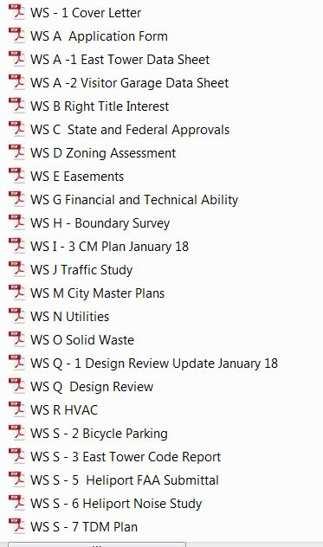

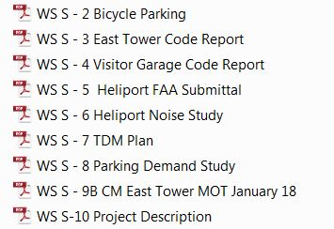

Second Workshop Applicants Submittal (numbering as per applicant)

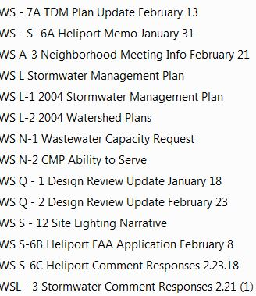

HEARING APPLICANTS SUBMITTAL (numbering as per applicant)

WS L – 4 Stormwater Comment Response Letter

WS N – 3 PWD Ability to Serve

WS Q – 3 Design Review Update 3.22.18

WS S – 6D FAA Submissions 3.22.18

WS S – 13 PB Workshop Presentation 2.27.18

WS S – 14 Bike Parking

WS S – 14 Maine Biz Article 3.5.18

First Workshop Plans (numbering as per applicant)

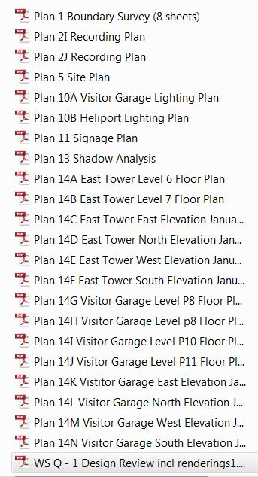

Second Workshop Plans

a. CMP/Detours

C:\Users\jf\Desktop\Capture 2.JPG

* + - * 1. 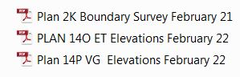 Other Plans

HEARING PLANS

1. CMP/Detours
   1. Detours Presentation v5
   2. MFP Communications Strategy
   3. WS 1 – 6 CM Plan 3.21.18
   4. WS S – 9E MOT Update 3.21.18
   5. Congress Street Closure Implementation Schedule 3.12.18
   6. WS S – 15A Weymouth St. Repairs
2. OTHER NONE???