**ATTACHMENTS**

First Workshop - Memo Attachments

Initial Traffic Comments

Fire Department Comments on CMP

Preliminary Design Review Comments

MMC Institutional Development Plan (IDP) as approved by PB

MMC IOZ Regulatory Framework (Ordinance 14-282) as adopted by CC

Second Workshop Memo Attachments

“Check In” meeting notes through Feb 15, 2018

Extract from Site Plan Ordinance regarding stormwater and sewer infrastructure

City comments on submitted TDM

Peer Engineer Review comments 1.25.18 and 2.7.18

Design E-mail re further info requested

Fire Department comments

Transportation Program Manager re bike parking, lighting and ADA access in ROW

Police Department re CMP and Detours

DPW re CMP/Detours and Drainage Infrastructure

Staff clarification re relocated helipad sound analysis

Kleinfelder third party review of “constructability” and closure of Congress Street

Hearing Report Attachments

17. Peer Engineer Review comments 3.21.18

18. URBAN DESIGNER

19 Updated CEhck in Meeting notes

Public comments

PC-1 Pringle 1.23.18

PC-2 Beever 2.27.18

First Workshop Applicants Submittal (numbering as per applicant)

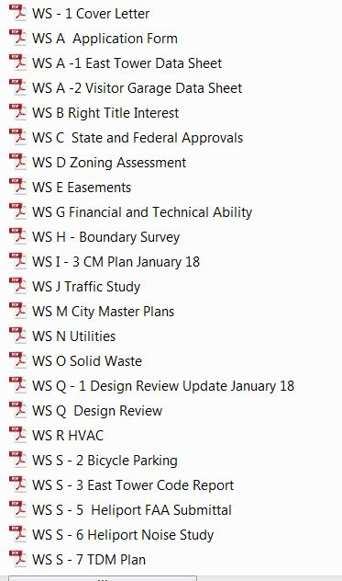

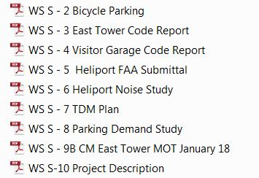

Second Workshop Applicants Submittal (numbering as per applicant)

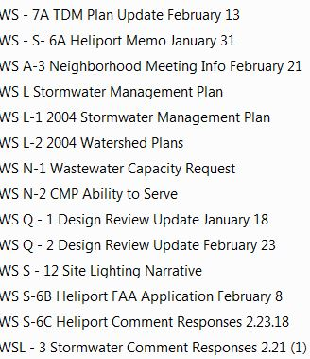

HEARING APPLICANTS SUBMITTAL (numbering as per applicant)

WS L – 4 Stormwater Comment Response Letter

WS N – 3 PWD Ability to Serve

WS Q – 3 Design Review Update 3.22.18

WS S – 6D FAA Submissions 3.22.18

WS S – 13 PB Workshop Presentation 2.27.18

WS S – 14 Bike Parking

WS S – 14 Maine Biz Article 3.5.18

First Workshop Plans (numbering as per applicant)

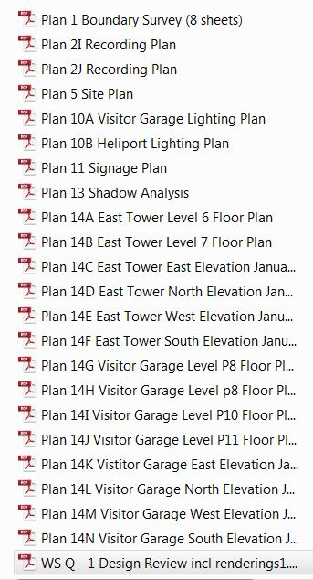

Second Workshop Plans

a. CMP/Detours

Capture 2

* + - * 1. 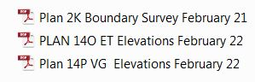 Other Plans

HEARING PLANS

1. CMP/Detours
   1. Detours Presentation v5
   2. MFP Communications Strategy
   3. WS 1 – 6 CM Plan 3.21.18
   4. WS S – 9E MOT Update 3.21.18
   5. Congress Street Closure Implementation Schedule 3.12.18
   6. WS S – 15A Weymouth St. Repairs
2. OTHER NONE???