**ATTACHMENTS**

**Folder – First Workshop- January 23, 2018**

**MMC (Memo)**

**MMC (Applicants Submittal) MMC (Site Plans)**

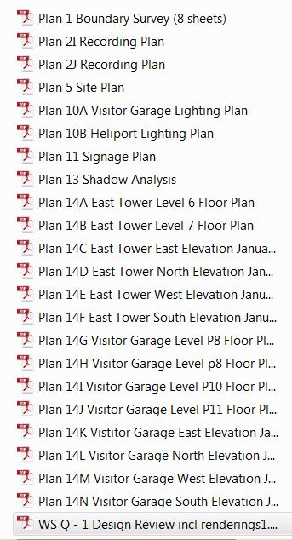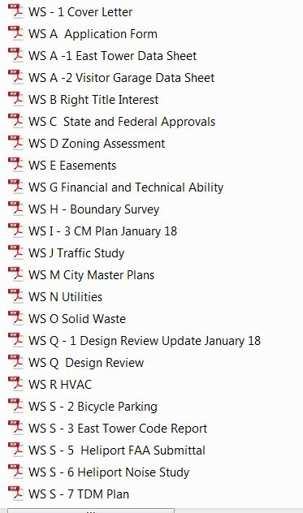

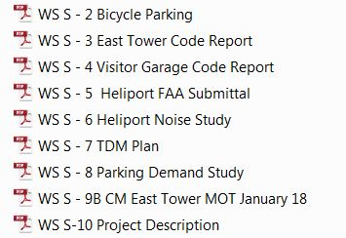

**Folder – Second Workshop- February 27, 2018**

**MMC (Memo)**

**MMC (Applicants Submittal) MMC (Plans)**

1. 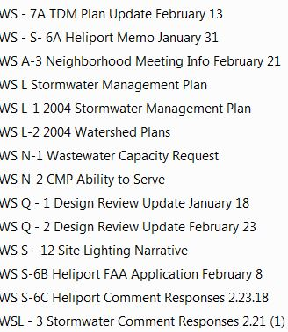 CMP/Detours

Capture 2

1. Other Plans

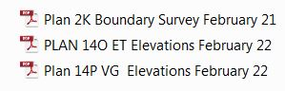

**Public Hearing Attachments – March 27, 2018**

Initial Traffic Comments

Fire Department Comments on CMP

Preliminary Design Review Comments

MMC Institutional Development Plan (IDP) as approved by PB

MMC IOZ Regulatory Framework (Ordinance 14-282) as adopted by CC

“Check In” meeting notes through Feb 15, 2018

Extract from Site Plan Ordinance regarding stormwater and sewer infrastructure

City comments on submitted TDM

Peer Engineer Review comments 1.25.18 and 2.7.18

Design E-mail re further info requested

Fire Department comments

Transportation Program Manager re bike parking, lighting and ADA access in ROW

Police Department re CMP and Detours

DPW re CMP/Detours and Drainage Infrastructure

Staff clarification re relocated helipad sound analysis

Kleinfelder third party review of “constructability” and closure of Congress Street

Peer Engineer Review comments 3.21.18

URBAN DESIGNER

Updated CEhck in Meeting notes

Public comments

PC-1 Pringle 1.23.18

PC-2 Beever 2.27.18

HEARING APPLICANTS SUBMITTAL (numbering as per applicant)

WS L – 4 Stormwater Comment Response Letter

WS N – 3 PWD Ability to Serve

WS Q – 3 Design Review Update 3.22.18

WS S – 6D FAA Submissions 3.22.18

WS S – 13 PB Workshop Presentation 2.27.18

WS S – 14 Bike Parking

WS S – 14 Maine Biz Article 3.5.18

HEARING PLANS

1. CMP/Detours
   1. Detours Presentation v5
   2. MFP Communications Strategy
   3. WS 1 – 6 CM Plan 3.21.18
   4. WS S – 9E MOT Update 3.21.18
   5. Congress Street Closure Implementation Schedule 3.12.18
   6. WS S – 15A Weymouth St. Repairs
2. OTHER NONE???