Memorandum
Planning and Urban Development Department
Planning Division

To: Sean Dundon, Chair and Members of the Portland Planning Board
From: Jean Fraser, Planner
Date: February 23, 2018
Re: MMC East Tower and Visitor Garage Vertical Expansion
22 Bramhall Street
Maine Medical Center (MMC)
Project #: 2017-289 CBL: 053D007/054H001/064C001
Meeting Date: February 27, 2018 (Second Workshop)
- INTRODUCTION
This is the second Workshop held to consider the preliminary Level III Site Plan application from Maine Medical Center (MMC) which proposes to extend the existing East Tower vertically by two stories (approx. 60,000 sq ft) to accommodate 64 single-occupancy inpatient beds, and to extend the existing Visitor’s Garage on Congress Street by 3 stories vertically to provide an additional 225 parking spaces. The applicant has confirmed that the application and review does not include the Central Utility Plant.

It is understood that the 64 single-occupancy bedrooms will not add patient capacity as they would allow existing double-occupancy patient rooms elsewhere to be single-occupancy.

The application is the first of three Site Plan applications associated with the short-term MMC expansion plans. The proposals follow on from the City’s recent adoption of an MMC Institutional Overlay Zone and the associated Institutional Development Plan and Regulatory Framework (both attached to this Memo). The review includes aspects of the MMC IOZ Regulatory Framework that required action at the time of the first site plan (TDM and Signage Plans).

This first Workshop was held on 1.23.18 and addressed the following topics:
- Design, including Street Activation
- Helipad
- Construction Management Plan overview, plus East Tower

This second Workshop will focus on the following topics:
- Construction Management Plan and associated Traffic Control (Detour) Plans
- Design Update
- Utilities including stormwater and wastewater capacity
- Other Updates eg helipad

Applicant: Maine Medical Center; Alexander Green, Director of system Planning and Regulatory Compliance
Agent and Engineer: Sebago Technics Inc
Architect: Perkins + Will; Jeffrey Keilman, Senior Project Manager, Senior Associate

Required Reviews:
Applicant’s Proposal | Applicable Standards
Addition of 60,940 sq ft to the East Tower; addition of 77,021 sq ft to the Visitor Garage | Level III Site Plan Review 14-526
Additions that would increase height; helipad | MMC IOZ Regulatory Framework

Waiver Requests: None identified at this time.

- PROJECT DATA
SUBJECT | DATA for EAST TOWER | DATA for VISITORS GARAGE
Existing Zoning | IOZ
Existing Use | Hospital | Hospital parking garage
Proposed Use | Hospital- adding single rooms for 64 patient beds | Hospital parking garage – 3-story addition for 225 parking spaces
Parcel Size | 12.52 acres
Impervious Surface Area  --Existing  --Proposed  --Net Change | 415,220 sq ft  0 sq ft  0 sq ft | 415,220 sq ft  0 sq ft  0 sq ft
Total Disturbed Area | 0 | 0
Building Footprint  --Existing  --Proposed  --Net Change | 30,470 sq ft  0 sq ft  0 sq ft | 25,674 sq ft  0 sq ft  0 sq ft
Building Floor Area  --Existing  --Proposed  --Net Change | 152,350 sq ft  213,290 sq ft  60,940 sq ft | 200,000 sq ft  277,021 sq ft  77,021 sq ft
Parking Spaces  --Existing  --Proposed  --Net change  --# of handicapped spaces | 2,328 (entire campus)  2,553  225  6
Bicycle parking Spaces  --Existing  --Proposed  --Net change | 193 (entire campus)  0  0
Estimated Cost of the Project | TBD

- First Planning Board workshop 1.23.2018
The following table summarizes the PB comments and the responses to date:

PB comment | Response
Design - comments regarding the East Tower such as:  - Looks like new building on top; Looks glaringly institutional; Seeking more cohesive- more integration  - Would like more info on how the white wall of the ET expansion will relate to other new buildings  - Would like to see renderings with other colors (?silver)/options for Board to consider | Staff met with MMC on 2/8/18 and encouraged them to address comments with additional information.  The applicant has submitted a “Design Review Update” (WS Q -2 2.23.18 under Second Workshop Applicants Submittal) and Section VII below provides an update. No additional renderings of the proposals or alternatives have been submitted.
How was visitor garage constructed? | See photo of the garage under construction in section VI below.
Would like to see details of visitor garage fencing and other fall protection | Included in “Design Review Update” (WS Q -2 2.23.18 under Second Workshop Applicants Submittal)
How is MMC addressing the loss of parking in visitors garage while under construction | Displaces visitors parking spaces will be relocated into employee garage. Access to visitors garage will be via the employee garage during construction.
Does Westcott Street need to be closed for such a long period of time?
What upgrading is planned for retail units under garage? | Fitting out for Turners but will anticipate future retail uses.
Interested in the 2-way Park Avenue option | Discussed a large “check -in” meeting between staff and MMC and concluded that this was too complicated to do safely and correctly in the time available (would need to be designed and implemented by May 8).
Disappointed not relating the buildings better to local streets to be part of neighborhood | No further information submitted.
Parking garage needs more visual interest – more creative way that doesn’t reinforce massing | No revisions or options submitted. No rendering from Congress Street submitted.

- SITE AND CONTEXT
The approved Institutional Development Plan (IDP) (Attachment 4.) provides information regarding the hospital site and its development over the years, along with context information. Photographs of the existing buildings (to be expanded) are included below.

- PROPOSALS
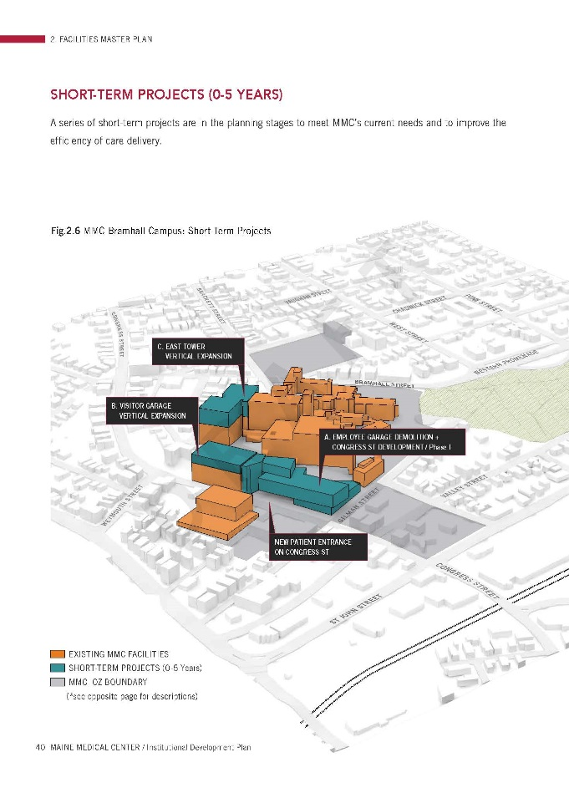
The submissions include a description of the proposals and plans and graphics of the proposed “overbuild”. The graphic to right is extracted from the IDP in Att.4 (pages 44/45)

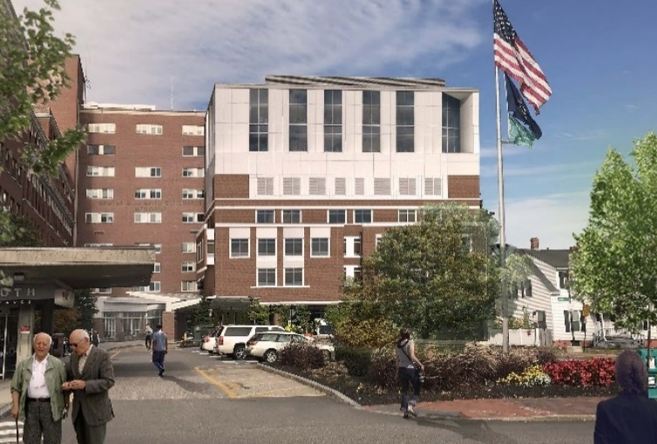
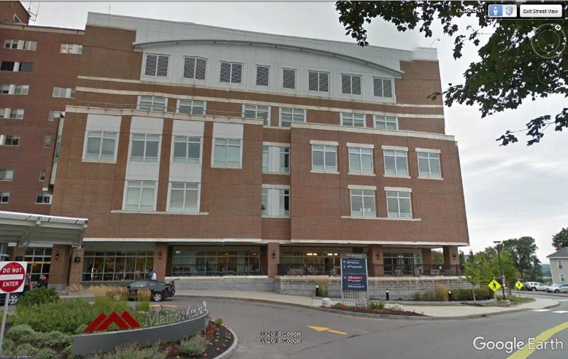
East Tower: Addition of two floors (64 patient rooms, single-occupancy):

Existing from south Proposed, comparable rendering (see WSQ – 1)

Visitor Garage: 3 additional floors of parking spaces: (renderings not submitted)
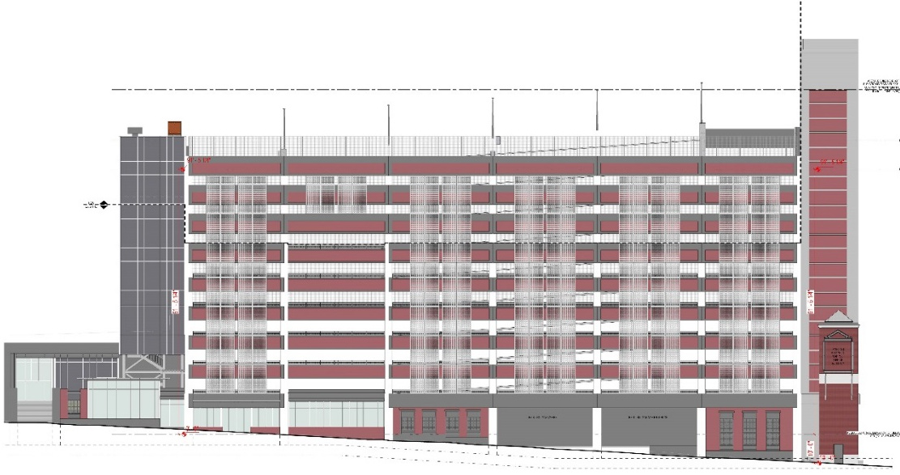
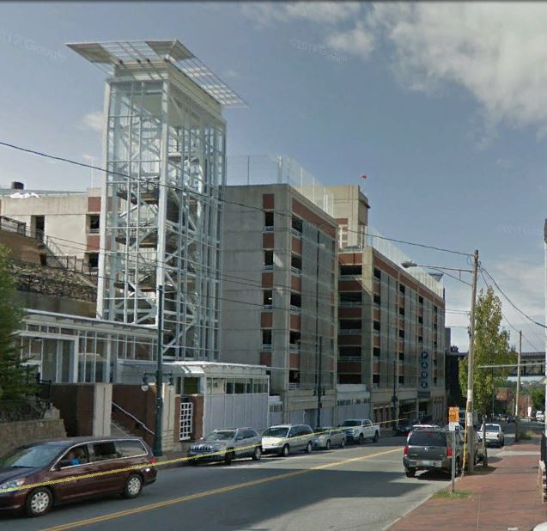

Existing as viewed looking west Proposed west elevation

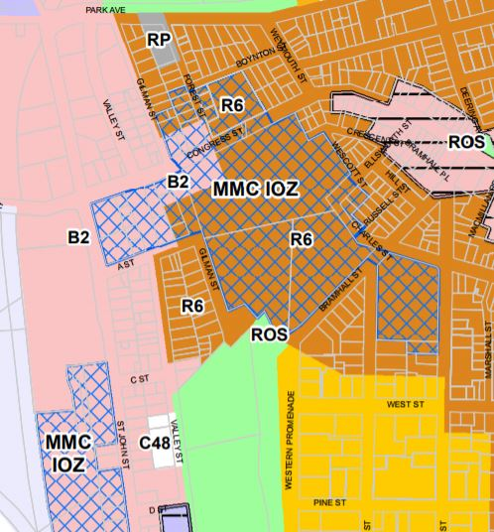
- ZONING ANALYSIS and REVIEW

Overview
The zoning map at right shows the recently adopted MMC IOZ in blue cross hatch:

The MMC IOZ Regulatory Framework (Attachment 5) is the zoning ordinance that applies to the proposed site plan projects; this was reviewed by the Planning Board in early 2017 and adopted by the City Council in December 2017.

The proposed additions to the East Tower and the Visitors Garage were included in the IDP background material for the zoning amendment, and the proposals now under site plan review are consistent with what was discussed during that review.

Table 1 below summarizes the Regulatory Framework provisions that apply to the current review and includes staff comments:

TABLE 1 RELEVANT EXTRACTS FROM MMC IOZ REGULATORY FRAMEWORK (entire document is in Att. 5)
MMC IOZ Regulatory Framework provisions | MMC Site Plan submissions to address the RF provisions, as updated in CAPITALS | Staff Comments for first PB Workshop | Staff comments (summary) for second PB Workshop
(c) Uses: Note under list:  1. Mixed Uses: In recognition that Maine Medical Center is part of a mixed-use area of the City, with important existing services and businesses that serve the local and wider community, healthcare facility development fronting onto Congress Street and St. John Street shall activate the public realm, to the extent able, with uses such as service and retail/restaurant, landscaping, active building entrances, pocket parks, etc., on the ground or other publicly accessible level, consistent with the design intent contained in the approved Institutional Development Plan (IDP). In areas identified in the IDP as “Priority zone for commercially oriented/retail uses,” usable ground floor retail, restaurant, or comparable community-oriented use that provides services to local residents and employees both during the day and evening hours is required. In areas labeled “Street activation through location of windows, entrances, etc.,” usable ground floor retail, restaurant, or community oriented use is encouraged to the extent practicable. Such uses, where constructed or facilitated as part of a healthcare related development, are expressly permitted whether ancillary or supporting the healthcare facility or not, and shall be open and welcoming to the general public in addition to employees or visitors of Maine Medical Center. | The current submission does not include proposals for the existing empty retail units along the base of the Visitors Garage.  IT IS UNDERSTOOD FROM MEETINGS THAT TURNER WILL BE FITTING OUT THESE UNITS SO THAT THE FILM WILL BE REMOVED & NEW INFRA-STRUCTURE (EG BATHROOMS) WILL BE DESIGNED TO ANTICIPATE FUTURE RETAIL USE. NO WRITTEN SUBMISSION RECEIVED. | Staff consider that the entire building is subject to the review and therefore MMC needs to develop strategies to address any “blank walls’ along Congress Street in accordance with the Regulatory Framework and the IDP Design Guidelines/Fig 5.15 re Street Activation (p117 of IDP in Att. 4 to this Memo) | Use of these units by Turners as construction base is welcomed; confirmation of this and the longer term intention is requested for the final submission.
Maximum Building Height: East Tower: 150 feet (the IDP indicated a future height of 141 ft including helipad) | Submitted proposals indicate a height of just over 146 ft but part of the helipad appears to be higher | Clarification required as to helipad height compared to the average grades identified in the IDP. | Additional information received; it confirms height including the helipad is 142 feet
Maximum Building Height: Visitors Garage: 125 feet (the IDP indicated a future height of 119 ft) | Submitted proposals indicate a height of 119 ft excluding part of the stair tower | Appears to meet dimensional requirements as stair and elevator overruns are considered appurtenances. | Additional information received: it confirms height is 119 feet
Transition Zones – none at these locations | N/A | N/A | N/A
Setbacks: East Tower - 20 ft  Visitors Garage - up to 40 ft | N/A | N/A | N/A
Design Guidelines | MMC submitted architectural narrative and graphics for inclusion in PB Memo for first PB workshop and presented it at the workshop. | Urban Design Review comments included in first workshop PB Memo | Staff and PB requested additional information at the first PB workshop, as reiterated to MMC at a 2.8.18 meeting and 2.15.18 e-mail. The submitted “Design Review Update” (WS Q -2 2.23.18 under Second Workshop Applicants Submittal) partially addressees comments (see Section VII).
(f) Signs:  1. At the time of first site plan review following IDP approval, a unified campus-wide Signage Plan shall be submitted for review and approval by the Planning Authority. Any update to such plan due to a change in name or logo shall not require amendment to the IDP.  2. Signs shall be designed in accordance with the campus-wide Signage Plan. All signs shall be designed in proportion and character with building facades and adjacent street typology. All signs shall be coordinated with the building and landscaping design and be constructed of appropriate permanent, high quality materials and finishes. | The applicant has submitted the Signage Plan (Plan 11) that illustrates how the existing signage fits into the campus. The current proposals for the East Tower and Visitors Garage do not necessitate any additional signage, so this plan comprises the current Signage Plan. | Staff anticipate that this Strategy would be updated to take account of the signage needs of the new St Johns Garage and new hospital building (future site plans). | No further comments.
(g) Transportation: (TDM)  1. Transportation Demand Management (TDM):  a. At the time of the first site plan review following IDP approval, MMC shall submit a campus- wide TDM Plan substantially in accordance with those TDM objectives and strategies identified in the approved Institutional Development Plan. The TDM Plan may be phased into short-,mid-, and long-term actions to allow for progressive implementation over time.  b. The TDM Plan shall be designed to provide transportation choice with the goal of reducing parking demand and single-occupancy vehicle trips to and from MMC by employees and visitors.  c. The TDM Plan shall establish parking and trip reduction targets associated with the short-term (0-2 years), mid-term (2-5 years), and the long-term (5+ years), as well as a data collection plan. | The applicant submitted a TDM Plan (Att. WS S-7) on 12.15.17  AN UPDATED TDM (ATTACHMENT X) WAS SUBMITTED ON 2.13.18 IN RESPONSE TO THE STAFF COMMENTS SENT 2.13.18 (ATT. 8) | This is currently under review and detailed comments will be forwarded to the applicant this week, and this will be a topic for the second PB workshop.  DETAILED COMMENTS SENT 1.24.18. | Discussions are continuing; this does not need to be finalized as part of this site plan review.
(g) Transportation: (Parking)  2. Parking:  a. Parking requirements in the IOZ shall be established at the time of site plan review based on a parking study that includes a campus-wide analysis of demand and supply. The parking demand study shall determine parking requirements and shall be sufficient to alleviate parking pressure on surrounding neighborhoods.  b. Parking studies developed by MMC shall integrate parking and trip reduction achievements and data contained in the TDM Plan. | The applicant submitted a Parking Demand Study (Att WS S-8) that identifies shortfalls in both visitor and employee parking supply and elaborates on the background information in the approved IDP. The proposals will temporarily remove 2 levels of parking during construction, but will result in a net increase of 225 visitor parking spaces when complete.  STAFF HAVE BEEN ADVISED VERBALLY THAT SPACES IN THE EMPLOYEE GARAGE WILL BE RE-ALLOCATED TO VISITORS; SOME EMPLOYEES THEN REALLOCATED TO OTHER LOTS | Tom Errico, City’s consultant traffic engineering reviewer, comments:  During the construction of the Visitor parking garage, the top two floors of the existing garage will be taken out of service. The applicant should provide parking management details addressing the loss of the noted parking spaces.  Staff note that 6 handicapped spaces are included in the 225 new spaces, and request confirmation that this meets ADA requirements | Request that the updated information, that responds to the Traffic Engineer comments, be documented as part of the final submissions.
(h) Environment. Development proposed by MMC shall be designed to integrate with the surrounding context, including open space and pedestrian networks and infrastructure. |  | Staff would like to understand how the Visitor Garage integrates into the surrounding pedestrian network both during construction and after it is completed. | Staff request CPTED review by applicant- see Section X regarding other Site Plan Standards.
(i) Mitigation measures. MMC shall mitigate site plan impacts to off-premise infrastructure in a manner proportionate to those impacts. Mitigation may include financial or in-kind contributions to existing or planned City projects focused on mitigating the impacts of MMC development. Mitigation contribution shall be determined based on the City’s standard procedure in effect at the time of site plan review. |  | The Construction Management Plan may have impacts on off-premise infrastructure; this is under review. | CMP/Traffic Detours agreed in principle subject to staff review comments and further detailed discussions.
 |  |  | Stormwater/Sewer capacity & impacts on combined sewer infrastructure under discussion
Helipad. MMC shall be governed by the provisions of the Helistop Overlay Zone with the following exceptions:  a. Setback requirements of Section 14-327(3); and  b. Fencing requirements of Section 14-327(4). | Partial noise info provided in original submissions.  ADDITIONAL HELIPAD SOUND INFORMATION SUBMITTED 2.23.18 | Request info re sound impacts of former helipad location and proposed and updated FAA application | Staff have not been able to review the additional technical information in time for comments to be included in this Memo; these will be provided at the Workshop.

VI Construction Management Plan and Associated Detours
- Review meetings with MMC:
At the first PB workshop the applicant provided an overview of the Construction Management Plan (CMP) (prepared by Turner, the contractor for this project). Since then there have been three meetings between the MMC team/contractor and City staff/site plan reviewers (including Traffic Engineers, representatives from DPW, Police, Fire Department and the City’s Parking Manager) to understand the construction constraints and consider what detour options were available if Congress Street was unavoidably closed. The summary notes of these meetings are included in Attachment 6 but City representatives have also provided comments (see below and Attachments 11, 13, and 14) to help the Board evaluate the CMP and associated traffic implications.

- Third Party Review of MMC construction approach:
In parallel with these discussions the Planning Division commissioned a firm with experience of large-scale construction projects (Kleinfelders) to provide an independent review the “constructability” of the MMC proposals and Turners CMP, with a view to determining if it might be possible to avoid or minimize the closure of Congress Street.

The Kleinfelder Review (see Attachment 16) did not consider major changes to the overall phasing of the MMC expansion project, but did consider options that would necessitate significant reconsideration of phasing and the current access to the hospital. Their review took account not only of construction feasibility, but also questions of alternative types of construction and crane sizes/types, public safety, impacts on the ongoing use of the garage and local utilities, access to the ER, and work scheduling.
The Review concluded that:

Closing Congress Street for an 8 week duration is the recommendation that Kleinfelder fully supports and would have proposed if developing this type of project independently for a client. It is recommended that the City work with Maine Medical Center to tighten up the schedule, as previously mentioned in this memo, with the use of incentive/disincentives, liquated damages associated with possible street damage, proper detour signing, and proper public outreach campaign.

- CMP for East Tower and Visitor Garage (Second Workshop Plan WSI-5 CM Plan)
The CMP for these expansions is particularly challenging because in both cases the hospital seeks to maintain current activity on the lower floors (patients in the East Tower and parking in the garage) plus maintain safe and efficient access for emergency vehicles to the ER.
.

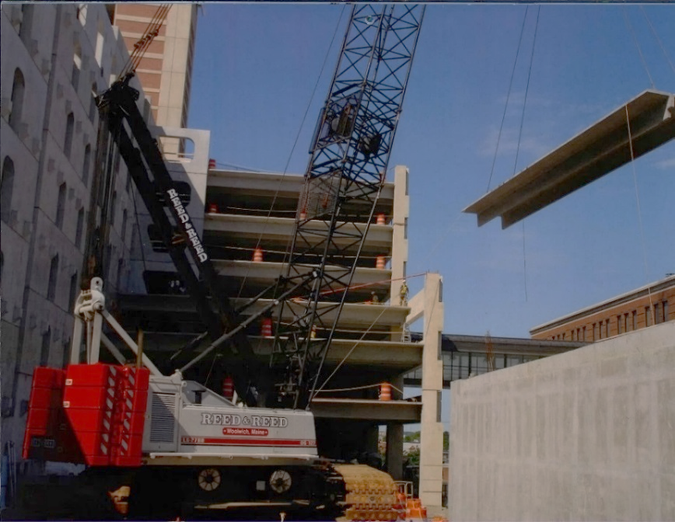
The original garage was constructed largely from inside the site; see photo below from the contractor (then Reed and Reed) as included in their 2018 calendar:

Since the first PB Workshop MMC and Turner has submitted a revised CMP (Second Workshop Plan WSI-5 CM Plan) that has been revised as follows:
- Access for ambulances has been revised to remain as existing by relocating the site fencing and modifying the curb to provide ambulance access to the bays under East Tower
- References to converting Ellsworth to two way have been removed
- Precast and steel delivery routes added
- Location of concrete washout areas added per Wright Pierce Peer Engineer comments (Att. 9, 1.25.18)
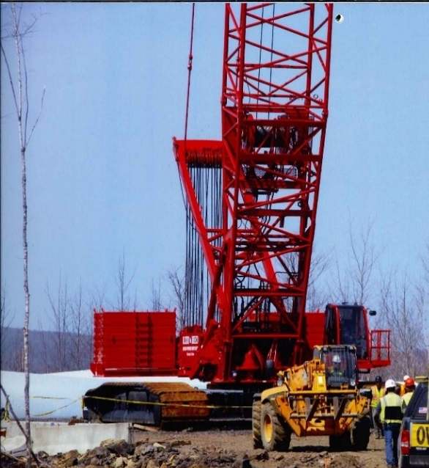
At the review “check in” meetings (Att. 6) there was general agreement that the 8 week closure of Congress Street presented the safest approach with the fewest “unknowns”, but there remain some concerns that require further discussion:
- The feasiblity of the pedestrian route alongside the crane in Congress Street (the crane at right is the type of crane that will be needed)
- The delivery route for the steel for the East Tower is proposed to go via Washington Avenue and Congress Street
- Delivery hours to avoid peak traffic times
- Enforcement of contractor employee parking not to be on local streets
- Introduction of penalties and other measures to ensure the closure is reopened prior the July 4th holiday weekend.

- Traffic Control/ Detours and associated signage, signals and parking restrictions (See Plan GP Traffic Analysis)
The Turner CMP discussed above has addressed the need for some parking and traffic restrictions plus signage on the local streets near the East Tower construction site, and these are shown in the graphics referenced above.

MMC has engaged Gorrill-Palmer to explore traffic management options to facilitate the closure of Congress Street to allow for the overbuild of the visitors garage. The “check-in” meeting notes of 2.1.18 and 2.15.18 document the issues that have been raised by City staff and reviewers which MMC and the consultants were asked to consider as the proposed detours were developed. One of the key concerns was the scope for congestion on the detour routes which would hamper emergency service vehicles being able to get through.

The detour options had included conversion of Park Avenue to two way which would take pressure off of the Congress/St Johns intersection, but the intersection with the Fore River Parkway and the need to install signals facing west at the railway overpass appeared to require more time to resolve than was available.

The proposals and associated details are outlined in GP Traffic Analysis (under Second Workshop Plans) and are based on a three -level approach to traffic diversions:
- Signage (eg variable message signs) outside central Portland to encourage different routes
- Barricades at Congress/St Johns and at Weymouth/Congress to re-route the bulk of traffic
- Local traffic to use Forest/Boynton (Boynton one way inbound)

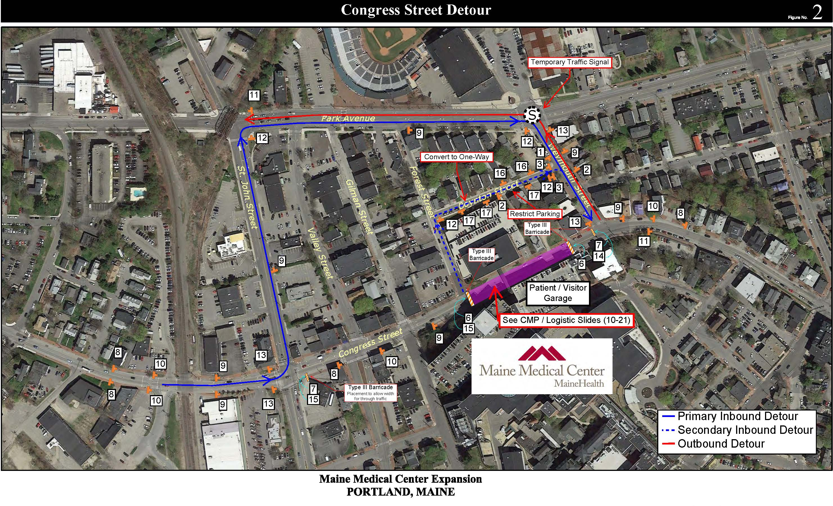
The Police, Fire and DPW Traffic Departments were initially concerned that closure of Congress Street was not workable. As information regarding the constraints of the construction process and the options to facilitate detours was provided and discussed, the proposals were more broadly supported subject to many caveats regarding the need for bringing detour streets up to standard so they can support the additional traffic (Attachment 14), street/lane/signal and pedestrian crossing modifications, communications strategies, and monitoring (Attachment 13) during the closure (see Second memo Attachments 11, 13 and 14).
- Design update
Following the first workshop discussion, Caitlin Cameron, the City’s Urban Designer, met with the applicants on Feb 8th to consider the issues raised by the Planning Board and the Preliminary Design Review Memo (Attachment 3) (notes in Attachment 6).

Staff articulated the key issues from that meeting in an e-mail sent 2/15/18 as quoted below:

1) Design submission for Planning Board workshop 2/27 - Staff suggest the PB workshop submission include at least a written narrative addressing the design points below which may also include some visual examples of past design iterations. The PB workshop presentation should definitely include visual responses to some of these points as we discussed in the meeting last week.

The following comments/questions from the Planning Board should be addressed regarding design:

- Mixed feelings about use of white panels - too sterile or stark contrast, not recessive enough?
1. Provide renderings showing options for material choices, grey or silver were specifically mentioned
2. Respond to question about re-cladding existing white on building

- Address request for integration:
1. Integration of existing building elements and new - looks like an addition
2. Clarify integration of East Tower proposal related to future campus design
3. Integration into neighborhood (especially at the edges, entrances, blank walls, retail)
- Long-term plan for Congress Street retail facade improvements
- How will streetscape at South Entrance change when new entrance is added on Congress Street?
- Screening of mechanicals on garage
- Concerns with parking garage design - rooftop fence quality, facade improvements
2) Design Comments - Based on the design meeting last week, staff continue to have the following comments/questions on the current proposal:
- East Tower: Staff, aligned with PB comment, continue to have some concern about the facade integration of the new and existing - especially in overall facade composition, proportion, and articulation. The existing building has a high level of articulation while the proposed new is much more minimal. Please clarify where new metal panel is proposed and where existing to remain and the strategy around getting those to match or blend. Staff suggest you consider articulation strategies in the new section that address these integration concerns whether that is a horizontal band, dimensional elements, color or other strategies.
- Garage: There are two opportunities to update or improve the design character of the garage - the fall protection fence, especially on the top level, and the metal screens.
The applicant has submitted an illustrated Design Narrative (Attachment WSQ-2 Design Review Update 2.23.18 under Second Workshop Applicants Submittal) that partially addresses the Planning Board comments; however, revised renderings or other options have not been submitted. The Board is requested to clarify to MMC what, if any, further information it would like to have submitted for the final review.
- Helipad Update
At the first PB Workshop the applicant and a representative from LifeFlight clarified regarding the operation of the proposed helipads and indicated that further sound information would be provided. Three new documents have been submitted:
- Revised FAA application (WS -S-6B Second Workshop Applicants Submittal) which confirms the likely number of flights as up to 63 per month (38 per month at present)
- Memo from MMC (WS-S-6A Second Workshop Applicants Submittal) documenting the information that was presented at the first PB Workshop, including one summary paragraph regarding sound
- Comment Responses (WS S-6C 2.23.18) to the staff e-mail of 2.16.18 (Att.15) (which requested comparative data as between ambient, current flight sounds and future sound levels when helipad is relocated). The Comment Response includes a narrative and associated data; however there has not been time for it to be reviewed prior to the completion of this Memo. Comments will be provided at the PB Workshop.

- Stormwater/Sewer issues
The original submission did not address stormwater management on the basis that there is no increase in the impervious surface associated with the proposed overbuilds. The Peer Engineer’s first Memo (Attachment 9, January) primarily requested further information and this was provided and discussed at a “check in” meeting on 2.1.18 (notes in Attachment 6).

Following that meeting the Peer Engineer provided a second comment Memo (also Attachment 9, dated 2.7.18) that include a request for MMC to remove some of the stormwater currently discharging into the Congress Street combined sewer and convey it to the separated system in nearby A Street.

Staff understand that MMC are questioning this request and staff have provided a Memo (Attachment 14 from the City Engineer Keith Gray) outlining the City’s ordinances and obligations that aim to reduce the stormwater flows into the combined system, with the Congress Street system noted as of particular importance because it is a tributary to a CSO that overflows at Marginal Way/Preble Street. The DPW city engineer will be at the PB Workshop to answer questions.

The Peer Engineer request is also supported by the Site Plan Standards (extracted in Attachment 7) which include provisions wherein the reviewing authority can require improvements “to connect or continue off-premises public infrastructure” and specify that “The development shall not overburden sanitary sewers and storm drains, water lines or other public infrastructure and utilities”.

- Update on other Site Plan standards
The focus of the review has been on the construction issues and impacts, and design. The review is of site plan applications for vertical expansions of buildings that received site plan approval in 2005, so in addition to the Regulatory Framework reviewers have considered the proposals to ensure that they meet all current site plan standards as noted below. It is anticipated that detailed discussions on some of these issues will take place between staff and the MMC team at “check-in” meetings so that they are addressed in the final submissions.
- Bicycle parking: See comments from the Transportation Program Manager Bruce Hyman (Attachment 12) which note that while the number of bicycle parking spaces meets the standards, they do not meet Technical Standards regarding the design and location. Reviewers request an inventory showing that a combination of existing and proposed bike racks will meet the number and design standard for location and design.
- CPTED (Crime Prevention Through Environmental Design): The original site plan approval for the Visitors Garage included a public pedestrian access between Crescent Street and Congress Street that partially used the garage stair tower. It is understood that this created security issues. The applicant should assess the access and lighting arrangements for the garage and confirm what improvements for public safety and security will be included in this site plan proposal eg improved or new lighting; signage; relocated pedestrian links etc.
- Exterior lighting: The applicant has provided photometric studies of the helipad lighting and the top level lights on the garage (Attachments First Workshop Submission), but these did not include any specifications or information as to whether these would be visible to neighbors. More information was submitted (WS S- 12 Site Lighting narrative) which clarifies the proposals in respect of these upper level lights. As part of the CPTED review the exterior ground level and internal garage lighting should be reviewed.
- ROW: Street Lighting and ADA Sidewalks: The Transportation Program Manager Bruce Hyman (Attachment 12) has noted that the existing street lights and sidewalk construction does not fully comply with the City’s Technical Standards. In view of the increased activity in this area generated by the MMC expansion, he recommends that the lighting be upgraded (to add the street level light), and the ADA deficiencies be addressed, by the applicant. This may also tie in with the CPTED review.
- Signage and Wayfinding- In the first PB memo staff requested further consideration be given to the pedestrian access/routes and associated wayfinding along Congress Street in conjunction with addressing the street activation.
- Land Transfers ref submitted “recording plats”: The original submission included two “recording plats” that identified street transfers and discontinuances that relate to the two buildings under review. After some research, staff agree that a procedural step (post PB approval of the initial site plan) may not have been completed at that time. This is under review and staff will update the Board when further information is available.
- NEXT STEPS - The final submissions will need to address the staff and Planning Board comments.

ATTACHMENTS

First Workshop - Memo Attachments
            - Initial Traffic Comments
            - Fire Department Comments on CMP
            - Preliminary Design Review Comments
            - MMC Institutional Development Plan (IDP) as approved by PB
            - MMC IOZ Regulatory Framework (Ordinance 14-282) as adopted by CC

Second Workshop Memo Attachments
            - “Check In” meeting notes
            - Extract from Site Plan Ordinance regarding stormwater and sewer infrastructure
            - City comments on submitted TDM
            - Peer Engineer Review comments Jan 25, 2018 and Feb 7, 2018
            - Design E-mail re further info requested
            - Fire Department comments
            - Transportation Program Manager re bike parking, lighting and ADA access in ROW
            - Police Department re CMP and Detours
            - DPW re CMP/Detours and Drainage Infrastructure
            - Staff clarification re relocated helipad sound analysis
            - Kleinfelder third party review of “constructability” and closure of Congress Street

Public comments (none received to date)

First Workshop Applicants Submittal (numbering as per applicant)
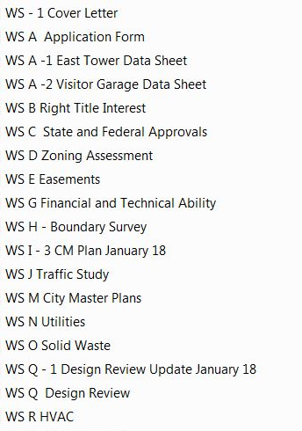

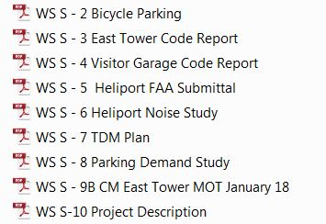

Second Workshop Applicants Submittal (numbering as per applicant)
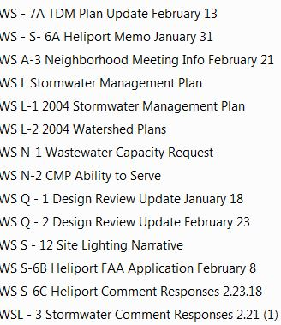

First Workshop Plans (numbering as per applicant)
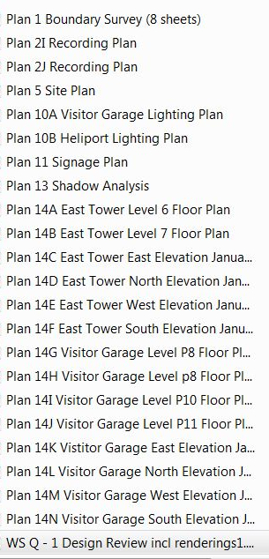

Second Workshop Plans
a. CMP/Detours
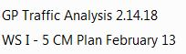

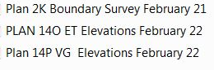
        - Other Plans

