Draft 1.18.18
Memorandum
Planning and Urban Development Department
Planning Division

To: Elizabeth Boepple , Chair and Members of the Portland Planning Board
From: Jean Fraser, Planner
Date: January 19, 2018
Re: MMC East tower and Visitor Garage Vertical Expansion
22 Bramhall Street
Maine Medical Center (MMC)
Project #: 2017-289 CBL: 053D007/054H001/064C001
Meeting Date: January 23, 2018

- INTRODUCTION
Maine Medical Center (MMC) has requested a preliminary review of the Level III Site Plan Application to extend the existing East Tower vertically by two stories (approx. 60,000 sq ft) to accommodate an additional 64 inpatient beds, and to extend the existing Visitor’s Garage on Congress Street by 3 stories vertically to provide an additional 225 parking spaces. The application also refers to work at the Central Utility Plant and includes the relocation the Helipad to the top of the East Tower.

The application is the first of three Site Plan applications associated with the short-term MMC expansion plans. The proposals follow on from the City’s recent adoption of an MMC Institutional Overlay Zone and the associated Institutional Development Plan and Regulatory Framework (both attached to this Memo). The review includes aspects of the MMC IOZ Regulatory Framework that required action at the time of the first site plan (TDM and Signage Plans).

It is anticipated that there will be two PB Workshops on the East Tower/Visitors Garage proposals. This first Workshop is expected to focus on the following topics:
- Design, including Street Activation
- Helipad
- Construction Management Plan overview, plus East Tower

Future topics would include:
- Construction Management Plan in more detail
- Transportation Demand Management (TDM) Plan
- Site Plan Details

Applicant: Maine Medical Center (Alexander Green)
Agent and Engineer: Sebago Technics Inc
Architect: Perkins and Will (Jeffrey Keilman)

Required Reviews:
Applicant’s Proposal | Applicable Standards
Addition of 60,940 sq ft to the East Tower; addition of 77.021 sq ft to the Visitor Garage | Level III Site Plan Review 14-526
Additions that would increase height; helipad | MMC IOZ Regulatory Framework

Waiver Requests: None identified at this time.

- PROJECT DATA
SUBJECT | DATA for EAST TOWER | DATA for VISITORS GARAGE
Existing Zoning | IOZ
Existing Use | Hospital | Hospital parking garage
Proposed Use | Hospital | Hospital parking garage
Parcel Size | 12.52 acres
Impervious Surface Area  --Existing  --Proposed  --Net Change | 415,220 sq ft  0sq ft  0sq ft | 415,220 sq ft  0 sq ft  0 sq ft
Total Disturbed Area | 0 | 0
Building Footprint  --Existing  --Proposed  --Net Change | 30,470 sq ft  0 sq ft  0 sq ft | 25,674 sq ft  0 sq ft  0 sq ft
Building Floor Area  --Existing  --Proposed  --Net Change | 152,350 sq ft  213,290 sq ft  60,940 sq ft | 200,000 sq ft  277,021 sq ft  77,021 sq ft
Parking Spaces  --Existing  --Proposed  --Net change  --# of handicapped spaces | 2,328 (entire campus)  2,553  225  6
Bicycle parking Spaces  --Existing  --Proposed  --Net change | 193 (entire campus)  0  0
Estimated Cost of the Project | TBD

- SITE AND CONTEXT
The approved Institutional Development Plan (IDP) (Attachment 1.) provides information regarding the hospital site and its development over the years, along with context information. Photographs of the existing buildings (to be expanded) are included below.
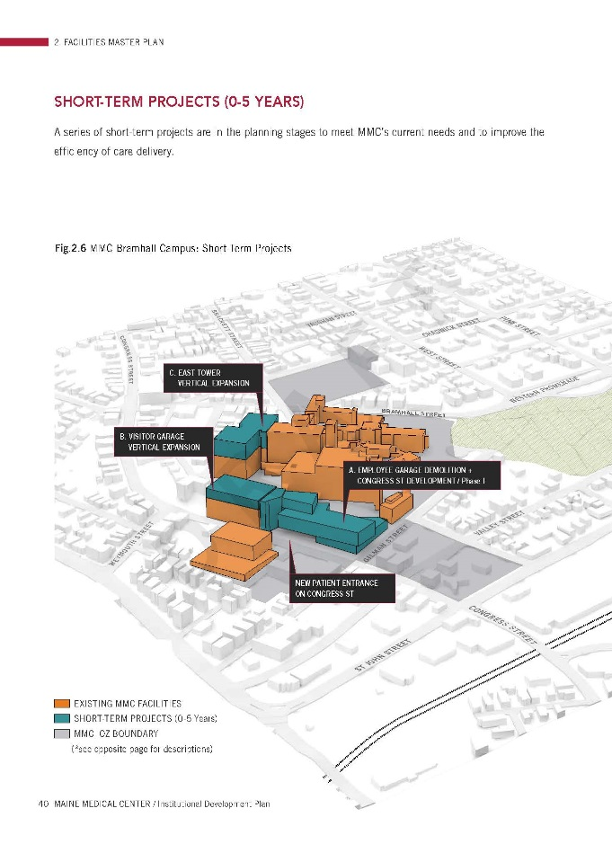
- PROPOSALS
The submissions include a description of the proposals and plans and graphics of the proposed “overbuild”. The graphic to right is extracted from the IDP in Att.1 (pages 44/45)

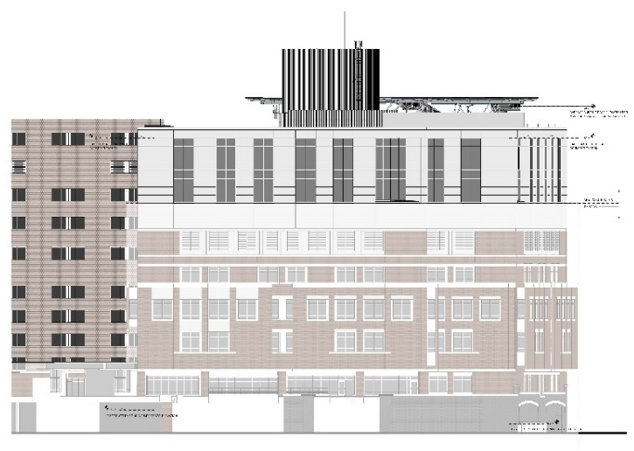
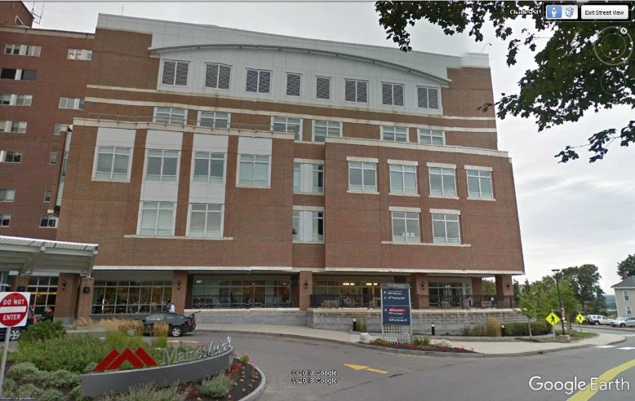
East Tower: Addition of two floors (634 patient beds): (will add rendering if rec’d in time)

Existing from south Proposed elevation showing part of east elevation

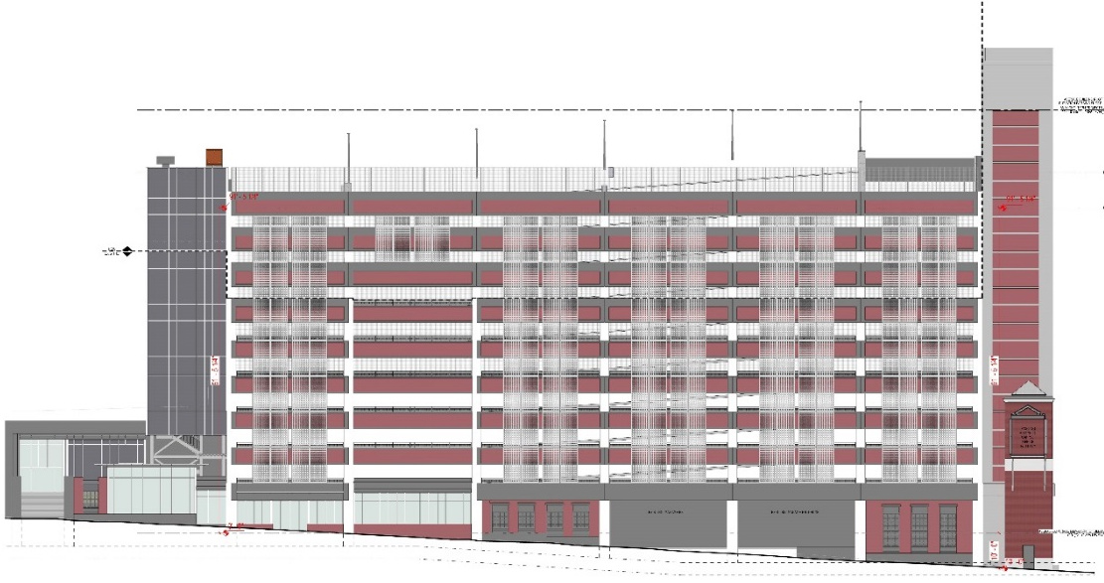
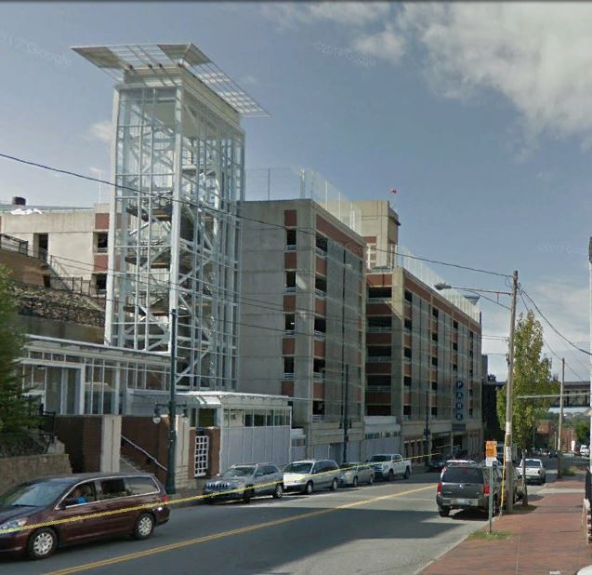
Visitor Garage: 3 additional floors of parking spaces: (will add rendering if rec’d in time)

Existing as viewed looking west Proposed west elevation

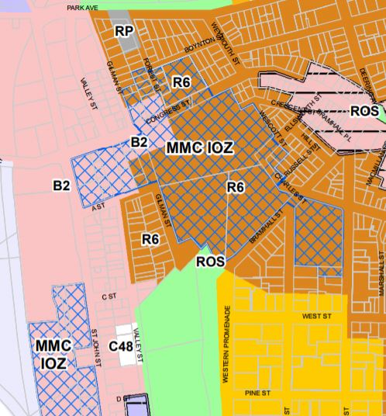
- ZONING ANALYSIS and REVIEW

Overview
The zoning map at right shows the recently adopted MMC IOZ in blue cross hatch:

The MMC IOZ Regulatory Framework (Attachment 2) is the zoning ordinance that applies to the proposed site plan projects; this was reviewed by the Planning Board in early 2017 and adopted by the City Council in December 2017.

The proposed additions to the East Tower and the Visitors Garage were included in the IDP background material for the zoning amendment, and the proposals now under site plan review are consistent with what was discussed during that review.

Table 1 below summarizes the Regulatory Framework provisions that apply to the current review and includes staff comments:

TABLE 1 RELEVANT EXTRACTS FROM MMC IOZ REGULATORY FRAMEWORK (entire document is in Att. 2)
MMC IOZ Regulatory Framework provisions | MMC Site Plan submissions to address the RF provisions | Staff Comments
(c) Uses: Note under list:  1. Mixed Uses: In recognition that Maine Medical Center is part of a mixed-use area of the City, with important existing services and businesses that serve the local and wider community, healthcare facility development fronting onto Congress Street and St. John Street shall activate the public realm, to the extent able, with uses such as service and retail/restaurant, landscaping, active building entrances, pocket parks, etc., on the ground or other publicly accessible level, consistent with the design intent contained in the approved Institutional Development Plan (IDP). In areas identified in the IDP as “Priority zone for commercially oriented/retail uses,” usable ground floor retail, restaurant, or comparable community-oriented use that provides services to local residents and employees both during the day and evening hours is required. In areas labeled “Street activation through location of windows, entrances, etc.,” usable ground floor retail, restaurant, or community oriented use is encouraged to the extent practicable. Such uses, where constructed or facilitated as part of a healthcare related development, are expressly permitted whether ancillary or supporting the healthcare facility or not, and shall be open and welcoming to the general public in addition to employees or visitors of Maine Medical Center. | The current submission does not include proposals for the existing empty retail units along the base of the Visitors Garage. | Staff consider that the entire building is subject to the review and therefore need to develop strategies to address any “blank walls’ along Congress Street in accordance with the Regulatory Framework and the IDP Design Guidelines/Fig 5.15 re Street Activation (p117 of IDP in Att. 1 to this Memo)
Maximum Building Height: East Tower: 150 feet (the IDP indicated a future height of 141 ft including helipad) | Submitted proposals indicate a height of just over 146 ft but part of the helipad appears to be higher | Clarification required as to helipad height compared to the average grades identified in the IDP.
Maximum Building Height: Visitors Garage: 125 feet (the IDP indicated a future height of 119 ft) | Submitted proposals indicate a height of 119 ft excluding part of the stair tower | Appears to meet dimensional requirements as stair and elevator overruns are considered appurtenances.
Transition Zones – none at these locations | N/A | N/A
Setbacks: East Tower 20 ft  Visitors Garage _ up to 40 ft | N/A | N/A
Design Guidelines | See Design Review below
(f) Signs:  1. At the time of first site plan review following IDP approval, a unified campus-wide Signage Plan shall be submitted for review and approval by the Planning Authority. Any update to such plan due to a change in name or logo shall not require amendment to the IDP.  2. Signs shall be designed in accordance with the campus-wide Signage Plan. All signs shall be designed in proportion and character with building facades and adjacent street typology. All signs shall be coordinated with the building and landscaping design and be constructed of appropriate permanent, high quality materials and finishes. | The applicant has submitted the Signage Plan (Att. X) that illustrates how the existing signage fits into the campus. The current proposals for the East Tower and Visitors Garage do not necessitate any additional signage, so this plan comprises the current Signage Plan. | Staff anticipate that this Strategy would be updated to take account of the signage needs of the new St Johns Garage and new hostpial builng (future site plans).
(g) Transportation: (TDM)  1. Transportation Demand Management (TDM):  a. At the time of the first site plan review following IDP approval, MMC shall submit a campus- wide TDM Plan substantially in accordance with those TDM objectives and strategies identified in the approved Institutional Development Plan. The TDM Plan may be phased into short-,mid-, and long-term actions to allow for progressive implementation over time.  b. The TDM Plan shall be designed to provide transportation choice with the goal of reducing parking demand and single-occupancy vehicle trips to and from MMC by employees and visitors.  c. The TDM Plan shall establish parking and trip reduction targets associated with the short-term (0-2 years), mid-term (2-5 years), and the long-term (5+ years), as well as a data collection plan. | The applicant has submitted a TDM Plan (Att. X). | This is currently under review and detailed comments will be forwarded to the applicant this week, and this will be a topic for the second PB workshop.
(g) Transportation: (Parking)  2. Parking:  a. Parking requirements in the IOZ shall be established at the time of site plan review based on a parking study that includes a campus-wide analysis of demand and supply. The parking demand study shall determine parking requirements and shall be sufficient to alleviate parking pressure on surrounding neighborhoods.  b. Parking studies developed by MMC shall integrate parking and trip reduction achievements and data contained in the TDM Plan. | The applicant submitted a Parking Demand Study (Att X) that identifies shortfalls in both visitor and employee parking supply and elaborates on the background information in the approved IDP. The proposals will temporarily remove 2 levels of parking in during construction, but will result in a net increase of 225 visitor parking spaces when complete. | Tom Errico, City’s consultant traffic engineering reviewer, comments:  During the construction of the Visitor parking garage, the top two floors of the existing garage will be taken out of service. The applicant should provide parking management details addressing the loss of the noted parking spaces.
(h) Environment. Development proposed by MMC shall be designed to integrate with the surrounding context, including open space and pedestrian networks and infrastructure. |  | Staff would like to understand how the Visitor Garage integrates into the surrounding pedestrian network both during construction and after it is completed.
(i) Mitigation measures. MMC shall mitigate site plan impacts to off-premise infrastructure in a manner proportionate to those impacts. Mitigation may include financial or in-kind contributions to existing or planned City projects focused on mitigating the impacts of MMC development. Mitigation contribution shall be determined based on the City’s standard procedure in effect at the time of site plan review. |  | The Construction Management Plan may have impacts on off-premise infrastructure; this is under review.
1. Helipad. MMC shall be governed by the provisions of the Helistop Overlay Zone with the following exceptions:  a. Setback requirements of Section 14-327(3); and  b. Fencing requirements of Section 14-327(4). | See review comments below

Design Review in context of MMC IOZ Regulatory Framework
[Caitlins comments in full]

Review of helipad in context of Regulatory Framework and Zoning Ordinance re Helistop Overlay Zone
There is an existing “Single Configuration” helipad (heliport) on the top of the existing employee garage; the helipad needs to be relocated as the garage is proposed to be demolished in the near future. The MMC IOZ IDP (Att. 1, page 94) includes background information regarding the proposed relocation of the helipad to the top of the East Tower, and the objective to retain flight routes as existing. It includes the following graphic which indicates that a third route would be added for high wind situations:

The Submission includes the FAA application and supporting information (Att X) that:
- Shows the same flight routes but does not qualify the use of the new (third) route as being secondary;
- Clarifies that the proposal is for a “Double heliport configuration” with a connecting taxiway. The primary landing area would be at the northeast corner of the East Tower which is the furthest (approximately 240 feet) from residential properties;
- Indicates that the number of landings per month could rise over the next 5 years from 250 per month to 750 per month.

The Helistop Ordinance requires:

(a) Helistops which have more than five landings per month:
(1) All such helistops must comply with all applicable Federal Aviation Association regulations, including those for marking of landing areas.
(2) All take-off, landing and parking areas at such a helistop site shall be surfaced with grass or with a dust-proof material.
(3) Each landing pad shall be set back at least two hundred (200) feet from any residence, school or church. Each landing pad shall be set back at least fifty (50) feet from any commercial or industrial structure. All setbacks shall be measured from the edge of the landing pad.
(4) The area in which a landing pad is located shall be enclosed by a fence or other barrier of not less than three (3) feet in height or shall be secured by a locked gate, as approved by the fire department.
(5) All such helistops shall be subject to review under article V of this chapter.

The Regulatory Framework does not require MMC to meet provisions (3) and (4) - it is understood that they relate to the fact that the secondary landing area is less than 200 feet from a few residential properties (appears to be about 80 feet) and that fencing is not practicable, although this is not discussed in the IDP.

While it is appreciated that these helicopter landings are life-saving operations and that the secondary landing area would be used if there happens to be two emergencies at the same time, staff suggest that further information should be submitted regarding the sound impacts given the proximity of the secondary landing area to residential areas, the addition of the third flight route, and the increase in anticipated helicopter landings. For example, the sound studies (Att X) appear to have gathered data but do not provide a sense of the likely change:
- In sound levels for nearby residents between the former location and the new location;
- Any potential impacts of the new route.

- STAFF REVIEW – SITE PLAN
The following comments cover relevant items that are not already addressed above. Comments relate to the East Tower and Visitor Garage proposals as the proposals for the Central Utility Plant have not been outlined in detail except in the CMP.

Transportation Standards:

Impact on Surrounding Street Systems

The vertical expansion has been reviewed by the City’s consultant Traffic Engineer Tom Errico and he comments:

This proposed project is not expected to increase traffic volumes and thus at completion will not have a significant impact on traffic conditions. I would note that a Traffic Movement Permit will be required in conjunction with the Congress Street Medical Office Building where additional employees are programmed. The TMP will require a comprehensive Traffic Impact Study. (Att X)

Environmental Quality:
- Water Quality/ Stormwater Management/Erosion Control - this is still under review

Public Infrastructure and Community Safety
- Public Safety & Fire Prevention - this is still under review

- Availability and Adequate Capacity of Public Utilities - Letters from the utilities confirming capacity should be submitted as part of the final submission.

Site Design
- Exterior Lighting - Further information is required regarding any exterior building mounted lighting or revised exterior lighting
  - HVAC and Mechanical Equipment - the applicant has indicated this information is not yet available and a condition of approval may be appropriate
- Signage and Wayfinding- Staff are concerned about the pedestrian access/routes and associated wayfinding along Congress Street and would request further consideration be given to that issue in conjunction with addressing the street activation.

Construction Management Plan
The applicant has submitted Construction Management Plan (prepared by Turner, the contractor for this project) and an associated Traffic Evaluation of traffic and parking impacts related to the CMP for the East Tower (Atts X and X).

The applicant will provide an overview at the PB Workshop. Staff have noted that the proposed closure of Congress Street (weeks) and requested further information and review, particularly regarding the impacts on emergency services and on traffic flows and detour routes - so that is suggested to be a key topic for the second PB workshop.

The staff review has therefore focused on the East Tower CMP proposals that include the closure of Wescott Street and conversion of Crescent and Ellsworth to two-way operation. The City’s Consultant Traffic Engineering reviewer Tom Errico has commented:

The following are initial East Tower Traffic Control Plan comments:
o The City does not support the conversion of Ellsworth Street to two-way flow between Congress Street and Crescent Street. The applicant has noted this to be acceptable. The plans should be revised to reflect this change.
o It is unclear if the bump out at the Crescent Street/Wescott Street intersection is to be removed. If it is to remain, vehicle turning templates should be provided for review and approval.
o Detailed routing and vehicle turning information for truck deliveries shall be provided for review and approval.
o It is my understanding that the Fire Department will be providing comments regarding concerns for Emergency Department vehicle access. (Att X)
o Specific parking information shall be provided as it relates to fully understanding current on-street parking usage, location of on-street parking prohibitions, and how existing properties parking needs will be addressed given loss of on-street spaces.

- NEXT STEPS
  - Further details regarding the CUP proposals
  - Respond to design comments and related requests for info (eg re height, street activation, site design details; integration with pedestrian network)
  - Address concern about interim loss of parking and associated management
  - Provide further infortmion on impacts of relocated and enlarged helipad
  - Address comments on East Tower CMP
  - Utility letters for final submissions
  - Planning Board comments

ATTACHMENTS
(TO BE COMPLETED- SOME ARRIVING FRI AM)

