Memorandum
Planning and Urban Development Department
Planning Division

To: Sean Dundon, Chair and Members of the Portland Planning Board
From: Jean Fraser, Planner
Date: January 19, 2018
Re: MMC East tower and Visitor Garage Vertical Expansion
22 Bramhall Street
Maine Medical Center (MMC)
Project #: 2017-289 CBL: 053D007/054H001/064C001
Meeting Date: January 23, 2018
- INTRODUCTION
Maine Medical Center (MMC) has requested a preliminary review of the Level III Site Plan Application to extend the existing East Tower vertically by two stories (approx. 60,000 sq ft) to accommodate 64 single-occupancy inpatient beds, and to extend the existing Visitor’s Garage on Congress Street by 3 stories vertically to provide an additional 225 parking spaces. The application also refers to work at the Central Utility Plant and includes the relocation the Helipad to the top of the East Tower.

It is understood that the 64 single-occupancy bedrooms will not add patient capacity as they would allow existing double-occupancy patient rooms elsewhere to be single-occupancy.

The application is the first of three Site Plan applications associated with the short-term MMC expansion plans. The proposals follow on from the City’s recent adoption of an MMC Institutional Overlay Zone and the associated Institutional Development Plan and Regulatory Framework (both attached to this Memo). The review includes aspects of the MMC IOZ Regulatory Framework that required action at the time of the first site plan (TDM and Signage Plans).

It is anticipated that there will be two PB Workshops on the East Tower/Visitors Garage proposals. This first Workshop is expected to focus on the following topics:
- Design, including Street Activation
- Helipad
- Construction Management Plan overview, plus East Tower

Future topics would include:
- Construction Management Plan in more detail
- Transportation Demand Management (TDM) Plan
- Site Plan Details

Applicant: Maine Medical Center; Alexander Green, Director of system Planning and Regulatory Compliance
Agent and Engineer: Sebago Technics Inc
Architect: Perkins + Will; Jeffrey Keilman, Senior Project Manager, Senior Associate

Required Reviews:
Applicant’s Proposal | Applicable Standards
Addition of 60,940 sq ft to the East Tower; addition of 77,021 sq ft to the Visitor Garage | Level III Site Plan Review 14-526
Additions that would increase height; helipad | MMC IOZ Regulatory Framework

Waiver Requests: None identified at this time.

- PROJECT DATA
SUBJECT | DATA for EAST TOWER | DATA for VISITORS GARAGE
Existing Zoning | IOZ
Existing Use | Hospital | Hospital parking garage
Proposed Use | Hospital- adding single rooms for 64 patient beds | Hospital parking garage – 3-story addition for 225 parking spaces
Parcel Size | 12.52 acres
Impervious Surface Area  --Existing  --Proposed  --Net Change | 415,220 sq ft  0sq ft  0sq ft | 415,220 sq ft  0 sq ft  0 sq ft
Total Disturbed Area | 0 | 0
Building Footprint  --Existing  --Proposed  --Net Change | 30,470 sq ft  0 sq ft  0 sq ft | 25,674 sq ft  0 sq ft  0 sq ft
Building Floor Area  --Existing  --Proposed  --Net Change | 152,350 sq ft  213,290 sq ft  60,940 sq ft | 200,000 sq ft  277,021 sq ft  77,021 sq ft
Parking Spaces  --Existing  --Proposed  --Net change  --# of handicapped spaces | 2,328 (entire campus)  2,553  225  6
Bicycle parking Spaces  --Existing  --Proposed  --Net change | 193 (entire campus)  0  0
Estimated Cost of the Project | TBD

- SITE AND CONTEXT
The approved Institutional Development Plan (IDP) (Attachment 4.) provides information regarding the hospital site and its development over the years, along with context information. Photographs of the existing buildings (to be expanded) are included below.
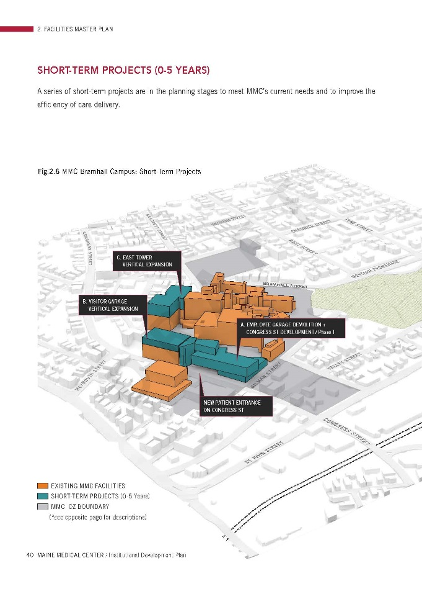
- PROPOSALS
The submissions include a description of the proposals and plans and graphics of the proposed “overbuild”. The graphic to right is extracted from the IDP in Att.4 (pages 44/45)

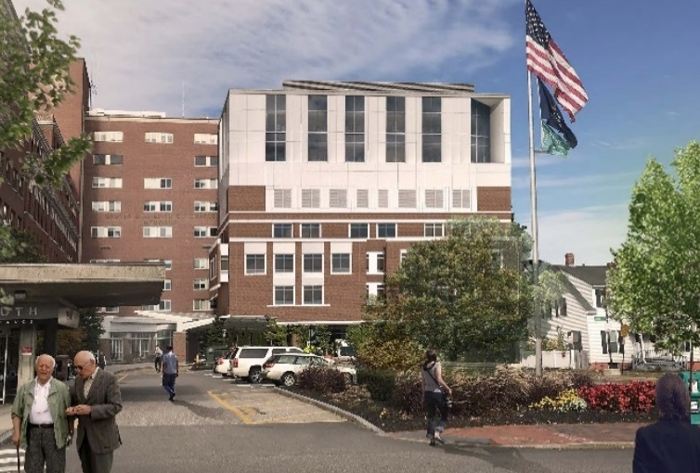
East Tower: Addition of two floors (64 patient rooms, single-occupancy):
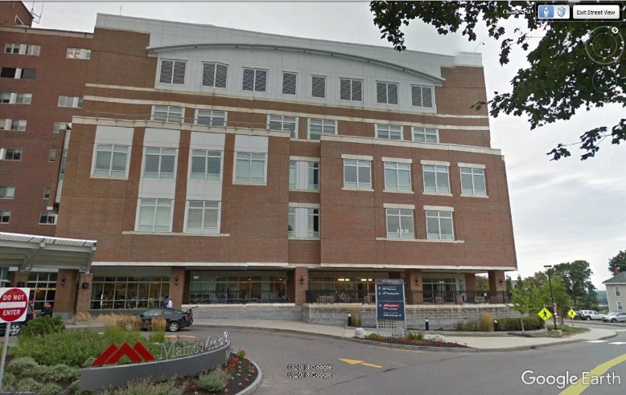
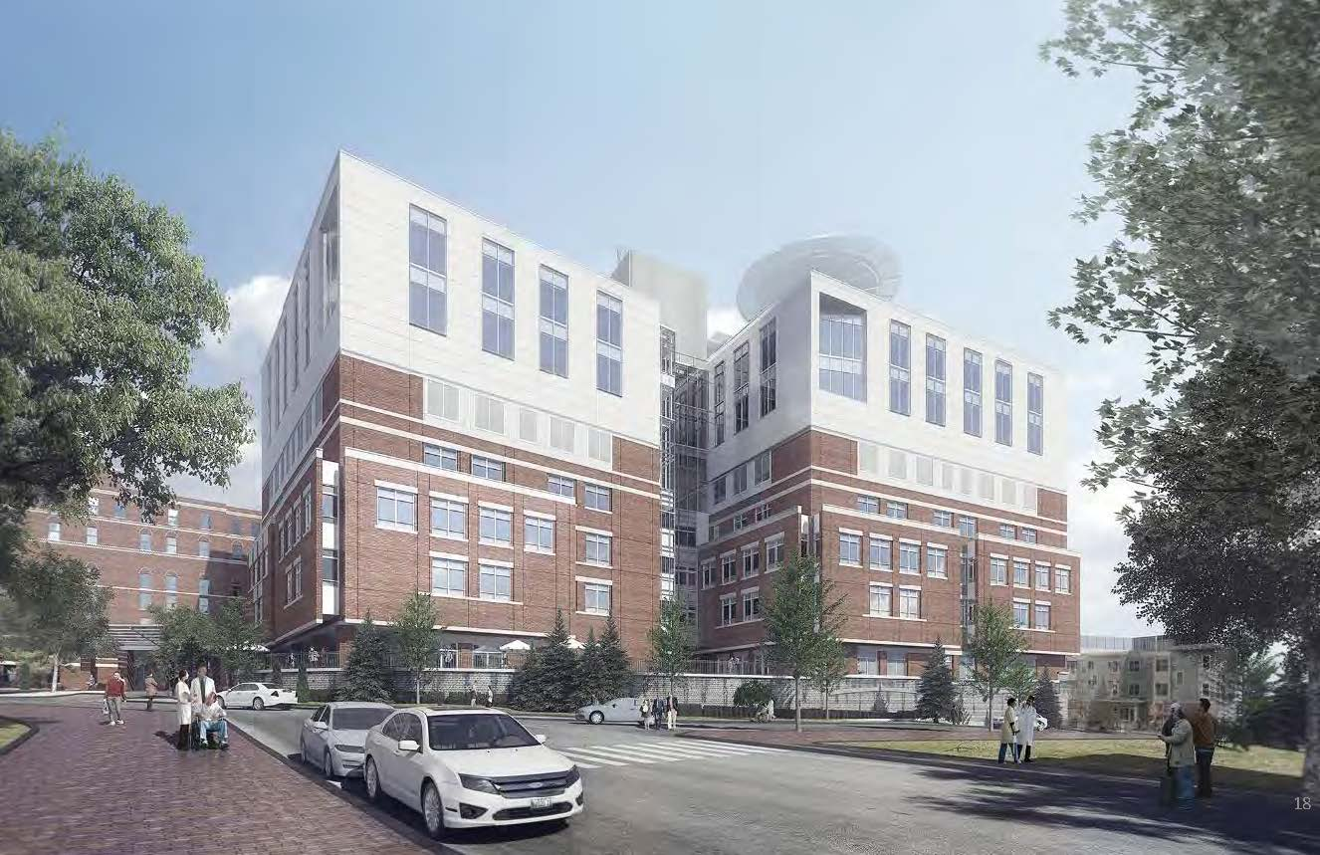
Existing from south Proposed, comparable rendering (see WSQ – 1)
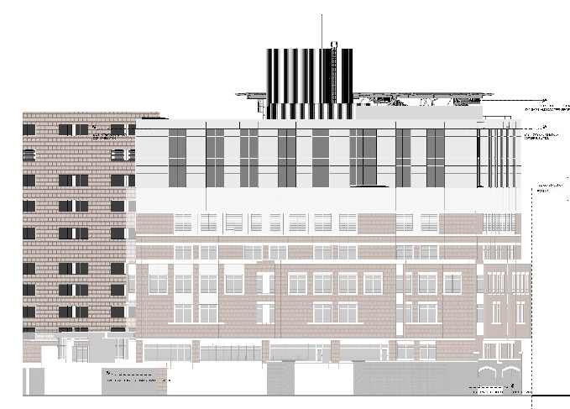

South elevation, showing part of east elevation (Plan 14F)

Rendering as viewed from east ( Ellsworth Street) showing secondary helipad
(see WS Q – 1 which includes additional renderings & before/after comparisons)

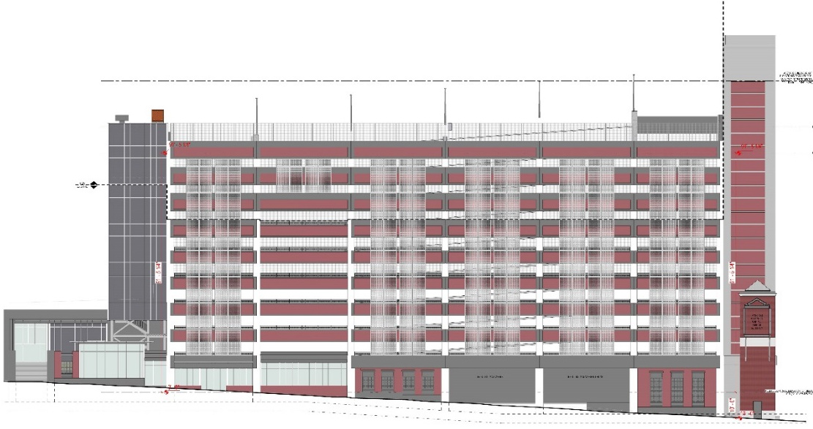
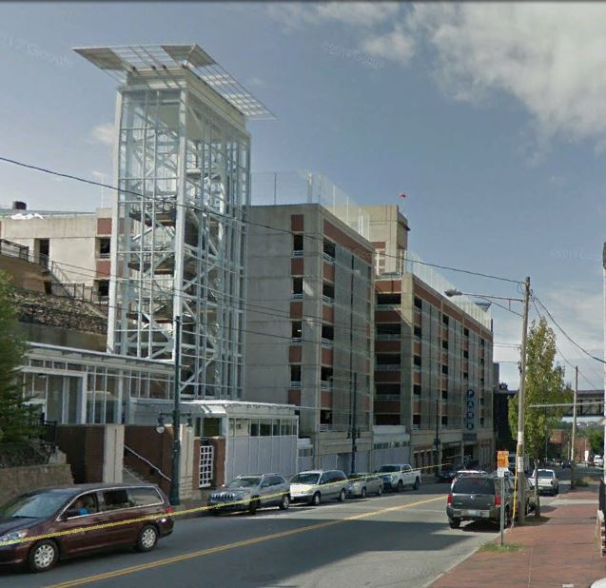
Visitor Garage: 3 additional floors of parking spaces: (renderings not submitted)

Existing as viewed looking west Proposed west elevation

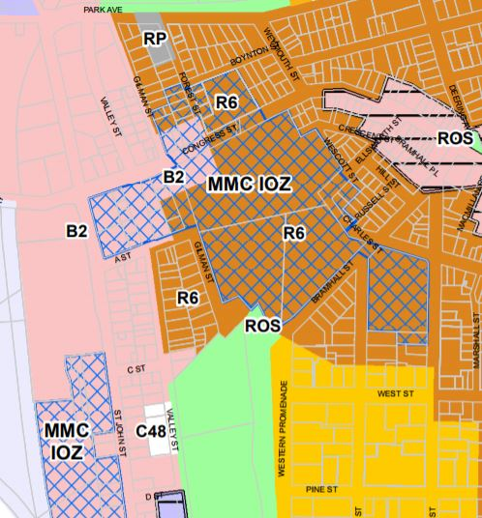
- ZONING ANALYSIS and REVIEW

Overview
The zoning map at right shows the recently adopted MMC IOZ in blue cross hatch:

The MMC IOZ Regulatory Framework (Attachment 5) is the zoning ordinance that applies to the proposed site plan projects; this was reviewed by the Planning Board in early 2017 and adopted by the City Council in December 2017.

The proposed additions to the East Tower and the Visitors Garage were included in the IDP background material for the zoning amendment, and the proposals now under site plan review are consistent with what was discussed during that review.

Table 1 below summarizes the Regulatory Framework provisions that apply to the current review and includes staff comments:

TABLE 1 RELEVANT EXTRACTS FROM MMC IOZ REGULATORY FRAMEWORK (entire document is in Att. 5)
MMC IOZ Regulatory Framework provisions | MMC Site Plan submissions to address the RF provisions | Staff Comments
(c) Uses: Note under list:  1. Mixed Uses: In recognition that Maine Medical Center is part of a mixed-use area of the City, with important existing services and businesses that serve the local and wider community, healthcare facility development fronting onto Congress Street and St. John Street shall activate the public realm, to the extent able, with uses such as service and retail/restaurant, landscaping, active building entrances, pocket parks, etc., on the ground or other publicly accessible level, consistent with the design intent contained in the approved Institutional Development Plan (IDP). In areas identified in the IDP as “Priority zone for commercially oriented/retail uses,” usable ground floor retail, restaurant, or comparable community-oriented use that provides services to local residents and employees both during the day and evening hours is required. In areas labeled “Street activation through location of windows, entrances, etc.,” usable ground floor retail, restaurant, or community oriented use is encouraged to the extent practicable. Such uses, where constructed or facilitated as part of a healthcare related development, are expressly permitted whether ancillary or supporting the healthcare facility or not, and shall be open and welcoming to the general public in addition to employees or visitors of Maine Medical Center. | The current submission does not include proposals for the existing empty retail units along the base of the Visitors Garage. | Staff consider that the entire building is subject to the review and therefore MMC needs to develop strategies to address any “blank walls’ along Congress Street in accordance with the Regulatory Framework and the IDP Design Guidelines/Fig 5.15 re Street Activation (p117 of IDP in Att. 4 to this Memo)
Maximum Building Height: East Tower: 150 feet (the IDP indicated a future height of 141 ft including helipad) | Submitted proposals indicate a height of just over 146 ft but part of the helipad appears to be higher | Clarification required as to helipad height compared to the average grades identified in the IDP.
Maximum Building Height: Visitors Garage: 125 feet (the IDP indicated a future height of 119 ft) | Submitted proposals indicate a height of 119 ft excluding part of the stair tower | Appears to meet dimensional requirements as stair and elevator overruns are considered appurtenances.
Transition Zones – none at these locations | N/A | N/A
Setbacks: East Tower - 20 ft  Visitors Garage - up to 40 ft | N/A | N/A
Design Guidelines | See Design Review below
(f) Signs:  1. At the time of first site plan review following IDP approval, a unified campus-wide Signage Plan shall be submitted for review and approval by the Planning Authority. Any update to such plan due to a change in name or logo shall not require amendment to the IDP.  2. Signs shall be designed in accordance with the campus-wide Signage Plan. All signs shall be designed in proportion and character with building facades and adjacent street typology. All signs shall be coordinated with the building and landscaping design and be constructed of appropriate permanent, high quality materials and finishes. | The applicant has submitted the Signage Plan (Plan 11) that illustrates how the existing signage fits into the campus. The current proposals for the East Tower and Visitors Garage do not necessitate any additional signage, so this plan comprises the current Signage Plan. | Staff anticipate that this Strategy would be updated to take account of the signage needs of the new St Johns Garage and new hospital building (future site plans).
(g) Transportation: (TDM)  1. Transportation Demand Management (TDM):  a. At the time of the first site plan review following IDP approval, MMC shall submit a campus- wide TDM Plan substantially in accordance with those TDM objectives and strategies identified in the approved Institutional Development Plan. The TDM Plan may be phased into short-,mid-, and long-term actions to allow for progressive implementation over time.  b. The TDM Plan shall be designed to provide transportation choice with the goal of reducing parking demand and single-occupancy vehicle trips to and from MMC by employees and visitors.  c. The TDM Plan shall establish parking and trip reduction targets associated with the short-term (0-2 years), mid-term (2-5 years), and the long-term (5+ years), as well as a data collection plan. | The applicant has submitted a TDM Plan (Att. WS S-7). | This is currently under review and detailed comments will be forwarded to the applicant this week, and this will be a topic for the second PB workshop.
(g) Transportation: (Parking)  2. Parking:  a. Parking requirements in the IOZ shall be established at the time of site plan review based on a parking study that includes a campus-wide analysis of demand and supply. The parking demand study shall determine parking requirements and shall be sufficient to alleviate parking pressure on surrounding neighborhoods.  b. Parking studies developed by MMC shall integrate parking and trip reduction achievements and data contained in the TDM Plan. | The applicant submitted a Parking Demand Study (Att WS S-8) that identifies shortfalls in both visitor and employee parking supply and elaborates on the background information in the approved IDP. The proposals will temporarily remove 2 levels of parking during construction, but will result in a net increase of 225 visitor parking spaces when complete. | Tom Errico, City’s consultant traffic engineering reviewer, comments:  During the construction of the Visitor parking garage, the top two floors of the existing garage will be taken out of service. The applicant should provide parking management details addressing the loss of the noted parking spaces.  Staff note that 6 handicapped spaces are included in the 225 new spaces, and request confirmation that this meets ADA requirements
(h) Environment. Development proposed by MMC shall be designed to integrate with the surrounding context, including open space and pedestrian networks and infrastructure. |  | Staff would like to understand how the Visitor Garage integrates into the surrounding pedestrian network both during construction and after it is completed.
(i) Mitigation measures. MMC shall mitigate site plan impacts to off-premise infrastructure in a manner proportionate to those impacts. Mitigation may include financial or in-kind contributions to existing or planned City projects focused on mitigating the impacts of MMC development. Mitigation contribution shall be determined based on the City’s standard procedure in effect at the time of site plan review. |  | The Construction Management Plan may have impacts on off-premise infrastructure; this is under review.
1. Helipad. MMC shall be governed by the provisions of the Helistop Overlay Zone with the following exceptions:  a. Setback requirements of Section 14-327(3); and  b. Fencing requirements of Section 14-327(4). | See review comments below.

Design Review in context of MMC IOZ Regulatory Framework
The City’s Urban Designer, Caitlin Cameron, has provided a preliminary design review in the context of the Regulatory Framework (Attachment 3); it is quoted below:

The projects at 22 Bramhall Street – East Tower and Visitor Garage expansion - were reviewed according to the adopted IOZ IDP and Regulatory Framework standards by Caitlin Cameron, Urban Designer, Jean Fraser, Planner, and Nell Donaldson, Senior Planner.

In the case of both proposals, the new construction is limited to vertical expansion of existing buildings. The proposals do not alter the footprints, plans, existing materials, or access points to each building. Therefore, the design evaluation is generally limited to the impact on the overall campus design, long views to the campus, and Congress Streetscape.

Design Review Comments: (questions and unmet standards in red)
- Please provide a rendering showing the visitor garage project in context on Congress Street.
- More information is requested regarding materials – label materials on elevations.
- More information is requested regarding site lighting.

IDP Design Guidelines
1. New buildings will be designed to contribute to the campus vision and organizational goals identified in the Master Facility Plan and the Transportation Plan, and best practice design standards for healthcare.
East Tower: The East Tower expansion seeks to introduce a contemporary tower that prioritizes the patient experience while also taking advantage of its visual prominence by creating a simple but strong contemporary statement that knits together some of the varying design components of the existing surrounding buildings. The stated MMC vision includes integrating inside and outside – achieved here through the internal circulation and window size and placement, as well as a “50 year palette” that selects materials based on cues from nature to create timeless environment. This vision includes Sky, Sea, and Land as concepts for material/color selection. The white metal panel and large curtain wall system intend to evoke the “sky” – light, recessive, neutral. Planning Board may want to consider if this East Tower design meets this vision for timelessness, integration of inside/outside, and a reflection of modern delivery of healthcare – these design decisions will likely inform future choices for other parts of the campus.
Visitor Garage: The architectural character remains consistent by continuing the existing material palette and expression. In the case of Congress Street, the City’s priority is the building interface with the street – keeping the urban street wall edge, activating the ground floor, providing a sense of scale and enclosure for the pedestrian. The MMC vision includes creating a sense of place while allowing new design reflect its location in Portland and Maine, as well as the historic context of the hospital and surrounding neighborhoods. In this case – those goals are met or at least existing conditions are improved upon.

2. The overall composition and experience of the campus will be considered for cohesive identity from approaches along Congress Street and I-295.
East Tower: The addition introduces a new design aesthetic to the MMC campus. The applicant proposes this as the first of several phases that incorporate the vision for the campus as described above and in the applicant’s submittal. Staff think this design creates a more visible and contemporary identity to the campus – if approved, future designs should be evaluated for cohesiveness with this new direction.
Visitor Garage: The architectural character remains largely the same as the existing condition and is found to be consistent with the established character. The building addition increases the visibility of the campus from those long views.

3. Building entrances will be oriented toward, located adjacent to, accessible from, a sidewalk in a public right-of-way to create a pedestrian-oriented environment.
East Tower: Not applicable – entrances remain the same with existing ground floor.
Visitor Garage: The existing building has two retail entrances facing Congress Street and steps with a door to access the circulation tower for the garage. The garage currently only has vehicle entrances facing Congress Street which pedestrians can use but there is not a designated pedestrian path/door. From Crescent Street, there is a pedestrian path and doorway.

4. Building designs will relate to and be compatible with the existing, or – in areas of change – planned character of residential and commercial neighbors. Design elements and characteristics to consider include:
- Building placement and relationship to the street
- Overall massing and scale
- Roof forms
- Proportion, directional expression, and composition of facades
- Rhythm of solids to voids
- Rhythm and proportion of openings
- Rhythm of entries and projections
- Relationship of materials, texture, and color
East Tower: The addition is simple in its massing, roof form, and material palette. These two additional floors also change the overall proportion of the building’s massing and façade composition. Staff support the direction given the constructability constraints and the limitations of the existing façade character. The window openings are places and scaled to reflect the long views and tower scale of the building. They establish a rhythm consistent with existing building and campus design. The white metal in contrast with the red brick make the proportions top-heavy, but the applicant makes the case that brick is not a viable option for the building addition and that white color palette was selected to integrate with the existing materials and details without introducing yet another element.
Visitor Garage: The massing, roof forms, rhythms, and material relationships remain mostly unchanged from the existing conditions. Scale is the most significant change to this building – staff have requested street view renderings to understand how that scale change will be experienced on the street.

5. Façade materials of buildings will be of high quality, and contribute to an attractive public realm.
East Tower: The applicant indicated the material choices are limited by construction constraints as well as the existing material palette. The proposal is simple white metal panel intended to visually blend with the existing white materials as well as provide a light, recessive quality to the increase in mass and height. Vi sual interest will be provided by material pattern, fenestration, and shadow lines created by angled windows on each façade.
Visitor Garage: The proposal maintains the existing material palette of brick, concrete, and metal screen. Staff agree this is a logical selection to provide consistency to the building. However, staff are concerned about the loss of the canopy on the stair tower as an architectural feature.

6. The design process will consider long views of new buildings including roofs and associated structures to minimize visual impacts and provide visual interest. Rooftop appurtenances will be either screened from view or integrated into the building design, and will not be visible from adjacent streets, Western Promenade, or the Congress Street approach (helipad excluded).
East Tower: The rooftop mechanicals are screened in a way that minimizes their impact and appearance and are visible only from a few directions.
Visitor Garage: Rooftop appurtenances have not been adequately screened or integrated into the building design - this is especially of concern for the long views.

7. Vibrant, contributing and sustainable active ground floors will be provided to add activity and a sense of place to the priority node identified in the City’s Comprehensive Plan.
East Tower: Not applicable
Visitor Garage: Staff request the applicant provide more information regarding the ground floor activation facing Congress Street. The building includes storefront, doors oriented to Congress Street, canopies, and adequate site lighting, however, the space is currently vacant and has a translucent film covering the windows and impeding the visual connection and activity from the sidewalk.

8. In areas where the occurrence of limited blank facades along public right-of-ways are unavoidable due to changes in topography or building use requirements, the following strategies will be used to mitigate visual impact:
- providing elements of visual interest along any black walls facing public streets, and,
- working with the City of Portland to ensure adequate lighting of public sidewalks to create a safe pedestrian experience.
East Tower: Not applicable
Visitor Garage: See comment 7. above.

9. Any parking structure within the IOZ will:
- screen views of cars from the public rights-of-way
- provide elements of architectural interest on upper floors to contribute positively to long views and gateway approaches
- for garage structures within 20’ of the public right-of-way, meet street activation intent according to street type
East Tower: Not applicable
Visitor Garage: Screening methods will follow the established existing design – solid wall with metal mesh railing with a trellis accent – this current condition successfully screens cars/headlights from Congress and Crescent streets. The current design includes a curtain wall stair tower with an accentuated canopy feature – this roof element appears to be removed from the new addition and rooftop mechanicals are shown without screening or design integration. Staff suggest keeping an element like the canopy will help screen the rooftop mechanicals and meet the guideline of providing architectural interest on upper floors – especially considering with the increased height, these elements will become even more visible from long views. For street activation, see comments 7. above.

Building Relationship to Public Street
- Urban Main Street (Congress Street)
MMC buildings abutting Congress St will be designed to:
- Provide urban-levels of density
- Create an urban street wall that provides a sense of enclosure to the public realm
- Have their primary orientation towards Congress Street
- Activate the public sidewalk with building entrances, lobbies, etc.
- To the extent possible, given programmatic needs, provide visual interest and ensure pedestrian safety with views into and out of the building along the public sidewalk
- To the extent possible, given programmatic needs, provide space for community-oriented uses such as services or retail that can be shared between MMC users, neighbors, and the broader Portland community
- Support the existence of neighborhood amenities such as restaurants and other retail uses providing services to local residents and employees both during the day and evening hours.
In addition to the guidelines listed above, buildings that have frontage on Congress Street and that include parking components will activate portions of or place liner buildings along the ground floor facing Congress Street.
East Tower: Not applicable
Visitor Garage: The building addition maintains the urban street wall already established. The existing building’s primary orientation is towards Congress Street. Entrances are not proposed to be changed – there are several existing entrances oriented to Congress Street. For activation, see comment 7. above.

Crime Prevention Through Environmental Design (CPTED)
MMC will incorporate the following design strategies that have been demonstrated to deter crime:
- Providing a clean and aesthetically pleasing campus environment that is designed with vandal-resistant materials
- Providing clear and properly-sized signs in safe locations to ensure safe wayfinding
- Ensuring that paths from transit stops, bike storage areas, and parking areas to main pedestrian entrances are well-lit, with clear sight lines
- Designing street-level elevations to minimize potential hideouts
- To the extent possible, given clinical program demands, providing views in and out of building ground floors populated by users to serve as “eyes on the street”
- Generating foot traffic on public sidewalks with pedestrian entrances
East Tower: Please indicate any changes to the site lighting or ground level building interface.
Visitor Garage: Please indicate any changes to the site lighting or ground level building interface.

Mitigating Impacts Through Design
Minimizing Shadow Impacts - Shadow impacts were evaluated as part of the IDP process. Both projects increase building height and will inevitably have some shadow impact – the garage height will increase the shadow cast across Congress Street but, as the applicant has argued, shadows on Congress Street are unavoidable due to the terrain, orientation, and street position. Refer to Plan 13 for shadow analysis of the approved IDP building heights – a couple of residential buildings are impacted in the winter by the increased height.
Context-Sensitive Lighting Design – More information is requested regarding site lighting for both projects.
Mitigating Wind Impact – No information was provided to evaluate this item.
Preserving and Enhancing Viewsheds – The building expansions do not impact Western Promenade viewsheds. Each of these expansions will increase the visibility of the campus from multiple long views.

Regulatory Framework
- Mixed Uses: . . . healthcare facility development fronting onto Congress Street and St. John Street shall activate the public realm, to the extent able, with uses such as service and retail/restaurant, landscaping, active building entrances, pocket parks, etc., on the ground or other publicly accessible level, consistent with the design intent contained in the approved IDP. . . .
East Tower: Not applicable
Visitor Garage: See comment 7. above.

Review of helipad in context of Regulatory Framework, IDP & Zoning (Helistop Overlay Zone)
There is an existing “Single Configuration” helipad (heliport) on the top of the existing employee garage; the helipad needs to be relocated as the garage is proposed to be demolished in the near future. MMC’s IDP (Att. 4, page 94) includes background information regarding the proposed relocation of the helipad to the top of the East Tower, and the objective to retain flight routes as existing. It includes the following graphic which indicates that a third route would be added for high wind situations:

The Submission includes the FAA application and supporting information (Att. WS S-5) that:
- Shows the same flight routes but does not qualify the use of the new (third) route as being secondary;
- Clarifies that the proposal is for a “Double heliport configuration” with a connecting taxiway. The primary landing area would be at the northeast corner of the East Tower which is the furthest (approximately 240 feet) from residential properties;
- Indicates that the number of landings per month could rise over the next 5 years from 250 per month to 750 per month.

The Helistop Ordinance requires:

(a) Helistops which have more than five landings per month:
(1) All such helistops must comply with all applicable Federal Aviation Association regulations, including those for marking of landing areas.
(2) All take-off, landing and parking areas at such a helistop site shall be surfaced with grass or with a dust-proof material.
(3) Each landing pad shall be set back at least two hundred (200) feet from any residence, school or church. Each landing pad shall be set back at least fifty (50) feet from any commercial or industrial structure. All setbacks shall be measured from the edge of the landing pad.
(4) The area in which a landing pad is located shall be enclosed by a fence or other barrier of not less than three (3) feet in height or shall be secured by a locked gate, as approved by the fire department.
(5) All such helistops shall be subject to review under article V of this chapter.

The Regulatory Framework does not require MMC to meet provisions (3) and (4) - it is understood that they relate to the fact that the secondary landing area is less than 200 feet from a few residential properties (appears to be about 80 feet) and that fencing is not practicable, although this is not discussed in the IDP.

Staff request further information should be submitted regarding the sound impacts of the proposed helipad. Although the applicant has submitted a Heliport Noise Study (Att WS S-6), further clarity is requested as to the scale and nature of the sound impacts compared to the existing situation.

- STAFF REVIEW – SITE PLAN
The following comments cover relevant items that are not already addressed above. Comments relate to the East Tower and Visitor Garage proposals as the proposals for the Central Utility Plant have not been outlined in detail except in the CMP.

Transportation Standards:

Impact on Surrounding Street Systems

The vertical expansion of the East Tower is to allow for the conversion of double-occupancy rooms elsewhere into single rooms and replacing the patient beds in the 64 single bed rooms being added. Thus the number of hospital beds remains unchanged.

The vertical expansion proposals have been reviewed by the City’s consultant Traffic Engineer Tom Errico and he comments:

This proposed project is not expected to increase traffic volumes and thus at completion will not have a significant impact on traffic conditions. I would note that a Traffic Movement Permit will be required in conjunction with the Congress Street Medical Office Building where additional employees are programmed. The TMP will require a comprehensive Traffic Impact Study. (Att 1)

Environmental Quality:
- Water Quality/ Stormwater Management/Erosion Control - this is still under review

Public Infrastructure and Community Safety
- Public Safety & Fire Prevention - this is still under review

- Availability and Adequate Capacity of Public Utilities - Letters from the utilities confirming capacity should be submitted as part of the final submission.

Site Design
- Exterior Lighting - Further information is required regarding any exterior building mounted lighting or revised exterior lighting
  - HVAC and Mechanical Equipment - the applicant has indicated this information is not yet available and a condition of approval may be appropriate
- Signage and Wayfinding- Staff are concerned about the pedestrian access/routes and associated wayfinding along Congress Street and would request further consideration be given to that issue in conjunction with addressing the street activation.

Construction Management Plan
The applicant has submitted Construction Management Plan (prepared by Turner, the contractor for this project) and an associated Traffic Evaluation of traffic and parking impacts related to the CMP for the East Tower (Atts WS I – 3 and WS S – 9B respectively).

The applicant will provide an overview at the PB Workshop. Staff requested further information and review for the proposed closure of Congress Street (weeks), particularly regarding the impacts on emergency services and on traffic flows and detour routes. The staff review of the CMP includes representatives from the Police, Fire, Parking, DPW, Traffic and Planning. The staff suggest that the CMP be a key topic for the second PB workshop.

The staff review has therefore focused on the East Tower CMP proposals that include the closure of Wescott Street and conversion of Crescent and Ellsworth to two-way operation. The City’s Consultant Traffic Engineering reviewer Tom Errico has commented (Att 1.):

The following are initial East Tower Traffic Control Plan comments:
o The City does not support the conversion of Ellsworth Street to two-way flow between Congress Street and Crescent Street. The applicant has noted this to be acceptable. The plans should be revised to reflect this change.
o It is unclear if the bump out at the Crescent Street/Wescott Street intersection is to be removed. If it is to remain, vehicle turning templates should be provided for review and approval.
o Detailed routing and vehicle turning information for truck deliveries shall be provided for review and approval.
o It is my understanding that the Fire Department will be providing comments regarding concerns for Emergency Department vehicle access. (see Att 2)
o Specific parking information shall be provided as it relates to fully understanding current on-street parking usage, location of on-street parking prohibitions, and how existing properties parking needs will be addressed given loss of on-street spaces.

- NEXT STEPS
  - Provide further details regarding the Central Utility Plant proposals
  - Respond to design comments and related requests for info (eg re height, street activation, site design details; integration with pedestrian network)
  - Address concern about interim loss of parking and associated management
  - Clarify sound impacts of the relocated helipad
  - Address comments on East Tower CMP
  - Submit utility letters for final submissions
  - Address Planning Board comments

ATTACHMENTS

Memo Attachments
            - Initial Traffic Comments
            - Fire Department Comments on CMP
            - Preliminary Design Review Comments
            - MMC Institutional Development Plan (IDP) as approved by PB
            - MMC IOZ Regulatory Framework (Ordinance 14-282) as adopted by CC

Public comments (none received to date)

Applicants Submittal (numbering as per applicant)
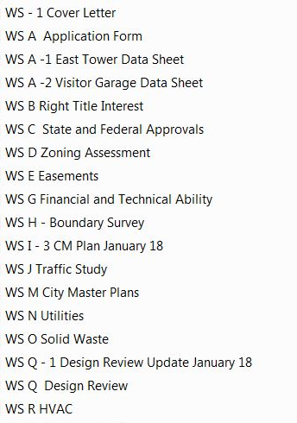

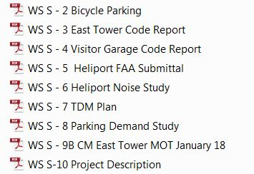

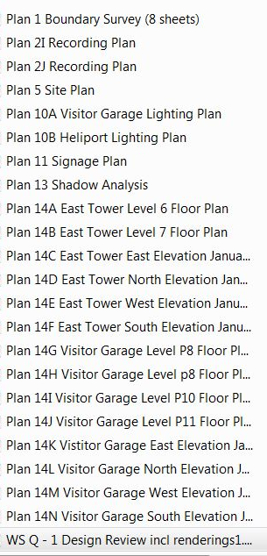
Plans (numbering as per applicant)

