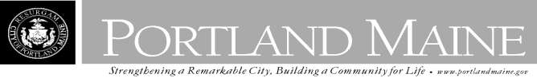
Director of Planning and Urban Development
Jeff Levine

June 27, 2013

KULPER MARK W
192 DEERING AVE PORTLAND, ME 04102

Inspection Services, Director
Tammy M. Munson

CBL: 051 D005001
Located at: 192 DEERING AVE
Certified Mail 7012 0470 0002 1928 5204

Dear Mr. Kulper,

An evaluation of the above-referenced property on
06/24/2013
shows that the structure fails to

comply with Chapter 6.Article V. of the Code of Ordinances of the City of Portland, The Housing
Code. Attached is a list of the violations.

This is a notice of violation pursuant to Section 6 of the Code. All referenced violations shall be

corrected within
21 days of the date of this notice. A re-inspection of the premises will occur

on 7/19/2013 at which time compliance will be required. Failure to comply will result in this office referring the matter to the City of Portland Corporation Counsel for legal action and possible civil
penalties, as provided for in Section 1-15 of the Code.

This constitutes an appealable decision pursuant to Section 6-127 of the Code.

Please feel free to contact me if you wish to discuss the matter or have any questions.

Please be advised that the Portland City Council has amended the Building regulations to include a
$75.00 re-inspection fee. This violation will automatically cause a re-inspection at no charge. If there are any subsequent inspections, however, the $75.00 fee will be assessed for each inspection.

Sincerely,

Chuck Fagone
Code Enforcement Officer
(207) 874-8789

