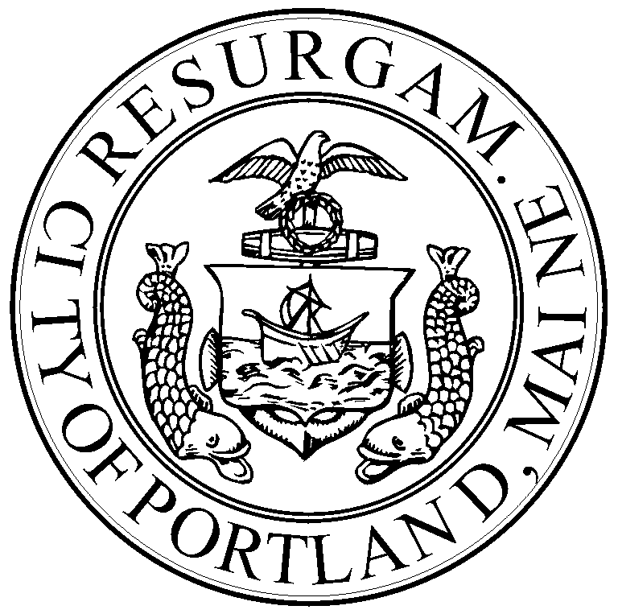

Memorandum
Planning and Urban Development Department
Housing and Community Development Program

To: Mayor and City Council

Cc:

From:

Date:

Re:

