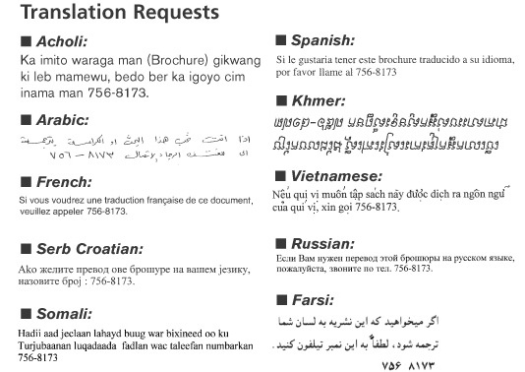

For more information, visit us on the Web at www.portlandmaine.gov
or call Housing and Neighborhood Services at 756-8246

