Memorandum
Planning and Urban Development Department
Planning Division

To: Chair Boepple and Members of the Portland Planning Board

From: Jean Fraser, Planner

Date: July 7th, 2017

Re: July 11^{th 2017} Planning Board Workshop
Level III Site Plan, Subdivision and Inclusionary Housing:
12 unit Condominium, One Joy Place
Onejoy Place, LLC , Applicant

- Introduction
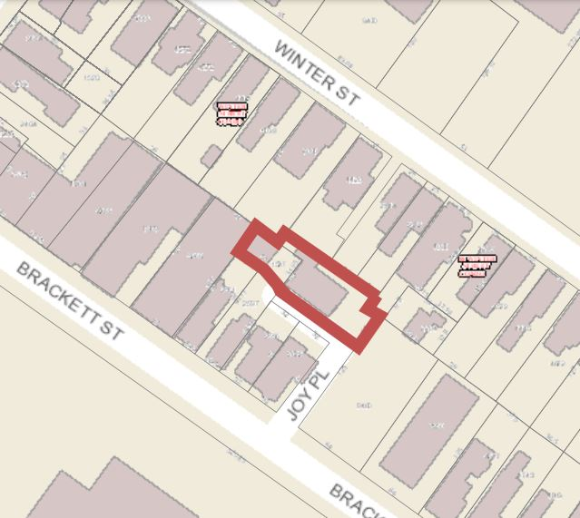
Onejoy Place, LLC has submitted a Level III Site Plan and Subdivision application for the construction of a three story 12 unit residential building on a 5,851 sq ft backland “urban infill” site at 1 Joy Place, a short private street located between 157 and 165 Brackett Street. The site is vacant and previously occupied by a dilapidated house. The parcel has existing access from Brackett Street via Joy Place.

The site is within the B-1 zone and within the West End Historic District. The Historic Preservation Board has held two Workshops on the design of the project and the submitted elevations have been revised to address the HP Board comments.

The project is subject to the Inclusionary Zoning requirements and the applicant has proposed one unit of Workforce housing.

The focus of the site plan review is the provision of parking, since the layout of the new building does not does not include space to meet all of the off-street parking requirements, and Joy Place is a narrow dead end street that serves 4 other units in the front duplex building nearest to Brackett Street.

The applicant has been in discussions with the City to develop this site in conjunction with the use and improvement of the abutting school parking lot, including some leased spaces for the new residential development. That project did not materialize and the proposal under review is for a self-contained development on this smaller lot.

The applicant held a Neighborhood Meeting on June 28, 2017 which was attended by one neighbor; notes are included in Attachment R. The Planning Division has received 7 public comments generally in support of the project (see Section VI below). This Workshop was noticed to 250 neighbors and interested parties, and the public notice appeared in the Portland Press-Herald on July 3rd and 4th, 2017.

Applicant: Onejoy Place, LLC (Todd Alexander)
Consultants: Terradyn Consultants (Michael Tadema-Wielandt), Engineers;
Archetype (David Lloyd, Architects

Required reviews and requested waivers (note that waivers have not been requested but may be needed):

Applicant’s Proposal | Applicable Standards
New structure of 12 dwelling units | Subdivision Review
Multifamily building of 3591 square feet | Level III Site Plan Review
Proposed building within West End Historic District | Requires a Certificate of Appropriateness (Article IX) from the Historic Preservation Board (note; B1 Design Standards not applicable)
Proposed one bed unit of workforce housing | Inclusionary Zoning

- PROJECT DATA

SUBJECT | DATA
Existing Zoning | B1
Existing Use | vacant
Proposed Use | residential
Parcel Size | 5,851 sq ft
Impervious Surface Area  --Existing  --Proposed  --Net Change | 3,164 sq ft  3,602 sq ft  438 sq ft
Total Disturbed Area | 5,851 sq ft
Building Footprint  --Existing  --Proposed  --Net Change | 0  2,612 sq ft
Building Floor Area  --Existing  --Proposed | 0  3,591 sq ft
Residential  - Existing # units  - Proposed # units | 0  12 one bed units
Parking Spaces | 12 required; 4 tandem on site; application refers to 10 being leased but lease not submitted; payment of a fee in lieu is also an option
Bicycle parking Spaces | 5 (in basement of new building)

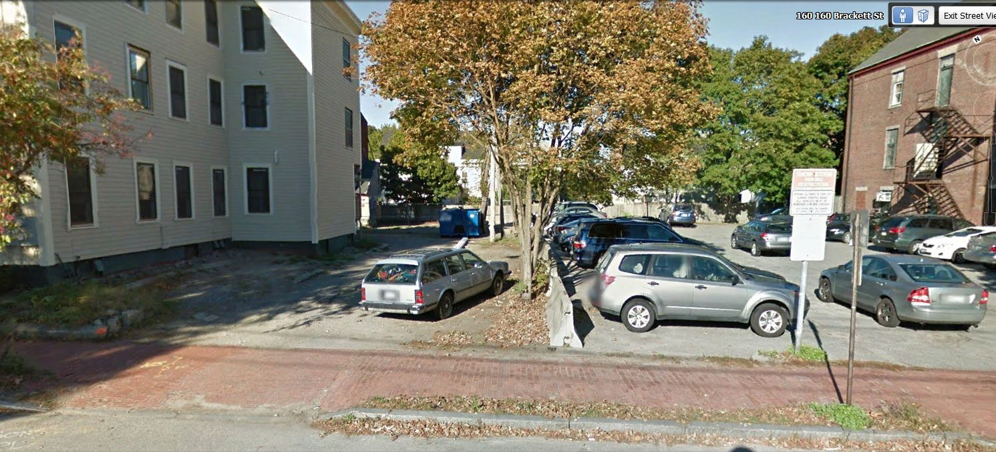
- EXISTING CONDITIONS
The generally flat site is located at the far end of Joy Place, pictured here where it joins Brackett Street between a duplex at 165/167 Brackett (comprising a single family home and a 3 unit apartment building) and the parking lot owned by the City of Portland and used by Reiche School staff as the school is across the street. To the rear of the site are the back yards of residential homes on Winter Street.

The site in the wider context is shown below:
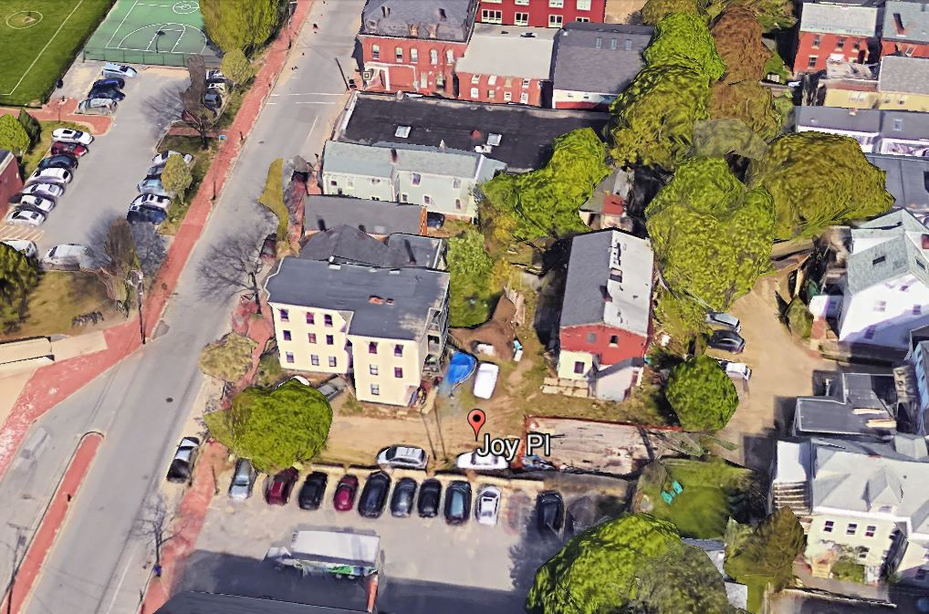
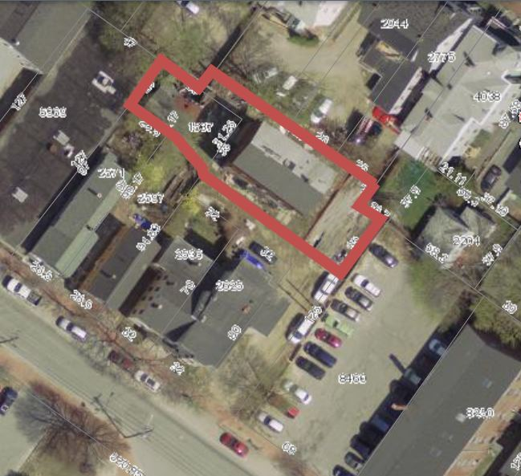
(The existing “red” building has been demolished).

Joy Place is a private street, 24 feet in width near Brackett Street and 12 feet wide at the rear after the bend. The abutting properties are understood to have deeds which require it to remain open and unobstructed.

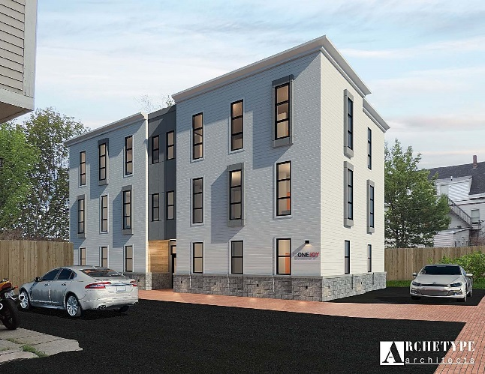
- PROPOSED DEVELOPMENT
The proposal is to construct a 3 story building with 4 units on each floor, with floor areas ranging from 475 sq ft to 660 sq ft in area. The proposals include improvements in Joy Place and the ROW; a description is in Attachment A and illustrated in the Plans.

Two of the first floor units have private yard areas at the back, and a community open landscaped area is provided for all residents to the north of the building (see Landscaping Plan below & in Plan P11)

The proposed sidewalk along Joy Place (with trees) is proposed to be located on City of Portland land.

- STAFF REVIEW

        - ZONING ASSESSMENT - PARKING REQUIREMENTS
The proposals meet all of the dimensional standards of the B1 zone but it is not clear how the parking requirement for 12 parking spaces is going to be addressed. The current application proposes:

- 4 parking spaces on site- of which 2 are accessible and 2 are tandem and compact
- 10 part time (overnight and weekend) spaces leased from the City in the abutting parking lot that serves the Reiche school.

In the past the applicant has discussed a different development proposal in conjunction with the City that anticipated use of and improvement to the City’s parking lot next to the site and the leasing of some parking spaces to the applicant. The City has determined that it does not wish to proceed with that project, and the availability of leased spaces in that lot may no longer be an option.

The Parking Zoning requirements allow residential development on the peninsula to consider the following options for meeting the parking requirements (14-332.1):

- Partially meet the parking requirement through provision of shared-use vehicles (one equates to 8 required parking spaces, but can be no more than 50% of the parking requirement);
- Requesting that the Planning Board establish different parking requirements based on unique conditions that result in a lesser parking demand (eg housing for persons who do not drive, availability of transit etc)

The site is located in the B1 zone and the applicant has two additional options for the provision of the required parking (below is a summary based on the ordinance sections 14- 331 and 14-345):

- Securing leased parking spaces (full time) within 1500 feet of the site, confirmed by a lease for at least 5 years;
- Payment of a fee in lieu (approx. $5000 per parking space) that would go into the Sustainable Transportation Fund for eligible projects. If this option was applied to this project the question is whether the payment would be for 10 spaces or 8 spaces, depending on how the tandem spaces are counted.

Staff are concerned that the absence of on site parking spaces will not only place more pressure on the limited on-street parking in this area, but also increase the chances that Joy Place will be blocked with illegal parking and prevent emergency access.

The City’s Parking Manager has outlined his perspective re the parking context, the current use of the adjacent school parking lot, and his concerns about the parking provision for the proposed 12 unit dvelopment (Attachment 5).

The focus of the review is to clarify how the applicant intends to address the off-street parking requirement.

B. SUBDIVISION STANDARDS

14-496. Subdivision Plat Requirements and 14-497. General Requirements (a) Review Criteria
The proposals appear to generally meet the Subdivsion standards apart from parking (see above under Zoning) and some minor technical comments.

C. SITE PLAN STANDARDS
The site plan standards appear to be generally addressed except for the following:

Parking: See discussion under Zoning above; the Board may wish to offer guidance to the applicant regarding the options or combination of options that address the parking requirement.

In addition the Traffic Engineer reviewer has noted a number of requirements regarding how parking for both the proposed project and for the adjacent property at 165 Brackett (3 unit) should be organized in relation to Joy Place and avoid backing out onto Brackett Street, and requested a layout plan (Attachment 1).

Bicycle Parking: the number of proposed bicycle parking spaces meets the ordinance, but all are located in the basement so there are no spaces available for visitors. Staff recommend at least two bicycle parking spaces be provided in a visible and accessible location outside the building.

Snow Storage: A Snow Removal Agreement will need to be developed and documented in the Condominium Documents and the Subdivision Plat.

Landscaping: The proposed brick sidewalk with trees appears to be located on City of Portland land and the applicant will need to provide a license or other agreement that gives him rights to carry out this work. This amenity could be located within Joy Place if the pedestrian paved area was flush. Revisions to the proposals for the area within the narrow part of Joy Place are anticipated in order to address the neighbor concerns (167 Brackett- see PC1) and any comments from the City Arborist.

Street Trees: The project needs to include 12 street trees (one per unit) and has proposed two street trees in Joy Place to demarcate the pedestrian walkway. A revised plan is required to show the final location of the trees that takes account of the emergency service access requirements and parking provision for the existing units adjacent to Joy Place. In addition, the applicant is requested to confirm how the remaining 10 required street trees will be provided (noting the options available in the Technical Standards).

Fire Prevention: The Fire Department raised a concern about cars parking in Joy Place and potentially preventing access for emergency service vehicles. The applicant provided further information to the Fire Department (Attachment O) as to how parking would be controlled, and the Fire Department has requested additional signage in terms of “No Parking – Fire Lane” be provided to discourage parking in Joy Place (Attachment 3).

Historic Resources: The Historic Preservation Board has held two Workshops on the project and the applicant has revised the architecture to address the HP comments. A HP Board hearing will be scheduled as soon as the site plan review is concluded.

Exterior Lighting and HVAC - this has not been reviewed in detail.

- DESIGN STANDARDS IN THE SITE PLAN ORDINANCE
The B1 Design Standards do not apply as the project is within the West End Historic District and the Historic Preservation Board review substitutes. Similarly, the design standards that are part of the Multi-family and Other Housing Types Design Standard are not applicable.

The following Multifamily Design Standards continue to apply:

3. Open space on the site for all two-family, special needs independent living unit, bed and
breakfast and multiple-family development shall be integrated into the development site. Such open space in a special needs independent living unit or a multiple-family development shall be designed to complement and enhance the building form and development proposed on the site. Open space functions may include but are not limited to buffers and screening from streets and neighboring properties, yard space for residents, play areas, and planting strips along the perimeter of proposed buildings;

Staff comment: two of the ground level units have private outdoor space, and a community open space available to all residents is provided adjacent to the building.

4. The design of proposed dwellings shall provide ample windows to enhance opportunities for sunlight and air in each dwelling in principal living areas and shall also provide sufficient storage areas;

Staff comment: This standard appears to be met.

5. The scale and surface area of parking, driveways and paved areas are arranged and landscaped to properly screen vehicles from adjacent properties and streets;

Staff comment: The four on-site parking spaces will be visible from Brackett Street but would appear as two cars. There is wood cedar board fencing between the parking spaces and the neighbor on Winter Street, but the plan envisages an open sidewalk oalong the side boundary between the site and the City’s parking lot.

- INCLUSIONARY ZONING
This project is subject to the Inclusionary Zoning ordinance that ensures the provision of workforce housing. A development of ten or more units of housing in the City is required to provide on-site workforce housing units or make an in-lieu payment to the City’s Housing Trust.

The applicant has submitted a Conditional Use application to address the Inclusionary zoning requirements (Attachment A) and has proposed one unit (one-bedroom) of workforce housing. This appears to meet the ordinance requirement, subject to further review of the deed restrictions and other details.

VI PUBLIC COMMENTS
The Planning Division has received 7 letters from neighbors, including the owners of the two properties between the proposed new building and Brackett Street (who share access via Joy Place). All but one of the letters generally support the project, with the abutter at 167 Brackett (single family) raising some detailed concerns relating to the location and design of the fencing and landscape and the need to maintain rear access to her property via Joy Place.

NEXT STEPS

The final submission will need to include:

- Clarification of how the parking requirement will be met, and associated leases or other documentation as required in the ordinance
- Subdivision Plat and draft condominium documents with reference to maintaining Joy Place clear for emergency services (and parking, if applicable)
- RTI documentation for installing sidewalk along Joy Place outside of parcel boundaries (or relocate within Joy Place)
- Clarification of how the street tree requirements will be met
- Revised Landscape Plan
- Provide additional Workforce Housing information (eg deed restrictions) to the Housing & Community Development Division and finalize details
- Revisions to address the Board and staff review comments, including a parking layout plan for Joy Place and vicinity.

(attachments next page)
ATTACHMENTS:
Attachments to Memorandum
  - Traffic Engineering Review comments
  - Engineering Review comments
  - Fire Department comments
  - City Arborist comments
  - Parking Manager comments

Public Comments
PC1 Holmes 6.23.17
PC2 Tousignant 6.30.17
PC3 Plymale 7.2.17 & 7.5.17
PC4 Gebhardt 7.2.17
PC5 Kimble 7.5.17
PC6 Watson 7.5.17
PC7 Rathband 7.5.17

Applicant’s Submittal
- Cover Letter and Application Site Plan
- Cover letter & Application IZ Conditional Use
- Development Description
- Right, title and Interest
- State and Federal Permits
- Land use Ordinance Review
- Easements/other burdens
- Financial and Technical Capability letter
- Construction Management
- Natural Features
- Stormwater Management
- Consistency with City Master Plans
- Utilities
- Solid Waste
- Fire Safety & Emergency Services Info
- Conformity with Standards
- HVAC Equipment
- Neighborhood meeting Information

Plans
P1. Cover Sheet
P2. General Notes
P3. Boundary Survey
P4. Existing Conditions and Removals
P5. Construction Management Plan
P6. Site Layout Plan
P7. Grading Plan
P8. Utility Plan
P9. Site Details
P10. Utility & Drainage Details
P11. Landscaping Plan
P12. Photometric Plan
P13. Floor Plans (4 sheets)
P14. Elevations

