PLANNING BOARD REPORT
PORTLAND, MAINE

Twelve-Unit Condominium Building
One Joy Place
Subdivision, Level III Site Plan
and Conditional Use Inclusionary Zoning

Onejoy Place LLC, Applicant

Project #2017-103 (Subdivision & Site Plan)
Project #2017-128 (Conditional Use Inclusionary Zoning)
CBL: 045 E049001
Submitted to: Portland Planning Board  Public Hearing Date: September 26, 2017 | Prepared by: Jean Fraser, Planner  Date: September 22, 2017

- Introduction
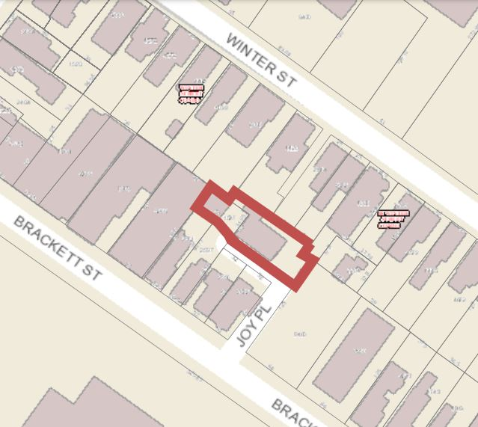
Onejoy Place, LLC is seeking final approval for a Level III Site Plan and Subdivision application for the construction of a three story 12-unit residential building on a 5,851 sq ft backland “urban infill” site at 1 Joy Place, a short private street located between 157 and 165 Brackett Street. The site is largely occupied by a dilapidated house. The parcel has existing access from Brackett Street via Joy Place.

The Board held a Workshop on this project in July 2017 where the question of the parking provision and integration with the City’s abutting parking lot were the main issues.

The site is within the B-1 zone and within the West End Historic District. The Historic Preservation Board has approved the design of the project subject to conditions re details, and the submitted elevations have been revised to address the HP Board review comments.

The project is subject to the Inclusionary Zoning requirements and the applicant has proposed one unit of workforce housing.

The applicant had originally proposed improvements and possibly parking on the adjacent lot owned by the City (currently used for school-related parking). The final proposals are completely on the applicant’s land or the private street of Joy Place, as the City is not able to provide the applicant with an easement or similar at this time.

This Hearing was noticed to 250 neighbors and interested parties, and the public notice appeared in the Portland Press-Herald on September 18 and 19, 2017. The applicant held a Neighborhood Meeting on June 28, 2017 which was attended by one neighbor; notes are included in Attachment R. The Planning Division has received 12 public comments as of the completion of the report, of which 5 are in support of the project, 2 raise minor concerns, and 5 comprise objections based on the lack of on-site parking and low number of affordable housing units within the project.

Applicant: Onejoy Place, LLC (Todd Alexander)
Consultants: Terradyn Consultants (Michael Tadema-Wielandt), Engineers;
Archetype (David Lloyd, Architects)

Required reviews and requested waivers

Applicant’s Proposal | Applicable Standards
New structure of 12 dwelling units | Subdivision Review
Multifamily building of 3591 square feet | Level III Site Plan Review
Proposed building within West End Historic District | Requires a Certificate of Appropriateness (Article IX) from the Historic Preservation Board (note; B1 Design Standards not applicable)
Proposed one 1-bedroom unit of workforce housing | Inclusionary Zoning
Waiver Requests | Applicable Standards
Location and spacing of driveways- To allow driveway spacing to remain as existing.  Staff Comments: Staff supports a waiver for driveway separation as it is an existing condition and low traffic volumes are expected from the project site (Attachment 1). | Technical Manual Section 1.7.2.7 Location and spacing of driveways shall be determined as follows: Along arterial, collector and local streets, minimum acceptable spacing between double or multiple driveways for driveways on adjacent lots or on the same parcel shall meet the criteria of 100 feet for 25 mph
Lighting trespass standards are slightly exceeded along the south boundary with City’s parking lot  Staff comments: The trespass at this location would also help provide surveillance for the abutting parking lot at night - and if the use (on the parking lot side) changes, shields could be added. | Technical Manual Section 12.2.5 Light Trespass states The maximum illumination level at a property line shall not exceed 0.1 foot candle, as measured at grade, except where abutting industrial, or other non-sensitive uses.

- PROJECT DATA

SUBJECT | DATA
Existing Zoning | B1
Existing Use | vacant
Proposed Use | residential
Parcel Size | 5,851 sq ft
Impervious Surface Area  --Existing  --Proposed  --Net Change | 3,164 sq ft  3,602 sq ft  438 sq ft
Total Disturbed Area | 7,851 sq ft
Building Footprint  --Existing  --Proposed  --Net Change | 0  2,612 sq ft
Building Floor Area  --Existing  --Proposed | 0  7,851 sq ft
Residential  - Existing # units  - Proposed # units | 0  12 one bed units
Parking Spaces | 12 required; 3 tandem on site; 11 provided in lot on Congress Street via lease agreement
Bicycle parking Spaces | 2 in community open space; 2-3 in basement

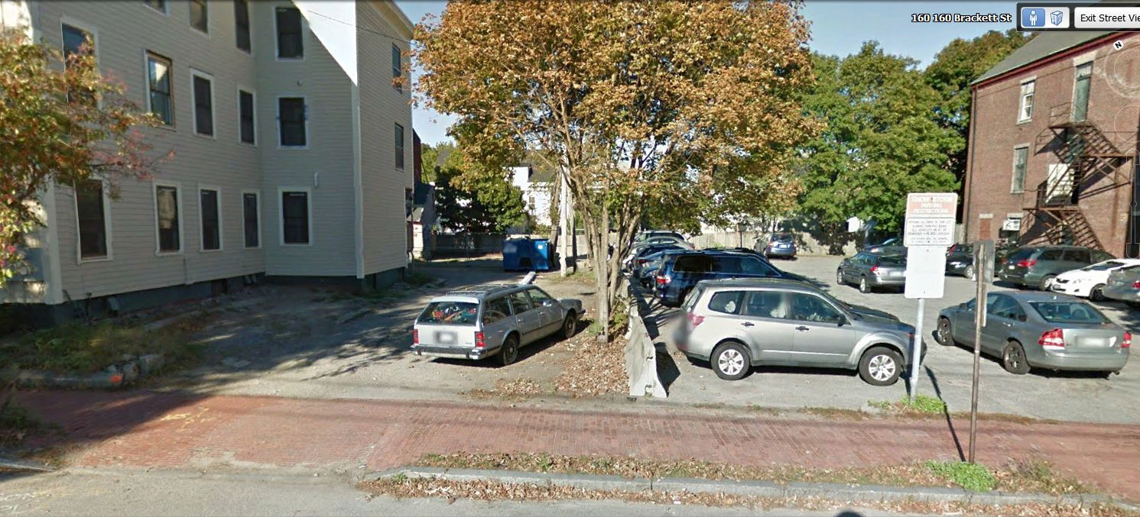
- EXISTING CONDITIONS
The generally flat site is located at the far end of Joy Place, pictured here where it joins Brackett Street. To the left (north) is a duplex at 165/167 Brackett (comprising a single-family home and a 3-unit apartment building). To the right (south) is a parking lot owned by the City of Portland and used by Reiche School staff and other visitors. To the rear of the site are the back yards of residential homes on Winter Street.

The site in the wider context is shown below.

Joy Place is a private street, 24 feet in width near Brackett Street and 12 feet wide at the rear after the bend. The abutting properties are understood to have deeds which require it to remain open and unobstructed.
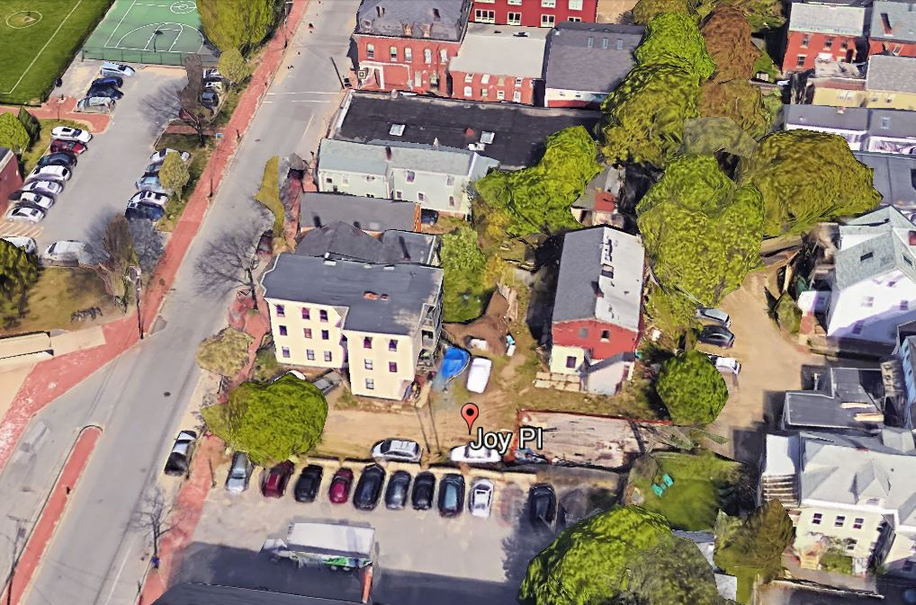
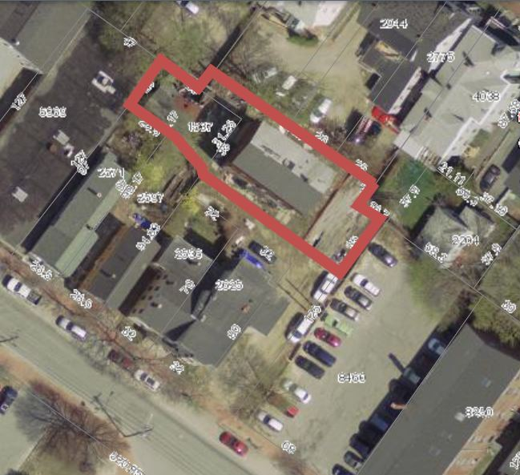

- PUBLIC COMMENT AND PLANNING BOARD WORKSHOP DISCUSSION
Three of the public comments raise concerns regarding the lack of on-site parking and that this will exacerbate the shortage of on-street parking in this area. This shortage is also noted by the City’s Parking Manager (Attachment 5). The Planning Board considered the question of parking provision and requested further information on the likely parking demand associated with the type of units being proposed. The Board indicated that they would consider a reduced parking provision (less than 12 spaces) though encouraged the introduction of a car-share.

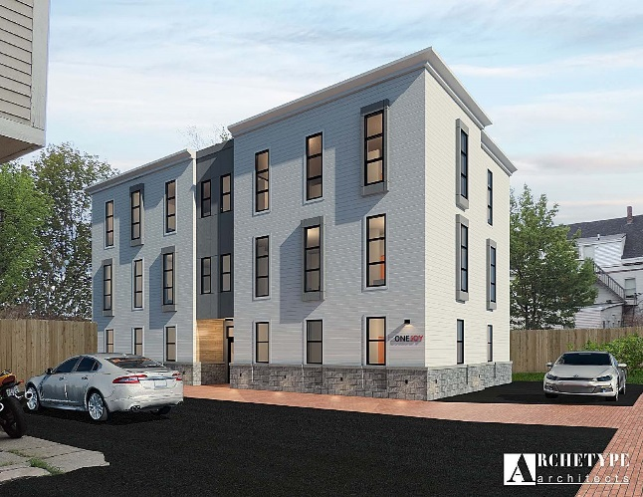
- PROPOSED DEVELOPMENT
The proposal is to construct a 3-story building with 4 units on each floor, with floor areas ranging from 477 sq ft to 704 sq ft. The proposals include improvements in Joy Place and the ROW; a description with graphics is in Attachment C and illustrated in the Plans.

Two of the first-floor units have private yard areas at the back, and a landscaped community area is provided for all residents to the north of the building (see Landscaping Plan below & in Plan P10).

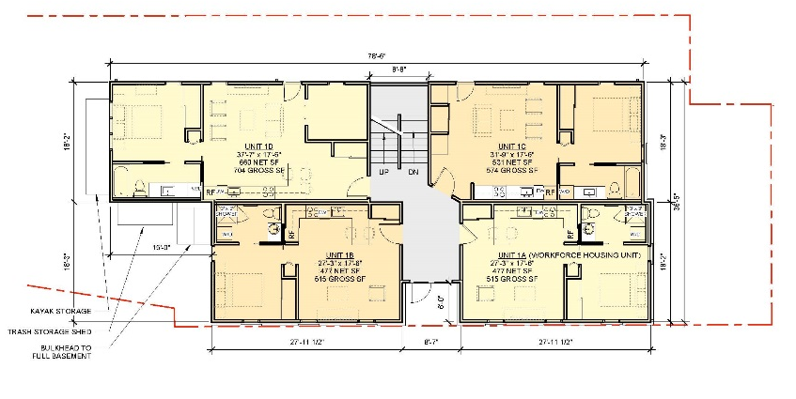
Under Inclusionary Zoning one workforce unit is required, and this is located on the first floor (see Plan 15 and first floor layout at right).

Three (3) parking spaces are provided on site, two in tandem and a handicapped space. Two bike parking spaces are proposed within the gated community landscaped area and 2-3 more are located in the basement for residents.

The proposals include new fencing (some metal; some wood) around the east, west and north sides of the site. A 5 foot wide brick walkway is proposed within and flush with Joy Place between the Brackett Street sidewalk and the brick paved section along the front of the new building. Bollard lighting is included along the edge (near south boundary with City parking lot) of the first part of the walkway.

The applicant had originally proposed trees along the edge of Joy Place, but these have been omitted due to the legal requirement to keep Joy Place clear. The applicant does not own any land alongside Joy Place, so the boundary is marked with a series of bollards with lighting.

- RIGHT, TITLE & INTEREST AND FINANCIAL AND TECHNICAL CAPACITY
The applicant has submitted a copy of the deed for the site which fronts onto Joy Place (Attachment D). The deed confirms the owner has access via Joy Place, which is a private street that is to be kept “open and unobstructed forever”. The applicant is proposing to remove two existing utility poles (with cobra lights) in Joy Place and has not provided evidence of the right to remove these poles and associated overhead lines - a suggested condition of approval relates to this question.

- STAFF REVIEW

        - ZONING ASSESSMENT - PARKING REQUIREMENTS
The proposals meet all of the dimensional standards of the B1 zone and address the parking requirements as follows (Attachment X):

- 3 parking spaces on site- of which 1 is a handicap parking space and the other two are tandem;
- 8 spaces leased in the parking lot at 699 Congress Street via a 5 year lease (within 1500 ft of the site);
- Requesting that the Planning Board establish a parking requirement of 11 off-street parking spaces to serve this project, based on the determination that there is less parking demand than one parking space per unit.

As noted in the Workshop Memo, the zoning ordinance for the B1 zone and the parking ordinance would allow the parking requirements to be met by one, or a combination of, the following options:

- Provision of 12 parking spaces on site
- Payment of a fee in lieu (approx. $5000 per parking space) that would go into the Sustainable Transportation Fund for eligible projects. If this option was applied to this project the question is whether the payment would be for 10 spaces or 8 spaces, depending on how the tandem spaces are counted.
- Provision of a shared-use vehicle (one equates to 8 required parking spaces, but can be no more than 50% of the parking requirement);
- Requesting that the Planning Board establish different parking requirements based on unique conditions that result in a lesser parking demand than the existing parking requirement of one space per unit.
- Securing leased parking spaces (full time) within 1500 feet of the site, confirmed by a lease for at least 5 years;

The applicant has provided additional information regarding the demand for parking by people renting one bedroom units in the vicinity (Attachment X) which indicates that it is unlikely all of the occupants will own a car. Staff recommend that the Planning Board reduce the parking requirement to 11 spaces and support the applicant’s proposal to meet this revised requirement by a combination of on-site and leased parking spaces. A suggested condition of approval sets out this recommendation.

B. SUBDIVISION STANDARDS
14-496. Subdivision Plat Requirements
The applicant has submitted a draft plat which will be finalized prior to signature in accordance with the standard condition of approval. The DPW Surveyor has provided comments (Attachment 7) and a suggested condition of approval requires that these be addressed. The future maintenance of Joy Place, including snow removal, and the proposed features such as bollards and brick paving, has not been addressed in the plat nor in the Condominium Documents and a suggested condition requires that this question be clarified.

14-497. General Requirements (a) Review Criteria
Water, Air Pollution and Soil Erosion
The applicant has received a capacity letter from the Portland Water District (Attachment M.) and provided Erosion Control Notes in Plan P11, thus meeting this standard.

Traffic
The Traffic Engineer has confirmed that the project is not expected to generate a significant amount of traffic nor create safety or congestion deficiencies (Attachment 1).

Parking - See under VII A Zoning above

Sanitary Sewer/Soils
The application has been reviewed by the consulting Peer Engineer (Attachment 2) and is acceptable subject to confirmation of wastewater capacity.

Storm water
The proposal creates a small amount of additional impervious surface and does not require stormwater management or treatment, as confirmed by the Peer Engineering reviewer in Attachment 2.

Scenic Beauty and Street Trees
The proposal replaces a delipidated residential building and improves Joy Place. The community landscaped space and landscaping around the building will contribute to the scenic beauty of the area. The street tree requirement is discussed under the Site Plan review.

Comprehensive Plan
The project is consistent with the Housing Goals and Policies of the Comprehensive Plan.

Electrical Service
The Subdivision ordinance requires electrical service to be underground and the proposals place the service underground between the Brackett Street right-of-way and the new building (Plan P9). A new utility pole will be installed at the corner of Joy Place and Brackett Street.
C. SITE PLAN STANDARDS
14-526 Site Plan Standards
The proposed development has been reviewed by staff for conformance with the relevant review standards
of Portland’s site plan ordinance and applicable regulations. Staff comments are listed below.

Traffic - Access, Circulation, Loading and Servicing
The Traffic Engineer is concerned that there be minimal maneuvering or backing out of cars in Joy Place and has reviewed the turning templates and management information. He recommends a condition that requires the parking spaces to be allocated in order to avoid casual use and associated access (Attachment 1).

Right of Way
The applicant is proposing to reconstruct the apron and part of the sidewalk in brick paving; this is considered acceptable subject to adherence to the Technical Standards regarding materials/design and to addressing the Traffic engineer comments regarding the 2% cross slope requirement. These requirements are incorporated into suggested conditions of approval.

Public Transit Access - these standards do not apply to this project.

Parking: See discussion under VII A Zoning above. The Traffic Engineering Reviewer supports the recommendation to reduce the parking requirement to 11 spaces and provide three spaces on site and eight in leased parking spaces (Attachment 1).

Bicycle Parking: The applicant has relocated 2 of the 4 required parking spaces to the community landscaped area, which can only be reached via a locked gate (the others are in the basement). Staff suggest this is acceptable in view of the limitations on placing fixed items in Joy Place.

Snow Storage: A Snow Removal Agreement will need to be developed and documented in the Condominium Documents and the Subdivision Plat.

Transportation Demand Management: does not apply to this project

Construction Management Plan
The applicant has submitted a revised Construction Management Plan that addresses the City’s CMP template (Attachment I). Both the Traffic Engineering and DPW reviewers (Attachments 1 and 8) are concerned about the impacts on the sidewalk, given the extensive use of this sidewalk by students and teachers at the school across the street. A suggested condition of approval requires minimal impacts and greater specificity as to the needed sidewalk closures and related impacts.

Landscape Preservation / Site Landscaping and Screening
The proposed landscaping has been reviewed by the City Arborist and he recommends substituting a different species of tree for the proposed Amur Maple in the community open area (Attachment 4).

The brick walkway between the Brackett Street sidewalk and the front door of the new building is welcomed. While tree planting along this route would have been desirable, it is understood to be prohibited by the legal requirement to keep Joy Place unobstructed (the additional information in Attachment Y has been superseded).

Street Trees: The project is required to include 12 street trees (one per unit). There is one existing street tree in the ROW and none are proposed on the site. The applicant has confirmed they will contribute to the tree fund in respect of the required street trees (11) (Attachment S). The City Arborist has confirmed the contribution will target tree planting in the Brackett/Spring Street and Reiche School area.

Water quality, Stormwater Management and Erosion Control - see discussion under Subdivision Review above.

Public Safety
The Crime Prevention through Environmental Design (CPTED) standards in the site plan ordinance address the principles of natural surveillance, access control and territorial reinforcement so that the design of developments enhance the security of public and private spaces and reduce the potential for crime.

The proposals have introduced fencing to limit access and provided bollard lighting along the walkway and building mounted lighting on the building along the front and two of the sides (see photometric and Plan P14). The area for the handicap and tandem parking is not proposed to be lit or enclosed, and if the nearby existing cobra light is removed that area will be very dark. Its location adjacent to the rear of the abutting parking lot (which is also dark) is of concern and lighting should be introduced here.

The applicant proposes to remove the two cobra lights (each on a separate pole) in Joy Place near the boundary with the City parking lot. One of these lights is the only light for the City’s parking lot and its removal creates an adverse impact by making the parking lot more unsafe for users. At the time of writing it is not clear whether the applicant has the right to remove or relocate these lights and how the City’s lot could be lit if they are removed. A suggested condition requests the applicant is requested to work with the City and other abutters of the City’s parking lot to clarify rights and responsibilities regarding the existing cobra lights just within Joy Place and to facilitate replacement lighting, with the removal of the cobra lights to be deferred until replacement lighting (or temporary replacement lighting) has been installed.

Fire Prevention: The Fire Department raised a concern about cars parking in Joy Place and potentially preventing access for emergency service vehicles. The applicant provided further information to the Fire Department (Attachment O) as to how parking would be controlled. The Fire Department has requested additional signage in terms of “No Parking – Fire Lane” be provided to discourage parking in Joy Place (Attachment 3) (and for all parking to be in designated parking spaces). The final site plan (Plan P7) has incorporated the requested signage and the condo documents should advise owners as to the parking limitations.

Public Utilities
The Peer Engineer has reviewed the utilities and these are considered acceptable (Attachment 4).

Massing, Ventilation and Wind Impact and Shadows: The project does not create any impacts of this nature.

Historic Resources: The Historic Preservation Board has approved the project. The Historic Preservation Program Manager has confirmed that the final plans and details presented to the Planning Board are generally consistent with those approved by the Historic Preservation Board (Attachment 6).

Exterior Lighting including Street Lighting
As noted above under Public Safety, the proposals generally include adequate lighting and the submitted photometric plan (Plan P14) shows appropriate lighting levels except in the vicinity of the on-site parking. There are several aspects that need revision:

- Need to introduce lighting for the parking area;
- Need to revise the bollard specification, as the specification in Plan P14 is not acceptable from an Historic Preservation viewpoint (see Attachment 4);
- A revised photometric will need to be submitted to reflect the above changes; and
- In the CPTED context some trespass from the bollard lighting is a positive impact and staff recommend that the Board waive the trespass requirement in this location.

The removal of the existing cobra lights is discussed under CPTED.

Noise and Vibration
The applicant has confirmed that the units will be heated/cooled using air source heat pumps and the specification (including for compressors) have been submitted in Attachment Q. The application does not contain any information about the location of the twelve compressors. Given the proximity of the building to other residential buildings, staff recommend a condition that requires the submission of a plan showing the location and screening of all such equipment for review and approval prior to installation, in order to ensure these meet the site plan standards.

- DESIGN STANDARDS IN THE SITE PLAN ORDINANCE
The B1 Design Standards do not apply as the project is within the West End Historic District and the Historic Preservation Board review substitutes. Similarly, the design standards that are part of the Multi-family and Other Housing Types Design Standard are not applicable.

The following Multifamily Design Standards continue to apply:
3. Open space on the site for all two-family, special needs independent living unit, bed and
breakfast and multiple-family development shall be integrated into the development site. Such open space in a special needs independent living unit or a multiple-family development shall be designed to complement and enhance the building form and development proposed on the site. Open space functions may include but are not limited to buffers and screening from streets and neighboring properties, yard space for residents, play areas, and planting strips along the perimeter of proposed buildings;

Staff comment: two of the ground level units have private outdoor space, and a community open space available to all residents is provided adjacent to the building.

4. The design of proposed dwellings shall provide ample windows to enhance opportunities for sunlight and air in each dwelling in principal living areas and shall also provide sufficient storage areas;

Staff comment: This standard appears to be met.

5. The scale and surface area of parking, driveways and paved areas are arranged and landscaped to properly screen vehicles from adjacent properties and streets;

Staff comment: The four on-site parking spaces will be visible from Brackett Street but would appear as two cars. There is wood cedar board fencing between the parking spaces and the neighbor on Winter Street, but the plan envisages an open sidewalk along the side boundary between the site and the City’s parking lot.

- INCLUSIONARY ZONING
This project is subject to the Inclusionary Zoning ordinance that ensures the provision of workforce housing. A development of ten or more units of housing in the City is required to provide on-site workforce housing units or make an in-lieu payment to the City’s Housing Trust.

The applicant has submitted a Conditional Use application to address the Inclusionary zoning requirements (Attachment B) and has proposed one unit (one-bedroom) of workforce housing.

The Housing Program Manager has reviewed the Conditional Use for Affordable Housing application at One Joy Place as required by Division 30, Section 14-487, Ensuring Workforce Housing. The ordinance requires a minimum of 10% of a project with 10 or more units to be restricted for Workforce Households and that the number of bedrooms required under Section 14-487(e)3 be at least 10% of the total number of bedrooms made available as part of the project.

The memo from the Housing Program Manager (Attachment 8) confirms the project complies with the ordinance and outlines the conditions that require an Affordable Housing Agreement to clarify and document the details of affordability restrictions.

- STAFF RECOMMENDATION
Subject to the proposed motions and conditions of approval listed below, Planning Division staff recommends that the Planning Board approve the proposed residential development at One Joy Place.

- PROPOSED MOTIONS

- Waivers
On the basis of the application, plans, reports and other information submitted by the applicant; findings and recommendations contained in the Planning Board report for the public hearing on September 26, 2017 for application 2017-103 relevant to Portland’s technical and design standards and other regulations; and the testimony presented at the Planning Board hearing:

- The Planning Board [finds/does not find], based upon the consulting traffic engineer’s review (Attachment 1), that extraordinary conditions exist or undue hardship may result from strict compliance with the Technical Manual Section 1.7.2.7 Location and spacing of driveways. The Planning Board [waives/does not waive] the Technical Manual standard (Technical Manual Section 1.7.2.7) to allow the existing condition to remain, as supported by the Traffic Engineering reviewer.

- The Planning Board [finds/does not find], based on the need to address CPTED requirements through improved lighting along the south boundary, that extraordinary conditions exist or undue hardship may result from strict compliance with the Technical Manual Section 12.2.5 Light Trespass. The Planning Board [waives/does not waive] the Technical Manual standard (Technical Manual Section 12.2.5) to allow limited light trespass from the bollard lighting at this location, subject to the revised photometric being reviewed and approved by the Planning Authority.

- Inclusionary Zoning – Conditional Use
On the basis of the application, plans, reports and other information submitted by the applicant; findings and recommendations contained in the Planning Board Report for the public hearing on September 26, 2017 for application 2017-128 (One Joy Place) relevant to the Conditional Use as authorized by Division 30, Section 14-487 Ensuring Workforce Housing; and the testimony presented at the Planning Board hearing:

The Planning Board finds that the Conditional Use is/is not in conformance with the standards of the land use code and approves/does not approve the application, subject to the following conditions of approval:

- Provided the Applicant and the City enter into an Affordable Housing Agreement (AHA) before a Building Permit may be issued.

- The AHA will outline the details of the affordability restrictions placed on the workforce units and will be filed as a covenant to the 75 Chestnut Street property’s deed with the Cumberland County Registry of Deeds before a Certificate of Occupancy may be issued.

- Subdivision
On the basis of the application, plans, reports and other information submitted by the applicant; findings and recommendations contained in the Planning Board report for the public hearing on September 26, 2017 (One Joy Place) relevant to the subdivision regulations; and the testimony presented at the Planning Board hearing:

The Planning Board finds that the plan is/is not in conformance with the subdivision standards of the land use code and approves/does not approve the application, subject to the following conditions of approval, which must be met prior to the signing of the plat:

      - The applicant shall submit a final subdivision plat for review and approval by Corporation Counsel, the Department of Public Works, and the Planning Authority; and

      - The final subdivision plat shall address the comments from Bill Scott, DPW Surveyor, dated 9.20.2017; and

      - The subdivision plat and Condominium Association documents shall include clarification of responsibilities for the maintenance, including snow removal, of Joy Place and associated features such as bollard lights and brick paving; and

      - That the Condominium Association documents and related plans shall require that residents do not park in Joy Place except in the designated parking spaces shown on the Plat, and that the On-Site Parking Space # 1 be designated to a specific residential unit and the On-Site Parking Spaces #2 and #3 be designated to a single residential unit; this is required in order to ensure emergency service access and to prevent vehicle blockage issues; and

      - The Condominium Association documents shall be finalized to the satisfaction of the Associate Corporation Counsel and Planning Authority.

- Site Plan
On the basis of the application, plans, reports and other information submitted by the applicant, findings and recommendations contained in Planning Board report for the public hearing on September 26, 2017 for application 2017-103 (One Joy Place) relevant to the Site Plan Ordinance and other regulations and the testimony presented at the Planning Board hearing:
The Planning Board finds that the plan is / is not in conformance with the site plan standards of the land use code, subject to the following conditions:
- That the parking required for the proposed 12 unit residential development has been determined by the Planning Board to be 11 spaces of which 3 spaces are provided on site and 8 spaces shall be provided in the identified off-site locations or equivalent. In the event that the uses change, the parking requirement would need further review by the Planning Board; and

- That the applicant shall work with the City and other abutters of the City’s parking lot to clarify rights and responsibilities regarding the two existing cobra lights (located just within Joy Place) and to facilitate replacement lighting, with the removal of the cobra lights to be deferred until replacement lighting (or temporary replacement lighting) has been installed; and

- That the Construction Management Plan shall be revised for review and approval by the Planning Authority and the Department of Public Works prior to the issuance of a building permit, to minimize impacts on the sidewalks and provide details to address the comments from the Traffic Engineer reviewer dated 9.21.2017 and from the DPW Senior Engineer dated 9.22.2017; and

- That the photometric plan shall be revised for review and approval by the Planning Authority prior to the issuance of a building permit, to show adequate lighting in the vicinity of the three on-site parking spaces and confirm the specification and photometric characteristics of the revised bollard lighting; and

- That the Landscaping Plan shall be revised, for review and approval by the City Arborist and Planning Authority prior to the issuance of a building permit, to replace the Amur Maple with a species suggested by the City Arborist in his comments dated 9.21.2017; and

- That a plan showing the location and screening of all HVAC/heatpump/compressor and similar equipment shall be submitted for review and approval by the Planning Authority prior to installation, in order to ensure these meet the site plan and zoning standards; and

- That the applicant has demonstrated that site constraints prevent the planting of all of the 12 required street trees (one per unit for multi-family development) in the right-of-way, and therefore the applicant shall contribute $4400 for eleven street trees to Portland’s tree fund, which the City Arborist will target for Brackett/Spring Street and Reiche School area; and

- That the design of the apron and associated sidewalk shall meet Technical Standards and conform to the design detail provided in the final submissions (2% maximum cross-slope); and

- That the Wastewater Capacity letter shall be submitted prior to the issuance of a building permit.

ATTACHMENTS:
Attachments to Report
  - Traffic Engineering Review final comments 9.21.2017
  - Peer Engineering Review final comments 8.30.2017
  - Fire Department comments (no update)
  - City Arborist final comments 9.21.2017
  - Parking Manager comments (as for PB Workshop)
  - Historic Preservation final comments 9.22.2017
  - DPW Surveyor final comments 9.20.2017
  - Housing Program Manager IZ Memo 9.18.17
  - DPW Senior engineer final comments 9.22.2017
Public Comments
PC1 Holmes 6.23.17
PC2 Tousignant 6.30.17
PC3 Plymale July 2 and 5, 2017
PC4 Gebhardt 7.2.17
PC5 Kimble 7.5.17
PC6 Watson 7.5.17
PC7 Rathband 7.5.17
PC8 Roseberry 7.8.17
PC9 Parker 7.11.17
PC10 Stauffer 9.18.17
PC11 Frederick 9.22.17
PC12 Carleton 9.22.17

Applicant’s Submittal
- Cover Letter and revised Application Site Plan
- Cover letter & Application IZ Conditional Use
- Development Description
- Right, title and Interest
- State and Federal Permits
- Land use Ordinance Review
- Easements/other burdens
- Financial and Technical Capability letter
- Construction Management (revised)
- Natural Features
- Stormwater Management
- Consistency with City Master Plans
- Utilities
- Solid Waste
- Fire Safety & Emergency Services Info
- Conformity with Standards
- HVAC Equipment
- Neighborhood Meeting Information
Since PB Workshop
- Letter Add’l Info 8.7.17
- Letter Comment response 8.7.17
- Condominium Bylaws and Declaration
- Inclusionary Zoning details
- Inclusionary Zoning Agreement
- Parking memorandum
- Letter Add’l Info (mainly sidewalk link to building)

Plans
P1. Cover Sheet
P2. General Notes
P3. Boundary Survey
P4. Existing Conditions and Removals
P5. Construction Management Plan
P6. Recording Plat
P7. Site Layout Plan
P8. Grading Plan
P9. Utility Plan
P10. Landscaping Plan
P11. Erosion Control Notes
P12. Site Details
P13. Utility & Drainage Details
P14. Bollard Detail & Photometric Plan
P15. Floor Plans (4 sheets)
P16. Elevations

