CITY OF PORTLAND, MAINE

PLANNING BOARD

Elizabeth Boepple, Chair
Sean Dundon, Vice Chair
David Eaton
Brandon Mazer
Carol Morrissette
Maggie Stanley
Lisa Whited

October 11, 2017

Onejoy Place LLC  Attention: Todd Alexander  c/o Renewable Housing Associates LLC  2 Union Street, 5th floor  Portland, ME 04101 | Michael Tadema-Wielandt, PE  Terradyn Consultants, LLC  565 Congress Street, Suite 310  Portland, ME 04101

Project Name: Onejoy Place Condominium - Twelve Unit Residential Building
Project ID: 2017-103 (Subdivision and Site Plan)
2017-128 (Conditional Use Inclusionary Zoning)
Address: 1 Joy Place CBL: 045 E049001
Applicant: Onejoy Place LLC
Planner: Jean Fraser

Dear Mr. Alexander:

On September 26, 2017, the Planning Board approved the construction of a three story twelve-unit residential building at 1 Joy Place, a short private street located between 157 and 165 Brackett Street. The Planning Board reviewed the proposal for conformance with the standards of the Inclusionary Zoning, Subdivision and Site Plan Ordinances, as well as the B-1 Commercial Business Zone Standards. The Planning Board voted unanimously 6-0 (Boepple absent) to approve the application with the following waivers and conditions as presented below.

- Waivers
On the basis of the application, plans, reports and other information submitted by the applicant; findings and recommendations contained in the Planning Board report for the public hearing on September 26, 2017 for application 2017-103 relevant to Portland’s technical and design standards and other regulations; and the testimony presented at the Planning Board hearing:

- The Planning Board voted unanimously 6-0 (Boepple absent) that it finds, based upon the consulting Traffic Engineer’s review (Attachment 1), that extraordinary conditions exist or undue hardship may result from strict compliance with the Technical Manual Section 1.7.2.7 Location and spacing of driveways. The Planning Board waives the Technical Manual standard (Technical Manual Section 1.7.2.7) to allow the existing condition to remain, as supported by the Traffic Engineering reviewer.

- The Planning Board voted unanimously 6-0 (Boepple absent) that it finds, based on the need to address CPTED requirements through improved lighting along the south boundary, that extraordinary conditions exist or undue hardship may result from strict compliance with the Technical Manual Section 12.2.5 Light Trespass. The Planning Board waives the Technical Manual standard (Technical Manual Section 12.2.5) to allow limited light trespass from the bollard lighting at this location, subject to the revised photometric being reviewed and approved by the Planning Authority.

- Inclusionary Zoning – Conditional Use
On the basis of the application, plans, reports and other information submitted by the applicant; findings and recommendations contained in the Planning Board Report for the public hearing on September 26, 2017 for application 2017-128 (One Joy Place) relevant to the Conditional Use as authorized by Division 30, Section 14-487 Ensuring Workforce Housing; and the testimony presented at the Planning Board hearing:

The Planning Board voted unanimously 6-0 (Boepple absent) that it finds that the Conditional Use is in conformance with the standards of the land use code and approves the application, subject to the following conditions of approval:

- Provided the Applicant and the City enter into an Affordable Housing Agreement (AHA) before a Building Permit may be issued.

- The AHA will outline the details of the affordability restrictions placed on the workforce units and will be filed as a covenant to the One Joy Place property’s deed with the Cumberland County Registry of Deeds before a Certificate of Occupancy may be issued.

- Subdivision
On the basis of the application, plans, reports and other information submitted by the applicant; findings and recommendations contained in the Planning Board report for the public hearing on September 26, 2017 for application 2017-103 (One Joy Place) relevant to the subdivision regulations; and the testimony presented at the Planning Board hearing:

The Planning Board voted unanimously 6-0 (Boepple absent) that it finds that the plan is in conformance with the subdivision standards of the land use code and approves the application, subject to the following conditions of approval, which must be met prior to the signing of the plat:

      - The applicant shall submit a final subdivision plat for review and approval by Corporation Counsel, the Department of Public Works, and the Planning Authority; and

      - The final subdivision plat shall address the comments from Bill Scott, DPW Surveyor, dated 9.20.2017; and

      - The subdivision plat and Condominium Association documents shall include clarification of responsibilities for the maintenance, including snow removal, of Joy Place and associated features such as bollard lights and brick paving; and

      - That the Condominium Association documents and related plans shall require that residents do not park in Joy Place except in the designated parking spaces shown on the Plat, and that the On-Site Parking Space # 1 be designated to a specific residential unit and the On-Site Parking Spaces #2 and #3 be designated to a single residential unit; this is required in order to ensure emergency service access and to prevent vehicle blockage issues; and

      - The Condominium Association documents shall be finalized to the satisfaction of the Associate Corporation Counsel and Planning Authority.

- Site Plan
On the basis of the application, plans, reports and other information submitted by the applicant, findings and recommendations contained in Planning Board report for the public hearing on September 26, 2017 for application 2017-103 (One Joy Place) relevant to the Site Plan Ordinance and other regulations and the testimony presented at the Planning Board hearing:

The Planning Board voted unanimously 6-0 (Boepple absent) that it finds that the plan is in conformance with the site plan standards of the land use code, subject to the following conditions:

- That the parking required for the proposed 12 unit residential development has been determined by the Planning Board to be 11 spaces of which 3 spaces are provided on site and 8 spaces shall be provided in the identified off-site locations or equivalent. In the event that the uses change, the parking requirement would need further review by the Planning Board; and

- That the applicant shall work with the City and other abutters of the City’s parking lot to clarify rights and responsibilities regarding the two existing cobra lights (located just within Joy Place) and to facilitate replacement lighting for the abutting parking lot, with the removal of the cobra lights to be deferred until replacement lighting (or temporary replacement lighting) has been installed; and

- That the Construction Management Plan shall be revised for review and approval by the Planning Authority and the Department of Public Works prior to the issuance of a building permit, to minimize impacts on the sidewalks and provide details to address the comments from the Traffic Engineer reviewer dated 9.21.2017 and from the DPW Senior Engineer dated 9.22.2017; and

- That the photometric plan shall be revised for review and approval by the Planning Authority prior to the issuance of a building permit, to show adequate lighting in the vicinity of the three on-site parking spaces and confirm the specification and photometric characteristics of the revised bollard lighting that has been approved by the Historic Preservation Program Manager; and

- That the Landscaping Plan shall be revised, for review and approval by the City Arborist and Planning Authority prior to the issuance of a building permit, to replace the Amur Maple with a species suggested by the City Arborist in his comments dated 9.21.2017; and

- That a plan showing the location and screening of all HVAC/heatpump/compressor and similar equipment shall be submitted for review and approval by the Planning Authority prior to installation, in order to ensure these meet the site plan and zoning standards; and

- That the applicant has demonstrated that site constraints prevent the planting of all of the 12 required street trees (one per unit for multi-family development) in the right-of-way, and therefore the applicant shall contribute $4400 for eleven street trees to Portland’s tree fund, which the City Arborist will target for Brackett/Spring Street and Reiche School area; and

- That the design of the apron and associated sidewalk shall meet Technical Standards and conform to the design detail provided in the final submissions (2% maximum cross-slope); and

- That the Wastewater Capacity letter shall be submitted prior to the issuance of a building permit.

The approval is based on the submitted plans and the findings related to inclusionary zoning, site plan and subdivision review standards as contained in the Planning Report for applications 2017-103 and 2017-128 (attached).

Standard Conditions of Approval
Please note the following standard conditions of approval and requirements for all approved site plans:
- Subdivision Recording Plat A revised recording plat listing all conditions of subdivision approval must be submitted for review and signature prior to the issuance of a performance guarantee. The performance guarantee must be issued prior to the release of the recording plat for recording at the Cumberland County Registry of Deeds.

- Subdivision Waivers Pursuant to 30-A MRSA section 4406(B)(1), any waiver must be specified on the subdivision plan or outlined in a notice and the plan or notice must be recorded in the Cumberland County Registry of Deeds within 90 days of the final subdivision approval.

- Develop Site According to Plan The site shall be developed and maintained as depicted on the site plan and in the written submission of the applicant. Modification of any approved site plan or alteration of a parcel which was the subject of site plan approval after May 20, 1974, shall require the prior approval of a revised site plan by the Planning Board or the Planning Authority pursuant to the terms of Chapter 14, Land Use, of the Portland City Code.

- Separate Building Permits Are Required This approval does not constitute approval of building plans, which must be reviewed and approved by the City of Portland’s Inspection Division.

- Site Plan Expiration The site plan approval will be deemed to have expired unless work has commenced within one (1) year of the approval or within a time period up to three (3) years from the approval date as agreed upon in writing by the City and the applicant. Requests to extend approvals must be received before the one (1) year expiration date.

- Subdivision Plan Expiration The subdivision approval is valid for up to three years from the date of Planning Board approval.

- Performance Guarantee and Inspection Fees A performance guarantee covering the site improvements as well as an inspection fee payment of 2.0% of the guarantee amount and three (3) final sets of plans must be submitted to and approved by the Planning Division and Public Services Department prior to the release of a subdivision plat for recording at the Cumberland County of Deeds, and prior to the release of a building permit, street opening permit or certificate of occupancy for site plans. If you need to make any modifications to the approved plans, you must submit a revised site plan application for staff review and approval.

- Defect Guarantee A defect guarantee, consisting of 10% of the performance guarantee, must be posted before the performance guarantee will be released.

- Preconstruction Meeting Prior to the release of a building permit or site construction, a pre-construction meeting shall be held at the project site. This meeting will be held with the contractor, Development Review Coordinator, Public Service's representative and owner to review the construction schedule and critical aspects of the site work. At that time, the Development Review Coordinator will confirm that the contractor is working from the approved site plan. The site/building contractor shall provide three (3) copies of a detailed construction schedule to the attending City representatives. It shall be the contractor's responsibility to arrange a mutually agreeable time for the pre-construction meeting.

- Department of Public Works Permits If work will occur within the public right-of-way such as utilities, curb, sidewalk and driveway construction, a street opening permit(s) is required for your site. Please contact Carol Merritt at 874-8300, ext. 8828. (Only excavators licensed by the City of Portland are eligible.)

- As-Built Final Plans Final sets of as-built plans shall be submitted digitally to the Planning Division, on a CD or DVD, in AutoCAD format (*, dwg), release AutoCAD 2005 or greater.

- Mylar Copies Mylar copies of the as-built drawings for the public streets and other public infrastructure in the subdivision must be submitted to the Public Services Dept. prior to the issuance of a certificate of occupancy.

The Development Review Coordinator must be notified five (5) working days prior to date required for final site inspection. The Development Review Coordinator can be reached at the Planning Division at 874-8632. All site plan requirements must be completed and approved by the Development Review Coordinator prior to issuance of a Certificate of Occupancy. Please schedule any property closing with these requirements in mind.

If there are any questions, please contact Jean Fraser at 207.874.8728.

Sincerely,


Sean Dundon, Vice Chair
Portland Planning Board

Attachments:
- Traffic Engineering Review final comments (Tom Errico) 9.21.2017
- DPW Surveyor final comments (Bill Scott) 9.20.2017
- DPW Senior Engineer final comments (Keith Gray) 9.22.2017
- City Arborist final comments (Jeff Tarling) 9.21.2017
- Planning Board Report for September 26, 2017 PB Hearing
- Performance Guarantee Packet

Electronic Distribution:

cc: Jeff Levine, AICP, Director of Planning and Urban Development

Tuck O’Brien, City Plannng Director

Barbara Barhydt, Development Review Services Manager

Jean Fraser, Planner

Philip DiPierro, Development Review Coordinator, Planning

Mike Russell, Director of Permitting and Inspections

Ann Machado, Zoning Administrator, Inspections Division

Jonathan Rioux, Inspections Division Deputy Director

Jeanie Bourke, Plan Reviewer/CEO, Inspections Division

Chris Branch, Director of Public Works

Katherine Earley, Engineering Services Manager, Public Works

Keith Gray, Senior Engineer, Public Works

Doug Roncarati, Stormwater Coordinator, Public Works

Greg Vining, Associate Engineer, Public Works

Michelle Sweeney, Associate Engineer, Public Works

John Low, Associate Engineer, Public Works

Jane Ward, Administration, Public Services

Rhonda Zazzara, Field Inspection Coordinator, Public Works

Jeff Tarling, City Arborist, Public Works

Jeremiah Bartlett, Public Works

Keith Gautreau, Fire Department

Daniele West-Chuhta, Corporation Counsel

Thomas Errico, P.E., TY Lin Associates

Lauren Swett, P.E., Woodard and Curran

Christopher Huff, Assessor

Attachment 1

(3 pages)
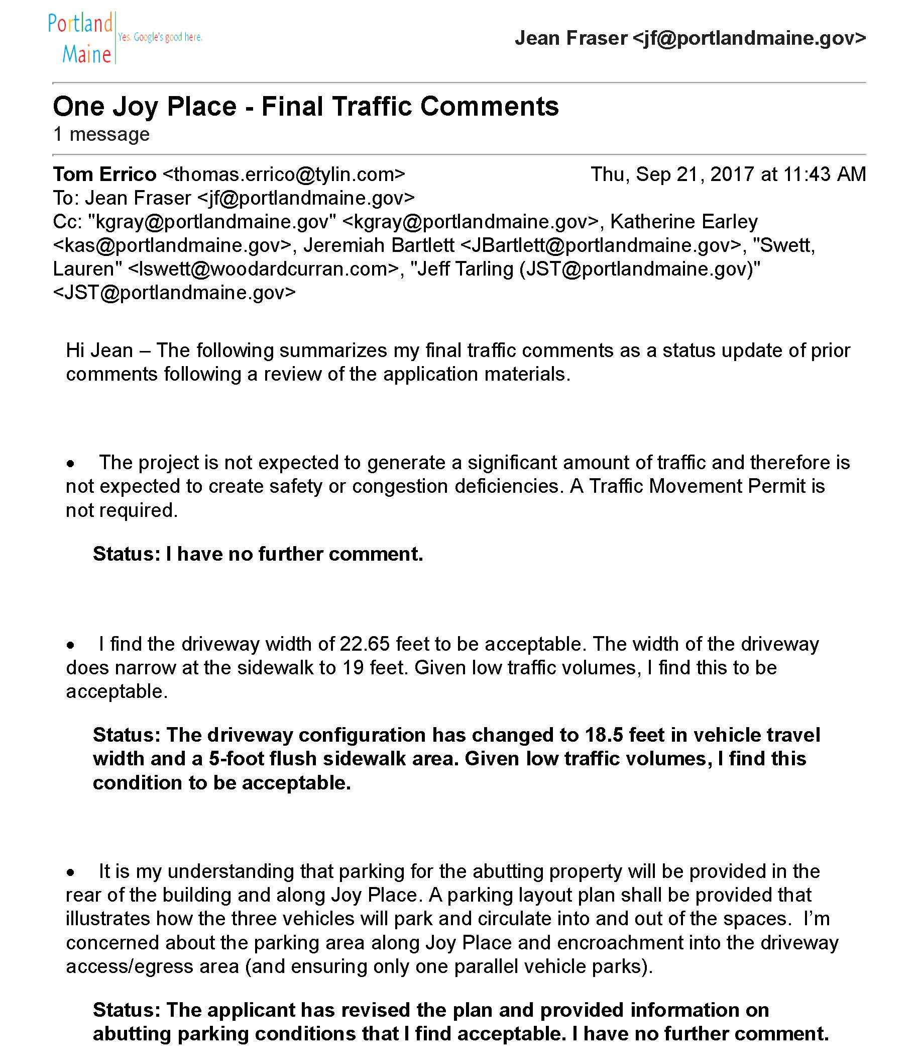

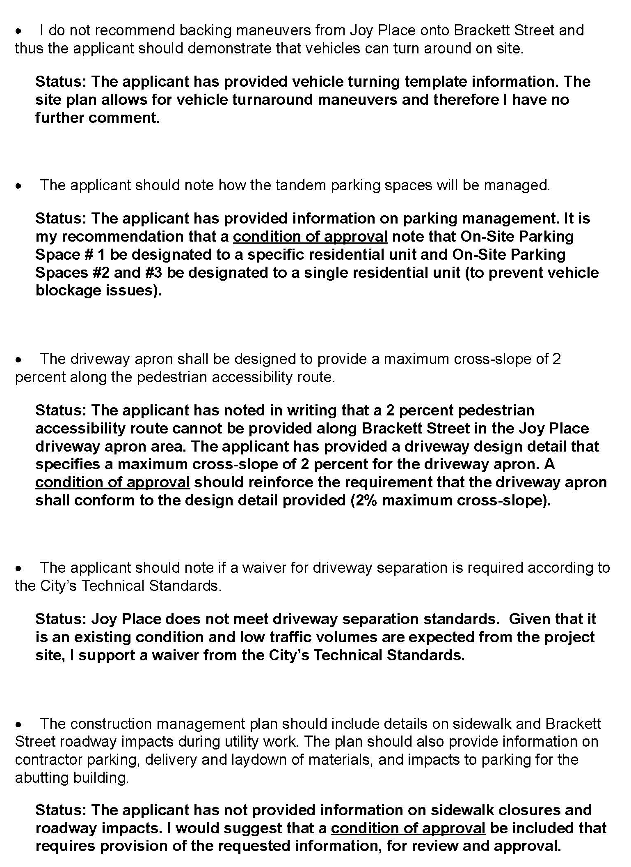


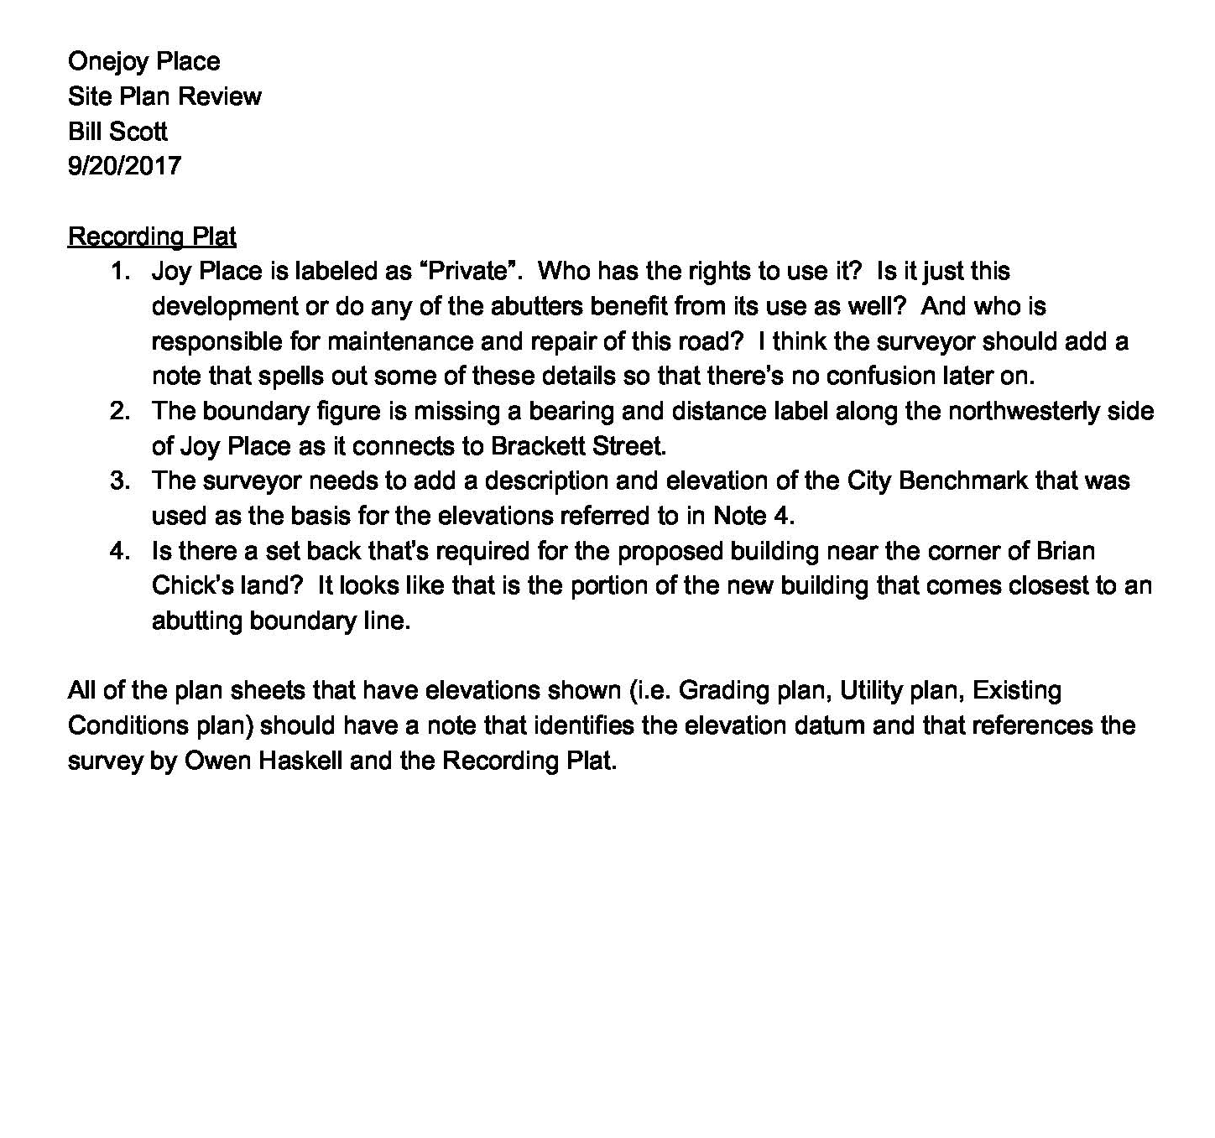
Attachment 2

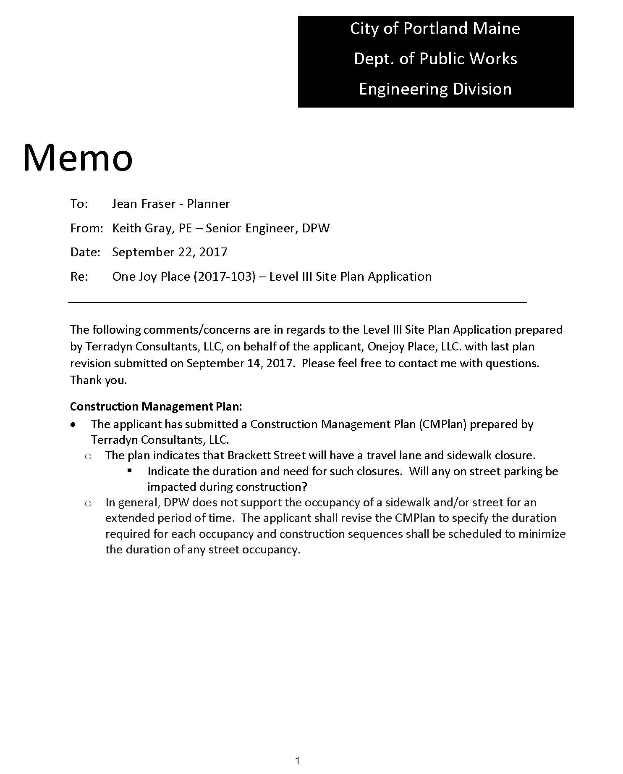
Attachment 3

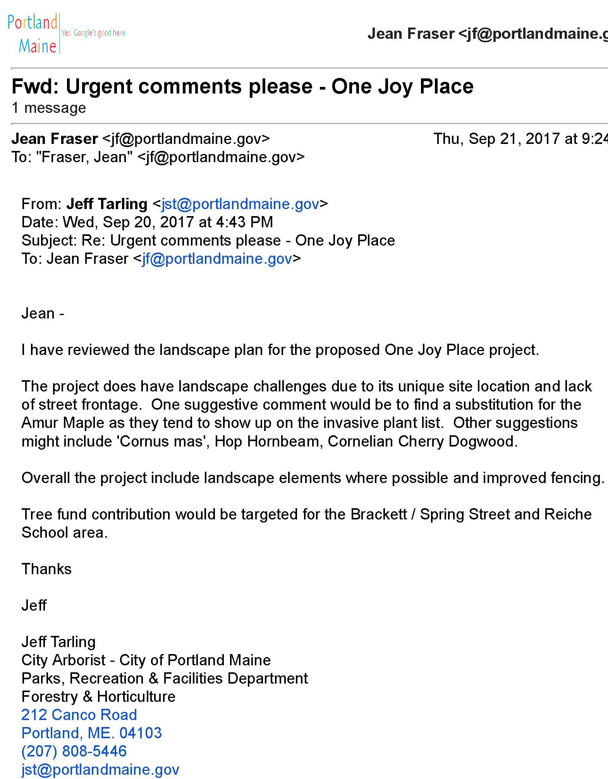
Attachment 4

