Draft 11.7.2013 – work in progress

PLANNING BOARD REPORT
PORTLAND, MAINE

Residential townhouse - 6 unit condominium
133 York Street
Level III Site Plan and Subdivision
Project ID 2013-187
133 York, LLC, Applicant

Submitted to:  Portland Planning Board  Public Hearing Date: November 12th, 2013 | Prepared by: Jean Fraser, Planner  Date: November 8th, 2013  Planning Board Report # 50-13

- Introduction
133 York, LLC has submitted a Level III Site Plan and Subdivision application for the construction of a 6 unit residential building on a 7,483 sq ft “urban infill” site at 133 York Street. The site is currently occupied by a dilapidated 2-unit residential structure. The site is located behind the existing brick 12-unit apartment building at 129 York Street and adjacent to the recently constructed Harborview Townhouse condominium development.

The parcel has an existing narrow pedestrian access from York Street, immediately to the west of the brick apartment building. The proposed building is located on the backland part of the site about 100 feet from York Street, and comprises 3 stories over parking.

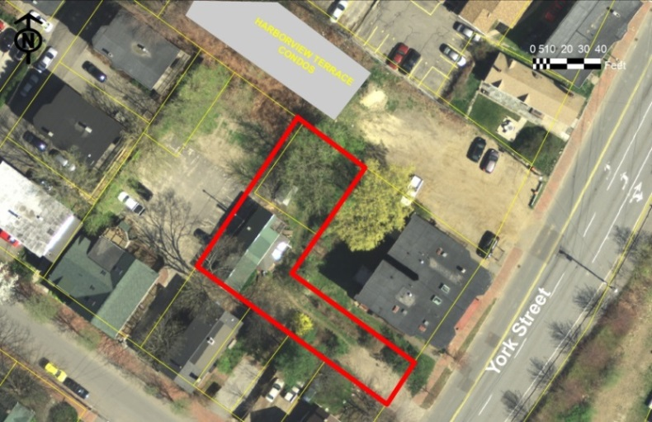
The site is within the R-6 zone but can not apply reduced lot dimensions under the R-6 “small residential lot development” as the lot is not vacant. It is subject to the R-6 design review.

The applicant has held two Neighborhood Meetings in May and August where neighbors raised concerns about the loss of the large tree in one corner, loss of privacy and views, and the increase in height over the existing building (Notes in Attachment I). The Planning Division has received X public comment letters since the Workshop: all objecting to the project based on the loss of trees, access and snow removal issues, height, boundary treatment,, and that the proposed design and materials do not integrate with the (historic) neighborhood.

This Workshop was noticed to 169 neighbors and interested parties, and the public notice appeared in the Portland Press-Herald on November 4th and 5th, 2013.

Required reviews and required waivers
Applicant’s Proposal | Applicable Standards
New structure of 6 dwelling units | Subdivision Review: Subdivision Standards - Section 14-497
Multifamily building of 9,424 square feet floor area | Level III Site Plan Review: Site Plan Standards – 14-526 and  R-6 and Multi-family design reviews
Proposed building is less than 100 feet from the Historic Preservation District to the north (other side of Harborview Terrace) | Ordinance 14-526 (d) 5 b requires that it be generally compatible with the major character-defining elements of the portion of the district nearest the proposed development.
Waiver requested for the six street trees required, due to limited right of way space. | Ordinance Subdivision 14- 499 Required Improvements and Technical Standard 4.6.1- requiring 1 tree per unit to be located in the Right of Way.
Waiver required for parking drive aisles that are approximately 20 ft (to garage support columns). | Technical Standard 1.14 Parking Lot and Parking Space Design rquire a drive aisle of 24 feet width for 90 degree parking.
- PROJECT DATA

SUBJECT | DATA
Existing Zoning | R-6
Existing Use | 2-unit residential building
Proposed Use | 6-unit new building; each unit 2 bedrooms
Parcel Size | 7483 sq ft
Impervious Surface Area  --Existing  --Proposed  --Net Change | 1918 sq ft  5570 sq ft  3652 sq ft
Total Disturbed Area | Approx. 7400 sq ft
Building Footprint  --Existing  --Proposed  --Net Change | 1918 sq ft  2335 sq ft  417 sq ft
Building Floor Area  --Existing  --Proposed | Not known  9424 sq ft
Parking Spaces | 6, under dwellings
Bicycle parking Spaces | 2
Proposed Paved Area | 3235 sq ft
Estimated Cost:
Land uses in the vicinity

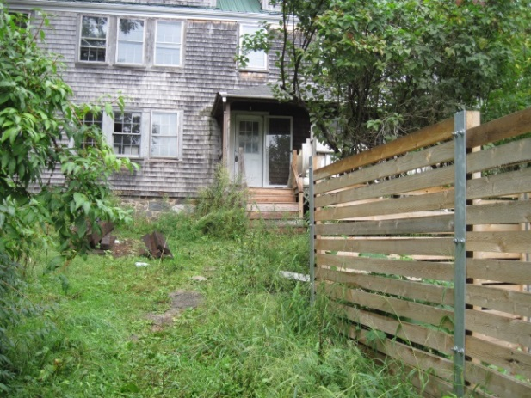
- EXISTING CONDITIONS
The proposal site is located on the north side of York Street between Park and High Streets, approximately 500 feet east of the Casco Bay Bridge intersection and approximately 250 feet west of the intersection of York Street and High Street. The buildable part of the site is set back behind the adjacent 3 story apartment building that fronts onto York Street, and about 5 feet above the amenity area associated with this apartment building (see Survey and Existing conditions, in Plans 1 & 3).

There are 4 upper rear decks on the apartment building that face towards the site.
Existing building on the site
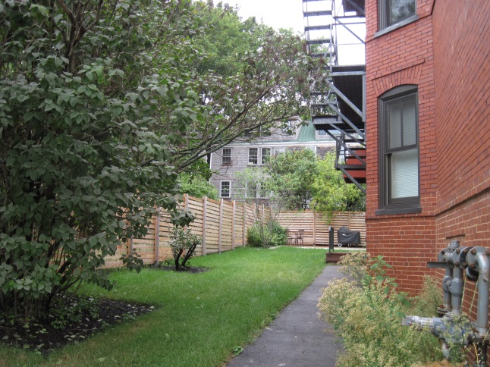
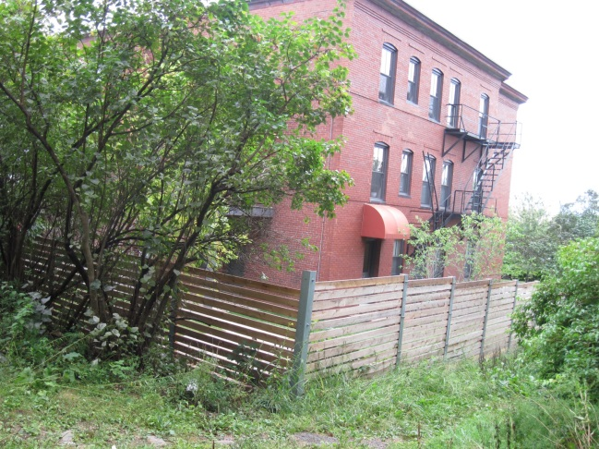

As viewed from York Street Within site, towards York Street
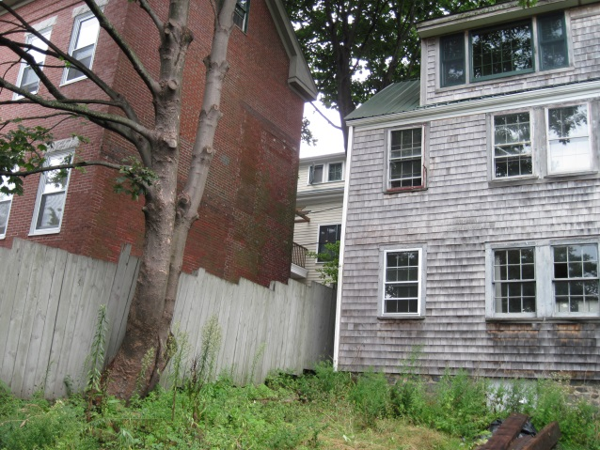
To the north the site abuts the parking area for the McCormick Place (5 unit) condominiums, which is about 5 feet above the level of the proposal site and several feet from the exsiting buildng. Immediately to the west there is a large single family house (see photo right) with one small window facing the proposal site.

To the east is the recently completed Harborview Townhouse (7 unit) condominium development (see photos below). This project is between the site and the historic district boundary to the east.
Looking west from within the site (tree to be removed)
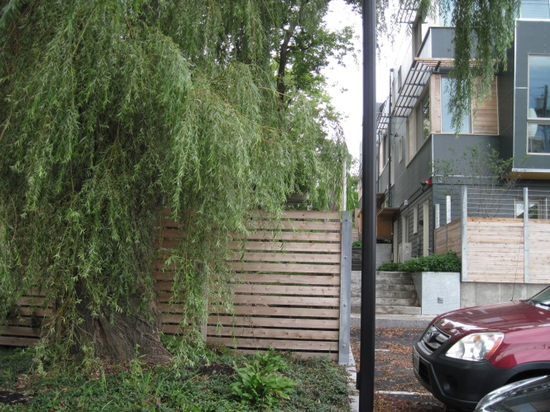
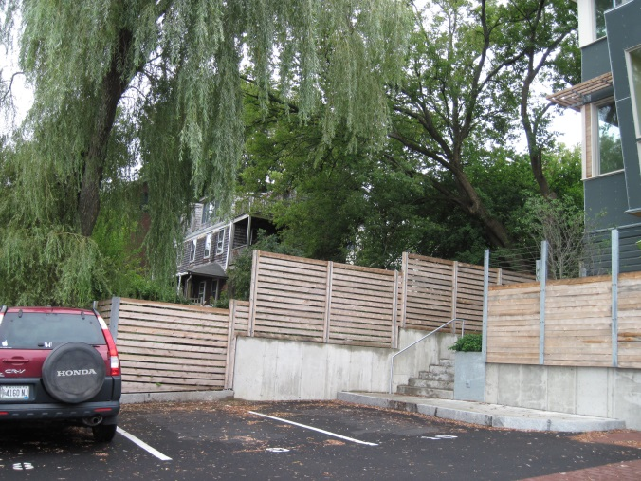

Within Harborview Townhouses towards site Harborview Townhouses western side
- PROPOSED DEVELOPMENT
The proposals, including floor plans and elevations, are included in the final Plan set and have been revised to address Board, staff and neighbor concerns. Changes since the Workshop include;

- Green wall introduced along southeast boundary (side towards York Street);
- Driveway now asphalt apron and no cobbles (as requested by DPS);
- Electrical and gas service from York Street;
- Revised planting near York Street;
- Revised side and rear elevation design.

The proposed building has 4 levels, with parking on the lowest level and sunk about 5 feet below grade (so it will be at about the same level as the rear amenity space for the brick apartment building). The absolute overall height is approximately 30-41 feet, 6-8.5 feet feet higher than the existing building at the west end and about 10 feet higher at the east end.

The new structure is set back 5 feet from the west and north boundaries, 11 feet from the east boundary (Harborview) and
16 feet from the south boundary.

Vehicle access is proposed from York Street via a new 16 foot wide drive with 4 foot sidewalk alongside (flush). As the drive gets near the building it will below the existing grade to give access to the sunken parking area and remove the existing vegetated grade change along the south boundary.
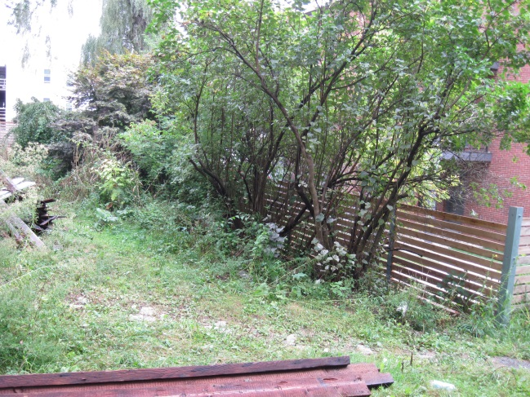
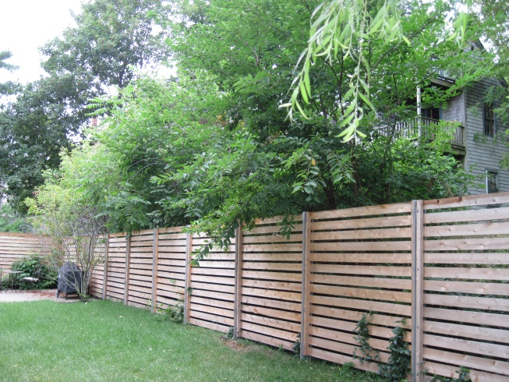

An 8 foot high green wall planted with climbing hydrangea (see location in Plans 3 and 6 and detail in Plan 8 and Attachment S) as a screen between the proposed development and the existing condos that face the site (beside the existing fence shown in the photos). At the rear of the proposed building the finished grade will be about the same as the abutting parking lot, and a shrub screen is proposed along that boundary. Small scale landscaping including some trees is proposed along the east side of the new building and three trees are proposed along the new driveway (Plan 6).

V. PUBLIC COMMENT
The applicant held two neighborhood meetings attended by X people and the notes are included in Attachment I. Comments at the Planning Board Workshop were similar and included concerns regarding of tree removal; design does not fit in; loss of views; construction impacts; loss of privacy; erosion and drainage; snow removal; and potential issues with air conditioners. The Planning Board asked the applicant to work with neighbors to resolve issues.

The applicant has submitted two sets of e-mail exchanges with neighbors and two letters to staff that address neighbors comments (staff forwarded the neighbor comments received so that they could be addressed) (Attachment T).

A total of x letters have been received and are included in Attachment 20, all raising concerns regarding the proposal. It should be noted that some plans were revised on 10.21.2013 (and sent to neighbors) so some of these comments may not take account of the revisions. The key issues are:
- Height
- Design
- Impact of construction
- Impact on trees
- Vehicle maneuvering
- Potential Air conditioners

Reviewers have taken account of the comments as part of the reviews presented in this report (as discussed on other sections) and potential conditions have been included to address most issues.

Many of the McCormick Place neighbors have raised the question regarding potential damage to their vehicles or property. Staff has discussed this with the Legal Department and confirm that the Board is limited in its ability to address these concerns (see Attachment 17). However, the Board is recommended to ensure that the proposed demolition and construction techniques meet engineering standards and a potential condition of approval is recommended to this effect. Similarly, the applicant will need to show appropriate agreements or temporary easements where the work is likely to impact neighbor’s property and trees that are on the property line.

Regarding the question of air conditioners, the City does not control the placement of small window air conditioners but the introduction of condensers outside is something that raise site plan issues. Therefore staff have included a potential condition regarding this kind of equipment to mitigate potential effects.

- RIGHT, TITLE AND INTEREST AND FINANCIAL/TECHNICAL CAPACITY
The proposed demolition and construction associated with the building development is practically on the site boundaries to the west and southwest. Although the construction plan confirms an approach that avoids any need for a construction easement on the McCormick Place property to the west, it is difficult to see how the proposals can be implemented (including tree limb removal and regrading) at the corner and along the Flint/Gilman property. Staff recommend that agreements with both abutters be obtained with respect to the tree work and that a construction easement be obtained with respect to the boundary (and fencing) along the Flint/Gilman property. The suggested condition requires that these be provided to the Planning division prior to the issuance of a building permit.

The application (Attachment B) refers to the fact that the site benefits from a sewer easement across the Harborview Flats property and this is not referenced on the Boundary Survey nor the draft Subdivision Plat.

- STAFF REVIEW

        - ZONING ASSESSMENT
The proposed subdivision is within the R-6 Residential Zone.

Marge Schmuckal, Zoning Administrator, has provided a determination that the project meets the required setbacks and meets the R6 zoning dimensional requirements (Attachment 4). She requested clarifying information on the height dimensions:

“The building height is being met (under 45'). However, the dimensions are being shown to the joist bering and not to the top of the joist as required by definition. I would like to see revised drawing that show the building height from grade (or average grade) to the top of the roof beam.

The architect has submitted detailed height information (Attachment O) and a revised dimensioned elevation, and the Zoning Administrator ….

B. SUBDIVISION STANDARDS
14-496. Subdivision Plat Requirements

The applicant has submitted a draft Subdivison Plat (Plan 2) and draft Condominium documents (Attachment D). The Plat should note the sewer easement and XXXX (from DPS). The Condominium Documents XXX

14-497. General Requirements (a) Review Criteria

- Will Not Result in Undue Water and Air Pollution (Section 14-497 (a) I), and Will Not Result in Undue Soil Erosion (Section 14-497 (a) 4)

An Erosion Control Plan has been submitted (Plan 5) and is acceptable (Attachment 3).

- Sufficient Water Available (Section 14-497 (a) 2 and 3)

A letter from the Portland Water District dated 5.16.2013 (Attachment J.1) confirms that availaibe of water.

- Will Not Cause Unreasonable Traffic Congestion (Section 14-497 (a) 5)
The proposals originally included a new 20 foot wide driveway to access the parking beneath the new building. The proposals have been revised to address the comments from Tom Errico (Attachment 2) that requested a pedestrian way between the York Street sidewalk and the new building. The current proposals provide a 16 foot vehicle way and an abutting and distinct 4 foot pedestrian way, which are flush to provide a 20 foot wide paved access route for fire apparatus. This is satisfactory to both Traffic and Fire Department reviewers (Attachments 14 and 10).

The size and placement of the building results in a narrow parking aisle leading to the 6 parking spaces located underneath eh building. This potentially could cause congestion if the layout encouraged residents to back out of the drive onto York Street, which is heavily trafficked at this location near the bridge to South Portland.
For this reason the Traffic Engineering Reviewer, Tom Errico, requested turning templates to illustrate the feasibility of access/maneuvering (Attachment 2). These were submitted and two of the parking spaces appeared difficult to access (see Attachment Y; an example is at right); Mr Errico wanted to confirm the adequacy of maneuvering space, as he has commented (Attachment 14):

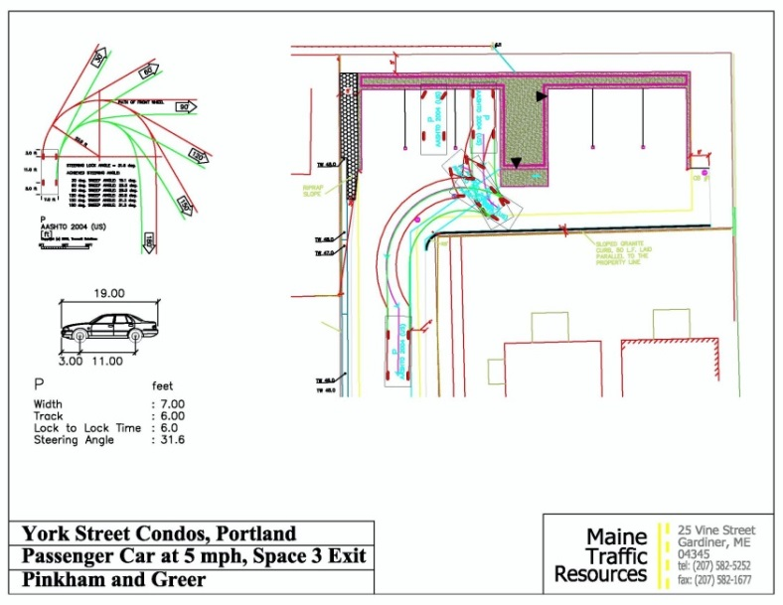
- Access and egress movements into the garages appear difficult given the narrow pavement area. The applicant shall provide turning template graphics for a standard passenger car illustrating the ability of vehicles to adequately circulate on-site.

Status: The applicant has provided the requested turning template graphics. Given site constraints, I also requested that the applicant provide a simulated site layout in a parking area so that I could determine if vehicles could access/egress the parking garages. Based upon the field study, some garages will require multiple maneuvers (k-turns) to enter and exit the garages. The site is very constrained and the ease in which vehicles can make their intended maneuver will be a function of the design vehicle. My field simulation was based upon a Subaru station wagon and this represents a mid-size vehicle. Large Single-Unit Vehicles (SUV) will have greater difficulty.

With all that said, I do support a waiver from our technical standards for parking lot aisle width dimensions. The waiver is suggested given the unlikelihood that vehicles will back down the driveway into York Street. There is a significant distance between the garages and York Street, and thus feel that all maneuvers will occur on-site. I would note that the bicycle rack should be relocated so that it does not impede circulation. Additionally, it will be very important that snow removal/maintenance is effective so that snow does not further constrain the site.

The motion for the Board to consider includes this waiver.

- Will Provide for Adequate Sanitary Sewer and Stormwater Disposal (Section 14-497 (a) 6), and Will Not Cause an Unreasonable Burden on Municipal Solid Waste and Sewage (Section 14-497 (a) 7)

The proposals propose to manage stormwater impacts by collecting the stormwater and directing it to a tree filter system, which also allows for some quality treatment. The applicants have provided revised plans and supplementary stormwater information (Attachment W) and these are considered satisfactory (Attachment 12). The Department of Public Services considers the storm drain system in York Street is adequate to handle the proposed project drainage and has no comments regarding the proposed sewer connections.

- Scenic Beauty, Natural, Historic, Habitat and other Resources (Section 14-497 (a) 8)
The impact on trees in the vicinity of the development is explained in Attachment M and shown on Plan 3. The applicant owns the trees to be removed, as indicated on the Survey (Plan 1). The loss of two existing substantial trees within this dense urban area is regrettable, but the ordinance allows for this as long as there is tree replacement.

The Survey (Plan 1) shows that the tree on the north to be preserved is on the site boundary. The proposals include the preservation of this tree, and another large tee 9willow) near the east corner will be protected. The City Arborist, Jeff Tarling, has reviewed the proposals and met with the applicant and neighbors on site; he considers the proposals are satisfactory (Attachment 11). His comments include some detailed recommendations that should be followed in respect of the trees to be preserved/protected and these are referenced in a suggested condition.

Street Trees
The subdivision requirement would be one tree per unit, or 6 street trees, in or near the ROW. The applicant has requested a waiver citing the limited space in the ROW. There are 3 trees proposed to be planted along the entrance drive which may be counted as street tees, so staff suggest that the waiver is supported subject to a contribution to the City’s Street Tree fund for three (3) trees.

- Comprehensive Plan (Section 14-497 (a) 9)
The applicant has referred to the Comprehensive Plan as related to housing policies (Attachment B) and the project is compatible with Comprehensive Plan goals and policies.

7. Financial Capability (Section 14-497 (a) 10)
A letter from Milk Street Capital LLC dated 6.26.2013 confirming financial capability is included at Attachment G.

C. SITE PLAN STANDARDS 14-526 Requirements for approval

- Transportaion

Impact on Surrounding Street Systems and Access and Circulation- see Subdivision Review.

Construction (Traffic) Management Plan
The proposal has been revised to provide underground utility connections from York Street (Plan 5) and this will entail street opening in York Street. Because of the heavy traffic at peak hours in this location the Traffic engineering Reviewer has requested a condition requiring a construction (traffic) management plan and notes that “given the high level of traffic on York Street, it is very likely that construction activity will not be allowed during peak traffic time periods.”

Loading and Servicing
The Traffic Engineering reviewer has commented (Attachment 14):

Sec 14-526 Site plan Standards (a) Transportation. 2.b. Loading and Servicing All developments served by delivery or other service vehicles shall provide a clear route and travel way geometric design that permits safe turning and backing for the maximum vehicle length that would service the development and does not impede site access, vehicle circulation, pedestrian movements or parking. The City has historically interpreted this standard as being applicable for large developments that have specific site truck features such as loading docks. This standard is not applicable in the core urban area of Portland and where little or no on-site vehicles circulation is provided (unless it is a large development). Accordingly, this standard does not apply to the proposed project.

Sidewalk and ROW
The Department of Public Services has commented that a note needs to be added to the plans requiring that work in the ROW meets City standards, and that according to the City’s materials policy the driveway apron should be asphalt and not brick as proposed (Attachment 6). The proposal has been revised to address this comment, and the cobbles have been omitted from the proposals because the existing cobbles are within the ROW and the applicant will be required to give those cobbles to the City when the construction begins.

Public Transit Access
The public transit requirements do not apply to this project.

Parking
There are 6 parking spaces to meet zoning requirements and these are located in the “sunken” level underneath the units.

Bicycle Parking (also Motorcycle and Scooter parking)
The proposals include 2 bicycle parking spaces at the rear of the existing building, which meets the ordinance standard of 2 bicycle spaces per 5 vehicle spaces.

Snow Storage
An “Off-Site Snow Removal Plan” is included on Plan 4 and staff consider this is acceptable. The importance of timely snow clearance was part of the Traffic Engineer comments (Attachment 14), so the “Snow Removal Plan” is suggested to be highlighted on the Condominium Association documents and on the Subdivision Plat.

TDM - does not apply to this proposal.

- Environmental Quality Standards

Preservation of significant Natural Features/Landscape Preservation- see Subdivision Review (Scenic Beauty)

Site Landscaping and Screening
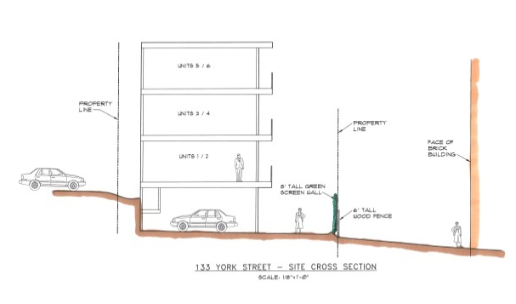
The Landscaping Plan (Plan 6) proposes the planting of 7 trees: 4 at the eastern side of the building and 3 along the access drive. Bayberry planting is proposed near York Street and shrub planting is proposed along the rear boundary where the final levels will be raised.

An 8 foot tall “Green Wall” (location in Plans 3 and 6 and detail in Plan 8 and Attachment S) is proposed along the boundaries nearest to the large brick 12 unit building (on side towards York Street) to provide screening (also see section in Plan 22 and right).

On the west side there is a rip rap slope and no proposed planting, but that is similar to the existing condition with the existing building.

The City Arborist, Jeff Tarling, has commented (Attachment 11):

a) Landscape review - The proposed development at 133 York Street presents challenges to
meet standard landscape treatment due to the shape and constraints of the project site. The project
does offer landscape amenities such as a green wall to provide screening along with two off-site
tree planting locations if agreeable. The building footprint close to existing building site poses
challenges to screen but improves on the long existing conditions. Two mature trees are close
and will likely have impact during the construction process. Best practices in regards to tree
protection are needed to prevent / reduce root zone damage.

b) Landscape plant material: plant sizes - Condition) shrub stock noted as "D" Clethra, "F" Deutzia,
"J" Northern Bayberry, "K" Climbing Hydrangea, "L" Stephanandra shall all be #3 pot size minimum
and tree sizes should be the following: "B" Flowering Crabapple 1.75-2" caliper, "C" Armstrong Red Maple
2" caliper. Items mentioned as "Existing", "G" Relocated Japanese Maple (#5 pot size), "H" Relocated
Lilac (3-4'H) should also have these sizes as replacements if the relocation is not successful. (Too often
good intent to save plants through construction are less then successful).

c) Green wall - the proposed project use of a green wall will help screen / buffer the adjacent building. The
green wall plant type: Climbing Hydrangea is slow growing, and thus the proposed 1 gallon pot size much to
small to be effective for many years... recommendations & condition the green wall plant sizes must be
#3 pot & #5 pot sizes alternating minimum to provide a good start for the green wall.
(from 11.4.2013 comments): A solid screen such as a fence, would not, in my view,
improve the proposed.

A potential condition of approval requires the revision to the Landscape Plan to incorporate these recommendations.
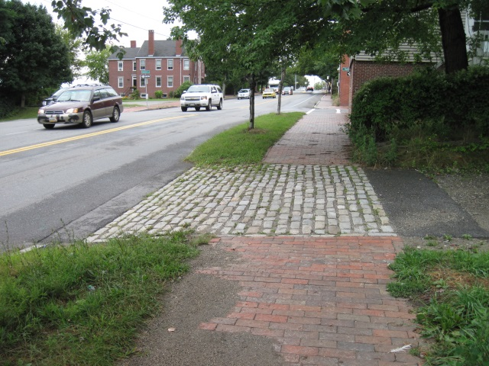
Street Trees - see subdivision Review.

Water quality, Stormwater Management and Erosion Control
As discussed above under Subdivision Review.

- Public Infrastructure and Community Safety Standards

Consistency with City Master Plans
The applicant has revised the materials where he new drive crosses the sidewalk to meet City requirements for materials in this area. The existing cobbles will be given to the City DPS as per DPS policy.

Public Safety and Fire Prevention
The Fire Department requested a NRPA 1 code analysis at the time of the Workshop and staff considered this a fundamental issue as the question of the length, width and radii of the drive access was at issue and potentially could impact the site layout substantially (Attachment 9).

An NFPA 1 Code Assessment was undertaken by a specialist and submitted in late October (Attachment Z). This confirmed that the proposed combination of drive and flush walkway met the standards, and that fire apparatus did not need to be able to drive around the bend in the drive. The Fire Department is satisfied with the proposals subject to the location of the FDC connection being at York Street (Attachment 10).

Public Safety
The Crime Prevention through Environmental Design (CPTED) standards in the site plan ordinance address the principles of natural surveillance, access control and territorial reinforcement so that the design of developments enhance the security of public and private spaces and reduce the potential for crime.

The backland nature of the site reduces the natural surveillance from the street but allows for some surveillance from nearby upper floor dwellings. Some low level lighting long the drive walkway was recommended by staff, and the applicant has introduced bollard lights along this walkway from York Street to the bend in the drive. Overhead garage lighting will provide lighting for the area by the entrance and parking spaces.

Availability and Adequate Capacity of Public Utilities
All utilties are now proposed to be underground and from York Street (Plan 4) and this is acceptable subject to the submission of a Construction (Traffic) Management Plan as discussed above.

Capacity letters have been received for water, sewer and gas- see Attachment J.

The removal of the existing electrical wires and pole (with existing light- see photo in Public Comment Attachment X) that serve the building on the site that will be demolished, has not been resolved. Staff suggested that the applicant contact CMP to determine who is paying for the light but no information has been submitted. It is understood that the McCormick Place Condominium owners may like to have the light (and pole), but that still leaves the question who pays for the electricity for the light. As the resolution of this issue is likely to takesome while, a suggested condition of approval suggests that it is the applicant’s responsibility (including any costs) to resolve this issue and ensure the redundant utilities here are removed.

- Site Design Standards

Massing, Ventilation and Wind Impact
The proposed new building is 26 feet wide by 89 feet long and rises a total of approximately 40 feet. The architect has compared the proposed absolute heights with those of the existing building in a letter (Attachment O and Plans 16 and 17). The footprint is 20% larger than existing and the height ranges from 6-8.5 feet higher than the existing building at the west end. The east end is a new structure and has been designed to be about 10 feet higher (Attachment O).

The proposed building is 12.5 feet from the single family brick dwelling (one window at 3rd floor) to the west (see their comments in Attachment X); 20 feet from the side elevation of Harborview Townhomes (decks and windows-to the east); and 43 feet (closest point) from the main wall of the 12 unit brick building to the south (decks and windows).

The applicable site plan standard is (14-526 (d) (1) b:

The bulk, location or height of proposed buildings and structure shall minimize, to the extent feasible, any substantial diminution in the value or utility to neighboring structures under different ownership and not subject to a legal servitude in favor of the site being developed.

Shadows/Snow and Ice Loading - not considered an issue for this proposal.

View corridors
The loss of views is not a review standard as the Portland Planning ordinances do not protect water views except where they are identified as a protected "view corridor" as per the “View Corridor Protection Plan” approved by the Portland City Council in 2001. Therefore the impact of the proposal on views may not be taken into consideration by the Planning Board.

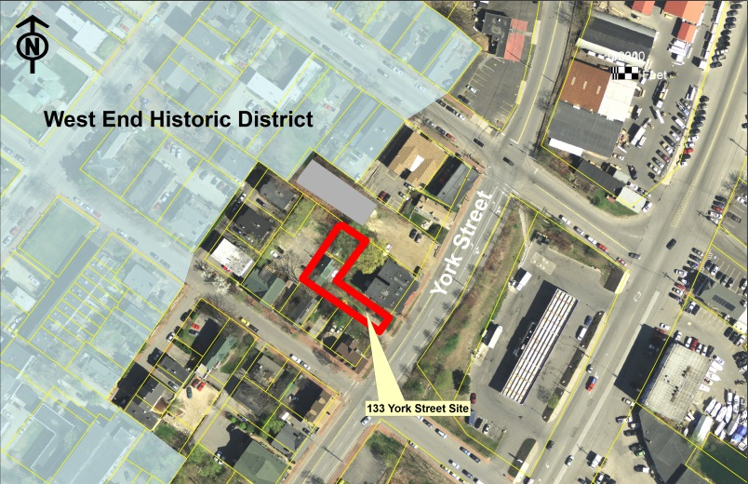
Historic Resources
The Site Plan ordinance includes a requirement for projects to be compatible with the character-defining elements of the portion of the historic district nearest the proposal. The proposal is about 65 feet from the West End Historic District, measured across the Harborview Townhomes site.

The Historic Preservation Program Manager has considered the proposals and provided a Memo (Attachment 18) that notes that between this site and the core of the historic district there are relatively recent developments that are more modern in design and therefore the compatibility of this proposal is not a major issue in this case.

Exterior Lighting
The proposal includes 4 ceiling lights with the parking area on the lowest level; the specification and resulting photometrics have been submitted in Attachment P. While this solution is preferable to pole lights, the photometrics show excessive light levels in the drive area located between the proposed building and the abutting lot and have not been revised for the final submission. The proposals have introduced bollard lighting along the drive walkway (Attachment R and Plan 3). While welcome, these bollard lights abut the 12 unit condo building. Staff suggest a condition requiring a revised photometric plan for both areas to document that the lighting meets the Technical Standards.

Noise and Vibration and Signage and Wayfinding - These standards do not apply to the proposal.

- ZONING RELATED DESIGN STANDARDS IN THE SITE PLAN ORDINANCE

R-6 Infill Development Design Principles and Standards
In September the applicant submitted a narrative outlining how the proposed design addresses the R-6 design standards (Attachment E) which has been updated and expanded in Attachment ZZ. Staff conducted a preliminary review based on black and white elevation plans and raised concerns regarding the front entrance treatment. At the Planning Board Workshop color elevations were presented and both the Planning Board and neighbors raised concerns over the materials (including the blue metal cladding) and the lack of articulation of the rear elevation which is overlooked by many neighbors.

Final Proposals for rear elevation: (see Plans 18, 19, 20, and 23-28)
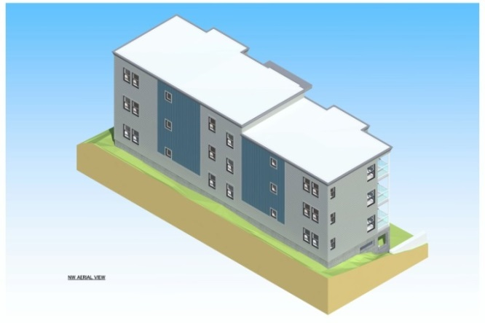
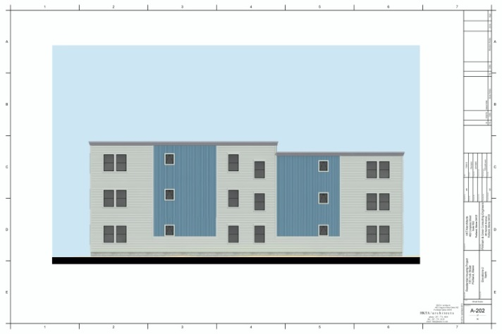

Following the workshop staff met with the applicant’s architect and understood that the decision regarding the colors and type of cladding materials was not going to be reconsidered but that further consideration could be given to other aspects. The final proposals reflect the input of staff regarding the front entrance, composition of cladding materials, number and size of windows and the use of a larger cornice on the rear elevation.

Staff have undertaken a design review which is summarized in the Design Review memo in Attachment 19. Staff have considered the character of the immediately surrounding area (photographs of these are attached to the Review Memo) and concluded that the overall scale and form of the proposed building generally meets the R6 standards regarding context, but that the minor adjustments in cladding (particularly the color scheme) and detailing of the rear elevation are needed to meet the R6 Design Standards in respect of materials and articulation. A draft condition of approval regarding the materials and articulation has been included in the motion for the Board to consider.

Multi-family and Other Housing Types Design Standard

This design standard also applies to this proposal is outlined in sections below with associated staff review comments:

(i) TWO-FAMILY, SPECIAL NEEDS INDEPENDENT LIVING UNITS, MULTIPLE-FAMILY, LODGING HOUSES, BED AND BREAKFASTS, AND EMERGENCY SHELTERS:
(1) STANDARDS. Two-family, special needs independent living units, multiple-family, lodging houses, bed and breakfasts, and emergency shelters shall meet the following standards:
a. Proposed structures and related site improvements shall meet the following standards:
1. The exterior design of the proposed structures, including architectural style, facade materials, roof pitch, building form and height, window pattern and spacing, porches and entryways, cornerboard and trim details, and facade variation in projecting or recessed building elements, shall be designed to complement and enhance the nearest residential neighborhood. The design of exterior facades shall provide positive visual interest by incorporating appropriate architectural elements;

Staff comment: The neighborhood is characterized by a variety of architectural styles and the proposed modern style is acceptable in principle. It is questionable whether the blue metal cladding “complements and enhances” the residential neighborhood, which is characterized by more subdued modern materials and greater articulation. However, the use of two different cladding materials helps break up the mass of the rear elevation.

  - The proposed development shall respect the existing relationship of buildings to public streets. New development shall be integrated with the existing city fabric and streetscape including building placement, landscaping, lawn areas, porch and entrance areas, fencing, and other streetscape elements;

Staff comment: The proposal effectively is an enlargement of an existing building with some improvement to setbacks and an increase in bulk. It is not well integrated in terms of landscaping, but introduces planting and screening along property lines except in one corner (north west).

3. Open space on the site for all two-family, special needs independent living unit, bed and
breakfast and multiple-family development shall be integrated into the development site. Such open space in a special needs independent living unit or a multiple-family development shall be designed to complement and enhance the building form and development proposed on the site. Open space functions may include but are not limited to buffers and screening from streets and neighboring properties, yard space for residents, play areas, and planting strips along the perimeter of proposed buildings;

Staff comment: All 6 of the new units will have balconies.

4. The design of proposed dwellings shall provide ample windows to enhance opportunities for sunlight and air in each dwelling in principal living areas and shall also provide sufficient storage areas;

Staff comment: This standard appears to be met.

5. The scale and surface area of parking, driveways and paved areas are arranged and landscaped to properly screen vehicles from adjacent properties and streets;

Staff comment: The parking is located underneath the units and is screened a ground level by the proposed “green wall” and existing slatted cedar fence, although there are no “garage doors”. The combination of the “green wall” and fence should limit the impact of headlights (although it is anticipated that most cars headlights would not face in that direction), but the effectiveness will depend on ongoing maintenance to ensure the structure is not damaged by nearby cars and that the planting remains robust. A potential condition of approval requires this responsibility of the Condominium Association to be clarified in the condominium Association documents.

- Staff Recommendation
Staff reluctantly recommend the approval of the proposed condo project subject to the proposed conditions. The number of conditions is necessitated by several factors:
- The applicant did not address some of the previous review/neighbor comments nor update information as plans were revised;
- The very constricted site has raised concerns about the details, landscaping/screening and implementation along all boundaries;
- The limited revisions to the exterior design of the building since the Workshop.

Staff have requested additional information and undertaken a comprehensive review in light of the above.

IX. MOTIONS FOR THE BOARD TO CONSIDER

- WAIVERS
On the basis of the application, plans, reports and other information submitted by the applicant, findings and recommendations, contained in the Planning Board Report #50-13 for application 2013-187 for 133 York Street relevant to Portland’s Technical and Design Standards and other regulations, and the testimony presented at the Planning Board hearing:

- The Planning Board (waives/does not waive) Section 14-526 (b) (2) (b) (iii) Street Trees to allow for a contributon of $600 to the City’s Street Tree Fund to be substituted for the provision on site of three of the required street trees.

- The Planning Board (waives/does not waive) Technical Design Standard Section 1.14 Parking Lot and Parking Space Design to allow a drive aisle of less than 24 feet , as shown on Plan 3.

- DEVELOPMENT REVIEW
On the basis of the application, plans, reports and other information submitted by the applicant, findings and recommendations contained in Planning Board Report # 50-11 for application 2013-187 for 133 York Street relevant to the Site Plan and Subdivision reviews and other regulations, and the testimony presented at the Planning Board hearing, the Planning Board finds the following:

- Subdivision:

That the Planning Board finds that the plan (is/is not) in conformance with the subdivision standards of the land use code, subject to the following conditions of approval:

Potential conditions of approval:

    - That the Subdivision Plat shall be finalized to the satisfaction of the Planning Authority, Corporation Counsel, and Department of Public Services and include detailed references to easements, snow removal, green wall maintenance, Condominium Association documents and relevant conditions; and

    - That the Condominium Association documents shall reference the Stormwater Maintenance Agreement and Stormwater Inspection and Maintenance Plan, and shall address the relevant conditions of approval and be finalized to the satisfaction of the Corporation Counsel prior to the recording of the Subdivision Plat; and

    - That the applicant and all assigns shall comply with the conditions of Chapter 32 Stormwater including Article III, Post-Construction Storm Water Management, which specifies the annual inspections and reporting requirements. The developer/contractor/subcontractor must comply with conditions of the construction stormwater management plan and sediment & erosion control plan based on City standards and state guidelines. A maintenance agreement for the stormwater drainage system as described in Attachment L and W of this Report, shall be approved by Corporation Counsel and Department of Public Services, and submitted and signed prior to the issuance of a Certificate of Occupancy with a copy to the Department of Public Services; and

    - That the applicant shall ensure that tree preservation/protection measures are undertaken in accordance with the comments of the City Arborist dated 9.6.2013 and 11.1.2013, and that the Condominium Association documents shall include responsibilities for ongoing tree preservation measures; and

    - That the applicant shall add a note on the Subdivision Plat that the Condominium Association shall be responsible for the maintenance of the green wall, both the structure and the planting, and that any damage from vehicles backing into green wall shall be repaired within one week; and

    - That the Subdivision Plat shall include a note confirming the Snow Removal Plan details and that the Condominium Association is responsible for this being undertaken in a timely fashion.

- Site Plan Review

The Planning Board finds that the plan (is/is not) in conformance with the site plan standards of the Land Use Code, subject to the following condition(s) of approval:

Potential conditions of approval:

- That the applicant shall submit a revised proposal for the materials (including color scheme) and rear elevation articulation of the proposed building, for review and approval by the Planning Authority prior to the issuance of a building permit; and

- That the applicant shall submit a revised Landscape Plan that addresses the 11.1.2013 City Arborist comments in respect of planting material and green wall, for review and approval by the Planning Authority and City Arborist prior to the issuance of a building permit; and

- That the applicant shall obtain easements or temporary construction agreements for all work outside the boundaries of the site, including with the abutters McCormick Place Condominiums and Gilman/Flint in respect of the tree work, and with Gilman/Flint in respect of the boundary (and fencing) along that property. Copies of the executed easements shall be provided to the Planning Division prior to the issuance of a building permit; and

- That the applicant shall submit a more detailed Construction Plan for the area to the north side and rear of the site that includes the items listed in the Engineering comments dated 11.7.2013 (and identify the method of supervision) and submit the plans for the temporary metal sheeting and associated excavation stamped by a professional engineer, all for review and approval by the Planning Authority prior to the issuance of a demolition permit for the existing building; and

- That the applicant shall submit a Construction (traffic) Management Plan for activities in York Street, for review and approval prior to the issuance of any City permits. In view of the high level of traffic on York Street, it is very likely that construction activity will not be allowed during peak traffic time periods; and

- That the applicant shall submit a revised Site Plan that relocates the bicycle parking rack so that it does not impede access to parking spaces, for review and approval prior to the issuance of a building permit; and

- That the FDC connection shall be located at York Street; and

- That the Condominium Association documents include the requirement that any external condensers for heating or cooling units shall be located out of sight of neighbors and include sound baffling so that the sound level at the property line is at or below 45dBA between 10pm and 7am, and below 50 dBa between 7am and 10pm; and

- That the applicant ensure, at their cost, that the electrical lines (from Park Street into the building to be demolished) are removed prior to the issuance of a Demolition Permit; and that the pole is removed prior to the issuance of a Certificate of Occupancy. If the pole and light are to remain to serve the parking lot at McCormick Place, the applicant shall provide evidence that the cost of the electricity to serve the retained light is being borne by a private party and not the City; and

- That the applicant shall submit a revised photometric plan, prior to the installation of the garage lighting and bollard lighting, that shows that the light levels from revised ceiling mounted lights within the parking garage area and the proposed bollards along the drive access meet the standards set out in Section 12 Site Lighting Standards in the City’s Technical Manual.

ATTACHMENTS:
Attachments to the Report
Workshop
  - Staff e-mail prelim review comments 8.22.2013
  - Traffic Engineering Review comments 8.23.2013
  - Engineering Review comments 8.27.2013 as updated 9.6.2013
  - Zoning comments 8.30.2013
  - Staff e-mail update 8.30.2013
  - DPS (David Margolis-Pineo) comments 9.5.2013
  - Fire Department comments 9.6.2013
  - City Arborist comments 9.6.2013

Hearing
  - Staff e-mail re fundamental issues 10.X.2013
  - Fire Department comments 10.29.2013
  - City Arborist comments 11.1.2013 and 11.4.2013
  - Engineering Review comments 11.6.2013 (stormwater)
  - Engineering Review comments 11.7.2013 (rear boundary construction)
  - Traffic Engineering Review comments 11.7.2013
  - Zoning comments
  - DPS (David Margolis-Pineo) comments
  - Legal Memo
  - Reserved
  - PUBLIC COMMENTS
- Kaplan
- Morrison
- McGee
- Foley
- Browne
- Higgins
- [more arriving]

Applicant’s Submittal
Workshop
- Cover Letter and Application 7.24.2013
- Project Description
- Right, title and Interest
- Draft condominium documents
- Narrative re Design Principals and Standards
- Building code summary
- Financial Capability letter
- Technical Capability information
- Neighborhood meeting Information
    - May 17, 2013 meeting
    - August 30, 2013
- Utility letters of capacity
- Construction Plan
- Stormwater Management Report June 19, 2013
- Letter Pinkham and Greer re trees and Fire code 8.22.2013
- Letter Pinkham and Greer response to staff comments 9.3.2013
- Letter HKTA architects re design and height 9.5.2013
- Lighting specifications and photometrics

Hearing
- Letter P&G & calcs response to Eng Rev comments 9.30.2013
- Vonda bollard cut Sheet
- Climbing hydrangea proposed for green wall
- Correspondence between applicant and neighbors
- Susan Kaplan re impact on 12 unit brick condos /green wall etc
- McCormick condo association re construction easement
- To staff re McGee letter (f/w to neighbors)
- To staff re Foley letter (f/w to neighbors)
- Architects memo 10.1.2013
- Letter Pinkham & Greer re revised plans 10.21.2013
- Additions to Stormwater Report October 2013
- Construction Plan 10.21.2013
- Parking Autoturn Templates 10.21.2013
- Fire Code Review 10.23.2013
ZZ. Updated Narrative re R6 Design Principles and Standards 11.7.2013

Final Plans
      - Boundary Survey
      - Subdivision Recording Plat
      - Site Plan
      - Existing Conditions and Demolition Plan
      - Grading and Utilities Plan
      - Erosion Control and Landscape Plan
      - To 9. Details
- Tree Filter Detail
- To 15. Floor plans
      - To 20. Elevations
21. Horizontal and Vertical Boundaries
22. Section across site
23. Roof Cornice Profile
24. to 28. Aerial views of exterior (renderings)

