CITY OF PORTLAND, MAINE

PLANNING BOARD
Stuart O'Brien, Chair
Timothy Dean, Vice Chair
Elizabeth Boepple
Sean Dundon
Bill Hall
Carol Morrissette
Jack Soley
February 3rd, 2014

Joe Flynn  133 York, LLC  110 Marginal Way Ste 292  Portland, ME 04101 | Thomas S Greer PE  28 Vannah Avenue  Portland, ME 04103

Project Name: | Residential townhouse - 6 unit condominium
Project ID: | 2013-187
Project Address:  CBL:  Applicant:  Planner: | 133 York Street  44-1-29 &31  133 York, LLC, Applicant  Jean Fraser
Dear Mr Flynn and Mr Greer:

On January 28th, 2014 the Portland Planning Board considered and approved a Level III Final Site Plan and Subdivision proposal for the construction of a 6 unit residential building at 133 York Street.

The Planning Board reviewed the proposal for conformance with the standards of the Subdivision Ordinance and Site Plan Ordinance and voted 6-0 (Dundon absent) to approve the application with the following waivers and conditions as presented below.

Waivers
On the basis of the application, plans, reports and other information submitted by the applicant, findings and recommendations, contained in the Planning Board Report for project #2013-187 (Addendum to Report #50-13) for 133 York Street relevant to Portland’s Technical and Design Standards and other regulations, and the testimony presented at the Planning Board hearing:

- The Planning Board voted 6-0 (Dundon absent) to waive the Ordinance Section 14-526 (b) (2) (b) (iii) Street Trees to allow for a contribution of $600 to the City’s Street Tree Fund to be substituted for the provision on site of three of the required street trees.

- The Planning Board voted 6-0 (Dundon absent) to waive the Technical Design Standard Section 1.14 Parking Lot and Parking Space Design to allow a drive aisle of less than 24 feet , as shown on Plan P3 subject to the requirement that the bike rack be relocated.

Development Review
On the basis of the application, plans, reports and other information submitted by the applicant, findings and recommendations contained in Planning Board Report for project #2013-187 (Addendum to Report #50-13) for 133 York Street relevant to the Site Plan and Subdivision reviews and other regulations, and the testimony presented at the Planning Board hearing, the Planning Board finds the following:

- Subdivision
The Planning Board voted 6-0 (Dundon absent) that the plan is in conformance with the subdivision standards of the land use code, subject to the following conditions of approval:

    - That the Subdivision Plat shall be finalized to the satisfaction of the Planning Authority, Corporation Counsel, and Department of Public Services and include detailed references to easements, snow removal, tree preservation, stormwater system maintenance, relevant conditions, and addressing the comments of the Associate Corporation Counsel dated 1.23.2014; and

    - That the Condominium Association documents shall reference the Stormwater Maintenance Agreement and Stormwater Inspection and Maintenance Plan, adequate snow removal and the ongoing maintenance of the preserved trees, to be reviewed and approved by Corporation Counsel prior to the recording of the Subdivision Plat; and

    - That the applicant and all assigns shall comply with the conditions of Chapter 32 Stormwater including Article III, Post-Construction Storm Water Management, which specifies the annual inspections and reporting requirements. The developer/contractor/subcontractor must comply with conditions of the construction stormwater management plan and sediment & erosion control plan based on City standards and state guidelines. A maintenance agreement for the stormwater drainage system as described in Attachment L and W of this Report, shall be approved by Corporation Counsel and Department of Public Services, and submitted and signed prior to the issuance of a Certificate of Occupancy with a copy to the Department of Public Services; and

    - That the applicant shall ensure that tree preservation/protection measures are undertaken in accordance with the comments of the City Arborist dated 9.6.2013 and 11.1.2013, and that the Condominium Association documents shall include responsibilities for ongoing tree preservation measures; and

    - That the Subdivision Plat shall include a note confirming the Snow Removal Plan details and that the Condominium Association is responsible for this being undertaken in a timely fashion.

- Site Plan Review
The Planning Board voted 6-0 (Dundon absent) that the plan is in conformance with the site plan standards of the Land Use Code, subject to the following condition(s) of approval:

- That the applicant shall submit a revised front elevation to address the Design Review comments dated 1.23.2014 concerning the lighting under the entrance canopy, for review and approval by the Planning Authority prior to the issuance of a building permit; and

- That the applicant shall submit a revised Site Plan, Utility Plan and Landscape Plan that address the 1.23.2014 City Arborist comments in respect of planting materials, and include documentation of fencing details on the south and west boundaries and utility modifications on and near the north boundary, for review and approval by the Planning Authority, Department of Public Services and City Arborist prior to the issuance of a building permit; and

- That the applicant shall finalize all easements/temporary construction agreements for work outside the site, and that recorded copies are submitted to the Planning Authority prior to the issuance of a building permit; and

- That the applicant shall submit a revised Construction (traffic) Management Plan for activities in York Street that addresses Tom Errico’s comments of 1.23.2014, for review and approval by the Planning Authority and Department of Public Services prior to the issuance of any City permits; and

- That the applicant shall submit a more detailed Construction Plan for the area to the north side and rear of the site that includes the items listed in the Engineering comments dated 11.7.2013 (and identify the method of supervision) and submit the plans for the temporary metal sheeting and associated excavation stamped by a professional engineer, all for review and approval by the Inspections Division as part of any demolition permit review and copied to the Planning Authority prior to the issuance of a demolition permit for the existing building; and

- That the applicant shall reconsider the location of the bicycle parking rack so that it does not impede access to parking spaces and is readily visible and accessible to potential users, with a plan showing the revised location to be reviewed and approval by the Planning Authority prior to the issuance of a building permit; and

- That the FDC connection shall be located at York Street; and

- That the Condominium Association documents shall include the requirement that any external condensers for heating or cooling units shall be located out of sight of neighbors and include sound baffling so that the sound level at the property line is at or below 45dBA between 10pm and 7am, and below 50 dBa between 7am and 10pm; and

- That the applicant shall submit a revised photometric plan, prior to the installation of the bollard lighting, that shows that the light levels from the new lighting under the entrance canopy and the proposed bollards along the drive access meet the standards set out in Section 12 Site Lighting Standards in the City’s Technical Manual.

The approval is based on the submitted plans and the findings related to site plan and subdivision review standards as contained in Planning Board Report for project #2013-187 (Addendum to Report #50-13) for 133 York Street, which is attached. The standard conditions of approval are listed below.

Standard Conditions of Approval
Please note the following standard conditions of approval and requirements for all approved site plans:

- Subdivision Recording Plat A revised recording plat listing all conditions of subdivision approval must be submitted for review and signature prior to the posting of a performance guarantee. The performance guarantee must be posted prior to the release of the recording plat for recording at the Cumberland County Registry of Deeds.

- Subdivision Waivers Pursuant to 30-A MRSA section 4406(B)(1), any waiver must be specified on the subdivision plan or outlined in a notice and the plan or notice must be recorded in the Cumberland County Registry of Deeds within 90 days of the final subdivision approval.

- Develop Site According to Plan The site shall be developed and maintained as depicted on the site plan and in the written submission of the applicant. Modification of any approved site plan or alteration of a parcel which was the subject of site plan approval after May 20, 1974, shall require the prior approval of a revised site plan by the Planning Board or the Planning Authority pursuant to the terms of Chapter 14, Land Use, of the Portland City Code.

- Separate Building Permits Are Required This approval does not constitute approval of building plans, which must be reviewed and approved by the City of Portland’s Inspection Division.

- Site Plan Expiration The site plan approval will be deemed to have expired unless work has commenced within one (1) year of the approval or within a time period up to three (3) years from the approval date as agreed upon in writing by the City and the applicant. Requests to extend approvals must be received before the one (1) year expiration date.

- Subdivision Plan Expiration The subdivision approval is valid for up to three years from the date of Planning Board approval.

- Performance Guarantee and Inspection Fees A performance guarantee covering the site improvements as well as an inspection fee payment of 2.0% of the guarantee amount and seven (7) final sets of plans must be submitted to and approved by the Planning Division and Public Services Department prior to the release of a subdivision plat for recording at the Cumberland County of Deeds, and prior to the release of a building permit, street opening permit or certificate of occupancy for site plans. If you need to make any modifications to the approved plans, you must submit a revised site plan application for staff review and approval.

- Defect Guarantee A defect guarantee, consisting of 10% of the performance guarantee, must be posted before the performance guarantee will be released.

- Preconstruction Meeting Prior to the release of a building permit or site construction, a pre-construction meeting shall be held at the project site. This meeting will be held with the contractor, Development Review Coordinator, Public Service's representative and owner to review the construction schedule and critical aspects of the site work. At that time, the Development Review Coordinator will confirm that the contractor is working from the approved site plan. The site/building contractor shall provide three (3) copies of a detailed construction schedule to the attending City representatives. It shall be the contractor's responsibility to arrange a mutually agreeable time for the pre-construction meeting.

- Department of Public Services Permits If work will occur within the public right-of-way such as utilities, curb, sidewalk and driveway construction, a street opening permit(s) is required for your site. Please contact Carol Merritt at 874-8300, ext. 8828. (Only excavators licensed by the City of Portland are eligible.)

- As-Built Final Plans Final sets of as-built plans shall be submitted digitally to the Planning Division, on a CD or DVD, in AutoCAD format (*,dwg), release AutoCAD 2005 or greater.

- Mylar Copies Mylar copies of the as-built drawings for the public streets and other public infrastructure in the subdivision must be submitted to the Public Services Dept. prior to the issuance of a certificate of occupancy.

The Development Review Coordinator must be notified five (5) working days prior to date required for final site inspection. The Development Review Coordinator can be reached at the Planning Division at 874-8632. All site plan requirements must be completed and approved by the Development Review Coordinator prior to issuance of a Certificate of Occupancy. Please schedule any property closing with these requirements in mind.

If you have any questions, please contact Jean Fraser at 874 8728 or jf@portlandmaine.gov.

Sincerely,

Stuart O’Brien, Chair
Portland Planning Board

Attachments:
- Associate Corporation Counsel comments dated 1.23.2014
- City Arborist comments dated 9.6.2013 and 11.1.2013 (underlined sections)
- Design Review comments dated 1.23.2014
- City Arborist comments 1.23.2014
- Traffic Engineering (Tom Errico) comments 1.23.2014
- Engineering comments dated 11.7.2013
- Planning Board Report for project #2013-187 (Addendum to Report #50-13) for 133 York Street
- City Code Chapter 32
- Sample Stormwater Agreement
- Performance Guarantee Packet

Electronic Distribution:
Jeff Levine, AICP, Director of Planning and Urban Development  Alexander Jaegerman, Planning Division Director  Barbara Barhydt, Development Review Services Manager  Jean Fraser, Planner  Philip DiPierro, Development Review Coordinator  Marge Schmuckal, Zoning Administrator  Tammy Munson, Inspections Division Director  Lannie Dobson, Inspections Division  Michael Bobinsky, Public Services Director  Katherine Earley, Engineering Services Manager, Public Services  Bill Clark, Project Engineer, Public Services  David Margolis-Pineo, Deputy City Engineer, Public Services  Doug Roncarati, Stormwater Coordinator, Public Services  Greg Vining, Associate Engineer, Public Service | Michelle Sweeney, Associate Engineer  John Low, Associate Engineer, Public Services  Rhonda Zazzara, Field Inspection Coordinator, Public Services  Mike Farmer, Project Engineer, Public Services  Jane Ward, Administration, Public Services  Jeff Tarling, City Arborist, Public Services  Jeremiah Bartlett, Public Services  Captain Chris Pirone, Fire Department  Danielle West-Chuhta, Corporation Counsel  Jennifer Thompson, Associate Corporation Counsel  Thomas Errico, P.E., TY Lin Associates  David Senus, P.E., Woodard and Curran  Rick Blackburn, Assessor’s Department  Approval Letter File

Attachment 1

From: Jennifer Thompson
To: Fraser, Jean
Date: 1/23/2014 7:29 AM
Subject: Re: 133 York Street Plat and Condo Docs

Jean - I agree with your assessment. The Plat and the condo docs for this application are marginal. Although I realize that the practice has, somewhat by necessity, been to make final edits to the plat and condo docs a condition of approval, there is still a requirement that applications for subdivision approval be complete when the go before the Board and that the proposed plat and condo docs contain sufficient detail to allow the Board to make an informed decision. As you say, for this one the plat and in condo docs need to clear in respect to:

snow clearance requirements
Maintenance requirements
Existing utilities
location and purpose of pedestrian walkway between York and the front door
tree preservation measures (ongoing- maybe also during construction?)
location of tree filter and ref stormwater system maintenance (confirming that this is not city and referring to agreement etc)
Agreement re fencing with York Street apartments (see draft attached)
Plat should show street trees
I would also prefer to see the construction easements depicted.

The subdivision plat really needs to inform folks of necessary information on its face. It is not sufficient to be incorporating by reference other sheets when it comes to the essential contents of the plat.

Jennifer L. Thompson
Associate Corporation Counsel
City of Portland, Maine
(207)784-8480

Attachment 2

From: Jeff Tarling
To: Jean Fraser
CC: David Margolis-Pineo
Date: 9/6/2013 1:56 PM
Subject: Re: 133 York comments needed urgently please
Attachments: Portland Recm. Tree List.xls

Hi Jean -

I have reviewed the landscape plans for 133 York Street and offer the following
review comments:

Landscape & Buffering:
Due to the lot shape & size the 133 York Street site is unusually "challenged" in regards for 'green space', buffering
and landscape improvements, particularly for an established residential neighborhood.

Recommendations: Additional buffering between the proposed project and brick residential property next
door should be a requirement condition. The proposed projects driveway and parking is next to their
backyard living space, patio & green space. Additional screening in the form of a 'green wall' and / or two to three
columnar trees to be planted on the adjacent property would improve.

See green-wall examples: http://www.greenscreen.com/home.html
A 'green-wall' in the patio area near the corner and two trees in the lawn? Understanding the proposed project
is limited in space and need to be in agreement with the neighboring property to be successful in the tree planting aspect of this condition.

Additional buffering / landscape treatment condition #2 - the left side of the driveway at York Street for the first
40' (area of hash marks on plan) landscape planting or fencing to screen the side yard of the existing residential property next door. The landscape planting should provide screening or buffering as not to adversely affect the
existing use next door. (I noted a small seating area on the lawn existing currently)

Tree Types - ALL trees should be from the City of Portland recommended list, (Little-leaf Linden is no longer on our
recommended list). Suggestions might include: 'Karpick' or 'Red Point' Red Maple, 'Armstrong' Red Maple, the first two are a little less columnar the Armstrong, European Hornbeam, upright Pin Oak also would work, this is the same for the lawn area trees above if needed.

Tree Saves - Tree protection measures should be included in the final plan and in the field as part of the preconstruction meeting. 'Tree Save' / protection for the root zone of the large Willow tree off site might include
fencing if needed, see: http://www.treesaregood.com/treecare/avoiding_construction.aspx

The existing American Elm near the SW corner is next to a large Norway Maple - unknown if this can be saved.
It appears to be near the property line and would need to be limbed up for construction. Elm trees should only be pruned during the dormant season to reduce Dutch Elm Disease as fresh cuts attract Elm Bark Beetles.

Relocated Plants - While it is great to try to save existing plants 99% of the time it is unsuccessful due to timing,
transplant shock, storage etc during project time line. Thus, all plants shown as to be relocated must be included
as new plants and included into the performance guarantees in case the transplants are not successful.

Cobblestone or granite paver driveway & sidewalk - These existing features could add some historic interest to the site and should be considered for saving & reuse. Our HP office & Public Services can offer suggestions.

With some creativity and attention to these suggestions the landscape plan could help the project fit into the existing residential neighborhood with reduced impact.
Jeff Tarling

>>> Jeff Tarling 11/1/2013 3:43 PM >>>
Hi Jean -

I have reviewed the latest landscape plan for the proposed 133 York Street project and offer
the following comments & conditions:

a) Landscape review - The proposed development at 133 York Street presents challenges to
meet standard landscape treatment due to the shape and constraints of the project site. The project
does offer landscape amenities such as a green wall to provide screening along with two off-site
tree planting locations if agreeable. The building footprint close to existing building site poses
challenges to screen but improves on the long existing conditions. Two mature trees are close
and will likely have impact during the construction process. Best practices in regards to tree
protection are needed to prevent / reduce root zone damage.

b) landscape plant material: plant sizes - Condition) shrub stock noted as "D" Clethra, "F" Deutzia,
"J" Northern Bayberry, "K" Climbing Hydrangea, "L" Stephanandra shall all be #3 pot size minimum
and tree sizes should be the following: "B" Flowering Crabapple 1.75-2" caliper, "C" Armstrong Red Maple
2" caliper. Items mentioned as "Existing", "G" Relocated Japanese Maple (#5 pot size), "H" Relocated
Lilac (3-4'H) should also have these sizes as replacements if the relocation is not successful. (Too often
good intent to save plants through construction are less then successful).

c) Green wall - the proposed project use of a green wall will help screen / buffer the adjacent building. The
green wall plant type: Climbing Hydrangea is slow growing, and thus the proposed 1 gallon pot size much to
small to be effective for many years... recommendations & condition the green wall plant sizes must be
#3 pot & #5 pot sizes alternating minimum to provide a good start for the green wall.

d) Tree Save - The project proposes to save or minimally effect the condition of two shade trees close to the
project property line on private property. From site inspection some root zone impact is expected and hopefully
can be minimized with good tree protection practices. This would include following steps in the ISA trees & construction recommendations; physical trunk protection and construction fence, no storage of materials or
equipment in the root zone area. Inspection of trenching etc when roots are exposed, cutting damaged roots
cleanly with saw vs leaving them damage by earth equipment. If trees can not saved or damaged, replacement trees shall be installed. This would follow site specification standards.

Trees & Construction damage info, See:

http://www.treesaregood.org/treecare/avoiding_construction.aspx

http://www.treesaregood.org/treecare/treatment_construction.aspx

The revised landscape plan addresses earlier comments in regards to buffer along the left side of the driveway
and the north side of the project. The project with the conditions mentioned would be acceptable.

Jeff Tarling
Attachment 3

Memorandum
Planning and Urban Development Department
Planning Division

To: Planning Board

From: Alex Jaegerman, Caitlin Cameron, Jean Fraser

Date: January 23, 2014

Re: Design Review 133 York Street- for January 2014 Hearing
R6 Design Standards

BACKGROUND

- Staff reviewed the submitted black and white elevations in early September and considered the proposals generally met the principles and standards of the R6 Design guidelines except regarding C-1 and F-6 (main entrance), where it was recommended that the central entrance at ground level be more strongly emphasized through the introduction of features such as transom windows, wider door, more robust canopy articulation. Staff also asked for information as to why one half of the building is higher than the other, and confirmed at the Workshop that the comments were preliminary as staff had not seen color renderings nor samples of materials.

- At the Workshop color renderings were shown which staff had not previously seen which showed large areas of blue metal cladding on the rear and side elevations. The Board and neighbors raised concerns over the materials and the bland rear elevation. These issues were discussed at a staff meeting on September 23, 2013 with Bob Howe the applicants architect. Staff were given to understand that the applicant was committed to the proposed materials (including colors) but open to some redesign. The discussion also reiterated staff concerns regarding the weak entrance area at the front.

- The architects submitted revised elevation treatments as part of the October 1, 2013 submission. Staff welcomed the improvements to the front door area but considered that the rear elevation was still unresolved, with little articulation and no obvious design aesthetic. The roof cornice at the rear was suggested as an aspect that could be improved, along with less blue cladding and more/larger windows. A revised elevation was submitted on October 4, 2013 that included more windows, less blue cladding and with the cornice at the rear to match the cornice round the rest of the building. This remains as the final submission for consideration at the hearing.

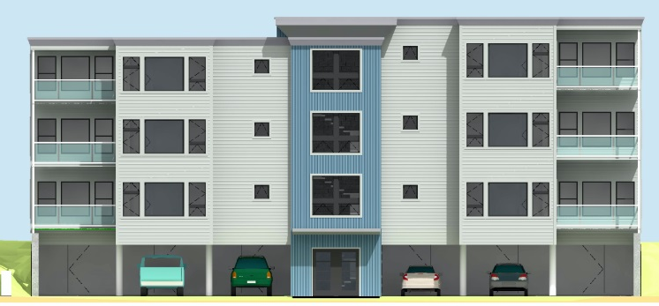
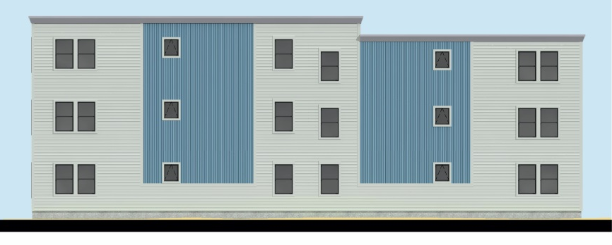
- The final plans submitted for the November 2013 hearing were:

- The design review comments for the November hearing regarding the final plans (above) were (in summary) that the proposed materials in and of themselves appear to meet the standard- but the choice of specific colors, trim and the scale and location of contrasting materials does not relate to any local design character. In addition staff noted that the rear elevation remained weak in relation to the standard; while more balanced with the addition of windows and improved by the larger cornice treatment, it still lacks in articulation and interest. The applicant had explored relatively minor cladding revisions and these do not fully address the Principle F regarding “Articulation”.

- At the November 12, 2013 Hearing the Planning Board tabled the project and requested that the applicant reconsider the design to address the Board, staff and neighbor comments regarding both elevations. The applicant has submitted the following final architectural designs for the elevations:
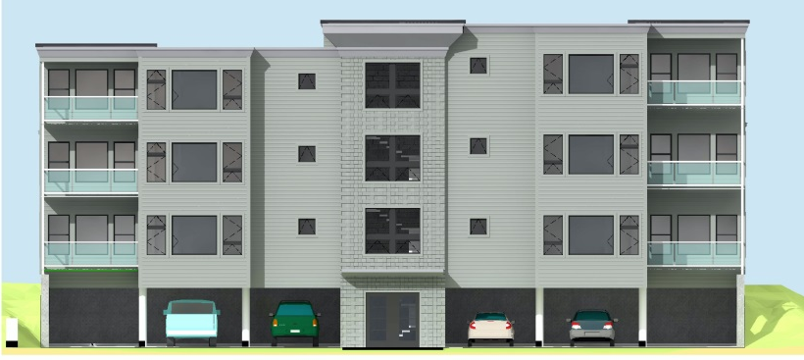
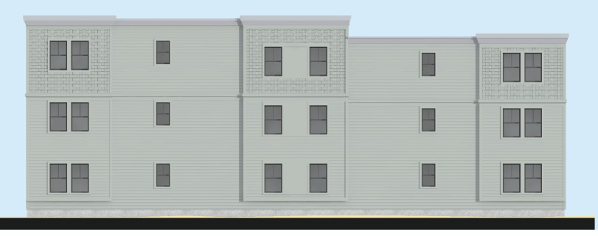

FINAL COMMENTS FOR HEARING ON JANUARY 28, 2014

- The rear elevation incorporates greater changes in texture and plane to break up the massing and overall more compatible with surrounding building styles though still lacking in a coherent “design approach” . The modification of the front elevation to remove the blue metal cladding makes the building design more harmonious and compatible, but reduces the prominence of the central front entrance section which faces York Street (which was an earlier design issue/comment).

- Staff recommend the following revisions to reemphasize the entrance function and address the roof line which does not appear to be completely resolved in these final elevations:
- The tone of the entire central entrance section should be somewhat darker to contrast with the abutting material;
- The overlarge and angled central cornice area should be simplified so it relates to the canopy over the entrance door and better ties into the roof line; and
- Lighting (downlighting) from underneath the entrance canopy should be added.

Attachment 4

From: Jeff Tarling
To: Jean Fraser
Date: 1/23/2014 8:41 AM
Subject: Re: 133 York

Hi Jean -

The hydrangea size should be #5 gallon pot size minimum, proposed #1 gal size is too small to provide any screening for several years, this buffer is an important feature of the landscape plan. Ideally, every fourth plant could be a #7 size pot to add some height to the planting from the start. Climbing Hydrangea are slow growing.

Jeff

Attachment 5

From: Tom Errico <thomas.errico@tylin.com>
To: Jean Fraser <JF@portlandmaine.gov>
CC: David Margolis-Pineo <DMP@portlandmaine.gov>, Katherine Earley <KAS@portlandmaine.gov>, Jeff Tarling <JST@portlandmaine.gov>, "JeremiahBartlett" <JBartlett@portlandmaine.gov>
Date: 1/23/2014 9:41 AM
Subject: 133 York Street

Jean - I have reviewed the document that discusses the general principles for utility construction work and impacts to York Street. The general principles are acceptable (e.g. that construction activity shall not impact peak times periods). With that said greater detail will be required in terms of how traffic and pedestrians are managed during construction. Accordingly, the applicant will be required to submit a traffic control plan for review and approval prior to the issuance of any City permit. I want to conclude that traffic volumes are very high on York Street and therefore careful attention to the plan is required. Lastly, pedestrian safety will be closely reviewed and plans must account for providing ADA compliant facilities, if detours are required.

If you have any questions, please contact me.

Best regards,

Thomas A. Errico, PE
Senior Associate
Traffic Engineering Director
[T.Y. Lin International]T.Y. Lin International
12 Northbrook Drive
Falmouth, ME 04105
207.781.4721 main
207.347.4354 direct
207.400.0719 mobile
207.781.4753 fax
thomas.errico@tylin.com
Visit us online at www.tylin.com
Twitter | Facebook | LinkedIn | YouTube

"One Vision, One Company"

Please consider the environment before printing.

Attachment 6

From: David Senus <dsenus@woodardcurran.com>
To: Jean Fraser <JF@portlandmaine.gov>
CC: Michael Farmer <Mfarmer@portlandmaine.gov>, "Thomas.Errico@tylin.com" <Thomas.Errico@tylin.com>
Date: 11/7/2013 1:15 PM
Subject: RE: final comments re 133 York Street

Hi Jean.
In reading through the Construction Plan for 133 York Street, I offer the following comments:

>The plan should note the anticipated duration of construction
>The plan should note work days and work hours
>The plan states that demolition will be completed in one day, but then states the "process" (demolition & removal) will take place within one to two working days; this should be clarified
>The plan notes installing "six foot tall construction fencing" across the property line; the fence should be installed along the property line and should not encroach on neighboring properties (unless an easement is granted)
>The plan should note that a stabilized construction entrance/exit will be constructed at the York Street driveway per the Erosion and Sediment Control Plan, and that the York Street Right-of-Way shall be kept clean from dust and construction debris and swept as determined necessary by the Contractor or as requested by the City of Portland to minimize dust and sediment originating from the site.

Tom, Mike or Jeremiah may have other comments related to construction access to the site on York Street from a traffic/signage perspective.

Thanks,
Dave

David Senus, PE (Maine), Project Manager
Woodard & Curran, Inc.
41 Hutchins Drive
Portland, ME 04102
Phone: (800) 426-4262 x3241
Cell: (207) 210-7035
Fax: (207) 774-6635

Woodard & Curran
www.woodardcurran.com<http://www.woodardcurran.com>
Commitment & Integrity Drive Results

