Draft 11.7.2013 – work in progress

PLANNING BOARD REPORT
PORTLAND, MAINE

Residential townhouse - 6 unit condominium
133 York Street
Level III Site Plan and Subdivision
Project ID 2013-187
133 York, LLC, Applicant

Submitted to:  Portland Planning Board  Public Hearing Date: November 12th, 2013 | Prepared by: Jean Fraser, Planner  Date: November 8th, 2013  Planning Board Report # 50-13

- Introduction
133 York, LLC has submitted a Level III Site Plan and Subdivision application for the construction of a 6 unit residential building on a 7,483 sq ft “urban infill” site at 133 York Street. The site is currently occupied by a dilapidated 2-unit residential structure. The site is located behind the existing brick 12-unit apartment building at 129 York Street and adjacent to the recently constructed Harborview Townhouse condominium development.

The parcel has an existing narrow pedestrian access from York Street, immediately to the west of the brick apartment building. The proposed building is located on the backland part of the site about 100 feet from York Street, and comprises 3 stories over parking.

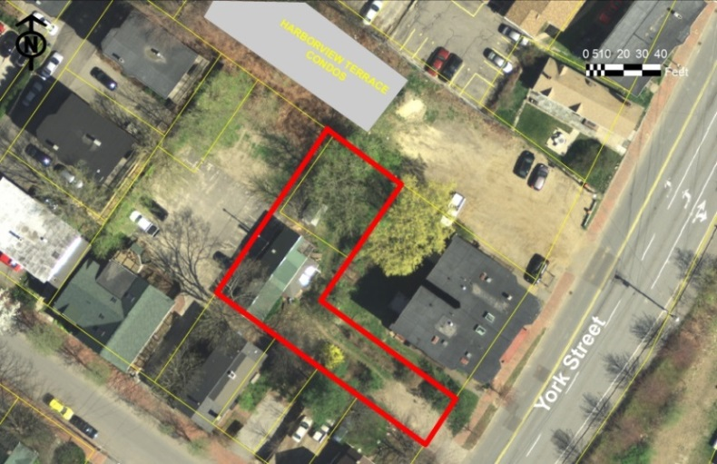
The site is within the R-6 zone but can not apply reduced lot dimensions under the R-6 “small residential lot development” as the lot is not vacant. It is subject to the R-6 design review.

The applicant has held two Neighborhood Meetings in May and August where neighbors raised concerns about the loss of the large tree in one corner, loss of privacy and views, and the increase in height over the existing building (Notes in Attachment I). The Planning Division has received X public comment letters since the Workshop: all objecting to the project based on the loss of trees, access and snow removal issues, direct adverse impacts on the neighbors, and that the proposed design and materials do not integrate with the (historic) neighborhood.

This Workshop was noticed to 169 neighbors and interested parties, and the public notice appeared in the Portland Press-Herald on November 4th and 5th, 2013.

Required reviews and requested waivers (note that waivers re parking aisle width and bicycle parking were not requested but may be needed):
Applicant’s Proposal | Applicable Standards
New structure of 6 dwelling units | Subdivision Review: Subdivision Standards - Section 14-497
Multifamily building of 9,424 square feet floor area | Level III Site Plan Review: Site Plan Standards – 14-526 and  R-6 and Multi-family design reviews
Proposed building is less than 100 feet from the Historic Preservation District to the north (other side of Harborview Terrace) | Ordinance 14-526 (d) 5 b requires that it be generally compatible with the major character-defining elements of the portion of the district nearest the proposed development.
Waiver requested for the six street trees required, due to limited right of way space. | Ordinance Subdivision 14- 499 Required Improvements and Technical Standard 4.6.1- requiring 1 tree per unit to be located in the Right of Way.
- PROJECT DATA

SUBJECT | DATA
Existing Zoning | R-6
Existing Use | 2-unit residential building
Proposed Use | 6-unit new building; each unit 2 bedrooms
Parcel Size | 7483 sq ft
Impervious Surface Area  --Existing  --Proposed  --Net Change | 1918 sq ft  5570 sq ft  3652 sq ft
Total Disturbed Area | Approx. 7400 sq ft
Building Footprint  --Existing  --Proposed  --Net Change | 1918 sq ft  2335 sq ft  417 sq ft
Building Floor Area  --Existing  --Proposed | Not known  9424 sq ft
Parking Spaces | 6, under dwellings
Bicycle parking Spaces | 2
Proposed Paved Area | 3235 sq ft
Estimated Cost:
Land uses in the vicinity

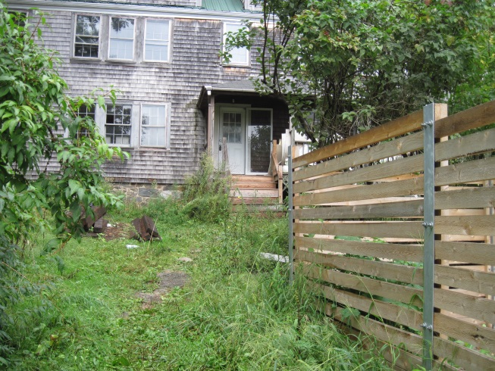
- EXISTING CONDITIONS
The proposal site is located on the north side of York Street between Park and High Streets, approximately 500 feet east of the Casco Bay Bridge intersection and approximately 250 feet west of the intersection of York Street and High Street. The buildable part of the site is set back behind the adjacent 3 story apartment building that fronts onto York Street, and about 5 feet above the amenity area associated with this apartment building (see Survey and Existing conditions, in Plans 1 & 3).

There are 4 upper rear decks on the apartment building that face towards the site.
Existing building on the site

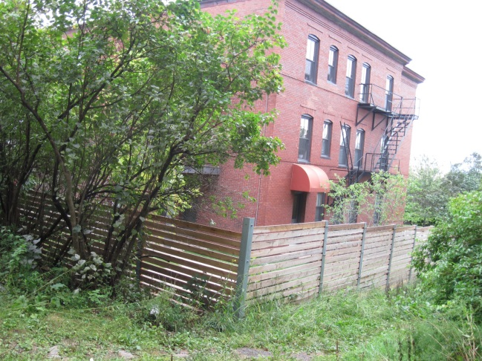
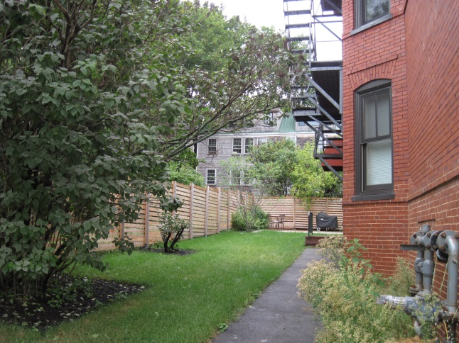

As viewed from York Street Within site, towards York Street
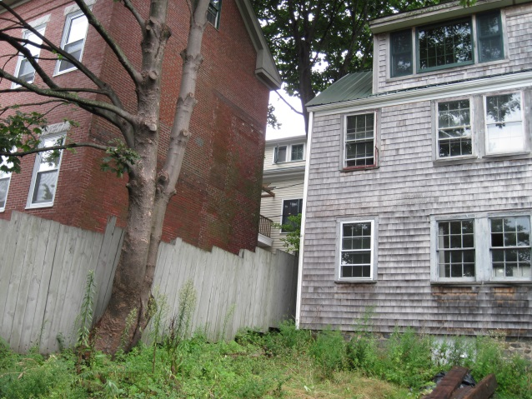
To the north the site abuts the parking area for the McCormick Place (5 unit) condominiums, which is about 5 feet above the level of the proposal site. Immediately to the west there is a large single family house (see photo right) with no windows facing the proposal site.

To the east is the recently completed Harborview Townhouse (7 unit) condominium development (see photos below). This project is between the site and the historic district boundary to the east.
Looking west from within the site (tree to be removed)
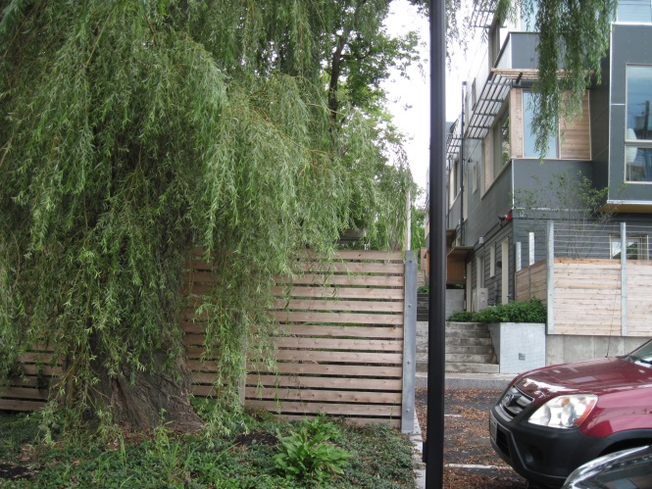
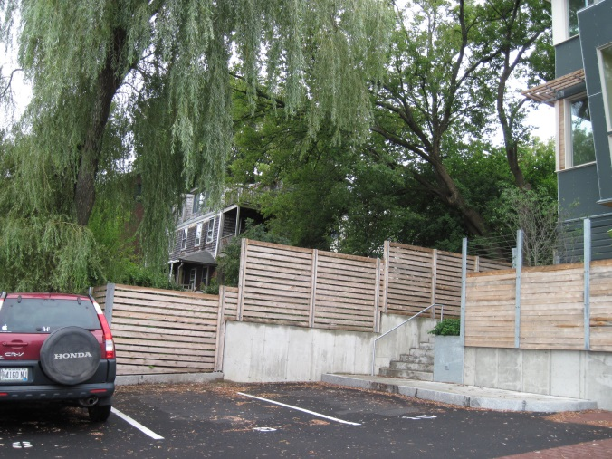

Within Harborview Townhouses towards site Harborview Townhouses western side

- PROPOSED DEVELOPMENT
The proposals, including floor plans and elevations, are shown in the Plan set. The proposed building has 4 levels, with parking on the lowest level and sunk about 5 feet below grade (so it will be at about the same level as the rear amenity space for the brick apartment building). The absolute overall height is approximately 30-41 feet, 6-8.5 feet feet higher than the existing building at the west end and about 10 feet higher at the east end.

The new structure is set back 5 feet from the west and north boundaries, 11 feet from the east boundary (Harborview) and 16 feet from the south boundary.

Vehicle access is proposed from York Street via a new 16 foot wide drive with 4 foot sidewalk alongside (flush). As the drive gets near the building it will below the existing grade to give access to the sunken parking area and remove the existing vegetated grade change along the south boundary.
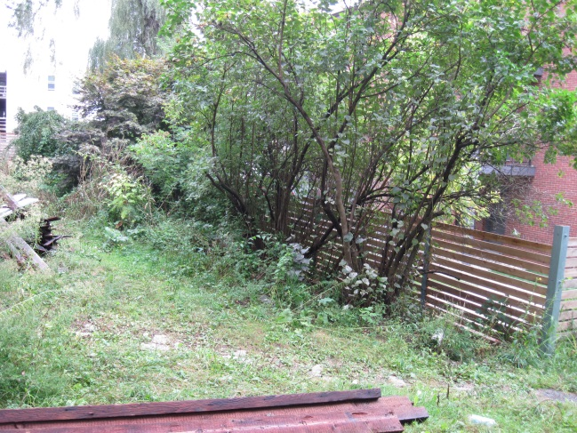
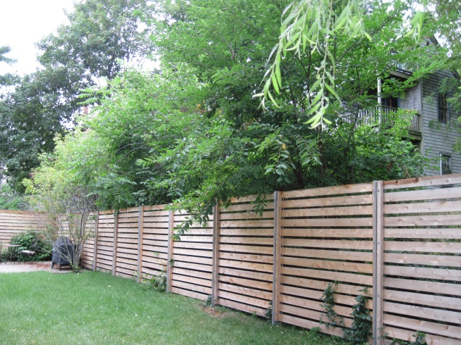

Small scale landscaping is proposed along the east and north sides of the new building and three trees are proposed along the new driveway (Plan 5).

V. PUBLIC COMMENT

The applicant held two neighborhood meetings attended by X people and the notes are included at Attachments X and C. Comments at the Planning Board Workshop were similar and covered issues of XXXXX; the Planning Board asked the applicant to work with neighbors to resolve issues.

The applicant has submitted two sets of e-mail exchanges as of the date of submission (Oct 1, 2013) and the exchange regarding the 12 uni red brick condos on York Street are also set out in Attachment X, and updated in Attachment X. All five of the units in McCormick Place condos have sent letters (Attachmens XXX) and XXX.

Issue | No of letters from different units raising this issue
Construction impacts (uphill parking area)
Design and materials
Screening/planting
Loss of/impact on existing trees
Loss of views
Access and snow Removal
Existing overhead wires

- RIGHT, TITLE AND INTEREST AND FINANCIAL/TECHNICAL CAPACITY

The owner of the property is Harborview Development LLC. The applicant has provided a copy of a Warranty Deed, recorded at the Cumberland County Registry of Deeds (Book 28330 Page 45) (Attachment A), which demonstrates their right, title and interest in the property.
The final submission will need to include:

- Subdivision Plat with revisions to address staff comments
- Provision of turning templates to allow assessment of adequacy of parking space access/circulation
- Increased screening of parking lot area and landscaping along boundaries
- Modified and additional lighting to address technical and CPTED standards
- Revisions to address the all review comments
- Further discussion regarding design review
- Clarification regarding necessary easements

The applicant has not submitted the estimated cost of the development. The applicant has submitted a letter from Redfern Properties and Bangor Savings Bank (Attachment H) as demonstration of their financial and technical capacity to complete the proposed development.

- STAFF REVIEW

        - ZONING ASSESSMENT

The proposed subdivision is within the R-6 Residential Zone.

Marge Schmuckal, Zoning Administrator, has provided a determination regarding the required setbacks and reviewed the project for conformity with the R-6 zoning requirements (Attachment 4):

This project is to demolish an existing (abandoned) two family dwelling and to replace it with a 6 residential condominium The project is in the R-6 zone and uses the regular R-6 zone dimensional requirements. However, because the existing building is on the existing rear property line, the rebuild is able to be moved forward and use section 14-433 to allow building additions to be within 5' of the side and rear line for buildings existing as of July 19, 1988. The existing building was present well before that date. The required front setback is being met.

The building height is being met (under 45'). However, the dimensions are being shown to the joist bering and not to the top of the joist as required by definition. I would like to see revised drawing that show the building height from grade (or average grade) to the top of the roof beam.

The open space ratio of 20% is being met at 25.56% per the information given The 50% lot coverage is being met. 6 parking spaces are being met.

Separate permits are required for the demolition and new construction.

It is noted that the minimum 40' street frontage requirement is not being met at 27.2 feet. Hiowever, this lot is already developed and is legally nonconforming for the street frontage. They will not lose that street frontage legal nonconformity unless the present building is demolished and then no work to rebuild begins after one year.

The architect has recently submitted detailed height information (Attachment O) but there has not been an opportunity for the Zoning Administrator to review these.

B. SUBDIVISION STANDARDS

14-496. Subdivision Plat Requirements
The final submission will need to include:

- Subdivision Plat with revisions to address staff comments
- Provision of turning templates to allow assessment of adequacy of parking space access/circulation
- Increased screening of parking lot area and landscaping along boundaries
- Modified and additional lighting to address technical and CPTED standards
- Revisions to address the all review comments
- Further discussion regarding design review
- Clarification regarding necessary easements

The site plan in Plan 2 is also the draft subdivision plat. It should be noted that the final subdivision plat will need to be stamped by a professional surveyor and address the DPS survey comments in Attachment 6.

14-497. General Requirements (a) Review Criteria

- Will Not Result in Undue Water and Air Pollution (Section 14-497 (a) I), and Will Not Result in Undue Soil Erosion (Section 14-497 (a) 4)

An Erosion Control Plan has been submitted (Plan 5) and is acceptable (Attachment 3).

- Sufficient Water Available (Section 14-497 (a) 2 and 3)

- Will Not Cause Unreasonable Traffic Congestion (Section 14-497 (a) 5)

Traffic
The proposals originally included a new 20 foot wide driveway to access the parking beneath the new building. The proposals have been revised to address the comments from Tom Errico (Attachment 2) that requested a pedestrian way between the York Street sidewalk and the new building. The current proposals provide a 16 foot vehicle way and an abutting and distinct 4 foot pedestrian way. The two are flush to provide a 20 foot wide paved access route for fire apparatus.

Parking
There are 6 parking spaces to meet zoning requirements and these are located in the “sunken” level underneath the units. The Traffic Engineering Reviewer Tom Errico has questioned the adequacy of the parking aisle provided between the parking level and the south site boundary, where 16 feet is proposed (without snow conditions) (Attachment 2). He requested turning templates to illustrate the feasibility of access/maneuvring, and these were submitted (Attachment Y).

- Will Provide for Adequate Sanitary Sewer and Stormwater Disposal (Section 14-497 (a) 6), and Will Not Cause an Unreasonable Burden on Municipal Solid Waste and Sewage (Section 14-497 (a) 7)

The application has been reviewed by the consulting Civil Engineer and DPS and is acceptable (Attachments 3 and 6).

The proposals propose to manage stormwater impacts by collecting the stormwater and directing it to a tree filter system, which also allows for some quality treatment. The engineering reviewer provided detailed comments on 8.27.2013 (Attachment 3) and the applicant has revised the plans to address these comments (Plan 4). The engineering reviewer has reviewed the revised plans and there are a few residual comments but the proposal are generally acceptable (Attachment 3). The Department of Public Services considers the storm drain system in York Street is adequate to handle the proposed project drainage.

- Scenic Beauty, Natural, Historic, Habitat and other Resources (Section 14-497 (a) 8)

The impact on trees in the vicinity of the development is explained in Attachment M and shown on Plan 3. The loss of two existing substantial trees within this dense urban area is undesirable. The City Arborist, Jeff Tarling, has reviewed the plans and his comments are attached (Attachment 8).

Street Trees

The subdivision requirement would be one tree per unit, or 6 street trees, in or near the ROW. The applicant has requested a waiver citing the limited space in the ROW. In this case the recommended alternative is that the applicant make an equivalent contribution to the Citys Street Tree fund.

- Comprehensive Plan (Section 14-497 (a) 9)

The applicant has referred to the Comprehensive Plan as related to housing policies (Attachment B) and the project is compatible with Comprehensive Plan goals and policies.

7. Financial Capability (Section 14-497 (a) 10)

C. SITE PLAN STANDARDS 14-526 Requirements for approval

- Transportaion

Impact on Surrounding Street Systems

Access and Circulation

Loading and Servicing

Sidewalk and ROW

The Department of Public Services has commented that a note needs to be added to the plans requiring that work in the ROW meets City standards, and that according to the City’s materials policy the driveway apron should be asphalt and not brick as proposed (Attachment 6). There are cobbles at this location and staff suggest further discussion should take place on how the cobbles might be incorporated into the new drive entrance design.

A Construction Plan has been submitted (Attachment K) and is broadly acceptable, although a more detailed Traffic management plan will be required when a street opening permit is applied for.

Public Transit Access

Parking

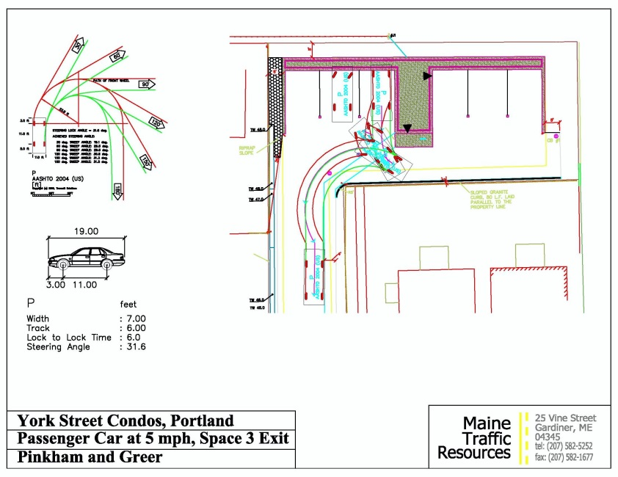

Bicycle Parking (also Motorcycle and Scooter parking)

The proposals include 2 bicycle parking spaces at the rear of the existing building, which meets the ordinance standard of 2 bicycle spaces per 5 vehicle spaces.

Snow Storage

An “Off-Site Snow Removal Plan” is included on Plan 4 and staff consider this is acceptable. It may be recommended to be a condition of approval, depending on the final vehicle access evaluation.

TDM

- Environmental Quality Standards

Preservation of significant Natural Features/Landscape preservation

Site Landscaping and Screening

The Demolition Plan (Plan 3) indicates the removal of 2 large trees on site and the smaller vegetation along the south boundary. The Landscaping Plan (Plan 5) proposes the planting of 7 trees: 4 at the eastern side of the building and 3 along the access drive. In a meeting with neighbors, attended by the City Arborist, nearby residents requested that the twin trunk 30 in tree in the NE corner (see Attachment 8) be retained but it appears this would not be possible given the proposed building location. Two replacement trees are proposed as allowed by the City Ordinance waiver provisions.

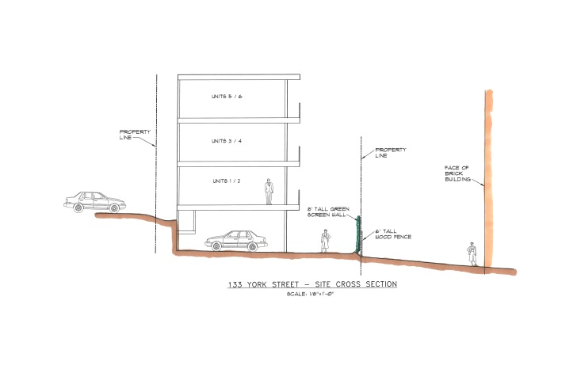
The City Arborist, Jeff Tarling, has reviewed the proposals and met with the applicant and neighbors on site. In addition to some recommendations regarding the species of new trees, he is concerned that measures are in place to save the two remaining large trees (Attachment 8).

Screening planting has been proposed on the north and east boundaries. On the west side there is a rip rap slope and no proposed planting, but that is similar to the existing condition with the existing building. To the south (along the boundary with the brick 12 unit apartment building) there is no scope for screening planting as that part of the drive will operate as a parking aisle and is already very constrained at 16 feet wide with paving right to the boundary. The Traffic Engineering Reviewer has questioned whether that 16 feet is adequate and turning templates have been requested.

Jeff Tarling, the City Arborist, has commented (Attachment 8):

Landscape & Buffering:
Due to the lot shape & size the 133 York Street site is unusually "challenged" in regards for 'green space', buffering and landscape improvements, particularly for an established residential neighborhood.

Recommendations: Additional buffering between the proposed project and brick residential property next door should be a requirement condition. The proposed projects driveway and parking is next to their backyard living space, patio & green space. Additional screening in the form of a 'green wall' and / or two to three columnar trees to be planted on the adjacent property would improve.

See green-wall examples: http://www.greenscreen.com/home.html
A 'green-wall' in the patio area near the corner and two trees in the lawn? Understanding the proposed project is limited in space and need to be in agreement with the neighboring property to be successful in the tree planting aspect of this condition.

Additional buffering / landscape treatment condition #2 - the left side of the driveway at York Street for the first 40' (area of hash marks on plan) landscape planting or fencing to screen the side yard of the existing residential property next door. The landscape planting should provide screening or buffering as not to adversely affect the existing use next door. (I noted a small seating area on the lawn existing currently)

Parking Lot Landscaping

Street Trees

Water quality, Stormwater Management and Erosion Control

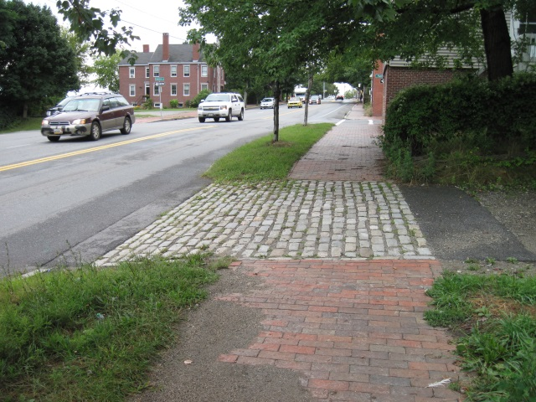
As discussed above under Subdivision Review.

- Public Infrastructure and Community Safety Standards

Consistency with City Master Plans

Public Safety and Fire Prevention

Public Safety

The Crime Prevention through Environmental Design (CPTED) standards in the site plan ordinance address the principles of natural surveillance, access control and territorial reinforcement so that the design of developments enhance the security of public and private spaces and reduce the potential for crime.

The backland nature of the site reduces the natural surveillance from the street but allows for some surveillance from nearby upper floor dwellings. The drive and pedestrian walkway are not lit between York Street and the “parking aisle” section (approx. 90 feet) and there should be some low level lighting long this walkway.

Fire Prevention

As with Harborview Townhouses, the Fire Department is concerned that the NRPA 1 Fire Code requirements regarding access and hydrants is clearly met. The applicant has not provided a full analysis of this Code but Captain Pirone has indicated that the combined vehicle/pedestrian way of 20 feet width is acceptable for access, and that an additional fire hydrant will be required (Attachment 7).

Availability and Adequate Capactiy of Public Utilities

The water and sewer service come from York Street and the gas, electric and cable will be from Park Street. The “Grading and Utility Plan” (Plan 4) has recently been revised to show the electric line as overhead to address reflect the Engineering comments about inconsistency (Attachment 3). The original submission showed the connection as being underground and that proposal should be re-instated to comply with the Subdivision ordinance which requires all utilities to be underground. The Engineering Reviewers (Attachments 3 and 6) point out that an easement from the McCormick Place condominiums appears to be necessary to achieve this connection, and may also be necessary regarding the gas and cable feed.

Capacity letters have been received for water, sewer and gas- see Attachment J.

- Site Design Standards

Massing, Ventilation and Wind Impact

The proposed new building is 26 feet wide by 89 feet long and rises a total of approximately 40 feet. The architect has compared the proposed absolute heights with those of the existing building in a letter (Attachment O). The footprint is 20% larger than existing and the height ranges from 6-8.5 feet higher than the existing building at the west end. The east end is a new structure and has been designed to be about 10 feet higher (Attachment O).

The proposed building is 12.5 feet from the single family brick dwelling (no windows) to the west; 20 feet from the side elevation of Harborview Townhomes (decks and windows-to the east); and 43 feet (closest point) from the main wall of the 12 unit brick building to the south (decks and windows).

The applicable site plan standard is (14-526 (d) (1) b:

The bulk, location or height of proposed buildings and structure shall minimize, to the extent feasible, any substantial diminution in the value or utility to neighboring structures under different ownership and not subject to a legal servitude in favor of the site being developed.

Shadows/Snow and Ice Loading

View corridors
The loss of views is not a review standard as the Portland Planning ordinances do not protect water views except where they are identified as a protected "view corridor" as per the “View Corrido Protection Plan”. Therefore the impact of the proposal on views may not be taken into consideration by the Planning Board.

Historic Resources

The Site Plan ordinance includes a requirement for projects to be compatible with the character-defining elements of the portion of the historic district nearest the proposal. The proposal is about 65 feet from the West End Historic District, measured across the Harborview Townhomes site. The Historic Preservation Program Manager considered the proposals and notes that between this site and the core of the historic district there are relatively recent developments that are more modern in design and therefore this proposal is generally compatible.

Exterior Lighting

The proposal includes 4 ceiling lights with the parking area on the lowest level; the specification and resulting photometrics have been submitted in Attachment P. While this solution is preferable to pole lights, the photometrics show excessive light levels in the drive area located between the proposed building and the abutting lot. Some modification is required to bring the light levels into compliance with the Technical Standards.

No lighting has been proposed for the 90 foot long drive leading to York Street, and staff consider some lighting should be provided to address CPTED concerns while avoiding impacts on the adjacent apartment building.

Noise and Vibration

Signage and Wayfinding

- ZONING RELATED DESIGN STANDARDS IN THE SITE PLAN ORDINANCE

R-6 Infill Development Design Principles and Standards

In September the applicant submitted a narrative outlining how the proposed design addresses the R-6 design standards (Attachment E). Staff conducted a preliminary review based on black and white elevation plans and raised concerns regarding the front entrance treatment. At the planning board Workshop color elevations were presented and boththe planning Board and neighbors raised concerns over the materials (including the blue metal cladding) and the lack of articulation of the rear elevation which is viewed by many neighbors.

Following the workshop staff met with the applicant’s architect and understood that the decision regarding the cladding materials was not going to be reviewed but that further consideration could be given to other aspects. The final proposals reflect the input of staff regarding the front entrance, composition of cladding materials, number and size of windows and the use of a larger cornice on the rear elevation (see Design Review memo in Attachment X).

Staff consider that the overall scale and form of the proposed building generally meets the R6 standards regarding context, but that the minor adjustments in cladding and detailing do not fully meet the R6 Design Standards in respect of materials and articulation.

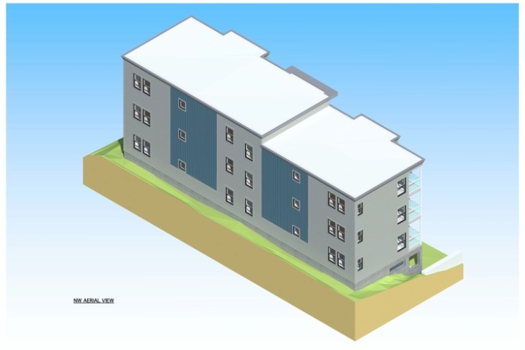
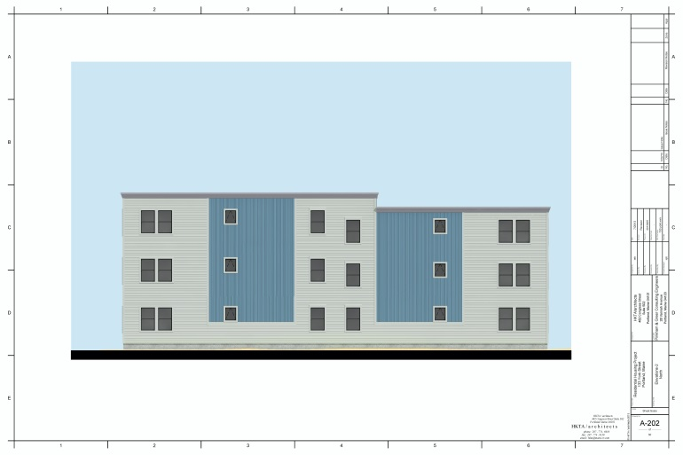

Multi-family and Other Housing Types Design Standard

This design standard also applies to this proposal is outlined in sections below with associated staff review comments:

(i) TWO-FAMILY, SPECIAL NEEDS INDEPENDENT LIVING UNITS, MULTIPLE-FAMILY, LODGING HOUSES, BED AND BREAKFASTS, AND EMERGENCY SHELTERS:
(1) STANDARDS. Two-family, special needs independent living units, multiple-family, lodging houses, bed and breakfasts, and emergency shelters shall meet the following standards:
a. Proposed structures and related site improvements shall meet the following standards:
1. The exterior design of the proposed structures, including architectural style, facade materials, roof pitch, building form and height, window pattern and spacing, porches and entryways, cornerboard and trim details, and facade variation in projecting or recessed building elements, shall be designed to complement and enhance the nearest residential neighborhood. The design of exterior facades shall provide positive visual interest by incorporating appropriate architectural elements;

Staff comment: The neighborhood is characterized by a variety of architectural styles and the proposed modern style is acceptable in principle. It is questionable whether the blue metal cladding “complements and enhances” the residential neighborhood, which is characterized by more subdued modern materials and greater articulation.

  - The proposed development shall respect the existing relationship of buildings to public streets. New development shall be integrated with the existing city fabric and streetscape including building placement, landscaping, lawn areas, porch and entrance areas, fencing, and other streetscape elements;

Staff comment: The proposal effectively is an enlargement of an existing building with some improvement to setbacks and an increase in bulk. It is not well integrated in terms of landscaping, particularly on the south side where the paved area abuts the neighbors fence.

3. Open space on the site for all two-family, special needs independent living unit, bed and
breakfast and multiple-family development shall be integrated into the development site. Such open space in a special needs independent living unit or a multiple-family development shall be designed to complement and enhance the building form and development proposed on the site. Open space functions may include but are not limited to buffers and screening from streets and neighboring properties, yard space for residents, play areas, and planting strips along the perimeter of proposed buildings;

Staff comment: All 6 of the new units will have balconies.

4. The design of proposed dwellings shall provide ample windows to enhance opportunities for sunlight and air in each dwelling in principal living areas and shall also provide sufficient storage areas;

Staff comment: This standard appears to be met.

5. The scale and surface area of parking, driveways and paved areas are arranged and landscaped to properly screen vehicles from adjacent properties and streets;

Staff comment: The parking is located underneath the units and partially screened, although there are no “garage doors”. The interior lighting over the parked cars will highlight this area, and headlights from vehicles maneuvering in the drive/parking aisle will be visible for properties on three of the boundaries. Solid fencing (possibly just for the lower part of the fence) and buffer planting or additional screening (eg “green wall”) is considered necessary )see City Arborist comments in Attachment 8) and requires further consideration.

- Staff Recommendation

IX. MOTIONS FOR THE BOARD TO CONSIDER

- WAIVERS
On the basis of the application, plans, reports and other information submitted by the applicant, findings and recommendations, contained in the Planning Board Report #50-13 for application 2013-187 for 133 York Street relevant to Portland’s Technical and Design Standards and other regulations, and the testimony presented at the Planning Board hearing:

- The Planning Board (waives/does not waive) Section 14-526 (b) (2) (b) (iii) Street Trees, ….

- The Planning Board (waives/does not waive) Technical Design Standard Section (from Tom???)

- DEVELOPMENT REVIEW
On the basis of the application, plans, reports and other information submitted by the applicant, findings and recommendations contained in Planning Board Report # 50-11 for application 2013-187 for 133 York Street relevant to the Site Plan and Subdivision reviews and other regulations, and the testimony presented at the Planning Board hearing, the Planning Board finds the following:

- Subdivision:

That the Planning Board finds that the plan (is/is not) in conformance with the subdivision standards of the land use code, subject to the following conditions of approval:

Potential conditions of approval:

    - That the Subdivision Plat shall be finalized to the satisfaction of the Planning Authority, Corporation Counsel, and Department of Public Services and include detailed references to approval dates, easements, snow removal; green wall maintenance; Condominium Association documents and relevant conditions; and

    - That the Condominium Association documents, including the Stormwater Maintenance Agreement and Stormwater Inspection and Maintenance Plan, shall address the relevant conditions of approval and be finalized to the satisfaction of the Corporation Counsel prior to the recording of the Subdivision Plat; and

    - That the applicant and all assigns shall comply with the conditions of Chapter 32 Stormwater including Article III, Post-Construction Storm Water Management, which specifies the annual inspections and reporting requirements. The developer/contractor/subcontractor must comply with conditions of the construction stormwater management plan and sediment & erosion control plan based on City standards and state guidelines. A maintenance agreement for the stormwater drainage system, as included in Attachment L of this Report, or in substantially the same form with any changes to be approved by Corporation Counsel, shall be submitted and signed prior to the issuance of a Certificate of Occupancy with a copy to the Department of Public Services; and

    - That the applicant shall ensure that tree preservation measures are undertaken in accordance with the comments of the City Arborist dated XXX and XXX, and that the Condominium Association docu,emnts shall include responsibilities for ongoing tree preservation ; and

    - That the applicant shall add a note on the Subdivision Plat that confirms that the Condominium Association shall be responsible for the maintenance of the green wall, both the structure and the planting, and that any damage from vehicles backing into green wall shall be repaired within one week; and

    - That the Subdivision Plat shall include a note confirming the Snow Removal Plan details and that the Condominium Associaton is responsible for this being undertaken in a timely fashion; and

    - That XXX vehicles shall not (re access/servicing)

    - RE access to parking spaces

- Site Plan Review

The Planning Board finds that the plan (is/is not) in conformance with the site plan standards of the Land Use Code, subject to the following condition(s) of approval:

Potential conditions of approval:

- That the Landscape plan XXX Plant List/Locations shall be revised to

- Construction management plan +++

- Fire connection

- Condensers for heating or cooling units

- Lighting: That revised ceiling mounted lights within the parking garage area shall be submitted for reiew and approval so that they meet the standards set out in Section 12 Site Lighting Standards in the City’s Technical Manual.

[Attachments next page]

ATTACHMENTS:
Attachments to the Report
Worskhop
  - Staff e-mail prelim review comments 8.22.2013
  - Traffic Engineering Review comments 8.23.2013
  - Engineering Review comments 8.27.2013 as updated 9.6.2013
  - Zoning comments 8.30.2013
  - Staff e-mail update 8.30.2013
  - DPS (David Margolis-Pineo) comments 9.5.2013
  - Fire Department comments 9.6.2013
  - City Arborist comments 9.6.2013

Hearing
  - Staff e-mail re fundamental issues
  - Fire Department comments
  - City Arborist comments
  - Engineering Review comments
  - Zoning comments
  - DPS (David Margolis-Pineo) comments
  - Traffic Engineering Review comments

Applicant’s Submittal
Workshop
- Cover Letter and Application 7.24.2013
- Project Description
- Right, title and Interest
- Draft condominium documents
- Narrative re Design Principals and Standards
- Building code summary
- Financial Capability letter
- Technical Capability information
- Neighborhood meeting Information
    - May 17, 2013 meeting
    - August 30, 2013
- Utility letters of capacity
- Construction Plan
- Stormwater Management Report June 19, 2013
- Letter Pinkham and Greer re trees and Fire code 8.22.2013
- Letter Pinkham and Greer response to staff comments 9.3.2013
- Letter HKTA architects re design and height 9.5.2013
- Lighting specifications and photometrics

Hearing
- Letter P&G & calcs response to Eng Rev comments 9.30.2013
- Vonda bollard cut Sheet
- Climbing hydrangea proposed for green wall
- Correspondence between applicant and neighbors
- Susan Kaplan re impact on 12 unit brick condos /green wall etc
- McCormick condo association re construction easement
- To staff re McGee letter (f/w to neighbors)
- To staff re Foley letter (f/w to neighbors)
- Architects memo 10.1.2013
- Letter Pinkham & Greer re revised plans 10.21.2013
- Additions to Stormwater Report October 2013
- Construction Plan 10.21.2013
- Parking Autoturn Templates 10.21.2013
- Fire Code Review 10.23.2013

Final Plans
      - Boundary Survey
      - Subdivision Recording Plat
      - Site Plan
      - Existing Conditions and Demolition Plan
      - Grading and Utilities Plan
      - Erosion Control and Landscape Plan
      - To 9. Details
- Tree Filter Detail
- To 14. Floor plans
- To 18. Elevations
19. Horizontal and Vertical Boundaries
20. Section across site
21. Roof Cornice Profile
22. to 26. Aerial views of exterior (renderings)

