***DRAFT***

## **Memorandum**

**Planning and Urban Development Department**

**Planning Division**

**To:** Chair Hall and Members of the Portland Planning Board

**From:** Jean Fraser, Planner

**Date:**  April 22, 2011

**Re: Harborview Townhouses; 121-129 York Street;**

**Harborview Development LLC, Applicant**

**Project #:** 2011-214 **CBL:** 44-A-4 and 5

**Meeting Date:**  Planning Board Workshop April 26, 2011

1. **Introduction**

Redfern Properties LLC, on behalf of Harborview Development LLC, as submitted a Level III Preliminary Site Plan and Subdivision application for the construction of a 7 unit residential building on a .32 acre “urban infill” site at 121 York Street. The site forms part of a .48 acre lot that includes an existing brick 12-unit apartment building and associated gravel parking area. Together these will create a 19 unit condominium development with common parking and accessed via the existing access from York Street.

The parcel for the new 7 unit building has a 58 foot frontage onto York Street and stretches back into the block approximately 240 feet; the new building is proposed to be set back approximately 150 feet from York Street.

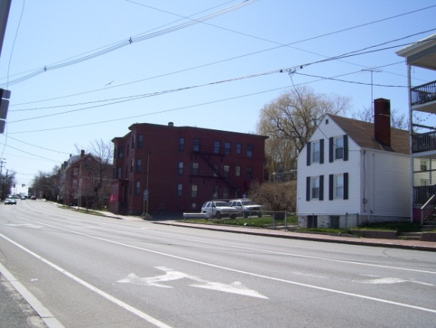 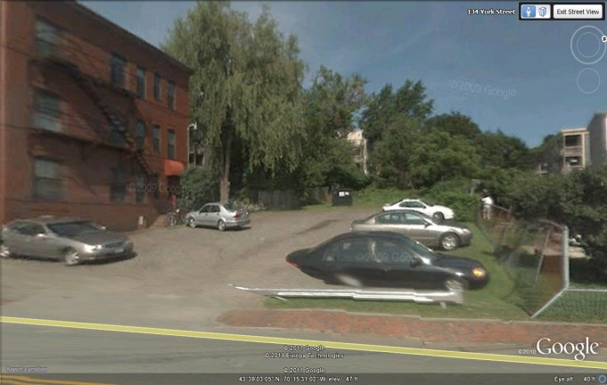

The Planning Board is being requested to review the application under Portland’s recently adopted Level III Preliminary Plan procedure and the applicant has requested this Workshop.

The applicant held a neighborhood meeting on April 20th, 2011 and the notes and attendance are included in Attachment F. A total of XX notices were sent out to neighbors and interested parties, and the public notice appeared in the Portland Press-Herald on April 18 and 19, 2010.

1. **PROJECT DATA (based on revised submission dated 4.128.2011)**

|  |  |  |  |
| --- | --- | --- | --- |
| ***DATA*** | ***Parcel 1 (Existing building)*** | ***Parcel 2 (open and gravel parking)*** | ***Total Lot*** |
| **Existing Zoning** | R-6 | R-6 | R-6 |
| **Existing Use** | 12 unit apartment | Vacant and gravel parking | 19 unit condo |
| **Proposed Use** | Duplex residential | Multiplex residential (triplex) | Multiple family Residential |
| **Parcel Size** | .16 acre (7,112 sq ft) | .32 acre (14,117 sq ft) | .48 acre (21,229 sq ft) |
| **Impervious Surface Area**  **--Existing**  **--Proposed**  **--Net Change** |  |  | 8,100 sq ft  16,310 sq ft  8,210 sq ft |
| **Total Disturbed Area** |  |  | Approx. 14,000 sq ft |
| **Building Footprint**  **--Existing**  **--Proposed** | 3080 sq ft | 4160 sq ft | )  ) 7,240 sq ft  ) |
| **Building Floor Area** | 11,764 sq ft | 12,480 sq ft | 24,244 sq ft |
| **Parking Spaces** | 12 (but space for more) | Additional 7 | 20 |
| **Bicycle parking Spaces** | 0 | - | 10 |
| **Paved Area** | 4,600 sq ft | Additional 950 sq ft | 5,550 sq ft |

1. **EXISTING CONDITIONS**

The proposal site is located on the north side of York Street between Park and High Streets, XXX feet east of the Casco Bay Bridge intersection and approximately120 feet west of the intersection of York Street and High Street. The West End Historic District buts the site on two boundaries at the northernmost end of the site (back part) where the proposed new building would be constructed (Historic District is toned gray on aerial below).

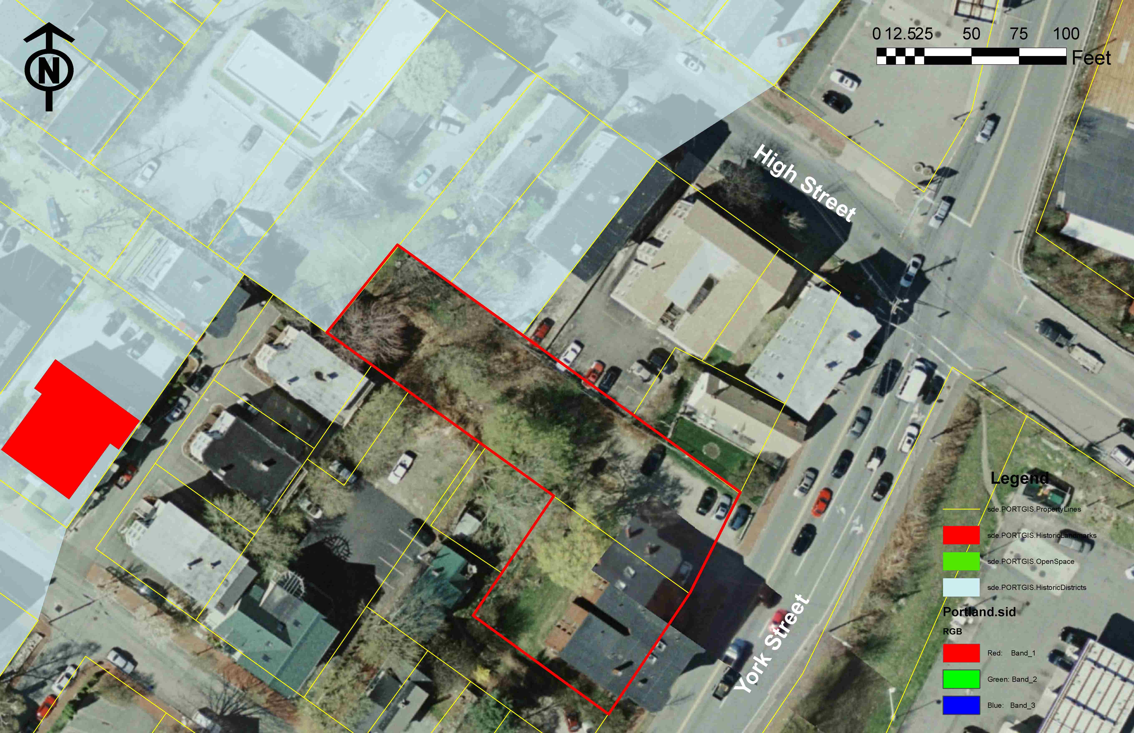

The frontage along York Street comprises an existing brick 12 unit apartment building (not well-represented on the aerial as it’s a photo join) and a gravel surface parking lot. The rear part of the long narrow parcel (to be developed with the new 7 unit building) is currently rough vegetation with a number of semi-mature trees on the lot and more mature trees along the boundary; it is partially enclosed by chain link fencing. There are no existing significant natural features located on the site.

The proposed new building and upgraded parking lot would abut 6 existing residential properties, primarily 3-4 story buildings with associated parking and open/green areas. These are shown in the above aerial photograph, in the submitted aerial photograph (Attachment G.2) and below:

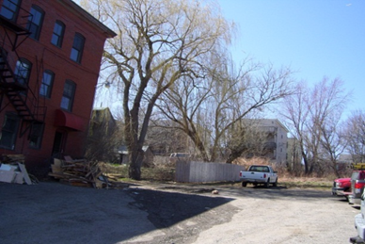 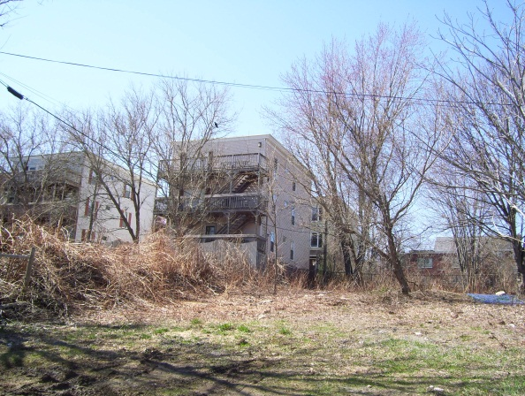

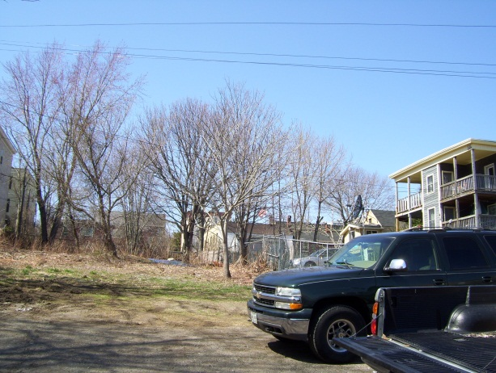 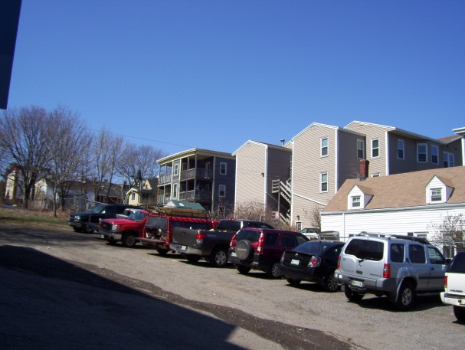

* A four story building located on Nye Street is approximately 150 feet back from the existing brick building and immediately abuts the west corner of the proposal boundary at the rear (top 2 photos);
* Two 1-2 story residential buildings are 30-50 feet from the project site boundary (rear east corner); these are within the Historic District;
* Two 3-story buildings (light and dark gray) set back approximately 50 feet from the north east side boundary; one is within the Historic District;
* One 2-story residential building (white) abutting the existing parking lot and about 30 feet from the site boundary.

The rear part of the site is about 20 feet higher than the York Street sidewalk, so the entire site slopes at about 1:12 and currently storm water sheet flows to York Street. The existing sidewalk is in brick in good condition; two street trees are located in the esplanade in front of the existing building.

1. **PROPOSED DEVELOPMENT**

The project retains the existing 12 unit building fronting York Street and proposes a new 7 unit residential wood framed building on the rear part of the open parcel, approximately 150 feet from York Street and set back 10 feet from each of the two side boundaries and 20 feet from the rear boundary. The building has a footprint of 4,160 sq ft and a total building area of 12,480 sq ft. The building is stepped back, with two flat-roofed sections at 3 stories and a rear-most (also with a flat roof) section that appears to be more than 3 stories but is 44.5 feet high above the average grade.

The building is of contemporary design, utilizing fiber-cement siding, decorative metal accents, sloped roofs and five integrated balconies. It will be sprinkled, built to low energy standards with high efficiency heating systems to meet a high level of LEED certification.

The proposal retains the existing vehicle access from York Street and the existing parking area, upgraded to asphalt paving and striped for 20 parking spaces. Pedestrian access is partly via a path from York Street along the side of the existing brick building. Access to the new building is generally from the front and west side of the building. Bicycle parking is proposed.

The submissions indicate 2 new street trees; 3 trees and a fence along the front of the parking lot, and 8 new trees around the new building; it is not clear what existing trees will be removed as some are on the boundary. Along the east side of the building (between the footprint and the site boundary) there are individual garden terraces. A 6 foot high wood fence is proposed around the three boundaries of the development parcel that abut other properties.

1. **STAFF REVIEW**
   * + - 1. **ZONING ASSESSMENT**

The proposed subdivision is within the R-6 Residential Zone.

Marge Schmuckal, Zoning Administrator, reviewed the original submitted plans and raised a number of fundamental concerns regarding the number of proposed new units, the number of stories and associated set backs, along with other zoning questions (Attachment 1). The applicant has responded with further information and slightly revised plans (Attachments B and G.4), but the proposed building has not been revised.

[Awaiting Marge second comments)

The key issue is the third section at the very rear part of the site where it appears to be 4 stories, due to a mezzanine level between the second and third floor.

The parking requirement is one parking space per unit and the proposed (revised) site plan (Attachment G.4) shows 20 spaces for the proposed 19 units.

**B. SUBDIVISION STANDARDS (excluding those not required at preliminary plan stage)**

14-496. Subdivision Plat Requirements

The applicant has not submitted a draft subdivision plat. As this is a subdivision based on the number of residential units, the plat would be similar to the site plan.

It should be noted that the Department of Public Services has identified a number of inaccuracies and omissions regarding the survey (Attachment 7) that would need to be corrected.

14-497. General Requirements (a) Review Criteria

***Water, Air Pollution and Soil Erosion***

A preliminary Sedimentation and Erosion Plan has been submitted (Attachment C.) and is acceptable in principle (engineering review comments in Attachment 2).

***Traffic***

The proposed development will utilize the existing two-way access from York Street, which will be moved slightly towards the east but remain about 20 feet wide. It will serve the parking lot which is proposed to be repaved and striped for 20 parking spaces.

A pedestrian path from York Street into the site alongside the existing building is provided but does not extend to the new building.

The applicant has submitted a Traffic Report regarding trip generation (Attachment A.) and reviewers accept that the trip generation is not an issue given the existing level of use.

The Traffic Engineering reviewer, Tom Errico, has identified three main areas of concern (Attachment 3 and below):

* Sightlines
* Width of parking lot
* Pedestrian access

His detailed comments (on the original submitted plans) are:

* York Street is a major arterial and carries a significant amount of traffic.  Accordingly, sight distance for vehicles exiting the site is a very important safety issue.  I do not support the installation of fencing or landscaping treatments that obstruct visibility.  The applicant should maintain clear sight 15-feet from the curb line on York Street.  I would also note that clear sight lines also ensure safe visibility to pedestrians on the sidewalk.
* The parking lot configuration includes a substandard parking aisle width (20 feet) near York Street and tapers to the compliant 24 feet internal to the site.  The applicant should provide justification for the reduced width and formally request a waiver from the City’s Technical Standards.  I would note that I ‘m somewhat concerned about this width issue at the driveway entrance where entry and exit movements are complicated by the heavy traffic volume levels on York Street.  If not well maintained during the winter, this area could become problematic.

•        The site plan does not provide pedestrian facilities between the public sidewalk system and the new building.  Accordingly, it appears pedestrians will be required to walk through the parking lot.  This is not preferred and I would suggest that a sidewalk connection be provided.

•        The site plan indicates a fenced dumpster will be located on the front of the new parking lot.  The applicant should provide information on how the dumpster will be accessed. *[Note- since these comments were received the proposed dumpster area has been converted to another parking space]*

•        I have reviewed the City’s standard as it related to corner clearance on an arterial street.  The standard requires 150 feet of separation.  Based upon plans provided the site driveway is located in excess of 150 feet and therefore I find the location to be acceptable.

These concerns and recommendations have implications for other aspects of the review, such as emergency access and landscaping.

***Sanitary Sewer/Soils***

The proposals have been reviewed by the Engineering Reviewer and DPS are satisfactory subject to further and revised details at the final plan stage (Attachments 2 and 7).

***Storm water***

The existing “open” site currently drains over the surface downhill to York Street into an existing catch basin. The submission includes a Preliminary Stormwater Report (Attachment D) and a Grading and Drainage Plan (Attachment G.7). It is proposed to install an under drained subsurface sand filter with detention in the corner of the parking area nearest to York Street. This has been sized to treat 95% of the new impervious area and 80% of the developed area.

The proposals have not been fully reviewed as further information is needed regarding groundwater and bedrock at the site (Attachment 2). A key issue to be addressed is the need for a new catch basin in York Street, as the City’s Technical Standards would not allow the proposed development to tie into the existing catch basin.

***Scenic Beauty***

The undeveloped lot is partly wooded with several mature trees (not shown in the boundary survey but evident in the aerial and other photos); some are on the boundary and it is not known which would have to be removed for the proposed development. The large tree behind the existing brick building is indicated to be retained.

The proposals show two new street trees, 3 new trees along the parking lot frontage, and 8 new trees around the new building. There are no proposed trees or landscaped areas within the parking lot. Staff recommend improved tree planting and/or reconfiguration of the site to provide additional planting as is consistent with this residential block (see further details under *Site Plan Standards*).

*Street Trees*

The subdivision requirement would be one tree per unit or 19 street trees (less the 2 existing). If the 3 trees along the proposed frontage are not feasible due to the issue of sight lines, the applicant would be required to provide 17 street trees or the equivalent via a contribution to the Citys Street tree fund.

***Comprehensive Plan***

The applicant has referred to the Comprehensive Plan as related to housing policies (Attachment A) and the project is compatible with Comprehensive Plan goals and policies.

**C. SITE PLAN STANDARDS**

14-526 Requirements for approval

***Traffic - as discussed above under Subdivision Review***

***Bicycle Parking***

The proposals include 10 bicycle parking spaces at the rear of the existing building and this meets the ordinance standard.

***Snow Storage***

Snow storage areas have not been shown on the proposed plans and as designed there is very limited space for snow storage.

***Site Landscaping***

The proposed Site Plan (Attachment 4 as revised; the submitted site plan in Att 3 is included for reference) shows landscaping along the frontage of the parking lot and around the existing and proposed buildings. Eleven new trees are proposed, of which 8 are within the private terraces for the units and 3 are in the landscaped area along the frontage of the parking lot.

Jeff Tarling, the City Arborist, has commented (Attachment 5):

The proposed building footprint and parking area occupies much of the site leaving a minimal area for landscape treatment.   "Ideally", the front parking area would include space for greenery that could also be used for parking lot snow storage.   The project does show landscape treatment on the upper sections of the lot near the building.  Reducing the impact to the single family Cape Cod house to the right of the project on York Street is important.

Goals would include: buffer planting and decorative wood fence screening (fencing would need to meet city codes), tree and landscape planting near front of the lot closer to York Street.   The tree types can up upright or tight canopy respective of the scenic views towards Portland Harbor.  While other site issues and space compromise ideal landscape treatment, it would be good to consider additional greenery on the site, especially the front view into the site from York Street.

*Parking Lot Landscaping*

The Site Plan ordinance includes specific standards for landscaping in parking lots:

*(ii) Parking Lot Landscaping:*

*(a) Developments with five (5) or more parking spaces shall include at least two (2) trees (or one (1) tree and three (3) shrubs) per five (5) parking spaces planted in landscaped islands to screen shade and break up parking. Trees and shrubs in parking lots may be in informal groups, straight rows, or concentrated in clusters as detailed in Section 4 of the Technical Manual.*

*(b) Landscaped islands shall be distributed so that uninterrupted pavement does not exceed forty (40) parking spaces.*

*(c) Landscaped islands shall be curbed and a minimum of eight (8) feet in width, not including curbing. The incorporation of bioretention into landscaped islands is strongly encouraged.*

*(d) Vehicle display lots shall be subject to the parking lot landscaping standards of this section.*

*(e) Waiver: Where site constraints prevent implementation of all or a portion of required parking lot landscaping, as determined by the Reviewing Authority, the requirements may be all or partially waived and the applicant shall contribute an amount proportionate to the cost of required parking lot trees to the City of Portland Tree Fund.*

The proposals do not meet these requirements for parking lots, and addressing these standards is particularly important given that landscaping along the frontage will be difficult due to the traffic recommendation to provide clear sight 15 feet from the curb line with York Street.

***Water quality, Stormwater Management and Erosion Control***

As discussed above under ***Subdivision Review.***

***Public Infrastructure and community safety standards***

*Public Safety*

The proposal creates a number of narrow access walkways which are not near the street nor overlooked by windows; the proposed 6 foot high wood fence around most of the site prevents overlooking or escape. Access to the new building units is along the west side boundary via a 10 foot walkway and would need careful design and lighting. A courtyard layout or central front door access would offer improved public safety.

*Fire Prevention*

Captain Gautreau of the fire Department raised concerns regarding fire and emergency access given the long setback from York Street and the narrow and congested access to only one side of the building through the parking lot. He met with the applicant on 4.21.2011 and concluded (Attachment 4):

**Here are some comments from today's on-site meeting:**1. Access is still very limited for a new building. (essentially one side, set back 100 +/- ft off York)  
2. In the winter some sort of snow removal plan should be in place to maintain the 20 ft of access for emergency vehicles.  
3. The entire building will be protected throughout with an approved sprinkler system by code.

4. The possibility of installing a fire alarm system throughout the entire building to allow for early detection and notification of a fire.

5. Possible easements with neighbors for ladder truck access off of Park Street and reinforcing the parking lot surface to support the weight of fire apparatus.

Some or all of these options would need to be implemented in order for the Fire Department to feel comfortable with approving this project with such limited emergency access.  Please feel free to forward these comments to the appropriate people.  I will also plan on attending the planning board workshop on Tuesday as well.

*Public Utilities*

A “Utility Plan” has been submitted (Attachment G.6) which indicates that all utilities will be underground. It is noted that some existing overhead utility lines crossing the site will need to be re-routed.

David Margolis-Pineo of DPs has noted that there is a 3’ sewer easement across the site and details and implications are requested. He also commented that if the proposed drainage system from site is 8” or larger it would require a manhole for connection to the sewer system (Attachment 7).

***Site Design Standards***

*Massing, Ventilation and wind impact*

The proposed new building is 40 feet wide by 105 feet long and rises a total of approximately 50 feet from the base level at the front to the roof level at the rear. It immediately abuts (10-15 feet between) the nearest building at the rear west corner, located alongside the building and porches.

Further information (accurate photomontages) could be requested to better understand the impact on the “utility” of neighboring structures.

*Historic Resources*

The site Plan ordinance includes the following standard in respect of Historic Resources. The proposal abuts the West end Historic District at the north end of the narrow parcel and the Historic Preservation Program Manager has been requested to comment on the proposals in the context of this requirement.

14-526 (d) 5 b:

*Development adjacent to designated landmarks, historic districts or historic landscape districts: when any part of a proposed development is within one hundred (100) feet of any designated landmark, historic district or historic landscape district, such development shall be generally compatible with the major character-defining elements of the landmark or portion of the district in the immediate vicinity of the proposed development. Character-defining elements of landmarks and historic districts are identified in the historic resources inventory and respective historic district designation reports For the purposes of this provision, “compatible” design shall be defined as design which respects the established building patterns and visual characteristics that exist in a given setting and, at the same time, is a distinct product of its own time. To aid the planning board in its deliberations, historic preservation staff shall provide a written analysis of the proposed development’s immediate context, identifying the major character-defining elements and any established building patterns that characterize the context*

Deborah Andrews, Historic Preservation Program Manager has provided a detailed narrative describing the character of the area and her preliminary comments on the proposed new townhomes development (Attachment 6). She has suggested that photomontages of the building from other vantage points would be helpful in assessing its impact, and concludes that the location of the building on the site away from the street is not compatible with the Historic District character, and that the contemporary architectural design is compatible (see extracts from her Memo below):

* Location of the building on the site: Ms Andrews comments:

Although the area exhibits an eclectic mix of buildings, there are nonetheless unifying development characteristics. Perhaps the strongest of these is the position of the buildings on their respective lots. Virtually all of the buildings sit at or near the front property line and most are oriented toward the street. Parking, where it is provided on site, is located on a driveway adjacent to the residence or behind the building at the rear of the lot and interior to the block.

The proposed project departs from this key development pattern, as it is set back a significant distance from the sidewalk behind a surface parking lot for 19 cars. While it could be argued that the proposed development’s anomalous setback and front yard parking will be ameliorated by the presence of a fence at the sidewalk line, the Board will need to determine whether this is sufficient to address this departure from the prevailing development pattern. Also, given likely concerns about exiting onto York Street and the need to provide ample sight lines, it is possible that the fence will need to be modified or eliminated.

* Design of the building: Ms Andrews comments:

As for the proposed design expression and material palette of the building itself, in staff’s view the eclectic nature of the surrounding context allows for a development of this nature. And, as the applicable site plan standard states, “compatible design shall be defined as design which respects the established building patterns and visual characteristics that exist in a given setting *and, at the same time, is a distinct product of its own time."* In this instance, it is the departure from the established development pattern--of buildings set directly behind the sidewalk line--that presents the most significant issue in terms of meeting this “general compatibility” standard.

1. **DESIGN STANDARDS IN THE SITE PLAN ORDINANCE**

Multi-family and Other Housing Types Design Standard

The design standard that applies to this proposal is outlined in sections below with associated staff review comments. The applicant has submitted a narrative outlining how they consider that the proposal meets these standards (Attachment A) :

*(i)* ***TWO-FAMILY, SPECIAL NEEDS INDEPENDENT LIVING UNITS, MULTIPLE-FAMILY, LODGING HOUSES, BED AND BREAKFASTS, AND EMERGENCY SHELTERS:***

*(1)* ***STANDARDS.*** *Two-family, special needs independent living units, multiple-family, lodging houses, bed and breakfasts, and emergency shelters shall meet the following standards:*

*a. Proposed structures and related site improvements shall meet the following standards:*

*1. The exterior design of the proposed structures, including architectural style, facade materials, roof pitch, building form and height, window pattern and spacing, porches and entryways, cornerboard and trim details, and facade variation in projecting or recessed building elements, shall be designed to complement and enhance the nearest residential neighborhood. The design of exterior facades shall provide positive visual interest by incorporating appropriate architectural elements;*

Staff comment: The neighborhood is characterized by a variety of architectural styles and the proposed contemporary style is acceptable in principle. The Historic Preservation Program Manager has also confirmed that the proposed design is acceptable in this location adjacent to the West End Historic District (Attachment 6).

* 1. *The proposed development shall respect the existing relationship of buildings to public streets. New development shall be integrated with the existing city fabric and streetscape including building placement, landscaping, lawn areas, porch and entrance areas, fencing, and other streetscape elements;*

Staff comment: In the immediate vicinity of the proposal (see staff plan showing built fabric below) there is one example of a set back building (next door to the existing building on this site) but otherwise buildings are at the street line. It is poorly integrated in terms of the building placement, and also due to the relatively larger scale of the building on the higher part of the site.

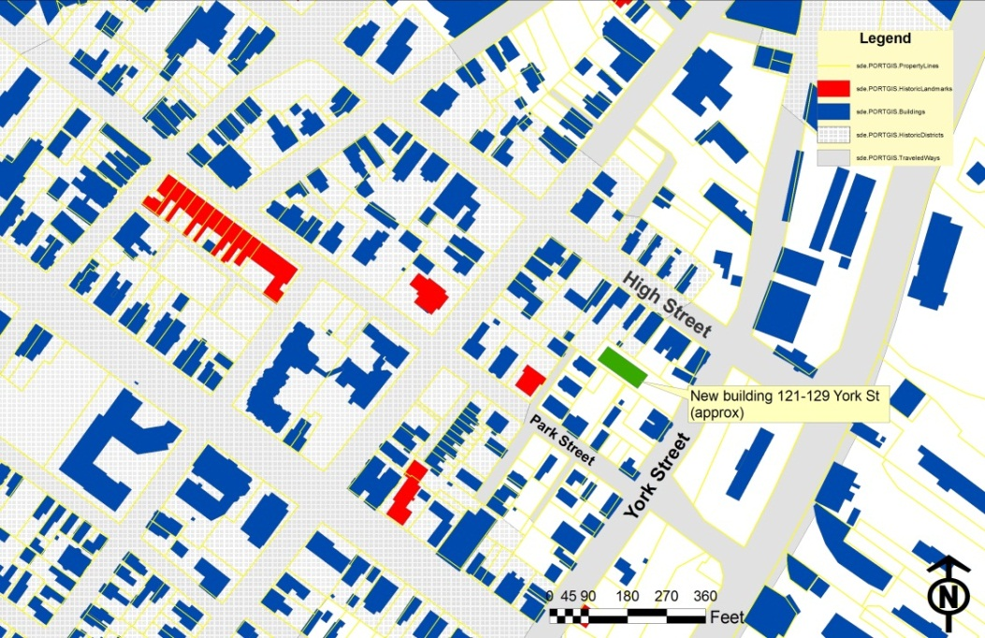

Staff understand that the building has been set back on the lot to achieve other objectives and that the fencing and trees along the frontage were intended to re-create a “street wall”. However, because enclosure of the parking lot is unlikely to be possible due to the need to preserve sightlines, the placement of the building could result in an open parking lot onto York Street.

*3. Open space on the site for all two-family, special needs independent living unit, bed and*

*breakfast and multiple-family development shall be integrated into the development site. Such open space in a special needs independent living unit or a multiple-family development shall be designed to complement and enhance the building form and development proposed on the site. Open space functions may include but are not limited to buffers and screening from streets and neighboring properties, yard space for residents, play areas, and planting strips along the perimeter of proposed buildings;*

Staff comment: It is understood that 5 of the new units will have balconies and all 7 units will have ground level terraces or patios. The existing 12-unit apartment building is provided with common grassed areas and terrace for use by residents and 4 units have balconies.

*4. The design of proposed dwellings shall provide ample windows to enhance opportunities for sunlight and air in each dwelling in principal living areas and shall also provide sufficient storage areas;*

Staff comment: This standard appears to be met.

*5. The scale and surface area of parking, driveways and paved areas are arranged and landscaped to properly screen vehicles from adjacent properties and streets;*

Staff comment: The proposals rely on a 6 foot high wood fence to screen the large (5,550 sq ft/20 spaces) parking area. If this fence is not feasible along the York Street frontage in order to meet sightline requirements, then the parking area would not be screened from York Street.

**VI NEXT STEPS**

The applicant has requested direction from the Board, particularly regarding the location of the new building within the site. The “Next Steps” will depend on the scale of revisions requested for the Final Plans.

The final submission will need to include:

* Subdivision Plat with all accurate contours, easements etc as in staff comments
* Fire prevention measures as requested by the Fire Department
* Further information on groundwater and bedrock so that storm water review can be completed
* Letters confirm adequacy of water and sewer service to the new building
* Increased landscaping in parking lot area
* Details to address CPtED concerns, including lighting
* Detials of waste and snow management
* Further information (photomontages etc) illustrating the impact of the proposal on the Historic District and abutters
* Revisions to address the reviewer comments
* Revisions to address Planning Board comments

**ATTACHMENTS:**

**Attachments to Memorandum**

* 1. Zoning comments on original submission 4.13.2011
  2. Engineering Review comments 4.19.2011
  3. Traffic Engineering Review comments 4.21.2011
  4. Fire Department comments 4.21.2011
  5. City Arborist comments 4.22.2011
  6. Historic Preservation comments 4.22.2011
  7. DPS (David Margolis-Pineo) comments 4.22.2011
  8. Zoning comments on revised submissions [to follow]

**Applicant’s Submittal**

1. Cover Letter and Application 3.30.2011
2. Response letter (to 4.13.2011 Zoning comments) 4.18.2011
3. Preliminary Erosion & Sedimentation Control Report (March 2011)
4. Preliminary Stormwater Report (March 2011)
5. Floor Plans (A1.3 revised to show mezzanines)
6. Neighborhood Meeting Information
7. Plan Set
   * + 1. Boundary Survey
       2. Boundary Survey over aerial showing context
       3. Submitted Sheet L1.0 Preliminary Site Plan (includes Landscaping)
       4. Revised Sheet L1.0 Preliminary Site Plan (includes Landscaping)
       5. Sheet L2.0 Illustrative Site Plan (in context of aerial)
       6. Sheet C1 Utility Plan
       7. Sheet C2 Grading, Drainage, Erosion & Sed Control Plan
       8. Elevations (as revised 4.15.2011)
       9. Elevation (as revised 4.15.2011)
       10. Photomontage of new building