

**PLANNING BOARD REPORT**

**PORTLAND, MAINE**

**Harborview Townhomes**

**127 YORK STREET (aka 121-129 York Street)**

**CBL:** 44-A-4, 5

Subdivision and Site Plan

Project ID 2011-214

Harborview Development LLC, Applicant

|  |  |
| --- | --- |
| Submitted to: Portland Planning Board  Public Hearing Date: June 28, 2011 | Prepared by: Jean Fraser, Planner  Date: June 24, 2011  **Planning Board Report # 13-11** |

1. **Introduction**

Redfern Properties LLC, on behalf of Harborview Development LLC, has submitted a Level III Preliminary Site Plan and Subdivision application for the construction of a 7 unit residential building on a .32 acre “urban infill” site at 121-129 York Street (aka 127 York Street). The site forms part of a .48 acre lot that includes an existing brick 12-unit apartment building and associated gravel parking area. Together these will create a 19 unit condominium development with common parking, accessed via the existing access from York Street.

The parcel for the new 7 unit building has 58 feet of frontage along York Street and stretches back into the block approximately 240 feet; the new building is proposed to be set back approximately 110 feet from York Street and abuts the West End Historic District at the north end.

The applicant requested a Preliminary Review and the Planning Board considered the preliminary submission at a Workshop on April 26, 2011. The Final Plan for this project was submitted June 7, 2011. The project is subject to review for conformance with the Subdivision and Site Plan ordinances of the Land Use Code.

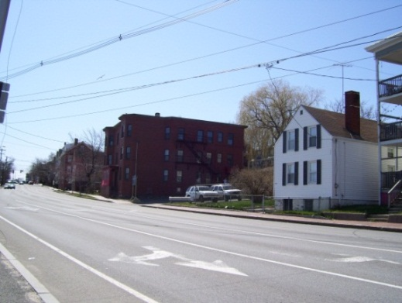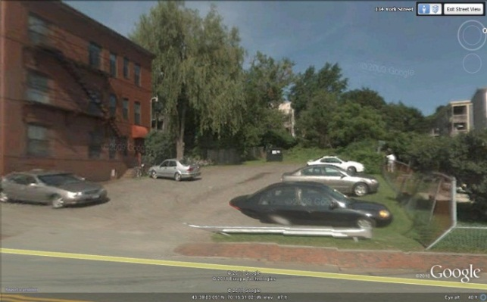

1. **PROJECT DATA**

|  |  |
| --- | --- |
|  | ***DATA*** |
| **Existing Zoning** | R-6 |
| **Existing Use** | 12 unit apartment and associated parking area; vacant land |
| **Proposed Use** | 7-unit new building to create  19 unit condominium |
| **Lots in subdivision** | 19 units |
| **Parcel Size** | .48 acre (21,239 sq ft) |
| **Impervious Surface Area**  **--Existing**  **--Proposed**  **--Net Change** | 10,429 sq ft  16,454 sq ft  6,025 sq ft |
| **Total Disturbed Area** | Approx. 14,000 sq ft |
| **Building Footprint**  **--Existing**  **--Proposed**  **--Total** | 3,080 sq ft  4,160 sq ft  7,240 sq ft |
| **Building Floor Area**  **--Existing**  **--Proposed**  **--Total** | 11,764 sq ft  12,087 sq ft  24,244 sq ft |
| **Residential Data**  **--Existing Residential Units:**  **--Proposed Residential Units:**  **--No. Units to be Demolished:**  **--No. of Affordable Units:** | 12  19  0  0 |
| **Building Height (new building)**  **--From ave. grade**  **--Actual re proposed fin. grade** | 44.62 feet  38.75 feet |
| **Parking Spaces**  **--Existing**  **--Proposed** | 12 (parking area not striped)  19 proposed (19 required by zoning) |
| **Bicycle Parking Spaces**  **--Existing**  **-Proposed** | 0  9 |
| **Proposed Paved Area** | 5,550 sq ft |

1. **BACKGROUND AND EXISTING CONDITIONS**

The applicant had requested a preliminary review by the Board to confirm that the overall layout (with the proposed large set back from York Street) was broadly acceptable.

The Planning Board members at the April Workshop supported the proposed location of the new building but noted there were a number of concerns to be addressed in the final submission:

* How project meets all zoning requirements;
* Details of the fire and emergency access and measures to meet Fire Prevention concerns;
* How project meets Historic Preservation concerns in the context of *14-526 (d) 5 b* so that the Board can assess in relation to the site plan standard;
* More information on history of the site and what was on the rear part of it;
* Revised design of the parking lot, landscaping and fencing between the new building and York Street so it is better defined and addresses standards; and
* CPTED issues regarding surveillance and “places to hide”.

The proposal site is located on the north side of York Street between Park and High Streets, approximately 600 feet east of the Casco Bay Bridge intersection and approximately150 feet west of the intersection of York Street and High Street. The West End Historic District abuts the site on two boundaries at the northernmost end of the site (back part) where the proposed new building would be constructed (Historic District is toned gray on aerial below).

The frontage along York Street comprises an existing brick 12 unit apartment building and a gravel surface parking lot. The rear part of the long narrow parcel (to be developed with the new 7 unit building) is currently rough vegetation with a number of semi-mature trees on the lot and more mature trees along the boundary; it is partially enclosed by chain link fencing. There are no existing significant natural features located on the site.

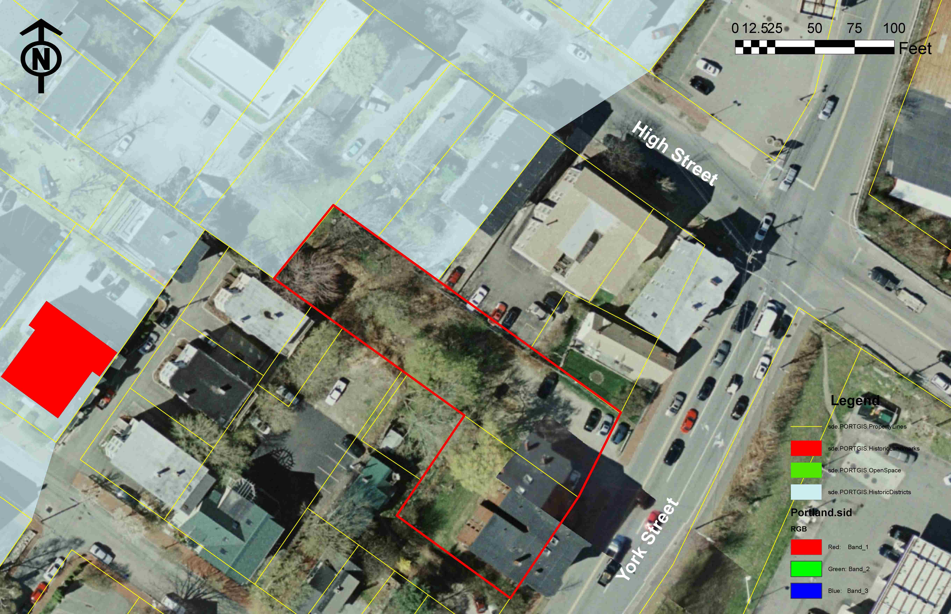

The proposed new building and upgraded parking lot would abut 6 existing residential properties, primarily 3-4 story buildings with associated parking and open/green areas.

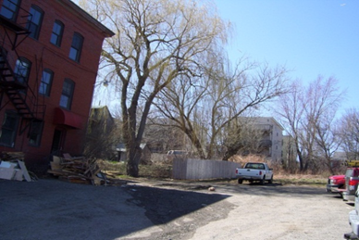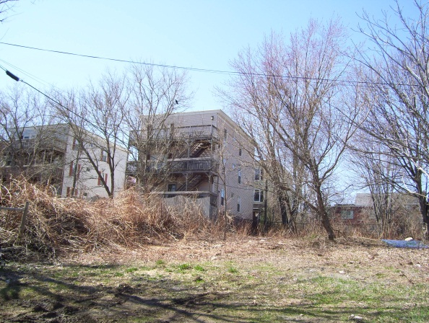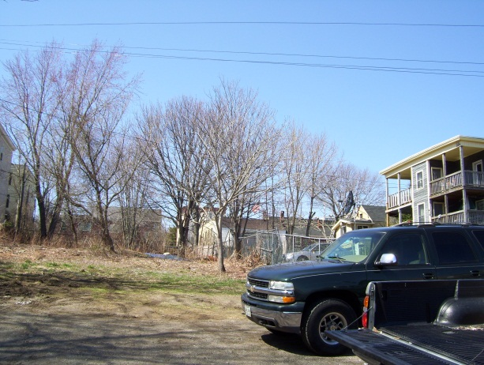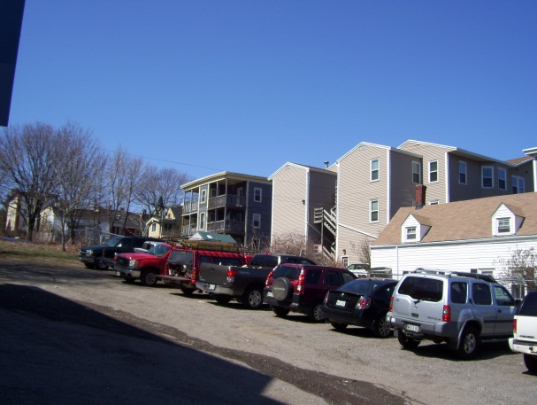

* A four story building located on Nye Street is approximately 150 feet back from the existing brick building and immediately abuts the west corner of the proposal boundary at the rear (top 2 photos);
* Two 1-2 story residential buildings are 30-50 feet from the project site boundary (rear east corner); these are within the Historic District;
* Two 3-story buildings (light and dark gray) set back approximately 50 feet from the north east side boundary; one is within the Historic District;
* One 2-story residential building (white) abutting the existing parking lot and about 30 feet from the site boundary.

The rear part of the site is about 20 feet higher than the York Street sidewalk, so the entire site slopes at about 1:12 and currently storm water sheet flows to York Street. The existing brick sidewalk is in good condition; two street trees are located in the esplanade in front of the existing building.

1. **PROPOSED DEVELOPMENT**

The project retains the existing 12 unit building fronting York Street and proposes a new 7 unit residential wood framed building on the rear part of the open parcel, approximately 110 feet from York Street and set back 10 feet from each of the two side boundaries and 20 feet from the rear boundary (Attachment O; site plan is at O.4). The new building has a footprint of 4,160 sq ft and a total floor area of 24,244 sq ft. The building is stepped back, with two flat-roofed sections at 3 stories and a rear-most (also with a flat roof) section that includes a mezzanine, which brings that section to 44.62 feet high above the average grade.

The building is of contemporary design, utilizing fiber-cement siding, decorative metal accents, sloped roofs and five integrated balconies. It will be sprinkled, built to low energy standards with high efficiency heating systems to meet a high level of LEED certification.

The proposal retains the existing vehicle access from York Street and the existing parking area, upgraded to asphalt paving and striped for 19 parking spaces. The existing building has three pedestrian access walkways directly from the public sidewalk. The pedestrian access to the proposed building utilizes the internal parking lot drive aisle (painted to indicate a pedestrian walkway). Bicycle parking is proposed.

The final submissions indicate 2 new street trees; 4 trees and a 4 foot high fence along the front of the parking lot, 2 trees adjacent to the parking lot at the front of the new building and 8 new trees around the new building. One large existing tree is retained. Along the east side of the building (between the footprint and the site boundary) there are individual garden terraces including small trees. A 6 foot high wood fence is proposed around the three boundaries of the development parcel that abut other properties.

**V. PUBLIC COMMENT**

Notices of this hearing were sent out to 171 neighbors and interested parties, and a public notice also appeared in the June 20 and 21, 2011 editions of the *Portland Press-Herald*. To date the Planning Division has not received any public comment. The applicant held a neighborhood meeting on April 20th, 2011 and the notes and attendance sheet are included in Attachment F.

1. **RIGHT, TITLE AND INTEREST AND FINANCIAL/TECHNICAL CAPACITY**

The owner of the property is Harborview Development LLC. The applicant has provided a copy of a Warranty Deed, recorded at the Cumberland County Registry of Deeds (Book 28330 Page 45) (Attachment A), which demonstrates their right, title and interest in the property.

The applicant has not submitted the estimated cost of the development. The applicant has submitted a letter from Redfern Properties and Bangor Savings Bank (Attachment H) as demonstration of their financial and technical capacity to complete the proposed development.

**VII. Zoning Assessment**

The proposed subdivision is within the R-6 Residential Zone.

**ZONING REVIEW**

Marge Schmuckal, Zoning Administrator, reviewed the preliminary plans in April 2011 and raised a number of fundamental concerns regarding the number of proposed new units, the number of stories and associated set backs, along with other zoning questions (Attachment 1).

The applicant appealed the Zoning Administrator’s interpretation of 14-139 (1) relating to the calculation of the land per dwelling unit and allowable number of dwelling units in the new building. The ZBA found in favor of the applicant (Attachment 10) and the proposed building is substantially as reviewed at the Preliminary Plan stage.

During the review of the Preliminary Plan there was a question regarding the height of the building and the number of stories; this issue centered on the definition of “mezzanine” as proposed in the rear section of the new building. The Final Plan includes information to clarify the proposal and the Zoning Administrator has confirmed that the proposals meet zoning requirements (Attachment 14).

**VIII. DEVELOPMENT REVIEW**

**A. SITE PLAN SUBMISSION REQUIREMENTS** (Section 14-527) and **SUBDIVISION PLAT AND RECORDING PLAT REQUIREMENTS (**Section 14-496)

The Final Plan application has addressed the ordinance requirements in terms of subjects covered but has not fully addressed the list of information requested by staff based on the Planning Board Workshop discussion (Attachment 9).

|  |  |
| --- | --- |
| **Information Requested in staff letter of 5.6.2011 (Attachment 9)** | **Status as of hearing report preparation** |
| Corrected boundary survey with all accurate contours, easements, abutting property building locations and correct identification etc as noted in staff comments | The boundary survey has been largely corrected.  (Attachment ).15) |
| Subdivision Plat based on the corrected Survey and incorporating site plan details as relevant and showing subdivision information (including street trees, storm water unit and storm water and other maintenance responsibilities, references to condominium association - see ordinance) | A draft Subdivision Plat has been submitted but needs considerable revision. (Attachment O.16) |
| Draft condominium association documents | Submitted (Attachment L) |
| Stormwater Maintenance Plan | Submitted (Attachment J and L) |
| Draft Stormwater Maintenance Agreement | Submitted (Attachment J ans L) |
| Further information on depth of groundwater and bedrock plus other site and engineering details as requested by engineering reviewers | Submitted (Attachment J (last section)) |
| Details to address CPTED concerns, including lighting | **Not submitted** |
| Details of solid waste management | Submitted (Attachment H) |
| Snow Removal Plan (required re fire and emergency access) | Submitted (Attachment O.14) |
| Further information (photomontages etc) illustrating the impact of the proposal on the Historic District and abutters | **Not submitted** |
| Revisions to address the traffic engineering review comments | Submitted (Attachments O.4 and O.6) |
| Letters that confirm adequacy of water and sewer service to the new building (see form in application packet regarding sewer capacity) | Submitted (Attachment H) |

*Subdivision Plat and Recording requirements*

The applicant has submitted draft Subdivision Plat (Attachment O.16) which has been reviewed by DPS (Attachment 16) and found to be missing many key items of information and almost illegible in the vicinity of the new building.

The applicant has also submitted draft Condominium Association documents which include the Stormwater Maintenance Agreement and the Stormwater Maintenance and Inspection Plan (Attachment L). These have been reviewed by the Associate Corporation Counsel and are generally acceptable subject to three detailed comments which further clarify responsibilities for trash removal, snow removal and maintenance of the stormwater drainage infrastructure (Attachment 22).

Two potential conditions of approval are suggested:

1. Requiring that the draft Condominium Association documents address staff comments and be finalized to the satisfaction of the Associate Corporation Counsel; and
2. Requiring that the revised recording plat be submitted for review and approval by the Planning Authority, Department of Public Services and Associate Corporation Counsel.

**B. SUBDIVISION STANDARDS** 14-497. General Requirements (a) Review Criteria

The proposed development has been reviewed by staff for conformance with the relevant review standards of Portland’s Subdivision Ordinance and applicable regulations. Staff comments are listed below.

1. *Will not result in undue water or air pollution.*

The project is not anticipated to result in any water or air pollution.

1. *Has sufficient water available for the reasonably foreseeable needs of the subdivision;* and (3) *Will not cause unreasonable burden on an existing water supply*;

The Portland Water District has confirmed sufficiency of water in later dated 4.28.2011 (Attachment H).

1. *Will not cause unreasonable soil erosion or reduction in the capacity of the land to hold water so that a dangerous or unhealthy condition may result;*

A final Sedimentation and Erosion Plan has been submitted (Attachment I) and has been found to be acceptable by the consulting civil engineer (Attachment 19).

(5) *Will not cause unreasonable highway or public road congestion or unsafe conditions with respect to use of the highway or public roads existing or proposed;*

The proposed development will utilize the existing two-way access from York Street, which will be moved slightly towards the east but remain about 24 feet wide. It will serve the parking lot which is proposed to be repaved and striped for 19 parking spaces (Attachment O.4 and O.6). The access location is greater than the required 150 feet from the corner of High Street, an arterial street, so it meets the city standards for separation from an intersection (confirmed in Attachment 18).

The Traffic Engineering reviewer, Tom Errico, has reviewed the Final Plan and provided the following update of his comments at the preliminary Plan stage as they relate to this standard: (Attachment 18)

York Street is a major arterial and carries a significant amount of traffic.  Accordingly, sight distance for vehicles exiting the site is a very important safety issue.  I do not support the installation of fencing or landscaping treatments that obstruct visibility.  The applicant should maintain clear sight 15-feet from the curb line on York Street.  I would also note that clear sight lines also ensure safe visibility to pedestrians on the sidewalk.

**Status:  The applicant is proposing a fence that is located within 15 feet of the curb line and therefore I am concerned about sight obstruction to both vehicles and pedestrians.  The applicant has provided graphics that indicated the fence will be transparent.  I would recommend that an example of the product be provided (or identify a location in the area) for review before final approval is issued.**

A suggested condition to this effect has been included in the proposed Motion for the Board to consider.

(6) *Will provide for adequate sanitary waste and storm water disposal and will not cause an unreasonable burden on municipal services if they are utilized;*

Water, sewer and CMP utilities have provided letters confirming adequate capacity (Attachment H).

The existing “open” site currently drains over the surface downhill to York Street into an existing catch basin. The Final Plan submission includes the following information regarding the proposed stormwater management:

* Stormwater Report (Attachments J and K)
* Post-Construction Stormwater insection and maintenance Plan (Attachment J)
* Draft Stomwater Drainage System Maintenance Agreement (Attachment J)
* Engineering Drawings C1-C6 (Attachments O.7 to O.13)
* Draft Condominium documents with attachments (Attachment L)

It is proposed to install an under drained subsurface sand filter with detention in the corner of the parking area nearest to York Street. This has been sized to treat 95% of the new impervious area and 80% of the developed area.

The Final Plan proposals submitted on 7.7.2011 were reviewed by the City’s Engineering consultant Woodard and Curran (David Senus) on 6.15.2011 (Attachment 13) and these review comments were forwarded to the applicant that day. The applicant’s engineer (Acorn Engineering, Will Savage) provided a response letter on 6.21.2011 along with revised engineering plans (Attachments K and O respectively).

Woodard and Curran undertook a second review of the response letter and revised engineering plans and provided a second set of comments dated 6.23.2011 (Attachment 19). These final comments indicate that the project proposals are generally satisfactory but there are numerous detailed concerns that still need to be addressed, including: (list based on comments)

* Need to clarify how proposed grading will match grading on adjacent properties;
* Need for easements or temporary construction agreements re disturbance to abutting properties;
* Need clarity re location and type of curbing and sidewalk materials;
* Need revision to inspection requirements to meet MDEP requirements;
* Need to ensure that the design of the underdrain systems is not compromised by addition of surface flows;
* Need to update utility plans to reflect work completed.

Staff recommend that a condition of approval be included that requires the applicant to address the 6.23.2011 engineering review comments and submit revised plans/documents prior to the issuance of a building permit.

(7) *Will not cause an unreasonable burden on the ability of the city to dispose of solid waste and sewage if municipal services are to be utilized;*

The applicant has submitted (Attachment H.30) a summary of the proposed private rubbish collection and this has also been confirmed within the draft condominium documents (Attachment L). DPS has confirmed that the applicant has the option to use a private rubbish collection service even though eligible for municipal collection (Attachment 15). A trash and recycling container is located in the parking lot near York Street with appropriate enclosure. The Traffic Engineer reviewer has commented that (Attachment 18):

The site plan indicates a fenced dumpster will be located on the front of the new parking lot.  The applicant should provide information on how the dumpster will be accessed.

**Status: The applicant has indicated that trash containers will be wheeled and emptied as necessary. Trash removal vehicles shall not block York Street during the afternoon peak travel times (after 3pm) on weekdays.**

A suggested condition to this effect has been included in the proposed Motion for the Board to consider.

(8) *Will not have an undue adverse effect on the scenic or natural beauty of the area, aesthetics, historic sites, significant wildlife habitat identified by the department of inland fisheries and wildlife or by the city, or rare and irreplaceable natural areas or any public rights for physical or visual access to the shoreline.*

The undeveloped lot is partly wooded with several mature trees (not shown in the boundary survey but evident in the aerial and other photos). Some trees are located on the boundary and it is not known which would have to be removed for the proposed development. The large tree behind the existing brick building is indicated to be retained.

The Final Plan proposals include 2 new street trees; 4 trees along the frontage with York Street, 2 trees adjacent to the parking lot at the front of the new building and 8 new trees around the new building within individual garden terraces.

*Street Trees*

The subdivision requirement would be 7 street trees ie one tree per unit in the proposed building. The City Arborist has reviewed the Landscape Plans (Attachments O.4-O.6) and considers that additional trees are required to meet the standard and the 2 proposed street trees may need relocation, possibly outside the ROW.

(9) *Is in conformance with the land development plan or its successor;*

The applicant has referred to the Comprehensive Plan as related to relevant housing policies (Attachment A and H.12) and staff recommend that the project is compatible with Comprehensive Plan goals and policies.

(10) *The subdivider has adequate financial and technical capacity to meet the standards of this section;*

A letter from Bangor Savings Bank dated June 3, 2011 (Attachment H.17) has been submitted but does refer to the specific project cost.

(11) – (15)

*(Whenever situated, in whole or in part, within the watershed of any pond or lake or within two hundred fifty(250) feet of any wetland, great pond or river as defined in Title 38, chapter 3, subchapter I, article 2‑B, will not adversely affect the quality of such body of water or unreasonably affect the shoreline of such body of water; (12) Will not, alone or in conjunction with existing activities, adversely affect the quality or quantity of groundwater; (13) Is or is not in a flood‑prone area, based on the Federal Emergency Management Agency's Flood Boundary and Floodway Maps and Flood Insurance Rate Maps, and information presented by the applicant. (14) All potential wetlands within the proposed subdivision shall be identified on any maps submitted as part of the application, regardless of the size of those wetlands. (15) Any river, stream or brook within or abutting the proposed subdivision shall be identified on any maps submitted as part of the application.*

These subdivision standards are not applicable to the Harborview Townhomes project.

**C. Site Plan Standards** (Section 14-526)

The proposed development has been reviewed by staff for conformance with the relevant review standards of Portland’s site plan ordinance and applicable regulations. Staff comments are listed below.

1. **Transportation Standards**

*Impact on Surrounding Street Systems and Site Vehicle Access*

See discussion above under VIII B. ***Subdivision Standards,*** (5).

*Pedestrian Access*

A pedestrian path (which includes steps) from York Street into the site alongside the existing building is provided but does not extend to the new building. In response to reviewer comments on the Preliminary Plan, the applicant has added an ADA compliant “route” from this path (before the steps) to the central parking lot drive aisle via a 4 foot wide path between 2 parking spaces. The central parking lot drive aisle is proposed to be striped (Attachment O.4-6) to indicate pedestrian priority as described in the 6.7.2011 cover letter, second page (Attachment H).

The applicant requests a waiver from the ordinance standard (requiring continuous walkways to building entrances) in view of the property dimensions and because a safe and reasonable walkway is available via the striped pedestrian route in the parking aisle. The Traffic Engineering reviewer, Tom Errico, has reviewed the Final Plan and does not support a waiver: (Attachment 18)

The site plan does not provide pedestrian facilities between the public sidewalk system and the new building.  Accordingly, it appears pedestrians will be required to walk through the parking lot.  This is not preferred and I would suggest that a sidewalk connection be provided.

**Status: I do not support the use of the parking lot aisle as the route for pedestrians to travel from the public right-of-way to the internal private portion of the site.  The City ordinance requires the following:**

*Site Plan Standards - 14-526*

*(a) Transportation*

*c. Sidewalks*

*(iii)  Continuous internal walkways shall be provided between existing or planned public sidewalks adjacent to the site, transit stops and street crossings and primary building entrances on the site.*

**I would suggest that the applicant extend the existing sidewalk along the eastern side of existing building to the proposed building.  This will required some parking spaces to be converted to compact spaces, such that adequate pedestrian width can be provided.  Pedestrian access to the parking lot aisle can continue for handicapped users.  I would not suggest painting the parking lot as proposed.**

* The site plan indicates a fenced dumpster will be located on the front of the new parking lot.  The applicant should provide information on how the dumpster will be accessed.

**Status: The applicant has indicated that trash containers will be wheeled and emptied as necessary. Trash removal vehicles shall not block York Street during the afternoon peak travel times (after 3pm) on weekdays.**

Potential conditions of approval have been included based on the Traffic Engineering review comments above.

*Public Transit*

The proposal is 19 units in total and below the 20-unit threshold for provision of a transit facility.

*Parking*

The preliminary proposals indicated a 20 space parking lot but this has been reduced to 19 spaces (1 per unit) to allow for the small trash container/enclosure and for the 4 foot walkway from the side path to the center aisle. The applicant has sought to balance parking, access and landscaping in this narrow site and requests waiver(s) from the city’s technical standards for the parking aisle width/parking space length.

Staff is concerned regarding potential congestion in the lot, primarily from a Fire Safety/emergency access view point and the snow removal plan is a key issue (see below under Section 3. *Public Safety and Fire Prevention*). The number of spaces meets zoning requirements.

After reviewing the applicant’s most recent plans, the Traffic Engineering reviewer Tom Errico has concluded (Attachment 18):

* The parking lot configuration includes a substandard parking aisle width (20 feet) near York Street and tapers to the compliant 24 feet internal to the site.  The applicant should provide justification for the reduced width and formally request a waiver from the City’s Technical Standards.  I would note that I ‘m somewhat concerned about this width issue at the driveway entrance where entry and exit movements are complicated by the heavy traffic volume levels on York Street.  If not well maintained during the winter, this area could become problematic.

**Status: I support the request for a waiver for the proposed parking lot aisle width.**

*Bicycle Parking*

The site plan (Attachment O.4) shows at least 9 bicycle parking spaces, which meets the City’s standard of 2 spaces per 5 dwelling units (eg 8). A detail has not been included but the submitted plan references using the city’s “Downtown” specification as included in the Technical Standards.

Traffic Engineering staff have noted that the designated bicycle parking area (shown on Plan L1.0 Attachment O.4) could accommodate more spaces and have suggested a condition that requires “A detail for the bicycle parking shall be provided for review and include: a) spacing between the racks; b) spacing from front of rack to wall; and c) dimensions for the entire bicycle parking area.” (Attachment 18)

*Snow storage*

See discussion under Section 3. *Public Safety and Fire Prevention*

*Transportation Demand Management (TDM)*

There are no requirements that apply to this project.

1. **Environmental Quality Standards**

*Preservation of Significant Natural Features*

The proposed Site Plan retains the largest tree on the site, located to the rear of the existing brick building. There may be other mature trees impacted by the development along the boundary and in these cases information should be submitted showing how those on adjacent properties are going to be protected.

*Site Landscaping*

The proposed Final Site Plan (Attachment O.4 details in O.6) shows a 4 foot metal fence along the frontage with 4 trees in small islands behind the fencing. In addition there are 2 trees in the parking lot near the front of the new building and 2 street trees proposed, giving a total of eight (8) proposed trees (excluding trees in private patio areas). Screening around the site is achieved by a 6 foot wood fence as shown in the detail in L3 (Attachment O.6).

For parking lots the site plan ordinance requirements are set out in (14-526 (a) (4) b:

*Developments with five (5) or more parking spaces shall include at least two (2) trees (or one (1) tree and three (3) shrubs) per five (5) parking spaces planted in landscaped islands to screen shade and break up parking. Trees and shrubs in parking lots may be in informal groups, straight rows, or concentrated in clusters as detailed in Section 4 of the Technical Manual.*

The parking lot standard, taken together with the street tree requirements, would require a minimum of 11 trees in front part of the site (7 new street trees and 4 parking lot trees with shrubs). The proposals show 8 trees (not clear regarding shrubs) and staff recommend that three (3) additional trees be incorporated into the Landscape Plan (Attachment 22) along with appropriate shrubs.

The treatment of the edge of the parking lot along York Street was the subject of discussions with the applicant in May 2011 based on the applicant developing some options and staff indicating a preference (some of the options and staff comment are in Attachment 12). The proposed layout reflects those discussions and achieves the objective of creating a green “street wall” along the frontage and avoids obscuring the sight lines for the egress of vehicles by setting the trees back. The material of the metal “slat” fence relates to the proposed architecture of the new building.

The City Arborist has reviewed the final Landscape Plans for this project and notes that the planting details are not included and that there is scope (as well as a requirement) for more trees (Attachment 22); in summary:

1) Landscape Key / Plant List needed for trees, shrubs & herbaceous planting.          
2) Tree Save - include tree protection measures to include 'off-site' trees.  
3)  Landscape Treatment, trees / shrub proposed for the areas shown as 'individual garden terraces', 'raised planters along entry corridor', 'front patio garden' should be included or shown in detail on the landscape plan.

4) To meet the standards of trees per unit and parking lot landscape three additional trees are needed (or a contribution to the City’s Street Tree fund of $200 per required street tree could be considered)

A potential condition is included that requires the submission of a revised landscape plan to address the City Arborist comments of 6.24.2011.

*Water Quality, Storm Water Management and Erosion Control*

See discussion above under VIII B. ***Subdivision Standards.***

1. **Public Infrastructure and Community Safety Standards**

*Public Infrastructure*

The Department of Public Services have confirmed that the existing sidewalk and curb along York Street is in good condition (Attachment 20) and have permitted the stubbing of utilities for this project.

*Public Safety and Fire Prevention*

The Crime Prevention through Environmental Design (CPTED) standards in the site plan ordinance address the principles of natural surveillance, access control and territorial reinforcement so that the design of developments enhance the security of public and private spaces and reduce the potential for crime.

At the Preliminary Plan stage the applicant was requested to address this issue more explicitly, given the distance the building is set back from the street with limited natural surveillance. The applicant has not provided a narrative addressing this issue but the proposals have been revised to improve natural surveillance by introducing lighting throughout the site and lowering the fence along the frontage to 4 feet and changing its design so it can be seen through (detail in Attachment O.6).

*Fire Prevention*

During the review of the Preliminary plan Captain Gautreau of the Fire Department raised concerns regarding fire and emergency access given the long setback from York Street and the narrow and congested access to only one side of the building through the parking lot. He met with the applicant on 4.21.2011 and concluded that there several additional features that would need to be implemented in order for the Fire Department to feel comfortable with approving this project with such limited emergency access  (Attachment 4).

One of the key requirements was a snow removal plan that ensured the front of the building would be accessible from York Street. The applicant has submitted several iterations of a Snow Storage/Removal Plan, the most recent is included as Attachment O.14. Through an e-mail exchange with Captain Gautreau (Attachment 17) this plan has evolved so that it is now acceptable provided there is a condition that requires note #1 to be revised so that it states: " SNOW MAY BE STORED WITHIN THE TEMPORARY SNOW STORAGE AREAS ***ONLY***". This condition is included in the Motion for the Board to consider and would assure the Fire Department that only the *designated areas* will be used unless a new plan is approved.

Captain Gautreau has also requested an intermediate sprinkler connection and final comments are awaited (Attachment 17).

*Availability and Adequate Capacity of Public Utilities*

A “Utility Plan” has been submitted (Attachment O.7) which indicates that all utilities will be underground once they reach the site at a pole near York Street. It is noted that some existing overhead utility lines crossing the site will need to be re-routed.

Sewer, water and storm drain connections have already been made as the applicant had the road open for work associated with refurbishment of the existing brick building- all required permits were obtained but the submitted plans do not reflect that actual stubbing work (Attachment 19, last point). The suggested condition requesting that the Engineering review comments be addressed will cover this issue.

Water, sewer and CMP utilities have provided letters confirming adequate capacity (Attachment H).

*Site Design Standards*

*Massing, Ventilation and Wind Impact*

The proposed new building is 40 feet wide by 115 feet long and is about 30 feet above ground level at the front and nearer 39 feet above ground level at the rear, bearing in mind the ground level rises from front to rear. It immediately abuts (10-15 feet between) the nearest building at the rear west corner, located alongside the building and porches (Attachments O.2 and O.3).

*Shadows, Snow and Ice Loading and View Corridors*

The proposed development is not anticipated to have these types of impacts*.*

*Historic Resources*

The site Plan ordinance includes the following standard in respect of Historic Resources. The proposal abuts the West End Historic District at the north end of the narrow parcel and the Historic Preservation Program Manager has been requested to comment on the proposals in the context of this requirement.

14-526 (d) 5 b:

*Development adjacent to designated landmarks, historic districts or historic landscape districts: when any part of a proposed development is within one hundred (100) feet of any designated landmark, historic district or historic landscape district, such development shall be generally compatible with the major character-defining elements of the landmark or portion of the district in the immediate vicinity of the proposed development. Character-defining elements of landmarks and historic districts are identified in the historic resources inventory and respective historic district designation reports For the purposes of this provision, “compatible” design shall be defined as design which respects the established building patterns and visual characteristics that exist in a given setting and, at the same time, is a distinct product of its own time. To aid the planning board in its deliberations, historic preservation staff shall provide a written analysis of the proposed development’s immediate context, identifying the major character-defining elements and any established building patterns that characterize the context;*

Deborah Andrews, Historic Preservation Program Manager has provided a detailed narrative describing the character of the area and her comments on the proposed new townhomes development (Attachment 6). She has suggested that photomontages of the building from other vantage points would be helpful in assessing its impact, and concludes that the location of the building on the site away from the street is not compatible with the Historic District character, and that the contemporary architectural design is compatible.

No further comment has been requested of Ms Andrews as the proposals have not been revised, but she was involved in the discussions regarding the edge treatment and has informally confirmed that in this respect the Final Plan proposals are an improvement.

*Exterior Lighting*

The Final Plan submission included a photometric plan and associated specification (Attachment H and O.17). The proposals included 16 small accent lights pointing up into the trees around the site which did not meet city standards and did not provide any lighting for the pedestrian walkway into the site nor the parking area (see staff comments in Attachment 11).

The applicant has submitted a revised and final photometric plan in Attachment O.18 (specs in Attachment M. along with response to staff comments), which removes all of accent lights and proposes full cut-off lights as listed:

* 2 pole LED lights in the parking lot;
* 3 bollard lights adjacent to the new building;
* 12 planter-mounted steplights along the narrow access walkway to the entrances to the new units;
* 1 wall mounted light in the bicycle parking area.

These final lighting proposals provide adequate lighting over all of the internal pedestrian walkways and parking lot drive aisle and are acceptable.

The photometric does not include the light levels for the (unspecified) building mounted (occupant controlled) lighting and staff suggest a condition that requires these to meet city standards, since they could be visible to the many rear facing windows in neighboring 3-4 story residences.

*Noise and Vibration; Signage and Wayfinding*

These are not anticipated to be an issue with this residential development to be managed by a Condominium Association.

*Zoning Related Design Standards*

Multi-family and Other Housing Types Design Standard

The design standard that applies to this proposal is outlined in sections below with associated staff review comments. The applicant has submitted a narrative outlining how they consider that the proposal meets these standards (Attachment A) :

*(i)* ***TWO-FAMILY, SPECIAL NEEDS INDEPENDENT LIVING UNITS, MULTIPLE-FAMILY, LODGING HOUSES, BED AND BREAKFASTS, AND EMERGENCY SHELTERS:***

*(1)* ***STANDARDS.*** *Two-family, special needs independent living units, multiple-family, lodging houses, bed and breakfasts, and emergency shelters shall meet the following standards:*

*a. Proposed structures and related site improvements shall meet the following standards:*

*1. The exterior design of the proposed structures, including architectural style, facade materials, roof pitch, building form and height, window pattern and spacing, porches and entryways, cornerboard and trim details, and facade variation in projecting or recessed building elements, shall be designed to complement and enhance the nearest residential neighborhood. The design of exterior facades shall provide positive visual interest by incorporating appropriate architectural elements;*

Staff comment: The neighborhood is characterized by a variety of architectural styles and the proposed contemporary style is acceptable in principle. The Historic Preservation Program Manager has also confirmed that the proposed design is acceptable in this location adjacent to the West End Historic District (Attachment 6).

1. *The proposed development shall respect the existing relationship of buildings to public streets. New development shall be integrated with the existing city fabric and streetscape including building placement, landscaping, lawn areas, porch and entrance areas, fencing, and other streetscape elements;*

Staff comment: In the immediate vicinity of the proposal (see map below) there is one example of a building set back from the street (next door to the existing building on this site) but otherwise buildings are at the street line. Along York Street as a whole there are more examples (as illustrated by panoramic photos shown to the Planning Board at the Workshop).

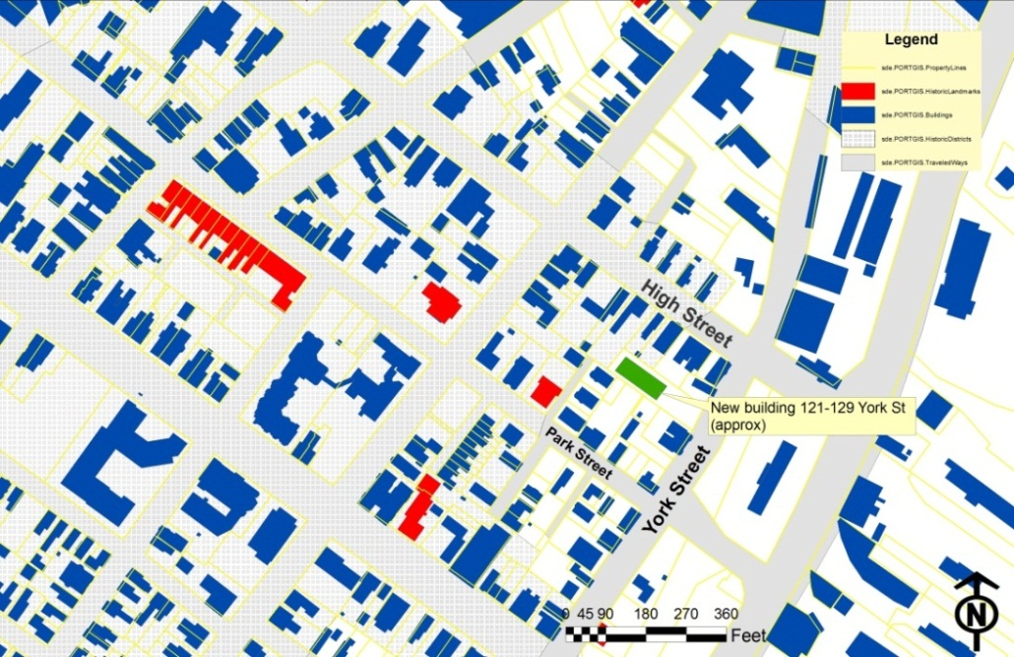

*3. Open space on the site for all two-family, special needs independent living unit, bed and*

*breakfast and multiple-family development shall be integrated into the development site. Such open space in a special needs independent living unit or a multiple-family development shall be designed to complement and enhance the building form and development proposed on the site. Open space functions may include but are not limited to buffers and screening from streets and neighboring properties, yard space for residents, play areas, and planting strips along the perimeter of proposed buildings;*

Staff comment: It is understood that 5 of the new units will have balconies and all 7 units would have ground level terraces or patios. The existing 12-unit apartment building is to be provided with common grassed areas and terrace for use by residents and 4 units have balconies.

*4. The design of proposed dwellings shall provide ample windows to enhance opportunities for sunlight and air in each dwelling in principal living areas and shall also provide sufficient storage areas;*

Staff comment: This standard appears to be met.

*5. The scale and surface area of parking, driveways and paved areas are arranged and landscaped to properly screen vehicles from adjacent properties and streets;*

Staff comment: The parking lot is screened from neighbors by a 6 foot high wood fence and screened from York Street by a 4 foot fence and 4 trees.

1. **STAFF RECOMMENDATION**

The applicant has addressed most of the issues raised at the Workshop. Reviewers have identified a number of details that still need to be addressed but these do not affect the overall layout. Subject to the proposed motions and conditions of approval listed below, Planning Division staff recommends that the Planning Board approve the proposed development.

The applicant has requested a waiver from the site plan ordinance requirement that requires a continuous walkway from the York Street sidewalk to the new 7 unit building at the rear of the site. Staff have not supported this waiver (see discussion VIII C Site Plan Standards 1 Transportation Standards and the Traffic Engineer Review in Attachment 18). The submitted plans include a segregated walkway for about 35 feet from the York Street sidewalk (it cannot be further into the site because of steps) and then pedestrians aiming for the new building would need to turn right for about 15 feet alongside parked cars (assuming the parked cars respect the striping) and continue uphill for the remaining 60 feet within the parking lot drive aisle.

1. **PROPOSED MOTIONS**

**Waiver**

On the basis of the application, plans, reports and other information submitted by the applicant, findings and recommendations, contained in the Planning Board Report # 13-11 for Harborview Townhomes, 127 York Street Application # 2011-214 relevant to Portland’s Technical and Design Standards and other regulations, and the testimony presented at the Planning Board hearing:

The Planning Board (**waives/ does not waive**) Technical Standard, Section 1.14 to reduce the parking aisle width in some locations as shown on the approved plan.

**Development Review**

On the basis of the application, plans, reports and other information submitted by the applicant, findings and recommendations contained in Planning Board Report # 13-11 for Harborview Townhomes, 127 York Street Application # 2011-214 relevant to the Site Plan and Subdivision reviews and other regulations, and the testimony presented at the Planning Board hearing, the Planning Board finds the following:

1. **Subdivision:**

That the Planning Board finds that the plan (**is/is not**) in conformance with the subdivision standards of the land use code, subject to the following conditions of approval:

Potential conditions of approval:

* + 1. That the Subdivision Plat shall be finalized to the satisfaction of the Planning Authority, Corporation Counsel, and Department of Public Services and include detailed references to approval dates, easements, the Condominium Association documents and relevant conditions; and
    2. That the Condominium Association documents, including the Stormwater Maintenance Agreement and Stormwater Inspection and Maintenance Plan, shall be finalized to the satisfaction of the Corporation Counsel prior to the recording of the Subdivision Plat; and
    3. **That the applicant and all assigns shall comply with the conditions of Chapter 32 Stormwater including Article III, Post-Construction Storm Water Management, which specifies the annual inspections and reporting requirements.  The developer/contractor/subcontractor must comply with conditions of the construction stormwater management plan and sediment & erosion control plan based on City standards and state guidelines. A maintenance agreement for the stormwater drainage system,** as included in Attachment L of this Report, or in substantially the same form with any changes to be approved by Corporation Counsel, shall be s**ubmitted and signed prior to the issuance of a Certificate of Occupancy with a copy to the Department of Public Services; and**
    4. That the applicant shall revise Note #1 on the “Offsite Snow Removal Plan” dated 6-21-2011 so that it states: " SNOW MAY BE STORED WITHIN THE TEMPORARY SNOW STORAGE AREAS ***ONLY***"; and
    5. That trash removal vehicles shall not block York Street during the afternoon peak travel times (after 3pm) on weekdays.

1. **Site Plan Review**

The Planning Board finds that the plan (**is/is not)** in conformance with the site plan standards of the Land Use Code, subject to the following condition(s) of approval:

Potential conditions of approval:

1. That the applicant shall submit an example of the fence product proposed for the frontage of the property (or identify a location in the area where it can be seen) for review and approval by the Planning Authority prior to the issuance of a building permit; and
2. That the site plans shall be revised to extend the existing sidewalk along the eastern side of existing building to the proposed building and remove the “pedestrian striping from the parking lot drive aisle, for review and approval by the Planning Authority prior to the issuance of a building permit; and
3. That the applicant shall submit revised plans/documents that address the 6.23.2011 Woodard & Curran Engineering Review comments for review and approval by the Planning Authority prior to the issuance of a building permit; and
4. That the applicant shall obtain easements or temporary construction agreements for all work outside the boundaries of the site; and
5. That the applicant shall submit a revised Landscape Plan that addresses the 6.24.2011 City Arborist comments in respect of preservation of existing trees; planting details; and additional trees for review and approval by the Planning Authority prior to the issuance of a building permit; and
6. That a detail for the bicycle parking that shows : a) spacing between the racks; b) spacing from front of rack to wall; and c) dimensions for the entire bicycle parking area, shall be submitted for review and approval prior to the issuance of a Certificate of occupancy; and
7. That any additional site lighting, including exterior wall mounted lighting, shall meet the City’s standards as currently set out in Section 12 *Site Lighting Standards* in the City’s Technical Manual.

**ATTACHMENTS:**

**As included in Memorandum 4.26.2011**

* 1. Zoning comments on original submission 4.13.2011
  2. Engineering Review comments 4.19.2011
  3. Traffic Engineering Review comments 4.21.2011
  4. Fire Department comments 4.21.2011
  5. City Arborist comments 4.22.2011
  6. Historic Preservation Program Manager Memorandum 4.22.2011
  7. DPS (David Margolis-Pineo) comments 4.22.2011
  8. Zoning comments on revised submissions 4.22.2011

**For Hearing 6.12.2011**

* 1. Staff letter confirming requirements for Final Plan/Hearing 5.6.2011
  2. Zoning Board of Appeal Decision 5.23.2011
  3. Staff comments on submitted lighting plan 6.10.2011
  4. Staff comments on applicant options for edge treatment 5.24.2011
  5. Engineering Review comments 6.13.2011
  6. Zoning comments on final plan submission 5.26.2011 and 6.9.11
  7. DPS comments Sold Waste issues 6.22.2011
  8. DPS comments on survey/plat 6.22.2011
  9. Fire Department comments 6.23.2011 (more awaited)
  10. Traffic Engineering Review comments 6.23.2011
  11. Final Engineering Review comments 6.23.2011
  12. DPS general comments 6.23.2011
  13. Associate Corporation Counsel comments 6.23.2011
  14. City Arborist comments 6.24.2011

**Applicant’s Submittal**

**As submitted for Preliminary Plan (Workshop April 26, 2011)**

1. Cover Letter and Application 3.30.2011
2. Response letter (to 4.13.2011 Zoning comments) 4.18.2011
3. [Omitted for hearing Report; available on request] Preliminary Erosion & Sedimentation Control Report (March 2011)
4. [Omitted for hearing Report; available on request] Preliminary Stormwater Report (March 2011)
5. [Omitted for hearing Report; available on request] Floor Plans (A1.3 revised to show mezzanines)
6. Neighborhood Meeting Information
7. [Omitted for hearing Report; available on request] Plan Set

**As submitted for Final Plan (Hearing , 2011)**

1. Cover Letter and Application for Final Site Plan Review 6.7.2011 (including Financial Capability; Utility letters; some lighting specs; Trsh Removal P)
2. Erosion & Sedimentation Control Report (June 2011)
3. Stormwater Report (June 2011) including Maintenance docs
4. Acorn letter response to Engineering review comments 6.21.2011 and associated summary of plan changes
5. Draft Condominium Association documents including 6.21.2011 versions of Maintenance Agreement and Plan
6. Revised Lighting submission – e-mail and specs 6.22.2011
7. Fire Prevention and Access proposals [awaited]
8. Final Plan Set
   * + 1. Rendered view cover sheet
       2. Building Plans – floor Plans
       3. Building Plans - Elevations
       4. Final site plan L1.0 Rev 6.21.2011
       5. Final landscape plan L2.0 Rev 6.21.2011
       6. Landscape Details L3.0 rev 6.21.2011
       7. Utility Plan C-1 Rev 6.21.2011
       8. Grading, Drainage, Erosion and Sed. Control plan c-2 Rev 6.21.2011
       9. (Engineering) Detail sheet 1 C-3 Rev 6.21.2011
       10. (Engineering) Detail sheet 1 C-4 Rev 6.21.2011
       11. (Engineering) Detail sheet 1 C-5 Rev 6.21.2011
       12. [no plan]
       13. (Engineering) Detail sheet 1 C-6 Rev 6.21.2011
       14. Offsite snow Removal Plan S 6.21.2011 (final)
       15. Boundary survey
       16. Draft subdivision Plat
       17. Site lighting Photometric Plan 6.7.2011 SL-1 (superceded)
       18. Site lighting Photometric Plan 6.22.2011 SL-1 (final)