DRAFT for comments 3.6.2013
For “Under the Clocktower” PUD Newsletter
Under “RECENTLY APPROVED DEVELOPMENT PROJECTS IN PORTLAND”
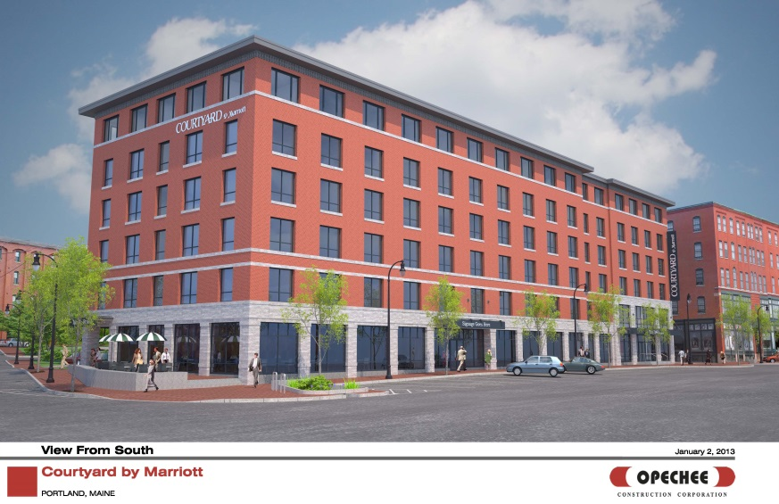

321 Commercial Street Mixed Use Development
Work on site has already started for a new 6 story 113,321 sq ft building at the corner of Commercial Street and Maple Street which will include a Marriott Courtyard hotel, a restaurant and 14 apartments for rent. The project is being developed by J B Brown & Sons with Opechee Construction Corporation undertaking the engineering design and construction. The Historic Preservation Board and Planning Board approvals were received in January and it is expected to be completed in ….
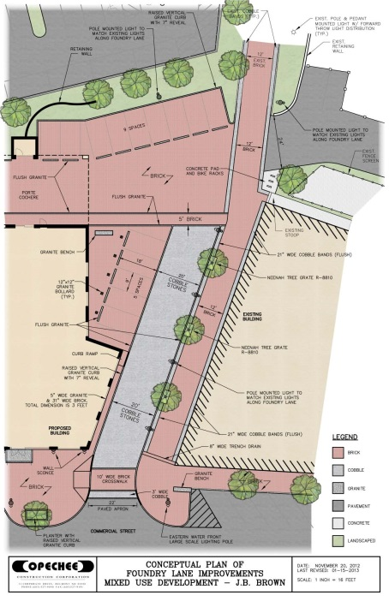
The building design was subject to Historic Preservation review because the site is within the Old Port Historic District. The footprint and elevation treatment was revised to address the local historic character.
The hotel will have 131 rooms and a pool; visitors reach the porte cochere at the rear via a reorganized Foundry Lane near Baxter Place.
Pedestrian amenities include a 12 foot wide brick lighted walkway between Commercial Street and the existing walkway leading to York Street following the line of the original Foundry Lane, plus a new crosswalk crossing Commercial Street near the corner with Maple Street.
The ground floor restaurant includes a patio at the corner of Maple Street, and the apartments have a separate pedestrian entrance further uphill on Maple Street.

