For “Under the Clocktower” PUD Spring Newsletter
Under “RECENTLY APPROVED DEVELOPMENT PROJECTS IN PORTLAND”
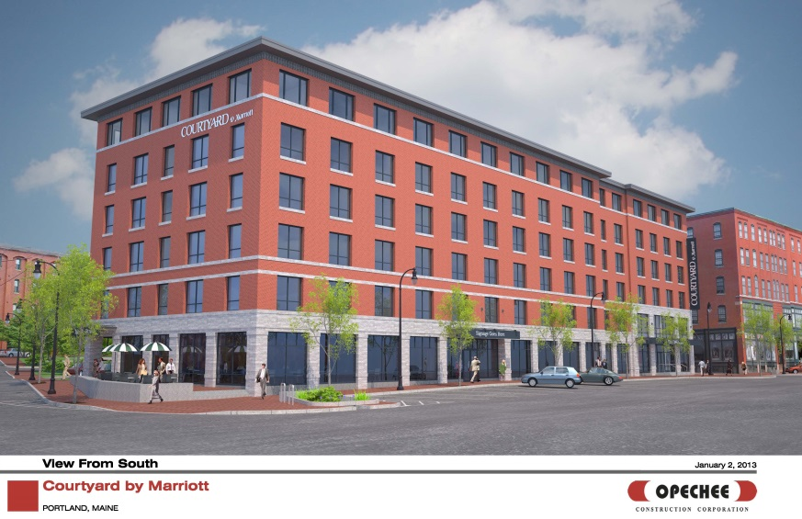

321 Commercial Street Mixed Use Development
Work on site has already started for a new 6 story 113,321 sq ft building at the corner of Commercial Street and Maple Street which will include a Marriott Courtyard hotel, a restaurant and 14 apartments for rent. The project is being developed by J B Brown & Sons with Opechee Construction Corporation undertaking the engineering design and construction. The Historic Preservation Board and Planning Board approvals were received in January 2013, and it is expected to be completed in early 2014.

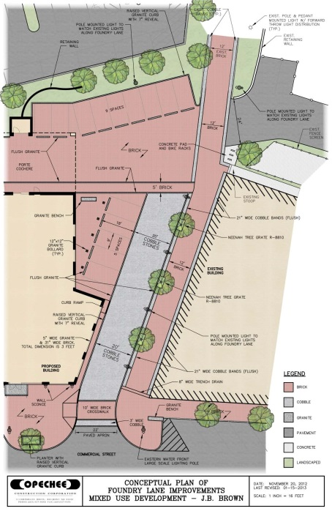
The building design was subject to Historic Preservation review as the site is within the Old Port Historic District. The building footprint was revised to more closely follow the existing lot configuration, which is typical of the building patterns in that district, and to respect the alignment of the former Foundry Lane. The applicant developed exterior elevations that reflect the massing and articulation of buildings in the area.

The hotel will have 131 rooms and a pool; visitors reach the porte cochere at the rear via a reorganized Foundry Lane near Baxter Place. The ground floor restaurant includes a patio at the corner of Maple Street, and the apartments have a separate pedestrian entrance along Maple Street.

Pedestrian amenities include a 12 foot wide brick walkway from Commercial Street to the existing walkway leading to York Street. This pedestrian link follows the line of the original Foundry Lane.

In addition a new crosswalk crossing Commercial Street will be installed near the corner with Maple Street.

