2.28.2018

Utility Capacity to serve

The existing structure located at CBL# 040 B004001 is documented in City records dating from 1961, to have a ¾” service line and ⅝” water meter.

“Based on calculations done by PWD, we have determined the peak water demand for the building is 53.75 gallons per minute (gpm). Under our current standards for sizing water service lines and water meters this peak demand would require a 1.5-inch service line with a 1-inch water meter.”

**Brian Johnson**

**MEANS Group**

Main Extensions and New Services

***Portland Water District***

225 Douglass Street

Portland, ME 04104-3553

P:(207)774-5961 Ext. 3199

F:(207)761-8307

MEANS@pwd.org

The current plan involves moving the existing street meter inside the building, upgrading domestic service 1.5-2”, and adding sprinkler service line 5-6”.

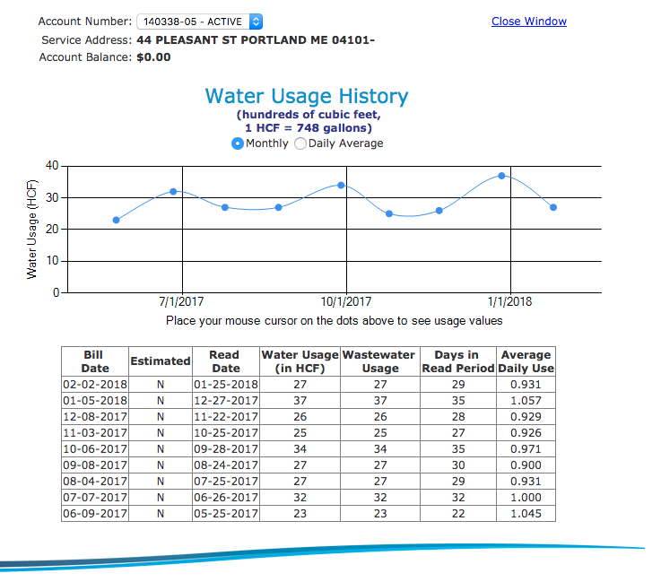

Thank you.

* 44 Pleasant St team:

[44pleasantstreet@gmail.com](mailto:44pleasantstreet@gmail.com) Josh- 207.233.037 Justin- 347.296.6438