

Memorandum
Department of Planning and Development
Planning Division

To: Chair Tevanian and Members of the Portland Planning Board

From: Jean Fraser, Planner

Date: Prepared: May 9, 20008
Presented: May 13, 2008

Re: Proposed parking lot and gardens
Site of former YWCA, 87 Spring Street
Portland Museum of Art, Applicant
Site Plan and Conditional Use Review

Introduction

Mohr & Seredin, on behalf of the Portland Museum of Art, has requested conditional use and site plan approval for a proposal to use an existing vacant site of 38,500 sq ft (.88 acre) as a surface parking lot for 45 vehicles, with associated access, lighting and landscaping improvements. The site is located at the corner of Spring Street and Oak Street and was formerly occupied by the YWCA, which has now been demolished.

The proposed parking lot (and associated access) comprises 60% of the site and would be for the use of Museum administration staff, volunteers and docents and not for the general public. The proposed landscaping comprises 16,000 sq ft of gardens which would cover 40% of the site. The gardens are intended as a “landscape statement identifying this parcel as part of the [Museum] campus” (Attachment 1). The proposals include upgraded vehicle and pedestrian access from Spring Street, new storm drainage, site lighting and planting.

The proposal is anticipated to be an interim use for 15-20 years while the Museum develops a longer range plan for Museum use of this site (see Attachments 1 & 2). Staff suggests that the Board review this proposal as if it were a permanent use and site plan development.

The property is zoned B-3 and this development will be reviewed for compliance with the B-3 Zone, Site Plan, and Conditional Use (14-218(3)) standards of the Land Use Code. This site is adjacent to a Historic Landmark (Clapp House) but not within the Historic District.

Project Summary

Zoning: B-3
Land Area: 38,500 sq ft (0.88 acre)
Existing Parking Spaces: 24-26 spaces
Proposed Parking Spaces: 35 spaces plus 10 “tandem” spaces; total of 45 parking spaces
Area of site for gardens: 16,000 sq ft (.37 acre)

Project Site

The site is currently vacant and flat, following the recent demolition of the former YWCA that covered most of the site (see Boundary Survey in Attachment 8b). It is bounded to the west by the boundary of the Historic District and Clapp House, an Historic Landmark. Behind the site towards Free Street, at a higher level, is a parking area for the Holiday Inn.

The museum has been using the existing graveled area for parking, with the numbers of vehicles at or below the numbers using the site when the YWCA occupied the site. (See Attachment 7 for additional photographs taken by staff).

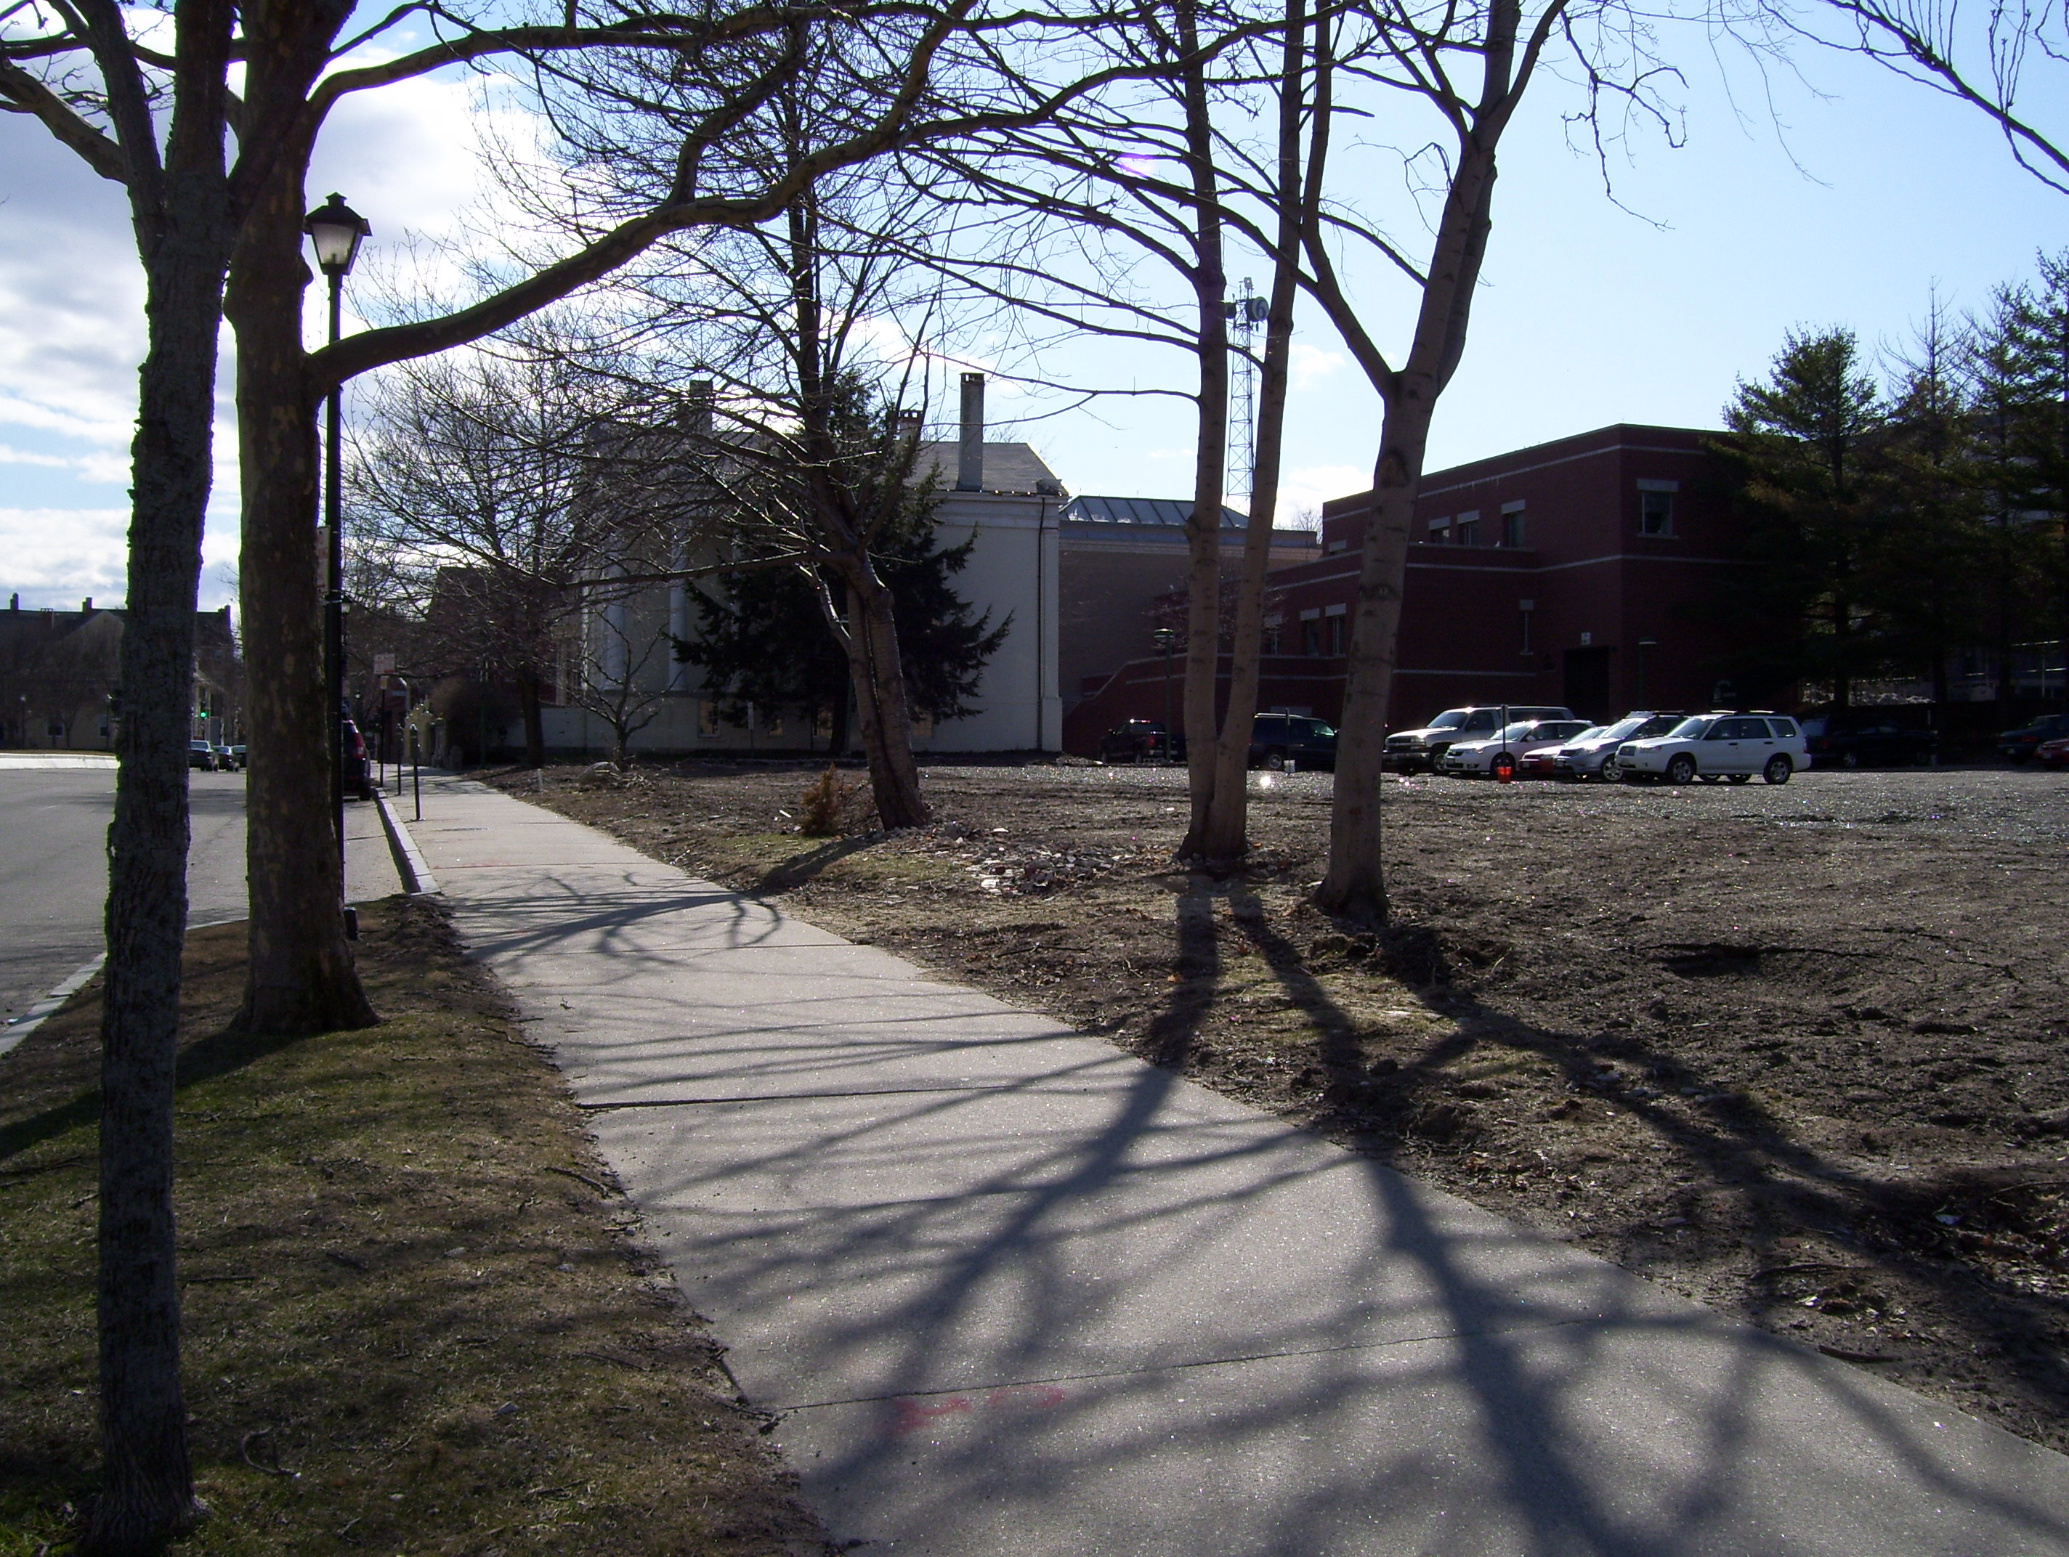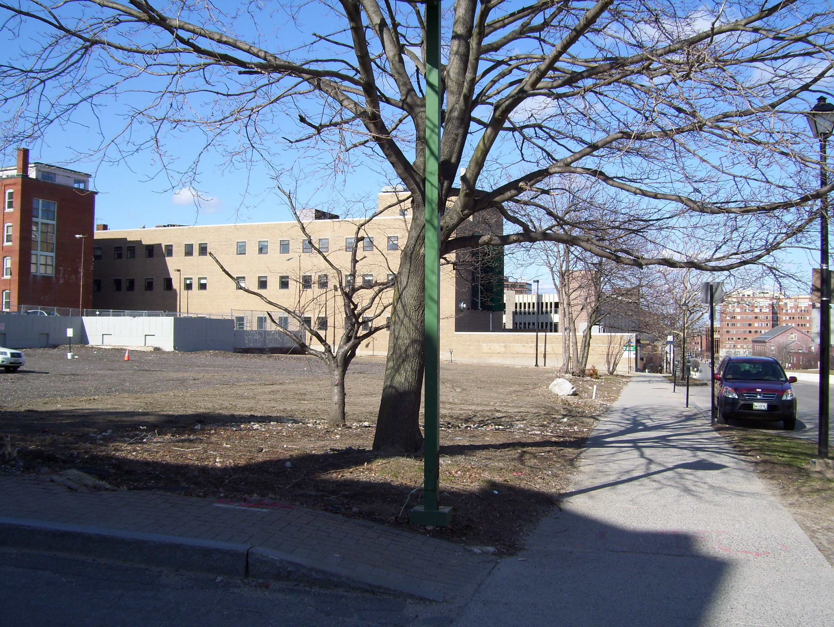
Spring Street, looking west Spring Street, looking east

Along the back of the site there is an existing concrete retaining wall (on Museum property) with chain link fencing above it, and 10 trees within the site in addition to one existing street tree (See Land Title survey and Existing Conditions Plan L1.0 in Attachment 8).

Proposal

The proposed Layout is shown in Plan L2.0 (Attachment 8d) and includes the following:
- Paving and striping of a parking lot towards the rear of the site, with low level lighting around the perimeter and new drainage
- Widening and repaving of the access drive, with brick pedestrian path alongside
- New bioretention cell/raingarden at east end of the parking lot (near Oak Street) as part of an improved drainage and water treatment system
- Three landscaped terraces along Spring Street, with lawn areas and bosques of birch trees (with irrigation; existing trees to be removed including adjacent to Clapp House) (also see Landscape Plan L4.0 and sketches in Attachments 7 & 8)
- Other tree and shrub planting to screen proposed parking (with irrigation)
- Repainting of concrete wall along the wall to rear, with trellis features and climbing plants (repair and repainting of existing chain link on top of wall, plus new sections of chain link where necessary to comply with code re safety) (See L5.2 in Attachment 8)

Key Site Plan Review Standards and Issues

Traffic/Circulation/Parking

The proposals retain the existing site access pattern, which comprise a single existing curb cut from Spring Street near Clapp House. The existing driveway into the parking lot is proposed to be widened from 16 feet to 20 feet. An existing 6 foot wide pedestrian path (subject to an easement with Harper Hotels Inc for connection to between the Holiday Inn and parking on Free Street) adjacent to the access drive is relocated to accommodate the widened drive and proposed to be resurfaced in brick with new lighting alongside.

The parking lot to the rear of the site is designed for 35 regular spaces and 10 tandem spaces for a total of 45 spaces. The previous use as a YWCA had 24-26 parking spaces on the site. A summary traffic statement by William Bray PE has been submitted (Attachment 1). The parking will be limited to vehicles directly involved in the administration of the Museum such as staff, volunteers, docents and occasional specialists associated with specific Museum activities such as setting up exhibits- this is described in more detail in the letters from Mohr & Seredin dated 4.23.2008 and 5.6.08 (Attachments 3 & 4).

Thomas Errico the City’s Traffic Engineering Reviewer, has confirmed that the proposed driveway design and parking space layout is acceptable as based on the confirmation that it will be used for long term duration vehicles (eg Museum employees) (Attachment 5c). A condition of any approval might include a restriction on the nature of the parking use and a requirement for submission of a parking management plan for the lot.

Mr Errico requested further clarification as to where the employees currently park. The applicant has responded in a letter from Mohr & Seredin dated 5.6.08 (Attachment 4) that employees currently park in non-metered street locations, metered parking on surrounding streets and daily fee parking on Free/Spring Streets.

B-3 Site Plan Standard- Design Standards

The site plan ordinance includes standard 16, which addresses design standards for proposals within the B-3 zone. The first section of this standard relates to the pedestrian environment and sub-paragraph 4 addresses sidewalk areas and open space. This standard applies to the proposal and is as follows:

- Sidewalk areas and open space: The design of publicly accessible sidewalk areas and open space shall complement the general pattern of the downtown pedestrian environment, conform with special City of Portland streetscape programs described in the Technical and Design Standards and guidelines, and enhance the attractiveness, comfort, security, and usability of the pedestrian environment. Factors to be considered include the design, placement, character, durability, and quality of the following:
  - Sidewalk, crosswalk, and street paving materials;
  - Landscaping, planters, irrigation, and tree guards and grates;
  - Lighting;
  - Pedestrian amenities such as benches and other seating, trash receptacles, kiosks, bus shelters, artwork, directional and informational signage, fountains, and other special features; and
  - Sidewalk vendors and sidewalk cafes.

The design features of the proposal are described below.

a. Sidewalk
Public Works have outlined the scale of improvements required to the sidewalks and sidewalk ramp at the corner of Oak Street and Spring Street (Attachment 5d). The submitted proposals will require minor revisions to meet this requirement.

b. Landscaping
The landscape proposals are described in the Application (Attachment 1) and illustrated on Plan L4.0 Landscape and Planting Plan (Attachment 8g). The proposals along Spring Street comprise a visual landscape design that suggest the massing of the historic homes removed from this site (prior to the YWCA); three flat terraces are separated by slopes with birch planting in the terraced areas. These tree plantings are augmented by groups of shrub planting and lawn; irrigation has been incorporated to assure survival of the planting. The garden proposals do not include amenities that would encourage or support public access such as stone dust paths, lighting, benches, artwork etc.

Based upon the landscape plan, it appears that all of the existing trees along the Spring Street frontage, including a large conifer adjacent to Clapp House, will be removed.

At the east end of the proposed parking lot there is a bioretention cell that will operate as a rain garden with herbaceous water plants.

Additional tree planting (mostly red maples) are proposed in groups of three at the throat of the parking lot and in four places along the rear of the site in front of the concrete retaining wall. The treatment of the concrete retaining wall is proposed to be painting with anti-vandal paint and the creation of an “armature of plant growth on the entire wall” (Attachment 4, second page). Staff has requested further information /graphic clarification of the wall treatment at the Workshop and the Mohr & Seredin letter of 5.6.08 (Attachments 3 & 4) suggests that the proposals shown in L4.0 and L5.2 (Attachment 8g & 8j) may be revised.
The staff had indicated to the landscape architects (Attachment 5f) that the quality of the rear wall treatment is an issue given the number of years that this is going to be "exposed". While the applicants agents have described the chain link fence as a “safety barrier” in Attachment 2 (which is an important function given the height of the retaining wall), staff consider a more permanent/attractive fence solution should be pursued. (also see comments under “Historic Congruity” below).

The City Arborist has reviewed the proposals but written comments were not received in time to be included in this Memorandum; they will be available at the Planning Board Workshop meeting.

c. Lighting
Attachment 1 includes a description of the proposed lighting and catalog cuts; Attachments 8d & 8e provide details of the location of the lights and associated illumination levels. Low level lights will be provided along the pedestrian walkway into the site from Spring Street and it is proposed that there be “low level, soft, polite illumination at the edges of the parking lot…By design the illumination levels are likely to be less that the city standards but as proposed are sufficient to provide safe, nighttime use of this area” (Attachment 1). The photometric and illumination levels are further described in Attachments 2 and 3 as staff had asked whether these levels would be adequate at night given that there is no additional lighting within the surrounding garden areas.

The City’s Technical and Design Standards set a minimum of .2 foot candles for areas “intended to be lighted” and the Photometric Plan in Attachment 8e is below that level in the vicinity of pedestrian cross walks, to the center rear of the parking lot nearest the retaining wall and near the “rain garden” to the east of the parking lot. Staff recommends that some low level lighting should be included within the gardens area, perhaps by the use of bollards, illuminating the birch trees or other creative solution, which enhance the attractiveness, comfort, security and usability of the area. Staff also suggest that the minimum level of .2 foot candles be achieved within the parking area, particularly in the vicinity of crosswalks and pedestrian routes.

- Pedestrian Amenities
The proposed gardens comprise about a third of the site and all of the Spring Street frontage. The gardens are not designed as a public open space, thus no benches, lighting of the gardens or other amenities are proposed. While it is not required that this open space be designed as a public park like setting, the site is accessible and may be visited by the public. Some lighting may be desirable for security and aesthetic purposes, and other amenities might make the space more usable.

Historic Congruity

Site Plan Standard 15-526 (18) requires that “if any part of a proposed structure or object is within one hundred (100) feet of any landmark…subject to the protection of article IX and not separated from such landmark or district by any public street, or any portion of any such street, such structure or object shall be determined not to be incongruous to the architectural style or character of those portions of such designated landmark or district as are currently visible to the development when viewed from a street or public open space”. The proposals have therefore been reviewed by the City’s Historic Preservation Program Manager (Deb Andrews) and have been determined to meet this standard (Attachment 5g).

However, Ms Andrews has raised a potential concern regarding the choice of retaining/replacing the chain link fence on the top of the retaining wall.

Engineering Issues

The most recent proposals (submitted 5.7.2008) appear to address the Engineering Review comments of 4.24.2008 (Attachment 5b) although a formal review has not been completed. The applicant was particularly advised of the comments regarding the bio-retention cell (See staff e-mail of 5.1.2008 in Attachment 5c) as the viability of the proposed herbaceous plantings may be affected by the design of this water treatment system.

Conditional Use Review Issues

Museums are a permitted institutional use under the B-3 Zoning Ordinance, but surface parking lots are a conditional use in the B-3 Zone and therefore must met the following standards as set out under (14-218) (see relevant extracts below with staff comments):

(b) The following uses are permitted as provided in section 14-474 (conditional uses), provided that, notwithstanding section 14-474(a) or any other provision of this Code, the Planning Board shall be substituted for the board of appeals as the reviewing authority:

(5) Surface parking provided that:

a/b. In the case of lot undergoing minor/major site plan review, no new surface parking spaces, parking aisles, or vehicle lanes shall be allowed within thirty-five (35) feet of any street, except for driveway(s) located perpendicular to the street and providing access to the site;

c. No surface parking spaces shall be encumbered by lease or other use commitment exceeding twenty-four (24) month term.

Staff comment: These standards have been met.

The proposals have been reviewed against 14-474 (Conditional Uses) and the applicant has addressed the three standards of section 14-474 in their Conditional Use application “Statement of Conformance with Conditional Use Criteria”(Attachment 1). Staff has the following comments:

(2) Standards. Upon a showing that a proposed use is a conditional use under this article, a conditional use permit shall be granted unless the board determines that:

a. There are unique or distinctive characteristics or effects associated with the proposed conditional use;

Staff comment: As outlined in the submitted note, the previous use of the site for the YWCA did include parking for 24-26 spaces and the gardens are suggested as having a positive effect for the public using Spring and Oak Streets and for adjacent properties.

- There will be an adverse impact upon the health, safety, or welfare of the public or the surrounding area; and

Staff comment: Staff suggest that the combination of low lighting within the parking area and absence of any lighting within the garden area could contribute to unsafe conditions for pedestrians using the paths across the site (Spring Street to the upper level parking for the Hotel; pedestrians coming from the Museum to the parking lot) and for pedestrians using Spring Street when it is dark/at night.

- Such impact differs substantially from the impact which would normally occur from such a use in that zone.

Staff comment: The B3 Zone and B3 Urban Design Standards include statements regarding the character of the B3 Zone, such as:

Downtown Portland is the center of the region’s business, governmental, cultural, and residential communities. It is also a physical environment comprised of a variety of individual buildings, streetscapes, parks, and districts in which people carry on with day-to-day interactions. As a physical environment, it should be designed to facilitate these uses in a setting that has beauty, is comfortable and secure, which provides amenity and interest for the pedestrian, and which celebrates the coming together of people in a concentrated pedestrian world. (page 1 of the Urban Design Guidelines).

Staff appreciate there is a practical timetable for the Museum which means that this site is unlikely to be developed for a permanent Museum facility for at least 15-20 years. The need for parking is recognized and the proposals in terms of that use do not create an inconsistent impact.

(d) Conditions on conditional use permits. The board of appeals may impose such reasonable conditions upon the premises benefited by a conditional use as may be necessary to prevent or minimize adverse effects therefrom upon other property in the neighborhood. Such conditions shall be expressly set forth in the resolution authorizing the conditional use permit and in the permit. Violation of such conditions shall be a violation of this article.

Attachments

- Applicant’s application, including Mohr & Seredin written statement re conditional use and
Right, Title, Interest information, Stormwater analysis, Traffic Note & Lighting Catalog cuts dated March 31, 2008
- Mohr & Seredin letter of April 11, 2008 regarding lighting, existing retaining wall and short/long range plans for the site
- Mohr & Seredin letter of April 23, 2008 regarding parking lot use, retaining wall treatment and lighting
- Mohr & Seredin letter of May 6, 2008 regarding engineering details, current and proposed staff parking, retaining wall treatment and omission of benches from the gardens
- Staff Comments
  - Zoning comments dated April 11, 2008
  - Engineering Review (Dan Goyette of Woodard & Curran) Memo of April 24, 2008
  - Planning staff e-mail of May 1, 2008
  - Public Services Memo re sidewalk improvements of May 1, 2008
  - Traffic Engineering Reviewer (Tom Errico) comments e-mail of May 6, 2008
  - Planning staff e-mail of May 6, 2008
  - Historic Preservation Program Manager comments of May 8, 2008
  - City Arborist Comments (to be available at the Workshop)
- Existing Condition Photograph (staff)
- Submitted Sketches (March 2008)
- Plan Set (final revisions as received May 6, 2008 which address traffic and engineering comments)
  - Cover Sheet
  - Land Title Survey
  - L1.0 Existing Conditions
  - L2.0 Layout, Materials and Lighting Plan
  - L2.1 Lighting Photometric Plan
  - L3.0 Grading, Drainage, Utilities and Erosion Control Plan
  - L4.0 Landscape and Planting Plan
  - L5.0 Site Details
  - L5.1 Site Details
  - L5.2 Site Details (including for retaining wall treatment)
  - C-1 Drainage Improvements Plan
  - C-2 Existing and Proposed Conditions Maps
  - C-3 Drainage Improvements Details
  - C-4 Overall Neighborhood Drainage Plan

