June 20, 2017 Project 151.06037

Barbara Barhydt, Development Review Manager
City of Portland, Planning Division
389 Congress Street, 4th Floor
Portland, Maine 04103

RE: Level III Site Plan Application
Five-Level Parking Garage
Ocean Gate Realty Garage
48 – 72 Brown Street
Portland, Maine

Dear Barbara:
On behalf of Ocean Gate, LLC, we are pleased to submit this Preliminary Level III Site Plan Application for the development of a five-level parking garage at 48-72 Brown Street in Portland’s downtown area.
This project will replace an existing surface parking lot with 5 levels of structured parking. Increasing parking density on this site will facilitate the conversion of adjacent surface parking lots to residential, commercial, office and potentially other land uses. The construction of privately funded structured parking has been strongly encouraged in the City’s various Master Plans.
Please consider that we will be submitting a Stormwater Credit application to the Water Resources Department for this project shortly. Our goal is to develop a design that meets both the Site Plan Standards and the Stormwater Credit requirements.
In order to demonstrate that this project meets the standards outlined in Section 14-526 of the Site Plan Ordinance, we have included the following documents in the following order:
A-Level-III-Site-Plan-Application
B-Right-Title-and-Interest
D-Zoning Assessment
G-Financial Capacity
J-Transportation Memo
L-Stormwater Management Plan
N-Ability to Serve Portland Water District
P-1-Code Review
P-2-Life Safety Plan
Q-Design Review
S-1-Cover Letter (this document)
S-2-Perspective Images
S-3-Boring Logs
S-4-Historic Preservation Narrative 5-30-17
If you have any questions regarding the attached application materials, please feel free to contact me at john.mahoney@ransomenv.com or (207) 772-2891 Ex 32.
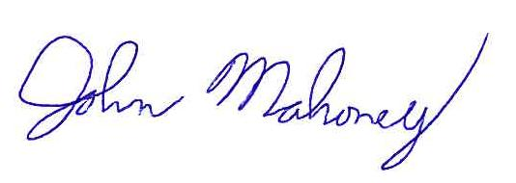
Sincerely,
RANSOM CONSULTING, INC.
John Mahoney, P.E.
Project Engineer

