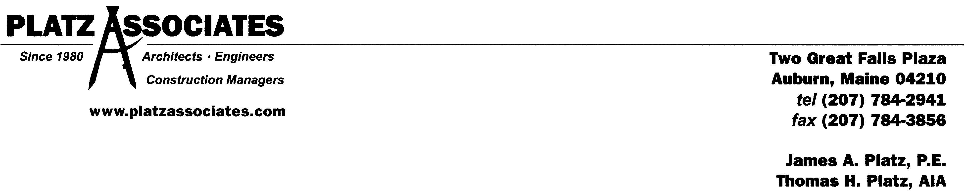

Ocean Gate Garage: Design Review
48 Brown Street, Portland, Maine 04101
June 13, 2017

.

CITY OF PORTLAND DESIGN MANUAL

B-3 Downtown Business Zone
~ Meet Section 14-526 of Land Use Code
~ Relationship to pedestrian = first 35’ of height shall enhance the character, comfort, security, and usability of pedestrian level.
~ Storefronts and building facades, materials and detailing, pedestrian character, transparency, and contemporary design.
~ Building entrances, street prominence, street access, ADA accessibility.
~ Reduce blank facades.
~ Special features such as arcades, skywalks, or elevated walkways.
~ Sidewalk areas per City of Portland Technical Manual, important factors include: materials, landscaping, lighting, pedestrian amenities, vendors or sidewalk cafes.
~ Integrate with the neighboring context with respect to: street walls and building setbacks, open space, building form/massing/scale, façade proportions/composition, pedestrian circulation and building entrances.

DOWNTOWN URBAN DESIGN GUIDELINES

I – Relationship to Pedestrian Environment

Section A: Distinguish lower 35’ of Building Facades
~ Storefronts and building facades should relate to the architecture of the building.
~ Signage should be incidental to the storefront and not overwhelm the façade.
~ High quality materials that are durable and low-maintenance.
~ Building entrances that relate to the building façade, have prominence on the City street, and provide access to the street, and provide ADA accessibility.
~ No more than 30’ of blank façade.

Section C: Sidewalks and Open Space
~ Brick sidewalks required, or concrete pavers that look like brick, per City’s Technical and Design Standards Guidelines.
~ Painted crosswalks with thermally-applied markings allowed.
~ Street design per City’s Technical and Design Standards Guidelines.
~ Landscaping is encouraged, especially flowers, colorful foliage, distinctive bark, and interesting shapes, with plant selection per City’s Technical and Design Standards Guidelines.
~ Landscape lighting is encouraged.
~ Tree grates and guards are encouraged.
~ Coordinated lighting program between: sidewalk & building lighting, building façade illumination, street lighting.
~ Sidewalk luminaries per City’s Technical and Design Standards Guidelines.

Section D: Pedestrian Amenities
~ Benches, trash receptacles, directional and informational signage per City’s Technical and Design Standards Guidelines.
~ Walls should be as low as possible, and integrated with landscaping where possible.

II – Relationship to Existing Development

Section A: Integrate with, Respect and Enhance
~ Maintain urban street wall context.
~ Building form, scale, and massing that is consistent with the structure of the City.
~ Distinctive elements on the skyline.
~ Diminish mass and bulk by: varying exterior walls with setbacks/recesses, varying building height, articulate different sections.
~ Composition in traditional base/middle/top relationship.
~ Proportions should strive to respect the surrounding development.
~ Pedestrian circulation and building entrances should be frequent to support pedestrian activities.
~ Parking garages:
- Street-level uses should be pedestrian-oriented uses where feasible, or accommodate conversion in the future.
- Incorporate through-block pedestrian connections, clearly designated, to allow connections separate and distinct from vehicular travel lanes.
- Positive aesthetic solution that supports pedestrian interest.
- Screen of direct sight to vehicles and lighting is important.
- Provide additional landscaping near public sidewalks.
- Adequate signage to attract and direct motorist without overwhelming the pedestrian environment.
- Public parking signage per City’s Technical and Design Standards Guidelines.
- Consider shared-use strategies, including the City’s residential clearinghouse program.

VI – Setback from Existing Structures
~ Maintain adequate setback to address snow loading.
~ Allow existing means of egress.

DESIGN GUIDELINES COMPLIANCE STATEMENT

CITY OF PORTLAND DESIGN MANUAL

Responding to the B-3 Downtown Business Zone requirements, the project meets Section 14-526 of the Land Use Code.
Special attention was paid to accentuating the first 35’ of the façade design, which looks and feels traditional, light, open, and contextual.
The design of the Brown Street Garage features open steel framing, traditional architectural forms, and active, human-scaled urban edges.
Particular attention was paid to the garage’s most publically visible and engaging facades; those seen directly from Cumberland and obliquely from Congress along Brown Street. These locations were embellished with glass storefront entry towers, providing well-lit and safe pedestrian connections through the garage. They are further softened and enlivened with quality façade materials like decorative grillwork and architectural cast stone elements, landscaped planter beds, and through the use of well-balanced site lighting.
Sidewalk connections are made with high-quality granite curbs and brick pavers that extend into the garage at the most important connections, providing a safe and seamlessly-integrated pedestrian experience from parking stall to the City’s sidewalk system on all three accessible sides of the building.
ADA accessibility is enhanced with signed and striped ADA and van accessible parking provided on both stories with ground level connections.
The design capitalizes on the steel structure of the garage as an architectural medium, accentuated with sculptural grillwork and cast stone elements, to provide beauty in its rhythm, punctuation, and detailing.
The building’s massing is couched by the elevation level-change from Casco to Brown Street, which greatly reduces the vertical impact of the structure as perceived from Casco Street. The building integrates with the adjacent context at Cumberland and Brown Street, activating the street wall with vehicular and pedestrian connections and aesthetically appealing as a well-designed building of scale and quality.
Signage is integrated into the vehicular entry canopy design, extending the visual impact artfully in a way that will enhance the effectiveness and design appeal of the garage.

