PLANNING BOARD REPORT

PORTLAND, MAINE

415 Cumberland Avenue

Building Renovation: Commercial & Residential

Subdivision Amendment

2018-011

Applicant: 415 CA, LLC.

Submitted to Portland Planning Board  Public Hearing Date: June 26, 2018 | Prepared by: Christian Roadman  Date: June 22, 2018

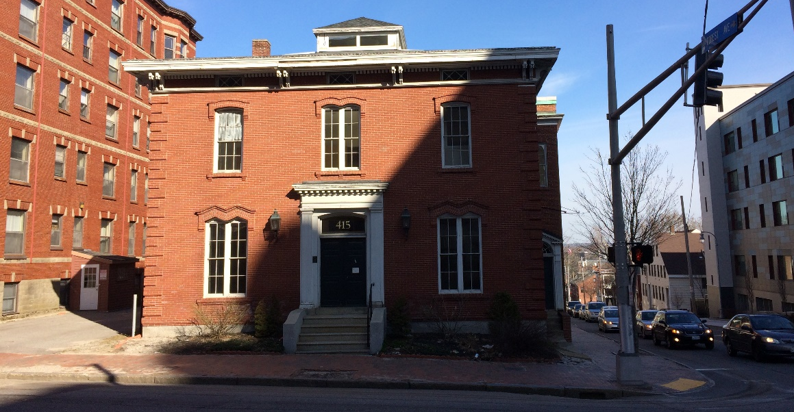

I. Project Summary
The owner of 415 Cumberland Avenue seeks a subdivision amendment for this previously approved project, which the Planning Board reviewed at an April 24 public hearing. The applicant’s original proposal included renovation of the building into eight residential units and two commercial units. The applicant now seeks to create nine residential units and two commercial units. The extra unit will be created out of square footage previously reserved for one of the two commercial spaces. The proposed amendment is intended to allow the project to better respond to market demand.

The property is not within a historic district, nor the downtown pedestrian overlay district, but it is within 100 feet of the Congress Street historic district. As such, this project’s previous review process included historic preservation advisory review. The newly proposed residential unit will primarily impact the interior of the building, but may result in replacement of four windows which the applicant now desires to be made operable. Review and approval of proposed window specifications by historic preservation staff is one of the existing, outstanding conditions of approval for the site plan (approved 4/24/18, Attachment 2).

The Planning Department sent 188 notices of this agenda item to property owners within 500 feet of the site. Notice of this item also appeared in legal advertisements on June 18 and June 19, 2018.

Applicant: Sam Reiche, 415 CA, LLC
Consultants: Walsh Engineering Associates (Thomas Greer, P.E.); Downeast Surveying & Development (Elwood Ellis); Archetype Architects (Barry Yudaken)

II. REQUIRED REVIEWS
Waiver Requests | Applicable Standards
None | n.a.
Review | Relevant Code
Subdivision | Section 14-497

III. PROJECT DATA
Existing Zoning | B-3c Downtown Business, R-6 Residential
Existing Use | Commercial
Proposed Use | Commercial and Residential
Proposed Development Program | 2 Commercial Units, 8 Residential Units
- Bedroom Mix | One Studio, Four 1-Bedroom, Three 2-Bedroom , One 3-Bedroom
Parcel Size | 6,098 sq. ft.
 | Existing | Proposed | Net Change
Building Footprint (sq. ft.) | 4,929 | 4,929 | 0
Building Floor Area (sq. ft.) | 15,820 | 15,820 | 0
Impervious Surface Area (sq. ft.) | 5,762 | 5,786 | 24
Parking Spaces | 6 | 6 | 0
Bicycle Parking Spaces | 0 | 4 | 4
Estimated Cost of Project | $800,000

VIII. ZONING ANALYSIS
The majority of the property at 415 Cumberland Avenue is located within the B-3c downtown business zone, while approximately 20 feet of the property’s northwest area is located in the R-6 residential zone (this area includes proposed apartments, but not the proposed commercial spaces). No additional parking is required for the project in either zone, and the six tandem-parked garage spaces will remain. Staff find the proposed project in conformance with zoning requirements.

z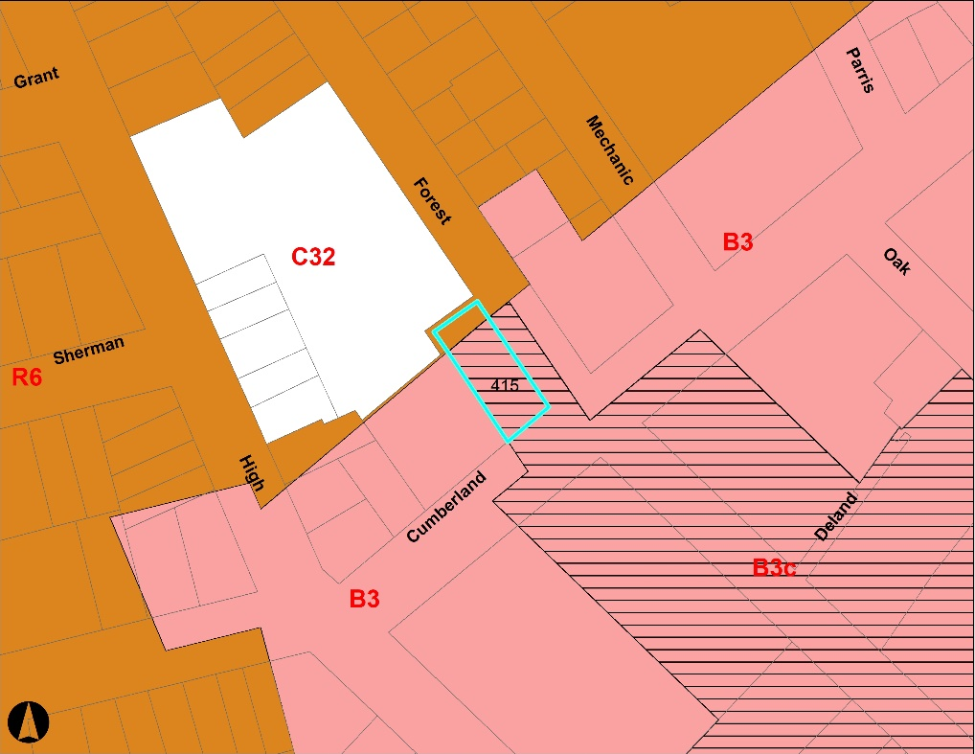
Zoning context of proposed 415 Cumberland Avenue. The project parcel is outlined in light blue.

IX. DEVELOPMENT REVIEW

A. SubDivision (Section 14-497)
The proposed development prompts review for conformance with relevant standards of Portland’s subdivision ordinance and applicable regulations.

Will Not Result in Undue Water and Air Pollution; Will Not Result in Undue Soil Erosion
Staff find the proposed project in conformance with this standard.

Sufficient Water Available
The applicant provided a capacity to serve letter from the Portland Water District.

Will Not Cause Unreasonable Traffic Congestion
Staff find the proposed project in conformance with this standard.

Will Provide for Adequate Sanitary Sewer and Stormwater Disposal; Will Not Cause an Unreasonable Burden on Municipal Solid Waste and Sewage
Staff confirmed wastewater capacity for the additional unit with the Department of Public Works.

Scenic Beauty, Natural, Historic, Habitat and other Resources
Staff find the proposed project will not have an adverse effect on the scenic or natural beauty of the area.

Comprehensive Plan
Staff find the proposed project compatible with the Comprehensive Plan, which includes the following applicable goals:
- “create economic prosperity by growing Portland’s tax and employment base”
- “encourage additional contextually appropriate housing density in and proximate to neighborhood centers, concentrations of services, and transit nodes and corridors as a means of supporting complete neighborhoods”

XII. PROPOSED MOTIONS

This application deals with an increase in number of units and amends the subdivision plat. The site plan approval granted by the Board on April 24, 2018 remains in effect, including all conditions, for this amendment.

- AMENDED SUBDIVISION
On the basis of the application, plans, reports, and other information submitted by the applicant; findings and recommendations contained in the Planning Board report for the public hearing on June 26, 2018 for application 2017-011 (415 Cumberland Avenue) relevant to the subdivision regulations; and the testimony presented at the Planning Board hearing, the Planning Board finds that the plan [is / is not] in conformance with the subdivision standards of the land use code.

XIII. ATTACHMENTS

Planning Board Report Attachments

- 415 Cumberland Planning Board Workshop Staff Report 4-24-18
- 415 Cumberland Approval Letter - Level III & Subdivision

Applicant’s Submittals

- Cover Letter
- Level III Application

Applicant’s PLANS

P1 Floor PLANS
P2 ELEVATIONS
P3 SUBDIVISION PLAN
P4 SITE PLAN
P5 LANDSCAPE PLAN
P6 DEMOLITION PLAN & DETAILS
P7 SURVEY

