

PLANNING BOARD REPORT
PORTLAND, MAINE

Subdivision and Change of Use/ Renovation of Building
to Co-Working Offices and Four Apartments
Amendment to July 2016 Approval

415 Cumberland Avenue (proposed residential addressed 62 Forest Avenue)
Level III Subdivision Plan and Site Plan (Amendment)
Project ID #2016-196 CBL 036 G033001
Andrew Kraus, M&A Lowcountry Investments, LLC, Applicant

Submitted to:  Portland Planning Board  Public Hearing Date: September 27, 2016 | Prepared by:  Jean Fraser, Planner  Date: September 23, 2016

I. INTRODUCTION
The applicant is requesting an amendment to the approved Level III application for conversion of the existing 3-4 story building at 415 Cumberland Avenue into residential units and a “co-working” shared business office unit. The proposal was approved with three residential units on July 26, 2016 (Approval letter in Attachment 1) and the amendment comprises reconfiguration of the residential part to create four units.

The previously approved project also included window replacements /reopenings, roof decks, recladding of part of the Forest Avenue façade, replacement garage doors, and modifications to the “alley” between the building and the abutting YMCA.

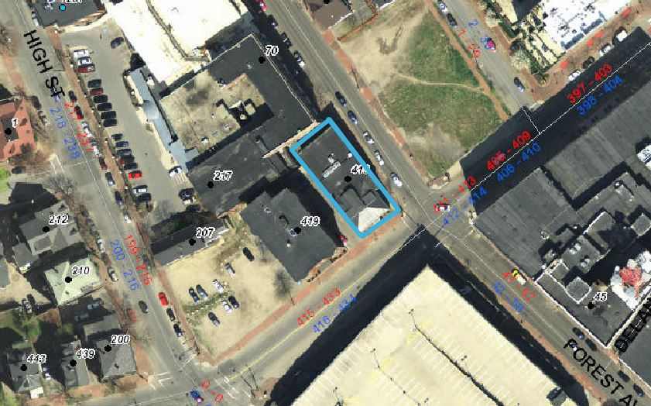
The property is located at the corner of Cumberland and Forest Avenues in the B3c zone. The building is of historic importance although not considered eligible for any specific historic designation. The Congress Street historic district is located diagonally across the Cumberland/Forest intersection.

A total of 198 notices of this Hearing were sent to residents within 500 feet and interested citizens. A notice also appeared in the September 19th and 20th, 2016 editions of the Portland Press Herald.

The previous proposal did not require a Neighborhood Meeting as it was being subdivided into fewer than 5 units. The amendment to create a fourth dwelling unit triggers the need for a Neighborhood Meeting, which was held on September 15, 2016 and the notes and details are included in Attachment I.

- REQUIRED REVIEWS {NO REQUESTED WAIVERS}

Review | Applicable Standards
Site Plan | Section 14-526 for the proposed redevelopment
Subdivision of overall site | Section 14-497 for the division into 1 business office unit and 4 residential units.

III. PROJECT SUMMARY

Existing Zoning: B3c Business Zone
Proposed Use: Commercial Co-Working and four (4) Residential Units
Parcel Size: 6098 sq ft
Total Disturbed Area: None- all interior improvements

Existing Building footprint: 4,929 sq ft
Proposed Building footprint: 4,929 sq ft
Existing Building floorspace: 15,745 sq ft over 4 stories
Proposed Building floorspace: 15,745 sq ft over 4 stories excluding decks

Existing use: Commercial space (most recently Hurley Travel)
Proposed uses: 5,549 sq ft residential including units, deck & parking
12,405 sq ft “co-working” offices, incl. basement, common area and deck

Residential Data:
Existing Res. Units: None
Proposed Res. Units: 4 units totaling 3,137 sq ft
Bedroom Mix: 2 No 1-bedroom unit
2 No 2- bedroom unit

Parking Spaces:
Existing: 6 (within garage as part of building)
Proposed: 6 (within garage as part of building shown for residential use) (includes one handicapped space)
Required: In this zone no parking provision is required for a change of use

Bicycle Parking Spaces:
Existing: None
Proposed: 14 (6 outside; 4 in garage for residential units; 4 in common area for business use
Required: Requirement is 2 spaces for residential; 2 for spaces for the business unit

Estimated Cost of Project: $950,000

PROJECT DESCRIPTION
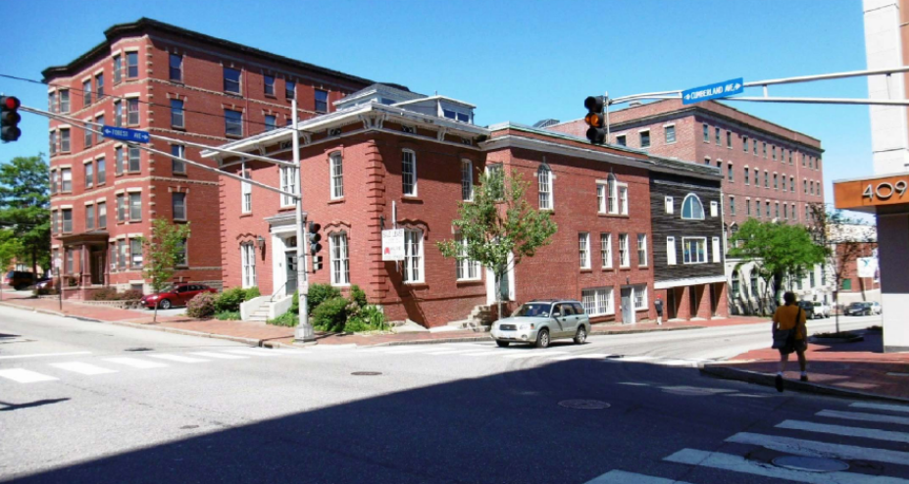
The existing 3-4-story building is part of a group of 4-5 story buildings that include the YMCA at the corner of Forest and Cumberland Avenues. The front part facing Cumberland Avenue dates from the 1860’s and the rear section is recent.

There are three small areas of open site: the landscaped area at the front; a paved sliver along the west side which is currently the location of a fire escape; and an open but fenced area at the north side which has an access easement over it for the YMCA. (see submitted photos in Plan P6)

The proposals are illustrated in Plans P2 to P7 and remain as previously approved except that the former 3 bedroom unit (first floor) has been divided into a 2 bedroom unit and a 1 bedroom unit and the elevations have been amended to show revising cladding and trash enclosure proposals. The previously approved proposals also include:

      - Creation of a “co-working” business office unit that includes a number of common amenities such as fitness center; kitchen/lounge; conference room
      - Installation of 15 new windows on three facades (not on the Cumberland Avenue elevation), most being a replacement of existing or a re-opening of original;
- Retention of historic exterior and interior features (eg ballroom)
- Addition of two roof top decks;
- Elevator to serve the co-working office unit including the penthouse and roof deck;
- Planting of two street trees in front landscaped area;
- Provision of 6 bicycle parking spaces in the vicinity of the fire escape on the west elevation and 8 inside;
- Use and improvement of part of the rear (north) open easement area for trash storage in 7 bins;
- Repair or replacement of the ADA ramp in the ROW at the corner of Forest and Cumberland Avenues.

V. RIGHT, TITLE AND INTEREST AND FINANCIAL CAPACITY
a. The owner of the property is M&A Lowcountry Investments, LLC and the deed in Attachment C. demonstrates their right, title and interest in the property. The YMCA has an access easement over a small area to the north of the property that provides ADA access to a side door. The project maintains access to this door.

b. The estimated cost of the development is $950,000 (see Attachment B data sheet) and the applicant has confirmed that funds have been secured (Attachment D).

VI. ZONING ASSESSMENT
The building is located primarily in the B3c zone, with the northern edge and abutting small yard located within the R6 zone. The previous use of the building was retail, workshop and offices (Hurley Travel; commercial under site plan definitions) and the proposed uses are a change of use to residential and general and business offices. The proposed uses are permitted in the B3c zone, and the residential part is within the R6 zone.

The site is not within the PAD Overlay Zone but the Downtown Urban Design Standards apply (see below). The project is exempt from providing any additional dedicated parking for the project under the zoning ordinance as a change of use in the B3c Downtown Business Zone. The proposal does not include any alterations to the existing footprint of the building nor its height. The staff finds the application to be in conformance with the B-3c zone, and notes that the trash storage is regulated in the External effects section 14-221.1.

VII. DEVELOPMENT REVIEW
A. SUBDIVISION and SITE PLAN SUBMISSION REQUIREMENTS (Section 14-497 & Section 14-527)
All requirements have been met. The subdivision plat (Plan P2.) clarifies the subdivision units and is comprehensive. The final version including any additional Planning Board subdivision conditions will need to be reviewed by the Legal Department and DPS Surveyor prior to signature by the Planning Board, as recommended in the condition of approval.

It is understood that the apartments are being created for market-rate rental so there are no Condominium Documents submitted. A suggested subdivision condition of approval requires the submission of such documents if the nature of the units is changed in the future.

B. Subdivision Review
The proposed development has been reviewed by staff for conformance with the relevant review standards of Portland’s Subdivision Ordinance and applicable regulations. Staff comments are listed below.

- Will Not Result in Undue Water and Air Pollution (Section 14-497 (a) I), and Will Not Result in Undue Soil Erosion (Section 14-497 (a) 4)
Staff finds the proposed project is in conformance with this standard.

- Sufficient Water Available (Section 14-497 (a) 2 and 3)
The applicant has submitted the capacity letter from the Portland Water District (Attachment H.)

- Will Not Cause Unreasonable Traffic Congestion (Section 14-497 (a) 5)
Please see paragraph C1 below. The staff finds the proposal will not cause unreasonable traffic congestion.

- Will Provide for Adequate Sanitary Sewer and Stormwater Disposal (Section 14-497 (a) 6), and Will Not Cause an Unreasonable Burden on Municipal Solid Waste and Sewage (Section 14-497 (a) 7)
The wastewater capacity letter is included in Attachment H. It relates to the previous proposal but the number of bedrooms has not changed. There are no stormwater issues as the applicant has addressed the previous conditions relating to roof drains and the Construction Management Plan.

- Scenic Beauty, Natural, Historic, Habitat and other Resources (Section 14-497 (a) 8)
The proposed project will not have an adverse effect on the scenic or natural beauty of the area, thus the proposed project is in conformance with this standard.

- Comprehensive Plan (Section 14-497 (a) 9)
The following statement is housing policy that is relevant to this proposal and the staff finds the proposed project is in conformance with this standard.
The first policy of Housing: Sustaining Portland’s Future is to ensure an adequate and diverse supply of housing for all. Objectives under that policy include the following:
- Ensure the construction of a diverse mix of housing types that offers a continuum of options across all income levels, which are both renter and owner-occupied. The list of potential housing options under this objective include:
ii. Housing units for decreasing household sizes, such as young professionals, empty nesters, single parent households and senior citizens.
v. Higher density housing, such as row houses, small lots, reuse of non-residential buildings, and mixed use buildings.
- Encourage higher density housing for both rental and home ownership opportunities, particularly located near services, such as schools, businesses, institutions, employers and public transportation.
    - Evaluate and update current zoning, as needed, to encourage higher density multi-family developments and mixed use projects that incorporate housing, particularly along major public transportation routes, near services areas, and in redevelopment or infill areas, where appropriate.
- Encourage housing within and adjacent to the downtown. Evaluate and update current zoning and building codes, as needed, to facilitate new housing and redevelopment opportunities….

The proposals also address Comprehensive Plan policies regarding economic development that derive from the
Portland Industry and Commerce Plan – 1994:

- Strengthen and Diversify the Economic Base
      - create a variety of job opportunities for the full spectrum of the labor pool which:
        - are appropriate to our current and potential skills
        - provide good pay and benefits - a living wage
        - are rewarding/satisfying
        - strengthen and diversify the tax base

- Financial Capability (Section 14-497 (a) 10) Please see above under Section IV.

C. Site Plan Standards (Section 14-526)
The proposed development has been reviewed by staff for conformance with the relevant review standards of Portland’s site plan ordinance and applicable regulations. Staff comments are listed below.

- Transportation Standards
  - Impact on Surrounding Street Systems
  - Access and Circulation
  - Public Transit Access
  - Parking
  - Transportation Demand Management (TDM)
STAFF COMMENT: The proposed project is not anticipated to have any significant adverse effect on regional traffic, and the parking needs have been addressed by the retention of the 6 existing parking spaces (shown on Plan P3 as “Residential”) in the garage which have an existing curb cut that is satisfactory. The Traffic Engineering reviewer Tom Errico has confirmed in Attachment 3 that the previous comments still apply; they were:
I have reviewed the project application materials and I find conditions to be acceptable. I would suggest a condition of approval that notes the parking tandem parking spaces be designated for the residential units only (or for low turnover use). Backing maneuvers onto Forest Avenue should be minimized given vehicle and pedestrian traffic levels.
A suggested condition of approval reflects these comments.
Bicycle parking totaling spaces for 14 bikes has been provided for both occupants and visitors (see Plan P3) and exceeds the ordinance requirement of 4 spaces. However, access to the 6 spaces outside is over property outside the site, so a suggested condition of approval requests that the bike parking be accessible over the applicant’s property.

A recent aspect of the review of pedestrian access relates to compliance with current ADA requirements and the applicant has submitted a letter confirming compliance as the creation of the fourth unit raised a question on this point (Attachment F). The City’s Associate Corporation Counsel Victoria Morales has confirmed agreement with the submitted analysis (Attachment 4). The Public Transit and TDM standards do not apply to this project.

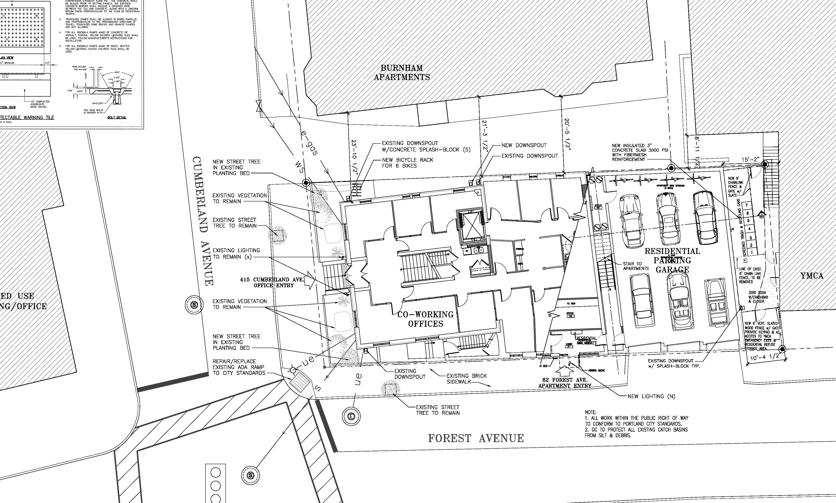
Proposed Site Plan

- Environmental Quality Standards
  - Preservation of Significant Natural Features
  - Landscaping and Landscape Preservation
  - Water Quality, Storm Water Management and Erosion Control

STAFF COMMENT: The applicant has added two street trees to the front (existing) landscaped area and, together with the existing two street trees, provide 4 street trees. With the creation of the fifth unit the street tree requirement is 5 street trees. The City Arborist has not advised on how best to meet this requirement and staff will make a recommendation at the Hearing.

The trash storage (7 totes) is provided within the “alley” between the building and the YMCA and the proposals include upgrading of the fenced enclosure and provision of a gated wood slat fence at the back of the Forest Avenue sidewalk (see Plans P3 and P5 for details).

The reuse of the building and surrounding impervious surfaces do not require any upgrading to meet current stormwater requirements. During the previous review there were comments regarding the erosion control during construction and the roof drains, which have been addressed in the submitted plans.

- Public Infrastructure and Community Safety Standards
  - Consistency with Master Plans
  - Public Safety and Fire Prevention
  - Availability and Adequate Capacity of Public Utilities
STAFF COMMENT: The previous review requested noted that the sidewalks along the frontage are in good condition and requested replacement or repair of the ramp panel within the tipdown at the corner crosswalk. The applicant has been in discussion with staff regarding the ramp as it does not lend itself to a “standard” detail, and it is anticipated a final detail for this ramp will be available at the Hearing. The condition requiring the ramp has been retained in the motion for the Board to consider, and can be struck if this detail is resolved.
The Fire Department has reviewed the three iterations of the building conversion and confirmed the comments remain applicable to the current proposal (same externally as the amended proposal). The 911 and street addressing is a particular concern because the entrances to the building are on two streets, and this has been highlighted in a suggested condition of approval. The current proposal gives these two different addresses which will also require further review in the context of emergency service concerns.
The capacity letters for water and wastewater have been received (Attachment H). These relate to the original proposal in July, but are still valid as the bedroom and bathroom numbers have not changed.
- Site Design Standards
  - Massing, Ventilation and Wind Impact; Shadows; Snow and Ice Loading; View Corridors: The alterations to the existing building are minor and would not alter these impacts.

  - Historic Resources: The proposal is 100ft +/- from the Congress Street Historic District and the landmark NE Telephone building. The proposals include recladding and new windows in part of the Forest Avenue elevation that faces the historic district and staff considered that this elevation should be reviewed under the Site Plan standard that requires compatibility with the historic context. The proposal also adds an elevator overrun in the roof area facing west (away from Forest Avenue) and this small structure has been well integrated into the roof design.

The applicant has revised the cladding since the July approval and discussed the amendment with the Historic Preservation Program Manager, Deb Andrews. A comparison between the approved and amended cladding is set out below:

The previously approved cladding was 48” X32” “Hardie” reveal panel system with aluminum trim over “Typar” building wrap, with aluminum fry reglets:
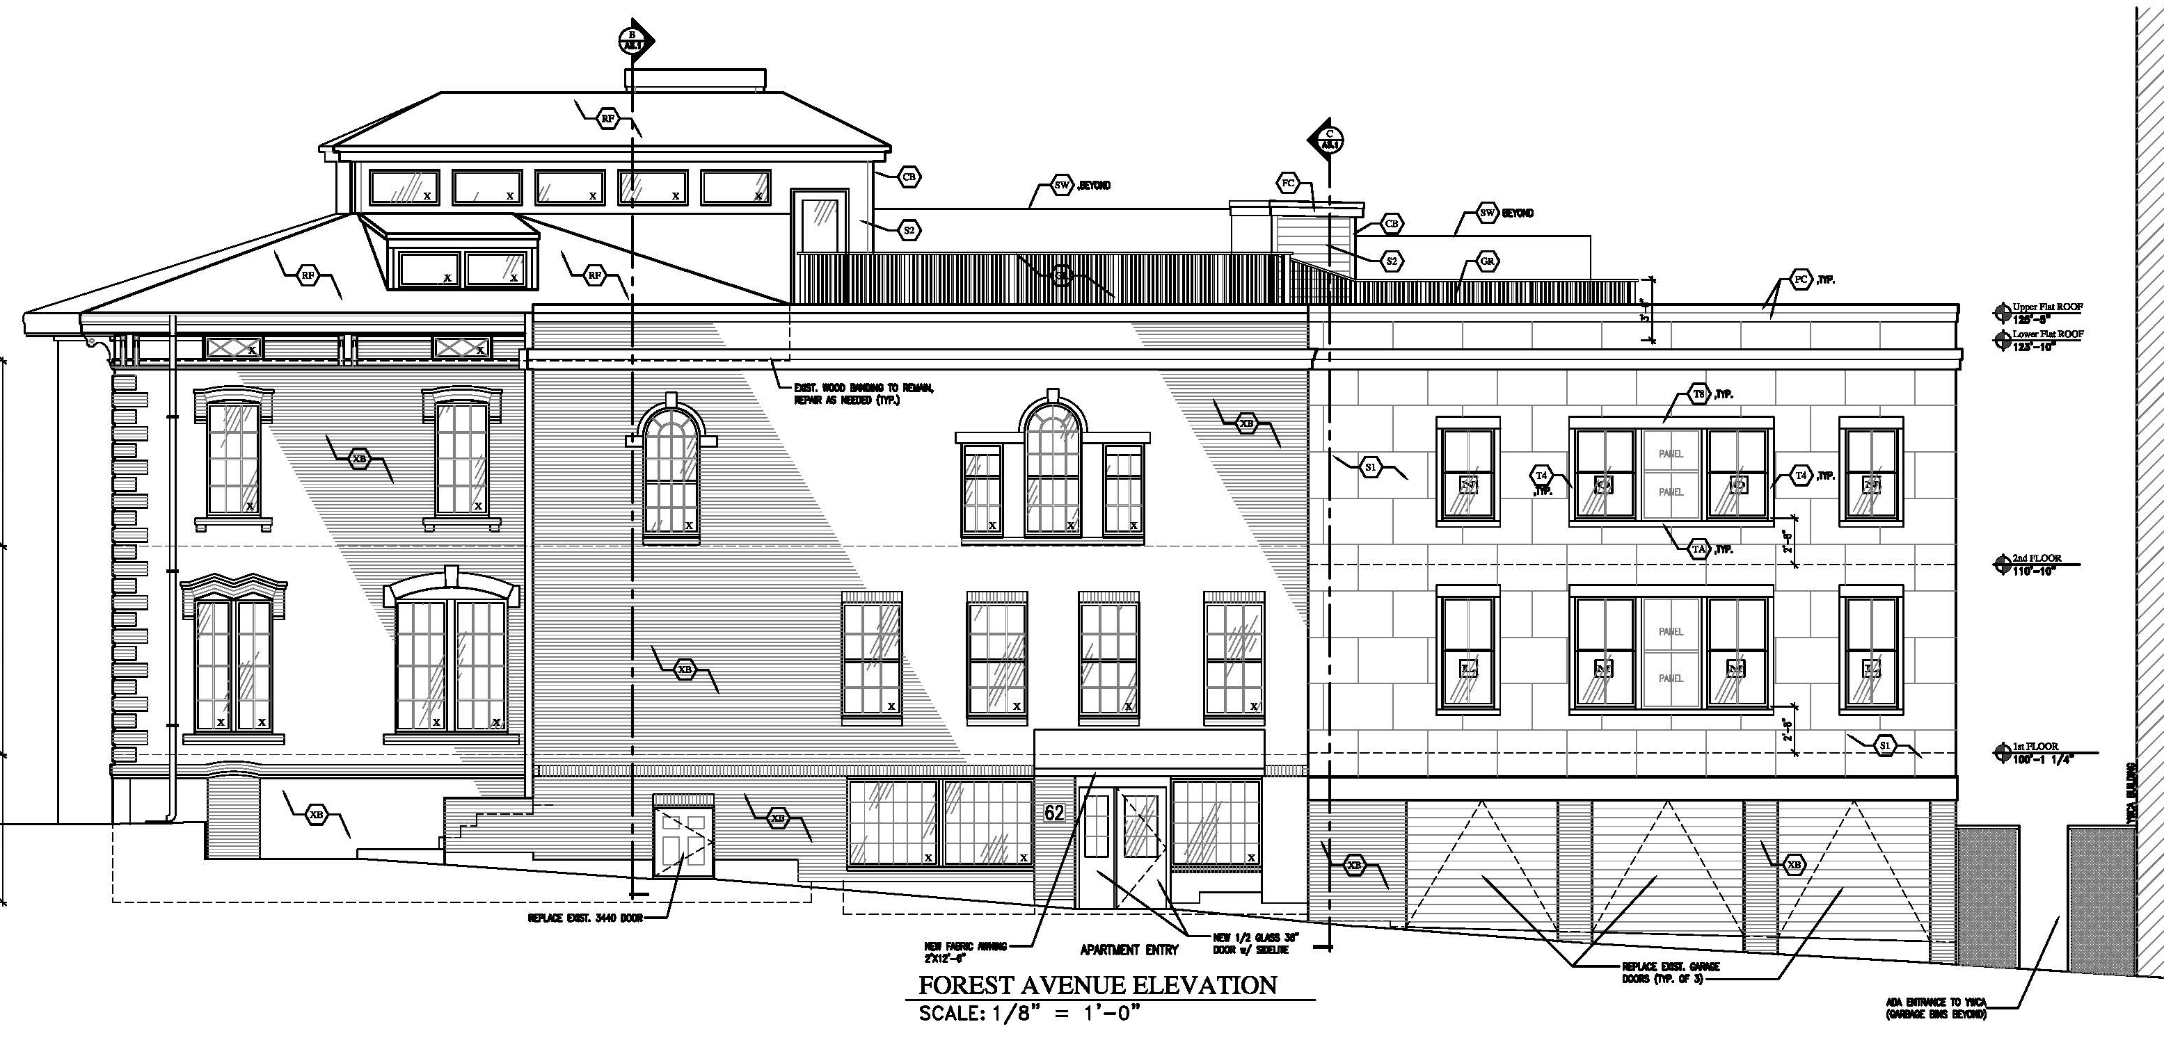
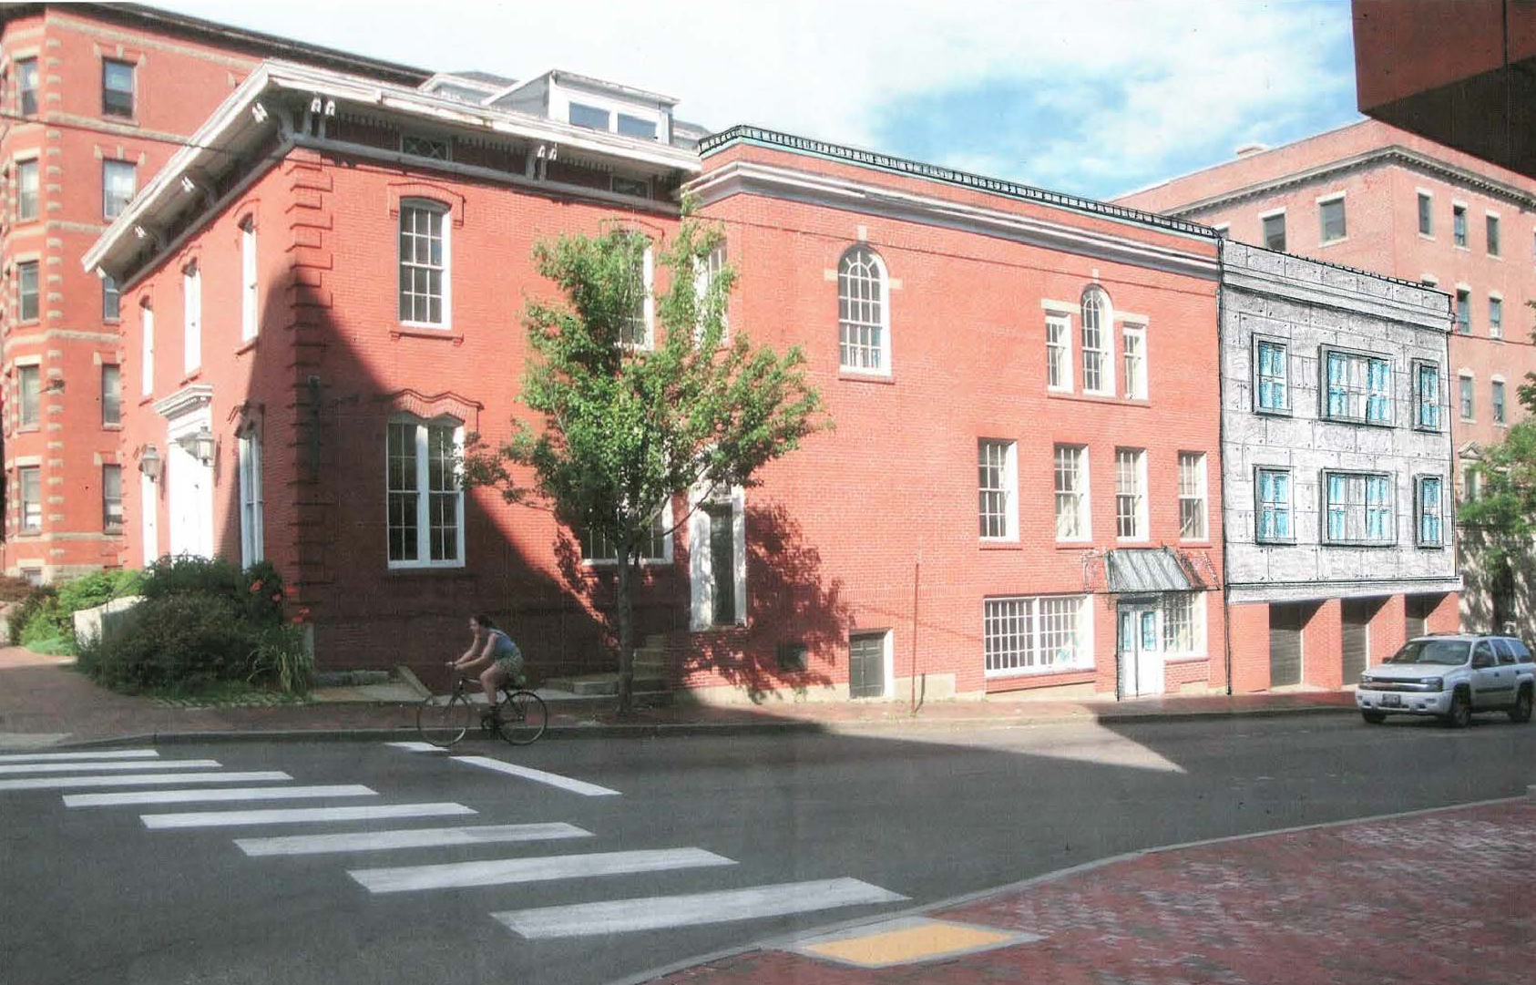

The current amended proposals (below) were revised to because of the high cost of the original specification. The proposed cladding is now 6” TTW “Hardie Plank” lap siding over “Typar” building wrap (color TBD) and illustrated below:
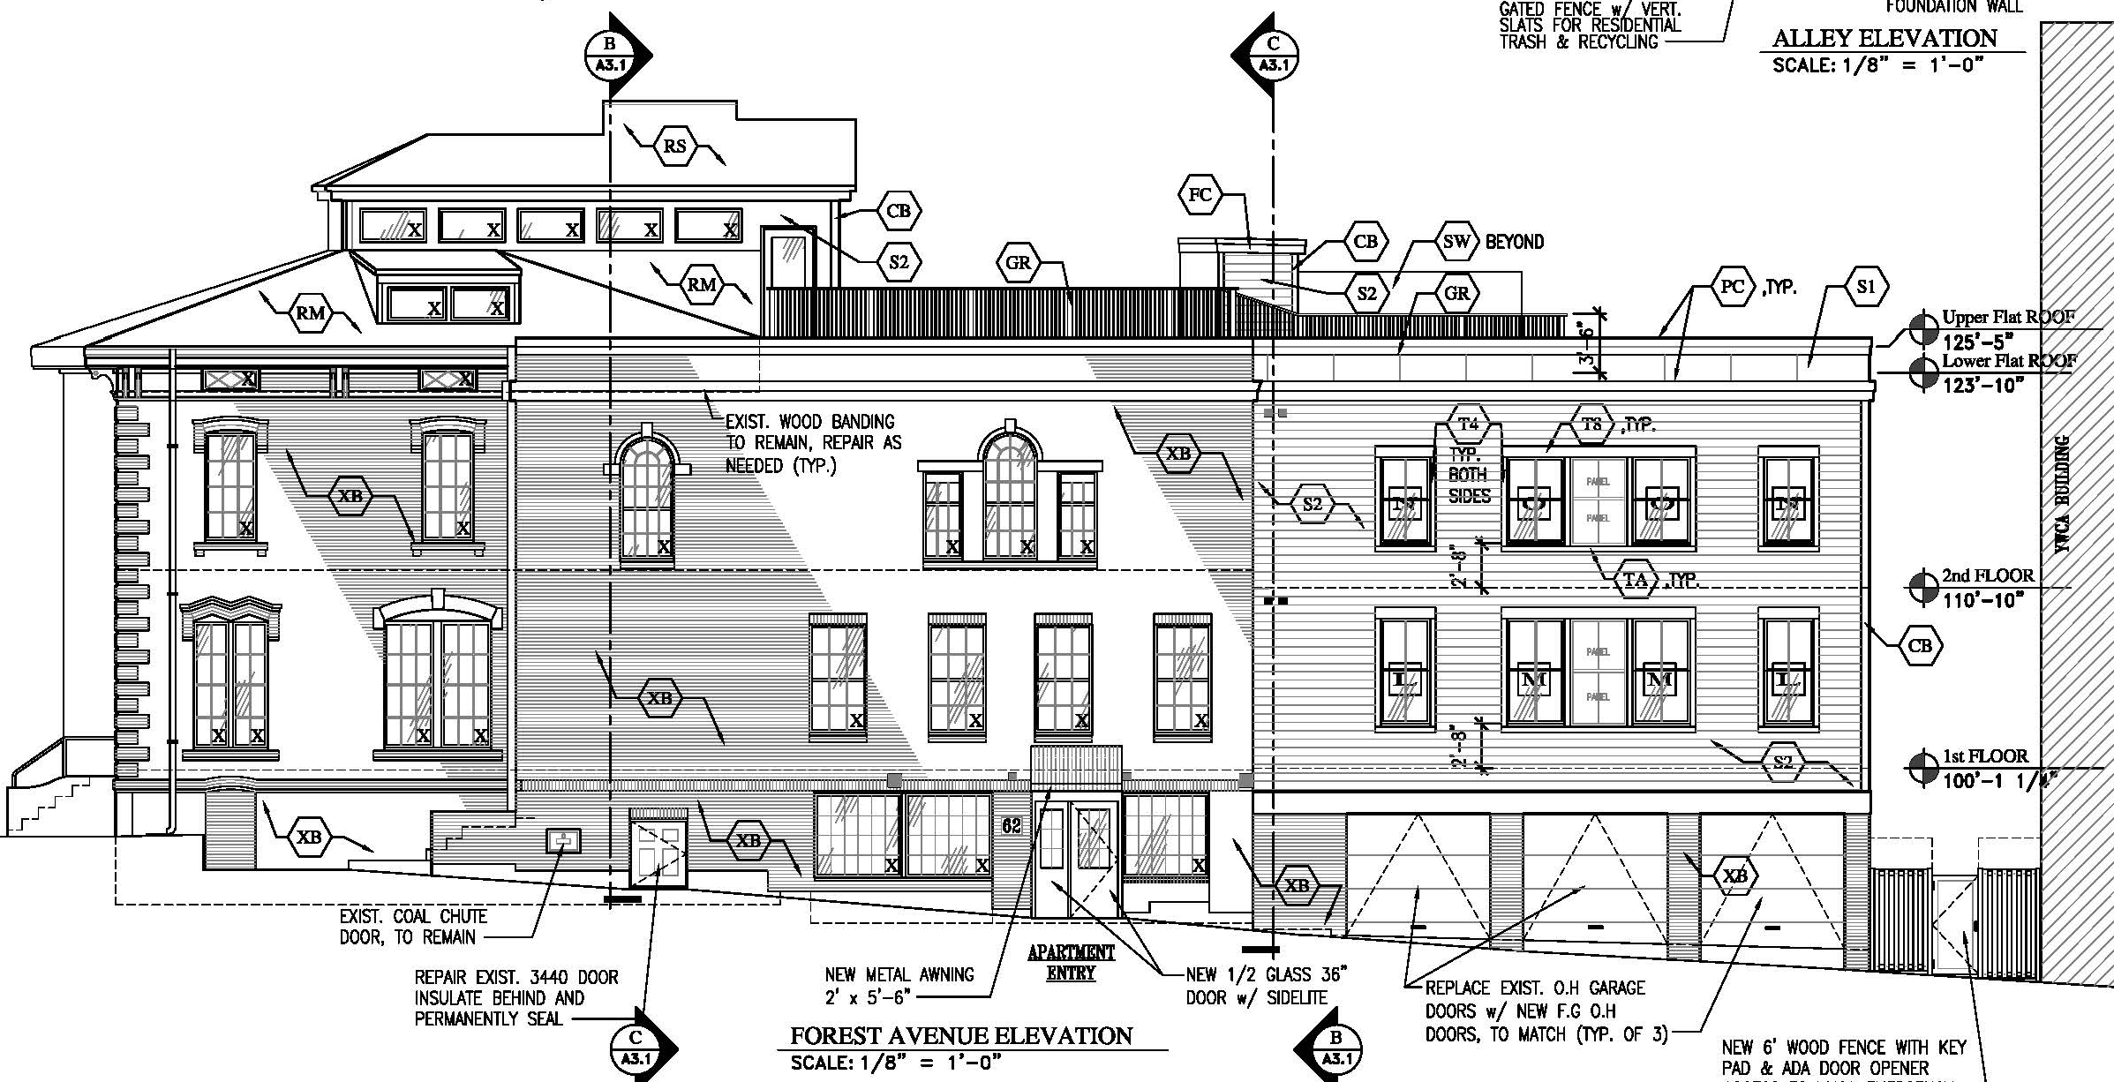
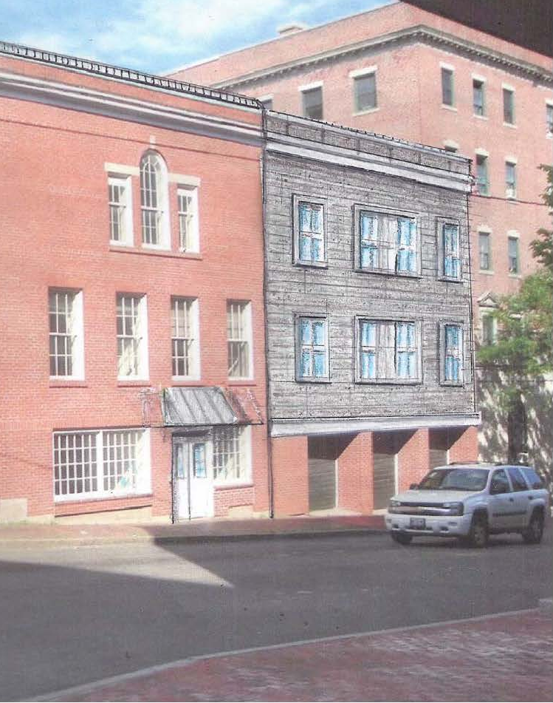
The Historic Preservation Program Manager, Deb Andrews, welcomes the removal of the brown wood cladding and has reviewed the amended proposals. She has confirmed that the final proposals are generally compatible with the historic structure/district (Attachment 5).

The applicant will clarify regarding the proposed color (and circulate a sample of the material) at the Hearing. Proposed Elevation facing Forest Ave.

  - Exterior Lighting
  - Noise and Vibration
  - Signage and Wayfinding

STAFF COMMENT: The application does not clarify the proposed lighting, so the submission of details has been included in a suggested condition of approval. The application shows (Plan P4., top left) a number of HVAC units, and further information showing that they comply with the B3c sound level maximums is requested in a suggested condition of approval. As noted by the Fire Department in relation to addressing, the fact that the same building is proposed to have two different addresses needs to be considered further in light of the 911 requirements and the need for clear associated signage.

  - Zoning Related Design Standards
STAFF COMMENT: The B3 Downtown Urban Design Standards technically apply to his property but generally focus on issues related to new build. These Standards require enclosure of rooftop appurtenances and compatible materials and entrance designs. The proposals do not clarify whether the rooftop mechanicals are visible from the public realm and the condition of approval seeks further information on this question.
The proposals include a multi-family development and therefore must meet the following standards:
TWO-FAMILY, SPECIAL NEEDS INDEPENDENT LIVING UNITS, MULTIPLE-FAMILY, LODGING HOUSES, BED AND BREAKFASTS, AND EMERGENCY SHELTERS:

(1) STANDARDS. Two-family, special needs independent living units, multiple-family, lodging houses, bed and breakfasts, and emergency shelters shall meet the following standards:
a. Proposed structures and related site improvements shall meet the following standards:

1. The exterior design of the proposed structures, including architectural style, facade materials, roof pitch, building form and height, window pattern and spacing, porches and entryways, cornerboard and trim details, and facade variation in projecting or recessed building elements, shall be designed to complement and enhance the nearest residential neighborhood. The design of exterior facades shall provide positive visual interest by incorporating appropriate architectural elements;
- The proposed development shall respect the existing relationship of buildings to public streets. New development shall be integrated with the existing city fabric and streetscape including building placement, landscaping, lawn areas, porch and entrance areas, fencing, and other streetscape elements;
Staff comment: The external alterations address the standards.

3. Open space on the site for all two-family, special needs independent living unit, bed and
breakfast and multiple-family development shall be integrated into the development site. Such open space in a special needs independent living unit or a multiple-family development shall be designed to complement and enhance the building form and development proposed on the site. Open space functions may include but are not limited to buffers and screening from streets and neighboring properties, yard space for residents, play areas, and planting strips along the perimeter of proposed buildings;
Staff comment: There is little opportunity for additional planting, and the proposal to upgrade the front planted area generally addresses this standard.

4. The design of proposed dwellings shall provide ample windows to enhance opportunities for sunlight and air in each dwelling in principal living areas and shall also provide sufficient storage areas;
Staff comment: This standard appears to be met.

5. The scale and surface area of parking, driveways and paved areas are arranged and landscaped to properly screen vehicles from adjacent properties and streets;
Staff comment: The parking is within an enclosed building and the vehicles are screened.

VIII. STAFF RECOMMENDATION
Subject to the proposed motions and conditions of approval listed below, Planning Division staff recommends that the Planning Board approve the amended proposals for the subdivision and site plan for four residential units and one co-working business offices unit within the existing building at 415 Cumberland Avenue.

IX. PROPOSED MOTIONS FOR THE BOARD TO CONSIDER

A. SUBDIVISION Review
On the basis of the application, plans, reports and other information submitted by the applicant, findings and recommendations contained in the Planning Board Report for the public hearing on September 27, 2016 for application #2016-196 (415 Cumberland Avenue) relevant to the Subdivision regulations, and the testimony presented at the Planning Board hearing, the Planning Board finds that the plan (is/is not) in conformance with the subdivision standards of the land use code subject to the following condition of approval:
    - That the Subdivision Plat shall be finalized to the satisfaction of the Planning Authority, Corporation Counsel, and Department of Public Works, prior to submission for Planning Board signature; and
    - That in the event the property is converted to a condominium, that the recorded condominium documents shall be copied to the Planning Authority.

        - Site plan review
On the basis of the application, plans, reports and other information submitted by the applicant; findings and recommendations contained in the Planning Board Report for the public hearing on September 27, 2016 for application #2016-196 (415 Cumberland Avenue) relevant to the site plan regulations; and the testimony presented at the planning board hearing, the planning board finds that the plan (is/is not) in conformance with the site plan standards of the land use code, subject to the following conditions of approval:

- That the applicant shall submit detailed plans/revised site plan to confirm the proposals for the following, all for review and approval by the Planning Authority (including the Transportation Division) and Department of Public Works prior to the issuance of a building permit:
- The repair/replacement of the ADA ramp panel in the ROW at the corner of Forest Avenue and Cumberland Avenue;
- The provision of an additional (fifth) street tree;
- The route to the outside bike racks located within the applicant’s property; and
- Details/specifications of the new fence along the back of the sidewalk near the trash storage area.

- That the tandem parking spaces be designated for the residential units only (or for low turnover use) to ensure that backing maneuvers onto Forest Avenue are minimized given vehicle and pedestrian traffic levels; and

- That any exterior lighting shall meet the City’s Site Lighting Standards in Section 12 of the Technical Manual; the HVAC sound levels shall meet the B3c External Effects standards; and the HVAC placement/screening shall meet the ordinance requirements of Section 14-526 (d)(7). Documentation of these to be submitted for review and approval by the Planning Authority prior to the issuance of a building permit; and

- That the applicant shall address the comments of the Fire Department dated 10.7.15 regarding the development of street addresses and their marking on the structure/signage prior to the issuance of a certificate of occupancy; and

- That a separate “change of use” permit shall be obtained from the Permitting and Inspections Division, and that any signage would require separate permits from the Permitting and Inspections Division.

Attachments:

Planning Board Report Attachments  - Previous approval letter (for 3 res units)  - Fire Department comments 2015 (confirmed still apply)  - Traffic Engineering Review comments 9.22.16 and 7.22.2016  - Legal Department comments 9.12.2016  - Historic Preservation Program Manager final comments 9.22.2016  Public comments (none received)  Applicant’s Submittal  - Cover e-mail  - Amendment application  - Evidence of RTI (Deed)  - Financial Capacity Information  - Construction Management Plan  - ADA, FHA, MHRC Analysis  - Code Certification  - Water and Sewer Capacity  - Neighborhood Meeting Certificate & Notes | Plans  Plan P1 Boundary Survey  Plan P2 Draft Subdivision Plat  Plan P3 Site Plan  Plan P4 Floor Plans (revised for 4 residential units)  Plan P5 Elevations (revised re cladding and trash enclosure)  Plan P6 Photos of existing building  Plan P7 Rendering from corner Forest/Cumberland Ave

