CITY OF PORTLAND, MAINE

PLANNING BOARD

Elizabeth Boepple, Chair
Sean Dundon, Vice Chair
Carol Morrissette
David Eaton
Kristien Nichols
Lisa Whited
Maggie Stanley

July 29, 2016
Andrew Kraus
M & A Lowcountry Investments, LLC
110 Marginal Way #154
Portland, ME 04101

Project Name: “Station 415” Subdivision and Change of Use: Co-Working Office Unit
and three (3) Apartments
Project ID: #2016-152
Address: 415 Cumberland Avenue CBL: 036 G033001
Applicant: Andrew Kraus, M & A Lowcountry Investments, LLC
Planner: Jean Fraser

Dear Mr Kraus:

On July 26, 2016, the Planning Board considered a Level III application for “Station 415”, the conversion of the existing 3-4 story building at 415 Cumberland Avenue into 3 residential units (rear part of building) and one “co-working” shared business office unit (front part of building). The project includes renovations comprising partial recladding, window replacements / re-openings and roof decks.

The Planning Board reviewed the proposal for conformance with the standards of the Subdivision Ordinance and Site Plan Ordinance and voted 7-0 to approve the application with the following conditions as presented below:

A. SUBDIVISION Review
On the basis of the application, plans, reports and other information submitted by the applicant, findings and recommendations contained in the Planning Board Report for the public hearing on July 26, 2016 for application #2016-152 (415 Cumberland Avenue) relevant to the Subdivision regulations, and the testimony presented at the Planning Board hearing, the Planning Board voted 7-0 that the plan is in conformance with the Subdivision Standards of the Land Use Code, subject to the following conditions of approval:

    - That the Subdivision Plat shall be finalized to the satisfaction of the Planning Authority, Corporation Counsel, and Department of Public Works, and include clarification of easement and other information along with relevant notes and conditions prior to submission for Planning Board signature; and
    - That in the event the property is converted to a condominium, that the recorded condominium documents shall be copied to the Planning Authority.

b. Site plan review
On the basis of the application, plans, reports and other information submitted by the applicant; findings and recommendations contained in the Planning Board Report for the public hearing on July 26, 2016 for application #2016-152 (415 Cumberland Avenue) relevant to the site plan regulations; and the testimony presented at the Planning Board hearing, the Planning Board voted 7-0 that the plan is in conformance with the Site Plan standards of the Land Use Code, subject to the following conditions of approval:

- That the applicant shall submit detailed plans/revised site plan to show the proposals for the following, all for review and approval by the Planning Authority (including the Transportation Division for item C) and Department of Public Works prior to the issuance of a building permit:
A) The locations of roof drains and their discharge locations, with surface erosion protection noted as necessary (roof drains shall not discharge into the sewer);
B) All work in the Right of Way, including but not limited to pavement for trench patching, utility installations, sidewalk repair and handicap ramp construction, to be in conformance with all City of Portland Technical Standards;
C) The repair/replacement of the ADA ramp panel in the ROW at the corner of Forest Avenue and Cumberland Avenue (to meet the City’s Technical Standards for any work in the ROW);
D) The route to the outside bike racks located within the applicant’s property; and
E) Improved screening of the trash storage area.

- That the applicant address the comments of the Historic Preservation Manager dated 7.21.2016 in respect of the tone of proposed new cladding on the Forest Avenue elevation, prior to the issuance of a building permit; and

- That the tandem parking spaces be designated for the residential units only (or for low turnover use) to ensure that backing maneuvers onto Forest Avenue are minimized given vehicle and pedestrian traffic levels; and

- That the Construction Management Plan shall be revised to note that existing catch basins near any disturbed areas shall be protected, and cleaned following construction as necessary, and that if the site disturbance results in the tracking of any sediment onto the surrounding streets, they will be swept as required; and

- That the applicant shall submit the capacity letters in respect of water supply and wastewater capacity prior to the issuance of a building permit; and

- That any exterior lighting shall meet the City’s Site Lighting Standards in Section 12 of the Technical Manual; the trash storage area and HVAC sound levels shall meet the B3c External Effects standards; - documentation of these to be submitted for review and approval by the Planning Authority prior to the issuance of a building permit; and

- That the applicant shall address the comments of the Fire Department dated 10.7.15 regarding the development of street addresses and their marking on the structure/signage prior to the issuance of a certificate of occupancy; and

- That a separate “change of use” permit shall be obtained from the Permitting and Inspections Division, and that any signage would require separate permits from the Permitting and Inspections Division.

The approval is based on the submitted plans and the findings related to site plan and subdivision review standards as contained in Planning Report for application #2016-152 which is attached.

Standard Conditions of Approval
Please note the following standard conditions of approval and requirements for all approved site plans:

- Subdivision Recording Plat A revised recording plat listing all conditions of subdivision approval must be submitted for review and signature prior to the issuance of a performance guarantee. The performance guarantee must be issued prior to the release of the recording plat for recording at the Cumberland County Registry of Deeds.

- Subdivision Waivers Pursuant to 30-A MRSA section 4406(B)(1), any waiver must be specified on the subdivision plan or outlined in a notice and the plan or notice must be recorded in the Cumberland County Registry of Deeds within 90 days of the final subdivision approval).

- Develop Site According to Plan The site shall be developed and maintained as depicted on the site plan and in the written submission of the applicant. Modification of any approved site plan or alteration of a parcel which was the subject of site plan approval after May 20, 1974, shall require the prior approval of a revised site plan by the Planning Board or the Planning Authority pursuant to the terms of Chapter 14, Land Use, of the Portland City Code.

- Separate Building Permits Are Required This approval does not constitute approval of building plans, which must be reviewed and approved by the City of Portland’s Inspection Division.

- Site Plan Expiration The site plan approval will be deemed to have expired unless work has commenced within one (1) year of the approval or within a time period up to three (3) years from the approval date as agreed upon in writing by the City and the applicant. Requests to extend approvals must be received before the one (1) year expiration date.

- Subdivision Plan Expiration The subdivision approval is valid for up to three years from the date of Planning Board approval.

- Performance Guarantee and Inspection Fees A performance guarantee covering the site improvements as well as an inspection fee payment of 2.0% of the guarantee amount and five (5) final sets of plans must be submitted to and approved by the Planning Division and Public Works Department prior to the release of a subdivision plat for recording at the Cumberland County of Deeds, and prior to the release of a building permit, street opening permit or certificate of occupancy for site plans. If you need to make any modifications to the approved plans, you must submit a revised site plan application for staff review and approval.

- Defect Guarantee A defect guarantee, consisting of 10% of the performance guarantee, must be posted before the performance guarantee will be released.

- Preconstruction Meeting Prior to the release of a building permit or site construction, a pre-construction meeting shall be held at the project site. This meeting will be held with the contractor, Development Review Coordinator, Public Service's representative and owner to review the construction schedule and critical aspects of the site work. At that time, the Development Review Coordinator will confirm that the contractor is working from the approved site plan. The site/building contractor shall provide three (3) copies of a detailed construction schedule to the attending City representatives. It shall be the contractor's responsibility to arrange a mutually agreeable time for the pre-construction meeting.

- Department of Public Works Permits If work will occur within the public right-of-way such as utilities, curb, sidewalk and driveway construction, a street opening permit(s) is required for your site. Please contact Carol Merritt at 874-8300, ext. 8828. (Only excavators licensed by the City of Portland are eligible.)

- As-Built Final Plans Final sets of as-built plans shall be submitted digitally to the Planning Division, on a CD or DVD, in AutoCAD format (*,dwg), release AutoCAD 2005 or greater.

- Mylar Copies Mylar copies of the as-built drawings for the public streets and other public infrastructure in the subdivision must be submitted to the Public Works Dept. prior to the issuance of a certificate of occupancy.

The Development Review Coordinator must be notified five (5) working days prior to date required for final site inspection. The Development Review Coordinator can be reached at the Planning Division at 874-8632. All site plan requirements must be completed and approved by the Development Review Coordinator prior to issuance of a Certificate of Occupancy. Please schedule any property closing with these requirements in mind.

If there are any questions, please contact Jean Fraser at 874-8728.

Sincerely,

Elizabeth Boepple, Chair
Portland Planning Board

Attachments:
- Historic Preservation Program Manager comments 7.21.2016
- Fire Department comments 10.7.2015
- Planning Board Report
- Performance Guarantee Packet

Electronic Distribution:

cc. Project Architect: Mark Sengelmann, ALPHAarchitects, 17 Chestnut Street, Portland ME 04101

cc:
Jeff Levine, AICP, Director of Planning and Urban Development  Barbara Barhydt, Development Review Works Manager  Jean Fraser, Planner  Philip DiPierro, Development Review Coordinator, Planning  Deb Andrews, Historic Preservation Program Manager  Mike Russell, Director of Permitting and Inspections  Ann Machado, Zoning Administrator, Inspections Division  Jonathan Rioux, Inspections Division Deputy Director  Jeanie Bourke, Plan Reviewer/CEO, Inspections Division  Chris Branch, Director of Public Works  Katherine Earley, Engineering Works Manager, Public Works  Bill Clark, Project Engineer, Public Works  Doug Roncarati, Stormwater Coordinator, Public Works | Greg Vining, Associate Engineer, Public Works  Michelle Sweeney, Associate Engineer, Public Works  John Low, Associate Engineer, Public Works  Rhonda Zazzara, Field Inspection Coordinator, Public Works  Jeff Tarling, City Arborist, Public Works  Jeremiah Bartlett, Public Works  Keith Gautreau, Fire Department  Danielle West-Chuhta, Corporation Counsel  Thomas Errico, P.E., TY Lin Associates  Lauren Swett, P.E., Woodard and Curran  Rick Blackburn, Assessor’s Department  Approval Letter File

Attachment 1

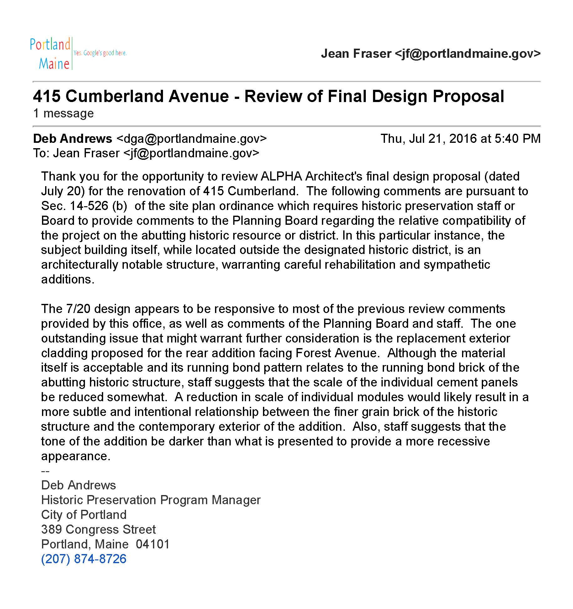

Attachment 2

