MEMORANDUM
City Council Agenda Item

TO: Mayor and City Council

FROM: Jeff Levine, Director, Planning and Urban Development Department

DATE: 4/4/16

DISTRIBUTION: Jon Jennings, City Manager; Mayor Ethan Strimling; Anita Lachance, Assistant City Manager; Danielle West-Chuhta, Corporation Counsel; Jennifer Thompson, Associate Corporation Counsel; Sonia Bean, Nancy English and Julie Sullivan

SUBJECT: Change request - Kennebec Street sidewalk material policy, 195 Kennebec Street

SPONSOR: Jeff Levine, Department of Planning and Urban Development

COUNCIL MEETING DATE ACTION IS REQUESTED:
1st reading_____________ Final Action___4/25/16_____

Can action be taken at a later date: ____ Yes __X_ No (If no why not?)
Construction on the 195 Kennebec Street site is nearing completion. Meanwhile, a temporary Certificate of Occupancy has been issued while the question of sidewalk material and design is resolved. The installation of the sidewalk is important in order to allow safe pedestrian access to the site. The Planning Department has given the applicant a May 13, 2016 deadline for completing the Kennebec Street sidewalk.

I. SUMMARY OF ISSUE (Agenda Description)
On April 14, 2015, the Planning Authority approved a Level II site plan for the redevelopment of the Century Tire site at 195 Kennebec Street. The plans included brick sidewalks, in accordance with the city’s sidewalk material policy, on both the Marginal Way and Kennebec Street frontages of the site (Attachment 1). In the intervening time, the redevelopment project has been largely completed, save for the sidewalk on Kennebec Street. On March 30, the developer requested a change in sidewalk material for this frontage, stating that “the Kennebec side of the site would be better served by a concrete sidewalk [than a brick sidewalk]” (Attachment 2).

Although the developer initiated this request, the Council may consider this an opportunity to reflect on the city’s sidewalk material policy more broadly, as the use of brick has been a matter of discussion for some time, particularly in areas, like Bayside, which lie outside the city’s historic districts and adjacent to existing concrete sidewalk zones. For example, the Council may wish to explore a change in material for the length of Kennebec Street from Forest Avenue east to Pearl Street. Kennebec Street is a secondary street in Bayside where the sidewalks are generally comprised of concrete and asphalt with some remnant cobbles, and the only existing segment of brick sidewalk on Kennebec Street can be found at 195 Kennebec (Attachment 3). Alternatively, the council may wish to consider a modification of the material policy for that section of Kennebec from Forest to Elm, where Kennebec’s profile changes markedly to become more of a shared street (i.e. there is very little curb reveal on the few sidewalks that do exist, where cobbles and even old rail ties are exposed.) At the very least, should the Council find merit in the deviation from the material policy along the 195 Kennebec frontage, it seems the change should be applied to the whole block of Kennebec between Forest Avenue and Hanover Street. Figure 1 depicts possible options for changing the sidewalk material policy on Kennebec Street.

Pearl Street
Elm Street
Hanover Street
Forest
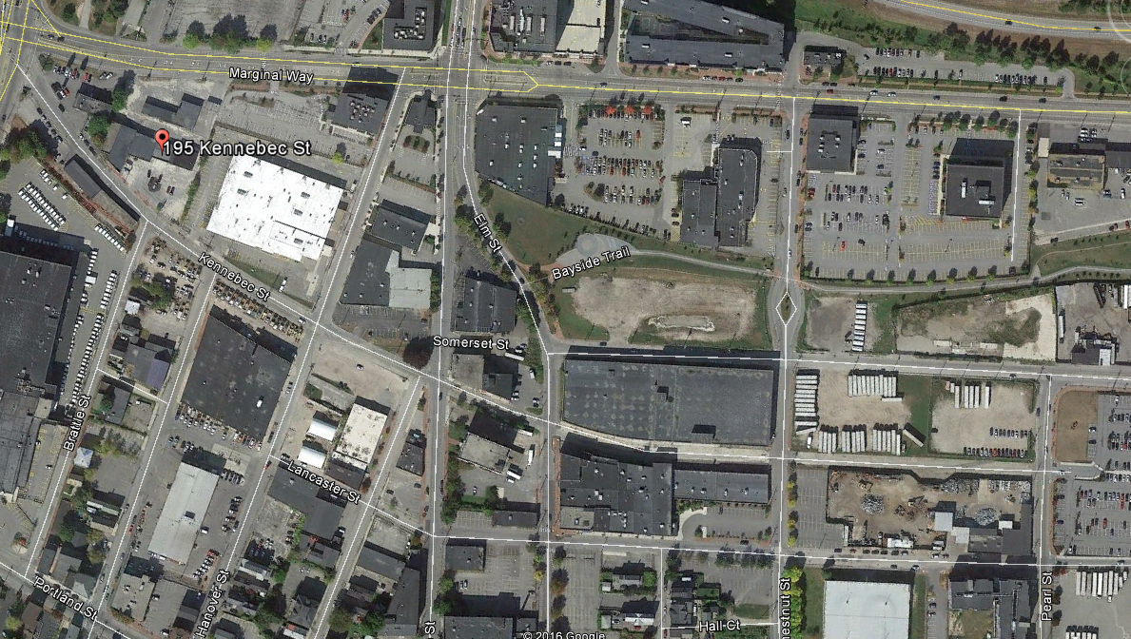
Figure 1: Options for sidewalk material policy change, Kennebec Street

II. REASON FOR SUBMISSION
Hanover Street
The developer has stated that “this change in material [from brick to concrete] will result in a public walkway that is safer and more consistent with the adjacent concrete sidewalks on Kennebec Street.” It should be noted that the sidewalks immediately east and west of the site, where they exist, are asphalt.

III. INTENDED RESULT
Concrete is not considered an inferior product to brick, and in fact, it has advantages. In discussion regarding the benefits of concrete sidewalks, as opposed to brick, staff has noted that concrete has lower initial construction costs, is more slip-resistant, and, if installed properly, results in a smoother walking surface as required by the ADA.

IV. COUNCIL GOAL ADDRESSED
Transportation Initiatives: Develop a transportation system that advances healthy living, minimizes environmental impacts and promotes the local economy by advancing opportunities for mass transit, bicycle use, and walking.

V. FINANCIAL IMPACT
If a change in material policy is adopted for any length of Kennebec Street, there could be construction cost savings for any city sidewalk replacement projects in this area.

VI. STAFF ANALYSIS AND RECOMMENDATION
Staff supports a sidewalk material change from brick to concrete for Kennebec Street from Forest to Elm as shown in Figure 2, for the reasons noted above. Staff is in the outreach phase and may come forward with a more comprehensive recommendation regarding a change to the sidewalk policy in Bayside at a future date.
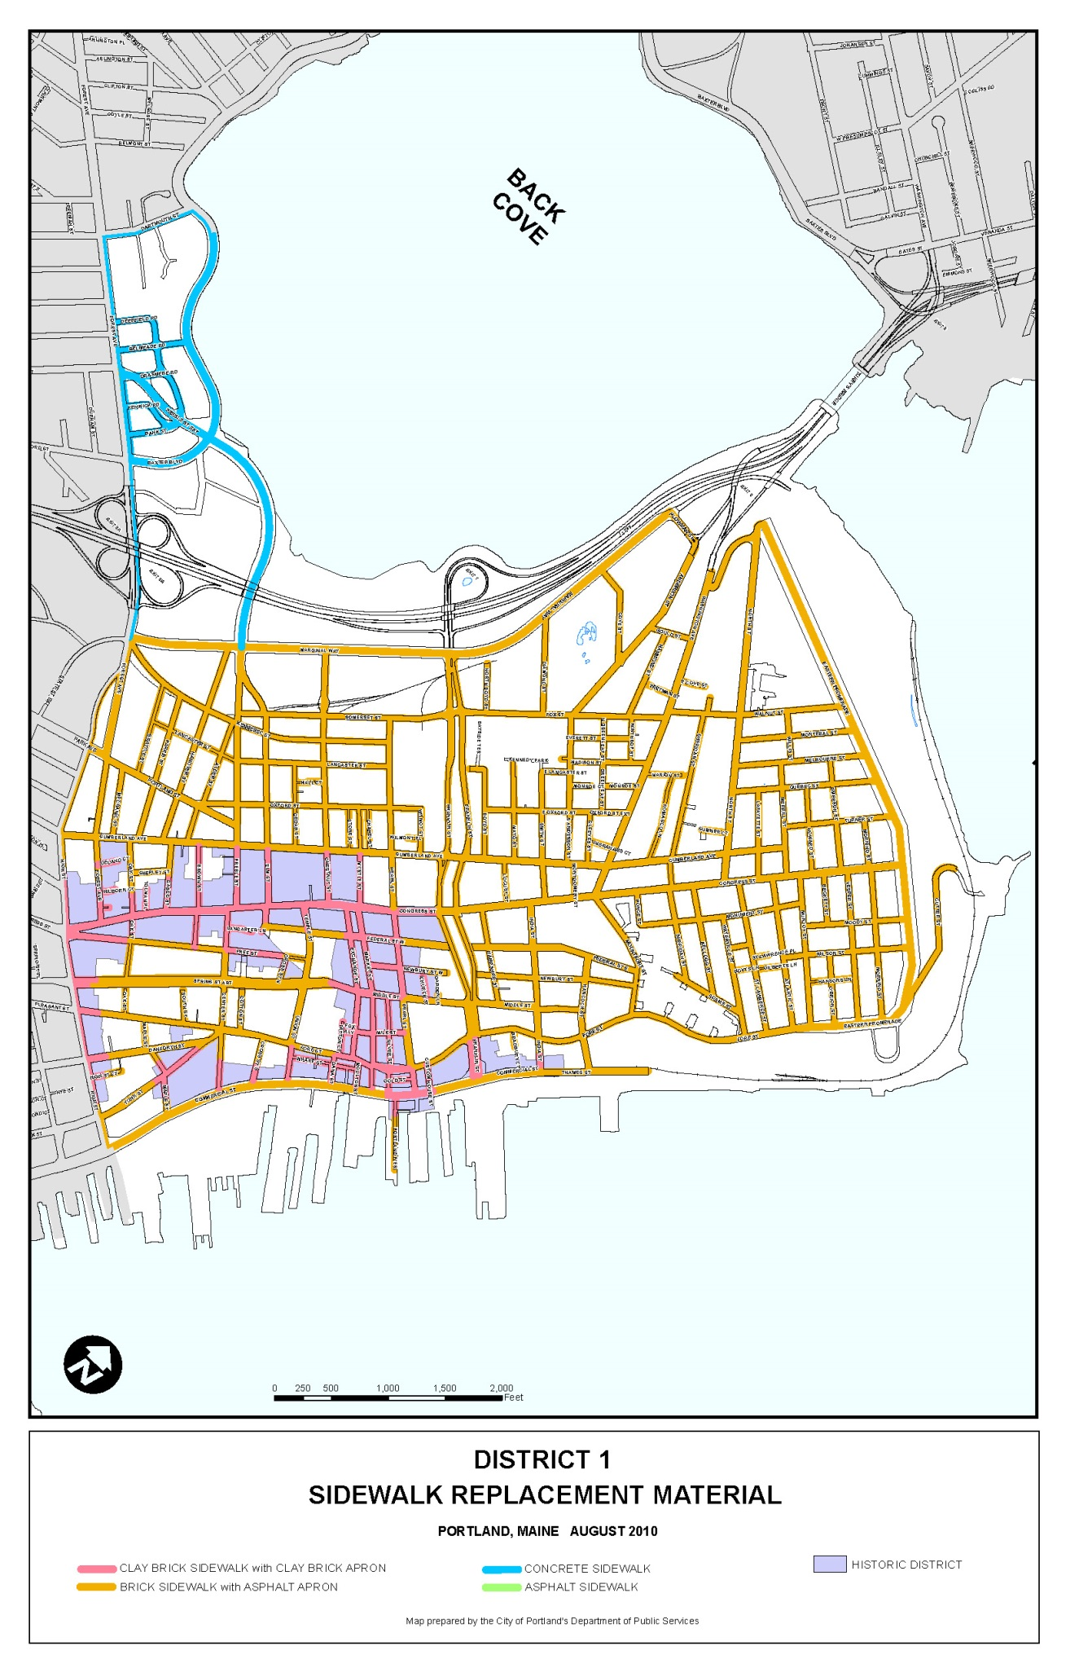
Recommended change in material policy from brick to concrete, Kennebec Street from Forest to Elm
Figure 2: Staff recommendation

VII. LIST ATTACHMENTS
1. 195 Kennebec, approved Level II site plan
2. Sidewalk material change request, letter from Josh Benthien, Vandelay Industries/Northland Enterprises
3. Photos, 195 Kennebec existing conditions
4. City Sidewalk Materials Policy

Prepared by: Nell Donaldson
Date: 4/4/16

Bean/agendarequestmemo/rev 11/2015

Attachment 3
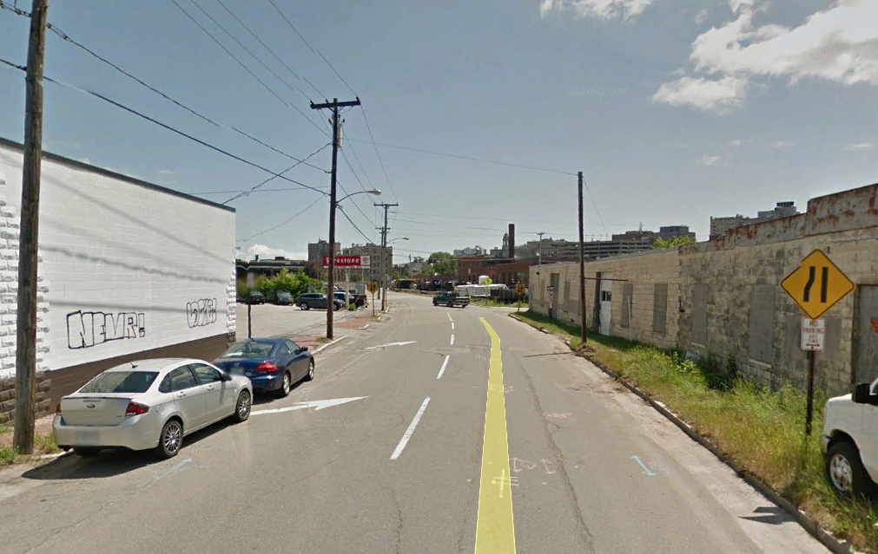
195 Kennebec

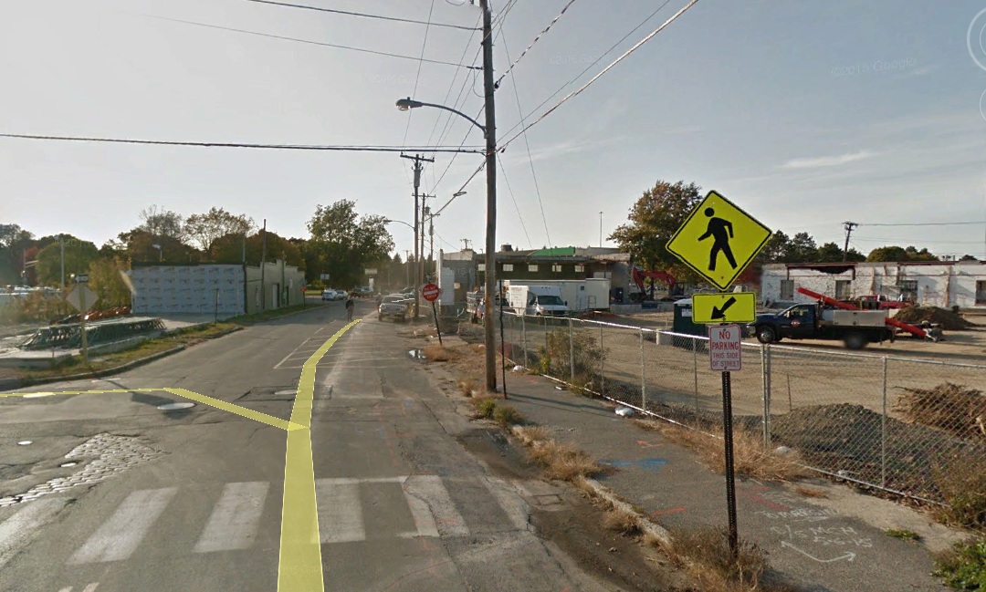
195 Kennebec
Kennebec Street frontage of 195 Kennebec from the west (above) and east (below)

