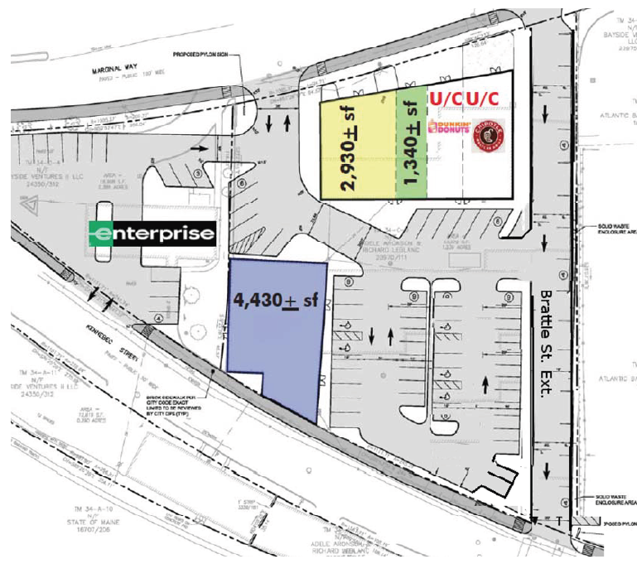

Christian Milneil public comment, 195 Kennebec, January 2015