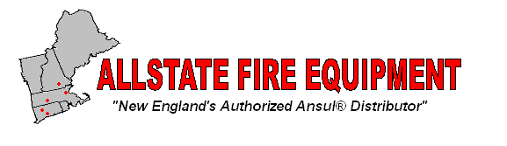

20C Del Carmine Street • Wakefield, MA • 01880
Phone: 781-224-1001 • Fax: 781-224-1005
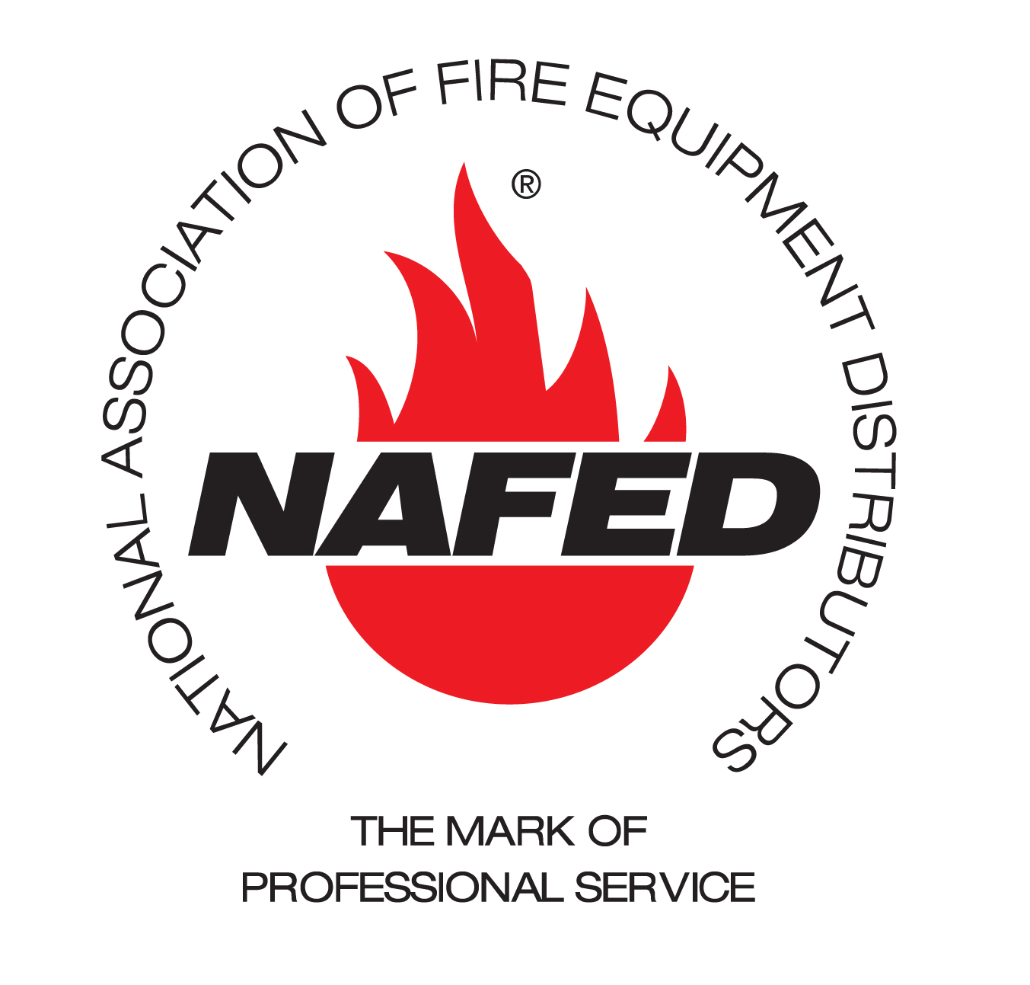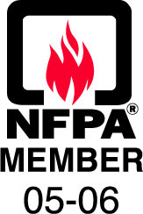
Ansul Fire Suppression System
Sequence of Operation

Fire Suppression System will activate when the fusible link senses a temperature above its operating rating or the remote pull station is manually pulled.

Upon activation, the system will discharge its fire suppressing chemical through the agent piping and out the duct, plenum and appliance nozzles.

The gas to all cooking appliances under the exhaust hoods will automatically shut-off by means of a mechanical or electrical gas valve.

All electrical power to any heat producing equipment under all protected hoods will be de-energized. (Including hood lights)

Make up air, if present, will shut down and building fire alarm, if present, will activate.

Exhaust fans will remain running upon discharge.

There can be up to four micro-switches in Ansul controller which are dry contact relays 250v 21amp rating to make the sequence of operation.
All 120 V connections must be pulled to an exterior electrical box on Ansul control box (Automan).

System will remain in the fired state until manually reset by a qualified Ansul technician.

A K Class extinguisher must be present in the kitchen in order for the Ansul system to meet code requirements.

