SURVEYING ENGINEERING LAND PLANNING

Northeast Civil Solutions

I N CO R PO R A T E D

www. northeastcivilsolutions.com

Proposed
Legal Description
For a
License Agreement #3
on
Fore Street,
Portland, Maine
For
Cow Plaza Hotel LLC
Project No. 29696.05

Dated January 10, 2013

153 U.S. Route 1

Scarborough

Maine 04074

tel
207.883.1000
800.882.2227

fax
207.883.1001

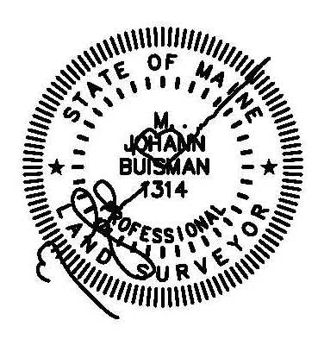
Exhibit A
License Agreement #3 (121 s.f.)

A certain lot or parcel of land, being a License Agreement with the City of Portland, located on the northwesterly side of Fore Street, in the City of Portland, County of Cumberland, State of Maine, as shown on a plan entitled “ALTA/ACSM Land Title Survey, 29 Union Street, Portland, Maine” by Northeast Civil Solutions, Inc., dated December 19, 2012, being more particularly bounded and described as follows:

BEGINNING at a point on the northwesterly right-of-way line of Fore Street at the southerly corner of land N/F of Cow Plaza Garage LLC as described in Deed Book 27480, Page 325, Cumberland County Registry of Deeds (CCRD);

THENCE S 57°15’00” W along the northwesterly right-of-way line of said Fore Street 9.20’ to a point;

THENCE S 60°18’00” W along the northwesterly right-of-way line of said Fore Street 64.32’ to a point;

THENCE S 61°16’30” W along the northwesterly right-of-way line of said Fore Street 46.99’ to a point;

THENCE S 28°43’30” E through the right-of-way of said Fore Street 1.00’ to a point;

THENCE N 61°16’30” E through the right-of-way of said Fore Street 47.00’ to a point;

THENCE N 60°18’00” E through the right-of-way of said Fore Street 64.36’ to a point;

THENCE N 57°15’00” E through the right-of-way of said Fore Street 9.18’ to a point;

THENCE N 30°03’30” W through the right-of-way of said Fore Street 1.00’ to the POINT OF BEGINNING.

The above described parcel contains 121 s.f. more or less.

Meaning and intending to describe a license agreement over a portion of the Fore Street right-of-way N/F owned by the City of Portland.

The basis of bearing for the above described parcel is Grid North. The above described parcel is shown on an ALTA/ACSM Land Title Survey prepared for Cow Plaza Hotel, LLC by Northeast Civil Solutions, Inc., dated December 19, 2012.

