SURVEYING ENGINEERING LAND PLANNING

Northeast Civil Solutions

I N CO R PO R A T E D

www. northeastcivilsolutions.com

Proposed
Legal Description
For a
License Agreement #2
on
Fore Street,
Portland, Maine
For
Cow Plaza Hotel LLC
Project No. 29696.05

Dated January 10, 2013

153 U.S. Route 1

Scarborough

Maine 04074

tel
207.883.1000
800.882.2227

fax
207.883.1001

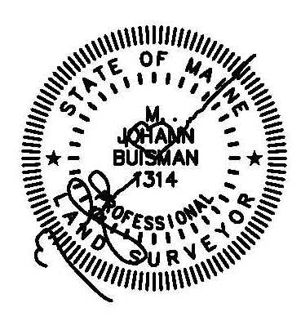
Exhibit A
License Agreement #2 (73 s.f.)

A certain lot or parcel of land, being a License Agreement with the City of Portland, located on the northwesterly side of Fore Street, in the City of Portland, County of Cumberland, State of Maine, as shown on a plan entitled “ALTA/ACSM Land Title Survey, 29 Union Street, Portland, Maine” by Northeast Civil Solutions, Inc., dated December 19, 2012, being more particularly bounded and described as follows:

STARTING at a point at the original intersection of the northwesterly right-of-way line of Fore Street and the northeasterly right-of-way line of Union Street;

THENCE N 61°16’30” E along the northwesterly right-of-way line of said Fore Street 40.63’ to the TRUE POINT OF BEGINNING;

THENCE S 61°16’30” W along the northwesterly right-of-way line of said Fore Street 21.00’ to a point of curvature;

THENCE on a curve to the right along the northwesterly right-of-way line of said Fore Street 7.15’ to a point. Said curve having a radius of 20.00’ and a chord of S 71°31’08” W 7.11’;

THENCE S 28°43’30” E through the right-of-way of said Fore Street 3.77’ to a point;

THENCE N 61°16’30” E through the right-of-way of said Fore Street 28.00’ to a point;

THENCE N 28°43’30” W through the right-of-way of said Fore Street 2.50’ to the TRUE POINT OF BEGINNING.

The above described parcel contains 73 s.f. more or less.

Meaning and intending to describe a license agreement over a portion of the Fore Street right-of-way N/F owned by the City of Portland.

The basis of bearing for the above described parcel is Grid North. The above described parcel is shown on an ALTA/ACSM Land Title Survey prepared for Cow Plaza Hotel, LLC by Northeast Civil Solutions, Inc., dated December 19, 2012.

