SURVEYING ENGINEERING LAND PLANNING

Northeast Civil Solutions

I N CO R PO R A T E D

www. northeastcivilsolutions.com

Proposed
Legal Description
For a
License Agreement #1
on
Union Street,
Portland, Maine
For
Cow Plaza Hotel LLC
Project No. 29696.05

Dated January 10, 2013

153 U.S. Route 1

Scarborough

Maine 04074

tel
207.883.1000
800.882.2227

fax
207.883.1001

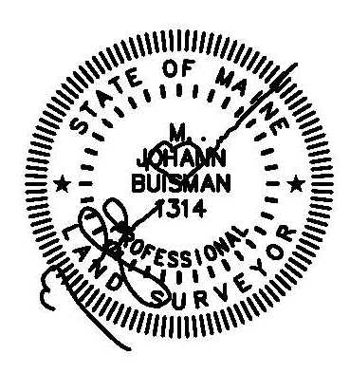
Exhibit A
License Agreement #1 (90 S.F.)

A certain lot or parcel of land, being a License Agreement with the City of Portland, located on the northeasterly side of Union Street, in the City of Portland, County of Cumberland, State of Maine, as shown on a plan entitled “ALTA/ACSM Land Title Survey, 29 Union Street, Portland, Maine” by Northeast Civil Solutions, Inc., dated December 19, 2012, being more particularly bounded and described as follows:

STARTING at a point at the original intersection of the northwesterly right-of-way line of Fore Street and the northeasterly right-of-way line of Union Street;

THENCE N 29°47’06” W along the northeasterly right-of-way line of said Union Street 34.63’ to the TRUE POINT OF BEGINNING;

THENCE S 29°47’06” E along the northeasterly right-of-way line of said Union Street 15.00’ to a point of curvature;

THENCE on a curve to the left along the northeasterly right-of-way line of said Union Street 3.01’ to a point. Said curve having a radius of 20.00’ and a chord of S 34°05’54” E 3.01’

THENCE S 60°12’54” W through the right-of-way of said Union Street 5.23’ to a point;

THENCE N 29°47’06” W through the right-of-way of said Union Street 18.00’ to a point;

THENCE N 60°12’54” E through the right-of-way of said Union Street 5.00’ to the TRUE POINT OF BEGINNING.

The above described parcel contains 90 s.f. more or less.

Meaning and intending to describe a license agreement over a portion of the Union Street right-of-way N/F owned by the City of Portland.

The basis of bearing for the above described parcel is Grid North. The above described parcel is shown on an ALTA/ACSM Land Title Survey prepared for Cow Plaza Hotel, LLC by Northeast Civil Solutions, Inc., dated December 19, 2012.

