

Memorandum
Planning and Urban Development Department
Planning Division

To: Carol Morrissette, Chair, and Members of the Portland Planning Board
From: Nell Donaldson, Planner
Date: October 5, 2012
Re: 433 Fore Street, Canal Plaza Hotel
Project #: 2012-558 CBL: 32-I-40
Meeting Date: October 9, 2012

I. INTRODUCTION
As previously introduced, Cow Plaza Hotel, LLC is requesting a Level III site plan review for a mixed-use development, the Canal Plaza Hotel, at the corner of Fore and Union Streets in downtown Portland. At a prior Planning Board workshop, held on September 11, 2012, the Board considered the preliminary plans for the project and requested that the applicant return for a second public workshop to further discuss outstanding issues of transportation and design. In response, the applicant submitted additional materials related to those topic areas. These materials are reviewed here for consideration by the Board. A complete, final review of the project is tentatively scheduled for a public hearing with the Planning Board on October 23.

A total of 151 notices were sent to property owners within 500 feet of the site and a legal ad ran on 9-4 and 9-5.

Applicant: Cow Plaza Hotel, LLC
Consultants: Greg Shinberg, Shinberg Consulting; Patrick Costin, Canal 5 Studio; Gorrill-Palmer Consulting Engineers; Woodard & Curran, Consulting Engineers

II. REQUIRED REVIEWS
Waiver Requests | Applicable Standards
Driveway separation, to allow driveways 50 feet east and 75 feet north of Fore and Union Streets | Technical Manual 1.7.2.7. Along arterial and collector streets, access driveways to corner lots shall be located a minimum of 150 feet from the nearest intersection.
Review | Applicable Standards
Site Plan | Section 14-526, including provisions related to historic district compatibility
Downtown Urban Design Guidelines | City of Portland Design Manual

III. PROJECT DATA
Existing Zoning | B-3 in Height Overlay District, Pedestrian Activities District
Existing Use | Surface parking lot
Proposed Use | Hotel and retail
Parcel Size | 19,130 SF (.44 acres)
 | Existing | Proposed | Net Change
Building Footprint | 0 SF | 10,900 SF | 10,900 SF
Building Floor Area | 0 SF | 79,197 SF | 79,197 SF
Impervious Surface Area | 14,639 SF | 17,785 SF | 3,146 SF
Parking Spaces (on site) | 45 | 0 | (45)
Bicycle Parking Spaces | 0 | 23 | 23
Estimated Cost of Project | $13,000,000

IV. CONTEXT & EXISTING CONDITIONS
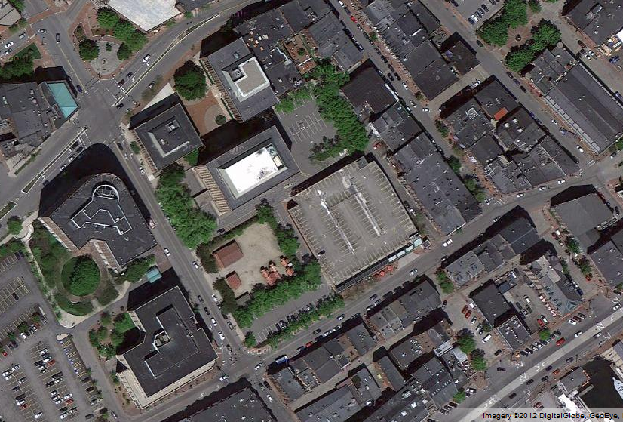
In review, the site of the proposed Canal Plaza Hotel lies at the southwest corner of the Canal Plaza block, at the edge of the Old Port and across Fore Street from the designated Old Port Historic District. The site has long been used as a surface parking lot, and lies adjacent to the Fore Street parking garage, which is under the same ownership. A Central Maine Power (CMP) substation lies immediately north of the site on Union Street. 2 Portland Square lies across the Fore Street/Union Street intersection, as does the Portland Harbor Hotel. The site is within 100’ of the Old Port Historic District.
Fore Street
Union Street
Exchange Street
Historic District

CMP
substatio
Site
Fore Street/Cow Plaza Garage
Portland Harbor Hotel
Figure 1: Canal Plaza Hotel site and surroundings

V. PROPOSED DEVELOPMENT
The proposed Canal Plaza Hotel development includes approximately 79,200 SF of building space on seven floors. The vast majority of the building’s floor area would be occupied by a new hotel. The hotel lobby, pool, and restaurant are proposed to occupy the first floor of the building, with the 123 guest rooms and several meeting rooms occupying the remaining six floors. Vehicular access to the hotel is proposed via a porte cochere on Fore Street. Parking would be provided in the adjacent garage, with access via the mid-block alley on Union Street. Service vehicles would also use this access. Lobby doors would open onto Fore Street at the mouth of the porte cochere. Doors leading to the restaurant would open onto Fore Street at the southeast corner of the proposed building. Hotel rooms on the seventh floor are proposed with private decks. Mechanical structures would be located on the building roof.
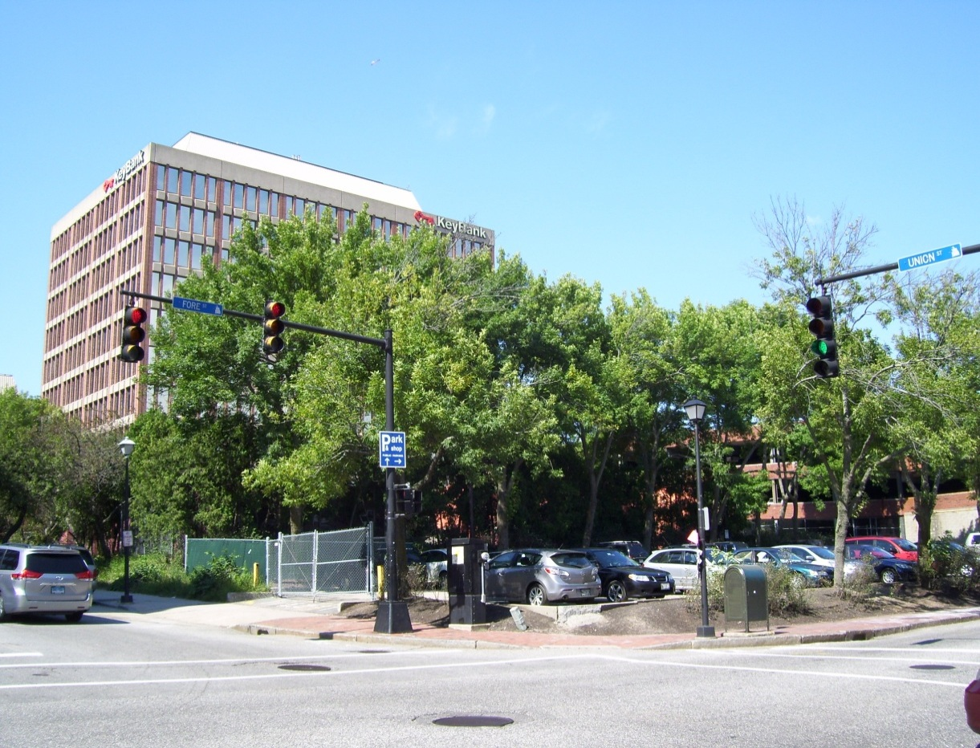
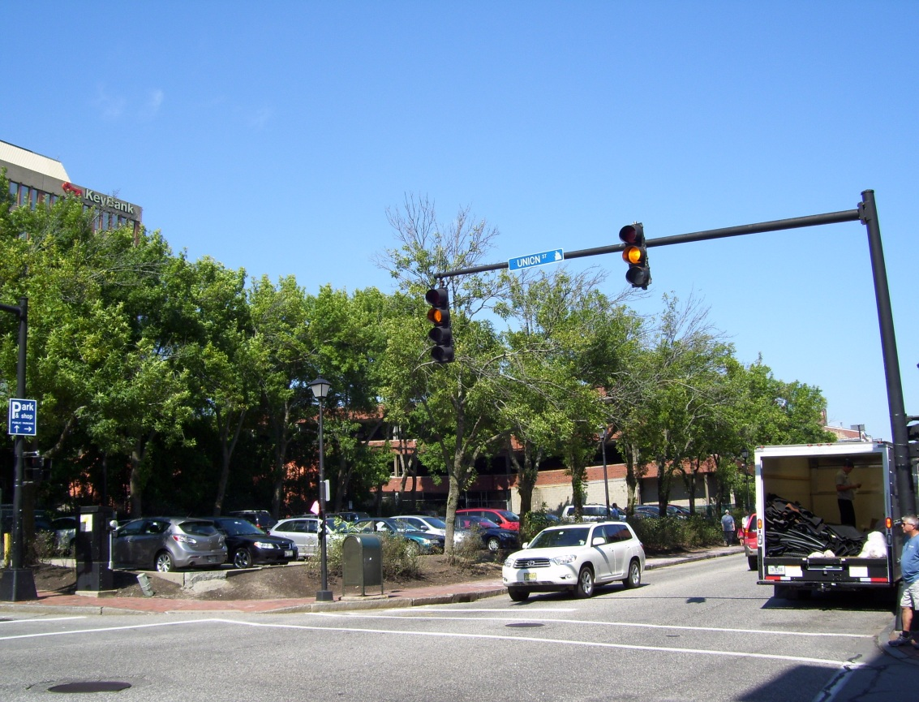
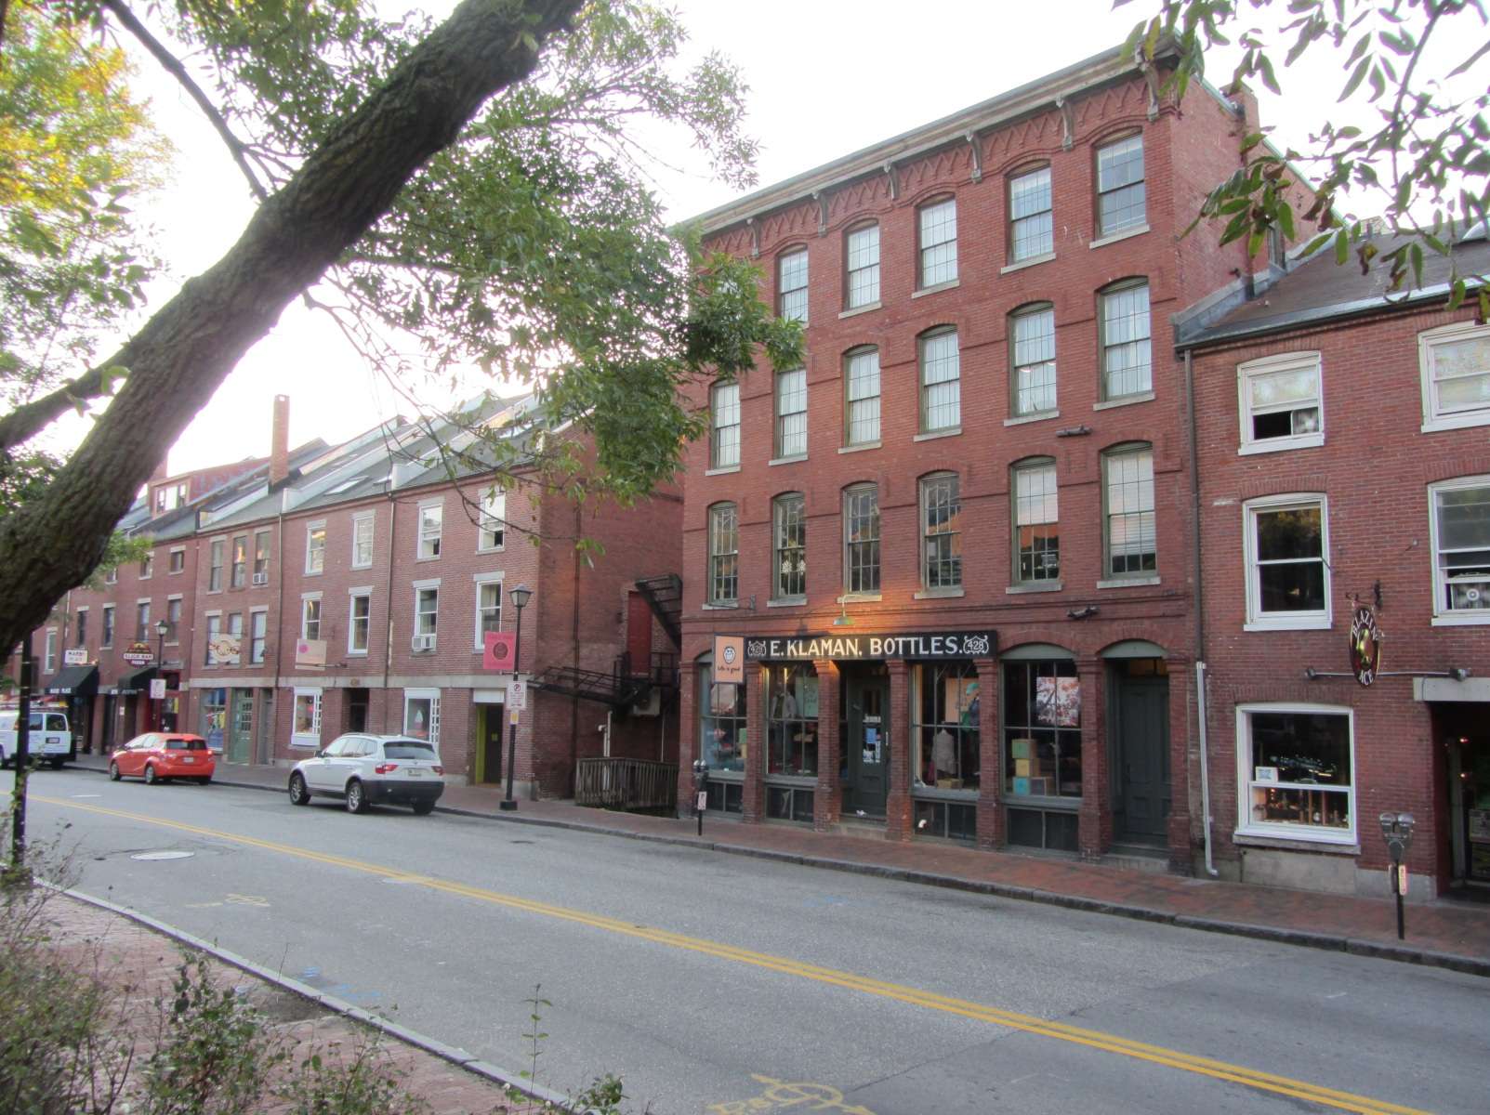
Figures 2 & 3: Canal Plaza Hotel site from the south (top) and adjacent Historic District (bottom)
The applicant has provided renderings and elevations and stated in their original submittal that they are seeking a contemporary design, with a variegated façade along the ground floor and heavy use of contemporary materials, including glass and stone composite paneling. The building façade on the ground floor in this area is proposed with a tall ceiling, significant use of glass, large granite columns, and an anodized aluminum bris soleil (shade canopy).

The proposal also includes 740 SF of retail, to be located in the corner of the building at Union and Fore Streets. Access would be from Fore Street.

Details of the proposed development are outlined in the Planning Division’s original memo to the Planning Board, dated September 7, 2012 (Attachment A) and shown in the attached plans.

VI. PUBLIC COMMENT
The Planning Division received notes from the applicant’s neighborhood meeting, held on September 18, 2012. Five neighbors attended, raising concerns about the placement and scale of signage, parking capacity at the adjacent garage, and disturbances during construction. The neighbors in attendance were generally supportive of the project. Notes from the public meeting are included as Attachment F.

V. SITE PLAN REVIEW
- Transportation Standards
Following the Planning Board workshop on September 11, the applicant submitted additional materials related to traffic movement on and parking for the site. These materials, included as Attachments B, C, and G and shown in the attached plans, did not address all of the transportation-related comments from the Planning Division’s original memo to the Planning Board. Outstanding transportation-related comments are reviewed below. Memos from reviewers are included in Attachments 1 and 2.

- Impact on Surrounding Street Systems
It was noted in the prior Planning Board memo that signal equipment modifications would be required at the intersection of Union and Fore Streets. With respect to this issue, Tom Errico, consulting traffic engineer, notes, [Note: See my email comments on this…. Did they tighten the radius of the corner like we asked them to? That should be explained here. Email asks for conversation about extent of improvements requested, and why move the controller. More conversation w/ Tom Errico needed, and possibly him to be at workshop. Lets clarify the requirement and justification.]

The City requests the following signal modifications.
- The controller cabinet should be relocated to the northwest corner of the intersection.
- A new mast arm shall be installed on the corner of the project and shall include all new equipment.
- All pedestrian heads and push buttons at the intersection shall be upgraded.

David Margolis-Pineo, of the city’s Department of Public Services, adds,

Please add note to plans that states “Coordinate Traffic Control Box relocation well in advance with City of Portland Traffic Engineer Jeremiah Bartlett (632-1062).

In the Division’s original Planning Board memo, it was also noted that, under the proposed plans, on-street parking spaces would be lost on Union Street. It should be reiterated that council action will be required for this action.

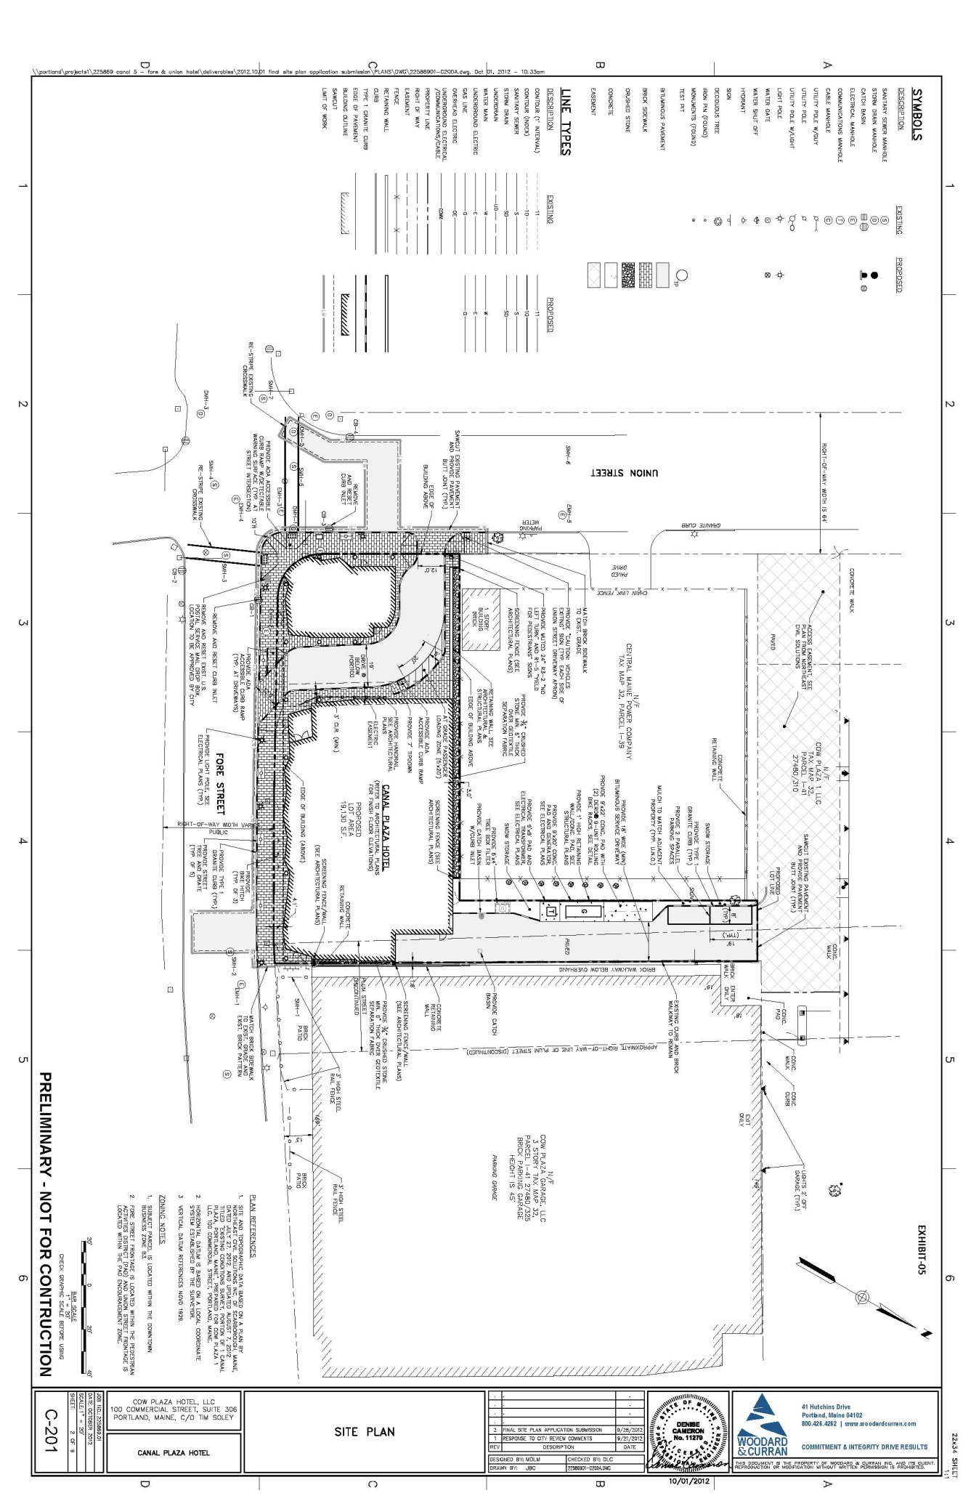
- Access and Circulation
Figure 4: Revised site plan, showing reconfigured porte cochere and service access
The applicant has redesigned the porte cochere to restrict left turn movements from Fore Street. The applicant also added a convex mirror and signs at this entrance to alert drivers to left turn restrictions and the pedestrian crossing. Mr. Errico writes,

The applicant has revised the geometry of the driveway entrance to discourage left-turn entry movements. Given area conditions, this change seems reasonable. I would also suggest that regulatory signs noting the left-turn prohibition be installed.

Concerns regarding stacking at this location remain. The applicant proposes to provide valet service in the porte cochere, and it is highly likely that, during peak hours, vehicles will queue in this area, potentially blocking traffic on Fore Street. The applicant has not provided a plan for managing traffic in the porte cochere, although they have indicated that this entry will have signage and an attendant present to direct guests to the passenger loading area in the elbow of the driveway. Tom Errico writes,

Given the location of the entry to the Hotel, I am concerned that there will be the tendency for guests to park directly next to the door, thus contributing to back-ups onto Fore Street. The applicant should provide information on how drop-offs will be managed.

Likewise, it is likely that some visitors to the hotel will opt out of the valet parking. The applicant should demonstrate how these visitors would access the adjacent parking.

The revised submittal includes changes to the rear alley area, where the footprint of the northeast corner of the hotel has been revised, the transformer pad has been updated, and an emergency generator pad has been added. The applicant has also provided turning movement sketches showing fire truck turns at the Fore Street/Union Street intersection, ambulance maneuvers through the porte cochere, and box truck movements in the rear alley. Ben Wallace, of the city’s Fire Prevention Bureau, asks that overhead clearance be added to the sketches showing ambulance movements through the porte cochere. Of the service delivery sketches, Tom Errico writes,

The applicant has provided an auto-turn graphic that illustrates a single-unit truck can access the loading dock. The applicant should provide information on how the truck will begin the “backing” maneuver (will the truck begin backing from Union Street) and provide information if any deliveries will be from a tractor-trailer truck.

If larger trucks will be providing deliveries to the site, the applicant should submit details regarding their access (including turning templates, as necessary). In addition, details should be provided regarding access from truck to “back of house” areas (e.g. kitchen).

It will be necessary to coordinate with CMP regarding the plans for the adjacent site to ensure that sight lines into and out of the service drive are not obstructed. Recent conversations wth CMP indicate that they will be upgrading the transformer yard and installing a 12-foot firewall along the northeasterly property line adjacent to the service lane.

- Public Transit Access
South Portland runs several bus routes on Union Street, and Metro runs a seasonal route, the 8A, on Fore Street from June through October. Originally, the applicant offered to locate a bus shelter for the 8A on their site. At the September 11 Planning Board workshop, they indicated that they are no longer proposing a shelter. [note: I don’t think we need a bus shelter here. Have we checked w/ Metro, and do they have to provide one? This is one of our updates to the Tech. Manual to allow waivers if not desired.]

- Parking
As noted in the Planning Division’s original memo, the Planning Board ultimately establishes the number of required parking spaces, since the proposed building is over 50,000 SF. Per the city’s zoning ordinance, only 31 spaces are required for the hotel (at one space/four rooms).

In response to a request for clarity on parking demand, the applicant submitted a memo from Gorrill-Palmer Consulting Engineers, which is included as Attachment C. This memo discusses various sources for estimating parking demand, including the ITE Parking Generation Manual, a standard source for such estimates, and field data from the Hampton Inn on Fore Street. Based on calculations from the ITE, with a factor to account for shared parking, peak parking demand estimates for the proposed hotel range from 85 to 107 spaces, depending on time of day. The Hampton Inn data shows a peak demand of .738 per room. When this figure is applied to the Canal Plaza Hotel, it results in a peak parking demand of 92 spaces at full occupancy. The memo suggests that this second figure, derived using the data from the Hampton Inn, is likely more accurate, given the similarity of the data source in terms of nature and context. Note that these parking demand figures do not account for the retail square footage on site.

As previously noted, the proposal relies on the use of the adjacent garage, the Cow Plaza Garage (which is under the same ownership) for parking purposes. The original application states that 218 of the 409 total spaces in the garage, currently occupied to some degree by month-to-month parkers, could be repurposed to both offset the loss of the existing surface lot and provide space for hotel guests. In the case of overflow needs, the applicant states that the accompanying 39-space surface lot, behind the garage, would also be available. The city is aware that deed restrictions may exist at the Cow Plaza Garage, which may limit the number of available spaces in that facility. This arrangement should be clarified. Mr. Errico writes,

The applicant has provided revised information on the anticipated parking demand for the project. I concur with this estimate. The applicant has not provided information requested above as it relates to parking garage supply adequacy. This information should be provided.

Bike racks are proposed in the front of the building on Fore Street. The applicant should indicate the number of bike parking spaces provided in this location.

2. Environmental Quality Standards
Revised plans include no major changes related to environmental quality standards. As such, the Division’s original comments remain.

3. Public Infrastructure and Community Safety Standards
Again, revised plans include no major changes related to public infrastructure and community safety standards. Some minor comments from David Margolis-Pineo are provided as Attachment 1.

4. Site Design Standards
The additional submittals include elevations and renderings intended to provide a better sense of the building’s design. These drawings, included as Attachments D and E, provided the basis for both the Historic Preservation Board’s and the Planning Division’s design review. Please note that additional drawings, included here as Attachments H, I, J, and K, were provided following these reviews. These drawings have been included here for the Board’s consideration and will be considered by Planning Division staff as part of the final design review process.

- Massing, Ventilation, and Wind Impact
The hotel is proposed as a seven-story building. The applicant’s material states that the building would extend up to the 65’ foot street wall limit of the height overlay zone, then step back 15 feet to accommodate a seventh floor within the 85’ maximum allowable height of the Height Overlay District. Originally, the applicant requested that the tower at the Fore/Union Street corner extend past the 65’ height limit at the street wall. Following the September 11 Planning Board workshop, Marge Schmuckal, Zoning Administrator, indicated that the tower in this area would be considered part of the building and, as such, would not be permitted to exceed the 65’ height limit. Ms. Schmuckal indicated that the tower feature could be retained in some form if stepped back at the height limit. The full 15’ step back would not be required. ,

In terms of context, the adjacent garage is a three-story building, and 2 Portland Square, the building across Union Street on Fore Street, is five stories at the street wall and seven stories total. The Portland Harbor Hotel, which lies on the opposite side of the Fore Street/Union Street corner is approximately 60’ at the street wall. All buildings across Fore Street in the historic district are generally three to five stories in height.

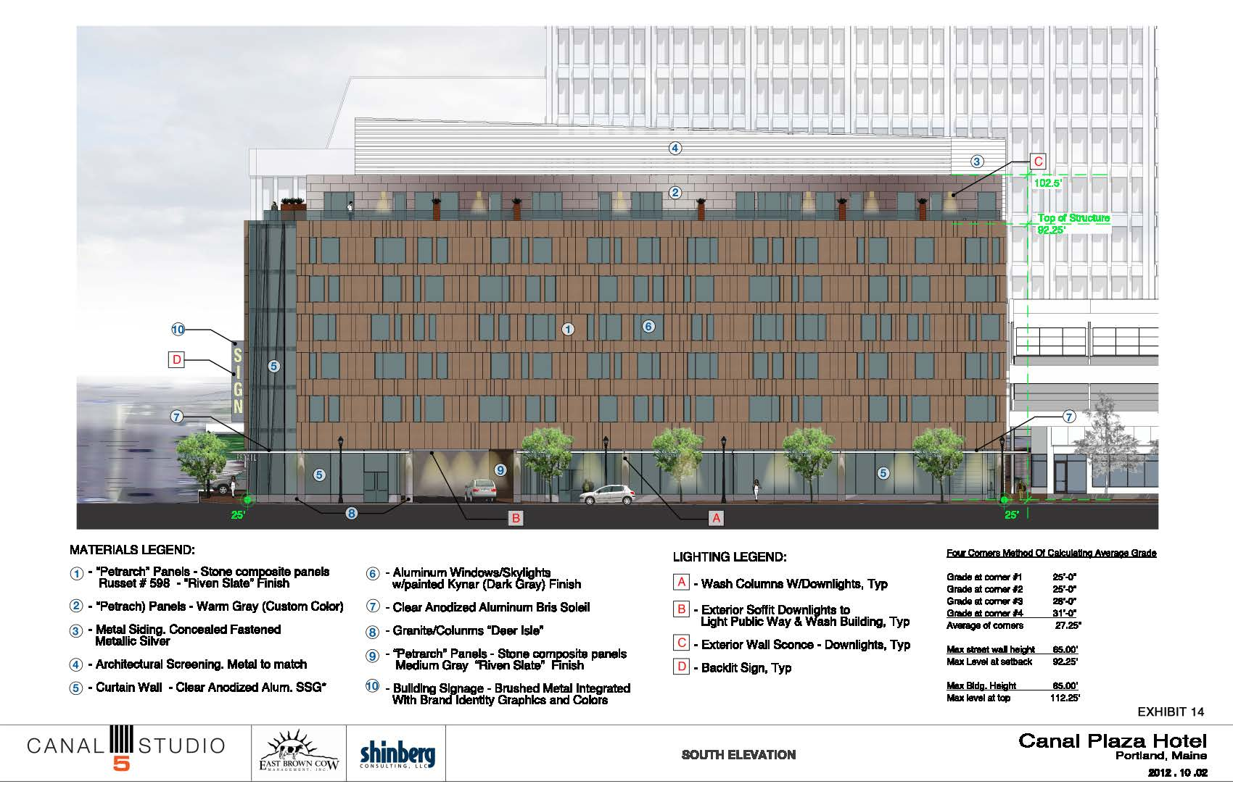
Figure 5: South elevation

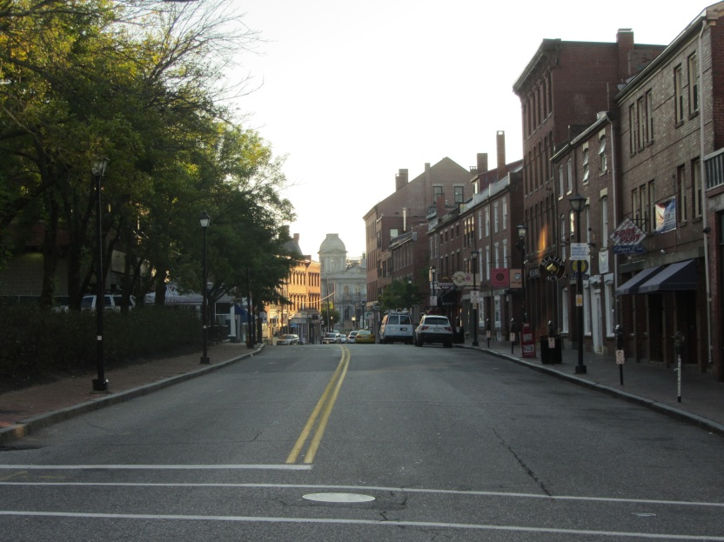
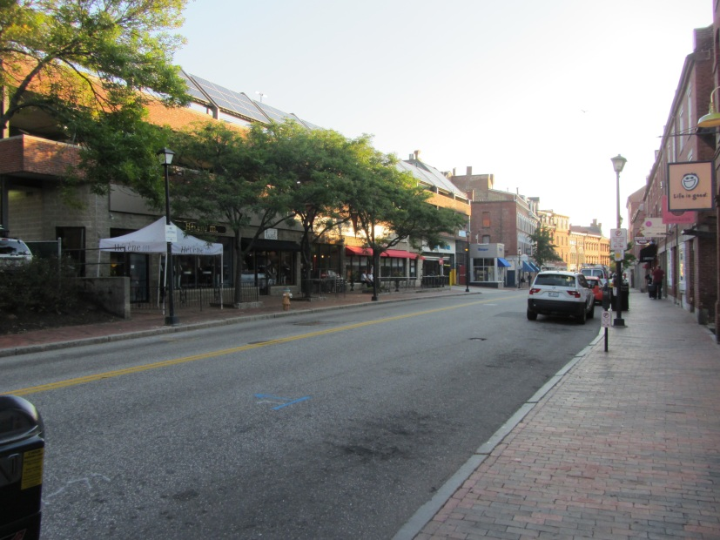
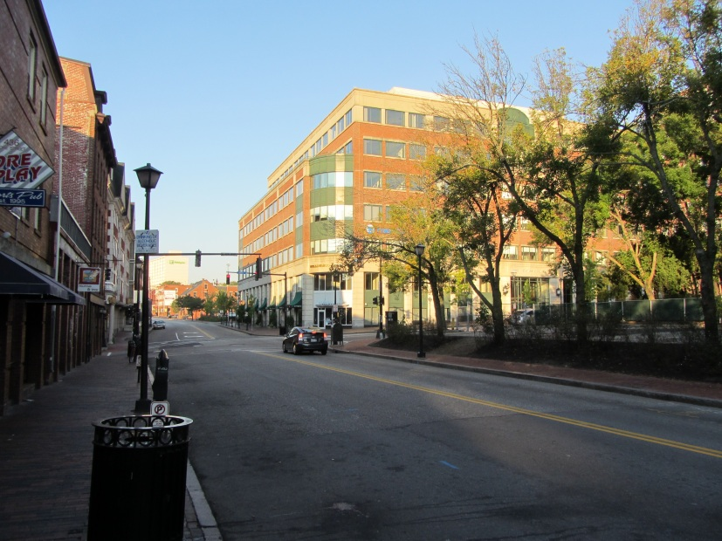
Figures 6, 7, & 8 (from top): Fore Street looking east, including Historic District, Fore Street Garage, 2 Portland Square
- Shadows
As noted in the Planning Division’s original memo, the building would be south facing. As such, much of the shadow impact would fall on the CMP substation and the adjacent garage, with some impact on Union Street.

- Snow and Ice Loading
No comments at this time.

- View Corridors
Again, as noted in the memo prepared for the Board’s September 11 meeting, both Union and Fore Streets are identified as subject to ‘viewing protection within view corridors’ in the city’s View Corridor Protection Plan. The Union Street view is to the south, and the Fore Street view is to the east. The massing and scale of the building, as proposed, do not substantially obstruct the views as identified in the View Corridor Protection Plan.

- Historic Resources
The site is located adjacent to the Old Port Historic District. As proposed, the building would be contemporary in design, with use of glass on the ground floor, a glass tower at the Fore Street/Union Street corner, and stone composite paneling on all facades. In the original submittal, the applicant stated that the design would mimic the tripartite form of the typical Old Port building, with a clear base, middle, and top, and that “the contemporary design…will be compatible in size, scale, material and character with this unique part of the city.” Elevations and renderings were provided to the Historic Preservation Board for their September 19 meeting, where they considered the proposed design’s compatibility with the adjacent historic district under Section 14-526(d)5.b. Deb Andrews, Historic Preservation Manager, has written a review summarizing the Board’s comments, included here as Attachment 3. INCLUDE SUMMARY?

- Exterior Lighting
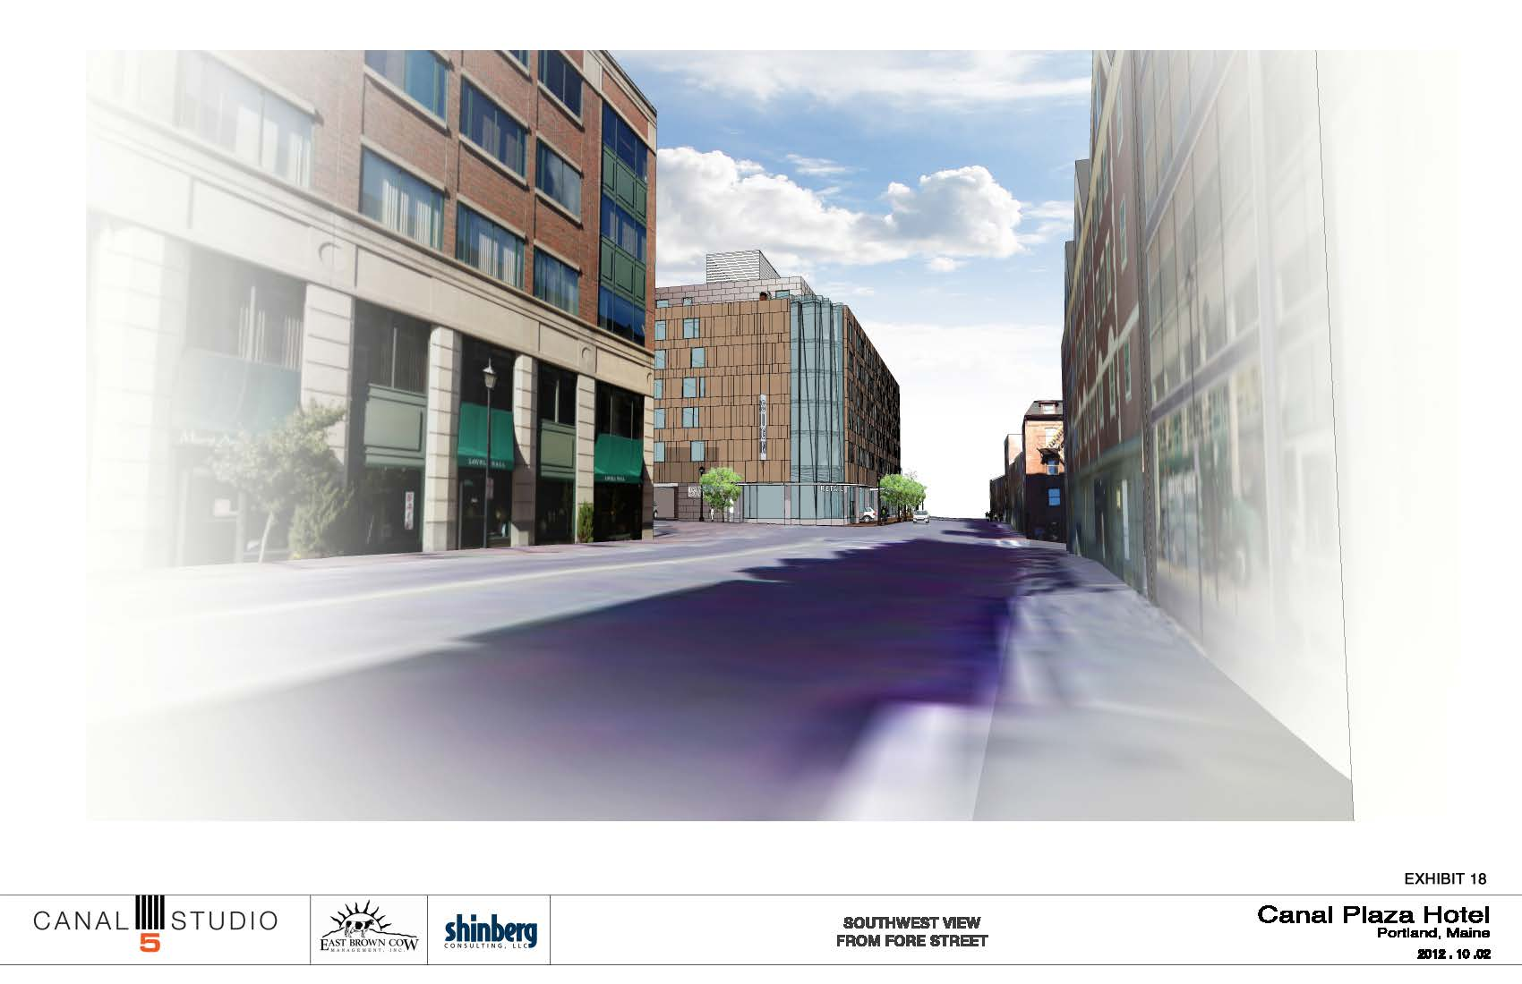
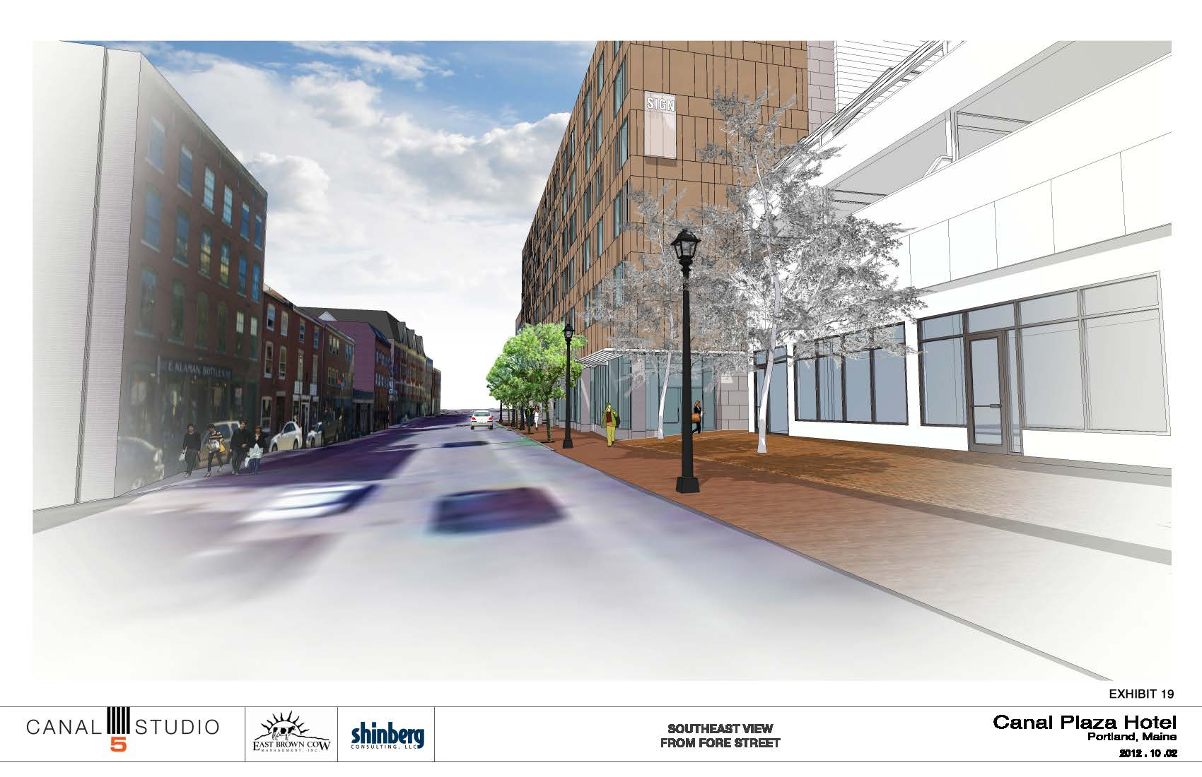
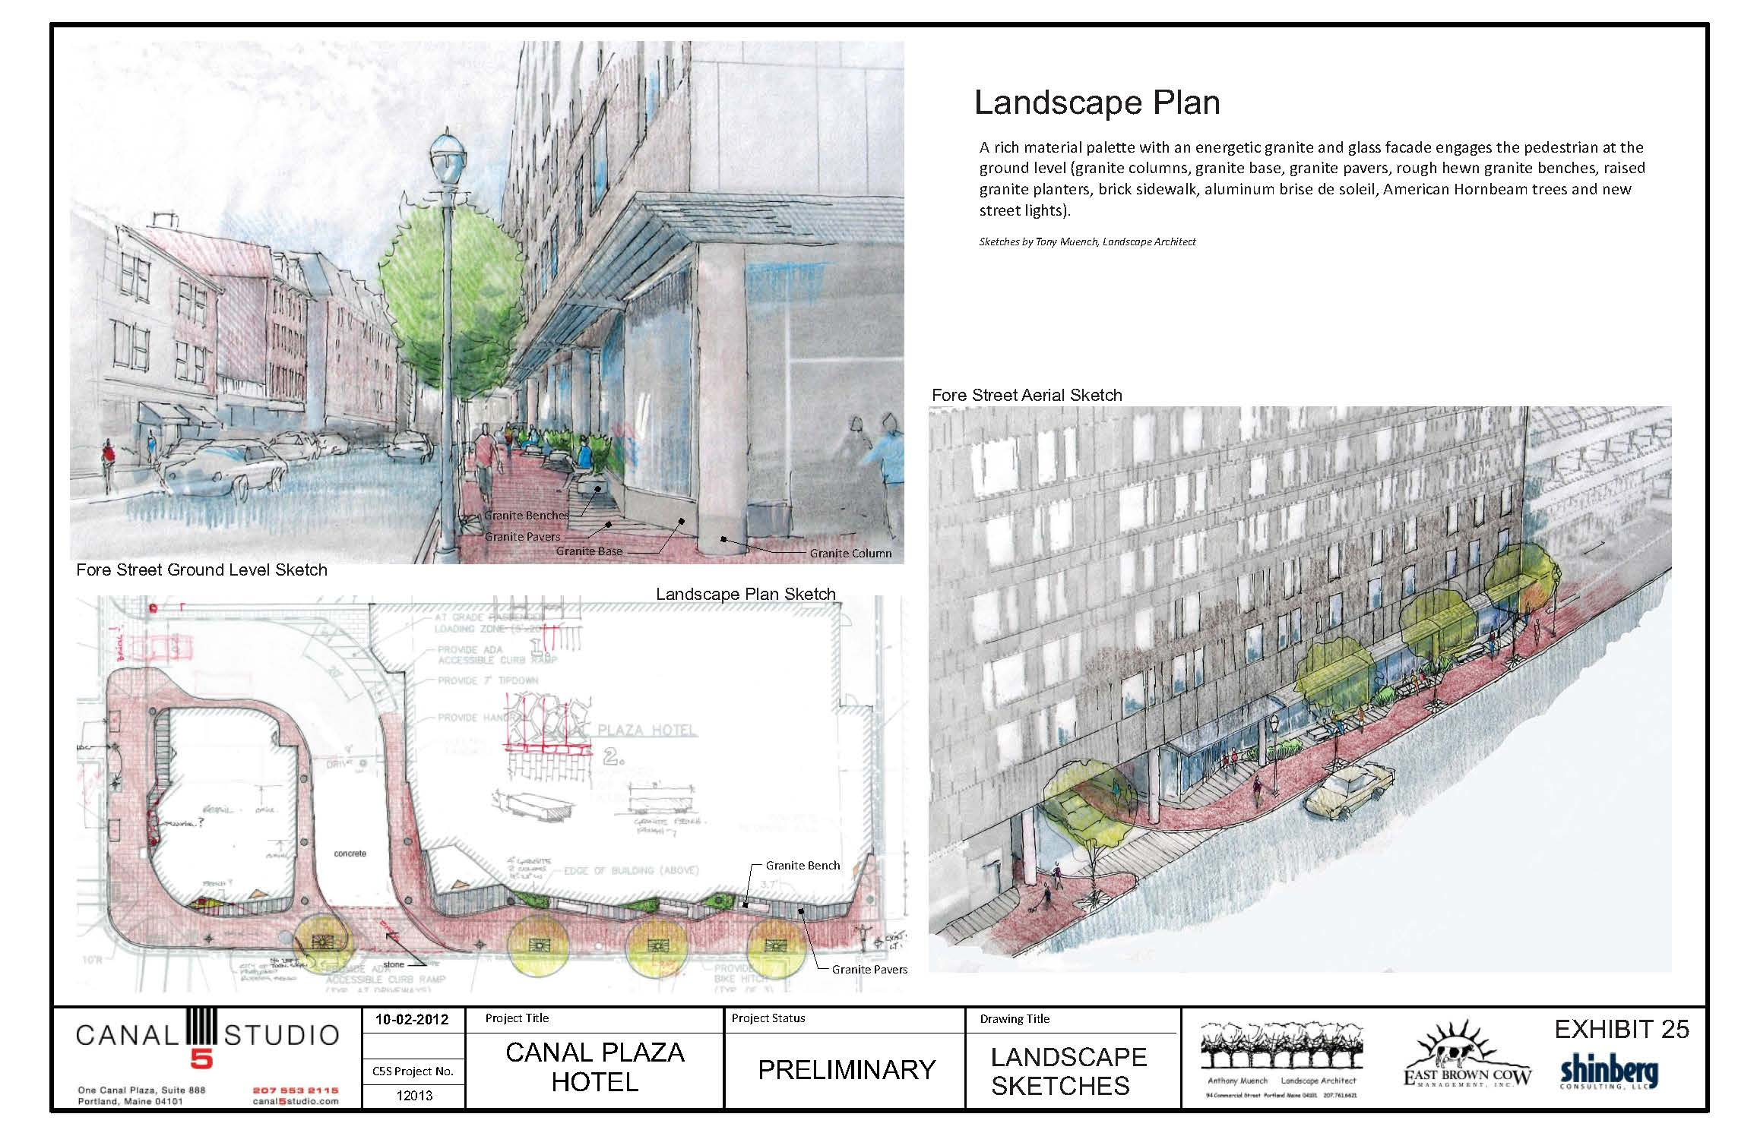
Details on exterior lighting, including proposed street lights, should be provided with the final plans. Note that, per Section 10 of the City of Portland Technical Manual, Union Street is in the Downtown Street Lighting District. Old Port lights are requested alon the Fore Street frontage.
Figures 6 & 7 (top & middle): Massing as viewed from Fore Street looking west.

- Noise and Vibration
Information on the HVAC and mechanical equipment should be provided with the final plans.

- Signage and Wayfinding
The most recent drawings (Attachments H and I) show building signs at third and fourth story height on the west and east facades. Pedestrian-scaled signs are also depicted at a lower elevation on the Union Street façade and at the corner of Fore and Union Streets. More information on signs, including wayfinding signage and sign lighting, will be required for final review.

- Zoning-Related Design Standards
As the site is located in the B-3 zone, it is subject to the Downtown Urban Design Guidelines. Members of the Planning Division staff met on September 20 to discuss aspects of the proposed design. Comments on the design, organized to correspond to the design guidelines, are summarized here.

I. Relationship to the Pedestrian Environment
Standard: The exterior design of portions of buildings within the first thirty-five feet of height shall enhance the character, attractiveness, comfort, security, and usability of the street level pedestrian environment.

The proposed design includes a number of features intended to activate the pedestrian realm, including a high level of first floor transparency, street furniture, a continuous first floor bris soleil, and regular street trees and street lights. The applicant has indicated that the round columns at the base of the building will be faced with granite and approximately 20 inches in diameter. The applicant has also indicated that samples of façade materials in the proposed colors/glazing will be provided. They were not available at the time of the review.

Given the renderings and perspectives supplied at the time of the design review, staff had the following comments:
- Consideration should be given to the Union Street façade. A large portion of the street level of this façade is devoted to the porte cochere exit and a largely blank wall. Especially given the functional ‘blank wall’ which exists directly north of this property on Union Street, all attempts should be made to enliven this space.
- The east end of the building, adjacent to the garage, appears unresolved. It remains unclear how the proposed canopy wraps the corner and abuts the garage.
- In conversation with the applicant following the design review meeting, the architect clarified that granite benches and planters will be proposed at the base of the building on Fore Street. In light of the environmental conditions in this area, careful consideration should be given to the type of tree which will work in this location, in consultation with the City Arborist.
- As plans develop, additional information is needed on lighting, architectural and otherwise. A rendering of the building at night should be provided. The crenelated glass corner provides an opportunity for internal illumination, along with the street level retail facace on Fore Street, which can provide a distinct architectural presence at night. Soffit lighting should be considered above the sidewalk to illuminate any recesses along the building face, in addition to internal illumination. This is also useful for CPTED considerations. The applicant has indicated that the lighting will be provided primarily by a combination of wall packs and recessed ceiling/soffit lights, but that those details are not yet fully resolved. They would like to have a condition of approval that a final lighting and photometric plan be submitted later for Planning Authority review and approval.
- Additional information is needed on transparency of the first floor glass.

II. Relationship to Existing Development
Standard: The proposed development shall respect, enhance, and be integrated with the existing character of the general pattern of development in the Downtown, surrounding building environment, and streetscape.

The site abuts both a city historic district and several relatively contemporary buildings. As such, the proposed hotel straddles two very different design palettes. While its mass is in some ways similar to the buildings found across Union Street, it differs dramatically from those across Fore Street. Similarly, its composition, while similar in some respects to both the buildings directly across Union Street and Fore Street, differs in significant ways as well.

The Historic Preservation Board met with the applicant to discuss compatibility with the historic district in particular. Deb Andrews has provided a summary of their comments in Attachment 3.

III. Rooftop Appurtenances
Standard: All mechanical equipment, ventilating, and air conditioning and other building systems, elevators, stairways, radio or television masts or equipment, or other rooftop elements not intended for human occupancy shall be fully enclosed in a manner consistent with the character, shape, and materials of the principal building.

Details regarding the height, width, and material of the rooftop screen are requested. The rooftop mechanical enclosure is a substantial presence on the building, and should be minimized in visual prominence. It appears to be larger and higher than necessary to screen the mechanical units, and this deserves further consideration.

IV. Shadows
Standard: The location, massing, and orientation of portions of buildings in excess of sixty-five feet in height shall be such that substantial shadow impacts on public plazas, parks, and other publicly accessible open space should be avoided

No further comments at this time. (See note on page 8.)

V. Wind
Standard: The location, massing, orientation, and architectural design of a new building or building addition shall be such that no significant adverse wind impacts are created.

No comments at this time.

VI. Setbacks
Standard: The location and design of proposed structures shall not create a detrimental impact on the structural integrity or safety of adjacent structures or the safety of occupants thereof.

No comments at this time.

VII. Building Tops
Standard: Building or structures which exceed 150 feet in height shall be designed so as to provide a distinctive top to the building which visually conveys a sense of interest and vertical termination.

Not applicable.

VIII. View Corridors/Gateways
Standard: The placement and massing of proposed development shall not substantially obstruct public views to landmarks and natural features from those locations identified on the View Corridor Protection Plan.

As noted above, both Union and Fore Streets are identified as subject to ‘viewing protection within view corridors’ in the city’s View Corridor Protection Plan. The design, as proposed, would not obstruct views in these corridors.

IX. Signage/Awnings/Canopies
The preliminary drawings show two building signs above the first story of the building and two building signs on street level. Two of these are located on the west façade. The design guidelines relating to signs indicate that “building signs…should be limited to one per building street frontage for each business or tenant.” Plans should be revised to address this guideline, or a waiver requested. Information on sign lighting should also be provided.

VI. NEXT STEPS
- Address staff comments, comments from the Historic Preservation Board, and additional comments from the Planning Board
- Submit final plans, including submittal requirements as included in 14-527(f), for review by the Planning Authority and Planning Board
- Hold final Planning Board Hearing

VII. ATTACHMENTS
Planning Board Report Attachments
- Department of Public Services review, 9-26-12 (email from David Margolis-Pineo)
- Traffic Engineer review, 10-2-12 (email from Tom Errico)
- Historic Preservation review, 10-X-12 (email from Deb Andrews)

Applicant’s Additional Submittals
- Planning Board Memo, 9-7-12
- Cover Letter from Greg Shinberg, 9-18-12
- Neighborhood Meeting Summary
- Parking Demand Update (memo from Gorrill Palmer, 9-18-12)
- Revised Site Plan Narrative & Turning Templates (email and attachments from Denise Cameron, Woodard & Curran, 9-21-12)
- Elevations, 9-18-12
- Perspectives, 9-11-12
- Elevations, 10-2-12
- Perspectives, 10-2-12
- Floor Plans, 10-1-12
- Preliminary Landscape Sketches, 10-2-12

Plans
Plan 1 Existing Conditions Survey
Plan 2 C-200 Demolition Plan
Plan 3 C-201 Site Plan

