Memorandum
Planning and Urban Development Department
Planning Division

To: Carol Morrissette, Chair and Members of the Portland Planning Board

From: Nell Donaldson, Planner

Date: November 1, 2012

Re: Addendum to the Planning Board Report – Canal Plaza Hotel, 433 Fore Street

Following the postponement of the Planning Board’s October 29 public hearing, Cow Plaza Hotel, LLC submitted additional information meant to address several of the conditions of approval and one of the waiver requests as outlined in the Planning Division’s October 26 Planning Board report. The content of this additional information and the Division’s responses, organized to correspond with the conditions of approval, are outlined here. Revised motions and conditions have also been provided.

I. REVIEW OF ADDITIONAL INFORMATION PROVIDED
Condition 1. Site plan modifications
The applicant’s submittal included a memo from Woodard and Curran indicating their intent to revise the final plans to address the first condition of approval from the October 26 Planning Board report (Attachment B). While a revised survey (Attachment E) was received by the Planning Division on October 25, no updated plans have been provided. As such, this condition, less the note regarding the survey, stands.

Condition 4. Availability and capacity of public utilities
The applicant provided a letter from the Portland Water District indicating sufficient capacity to serve the water needs of the project and a letter from the Department of Public Services regarding adequate sewer capacity was received on November 1st. These letters are included as Attachment C and the associated condition has been deleted.

Condition 7. Signal improvements at Fore and Union Streets
The applicant has reiterated that they are not proposing to relocate the mast arm, nor are they proposing pedestrian signal upgrades, at the northeast corner of Fore and Union Streets (Attachment B). Tom Errico, the city’s consulting traffic engineer, provided the following comment, reflected in the October 26 report, with respect to this issue,
The City continues to request that the following signal modifications be implemented in conjunction with the project:
  - The City no longer requests that the controller cabinet be located to the opposite corner of the intersection. The applicant shall coordinate with DPS Traffic staff in coordinating the relocation of the existing cabinet on the same corner.
  - The existing mast arm location must be relocated for following reasons.
    - The current mast arm is located near the middle of the sidewalk and while it does meet minimum ADA clearance requirements, it will present difficulties for sidewalk snow plows.
    - The mast arm pole is used to mount both pedestrian signal heads and push buttons for crossing two crosswalks, the northerly Union Street crosswalk and the easterly Fore Street. Placement of the push buttons on the existing mast arm will not meet accessibility requirements of the Manual on Uniform Traffic Control Devices, Federal Highway Administration. While installation of a pedestal post (in addition the having the mast arm) is an option, we believe given that the existing mast arm should be relocated, minimizing sidewalk clutter is preferred.
    - While not related to location of the mast arm, the mast arm structure is old. It is not practical to remove, install a new foundation, and re-install an aging structural support.

  - The existing pedestrian signal heads and push buttons do not meet current standards. Given both existing pedestrian volumes and the added activity that the proposed project will have on the intersection, replacing existing non-conforming signal equipment is necessary.

In correspondence dated November 1 and included as Attachment 1, Mr. Errico added the following information related to potential costs for the requested improvements,

The following summarizes the approximate cost associated with the recommended signal modifications. I don’t have a cost for the relocation of the traffic signal controller cabinet (The applicant has indicated that they will relocate the cabinet in conjunction with the project).
  - Upgrade non-compliant pedestrian signal heads at the Fore Street/Union Street intersection to current standards - $5,000
  - Replace the existing mast arm on the project corner - $15,000 to $20,000

As in the Division’s October 26 report, the Division continues to request the signal equipment modifications as outlined by Mr. Errico. As such, the associated condition remains unchanged.
Figure 1: Proposed Canal Plaza Hotel as shown from Fore Street looking east, with building sign.
Condition 13 (and Waiver 2). Freestanding sign at the porte cochere entrance on Fore Street
In their cover email (Attachment A), the applicant has reiterated their proposal for a freestanding sign at the mouth of the porte cochere on Fore Street. The applicant has also provided an updated rendering of the proposed sign, included as Attachment D. In the Division’s October 26 report to the Board, the proposed sign was reviewed in light of the waiver criteria as outlined in Section 14-526(d).8.a.(iv) of the city’s site plan ordinance. In that report, it was noted that:

- With respect to Criteria a) and b), the proposed sign is deemed out of character with the context both in terms of scale and general nature, as there are no other known freestanding signs in this area of Fore Street.

- With respect to Criteria c), there are no known unique circumstances of the site which require special consideration. It was noted that the visibility of the proposed building sign for arriving traffic from the east would appear to be fairly good, given the setback of the adjacent garage. This is shown in Figure 1.

In their most recent submittal, the project architect notes that “we are advocating for the sign’s inclusion as an important cue for motorists seeking the hotel entrance as there are no other signs on the Fore Street façade indicating ‘entrance.’ We also feel it is an important pedestrian safety feature as it will prompt pedestrians that they are nearing an entrance and should therefore exercise caution as they cross the drive.” The architect notes that, ‘as for the scale of the sign it has been carefully considered in light of both the porte cochere entrance scale as well as the human scale relative to pedestrians.”

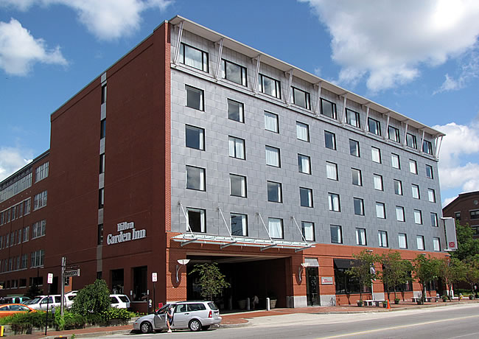
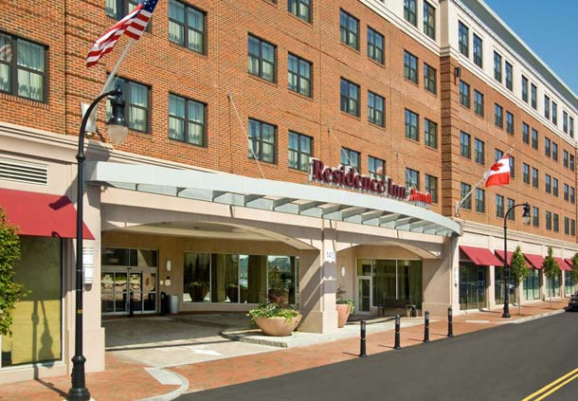
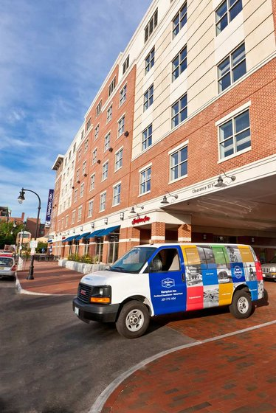
The Division’s concerns regarding need and precedent remain, and as such, the Division does not support the waiver at this time. The planning staff continues to recommend that a comprehensive signage plan be submitted as a condition of approval, and suggests that the applicant explore alternatives for delineating the porte cochere entrance. These might include:
Figure 2: Porte cochere at the Hilton Garden Inn on Commercial Street, which lies in the B-3 zone and the Old Port Historic District, and includes a canopy and lighting to highlight the entrance
Figure 3: Porte cochere at the Marriott Residence Inn, which lies at 145 Fore Street in the B-5b zone, including lighted bollards, a canopy, signage, and landscaping improvements.
Figure 4: Porte cochere at the Hampton Inn at 209 Fore Street, which also lies in the B-3 zone, and includes building signage and lighting treatments to signify the entrance.
- lighted bollards,
- building signage either over the
porte cochere entrance or on
the interior wall of the porte
cochere,
- hanging signage as proposed
elsewhere on the Fore Street
façade brise soleil, or
- a blade sign at the hotel
entrance.

Recent local examples of some of these forms of identification for porte cocheres are shown in Figures 2, 3, and 4.

II. REVISED PROPOSED MOTIONS
- Waivers
- On the basis of the application, plans, reports and other information submitted by the applicant; findings and recommendations contained in Planning Board Report # 48-12 for application 2012-558 relevant to Portland’s Technical and Design Standards and other regulations; and the testimony presented at the Planning Board hearing:

The Planning Board waives/does not waive the Technical Standard (Section 1.7.2.7) regarding the minimum separation of 150 feet between driveways and intersections to allow driveways to the porte cochere within 50’ from the intersection on Fore Street, and within 75’ from the intersection on Union Street

- On the basis of the application, plans, reports and other information submitted by the applicant; findings and recommendations contained in Planning Board Report # 48-12 for application 2012-558 relevant to Portland’s Technical and Design Standards and other regulations; and the testimony presented at the Planning Board hearing:

The Planning Board waives/does not waive/or tables to a date certain the prohibition of freestanding signs in the B-3 zone on the peninsula (Section 14-369.5, Table 1, Footnote (b)) to allow a freestanding sign at the entrance to the porte cochere on Fore Street.

- Development Review
On the basis of the application, plans, reports and other information submitted by the applicant; findings and recommendations contained in Planning Board Report #48-12 for application 2012-558 relevant to the site plan regulations; and the testimony presented at the Planning Board hearing, the Planning Board finds that the plan is in conformance the site plan standards of the land use code, subject to the following conditions of approval that must be met prior to the issuance of a building permit, unless otherwise stated:

- The applicant shall revise the final plans prior to the issuance of a building permit to include:
- A “Do Not Enter” sign at the egress drive location on Union Street
- A note indicating that LED versions of the proposed street lights will be installed, and that the applicant will coordinate with the city regarding model numbers
- Tree grates as specified by the city arborist
- The applicant shall revise the survey such that horizontal datum is tied to the city’s coordinate system prior to the issuance of a building permit.

- The applicant shall acquire easements for drainage and service access, as well as formalize an easement to CMP which corresponds to the actual location of the electrical duct bank on site, for review and approval by the Planning Authority prior to the issuance of a building permit;

- The applicant shall obtain revocable licenses for the proposed brise soleil, signage, and footings required in the city’s right-of-way;

- The applicant shall obtain a letter from the Department of Public Services verifying sewer capacity and a letter from the Portland Water District verifying water capacity;

- The applicant shall submit the HVAC system specifications meeting applicable standards for the Zoning Administrator’s review and approval;

- The applicant shall submit a revised construction management plan for review and approval by the Planning Authority, the Department of Public Services, the city’s Parking Manager, and the city’s Fire Prevention Bureau;

- The applicant shall revise the site plan to include a note indicating that the existing mast arm at the northeast corner of Fore Street and Union Street will be relocated and that the pedestrian signal heads will be upgraded, for review and approval by the Department of Public Services;

- The applicant shall provide information on slip-resistance and prepare a maintenance agreement regarding the granite driveway aprons for review and approval by the city’s Department of Public Services and Corporation Counsel;

- The applicant shall submit a detailed plan for managing traffic in the porte cochere and for the handling of large truck deliveries for review and approval by the Planning Authority and the city’s Department of Public Services;

- The applicant shall increase the clearance in the porte cochere to 10’, for review and approval by the city’s Fire Prevention Bureau;

- The applicant shall provide additional parking supply information for review and approval by the Planning Authority, the city’s Department of Public Services, and the city’s Parking Manager;

- A final lighting plan, including photometric data and meeting relevant Technical Standards, shall be submitted for review and approval by the Planning Authority prior to the issuance of a certificate of occupancy;

- A final comprehensive signage plan , including design and illumination details for all proposed signs, shall be submitted for review and approval by the Planning Authority prior to the issuance of a certificate of occupancy;

- The applicant shall submit samples of the final custom color of the limestone composite panels proposed for the exterior of the building for review and approval by the Planning Authority;

- The applicant shall submit revised elevations and specifications for the rooftop mechanical screen and stair tower, which address the recommendations of the Planning staff and the Historic Preservation Board, for review and approval by the Planning Authority.

III. ATTACHMENTS
A. Planning Board Report Attachments
- Traffic Engineer review, 10-31-12 (email from Tom Errico)

B. Applicant’s Additional Submittals donaldson
- Cover email, 10-31-12 (email from Tim Hart, Canal5Studio)
- Response to conditions of approval (memo from Denise Cameron, Woodard & Curran)
- Water capacity letter, 9-14-12 (letter from Portland Water District) and Sewer Capacity Letter from the Department of Public Services dated 11-1-12
- Rendering of proposed freestanding sign
- Revised survey, 10-25-12

Photo credits:
Figure 2: http://bhmilliken.com/projects.php?p=6
Figure 3: http://www.marriott.com/hotels/hotel-information/travel/pwmdt-residence-inn-portland-downtown-waterfront/
Figure 4: http://hamptoninn3.hilton.com/en/hotels/maine/hampton-inn-portland-downtown-waterfront-PWMDTHX/index.html

