PLANNING BOARD REPORT
PORTLAND, MAINE

Canal Plaza Hotel
433 Fore Street
Level III Site Plan Review
2012-558
Cow Plaza Hotel, LLC, Applicant

Submitted to: Portland Planning Board  Public Hearing Date: October 29, 2012  Planning Board Report Number: #48-12 | Prepared by: Nell Donaldson, Planner  Date: October 26, 2012  CBL: 32-I-40

I. INTRODUCTION
Cow Plaza Hotel, LLC is requesting a Level III site plan review for an 80,000 SF development, the Canal Plaza Hotel, at the northeast corner of Fore and Union Streets in downtown Portland. The plans include a seven-story hotel, a restaurant, a retail space, as well as streetscape and landscape improvements. Vehicular access is provided via a porte cochere. At prior Planning Board workshops, held on September 11 and October 9, 2012, the Board considered the preliminary plans for the project and undertook detailed discussion of the proposal’s design and transportation implications. This report outlines the applicant’s final, complete submittal and notes outstanding comments.

A total of 151 notices were sent to property owners within 500 feet of the site and a legal ad ran on 10-24 and 10-25.

Applicant: Cow Plaza Hotel, LLC
Consultants: Greg Shinberg, Shinberg Consulting; Patrick Costin, Canal 5 Studio; Tom Gorrill, Gorrill-Palmer Consulting Engineers; Woodard & Curran, Consulting Engineers

II. REQUIRED REVIEWS
Waiver Requests | Applicable Standards
Driveway separation, to allow driveways 50 feet east and 75 feet north of Fore and Union Streets | Technical Manual 1.7.2.7. Along arterial and collector streets, access driveways to corner lots shall be located a minimum of 150 feet from the nearest intersection. Supported by the city’s consulting traffic engineer.
Prohibition of freestanding signs in the B-3 zone, to allow a freestanding sign at the entrance to the porte cochere on Fore Street | 14-369.5, Table 1, Footnote (b). Freestanding signs shall be allowed in the B-3 zone on the Portland Peninsula “only if the front façade of the building…is set back a distance of at least 20 feet from either of the front facades of the abutting buildings…”  14-526(d).8.a.(iv). Waiver criteria, as discussed below.
Review | Applicable Standards
Site Plan | Section 14-526, including provisions related to historic district compatibility
Downtown Urban Design Guidelines | City of Portland Design Manual

III. PROJECT DATA
Existing Zoning | B-3 in Height Overlay District, Pedestrian Activities District
Existing Use | Surface parking lot
Proposed Use | Hotel and retail
Parcel Size | 19,130 SF (.44 acres)
 | Existing | Proposed | Net Change
Building Footprint | 0 SF | 10,900 SF | 10,900 SF
Building Floor Area | 0 SF | 79,197 SF | 79,197 SF
Impervious Surface Area | 14,639 SF | 17,785 SF | 3,146 SF
Parking Spaces (on site) | 45 | 0 | (45)
Bicycle Parking Spaces | 0 | 24 | 24
Estimated Cost of Project | $13,000,000

IV. CONTEXT & EXISTING CONDITIONS

The site of the proposed Canal Plaza Hotel lies at the southwest corner of the Canal Plaza block, at the edge of the Old Port and across Fore Street from the designated Old Port Historic District. The site has long been used as a surface parking lot, and lies adjacent to the Fore Street parking garage, which is under the same ownership. A Central Maine Power (CMP) substation lies immediately north of the site on Union Street. 2 Portland Square lies across the Fore Street/Union Street intersection, as does the Portland Harbor Hotel. The site is within 100’ of the Old Port Historic District.
Figure 1: Site of the proposed Canal Plaza Hotel
CMP substation

Site
Fore Street/Cow Plaza Garage
Portland Harbor Hotel
Historic District
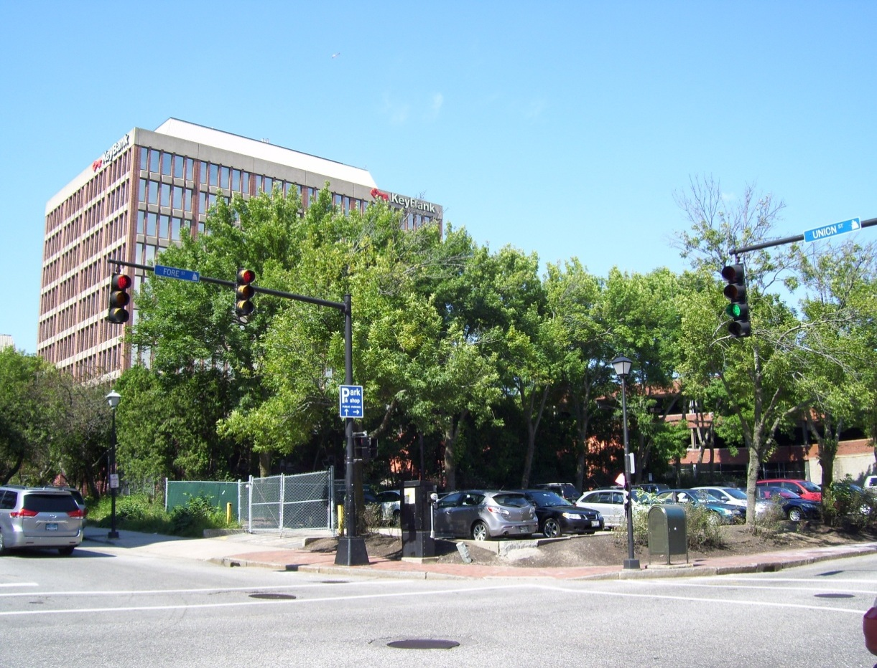
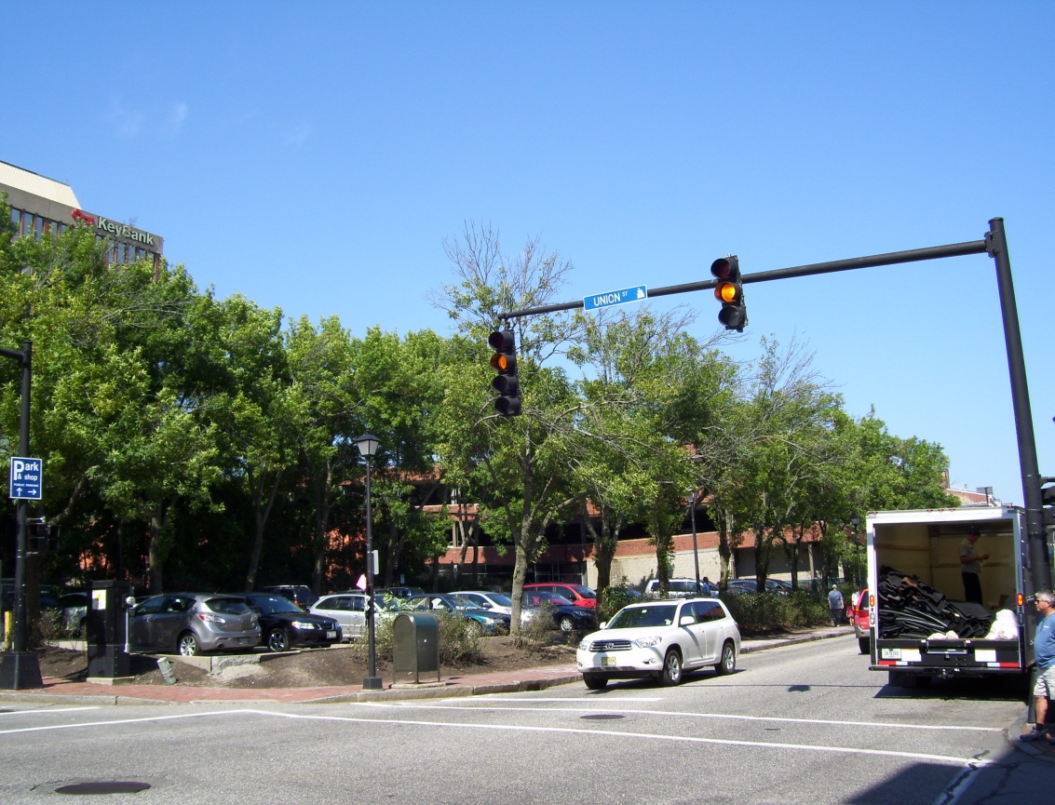
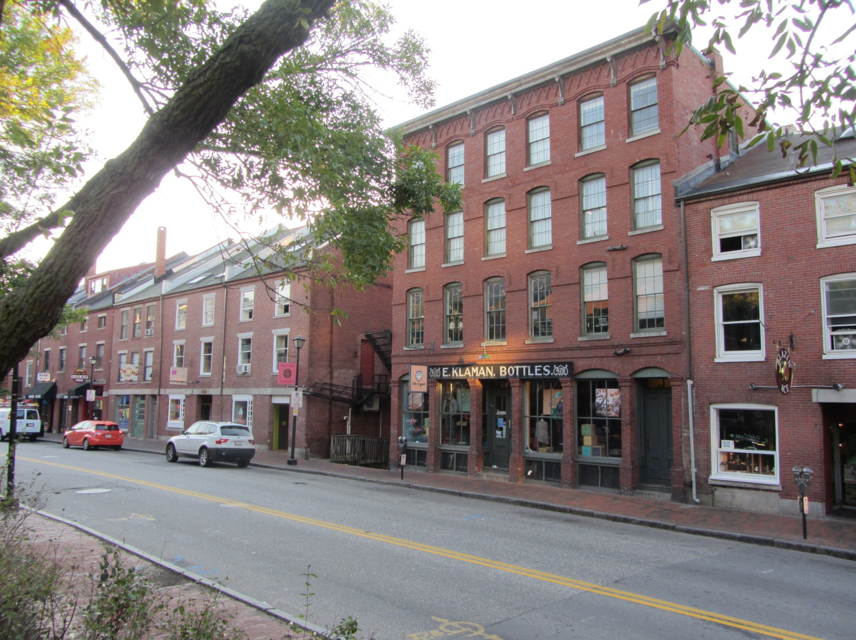
V. PROPOSED DEVELOPMENT
Figures 2 & 3: Canal Plaza Hotel site from the south (top) and adjacent Historic District (bottom)
V. PROPOSED DEVELOPMENT
Figure 4: Revised site plan, showing final configuration of building, service alley, porte cochere, and sidewalk
The proposed Canal Plaza Hotel development includes approximately 79,200 SF of building space on seven floors. The vast majority of the building’s floor area would be occupied by a new hotel. The hotel lobby, pool, and restaurant are proposed to occupy the first floor of the building, with the 123 guest rooms and several meeting rooms occupying the remaining six floors. Hotel rooms on the seventh floor are proposed with private decks.

Vehicular access to the hotel is proposed via a porte cochere with an entrance on Fore Street. Lobby doors would open in two locations onto Fore Street at the mouth of the porte cochere. Doors leading to the restaurant would open onto Fore Street at the southeast corner of the proposed building.

Parking would be provided in the adjacent garage, with vehicular access via the mid-block alley on Union Street. On foot, guests would access the garage by exiting the hotel and using the west or east Fore Street garage entrance. Service vehicles would use the Union Street alley for access.

Some landscaping, including street trees, raised planters, and granite benches, is proposed along the Fore Street frontage. Street trees are also proposed on the Union Street frontage.

The proposal also includes 740 SF of retail, to be located in the corner of the building at Union and Fore Streets. Access would be from Fore Street.

Details of the proposed development are outlined in the applicant’s original cover letter, dated August 7, 2012 (Attachment A), additional cover letters included as Attachment B, and shown in the attached plans.

VI. PUBLIC COMMENT
The Planning Division received notes from the applicant’s neighborhood meeting, held on September 18, 2012. Five neighbors attended, raising concerns about the placement and scale of signage, parking capacity at the adjacent garage, and disturbances during construction. The neighbors in attendance were generally supportive of the project. Notes from the public meeting are included as Attachment C.

At previous Planning Board workshops, residents have raised concerns regarding the design of the porte cochere and traffic flow), access to parking, the proposed valet parking arrangement, and disruptions associated with construction. The Planning Division received one comment following the October 9 public workshop. It concerned disruptions during construction, particularly with regard to parking and traffic flow on Fore Street.

VII. RIGHT, TITLE, and INTEREST & FINANCIAL and TECHNICAL CAPACITY
There is a CMP easement on the property, although it does not correspond with the actual location of an electrical duct bank which crosses the site from north to south. This situation is being corrected with a new easement, revised to correspond to the actual location of the electrical conduit. The project has been designed so that this new easement would lie under the porte-cochere. In this way, the CMP lines would remain accessible to the power company. The terms of this easement are currently being negotiated. The applicant has provided an email from Stephen Daniels, of CMP’s marketing and sales department, indicating support for the project and an intention to work collaboratively with the applicant. This email is included as Attachment G.

Additional easements, including an access easement for the use of the alley on Union Street and a drainage easement to connect to the existing sewer line underneath the adjacent garage, will also be required for the project. The ownership of the easement-granting properties in these cases is the applicant.

Revocable license agreements for foundation footings, the brise soleil, and some of the proposed signs, which are designed to extend into the right-of-way, will also be necessary.

VIII. ZONING ANALYSIS
Marge Schmuckal, Zoning Administrator, whose comments are included as Attachment 1, has indicated the following,

I have been able to view the most recent submission. Currently the room number count has been reduced by one to 123 rooms. I have also reviewed the elevations showing the average grade using the computation method that I commonly use. The 65' maximum street wall height is being met. The so-called krinkle wall is also meeting the maximum street wall height requirement. The maximum allowable height for the structure is 85' and the top of the highest roof beam is 75.25'. There is a roof wall surrounding the HVAC units and elevator shafts that is not required to meet the height requirement by Ordinance.

All other zoning requirements are being met. My previous comments about signage and HVAC units still are in force.

It should be noted that the current plans include a non-conforming freestanding sign at the mouth of the porte cochere. The applicant has requested a waiver for this sign. A discussion of the waiver request is included below.

IX. SITE PLAN REVIEW

- SITE PLAN STANDARDS (Section 14-526)
- Transportation Standards
The main vehicular point of access for the proposed hotel is via Fore Street, where both a porte cochere and the lobby doors are located. The applicant has designed the porte cochere to restrict left turn movements, so that the traffic would flow from Fore Street to Union Street. The applicant proposes to manage all arriving and departing traffic with valets, who would move the cars from the porte cochere to the adjacent garage using the mid-block alley on Union Street, and from the garage to the porte cochere using Fore Street.

The applicant has proposed to make a number of improvements to the pedestrian realm, including rebuilding the sidewalk, decreasing the turning radius at the Fore Street/Union Street corner to allow the city’s preferred ramp alignment, and adding street trees and furniture. Pedestrian access to the hotel, the retail, and the restaurant would be provided via doors on Fore Street.

In their final submittal, the applicant:
- Added a ‘No Left Turn’ sign at the porte cochere entrance on Fore Street;
- Redesigned the porte cochere crosswalks to use granite pavers, similar in design to those used at the base of the building, to accent the pedestrian zone;
- Included a note indicating that that the traffic control box at the corner of Fore and Union Streets will be relocated;
- Provided a narrative regarding the valet parking arrangement; and
- Provided calculations regarding parking supply.

These materials are included in the attached plans and as Attachments F and I. Tom Errico, consulting traffic engineer, has reviewed the final plans. His comments are included as Attachment 2. The final plans have also been reviewed by the city’s parking manager, John Peverada. His comments are included as Attachment 3. The comments of David Margolis Pineo, of the city’s Department of Public Services, are included as Attachment 4.

- Impact on Surrounding Street Systems
The applicant has requested a waiver from the 150’ separation requirement for the driveways in the porte cochere area (See Technical Manual 1.7.2.7). As proposed, the vehicular ingress via the porte cochere is 50’ from the intersection on Fore Street, and the egress is 75’ from the intersection on Union Street. Of this, Tom Errico notes,

The project does not meet City driveway corner clearance standards. Given the proposal for turn prohibitions and geometric design features, I support a waiver from the City’s Technical standard.

It was noted in prior Planning Board memos that signal equipment modifications would be required at the intersection of Union and Fore Streets. As stated above, the applicant has added a note indicating that that the traffic control box at the corner of Fore and Union Streets will be relocated in coordination with the city. With respect to this issue, Tom Errico, consulting traffic engineer, writes,

The City continues to request that the following signal modifications be implemented in conjunction with the project:
- The City no longer requests that the controller cabinet be located to the opposite corner of the intersection. The applicant shall coordinate with DPS Traffic staff in coordinating the relocation of the existing cabinet on the same corner. See note above.
- The existing mast arm location must be relocated for following reasons.
- The current mast arm is located near the middle of the sidewalk and while it does meet minimum ADA clearance requirements, it will present difficulties for sidewalk snow plows.
- The mast arm pole is used to mount both pedestrian signal heads and push buttons for crossing two crosswalks, the northerly Union Street crosswalk and the easterly Fore Street. Placement of the push buttons on the existing mast arm will not meet accessibility requirements of the Manual on Uniform Traffic Control Devices, Federal Highway Administration. While installation of a pedestal post (in addition the having the mast arm) is an option, we believe given that the existing mast arm should be relocated, minimizing sidewalk clutter is preferred.
- While not related to location of the mast arm, the mast arm structure is old. It is not practical to remove, install a new foundation, and re-install an aging structural support.
- The existing pedestrian signal heads and push buttons do not meet current standards. Given both existing pedestrian volumes and the added activity that the proposed project will have on the intersection, replacing existing non-conforming signal equipment is necessary.

In the Division’s prior Planning Board memos, it was also noted that, under the proposed plans, on-street parking spaces would be lost on Union Street. Council action will be required for this item.

- Access and Circulation
Since their original submittal, the applicant has redesigned the porte cochere to restrict left turn movements from Fore Street. The applicant also added a convex mirror and signs at the porte cochere to alert drivers to left turn restrictions and the pedestrian crossing. Mr. Errico writes,

The plans include installing a sign and I have no further comment. There was a comment about installing a “Do Not Enter” sign at the egress drive location on Union Street. The applicant should install the noted sign.

In addition, the applicant has added granite crosswalks at the mouth of the porte cochere. Mr. Errico writes,

The applicant has revised the plan to include granite pavers for the driveway apron areas. The City finds this condition to be acceptable with the following conditions: 1) the applicant will be responsible for the maintenance of the granite paver aprons; and 2) the applicant shall provide documentation on existing examples of the proposed slip-resistant details for review and approval prior to construction.

Of the granite pavers, David Margolis-Pineo, of the city’s Department of Public Services, adds,

The required driveway apron material for this area with brick sidewalks is asphalt. It is my understanding that the applicant would prefer not to use asphalt and has proposed using Jonesboro Granite. This is a change from the City’s sidewalk material policy and may require Council approval. If it is determined that this material is to be allowed, and since the City does not keep Jonesboro granite in stock, I would recommend an agreement between the applicant and the City be drafted stating that maintenance of these sidewalk areas would be the responsibility of the applicant even if damaged inadvertently by City equipment. Also, since wet granite has resulted in slipping issues elsewhere in the City, can the applicant provide assurance this will be a non-slip surface?

Concerns regarding stacking at the porte cochere remain. The applicant has provided a letter from Commonwealth Hotels, LLC, the proposed hotel management company, which is included as Attachment F and describes how valet parking will be managed in the porte cochere. The letter predicts that one to five cars will use the porte cochere per half hour during the afternoon peak (during check-in), and that not more than one or two cars will actually be in the porte cochere at any point. During the morning peak (during check-out), the letter estimates a peak demand of one to four cars using the porte cochere per half hour and, again, not more than one or two cars at any point. The letter implies that four cars could feasibly fit in the porte cochere if necessary. Tom Errico writes,

The applicant has provided some general information on managing the drop-off area and the conclusion that it will not be problematic. I do not find the information to be sufficient for documenting specific details for avoiding potential back-up problems. I would suggest that a condition of approval be included that requires the applicant to provide specific details of the valet program and examples of existing hotel programs that address how they manage vehicle queuing problems.

The Commonwealth Hotels letter also notes that some guests will likely self-park. In conversations with the applicant, they have indicated that, as with the valets, self-parkers would be directed to the garage via the alley from Union Street. In order to access their cars for departure, they would exit the hotel onto Fore Street, then reach the garage via one of its several entrances.

In prior submittals, the applicant made changes to the rear alley area. The applicant has provided turning movement sketches showing a 30’ box truck entering the alley frontwards and backing down the service access (Attachment L). Of the service delivery sketches, Tom Errico writes,

The applicant has provided a graphic that illustrates a Single-Unit truck maneuvering into the loading dock without having to back from Union Street. I find this condition to be acceptable. The applicant has not provided information on how large truck deliveries will be accommodated. This issue is outstanding.

Ben Wallace, of the city’s Fire Prevention Bureau, asked in prior correspondence that overhead clearance in the porte cochere be verified. The applicant has indicated that the minimum clearance, at the Union Street exit from the porte cochere, is 9’6”. Of this, Mr. Wallace writes,

There is a serious concern on the part of our apparatus chief that 9'-6" is too close. He wants 10'-0" due to the Ford F series diesel ambulance chassis no longer being available and the potential need to move to a medium duty ambulance chassis such as the Navistar. If less than 13'-6" an approved sign will need to be installed and maintained indicating the established vertical clearance.

Mr. Wallace’s complete comments are included as Attachment 6.

As noted in prior Planning Board memos, it will be necessary to coordinate with CMP regarding the plans for the adjacent site to ensure that sight lines into and out of the service drive are not obstructed. Recent conversations with CMP indicate that they will be upgrading the transformer yard and installing a 12-foot firewall along the northeasterly property line adjacent to the service lane.

- Public Transit Access
No transit access improvements are proposed.

- Parking
As noted in the Planning Division’s prior memos, the Planning Board ultimately establishes the number of required parking spaces, since the proposed building is over 50,000 SF. Per the city’s zoning ordinance, only 31 spaces are required for the hotel (at one space/four rooms).

In response to a request for clarity on parking demand, the applicant previously submitted a memo from Gorrill-Palmer Consulting Engineers, which is included as Attachment H. This memo discusses various sources for estimating parking demand, including the ITE Parking Generation Manual, a standard source for such estimates, and field data from the Hampton Inn on Fore Street. Based on calculations from the ITE, with a factor to account for shared parking, peak parking demand estimates for the proposed hotel range from 85 to 107 spaces, depending on time of day. The Hampton Inn data shows a peak demand of .738 per room. When this figure is applied to the Canal Plaza Hotel, it results in a peak parking demand of 92 spaces at full occupancy. The memo suggests that this second figure, derived using the data from the Hampton Inn, is likely more accurate, given the similarity of the data source in terms of nature and context. Note that these parking demand figures do not account for the retail square footage on site.

As previously noted, the proposal relies on the use of the adjacent garage, the Cow Plaza Garage (which is under the same ownership) for parking purposes. The original application states that 218 of the 409 total spaces in the garage, currently occupied to some degree by month-to-month parkers, could be repurposed to both offset the loss of the existing surface lot and provide space for hotel guests. In the case of overflow needs, the applicant states that the accompanying 39-space surface lot, behind the garage, would also be available. In the final submittal, the applicant includes a revised parking supply table (Attachment I). This table indicates that there are 423 total parking spaces in the garage. Accounting for the spaces used to offset the loss of the surface lot on the site (45) and all parking dedicated by covenant to public (100) or private (179) users, there is a total available supply of 99 parking spaces in the garage. The Gorrill-Palmer memo estimates a daytime peak demand of 78 at 8 a.m. This leaves a surplus of 21 spaces during times of peak demand.

Mr. Errico writes,

The applicant has provided a summary of current parking garage contracts that indicates there is adequate parking supply to accommodate the parking needs for the proposed hotel. The general conclusion is that the current hotel project combined with existing parking agreements will result in a full garage facility. The applicant has indicated that some month-to-month parking garage customers may need to be displaced. The applicant should note how many existing month-to-month customers will be displaced.

It should be noted that the city’s parking manager, John Peverada, raised concerns regarding the parking supply calculations, particularly with regard to the 179 spaces required by covenant for tenants of Canal Plaza. The parking manager noted that the Fore Street Garage was built to house parking for 1, 2, and 3 Canal Plaza. While the zoning administrator confirmed that the ordinance did not require parking in the B-3 zone at the time of Canal Plaza’s construction, should the office space in Canal Plaza be built today, it would require considerably more parking (over 600 spaces, based on square footage data from the city assessor) than is currently supplied by the garage. Mr. Peverada writes,

There is a covenant in the Fore St. parking garage deed that states at least (100) parking spaces shall be provided for short-term parking (less than one day), which spaces shall be available to the general public. The developer should be required to provide the City upon request with verification from the parking garage access and revenue control software that at all times there are 100 spaces for turnover parking. In other words document that there are never more than 310 monthly cardholders in the garage at one time.

How many monthly parkers currently parking in the Fore St. Garage and the parking lot on the existing site will be displaced?

- Environmental Quality Standards

- Preservation of Significant Natural Features
There are no known significant natural features on the site.

- Landscaping and Landscape Preservation
The proposal includes street trees on both Fore and Union Streets, as well as landscaped areas in planters along the Fore Street façade. In order to optimize chances of survival, species were selected in consultation with the city arborist. Raised tree wells were not used due to space constraints on the Fore Street sidewalk.

The final plans have been reviewed by Jeff Tarling, City Arborist. His comments are included as Attachment 7 and as follows,

I have reviewed the proposed landscape plan and tree planting for the proposed
hotel project on Fore Street and find the plan acceptable. Due to the narrow
width of sidewalk along Fore Street we would recommend tree grates, either
the NEENAH R-8810 (36"x60") or the R-8811 (48"x72") grate. The greater the
soil volume in the proposed sidewalk tree pit the better for the tree. Deicing salt
is one of the biggest challenges for urban tree survivability, in many areas we like
to see the use of raised granite tree wells to reduce salt and compaction - this site
is somewhat limited. The applicant will need to ensure that the proposed 3" tree
which has a minumum rootball width of 32" spec can fit into the space.
The proposed planting of Bayberry and Viburnum should provide a hardy, native plant
type in other areas.

- Water Quality/Storm Water Management/Erosion Control
With the development of the site, the total impervious area would increase by 3,146 SF to a total of 17,785 SF. Pollutant loading is expected to decrease, given the nature of the existing and proposed uses. The storm water in the area near the service drive would be captured by a new catch basin immediately outside the service entrance, which would connect to the combined sewer system beneath the adjacent parking garage. A tree box filter is proposed upstream of the new catch basin in an effort to treat storm water runoff from the access driveway. The runoff from the impervious surface created by the hotel building would be collected through roof drains which outlet to a short section of separated sewer system at Union Street and Fore Street.

Steve Bushey, the city’s consulting civil engineer, has reviewed the submittal and indicated that he has no further comments (Attachment 8).

- Public Infrastructure and Community Safety Standards

- Consistency with Related Master Plans
The project is generally consistent with related master plans.

- Public Safety and Fire Prevention
Ben Wallace, of the city’s Fire Prevention Bureau, is requiring 10 feet clearance for the porte cochere (Attachment 6). His review is as follows:

There is a serious concern on the part of our apparatus chief that 9'-6" is too close. He wants 10'-0" due to the Ford F series diesel ambulance chassis no longer being available and the potential need to move to a medium duty ambulance chassis such as the Navistar. If less than 13'-6" an approved sign will need to be installed and maintained indicating the established vertical clearance.

The Fire Prevention Bureau has indicated that there are no other comments on the site plan.

- Availability and Capacity of Public Utilities
The applicant has requested capacity letters from both the city and the Portland Water District. These will be required as a condition of approval.
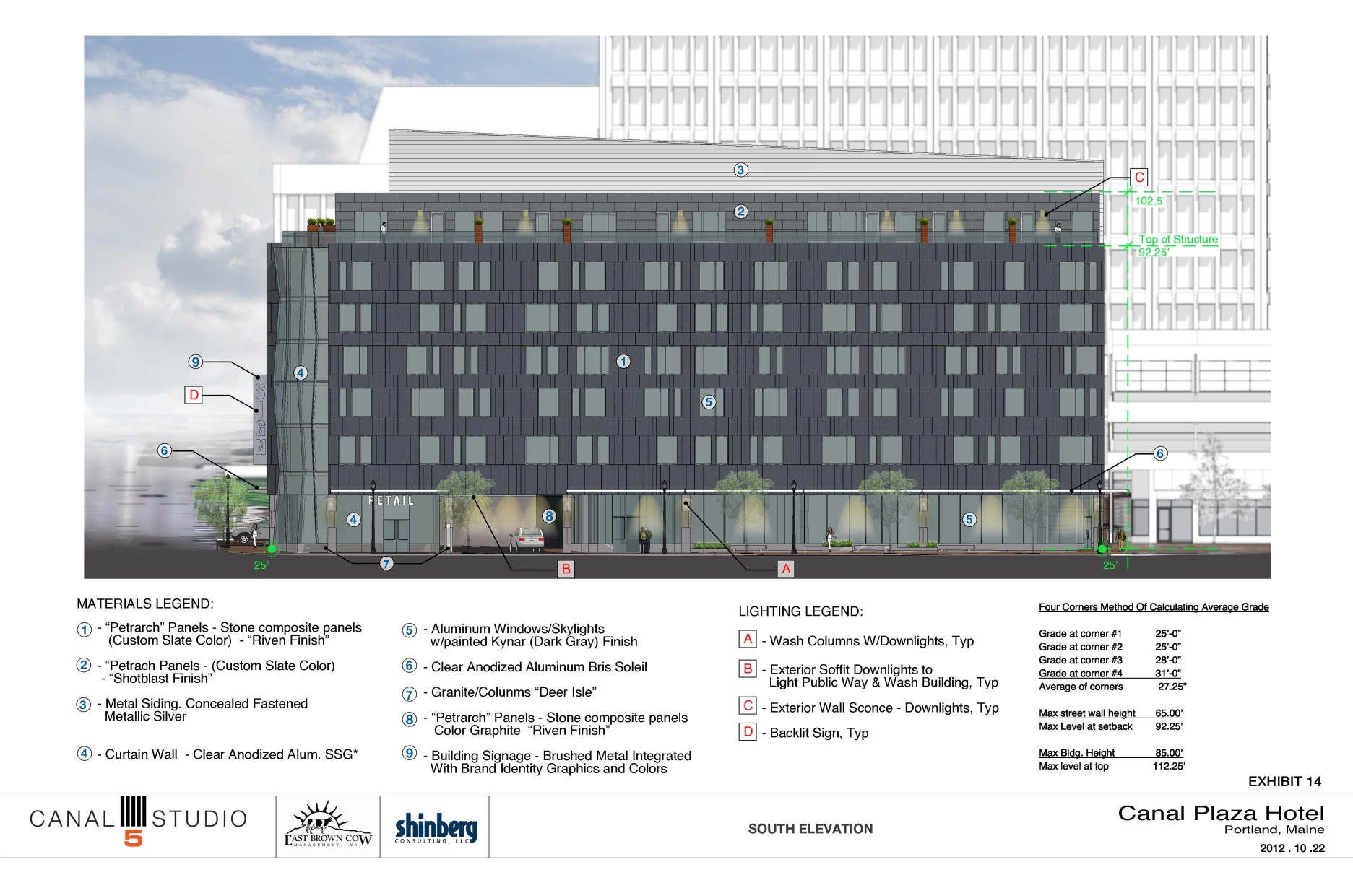
Figure 5: South (Fore Street) elevation

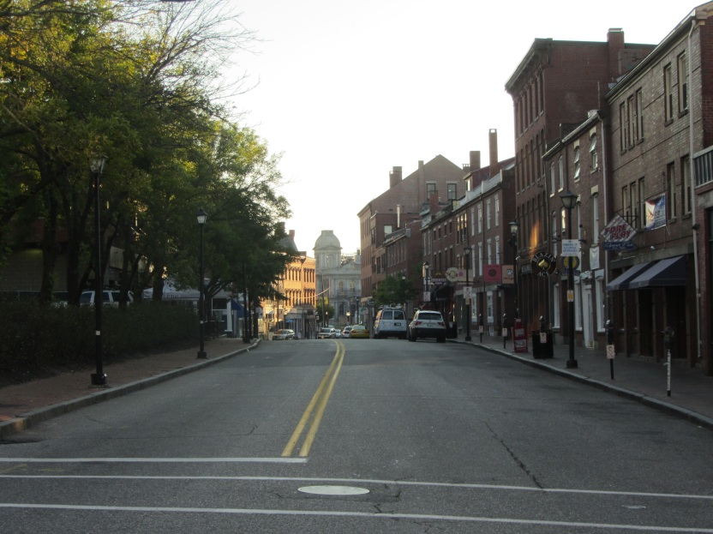
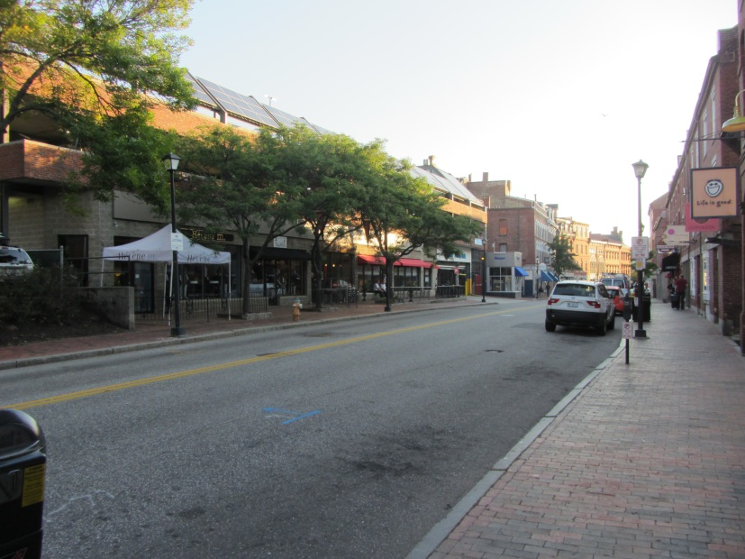
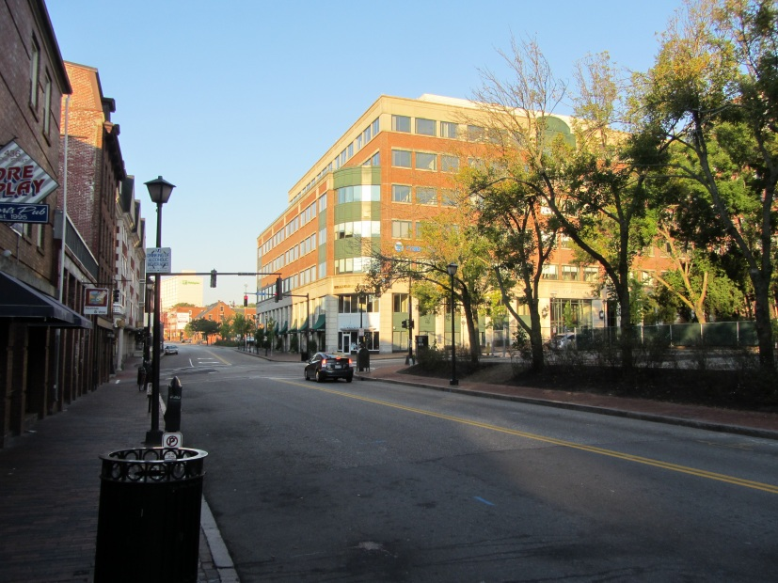
- Site Design Standards
Figures 6, 7, & 8 (from top): Fore Street looking east, including the Historic District, Fore Street Garage, 2 Portland Square

As previously described, the proposed Canal Plaza Hotel is fairly contemporary in design. It stands seven stories and approximately 75 feet in height, with a setback at the 65’ height limit at the street wall. The proposed façade is variegated on the ground floor, with a ‘crinkled’ glass wall which weaves in and out between granite-wrapped columns. At the Fore Street/Union Street intersection, this glass wall rises to form a tower. Along its entire edge, the glass wall is grounded in a granite base, and, on Fore Street, is fronted by granite planters and benches. At the last workshop, a brise soleil wrapped the building. Street trees and street lights are proposed on both frontages. The façade materials consist primarily of composite limestone panels in a custom gray color, with some metal siding proposed as well. The Fore Street façade is depicted in Figure 5 and the architect’s narrative, describing the design, is included as Appendix J.

The final submittal includes updated elevations, renderings, and a lighting concept plan. These drawings are included as Attachments N and O and depict several changes. In the revised drawings, the applicant has:
- Revised the façade color to a ‘custom slate,’ to be reviewed at a later date
- Broken the brise soleil in the area of the glass corner tower, and revised the tower design to extend the faceted glass to the base
- Added windows in the stair tower on the east end of the building
- Resolved the western edge of the building to enclose a pillar within the building and clarified the western stairwell exit
- Lowered the sign on the east end
- Eliminated the pedestrian-scaled sign on the west end
- Added restaurant sign on east end (in narrative, but not in depicted in drawings)

- Massing, Ventilation, and Wind Impact
The hotel is proposed as a seven-story building. As noted above, the building would extend up to the 65’ foot street wall limit of the height overlay zone, then step back 15 feet to accommodate a seventh floor within the 85’ maximum allowable height of the Height Overlay District. In terms of context, the adjacent garage is a three-story building, and 2 Portland Square, the building across Union Street on Fore Street, is five stories at the street wall and seven stories total. The Portland Harbor Hotel, which lies on the opposite side of the Fore Street/Union Street corner, is approximately 60’ at the street wall. All buildings across Fore Street in the historic district are generally three to five stories in height. The proposed building is shown in context in Figures 9 and 10.
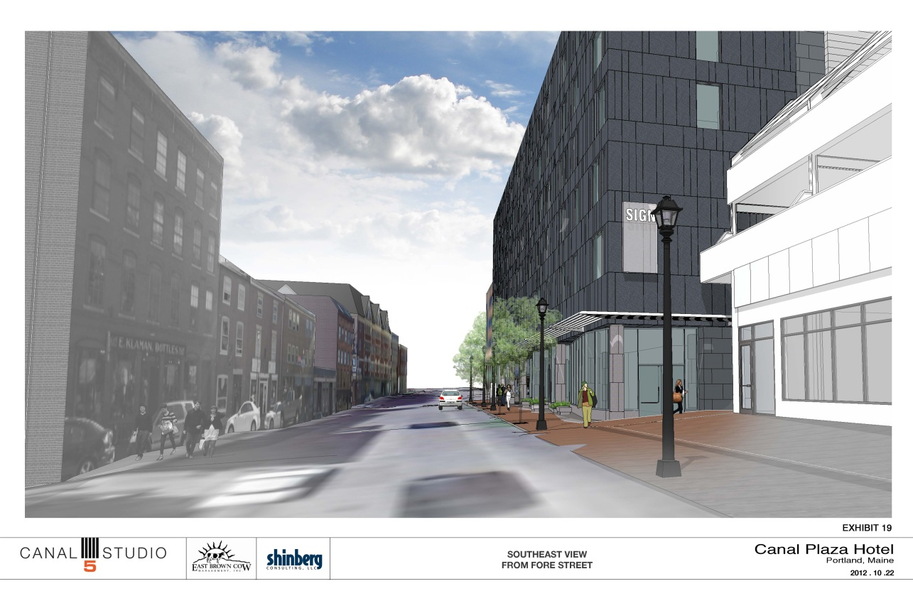
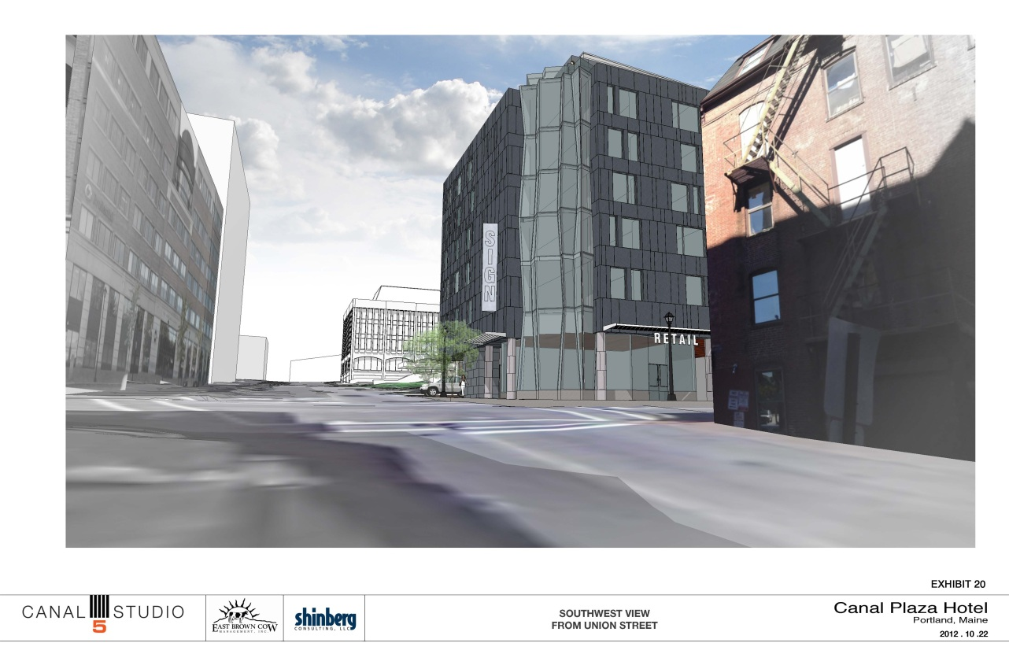
Figures 9 & 10 (top & bottom): Street views from Fore Street looking west; Union Street looking north

- Shadows
As noted in the Planning Division’s original memo, the building would be south facing. As such, much of the shadow impact would fall on the CMP substation and the adjacent garage, with some impact on Union Street.

- Snow and Ice Loading
No comments.

- View Corridors
As noted in prior memos to the Planning Board, both Union and Fore Streets are identified as subject to ‘viewing protection within view corridors’ in the city’s View Corridor Protection Plan. The Union Street view is to the south, and the Fore Street view is to the east. The massing and scale of the building, as proposed, do not substantially obstruct the views as identified in the View Corridor Protection Plan.

- Historic Resources
The site is located adjacent to the Old Port Historic District. Updated elevations and renderings were provided to the Historic Preservation Board for their October 17 meeting, where they considered changes to the proposed design in terms of compatibility with the adjacent historic district under Section 14-526(d)5.b. It should be noted that these drawings were not the same as those presented here, but represent an earlier version. Deb Andrews, Historic Preservation Manager, has written a review summarizing the Board’s comments, included here as Attachment 9. These comments include a discussion of building materials, lighting, and signage.

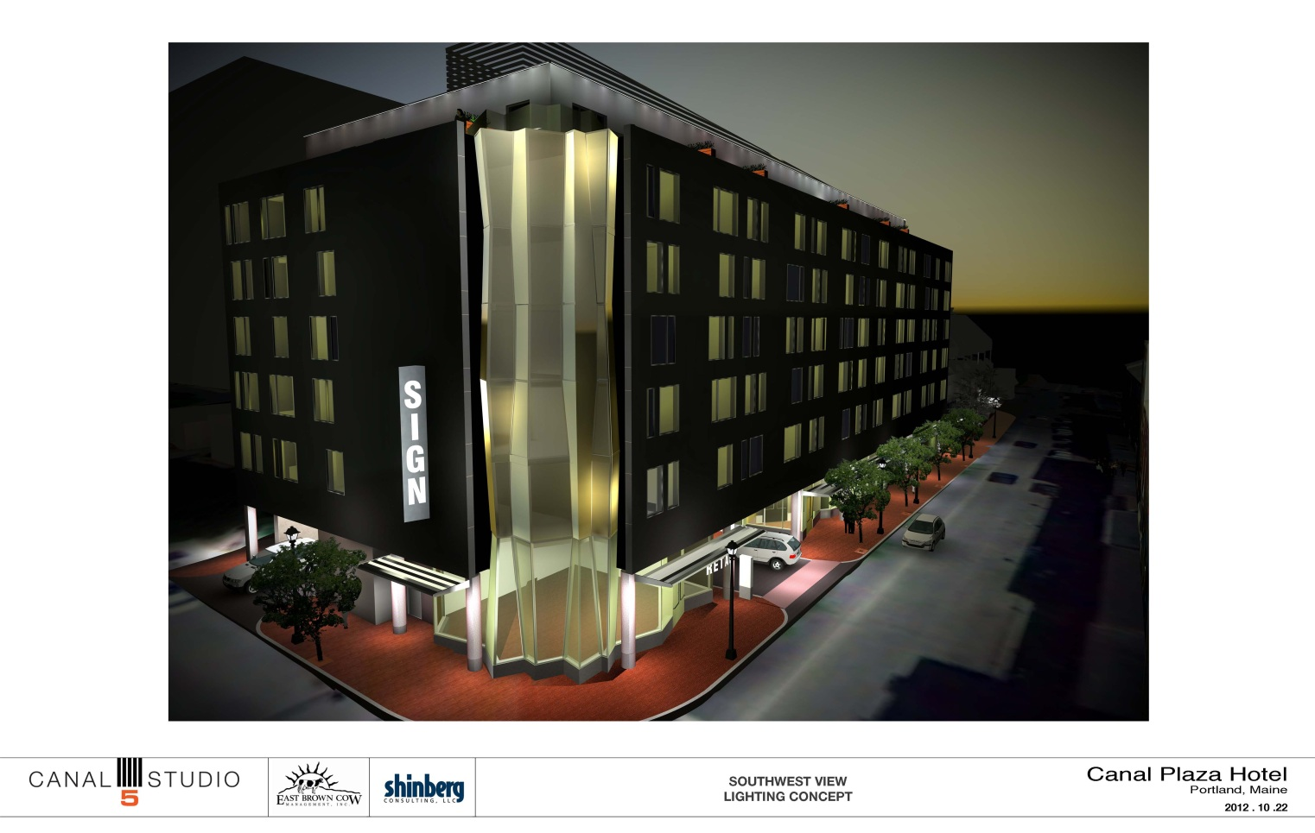
- Exterior Lighting
Figure 11: Lighting concept
The applicant has provided a preliminary lighting concept, included as Figure 11 and Attachment N. This concept shows architectural lighting on the glass corner tower, in addition to downlights on the columns, doorways, and spaces between the columns, and sconces at the top floor balcony doors. A wash is also proposed on the top floor. In order to reduce the appearance of height on this top floor, the Planning Division has suggested eliminating the top floor wash and lowering the balcony sconces to door height. Given that the applicant’s lighting plan is still evolving, the staff is recommending a condition of approval for the final lighting plan, including photometric data, be reviewed and approved by the Planning Authority prior to the issuance of a certificate of occupancy.

As requested by the Division, Old Port street lights have been proposed along the Fore Street frontage, and Downtown lights have been proposed along Union Street. A note should be added to the plans indicating that these will be LED lights.

- Noise and Vibration
Information on the HVAC and mechanical equipment will be required as a condition of approval.

- Signage and Wayfinding
The most recent drawings (Attachment O) show a protruding, triangular building sign at second and third story height on the west façade and a rectangular sign at second story height on the east facade. These are proposed as backlit signs. Pedestrian-scaled signs are also depicted hanging from the brise soleil in front of the retail entrance. In narrative, the architect has also indicated that a similar sign will be provided for the restaurant at the east end of the Fore Street façade. Lastly, a freestanding pylon sign is proposed at the mouth of the porte cochere. This sign is proposed as a 7’h x 2’w x 10”d granite and stainless steel, internally lit wayfinding sign. A waiver is required, as freestanding signs are prohibited in the B-3 zone under Section 14-369.5. The applicant has requested such a waiver.

Section 14-526(d).8.a.(iv) includes a provision for sign waivers and identifies four standards for use in granting a waiver:
(a) Signs shall meet the site plan requirements of 14-526, including that:
- the size, scale, proportions, design, materials, placement, and source and intensity of illumination shall be designed to complement both the building and its context; and
- on-site directional traffic signage may be provided to enable users to navigate to, around, and out of the site.
Generally, the proposed sign materials, placement (as shown on the site plan), and illumination are consistent with the building. However, there are no other permanent, freestanding signs on Fore Street. Similarly, the scale of the sign, which is proposed to stand 7’ in height, seems out of context with the surroundings. A design for the sign has not been submitted to the Planning Division.

(b) The size, scale, proportions, design, materials, placement, quantity, and source and intensity of illumination must be designed to complement and enhance the architectural attributes of the building. In addition, such signs shall be appropriate to the scale and character of the neighborhood in which it is located.
See above.

(c) The signage shall either be of special design merit or shall respond to the unique circumstances or characteristics of the site
In the architect’s narrative (Attachment J), the applicant states that “this modest sign will be an important way finding tool for guests arriving by automobile by providing a sign in their line of sight as they approach the hotel along Fore Street. The narrow, congested character of Fore Street makes it unlikely that the building signage on the east façade, which we have lowered, will be noticed by motorists.” It should be noted that the adjacent Fore Street Garage is set back from the street edge, which opens views to the proposed hotel from the east. As noted above, there are no other freestanding signs located on Fore Street in this area.

(d) The provisions of this subsection shall be limited to commercial uses in business or industrial zones…
This proposed use is commercial in nature.

Since the applicant does not have a detailed signage plan or specifications for any of the building signs at this time, it seems premature to consider a request for a waiver of the sign provisions. The Planning Staff has raised concerns about the scale, location, and precedent of the freestanding sign along Fore Street and note that other recent hotel projects have relied on building signage for adequate visibility. The Planning staff does not support the waiver at this time. The staff is recommending as a condition of site plan approval that a final comprehensive signage plan be submitted for review and approval prior to the issuance of a certificate of occupancy. As confirmed with Danielle West-Chuhta, Acting Corporation Counsel, the review of this project is within the jurisdiction of the Planning Board, thus any waiver requests require Planning Board action. The Planning Board could decide this matter at the public hearing or seek to table this waiver request to a date certain for further consideration.

- Zoning-Related Design Standards
As the site is located in the B-3 zone, it is subject to the Downtown Urban Design Guidelines. Outstanding comments on the design, organized to correspond to the design guidelines, are summarized here.

I. Relationship to the Pedestrian Environment
Standard: The exterior design of portions of buildings within the first thirty-five feet of height shall enhance the character, attractiveness, comfort, security, and usability of the street level pedestrian environment.
The applicant has made considerable effort to activate the pedestrian realm at the base of the building using landscaping, street furniture, sidewalk materials, lighting, and a high degree of building transparency. The exact gray of the composite limestone panels proposed for use on the majority of the building facade has not been entirely resolved, as it will be a custom color. As such, the final color will require Planning Authority review.

II. Relationship to Existing Development
Standard: The proposed development shall respect, enhance, and be integrated with the existing character of the general pattern of development in the Downtown, surrounding building environment, and streetscape.
The site abuts both a city historic district and several relatively contemporary buildings. As such, the proposed hotel straddles two very different design palettes. While its mass is in some ways similar to the buildings found across Union Street, it differs dramatically from those across Fore Street. Similarly, its composition, while similar in some respects to both the buildings directly across Union Street and Fore Street, differs in significant ways as well. The Planning Division has asked the applicant to lessen this contrast by making the building top more recessive in nature by reducing the height of the rooftop screen and changing the material or color on the stair tower at the east end, and, as necessary, the screen as well. The plans before the Board do not incorporate the changes recommended by the staff and a condition of approval is included for the Planning Board’s consideration.

The Historic Preservation Board met with the applicant to discuss compatibility with the historic district in particular. Deb Andrews has provided a summary of their comments in Attachment 9.

III. Rooftop Appurtenances
Standard: All mechanical equipment, ventilating, and air conditioning and other building systems, elevators, stairways, radio or television masts or equipment, or other rooftop elements not intended for human occupancy shall be fully enclosed in a manner consistent with the character, shape, and materials of the principal building.
See above regarding the size of the rooftop screen.

IV. Shadows
Standard: The location, massing, and orientation of portions of buildings in excess of sixty-five feet in height shall be such that substantial shadow impacts on public plazas, parks, and other publicly accessible open space should be avoided
No further comments at this time.

V. Wind
Standard: The location, massing, orientation, and architectural design of a new building or building addition shall be such that no significant adverse wind impacts are created.
No comments at this time.

VI. Setbacks
Standard: The location and design of proposed structures shall not create a detrimental impact on the structural integrity or safety of adjacent structures or the safety of occupants thereof.
No comments at this time.

VII. Building Tops
Standard: Building or structures which exceed 150 feet in height shall be designed so as to provide a distinctive top to the building which visually conveys a sense of interest and vertical termination.
Not applicable.

VIII. View Corridors/Gateways
Standard: The placement and massing of proposed development shall not substantially obstruct public views to landmarks and natural features from those locations identified on the View Corridor Protection Plan.
As noted above, both Union and Fore Streets are identified as subject to ‘viewing protection within view corridors’ in the city’s View Corridor Protection Plan. The design, as proposed, would not obstruct views in these corridors.

IX. Signage/Awnings/Canopies
See notes above regarding building signage.

X. STAFF RECOMMENDATION
Subject to the proposed motions and conditions of approval listed below, Planning Division staff recommends that the Planning Board approve the proposed development at 433 Fore Street.

XI. PROPOSED MOTIONS
- Waivers
- On the basis of the application, plans, reports and other information submitted by the applicant; findings and recommendations contained in Planning Board Report # 48-12 for application 2012-558 relevant to Portland’s Technical and Design Standards and other regulations; and the testimony presented at the Planning Board hearing:

The Planning Board waives/does not waive the Technical Standard (Section 1.7.2.7) regarding the minimum separation of 150 feet between driveways and intersections to allow driveways to the porte cochere within 50’ from the intersection on Fore Street, and within 75’ from the intersection on Union Street

- On the basis of the application, plans, reports and other information submitted by the applicant; findings and recommendations contained in Planning Board Report # 48-12 for application 2012-558 relevant to Portland’s Technical and Design Standards and other regulations; and the testimony presented at the Planning Board hearing:

The Planning Board waives/does not waive/or tables to a date certain the prohibition of freestanding signs in the B-3 zone on the peninsula (Section 14-369.5, Table 1, Footnote (b)) to allow a freestanding sign at the entrance to the porte cochere on Fore Street.

- Development Review
On the basis of the application, plans, reports and other information submitted by the applicant; findings and recommendations contained in Planning Board Report #48-12 for application 2012-558 relevant to the site plan regulations; and the testimony presented at the Planning Board hearing, the Planning Board finds that the plan is in conformance the site plan standards of the land use code, subject to the following conditions of approval that must be met prior to the issuance of a building permit, unless otherwise stated:

- The applicant shall revise the final plans prior to the issuance of a building permit to include:
- A “Do Not Enter” sign at the egress drive location on Union Street
- A note indicating that LED versions of the proposed street lights will be installed, and that the applicant will coordinate with the city regarding model numbers
- Tree grates as specified by the city arborist
- The applicant shall revise the survey such that horizontal datum is tied to the city’s coordinate system prior to the issuance of a building permit.

- The applicant shall acquire easements for drainage and service access, as well as formalize an easement to CMP which corresponds to the actual location of the electrical duct bank on site, for review and approval by the Planning Authority prior to the issuance of a building permit;

- The applicant shall obtain revocable licenses for the proposed brise soleil, signage, and footings required in the city’s right-of-way;

- The applicant shall obtain a letter from the Department of Public Services verifying sewer capacity and a letter from the Portland Water District verifying water capacity;

- The applicant shall submit the HVAC system specifications meeting applicable standards for the Zoning Administrator’s review and approval;

- The applicant shall submit a revised construction management plan for review and approval by the Planning Authority, the Department of Public Services, the city’s Parking Manager, and the city’s Fire Prevention Bureau;

- The applicant shall revise the site plan to include a note indicating that the existing mast arm at the northeast corner of Fore Street and Union Street will be relocated and that the pedestrian signal heads will be upgraded, for review and approval by the Department of Public Services;

- The applicant shall provide information on slip-resistance and prepare a maintenance agreement regarding the granite driveway aprons for review and approval by the city’s Department of Public Services and Corporation Counsel;

- The applicant shall submit a detailed plan for managing traffic in the porte cochere and for the handling of large truck deliveries for review and approval by the Planning Authority and the city’s Department of Public Services;

- The applicant shall increase the clearance in the porte cochere to 10’, for review and approval by the city’s Fire Prevention Bureau;

- The applicant shall provide additional parking supply information for review and approval by the Planning Authority, the city’s Department of Public Services, and the city’s Parking Manager;

- A final lighting plan, including photometric data and meeting relevant Technical Standards, shall be submitted for review and approval by the Planning Authority prior to the issuance of a certificate of occupancy;

- A final comprehensive signage plan , including design and illumination details for all proposed signs, shall be submitted for review and approval by the Planning Authority prior to the issuance of a certificate of occupancy;

- The applicant shall submit samples of the final custom color of the limestone composite panels proposed for the exterior of the building for review and approval by the Planning Authority;

- The applicant shall submit revised elevations and specifications for the rooftop mechanical screen and stair tower, which address the recommendations of the Planning staff and the Historic Preservation Board, for review and approval by the Planning Authority.

XII. ATTACHMENTS
A. Planning Board Report Attachments
- Zoning Administrator review, 10-3-12 (email from Marge Schmuckal)
- Traffic Engineer review, 10-25-12 (email from Tom Errico)
- Parking Manager review, 10-24-12 (memo from John Peverada)
- Department of Public Services review, 10-25-12 (email from David Margolis-Pineo)
- Fire Prevention Bureau review, 10-24-12 (email from Chris Pirone)
- Fire Prevention Bureau comment, 10-24-12 (email from Ben Wallace)
- City Arborist review, 10-25-12 (email from Jeff Tarling)
- Civil Engineer review, 10-23-12 (email from Steve Bushey)
- Historic Preservation review, 10-25-12 (memo from Deb Andrews)
- Wastewater Capacity application comments, 10-25-12 (email from David Margolis-Pineo)

B. Applicant’s Additional Submittals
- Original Cover Letter from Greg Shinberg, 8-7-12
- Cover Letter from Greg Shinberg,
- Neighborhood Meeting Summary
- Letter of Financial Capacity, 8-3-12 (letter from Androscoggin Bank)
- Preliminary Landscape Sketches, 10-2-12
- Valet Parking Letter, 10-19-12 (letter from Commonwealth Hotels)
- CMP email, 10-22-12 (email from Stephen Daniels, CMP)
- Parking Demand Update (memo from Gorrill Palmer, 9-18-12)
- Parking Supply Update
- Architect’s Narrative, 10-22-12 (letter from Patrick Costin)
- Response to Site Plan Review Comments, 10-22-12 (memo from Denise Cameron, Woodard & Curran)
- Revised Turning Template, 30-foot Box Truck
- Revised Sewer Capacity Calculations
- Lighting Concept, 10-22-12
- Elevations and Renderings, 10-22-12
- Construction Management Plan, 10-22-12
- Draft Geotechnical Report, 8-3-12

C. PLANS
Plan 1 Existing Conditions Survey
Plan 2 C-200 Demolition Plan
Plan 3 C-201 Site Plan
Plan 3 C-202 Grading, Drainage, and Erosion Control Plan
Plan 4 C-203 Utility Plan
Plan 5 C-300 Civil Details – 1
Plan 6 C-301 Civil Details – 2
Plan 7 C-302 Civil Details – 3
Plan 8 C-303 Civil Details – 4
Plan 9 C-304 Civil Details – 5
Plan 10 L-100 Landscaping and Site Amenities Plan
Plan 11 L-101 Landscaping Details
Plan 12 A10.1 Floor 1 Plan
Plan 13 A10.2 Floor 2 Plan
Plan 14 A10.3 Floors 3-6 Typical Plan
Plan 15 A10.4 Floor 7 Plan

