Inspection Services Department of Urban Development
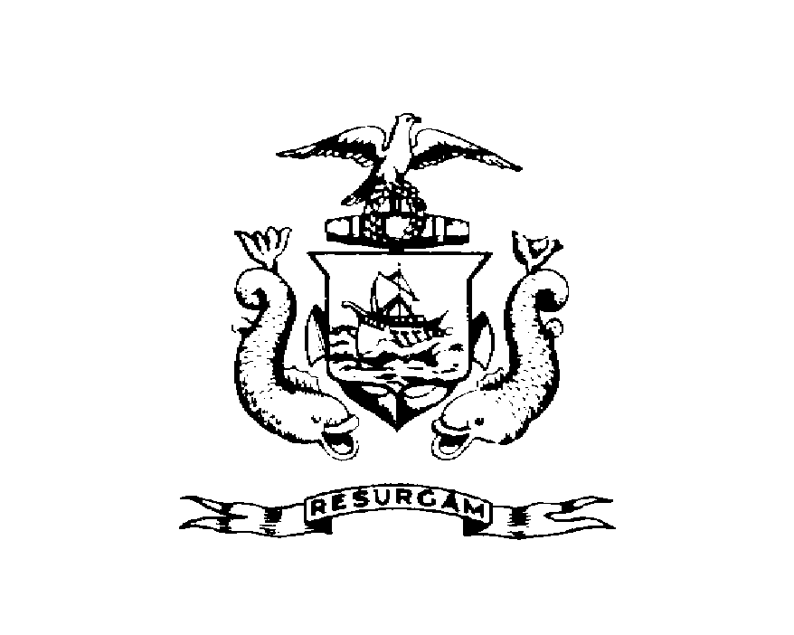
Michael J. Nugent Joseph E. Gray, Jr.
Manager Director

CITY OF PORTLAND

December 14, 2000

Todd & Clifford Proctor
Pizza Prima
1 Exchange Street

RE: 1 Exchange St.
CBL: 032-F-014

Dear Sirs:

A health inspection of your establishment was made on December 11, 2000.

Attached is a copy of the inspection report, if you have not already been provided with one, which indicated the sanitary condition of your establishment at the time of inspection was found to be unsatisfactory.

The next inspection of your establishment will be carried out within ten days, at which time I require that all operational and maintenance practices comply with the standards set forth in Chapter 11 of the City's Ordinance. If, upon re-inspection your establishment is graded unsatisfactory, the matter will be referred to the City's Corporation Counsel for action pursuant to Section 15.8 of the License Ordinance. Action may include license suspension or revocation and possible civil penalties pursuant to Section 1-15.

If you have any questions regarding this report, please do not hesitate to contact me at
874-8715.

Sincerely,

Jeanie Bourke
Code Enforcement Officer

