PLANNING BOARD REPORT
PORTLAND, MAINE

Studios at 46 Market Street
46 Market Street
Level III Site Plan and Subdivision Review
2013-245
Market Milk Partners, LLC, Applicant

Submitted to: Portland Planning Board  Public Hearing Date: November 26, 2013  Planning Board Report Number: #55-13 | Prepared by: Nell Donaldson, Planner  Date: November 21, 2013  CBLs: 32-E-10001

I. INTRODUCTION
Market Milk Partners, LLC has submitted plans for the redevelopment of an existing building at 46 Market Street in the Old Port for Level III site plan and subdivision review. The existing structure currently contains first floor retail, second floor office, and third floor residential space. The proposal involves a change of use including the interior buildout of three residential apartment units on the second floor and the addition of one apartment unit on the fourth floor, effectively eliminating all office space and bringing the total number of residential units in the building to five. At this time, the proposal does not include any site work.

The Planning Board did not hold a workshop on this proposal. Instead, the applicant has elected to submit final plans and proceed directly to public hearing.

A total of 221 notices were sent to property owners within 500 feet of the site and a legal ad ran on November 18 and 19, 2013.

Applicant: Tom Watson, Market Milk Partners, LLC
Consultants: Mark Mueller Architects; Owen Haskell, Inc.

II. REQUIRED REVIEWS
Waiver Requests | Applicable Standards
Street Trees – 5 trees required (1/unit), 0 provided, contribution of $1,000 requested | Site Plan Standard and waiver (Section 14-526(b)2.b(iii))
Review | Applicable Standards
Site Plan | Section 14-526
Subdivision (creation of 3 or more dwelling units) | Section 14-497

III. PROJECT DATA
Existing Zoning | B-3
Existing Use | Mixed (retail, office, residential)
Proposed Use | Mixed (retail, residential)
Proposed Development Program | Addition of four residential units
Parcel Size | 2,065 SF
 | Existing | Proposed | Net Change
Building Footprint | 2,065 SF | 2,065 SF | 0 SF
Building Floor Area | 8,136 SF | 8,136 SF | 0 SF
Impervious Surface Area | 2,065 SF | 2,065 SF | 0 SF
Parking Spaces (on site) | 0 | 0 | 0
Bicycle Parking Spaces | 0 | 0 | 0
Estimated Cost of Project | $250,000

IV. EXISTING CONDITIONS
Figures 1 and 2: 46 Market Street today (top); the site at Market and Milk Streets in the Old Port (bottom)
The site at 46 Market Street is currently built, occupied by a turn-of-the-century brick mixed-use building characteristic of the Old Port. The ground floor on the Market Street façade features large storefront windows; the upper floors are punctuated by a typical office or residential window pattern. Doorways are found at the northeast and southwest corners of the building, on both the Market and the Milk Street frontages; however, these doors provide access solely to the first floor and basement of the building. Access to the second and third floors is provided via an enclosed, upper story walkway from the adjacent building at 31 Exchange Street. The exterior door leading to this walkway can be found on Exchange Street. Currently, the first floor of 46 Market Street is unoccupied retail space, the second floor contains three office units, and the third floor is occupied by one large residential unit. There is also a basement with leasable space.

The project lies in the B-3 zone and also in the heart of the Old Port Historic District.

V. PROPOSED DEVELOPMENT
The residential redevelopment at 46 Market Street, as proposed, consists of four additional residential apartment units, designed as studios, and would bring the total number of units in the building to five. The existing office space on the second floor would be converted to residential space, and the existing third floor unit would be split into two. Access to all of these units would be provided via the existing elevated walkway from 31 Exchange. No exterior work is currently proposed.

VI. PUBLIC COMMENT
The Planning Division received one request for information about the project, but received no written or verbal comments.

VII. RIGHT, TITLE, & INTEREST
The applicant’s submittal includes a deed demonstrating rights to the property (Attachment C). The applicant also submitted copies of a 1993 “agreement” between the adjacent property owner at 31 Exchange Street and the then current owner of 46 Market (Attachment D). This agreement was recorded when the Exchange Street property owner, who originally owned both buildings, sold 46 Market Street as an outparcel. This agreement notes that the two buildings are “connected at certain points and are served by common utilities and access corridors, among other things,” and ultimately grants 46 Market Street an access easement “over the entrance, stairway, corridors, and walkways” in 31 Exchange. The agreement also conveys to 46 Market the rights to construct and repair utilities, heating and ventilation equipment, restrooms, and drainage systems in the joined area, known as “the strip.” This area is pictured in Figures 3 & 4.
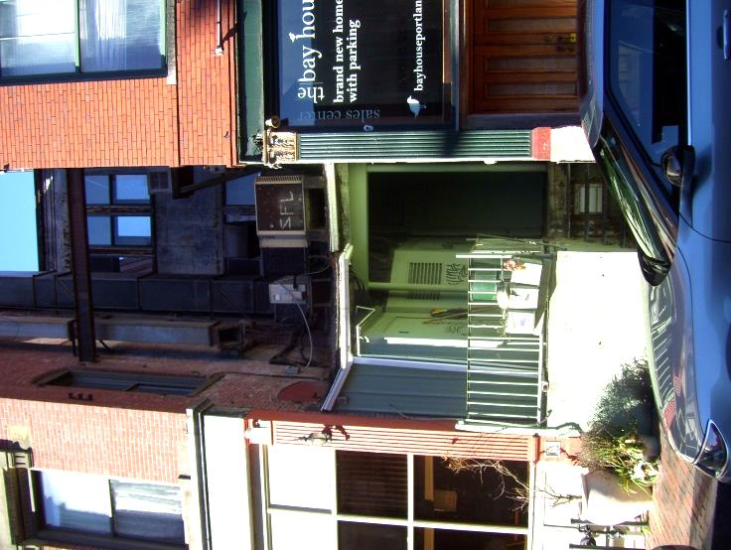
VIII. FINANCIAL & TECHNICAL CAPACITY
The estimated cost of the development is $250,000. The applicant has provided a letter from Bangor Savings Bank indicating their intent to finance the project at 46 Market Street (Attachment F).

IX. ZONING ANALYSIS
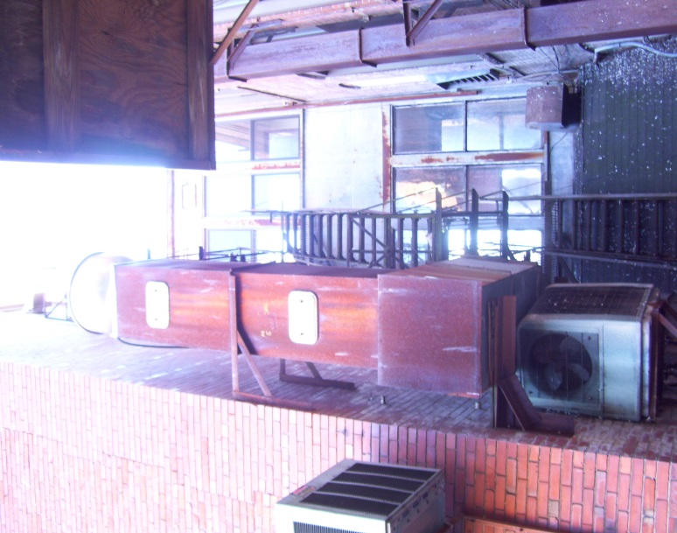
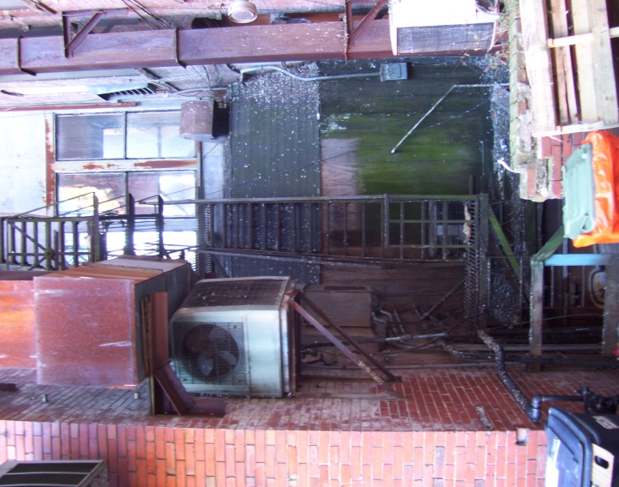
Marge Schmuckal, Zoning Administrator, has provided comments conditionally approving the project from a zoning perspective. She writes,
Figures 3 and 4: The “strip” area between the buildings at 46 Market and 31 Exchange Streets, including the second & third floor walkways providing access to 46 Market

This project is proposing to add 4 more dwelling units to be located on the 2nd and 3rd floors. Since there is one approve[d] residential unit currently, the total of dwelling units will be five. Three dwelling units will be on the 2nd floor and two dwelling units will be on the 3rd floor.

The property is located in the B-3 Downtown Business zone which allows residential dwelling units as a permitted use. There are no requirements for land area per dwelling unit in the B-3 zone. There is also an exemption for showing required parking in the B-3 zone for any change of use. This property is also within a Historic District that exempts the necessity of showing parking for the new uses.

Separate building permits are required for the change of use, along with separate permits for new HVAC and additional air cooled water chillers on the roof. Such units shall meet the maximum allowance for noise levels for the B-3 zone. At the time of permit application, the unit's decibel levels must be submitted for analysis.

X. SITE PLAN SUBMISSION REQUIREMENTS (Section 14-527) and SUBDIVISION PLAT AND RECORDING PLAT REQUIREMENTS (Section 14-496)
The applicant has submitted application materials in accordance with the site plan and subdivision requirements of the city’s land use ordinance. Where these materials are insufficient or incomplete, they have been discussed below. It should be noted that the submittal of a revised subdivision plat meeting the city’s plat requirements is included as a condition of approval. Prior to signing, the applicant will need to modify the draft plat to include waivers and conditions of approval as decided by the Planning Board. The revised plat will also need to clearly depict all areas subject to agreements with the adjacent property owner.

XI. SUBDIVISION REVIEW (14-497(a). Review Criteria; 14-198. Technical and Design Standards; & 14-499. Required Improvements)
The proposed development has been reviewed by staff for conformance with the relevant review standards of the City of Portland’s subdivision ordinance. The findings of that review are discussed below.

1. Water, Air Pollution
As noted above, no new construction is proposed as part of this project. No detrimental water or air quality impacts are anticipated.

2 & 3. Adequacy of Water Supply
The applicant has not provided a letter from the Portland Water District confirming the district’s ability to serve the proposed project. This has been included as a condition of approval.

4. Soil Erosion
As previously discussed, the site is currently built out. As such, no soil erosion is anticipated.

5. Impacts on Existing or Proposed Highways and Public Roads
The project would result in four additional residential units on site. All of these are designed as studios. The project is not expected to generate significant traffic volumes or have a major impact on existing or proposed highways and public roads.

6. Sanitary Sewer/Stormwater
The applicant has submitted a wastewater capacity application to the Department of Public Services requesting confirmation of adequate sewer capacity (Attachment J). A letter from DPS confirming sewer capacity has been included as a condition of approval.

Since the site is currently built out and no site work is proposed, there are no new impervious surfaces anticipated. As such, no stormwater impacts are expected from the project.

7. Solid Waste
The applicant has stated in their application that “existing solid waste is removed from the building by the tenants” and that “no on site waste receptacles exist or are proposed” (Attachment A). Additional details regarding solid waste storage and disposal have been requested from the applicant and will be required on the revised subdivision plat.

8. Scenic Beauty
Again, since all the proposed work is interior, the proposal is not deemed to have an adverse impact on the scenic beauty of the area.

9. Comprehensive Plan
In the creation of more housing units on the peninsula, the project is deemed compatible with Comprehensive Plan goals and policies, including the vision for the community’s future, which envisions an “adequate supply of quality housing for all,” “proximity of commercial uses near residences,” and “high-density areas on the peninsula.”

10. Financial and Technical Capacity
As noted above, the applicant has submitted a letter from Bangor Savings Bank indicating the intent to finance the project.

11. Wetland Impacts
There are no anticipated impacts to wetlands.

12. Groundwater Impacts
There are no anticipated impacts to groundwater supplies.

13. Flood-Prone Area
The project is not located in a flood-prone area.

Technical and Design Standards and Required Improvements
The already constructed building meets applicable requirements contained in the subdivision ordinance. It should be noted that underground electric already exists to the site.

XII. SITE PLAN REVIEW
The proposed development has been reviewed by staff for conformance with the relevant review standards of the City of Portland’s site plan ordinance. A summary of this review is included below.

- Transportation Standards
- Impact on Surrounding Street Systems
As noted above, the proposal is not expected to generate a change in traffic volumes to the site or thus have any significant impact on the surrounding street system.

- Access and Circulation
There is no existing or proposed vehicular access to the site. Pedestrian access, as described above, would remain unchanged, with walkup entry to the second and third floors via 31 Exchange Street. A fire escape exists at the northwest corner of the building, with access via a shared landing.

There is an existing ramp at the corner of Market and Milk Streets that fails to meet the city’s current technical standards. Of this ramp, David Margolis-Pineo, of the city’s Department of Public Services, writes,

The applicant is requested to re-build the sidewalk ramp at the corner of Milk and Market Streets installing a detectable warning panel for the historic district per Figure I-7A on page 40 of the City’s Technical Manual. The applicant is also request to install a short section of flush granite curb in conjunction with this ramp. The City may have a piece of granite curbing stored on outer Congress St which may be used at no cost to the applicant except to pick up and transport. The applicant is requested to use the Pinehall Pathway Pavers bricks when rebuilding this ramp.

Likewise, there are portions of the existing brick sidewalk north of this ramp on Market Street which require small renovations. Mr. Margolis-Pineo writes,

There are two potential tripping areas in the Market St. sidewalk adjacent to sidewalk ramp. One next to the building corner and the other around the catchbasin headstone. The applicant is requested to remove the brick as necessary in these two areas and reconstruct as necessary to eliminate these tripping hazards. Again, the City may have bricks at the outer Congress Street storage area which will match the existing brick. The applicant is welcome to use these brick as necessary to facilitate these repairs.

- Public Transit Access
The proposed development is not located along a public transit route, nor is it of sufficient size to trigger the city’s site plan standard regarding public transit access. As such, no provisions for transit access are required.

- Parking
Division 20 of the land use ordinance requires one parking space/unit for residential development located on the peninsula (Section 14-332(a)3). However, Division 20 also includes exceptions under specific circumstances, including changes of use in the B-3 zone (Section 14-332.1(e)). As such, the project is exempt from off-street parking requirements. Thus, the project is also exempt from the bicycle parking standards of the site plan ordinance.

- Transportation Demand Management
A transportation demand management plan is not required.

2. Environmental Quality Standards
- Preservation of Significant Natural Features
There are no known significant natural features on the site.

- Landscaping and Landscape Preservation
The site is currently unlandscaped and no landscaping is proposed. The city’s site plan standards include a requirement that multi-family residential developments provide one street tree/unit (Section 14-526(b)2.b(iii)). Per this requirement, five street trees are required on the site’s street frontages. The applicant has requested a waiver on the grounds that there are existing site constraints, namely relatively narrow sidewalks. The waiver criteria for street trees under 14-526 state,

Where the applicant can demonstrate that site constraints prevent the planting of required street trees in the City right of way, the Reviewing Authority may permit the planting of street trees in the front yard, within 10 feet of the property line… If planting street trees is neither feasible in the City right of way nor within the site, the applicant shall contribute to the City of Portland Tree Fund an amount proportionate to the cost of required street trees.

Due to site constraints, staff recommends a waiver of the street tree standard and a contribution to the tree fund in the amount of $1,000. A waiver of this kind is generally supported in cases of narrow sidewalks by the city’s Department of Public Services.

- Water Quality/Storm Water Management/Erosion Control
Since the site is currently built out, no changes in stormwater flows or impervious surfaces are anticipated. No stormwater treatment or mitigation is required.

3. Public Infrastructure and Community Safety Standards
- Consistency with Related Master Plans
As noted above, the project is generally consistent with related master plans.

- Public Safety and Fire Prevention
The rear of the building, which abuts the gap between 46 Market and 31 Exchange Streets, referred to by agreement as “the strip,” currently poses health and safety concerns. The applicant possesses some rights to this area, as noted above, and has indicated that the fire escape will be rebuilt, the basement stair will be rebuilt, and much of the mechanical equipment affixed to the side of the building will be removed from this area.

The applicant has provided a brief NFPA code analysis for review by the Fire Prevention Bureau (Attachment C). The building will be fully sprinkled. However, as of now, internal fire code issues remain. Captain Chris Pirone of the city’s Fire Prevention Bureau has indicated that an independent review by a certified Fire Protection Engineer will be required for building permit purposes. In addition, Captain Pirone has indicated that addressing for 911 remains unresolved. These items have been included as conditions of approval to be met prior to the issuance of a building permit.

- Availability and Capacity of Public Utilities
As noted above, the applicant has not provided evidence of water or sewer capacity. This has been included as a condition of approval.

4. Site Design Standards
- Massing, Ventilation, and Wind Impact
- Shadows
- Snow and Ice Loading
As the exterior of the building is not proposed to change, there are no anticipated changes in impacts in terms of massing, wind or shadows, or snow and ice loading.

- View Corridors
The site is not located on a recognized view corridor.

- Historic Resources
While this site is located in the Old Port Historic District, no exterior building work is being proposed as part of the project. As such, no Historic Preservation review is required.

- Exterior Lighting
No new exterior lighting is proposed.

- Noise and Vibration
The applicant has not provided information on the noise and vibration of HVAC and mechanical equipment, which are slated to be roof-mounted. Submission of this information for the Zoning Administrator’s review is proposed as a condition of approval.

- Signage and Wayfinding
There is no proposed signage or wayfinding.

- Zoning-Related Design Standards
Again, as the site is currently built out, the city’s B-3 Design Guidelines do not apply.

XIII. STAFF RECOMMENDATION
Subject to the proposed motions and conditions of approval listed below, Planning Division staff recommends that the Planning Board approve the proposed subdivision and site plan for the Studios at 46 Market Street.

XIV. PROPOSED MOTIONS
- Waivers
On the basis of the application, plans, reports and other information submitted by the applicant; findings and recommendations contained in Planning Board Report # 55-13 for application 2013-245 relevant to Portland’s Technical and Design Standards and other regulations; and the testimony presented at the Planning Board hearing:

- The Planning Board waives/does not waive the Site Plan Standard (Section 14-526(b)2.b(iii)) regarding street trees due to site constraints. The applicant shall contribute $1,000 for five street trees to Portland’s tree fund.

- Subdivision
On the basis of the application, plans, reports and other information submitted by the applicant; findings and recommendations contained in Planning Board Report #55-13 for application 2013-245 relevant to the subdivision regulations; and the testimony presented at the Planning Board hearing, the Planning Board finds that the plan is/is not in conformance with the subdivision standards of the land use code, subject to the following condition of approval, which must be met prior to the signing of the plat:

    - The subdivision plat shall be revised to include:
      - notes defining the location and terms of solid waste disposal;
      - notes identifying areas subject to agreements with the property owner at 31 Exchange Street;
      - notes regarding unit sizes;
      - sidewalk and ramp reconstruction as required by the city’s Department of Public Services; and
      - relevant waivers and conditions,
and be finalized to the satisfaction of the Planning Authority, Department of Public Services, and Corporation Counsel.

- SITE PLAN Review
On the basis of the application, plans, reports and other information submitted by the applicant; findings and recommendations contained in Planning Board Report #55-13 for application 2013-245 relevant to the site plan regulations; and the testimony presented at the Planning Board hearing, the Planning Board finds that the plan is/is not in conformance with the site plan standards of the land use code, subject to the following conditions of approval that must be met prior to the issuance of a building permit, unless otherwise stated:

- The applicant shall provide evidence of water and sewer capacity from the Portland Water District and the city’s Department of Public Services respectively, for review and approval by the Planning Authority;

- The applicant shall provide plans, stamped by a licensed engineer and including details, depicting:
  - the reconstruction of the ramp at Milk and Market Streets to include a standard detectable warning panel and flush granite curb, and
  - the reconstruction of areas of sidewalk on Market Street to eliminate tripping hazards
for review and approval by the city’s Department of Public Services and Planning Authority;

- The applicant shall provide addressing and life safety plans meeting the standards of the city’s Fire Prevention Bureau, for review and approval by that department and the Planning Authority; and

- The applicant shall submit HVAC system specifications meeting applicable standards for the Zoning Administrator’s review and approval prior to the issuance of a HVAC/Heating/Cooling permit.

XV. ATTACHMENTS
Planning Board Report Attachments
- Zoning Administrator review (memo from Marge Schmuckal, 11/12/13)
- Department of Public Services review (memo from David Margolis-Pineo, 11/18/13)

Applicant’s Submittals
- Cover Letter (from Matt Provencal, Mark Mueller Architects)
- Application
- Quitclaim Deed with Covenant
- Agreement Between 31 Exchange and 46 Market Streets
- Market Milk Partners, LLC Agreement
- Letter of Financial Capacity (from Bangor Savings Bank, 10/25/13)
- Photos of Existing Site
- PWD Infrastructure Map
- Waiver Request Letter (from Matt Provencal, Mark Mueller Architects, 10/31/13)
- Wastewater Capacity Letter

C. PLANS
Plan 1 Land Title Survey
Plan 2 Draft Recording Plat
Plan 3 Proposed Floor Plans
Plan 4 Proposed Elevations
Plan 5 Existing Floor Plans
Plan 6 Existing Elevations

