Applicant: Norris Inc.
App Phone #: 207-883-3473
Building Name: Old Portland Press Herald
Building z
Building Address: 390 Congress St
Occupancy: High-rise business
Assembly OL>300, 20 unit apartment building, etc.
Emergency Contact: Steve Stewart
Emergency phone #: 207-878-5000
Date of Application: 3/21/12
Billing Address: Electrical Maintenance &
Installation, Inc.
PO Box 15007, Portland, ME 04112
Comments: Use Market St enterance

Applicant completes red box and submits with Fire Alarm Permit
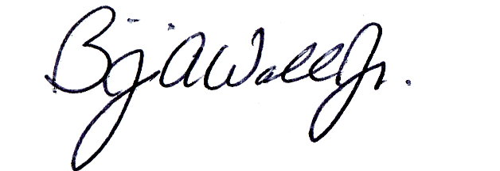Fire Prevention: Approved Denied
1
10 / 14 / 11 _____________________________________________
Date Fire Prevention Officer
Zone 1: Water flow Zone 2: City disconnect: Water Flow .
Zone 3: Sub-basement – 4th floor . Zone 4: City disconnect: Sub-basement – 4th floor
Zone 5: 5th floor – penthouse Zone 6: City disconnect: 5th floor – penthouse.
Zone 7: Unassigned Zone 8: AES Tamper switch . .
Modify City Box response to alarm sounding in CAD: YES NO .
2
Fire Alarm: Box #: Reuse 4428; discontinue 4429

Electrical Division: Approved Denied
Box Type: AES Radio Box / __________________
New Other
3
Test Date: _____/_____/_____ In Service Date: _____/_____/_____ __________________
Fire Alarm Technician
AES
Circuit if applicable:

Fire Alarm: Same Running Assignment As Box: _____
4
Notifications: All Stations Run Books Digitizer Computer Cad Box Test
South Portland ___________________________ ____________________________________
Other Dispatcher
5
Billing: Entered ____________________________________
Financial Officer

